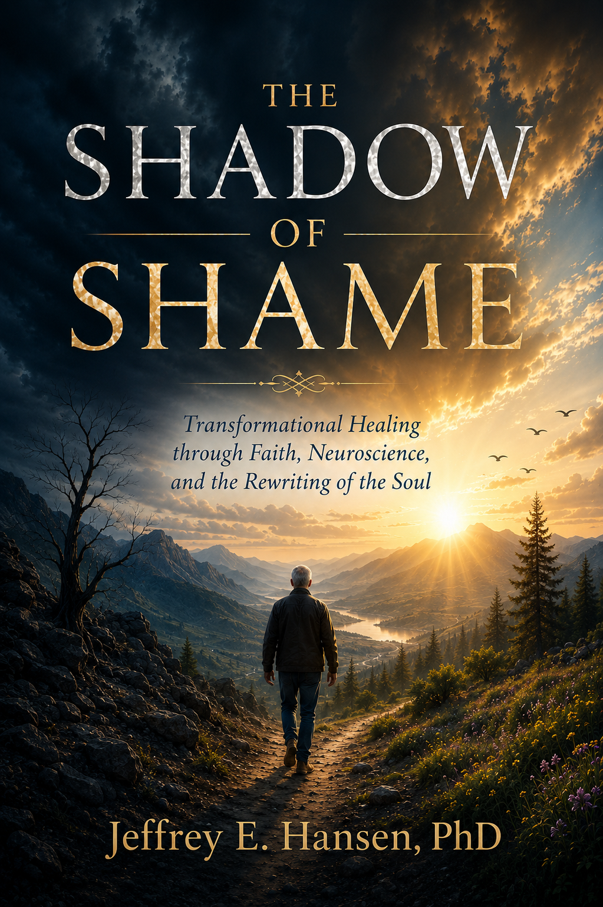

The Chapters Ahead

Introduction: The Question That Would Not Let Go 5
Part 1: The Birth of Shame 11
The Garden and the First Hiding ………………………..…..………………………...……..12
Trauma and the Making of Shame……………………………………………………….……20
Part II: The Neuroscience of Shame……………………………………………………………..67
Polyvagal Theory: When Safety is Lost…………………………….…………………….….68
The Heart Remembers: Shame, Stress, and the Neurobiology of the Heart..78
The Brain Under Shame: Identity and the Default Mode Network……………..86
Part III:The Way Home: Reclaiming Your Life 101
Calming the Storm: Restoring Safety to the Body and Heart 102
Restore What Shame Stole 125
The Space in My Heart Where Gregg Once Lived………………………………………..169
Conclusion: The Light Beyond the Shadow 181
References 186
About the Author 214

The Shadow of Shame
Transformational Healing Through Faith, Neuroscience, and the Rewriting of the Soul

NO MEDICAL ADVICE IS GIVEN NOR PROVIDED IN THIS BOOK. SUCH INFORMATION, WHICH MAY BE MEDICAL IN NATURE, IS INFORMATION ONLY FOR THE USE OF LICENSED AND EXPERIENCED MEDICAL PRACTIONERS. A READER INTERESTED IN MEDICAL ADVICE OR MEDICAL TREATMENT SHOULD CONSULT A MEDICAL PRACTIONER WITH AN APPROPRIATE SPECIALTY WHO IS PROPERLY LICENSED IN THE READER’S JURISDICTION.
Author’s Note on AI Collaboration
This book reflects decades of clinical work, research, and the development of the NeuroFaith® model, integrating neuroscience, trauma-informed therapy, and Christian spirituality. In the writing process, I utilized AI tools, including ChatGPT, to assist with drafting, organization, and refinement of ideas. These tools served strictly as supports for clarity and efficiency. All clinical insights, theoretical frameworks, and conclusions presented in this work are my own, and I stand fully behind them.

Published by NeuroFaith®, LLC
Prescott Valley, AZ

Copyright © Jeffrey E. Hansen, PH.D.
2026

No part of this book may be reproduced, stored in a retrieval system, or transmitted in any form or by any means—electronic, mechanical, photocopy, recording, or otherwise—without the prior written permission of the publisher, except for brief quotations in critical reviews or articles.
Scripture quotations, unless otherwise noted, are taken from the Holy Bible, New International Version®, NIV®. Copyright © 1973, 1978, 1984, 2011 by Biblica, Inc.™ Used by permission under Biblica’s open license, which allows limited quotations without individual request. All rights reserved worldwide

Introduction
The Question That Would Not Let Go



O
ver the years, I have written a number of books exploring the intersection of neuroscience, psychology, trauma, addiction, and faith. If you are familiar with my work, you know that I am endlessly fascinated by two great passions: the remarkable design of the human body and brain and the equally remarkable power of spirituality to heal.
Those passions eventually led me to develop the NeuroFaith® model, an approach that integrates neuroscience, trauma-informed therapies, neurocardiology, Internal Family Systems, and spirituality into a unified framework for healing. Although I am a Christian by conviction, I have always believed that spirituality in its many forms can play a profound role in recovery and transformation. Across cultures, traditions, and faiths, human beings have long understood something that modern science is only beginning to appreciate: we are more than biological creatures. We are meaning-seeking, relationship-seeking, spiritual beings.
As I have reflected on decades of clinical work, however, one subject continues to rise above all others. It appears in every book I have written, every therapy office I have sat in, every addiction story I have heard, and every trauma narrative I have helped unravel. It is the shadow that follows so many human beings through their lives.
That shadow is shame.
Shame is perhaps the most toxic and destructive of all human emotions. It is also among the least understood. We often confuse it with guilt, embarrassment, regret, or remorse. Yet shame is something entirely different. Guilt says, "I did something bad." Shame says, "I am bad."
That distinction changes everything.
Many gifted writers and thinkers have helped us understand shame more deeply. John Bradshaw exposed the devastating effects of toxic shame. Tim Fletcher illuminated the relationship between shame, developmental trauma, and addiction. Curt Thompson explored the profound human need to be seen, known, and loved. Each has made important contributions to our understanding of this powerful force.
Yet I remain convinced that shame deserves even deeper examination because it lies at the center of so much human suffering.
In my clinical experience, I have found that nearly every serious psychological struggle contains some element of shame. Depression. Anxiety. Addiction. Relationship difficulties. Perfectionism. Self-hatred. Trauma. While shame may not be the entire story, it is almost always somewhere in the room.
I know this not only as a psychologist, but as a human being.
Shame nearly killed me.
It also played a profound role in the suffering of my identical twin brother, Gregg, whose death forever changed the landscape of my life. Years ago, a devastating event altered the course of our family in ways I could never have imagined. The details of that story will unfold throughout this book, but the lessons it taught me remain painfully clear. Shame is not simply an emotion. It is a force. It can distort identity, fracture relationships, fuel addiction, and convince good people that they are beyond hope.
But I have also witnessed something else.
For more than four decades, I have had the privilege of sitting with extraordinary men and women whose lives were marked by trauma. Some carried the wounds of childhood neglect. Others survived abuse, violence, abandonment, combat, betrayal, addiction, or devastating loss. Many arrived believing they were broken beyond repair.
They were not.
As they learned to confront shame rather than hide from it, something remarkable happened. Their stories began to change. Their nervous systems calmed. Their relationships deepened. Their addictions loosened their grip. Their hearts softened. Their identities healed.
Many went on to build beautiful lives.
That transformation is what this book is about.
This is a book about the hidden wound beneath so much human suffering. It is about the neuroscience of shame, the psychology of shame, the spiritual dimensions of shame, and most importantly, the path beyond shame.
Because the opposite of shame is not pride. The opposite of shame is love. And every human soul was created for that journey.
The good news, and perhaps the most important message in this entire book, is that shame does not get the final word. For all of its power, shame is ultimately a liar. It whispers that we are beyond redemption, beyond healing, beyond belonging. It tells us that our wounds define us, that our failures are our identity, and that the safest path is to remain hidden. Shame is relentless. It is merciless. Left unchallenged, it will tighten its grip year after year, convincing us that the darkness is all there is and all there ever will be.
But shame is wrong.
I say that with conviction because I have spent much of my professional life watching shame lose. That may sound like an odd statement coming from someone who has spent more than four decades listening to stories of trauma, addiction, loss, betrayal, and suffering. In many ways, I have witnessed some of the darkest aspects of the human experience. I have listened to stories that left me heartbroken. I have sat with people who believed they were beyond repair. I have watched individuals carry burdens they were never meant to carry and blame themselves for wounds they did not create.
Yet what has struck me repeatedly over the years is not the power of human brokenness. It is the power of human resilience. Again and again, I have watched people confront experiences that should have destroyed them and somehow find the courage to keep moving forward. I have seen individuals who spent years hiding behind addiction begin telling the truth. I have watched trauma survivors discover that their wounds did not define them. I have seen relationships heal, families reconcile, and men and women recover a sense of dignity they thought was lost forever. The transformation was rarely quick and almost never easy, but it was real.
Those experiences profoundly shaped my understanding of healing. They taught me that shame is far less powerful than it pretends to be. Shame thrives in secrecy. It thrives in isolation. It thrives in the belief that we are alone. Yet the moment shame is brought into the light, something begins to change. The story starts to loosen. The grip begins to weaken. The possibility of healing emerges.
Perhaps this is one reason this book became so important to me. It is not merely a professional topic. It is personal.
As I reflect on my own life, I can see the ways shame quietly shaped my story. I can see the conclusions I drew about myself, the defenses I developed, and the ways I learned to cope with pain. I can also see those same patterns in the life of my brother Gregg. Although our stories unfolded differently, shame left fingerprints on both of our lives. Looking back, I often find myself wishing I had understood then what I understand now about trauma, identity, and healing.
Yet even that realization carries an important lesson. Healing does not require that we fully understand the past before we move toward the future. It requires only the courage to begin. It requires a willingness to tell the truth about our wounds, to step out of hiding, and to believe that our story may not be finished yet.
Healing is rarely accidental. It requires courage. It requires honesty. It requires a willingness to choose a different path, often one difficult step at a time. Yet every choice toward truth weakens shame's hold. Every choice toward connection loosens its grip. Every choice toward grace begins rewriting the narrative that trauma, loss, and suffering attempted to write upon the soul.
As that process unfolds, something beautiful begins to happen. The nervous system settles. The heart finds its rhythm again. The mind begins telling a different story. The inner critic loses some of its authority. What once felt impossible begins to feel attainable. The world itself starts to look different. The valleys no longer seem quite so deep. The mountains appear higher. The stars seem brighter against the night sky. The birds somehow sing louder in the morning. Relationships become richer. Love becomes stronger. Joy, once thought lost forever, quietly finds its way back home.
This book is about understanding the shadow of shame, but even more importantly, it is about discovering the light beyond it. No matter what has happened to you, no matter how long shame has occupied your story, there is hope. There is healing. There is freedom. And there is a path forward into a life that is far more beautiful than shame ever wanted you to believe was possible.



The Garden and the First Hiding

T
o understand shame fully, we must travel far beyond psychology, neuroscience, or even trauma therapy. We must go back to the earliest account of the human condition itself. We must return to the Garden.
As a psychologist, I have spent decades studying the brain, trauma, addiction, attachment, and human behavior. Through the NeuroFaith® model, I have sought to integrate the best of neuroscience with the enduring wisdom of faith. Both disciplines have much to teach us. Neuroscience helps us understand how shame becomes embedded in the nervous system and the brain. Faith helps us understand something equally important: why shame exists in the first place.
The story begins in the garden. As I have reflected on this story over the years, both as a psychologist and as a fellow traveler, I have become increasingly convinced that every human being carries some version of Adam's experience. The details differ, but the emotional reality remains remarkably similar. At some point, most of us encounter circumstances that leave us questioning our worth, our identity, or our place in the world.
I know I have.
There have been seasons in my own life when shame whispered that I was not enough, that I should have been stronger, wiser, or somehow different than I was. Like many of the people I have worked with over the years, I discovered that shame rarely announces itself directly. Instead, it quietly attaches itself to our wounds, convincing us that our struggles reveal something defective about who we are.
The longer I have practiced psychology and the longer I have walked with people carrying trauma, addiction, grief, and loss, the more I have come to appreciate this truth: shame thrives in hiding. It grows in silence. It deepens in isolation. But when it is brought into the light, understood, and challenged, its grip begins to loosen.
That realization lies at the heart of this book.
To understand how shame gains such influence over our lives, we must next examine one of its most common pathways. For most people, shame does not emerge from a single moment of disobedience or failure. It develops gradually through painful experiences that shape how we see ourselves and how we understand our place in the world.
This is where trauma enters the story.
Before shame entered the world, Adam and Eve lived in complete openness with God and with one another. There was no hiding, no self-consciousness, no fear of exposure, and no sense that something was fundamentally wrong with them. They existed in a state of innocence, trust, and belonging. Scripture captures this beautifully when it tells us that they were naked and felt no shame.
Then something changed.
The temptation presented to Adam and Eve was not simply about eating forbidden fruit. At its core, it was an invitation to step outside the boundaries God had established and to place their own judgment above His wisdom. It was an invitation to seek autonomy apart from the One who created them. It was, in many ways, humanity's first attempt to become something other than what God designed us to be.
The consequences were immediate.
For the first time, Adam and Eve became painfully aware of themselves. They recognized their nakedness. They felt exposed. They felt vulnerable. They felt unsafe. When God came looking for them in the garden, Adam's response revealed something entirely new in the human experience.
"I heard You in the garden, and I was afraid because I was naked; so I hid."
With those words, shame entered the story.
Notice that Adam did not merely admit wrongdoing. He hid. Fear and shame became intertwined. Something had changed not only in his behavior but in his perception of himself. The rupture was deeper than disobedience. It was a wound to identity, a fracture in relationship, and a loss of innocence.
This is the first great lesson of shame. Shame does not simply tell us that we have done something wrong. Shame tells us that there is something wrong with us.
The hiding that began in the Garden continues today. We hide behind accomplishments. We hide behind perfectionism. We hide behind addiction, success, anger, people-pleasing, busyness, and a thousand other strategies designed to protect us from exposure. We fear that if others truly knew us, they would reject us. More painfully still, we often fear that God would as well.
That fear lies at the heart of shame.
What makes shame so devastating is not merely the emotional pain it creates. It is the sense of separation it produces. Adam and Eve lost more than a garden. They experienced the anguish of stepping outside the relationship and design for which they were created. The physical consequences were profound, but the emotional and spiritual consequences may have been even deeper. For the first time, humanity experienced the sorrow of alienation, the ache of brokenness, and the burden of self-condemnation.
It is difficult for us to fully appreciate the magnitude of that moment because most of us have never known a life completely free from shame. We are born into a broken world. We assume anxiety, insecurity, self-consciousness, and self-doubt are simply part of being human. Adam knew something different. He knew what it was like to live without fear, without self-condemnation, and without the constant internal questioning that so many of us experience.
Then, in a single moment, everything changed.
Imagine becoming aware of yourself for the very first time through the lens of inadequacy. Imagine looking inward and sensing that something precious had been lost. Imagine feeling exposed, vulnerable, and uncertain in a way you had never experienced before. The innocence that once allowed complete openness was gone. In its place came a painful awareness that something was no longer as it should be.
This is the beginning of shame.
Shame is more than regret. More than guilt. More than sorrow. Shame strikes at identity itself. It whispers that the problem is not simply what we have done but who we are. It convinces us that something within us is fundamentally defective, damaged, or unworthy.
For Adam, the consequences were not merely theological. They were deeply personal. The garden around him may have looked the same, yet everything would have felt different. The trees were the same trees. The rivers were the same rivers. The sky was the same sky. Yet the lens through which he experienced them had changed. Shame has a way of doing that. It alters not only how we see ourselves but how we experience the world around us.
Perhaps the deepest wound was the awareness of what might have been. Adam knew, at least in part, the beauty of God's design. He had experienced life as it was intended to be lived. He knew connection without fear. Love without suspicion. Belonging without performance. To lose something so precious is a grief beyond words.
At the heart of shame is often a profound mourning. We grieve not only what happened to us. We grieve what could have been. We grieve the relationships that never became what they might have been. We grieve the childhood that was stolen. We grieve the innocence that was lost. We grieve the life we imagined and the person we hoped to become.
This is why shame can feel so overwhelming. It is not merely an emotional experience. It is an existential one. It touches our understanding of ourselves, our relationships, our purpose, and our place in the world. It creates a sense of separation not only from others but often from ourselves and from God.
And because human beings are not merely thinking creatures but embodied creatures, this separation is felt throughout the body. The heart grows heavy. The chest tightens. The stomach knots. Breathing becomes shallow. The body prepares for danger. Long before neuroscience would give us language for these reactions, the human experience itself testified to a simple truth: shame is carried not only in the mind but in the body.
The first hiding in the garden was therefore more than a physical act. It was the beginning of a pattern that has echoed throughout human history. Shame entered the human story, and with it came the impulse to conceal, withdraw, protect, and hide.
Every trauma survivor knows something of this feeling.
Although separated by thousands of years and vastly different circumstances, the emotional experience is remarkably similar. The details may differ, but the wound often feels the same. The child repeatedly criticized by a parent, the adolescent rejected by peers, the victim of abuse, the combat veteran, the betrayed spouse, and the person trapped in addiction all eventually confront the same painful question: What is wrong with me?
That question lies at the heart of shame.
Trauma has a unique ability to transform painful experiences into painful conclusions about identity. What begins as something that happened to us slowly becomes something we believe about ourselves. A child who is neglected does not typically conclude that his caregivers were emotionally incapable of meeting his needs. More often, he concludes that he must not be worthy of love. A child who is abused rarely thinks, "The adults around me failed me." Instead, the child frequently concludes, "Something must be wrong with me."
The wound becomes a narrative.
The narrative becomes an identity.
And the identity becomes a prison.
This is why shame can be so difficult to recognize and even harder to heal. Over time, it no longer feels like a belief. It feels like reality. The story becomes so familiar that we stop questioning it. We simply assume it is true. The hiding that began in the garden continues today. Some of us hide behind perfectionism. Others hide behind success, achievement, anger, addiction, people pleasing, busyness, or emotional withdrawal. We spend enormous amounts of energy attempting to protect ourselves from exposure because beneath these strategies often lies the same fear that drove Adam into the trees.
The fear of being seen.
The fear of being known.
The fear that if others truly understood us, they would reject us.
Yet just as the story of shame begins in the garden, so does an important truth. God did not abandon Adam in his hiding. He sought him. The first question recorded after humanity's fall was not an accusation but an invitation: "Where are you?" That question still echoes through every generation. It echoes in therapy offices, addiction treatment centers, churches, support groups, hospital rooms, and lonely bedrooms. It echoes in the hearts of men and women who have spent years running from their wounds because shame convinced them that hiding was safer than being known.
To understand how shame becomes written into the story of a person's life, however, we must move beyond the garden and into the world of trauma. There we discover that shame is not merely an ancient human problem. It is a living wound that continues to shape identities, relationships, and lives every day. It is through trauma that we begin to understand how shame becomes written into the story of the self.

Trauma and the Making of Shame

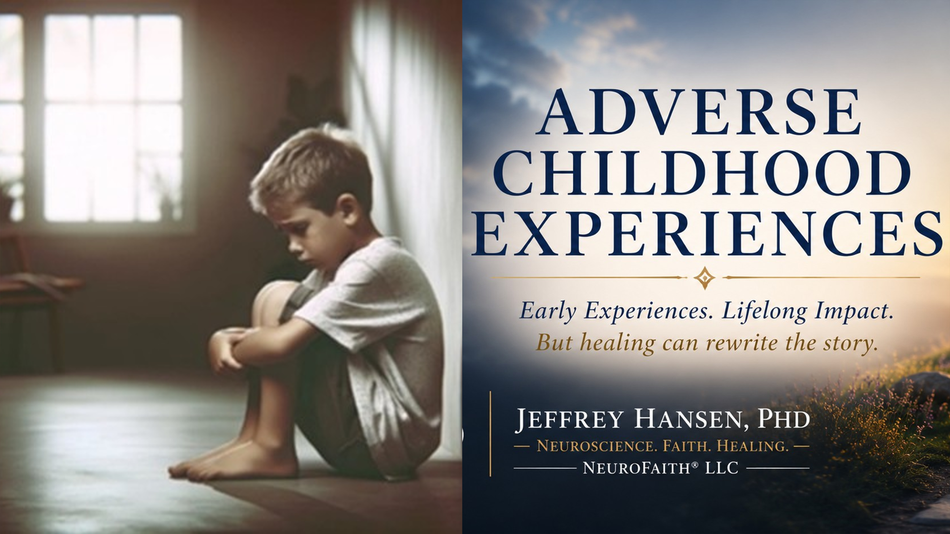
I
n the previous chapter, we explored the story of Adam and Eve and the first appearance of shame in the human experience. We considered what it might have felt like to suddenly become aware of one's own vulnerability, brokenness, and separation. We reflected on the possibility that shame was not simply the recognition that a mistake had been made, but the painful belief that something within the self had fundamentally changed. The hiding that began in the garden has continued throughout human history, finding expression in countless forms and touching every generation.
Yet for most people, shame does not emerge from a single defining moment. More often, it develops gradually through experiences that shape how we see ourselves and how we understand our place in the world. This is where trauma enters the story.
When most people hear the word trauma, they think of catastrophic events. They think of violence, combat, sexual assault, natural disasters, or horrific accidents. Certainly, those experiences can be profoundly traumatic and often leave lasting emotional scars. But trauma is much broader than that. Trauma also occurs in the quieter moments of life. It emerges through neglect, chronic criticism, rejection, humiliation, abandonment, emotional unavailability, betrayal, and the countless ways human beings fail one another.
Sometimes trauma comes from what happened to us. Just as often, it comes from what did not happen. The comfort that never came. The encouragement that was never spoken. The protection that was absent. The parent who was physically present but emotionally unavailable. The teacher who humiliated us. The peers who rejected us. The people who should have seen us, valued us, protected us, and helped us feel safe, but somehow never did.
The common denominator is not necessarily the event itself. The common denominator is the wound it leaves behind.
As a psychologist, I have become increasingly convinced that trauma's most damaging effect is not what it does to our emotions, but what it does to our identity. Trauma wounds our understanding of who we are. It changes the story we tell ourselves. Over time, painful experiences begin to generate painful conclusions, and those conclusions become the lens through which we interpret ourselves, others, and the world around us.
A child who is repeatedly ignored may conclude that he does not matter. A child who is abused may conclude that she is somehow defective. An adolescent who is repeatedly rejected may begin to believe that he is fundamentally unlovable. A spouse who experiences betrayal may question her worth. A combat veteran may carry not only memories of war, but also a profound sense of guilt, isolation, or moral injury. Although the circumstances differ dramatically, the conclusions often sound remarkably similar.
Something is wrong with me.
This is where trauma and shame become deeply intertwined.
For decades, researchers have documented the devastating impact trauma can have on emotional, psychological, relational, and physical health. Trauma, particularly in the form of child maltreatment such as neglect, emotional abuse, physical harm, and sexual violation, has been identified as a major contributor to emotional dysregulation and poor mental health outcomes across the lifespan. It is one of the most significant risk factors not only for depression, but also for post-traumatic stress disorder and a wide array of emotional and relational struggles (McLaughlin et al., 2012, 2013).
The wound becomes a narrative.
The narrative becomes a belief.
The belief becomes part of who we think we are.
Over time, these conclusions become so familiar that they no longer feel like beliefs. They feel like reality.
Yet perhaps trauma's most devastating effect is not what it does to the nervous system. It is what it does to identity.
As I reflect on my own life, I can see this process clearly. Growing up, there were many blessings in my family, but there were also wounds. My father carried struggles of his own, struggles that I would not fully understand until much later in life. As a child, I did not possess the maturity to appreciate the complexities of what he was carrying. I simply experienced the instability, the unpredictability, and the emotional tension that occasionally found its way into our home.
Children rarely ask, "What happened to my parents?" They ask a much different question.
"What does this mean about me?"
That is where shame often begins.
Looking back, I can see how some of my own beliefs about worth, performance, vulnerability, and emotional safety began forming long before I was consciously aware of them. At the time, I simply assumed these were aspects of my personality. I thought I was driven because I was driven. I thought I was independent because I was independent. I thought my tendency to push through difficulty without asking for help was simply strength.
Years later, I began to understand that many of these characteristics were also adaptations. They had developed for reasons. They were responses to experiences, attempts by a young mind and nervous system to make sense of a complicated world.
What I did not realize at the time was that trauma rarely remains an event. It gradually becomes a story. And if that story goes unchallenged, it can eventually become part of our identity.
Clearly, one of the most insidious effects of unresolved trauma is the formation of negative core beliefs. These deeply ingrained assumptions, such as I am not lovable, I am not worthy, or I have no value, become embedded within us over time. As clinicians like Tim Fletcher have emphasized, these beliefs do not simply exist as thoughts. They become organizing principles through which we experience ourselves and the world. They are etched into the brain's implicit memory systems, particularly within the default mode network, which governs self-referential thought. Over time, the default mode network can become a carrier of a toxic internal narrative.
These are not merely painful thoughts. They become painful conclusions about identity. Scripture speaks often about the power of truth and the danger of deception. Jesus described the enemy as "a murderer from the beginning" in whom "there is no truth" (John 8:44, NIV). Whether viewed through the lens of neuroscience, psychology, or faith, shame thrives in distortion. It convinces us that our wounds define us, that our failures identify us, and that our brokenness is the final word about who we are.
Nothing could be further from the truth.
Yet shame feels true.
That is what makes it so powerful.
For adolescents whose brains are still developing, and for adults whose early wounds were never adequately addressed, these beliefs become the lens through which future experiences are filtered. Compliments are discounted. Rejection is magnified. Failure confirms what shame already suspects. Success may provide temporary relief, but it rarely silences the deeper narrative. The wounded story remains active beneath the surface, quietly shaping perception, relationships, choices, and identity itself.
As Fletcher and others have noted, trauma is not stored as narrative memory alone. It is carried in the body itself. It lives within the nervous system and expresses itself through our relationships, behaviors, and patterns of protection. When we carry trauma, we may appear avoidant, perfectionistic, overly compliant, oppositional, emotionally distant, or chronically self-critical, not because we are defiant or disordered, but because we are trying to survive.
These are survival strategies.
They are also hiding strategies.
Just as Adam hid among the trees, many of us spend years hiding behind achievement, perfectionism, busyness, addiction, people pleasing, anger, or emotional withdrawal. We may not realize we are hiding, but beneath many of these protective strategies lies the same fear that emerged in the garden.
The fear of being seen.
The fear of being known.
The fear that if others truly knew us, they would turn away.
These trauma-driven beliefs quietly shape and often sabotage every area of our lives. They distort how we see ourselves, how we interpret the intentions of others, and how we engage in relationships. Social interactions may feel unsafe. Occupational challenges may feel overwhelming. Intimacy may feel threatening rather than life-giving. Many people carry invisible scripts of shame and fear for decades, unless those scripts are brought into the light and challenged by truth, grace, and healing relationships.
The impact of trauma is not limited to the emotional or relational domains. Trauma leaves fingerprints throughout the entire human system. It affects the mind, the body, relationships, and even physical health. One of the most important discoveries in modern trauma research emerged through the Adverse Childhood Experiences study conducted by Felitti and colleagues (1998, 2009, 2014).
The findings were sobering.
They revealed that childhood trauma is directly correlated with increased risk for physical illness, substance abuse, depression, suicide, and early mortality. Emotional abuse, in particular, was found to be even more strongly associated with adult depression than sexual abuse. These findings underscore a profound truth: how we are emotionally treated, especially during childhood, helps shape not only our emotional health but also our physical well-being.
If trauma helps explain how shame becomes written into the story of the self, the ACE study helps us understand just how widespread and consequential those wounds can become.
To appreciate the full impact of trauma on human development, we must take a closer look at what the ACE research revealed.

Adverse Childhood Experiences

The ten categories of adverse childhood experiences identified by Felitti and Anda (2009) represent far more than statistics on a page. Behind every category is a human story. Behind every percentage is a child who experienced something no child was meant to carry alone.
When we look at the ACE categories, it is tempting to focus on the events themselves. Emotional abuse. Physical abuse. Sexual abuse. Neglect. Addiction in the home. Mental illness. Family disruption. Violence. Incarceration. Yet the deeper question is not simply what happened. The deeper question is what those experiences taught the child about themselves.
This is where trauma and shame become inseparable.
A child who is repeatedly humiliated may begin to believe there is something fundamentally wrong with them. A child who is neglected may conclude that they do not matter. A child exposed to violence may come to view the world as dangerous and themselves as powerless. Over time, these experiences become more than memories. They become stories. The stories become beliefs. The beliefs become identity.
The tragedy is that children rarely possess the developmental capacity to accurately interpret what is happening around them. They do not conclude that their caregivers were emotionally unavailable, overwhelmed, addicted, or wounded themselves. Instead, children often assume the problem resides within them.
Something is wrong with me.
That is the language of shame.

ACE Survey

Abuse
Emotional Abuse
Recurrent threats, humiliation, ridicule, or emotional degradation (11%)
Physical Abuse
Beating or physical assault beyond corporal punishment (28%)
Sexual Abuse
Contact sexual abuse
28% of women, 16% of men, 22% overall

Household Dysfunction
Mother Treated Violently (13%)
Household Substance Abuse
Alcohol or drug misuse by a household member (27%)
Household Incarceration
A family member imprisoned (6%)
Mental Illness in the Home
Household member chronically depressed, suicidal, mentally ill, or psychiatrically hospitalized (17%)
Parental Separation or Loss
Not raised by both biological parents (23%)

Neglect
Physical Neglect (10%)
Emotional Neglect (15%)
Adapted from Felitti & Anda (2009)

Trauma experts often distinguish between "Big T" trauma and "little t" trauma. Big T traumas are the events most people readily recognize as traumatic: violence, disaster, assault, combat, or severe accidents. Little t traumas involve the repeated relational wounds that occur over time through rejection, criticism, emotional neglect, abandonment, humiliation, or the absence of healthy emotional attunement.
Yet there is often nothing little about little t trauma.
In my own work as a psychologist, I have repeatedly observed that the chronic absence of emotional attunement can be every bit as damaging as more obvious forms of trauma. Children need more than food, shelter, and physical safety. They need to be seen. They need to be known. They need to feel valued. They need someone who can help them make sense of their emotions and experiences.
When that process is absent, something important is lost.
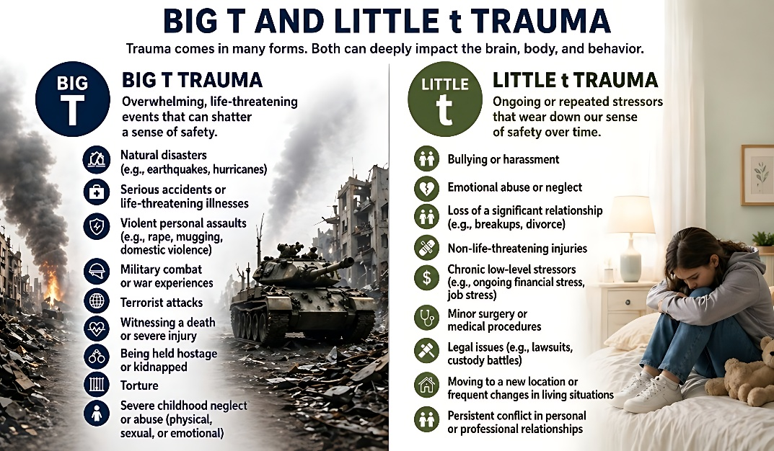

Barta (2015) noted that trauma is not necessarily caused by bad parents but often by emotionally unavailable ones. Most parents genuinely love their children and do the best they can with the tools they possess. Yet good intentions do not always protect children from emotional wounds. When a child's emotional world is consistently overlooked, dismissed, or misunderstood, the consequences can be quietly devastating.
Children raised without emotional mirroring often learn to hide parts of themselves. They suppress feelings that seem unacceptable. They minimize needs that go unmet. They learn to adapt in ways that preserve attachment and reduce emotional pain.
In many ways, this is another version of the story we encountered in the garden.
The hiding continues.
The child hides sadness.
The child hides fear.
The child hides loneliness.
Eventually, the child may even hide from themselves.
What begins as a survival strategy gradually becomes a way of life. These adaptations may later fuel depression, anxiety, addiction, perfectionism, people pleasing, relational difficulties, and countless other struggles that emerge across the lifespan.
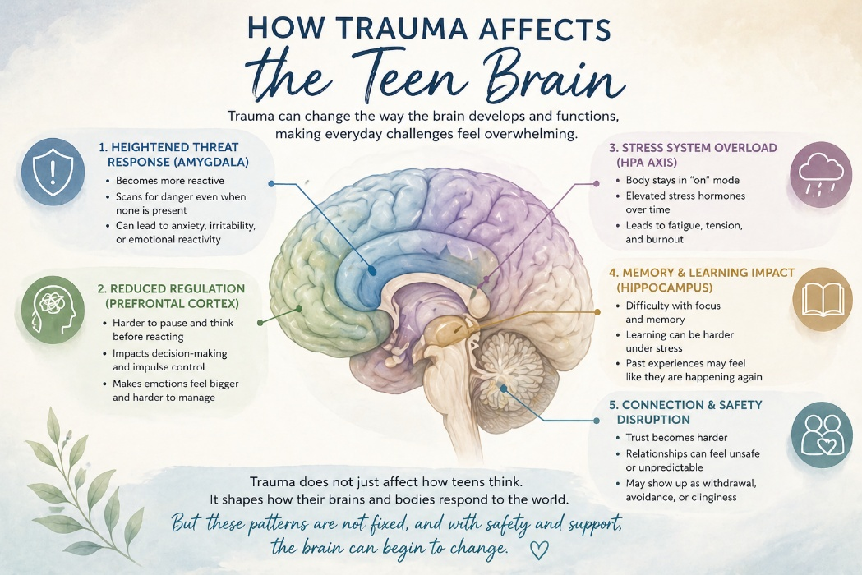
Dr. Peter Levine (2008) writes, "Trauma is about loss of connection, to ourselves, our bodies, our families, others, and the world around us." This loss of connection often develops gradually. People learn to avoid feelings, people, places, and memories that trigger pain. Yet in avoiding pain, they frequently lose access to joy, vitality, authenticity, and the ability to fully engage with life.
Perhaps nowhere is this more evident than in the disruption of what researchers describe as social engagement. Human beings are born with a remarkable neurological system designed to promote connection, safety, communication, and co-regulation. Healthy development depends upon relationships in which we are seen, soothed, protected, and understood.
Early trauma disrupts this process.
As Anda et al. (2018) note, adverse childhood experiences may impair the ability to form secure attachments in adulthood. The unsuccessful search for connection often manifests through unhealthy relational patterns, compulsive behaviors, promiscuity, addiction, and other attempts to soothe emotional pain.
At its core, trauma creates disconnection.
Shame deepens it.
Together they form a powerful cycle. Trauma wounds the self. Shame interprets the wound. Trauma creates pain. Shame assigns meaning to that pain. Trauma says, "You were hurt." Shame says, "You are the problem."
This distinction is critical.
Because healing begins when we learn to separate what happened to us from who we are.
As Dr. Felitti highlighted in his landmark 2009 lecture, the long-term consequences of adverse childhood experiences are staggering. The research consistently demonstrates that the greater the number of ACE categories experienced, the greater the risk for depression, addiction, chronic illness, suicide, and a host of other adverse outcomes.
For every category of childhood trauma experienced, the likelihood of depression increases substantially. Individuals with ACE scores of four or higher are approximately 260 percent more likely to develop chronic obstructive pulmonary disease, 240 percent more likely to contract hepatitis, 460 percent more likely to experience depression, and 1,220 percent more likely to attempt suicide. Those with six categories of ACEs are five times more likely to become depressed as adults, while individuals with seven categories are more than 3,100 percent more likely to attempt suicide (Felitti et al., 2014; Felitti, 2004; Felitti and Anda, 2009; Felitti et al., 1998).
These findings are sobering.
Yet behind every statistic stands a person.
A child.
A story.
A wound.
A life shaped by experiences that were never meant to be carried alone.
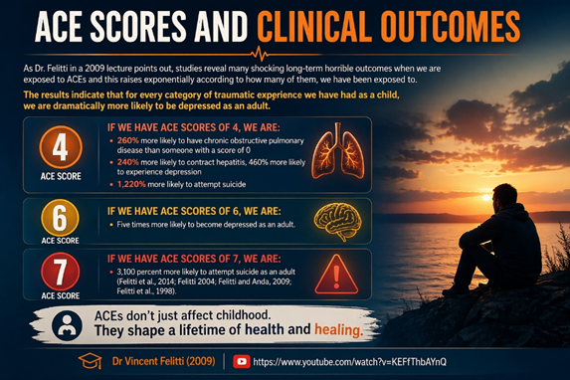
In the 2009 lecture, Dr. Felitti offered the following graphs, which nicely detail the dramatic impact that ACEs have on our society:
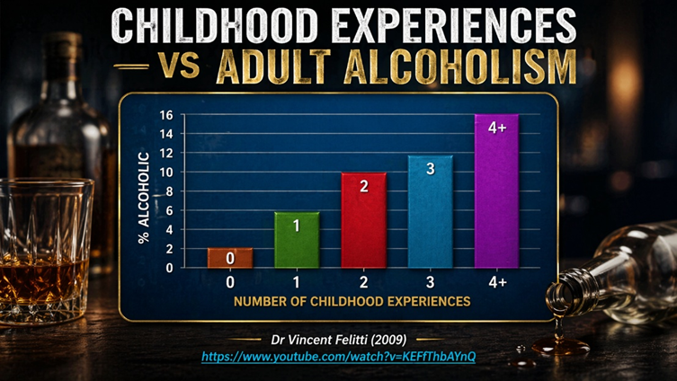
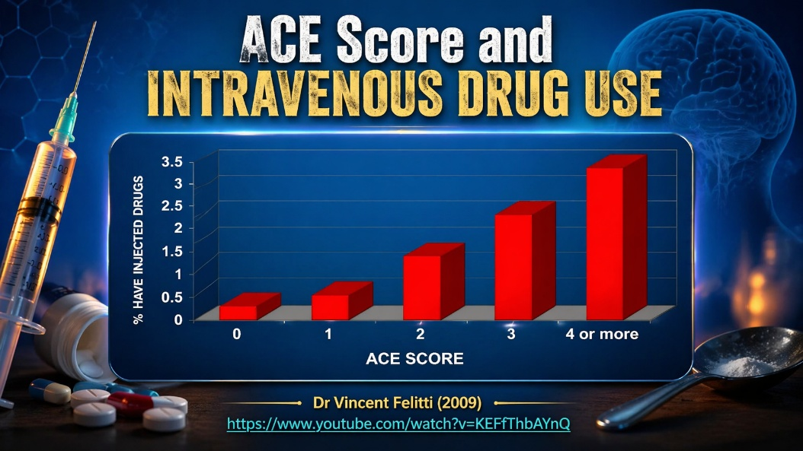
The ACE research helps us appreciate the scope of trauma's impact, but it also raises an important question. How does trauma gain such profound influence over our lives? How do painful experiences become painful beliefs? How do wounds become narratives? And how do those narratives become part of our identity?
I remember the first time I completed my own ACE inventory.
At the time, I was already a psychologist. I had served in the military, earned advanced degrees, built a career, raised a family, and achieved many of the things that society associates with success. Yet as I worked through the questions, I found myself reflecting on experiences I had long ago filed away as simply "the way things were."
That is one of the great deceptions of childhood.
Children normalize their environment.
Whatever is familiar becomes normal, even when it is painful.
Many of us do not recognize the significance of our own adverse experiences until years or even decades later. We adapt. We survive. We move forward. Yet the nervous system remembers, and the beliefs formed during those years often continue influencing us long after the events themselves have passed.
The ACE research helped me understand something important. Trauma is not a competition. It is not about whether someone else's experiences were worse. It is about understanding how our own experiences shaped us. For many people, including myself, that realization becomes the beginning of a very different conversation about healing.
To answer those questions, we must examine three pathways through which trauma takes root and continues to shape the human experience: attachment, social learning, and epigenetics.
So how does trauma take root so deeply within us, and why is it so difficult to let go? Trauma does not stay contained in one part of our lives. It moves through us. It settles into the ways we see ourselves, the ways we connect with others, and the patterns we find ourselves repeating, often without fully understanding why.
We carry it into our closest relationships, where it shapes how we trust, how we protect ourselves, and how we respond when we feel hurt or afraid. We absorb it through the environments we grow up in, learning from what is modeled around us, even when those patterns are unhealthy or painful. And over time, trauma can reach even deeper, leaving its imprint on our biology, influencing how our bodies respond to stress and how certain tendencies may be passed forward.
The ACE research helps us appreciate the scope of trauma's impact, but it also raises an important question. How does trauma gain such profound influence over our lives? How do painful experiences become painful beliefs? How do wounds become narratives? And how do those narratives become part of our identity?
Trauma does not simply happen and then disappear. It leaves traces. It shapes the way we relate to others, the way we interpret the world around us, and even the way our bodies respond to stress. Over time, trauma becomes woven into the very fabric of how we experience ourselves, others, and God.
Understanding these processes is essential because healing requires more than recognizing that we have been wounded. Healing requires understanding how those wounds took root and how they came to influence the story we tell ourselves about who we are.
Although trauma affects each person differently, three primary pathways help explain how its influence becomes embedded in our lives and contributes to the formation of shame.
Pathway One: Attachment
How trauma shapes the way we connect, trust, and feel safe with others
Our earliest relationships become the foundation upon which we build our understanding of ourselves and the world. When attachment is secure, children learn that they are safe, valued, protected, and worthy of love. When attachment is disrupted through neglect, inconsistency, rejection, emotional unavailability, or abuse, the seeds of shame often begin to take root. The child does not simply experience pain. The child begins to draw conclusions about identity and worth.
Pathway Two: Social Learning
How trauma is modeled, observed, learned, and repeated across relationships
Children learn far more from what they experience than from what they are told. The behaviors, beliefs, coping strategies, emotional responses, and relational patterns modeled by parents, caregivers, and significant others often become templates that shape future relationships and self-perception. Trauma can therefore be learned, reinforced, and repeated across generations, quietly influencing how individuals view themselves, others, and the world around them.
Pathway Three: Epigenetics
How trauma leaves its imprint on the body and may influence future generations
Trauma affects more than thoughts and emotions. Increasingly, research suggests that chronic stress and adversity can alter biological systems in ways that affect health, stress responses, emotional regulation, and vulnerability to future difficulties. In this sense, trauma leaves footprints not only on the mind and heart but also on the body itself. The effects of adversity can echo across years and, in some cases, even across generations.
Together, these three pathways help explain how adversity becomes identity, how wounds become shame, and why experiences from long ago can continue influencing our lives decades later. Trauma wounds us, but shame gives those wounds a voice. Understanding these pathways is one of the first steps toward understanding how healing becomes possible.
We begin with attachment, because it is within our earliest relationships that many of our deepest beliefs about ourselves are first formed.
Pathway One: Attachment
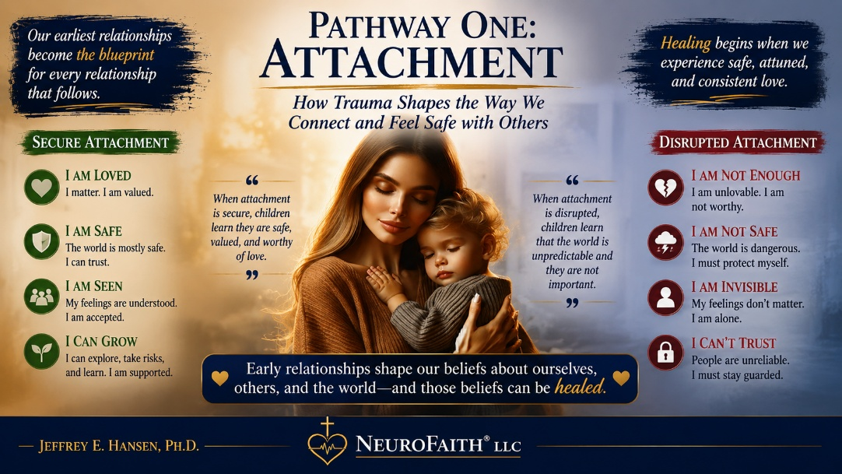
Attachment is not merely a psychological theory. It is one of the most fundamental experiences of being human.
Every one of us knows what it feels like to reach for connection. We know what it feels like to seek comfort when we are afraid, to look for reassurance when life feels uncertain, and to long for the presence of someone who makes us feel safe. From the moment we enter the world, we are wired for relationship. We come into this life needing far more than food, shelter, and physical protection. We need to be seen. We need to be soothed. We need to be known. We need to know that we matter.
When those needs are met consistently, something beautiful begins to develop within us. We begin to trust. We begin to believe that relationships can be safe. We develop a quiet confidence that we are valued, worthy of love, and capable of navigating the world around us.
But when those needs are met inconsistently, neglected, or ignored, something else begins to develop. We adapt. We learn how to survive emotionally. We discover ways of protecting ourselves from disappointment, rejection, abandonment, or pain. What begins as a survival strategy in childhood often becomes a relational pattern that follows us well into adulthood.
This is the heart of attachment.
Attachment is the deep and enduring emotional bond that forms between us and those who care for us. Although attachment begins in childhood, it does not remain there. It becomes the blueprint through which we experience relationships, regulate emotions, respond to conflict, and understand ourselves. In many ways, attachment becomes one of the primary architects of identity.
This is why attachment matters so deeply in a book about shame.
Children do not learn who they are in isolation. They learn who they are through relationships. They discover whether they are lovable, valued, safe, and worthy through thousands of interactions with the people closest to them. Healthy attachment tends to reinforce a sense of worth and belonging. Disrupted attachment often creates fertile ground for shame.
A child who feels consistently seen and comforted may conclude, "I matter."
A child who feels consistently ignored may conclude, "I do not matter."
A child who experiences reliable love may conclude, "I am worthy of love."
A child who experiences chronic rejection may conclude, "Something is wrong with me."
The events may differ, but the conclusions often become remarkably similar.
This is why shame and attachment are so closely connected. Attachment shapes the stories we tell ourselves about who we are.
Long before modern psychology articulated these truths, Scripture recognized the profound influence of early relationships and development. Proverbs 22:6 reminds us, "Start children off on the way they should go, and even when they are old, they will not turn from it." The relationships that shape us early do not simply disappear. They echo across a lifetime.
The groundbreaking work of John Bowlby and Mary Ainsworth helped modern psychology understand why this is true. Their research provided a framework for understanding what parents, caregivers, counselors, and pastors had observed for generations: the quality of our earliest relationships profoundly influences the quality of our later ones.
Before Bowlby became known as the father of attachment theory, he was a physician searching for answers. That search took a decisive turn during a six-month experience working with maladjusted children at Priory Gates. What he encountered there changed the trajectory of his life. Reflecting on that period, Bowlby described it as one of the most important experiences of his professional career because it helped him recognize that many of the struggles appearing in the present were deeply rooted in early developmental experiences (Kanter, 2007).
That insight remains just as important today.
Many of the difficulties we face as adults are not random. They are connected to the relationships and environments that shaped us long before we had the language to understand what was happening.
As Bowlby's work continued, Mary Ainsworth helped bring attachment theory into even sharper focus. Together they sought to answer a profoundly important question: How do children experience connection, safety, and separation?
To answer that question, Ainsworth developed what became known as the Strange Situation, a carefully designed observation in which young children were briefly separated from their caregivers in an unfamiliar environment. What happened next revealed something extraordinary. The children's responses to separation and reunion reflected the attachment patterns they had developed over time.
Some children sought comfort and were quickly soothed.
Some avoided connection.
Others desperately sought closeness while simultaneously struggling to trust it.
What Ainsworth discovered is something many of us recognize in ourselves. We do not all approach relationships in the same way. Some move toward connection with trust and openness. Some keep others at a distance. Others find themselves caught in a painful tension, longing for intimacy while fearing the vulnerability it requires.
From this work emerged the attachment patterns we continue to study today: secure attachment, anxious-avoidant attachment, and anxious-resistant attachment. These are not merely childhood categories. They are relational templates that often continue shaping our adult lives, influencing how we love, trust, protect ourselves, and respond to uncertainty (VeryWellMind, 2019).
Understanding attachment helps us understand something profoundly important.
The ways we learned to connect were learned.
And what was learned can be healed.
And as research continued, it became clear that attachment is not a single moment, but a process that unfolds over time. In a longitudinal study of infants, Rudolph Schaffer and Peggy Emerson observed how attachment develops across the first years of life. Infants were followed closely throughout their first year and again at 18 months, revealing that attachment forms in distinct stages rather than all at once. These findings remind us that connection is built over time, shaped by repeated experiences of care, responsiveness, and presence (Schaffer & Emerson, 1964).
Attachment develops gradually. It is not a switch that suddenly turns on, but rather a relationship that unfolds over time through thousands of moments of connection, comfort, and responsiveness. Schaffer and Emerson (1964) observed that attachment emerges in several predictable stages during infancy and early childhood.
During the pre-attachment stage, from birth to approximately three months of age, infants do not yet show a strong preference for a particular caregiver. Their cries, smiles, eye contact, and other signals naturally draw adults close. In many ways, this stage lays the foundation for connection, as caregivers learn to respond to the infant's needs and the infant begins learning that distress can bring comfort (Schaffer & Emerson, 1964).
Between approximately six weeks and seven months of age, infants enter what Schaffer and Emerson called the indiscriminate attachment stage. During this period, babies begin developing trust that caregivers will respond when needed. Although they generally accept care from multiple people, they increasingly recognize familiar caregivers and respond more positively to those who consistently meet their needs (Schaffer & Emerson, 1964).
From approximately seven to eleven months, infants enter the discriminant attachment stage. At this point, a strong emotional preference for a primary caregiver becomes apparent. Separation anxiety often emerges because the child now understands that this particular person is deeply connected to feelings of safety, comfort, and protection. Stranger anxiety also begins to appear as children become more aware of the difference between familiar and unfamiliar people (Schaffer & Emerson, 1964).
As development continues, children gradually form multiple attachments. Beyond their primary caregiver, they develop meaningful emotional bonds with fathers, grandparents, siblings, and other important people in their lives. These expanding relationships help children build a broader sense of belonging, security, and connection (Schaffer & Emerson, 1964).
While these developmental stages help us understand how attachment forms, Mary Ainsworth's research helped us understand something even more important: not all attachments feel the same.
As summarized by Lyons-Ruth (1996), the pioneering work of John Bowlby and Mary Ainsworth, later expanded by Mary Main and Judith Solomon (Main & Solomon, 1986), identified several patterns of attachment that continue influencing people throughout their lives.
Secure Attachment

Secure attachment is characterized by distress during separation and comfort upon reunion with a caregiver (Lyons-Ruth, 1996). Securely attached children learn one of life's most important lessons: when I am distressed, someone comes. When I need comfort, I am not alone.
Because their caregivers are generally responsive, predictable, and emotionally available, these children develop a sense of trust. They learn that relationships can be safe. They learn that emotions can be tolerated. They learn that vulnerability does not automatically lead to rejection.
In the language of this book, secure attachment helps protect against shame because it repeatedly communicates a powerful message:
You matter.
Ambivalent Attachment
Children with ambivalent or anxious-resistant attachment often experience caregiving as inconsistent (Lyons-Ruth, 1996). Sometimes comfort is available. Sometimes it is not. As a result, these children become highly sensitive to signs of separation, abandonment, or rejection.

The child longs for connection but never feels entirely secure within it.
Over time, they may begin to believe that relationships are unpredictable and that love can disappear without warning. The resulting anxiety often follows them into later relationships, creating a constant tension between wanting closeness and fearing loss.
Avoidant Attachment
Children with avoidant attachment often learn that emotional needs will not be met consistently (Lyons-Ruth, 1996). Rather than repeatedly experiencing disappointment, they adapt by minimizing vulnerability and reducing attempts to seek comfort.
From the outside, these children may appear independent and self-sufficient. Internally, however, they have often learned that depending on others is unsafe.
The lesson becomes clear:
Do not need too much.
Do not feel too much.
Do not ask for too much.
Over time, emotional distance becomes protective, even though the longing for connection remains.
Disorganized Attachment

Disorganized attachment, later identified by Main and Solomon (1986), is perhaps the most painful attachment pattern. In these situations, the caregiver becomes both a source of comfort and a source of fear.
The child's nervous system receives two conflicting messages simultaneously: move toward safety and move away from danger.
Children with disorganized attachment often appear confused, fearful, or emotionally disoriented because the very person they instinctively seek for protection is also associated with distress or fear. The longing for connection remains, but connection itself no longer feels safe.
Research by Ainsworth and colleagues (1978) suggested that approximately 70 percent of American infants demonstrated secure attachment patterns, while approximately 20 percent were classified as avoidant-insecure and 10 percent as resistant-insecure. More recent researchers have expressed concern that rates of secure attachment may be declining in some populations (Andreassen et al., 2007; Kain & Terrell, 2018).
Why does this matter?
Because attachment influences far more than childhood behavior. Studies consistently demonstrate that early relational experiences affect cognitive development, emotional regulation, physical health, and psychological well-being throughout life (Colmer et al., 2011).
Parents become emotional templates for their children. Through countless daily interactions, children learn how to manage emotions, cope with stress, approach relationships, and understand themselves. Secure attachment helps children develop resilience and emotional regulation. Insecure attachment often teaches children to suppress distress, exaggerate emotional needs, or disconnect from their feelings in order to preserve connection with caregivers who may be inconsistent or emotionally unavailable (Laible, 2010).
These adaptations may help children survive emotionally, but they frequently carry long-term costs. Research links insecure attachment to emotional dysregulation, anxiety, depression, peer rejection, social difficulties, low self-esteem, and relational struggles (Lewis et al., 2015; Newman, 2017).
Yet attachment theory does not end with childhood, nor does it end with diagnosis.
One of the most encouraging perspectives comes from psychiatrist and Internal Family Systems therapist Dr. Frank Anderson. Anderson (2021) challenges the idea that attachment styles are fixed labels permanently established in the first few years of life. Instead, he suggests that many attachment patterns are better understood as wounded parts and protective parts that develop in response to difficult experiences.
This distinction is profoundly hopeful.
What is wounded can heal.
What is protective can soften.
What was learned can be relearned.
According to Anderson, different parts of ourselves attach to different parts of others throughout life. Some parts seek closeness. Some fear vulnerability. Some carry old wounds. Some work tirelessly to protect us from future pain. Through healing relationships, self-awareness, and intentional therapeutic work, these parts can begin to find greater balance and integration (Anderson, 2021).
The lesson of attachment is ultimately a lesson about both vulnerability and hope.
Our earliest relationships matter enormously. They help shape how we view ourselves, how we relate to others, and how we experience love, trust, and belonging. They can nurture security and confidence, or they can contribute to fear, insecurity, and shame.
Yet attachment theory offers more than an explanation of how we were wounded. It also offers a pathway toward healing.
Human beings were designed for connection. The same relationships that can wound us also possess the capacity to restore us. Safe relationships challenge old beliefs. Consistent love softens fear. Truth confronts shame. New experiences gradually rewrite old conclusions.
Perhaps most importantly, attachment reminds us that our wounds are not our identity. The child who once concluded, "I am not enough," can learn a different story. The adult who spent years believing, "I do not matter," can discover that they do. The person who learned to hide can learn to be seen.
As 1 John 4:18 reminds us, "There is no fear in love. But perfect love drives out fear."
And that is where healing begins.

Pathway Two: Social Learning
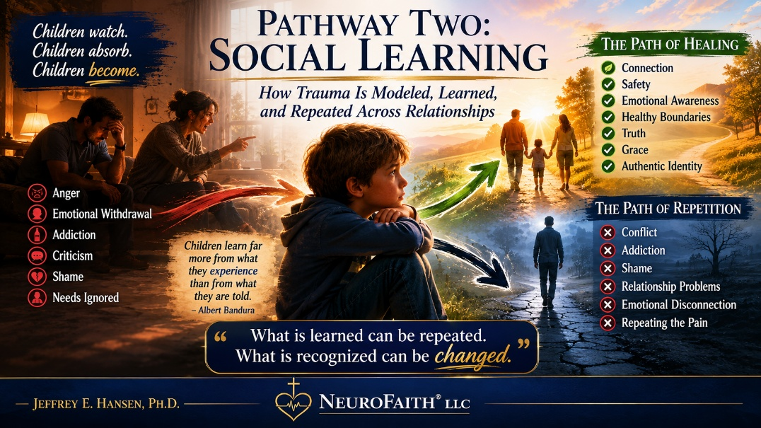
How Do We Absorb Trauma Through Relationship?
Albert Bandura (1977) revolutionized psychology with his theory of social learning. One of his most important insights was that human beings learn not only through direct experience but also through observation. We watch. We imitate. We absorb. Long before we understand the world intellectually, we are studying the people around us and learning how life works.
Children are especially powerful observers.
They watch how their parents handle stress. They watch how conflict is managed. They watch how emotions are expressed or suppressed. They watch how love is given, how mistakes are handled, how forgiveness is extended, and how shame is carried. Even when adults believe children are not paying attention, children are often absorbing far more than anyone realizes.
This is one of the ways trauma quietly moves through families.
Children raised in emotionally healthy environments learn valuable lessons. They learn that emotions are manageable. They learn that relationships can be safe. They learn that mistakes can be repaired. They learn that conflict does not have to destroy connection. They learn that their needs matter and that they themselves have value.
But children raised in chaotic, emotionally unsafe, or traumatized environments often learn very different lessons.
They may learn that anger is dangerous.
They may learn that vulnerability is weakness.
They may learn that expressing needs leads to rejection.
They may learn that love is conditional.
They may learn that people cannot be trusted.
And perhaps most painfully, they may learn that something is wrong with them.
These lessons are rarely taught explicitly. No parent sits a child down and says, "You are not lovable," or "You do not matter." Instead, these messages are communicated indirectly through thousands of small interactions, omissions, disappointments, and emotional experiences that accumulate over time. The child simply draws conclusions based on what they repeatedly observe and experience.
This is where social learning and shame intersect.
Children do not merely learn behaviors. They learn identities.
A child raised by a perfectionistic parent may learn that mistakes are dangerous. A child raised in a home dominated by criticism may learn that approval must be earned. A child raised around addiction may learn to ignore feelings, avoid conflict, or care for everyone except themselves. A child exposed to chronic emotional neglect may learn to expect very little from relationships and may eventually stop asking for what they need altogether.
Over time, these patterns become normal.
That is one of trauma's most deceptive qualities. It normalizes what is unhealthy. It teaches us to adapt to environments that were never healthy in the first place. The child who grows up surrounded by dysfunction often assumes that dysfunction is simply how life works. The child who grows up surrounded by shame often assumes that shame is part of being human.
Without realizing it, they begin carrying those beliefs into adulthood.
They choose relationships through those beliefs.
They parent through those beliefs.
They interpret life through those beliefs.
And unless those beliefs are brought into awareness and challenged, they are often passed to the next generation.
This is one of the reasons Scripture repeatedly emphasizes the importance of truth. Jesus taught that "the truth will set you free" (John 8:32, NIV). Healing begins when we become aware of the stories we have inherited, the beliefs we have absorbed, and the patterns we have repeated without question. What remains hidden continues to shape us. What is brought into the light can begin to change.
The encouraging news is that social learning works both ways.
Just as unhealthy patterns can be learned, healthy patterns can also be learned. New relationships can teach new lessons. Safe people can help us experience trust again. Loving relationships can challenge the belief that we are unworthy of love. Grace can challenge perfectionism. Truth can challenge shame.
In many ways, healing begins when we encounter people who help us rewrite the stories that trauma taught us. We discover that what was modeled to us was not necessarily true. We discover that the beliefs we inherited are not necessarily accurate. We discover that the shame we have carried for years was never our true identity.
And that realization can change everything.
Pathway Three: Epigenetics


Of the three pathways we have explored, this may be the most surprising and, for many readers, the most sobering.
Throughout this book, we have been tracing the journey of shame. We began in the garden, where Adam and Eve first hid. We explored how trauma wounds identity and how painful experiences gradually become painful conclusions about who we are. We examined how attachment relationships shape our sense of safety and belonging, and how social learning quietly teaches us what to believe about ourselves, others, and the world around us. At every step, we have returned to the same central truth: shame is not merely something we feel. It is something we come to believe.
This distinction is important because shame is often described as an emotion, yet it is far more than that. Emotions come and go. We feel sadness, fear, anger, or joy, and those experiences rise and fall with circumstances. Shame tends to operate differently. Shame settles into identity. It becomes a lens through which we interpret our experiences and ourselves. Over time, it influences how we understand success and failure, acceptance and rejection, intimacy and vulnerability, and even our relationship with God. Rather than simply being an emotion, shame often becomes a story about who we are.
This is why trauma and shame are so deeply connected. Trauma may be the wound, but shame is often the meaning we assign to the wound. A child who experiences neglect may conclude, "I do not matter." A child who experiences abuse may conclude, "Something is wrong with me." An adolescent who experiences repeated rejection may begin to believe, "I am not lovable." The painful event eventually passes, but the conclusions often remain. What began as an experience becomes a belief, and what becomes a belief can eventually become part of identity itself.
Because shame operates at the level of identity, it rarely remains confined to our thoughts. It affects the way we experience relationships, the way we perceive danger and safety, and the way our bodies respond to stress. The child who repeatedly concludes that the world is unsafe develops a nervous system that remains watchful. The adolescent who carries shame may live in a constant state of self-protection, fearing exposure or rejection. The adult who secretly believes they are defective often experiences anxiety, hypervigilance, exhaustion, or emotional disconnection long after the original wounds have faded into memory.
In other words, shame becomes embodied.
Over time, these deeply held beliefs do not merely shape behavior. They influence physiology. The body adapts to the story it has learned. Stress-response systems adjust. Hormonal systems adjust. Immune systems adjust. The body learns to survive in the environment it believes it inhabits. What began as a psychological wound gradually becomes a biological reality.
This is where epigenetics enters the story.
For generations, families have observed patterns that seem to repeat themselves. Anxiety appears in one generation and then another. Addiction echoes through family systems. Depression, fear, emotional distance, and chronic stress often seem to travel across decades. Attachment and social learning explain part of this process. Children absorb the beliefs, behaviors, and emotional patterns of the people around them. Yet emerging research suggests that another process may also be at work.
The body remembers.
Not only through memory and emotion, but through biology itself.
Epigenetics is the study of how life experiences influence the expression of our genes without changing the DNA code itself (Moore et al., 2013). In simple terms, our experiences help determine which genetic instructions are activated and which remain quiet. Far from suggesting that DNA is destiny, epigenetics reveals something much more hopeful. It demonstrates that experiences matter. Relationships matter. Safety matters. Love matters. The environments we inhabit shape us in ways we are only beginning to understand.
And unfortunately, shame matters too.
When shame becomes chronic, particularly when it emerges from trauma, neglect, abuse, rejection, or repeated relational wounds, it creates patterns of stress that extend far beyond conscious awareness. The nervous system adapts. Hormonal systems adapt. Immune systems adapt. The body learns to organize itself around survival. The remarkable discovery of epigenetics is that these adaptations may leave biological footprints.
Yet this chapter is not ultimately about how shame harms us. It is about how healing restores us. If painful experiences can influence biological expression, then healing experiences can influence biological expression as well. If shame can leave an imprint, so can love. If fear can be learned, safety can be learned. If wounds can echo across generations, healing can echo across generations too.
That is the hope at the center of this chapter.
Shame may leave footprints.
But healing leaves footprints as well.
To better understand epigenetics, it can help to think of our genes as a vast library of instructions stored within every cell of our body. These instructions tell our cells how to build proteins, the essential components of nearly everything within us, including our muscles, our hormones, our neurotransmitters, and even the chemistry of our brain. But having the instructions is not the same as using them.
Those instructions have to be read.
And this is where epigenetics becomes so important. It helps determine which parts of that library are opened and which remain closed, which instructions are read and which are left untouched. Some experiences signal the body toward growth, regulation, and resilience. Others, particularly prolonged stress and trauma, can signal the body toward protection, survival, and heightened reactivity.
In other words, trauma and resultant shame can influence which “books” get pulled off the shelf. Sometimes instructions are activated that were never meant to dominate, while others that are essential for balance and health remain unread. And over time, that imbalance can begin to show up in very real ways. Increased anxiety. Depression. Chronic stress reactivity. Even disruptions in our body’s immune and regulatory systems.
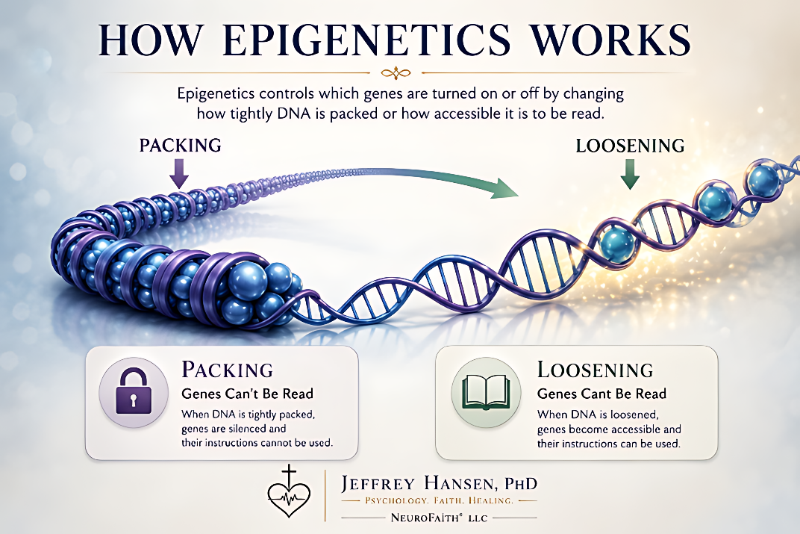
For many of us, this means that trauma and shame do not simply live in our memories. It shapes how our bodies respond to the world, how quickly we move into fear or overwhelm, and how difficult it can feel to return to a sense of calm. It is not just something we think about. It is something we carry.
And yet, even here, there is something deeply hopeful. These patterns are not fixed. Just as negative experience can shape which genes are expressed, new experiences, especially those grounded in safety, connection, and healing, can begin to shift what gets “read” and what does not in a good way. The library is still there. And over time, it can be accessed in a different and healing way.
DNA Methylation
To better understand how epigenetics works, it can be helpful to return to the image of a library. If our DNA contains the complete library of genetic instructions for building and maintaining the human body, epigenetics helps determine which books are opened, which remain closed, and which instructions are actually read.
One way this occurs is through a process known as DNA methylation. DNA methylation is like placing tape over the cover of a book. The book remains in the library, but the tape prevents anyone from opening it. The information is still present, yet the instructions cannot be accessed or used. The gene remains part of the genetic code, but it is effectively silenced because its instructions are no longer being read.
Histone Modification
Another mechanism involves histone modification. Histones are proteins around which DNA is wrapped, much like thread wound around a spool. How tightly or loosely the DNA is wrapped helps determine whether particular genes can be accessed and read.
If the DNA is wound too tightly around these proteins, it is like books being shoved so tightly onto a shelf that they cannot be removed. The information remains there, but it cannot be accessed. The genes are effectively hidden from view, and their instructions remain unused.
However, histone modification can also work in the opposite direction. When the DNA becomes more loosely wrapped, it is like pulling books off the shelf and opening them for reading. Genes that were previously inaccessible can now be read, and their instructions can be carried out. This is an important distinction because epigenetics is not simply about turning genes off. It is also about turning genes on.
Healthy functioning depends upon balance. Certain genes need to be readily accessible, while others need to remain temporarily quiet. Problems arise when genes that should be available become hidden, or when genes that should remain relatively inactive become overly accessible and begin exerting influence when they are not needed. In this way, histone modification functions less like an on-off switch and more like a dimmer switch, helping regulate how much access the cell has to specific genetic instructions at any given time.
Histone modification therefore plays a critical role in maintaining the body's delicate balance, influencing which genetic instructions are available when they are needed and which remain temporarily out of reach.
RNA-Associated Silencing
A third mechanism is known as RNA-associated silencing. This process is similar to placing a note over certain pages of a book that says, "Skip this section." The words remain printed on the page, but the reader moves past them without using the information. The instructions exist, but they are effectively ignored.
Together, these processes are essential for normal growth and development. They allow the body to adapt to changing environments and circumstances. Yet they can also be influenced by prolonged adversity, chronic stress, and traumatic experiences. Because shame often emerges from trauma and becomes woven into identity, it is possible that the body is responding not only to painful events themselves, but also to the ongoing burden of carrying those wounds over time. What begins as an emotional and relational injury may eventually become reflected within the biology of the body itself.
The impact is not merely theoretical. It is real, measurable, and increasingly supported by scientific research.

The Legacy of the Holocaust

One of the most sobering examples comes from the work of Dr. Rachel Yehuda and her colleagues (1998), who studied Holocaust survivors and their children. Remarkably, the children of survivors, despite never experiencing the concentration camps themselves, demonstrated measurable alterations in their stress-response systems. The trauma had left biological footprints that appeared to extend into the next generation. In a very real sense, the body seemed to remember what the mind had never personally experienced.
This finding challenges many of our assumptions about human suffering. We often think of trauma as something that belongs solely to the individual who experienced it. Yet the research suggests that severe adversity may leave traces that extend beyond a single lifetime. The echoes of suffering can persist in ways we are only beginning to understand.
The Dutch Hunger Winter
The Dutch Hunger Winter provides another powerful example. During the winter of 1944 to 1945, Nazi forces blockaded food supplies to punish the Dutch resistance, plunging large portions of the Netherlands into famine. More than 20,000 people died of starvation. Pregnant women were among those most profoundly affected.

Researchers later discovered that children who had been exposed to the famine while still in the womb exhibited epigenetic changes in genes associated with growth and metabolism, particularly the IGF2 gene. As adults, these individuals demonstrated significantly higher rates of obesity, heart disease, diabetes, schizophrenia, and premature mortality. Even more remarkable, some of these epigenetic changes were later identified in their own children and grandchildren (Heijmans et al., 2008).
Pause for a moment and consider the implications.
Imagine carrying the biological memory of a winter you never lived through. Imagine entering the world with a body already tuned toward scarcity and survival because of hardships experienced by a previous generation. Imagine feeling the echoes of a story that began before your own life ever started. That is the profound and sometimes unsettling reality revealed through epigenetic research.
These findings are not simply fascinating historical observations. They reveal something deeply human and, perhaps, deeply spiritual. Trauma may leave biological footprints, but it is often shame that carries those footprints into everyday life. Shame influences how we interpret danger, how we understand ourselves, how we relate to others, and how we experience the world around us. Over time, these patterns become embedded not only in our thoughts but throughout the systems of the body itself. The nervous system adapts. Hormonal systems adapt. Immune systems adapt. In this way, the wounds we carry become more than memories. They become embodied experiences.
The Hope of Healing
Yet this is not the end of the story.
One of the most hopeful discoveries in epigenetics is that many of these changes are not permanent. Just as adversity can influence biological expression, healing experiences can influence biological expression as well. The nervous system that adapted to survive can also learn to thrive. The body that learned fear can learn safety. The systems shaped by chronic stress can begin moving toward restoration.
Research increasingly suggests that practices such as regular physical activity, restorative sleep, meaningful spiritual connection, secure attachment relationships, healthy nutrition, and trauma-informed therapy can positively influence these biological systems. Over time, healing begins to reshape what trauma once inscribed. The scars may remain, but the script can change.
This reality brings both responsibility and hope. We are not doomed by our lineage, nor are we permanently defined by what happened to us. We are not prisoners of our family history. Through deliberate choices, healthy relationships, faith, truth, and healing, we can begin changing the biological legacy we pass to future generations. As we heal, our bodies remember. Our minds remember. Our relationships remember. The effects of healing, like the effects of trauma, often extend far beyond ourselves and touch the lives of those who come after us.
Scripture captures this tension beautifully. In Deuteronomy 30:19, God declares, "Now choose life, so that you and your children may live." Likewise, Exodus 20:5-6 acknowledges that the consequences of one generation can affect the next while simultaneously proclaiming God's steadfast love to a thousand generations of those who love Him and walk in His ways. The message is both sobering and hopeful. Trauma may shape a family line, and shame may shape a family line, but so can faith, love, courage, and healing. The chain of suffering can be broken, and every journey of healing begins with a choice.
At this point, we have explored the three primary pathways through which trauma exerts its influence: attachment, social learning, and epigenetics. Together, these pathways help us understand how painful experiences become woven into our relationships, our beliefs, our behaviors, and even our biology. We have seen how trauma can shape identity and how shame often emerges from those wounds, becoming far more than an emotion. Shame becomes a way of seeing ourselves. It becomes a lens through which we interpret our worth, our relationships, and our place in the world.
Yet an important question remains. How does shame become so powerful? Why does it feel so deeply rooted, so persistent, and so difficult to silence, even when we know intellectually that the stories it tells us are not true?
To answer those questions, we must look more closely at the systems through which shame is experienced and expressed. Shame does not live in a single location. It is reflected in the brain, carried within the nervous system, stored within the body, reinforced through relationships, and woven into the stories we tell ourselves about who we are. It influences our thoughts, our emotions, our physiology, and even our sense of identity. In many ways, shame touches the whole person.
In the next section, we will explore the neuroscience of shame and the remarkable ways the brain, nervous system, and body work together to shape our experience of threat, rejection, belonging, connection, and self-worth. Understanding these systems helps us see why shame can feel so overwhelming, but also why healing is possible. The same neural networks that learn shame can learn truth. The same nervous system that adapts to survive can learn safety. And the same person who once hid in shame can gradually learn to live in freedom, connection, and grace.

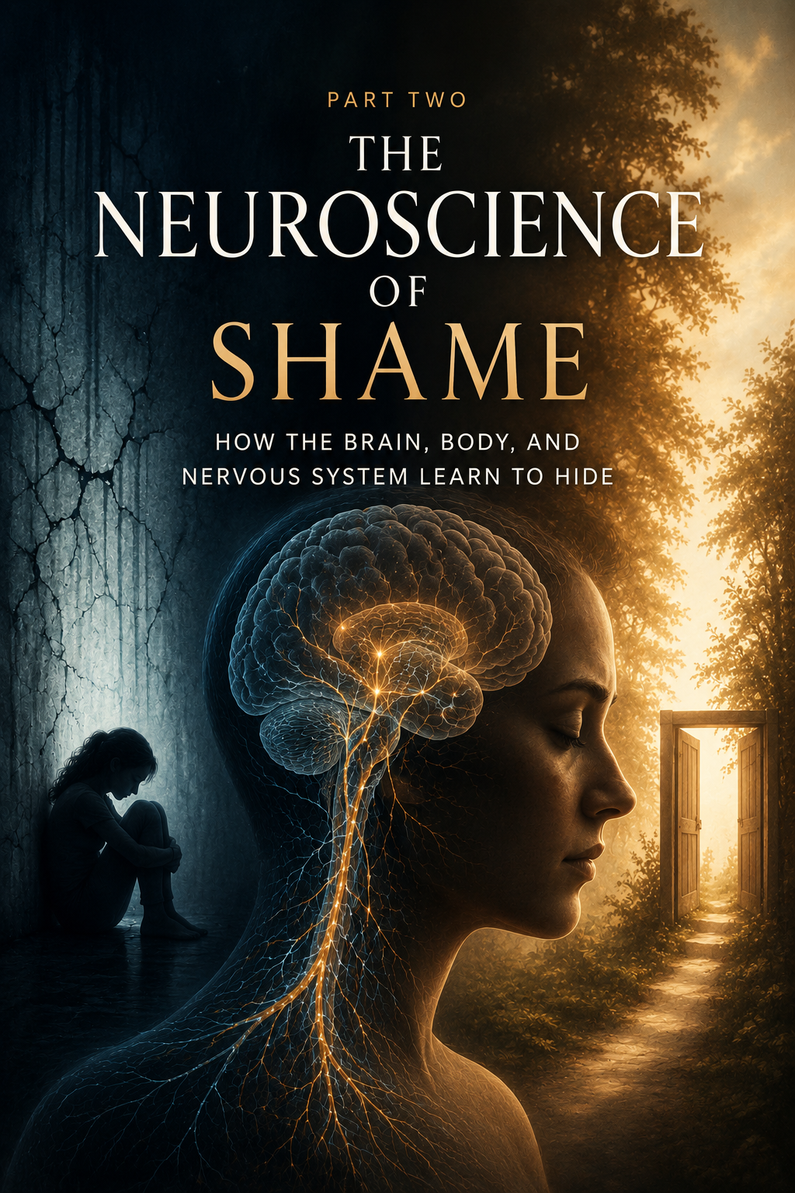

Polyvagal Theory
When Safety Is Lost

B
y this point in our journey, we have explored how trauma can shape identity through attachment, social learning, and even epigenetic processes. We have seen that shame is far more than an unpleasant feeling. It is far more than an emotion. Shame becomes a way of experiencing ourselves. It becomes a lens through which we interpret our worth, our relationships, and our place in the world. Over time, shame begins to influence not only what we think but also how we feel, how we relate, and even how our bodies respond to the world around us.
Yet an important question remains. Why does shame feel so powerful? Why does it seem to take hold not only of our thoughts, but of our bodies as well?
The answer begins with understanding the nervous system.
If shame were simply a belief, it would be much easier to overcome. We could replace one thought with another and move forward. But anyone who has struggled with shame knows it does not work that way. Long before we find words for it, our bodies are already responding. Our stomach tightens. Our chest feels heavy. Our breathing changes. We avoid eye contact. We withdraw from relationships. We feel exposed, vulnerable, and unsafe.
In many ways, shame is not simply a psychological experience. It is a physiological one.
Dr. Stephen Porges' Polyvagal Theory provides a powerful framework for understanding why. According to Porges, our autonomic nervous system is continuously scanning the environment for cues of safety and danger through a process he calls neuroception (Porges & Porges, 2023). This process occurs largely outside of conscious awareness. Before we have time to think about a situation, our nervous system has already begun evaluating it. Is this person safe? Is this relationship safe? Am I accepted here? Do I belong?
For those carrying shame, these questions are often operating beneath the surface of nearly every interaction. The nervous system is not simply asking whether we are physically safe. It is also asking whether we are emotionally safe. Whether we are welcome. Whether we are valued. Whether we matter.
This insight is particularly important because shame is fundamentally a relational wound. Shame develops in the context of human relationships, and it is experienced as a threat to connection. We fear exposure. We fear rejection. We fear being seen and found lacking. As a result, the nervous system often responds to shame in much the same way it responds to physical danger.
To understand how this occurs, we need a basic understanding of the autonomic nervous system. The autonomic nervous system regulates many of the body's automatic functions, including heart rate, breathing, digestion, arousal, and emotional regulation. Traditionally, it has been described as consisting of two major branches. The sympathetic nervous system mobilizes us for action, preparing us for fight or flight. The parasympathetic nervous system restores calm, regulation, and balance.
Porges' contribution was recognizing that the parasympathetic system is more sophisticated than previously understood. Through the vagus nerve, the tenth cranial nerve and one of the most influential nerves in the body, the parasympathetic system contains two distinct pathways that produce very different responses to the world around us (Porges & Porges, 2023).
These pathways help explain why we sometimes feel calm and connected, why we sometimes become anxious and reactive, and why we sometimes shut down entirely. More importantly, they help us understand why shame can feel so overwhelming and why healing often requires more than insight alone.
Ventral Vagal: When Connection Feels Safe
According to Polyvagal Theory, the ventral vagal pathway represents the physiological foundation of safety, connection, and social engagement (Porges & Porges, 2023). When this system is active, we feel grounded and present. Our breathing is regulated. Our heart rate is steady. We are able to make eye contact, engage in meaningful conversation, and remain emotionally available to others. We can listen without becoming defensive. We can disagree without feeling threatened. We can be vulnerable without becoming overwhelmed.
In many ways, the ventral vagal state is the biological experience of connection.
This is the state in which children learn best. It is the state in which healthy relationships flourish. It is the state in which healing most often occurs.
When we feel safe, our nervous systems and entire bodies undergo what Porges and Porges (2023) describe as a profound physiological shift, one that promotes learning, problem solving, emotional regulation, physical health, and deeper connection with others. We become more resilient, more flexible, and more capable of navigating life's inevitable challenges.
From the perspective of shame, this state is profoundly important because shame cannot thrive in the presence of genuine connection. Shame grows in secrecy, isolation, and fear. It weakens when we are fully seen and fully accepted.
This may help explain why some of the most healing moments in life are surprisingly simple. A compassionate friend. A trusted therapist. A loving spouse. A wise mentor. A parent who listens without judgment. In those moments, the nervous system receives a powerful message:
You are safe.
You belong.
You matter.
For many people, those experiences become the beginning of healing.
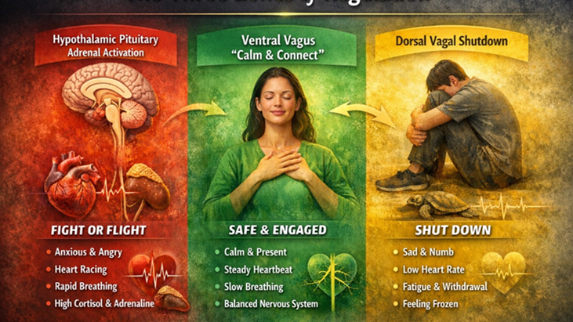
Sympathetic Activation: When Shame Feels Threatening
When our nervous system perceives danger, it shifts into sympathetic activation. This is the classic fight-or-flight response that has helped human beings survive for thousands of years. God designed this system beautifully. When a genuine threat appears, our body rapidly mobilizes energy so we can respond effectively. Heart rate increases. Breathing accelerates. Blood flow is redirected to the large muscles. Attention narrows. The body prepares for action.
This response is coordinated through several interconnected systems, including the sympathetic nervous system and the hypothalamic-pituitary-adrenal (HPA) axis. The hypothalamus signals the pituitary gland, which then stimulates the adrenal glands to release stress hormones such as cortisol and adrenaline into the bloodstream. These changes occur rapidly and largely outside of conscious awareness. They are designed to keep us alive.
The problem is not the system itself. The problem arises when the system is repeatedly activated during development.
Children who grow up in environments characterized by criticism, rejection, emotional neglect, abuse, unpredictability, or chronic conflict often experience the world as fundamentally unsafe. Their nervous systems adapt accordingly. Instead of reserving sympathetic activation for occasional threats, the system begins to expect threat. Hypervigilance becomes normal. Anxiety becomes familiar. Tension becomes a way of life.
Over time, shame becomes woven into this process. The child does not simply learn that the world is dangerous. The child often concludes that he or she is the problem. Something must be wrong with me. I am not enough. I am not lovable. I do not matter.
As these beliefs become embedded, the nervous system becomes increasingly reactive to anything that resembles rejection, criticism, embarrassment, or failure. What might appear to be a minor disappointment to one person may feel like a profound threat to another because the nervous system is responding not only to the present moment but also to years of accumulated experience.
This is why shame often produces anxiety. The nervous system remains on guard, constantly scanning for signs of danger. We become preoccupied with performance, approval, achievement, appearance, or control. We try to avoid exposure. We work harder. We strive more. We become perfectionistic. We stay busy. We attempt to outrun the fear that we are somehow inadequate.
Although these behaviors may appear productive, they are often driven by a nervous system that has learned to survive rather than a nervous system that feels truly safe
Dorsal Vagal Shutdown: When Shame Leads Us to Hide
While sympathetic activation represents increased energy and mobilization, the dorsal vagal response represents decreased energy and conservation. Both are survival responses. Both are adaptive. Both are part of God's design. The issue is not that these systems exist. The issue is what happens when trauma and shame teach us to live in them.
As discussed earlier, Dr. Stephen Porges' work demonstrated that the parasympathetic nervous system contains two distinct pathways. The ventral vagal pathway supports connection, safety, and social engagement, while the dorsal vagal pathway serves a very different purpose. When threat becomes overwhelming and escape no longer feels possible, the nervous system may shift into shutdown, collapse, withdrawal, or immobilization (Porges & Porges, 2023; Barta, 2018). In the natural world, we see this response when an animal becomes trapped and can neither fight nor flee. The body conserves energy by shutting down.
Human beings do something remarkably similar.
Many people imagine shame as an intense emotional experience characterized by anxiety, fear, or self-criticism. Sometimes it is. Yet some of the deepest forms of shame are surprisingly quiet. Rather than becoming activated and reactive, we become withdrawn and disconnected. We stop reaching out. We stop hoping. We stop believing that anything will change.
This is the teenager who retreats to a bedroom and gradually disengages from friends, family, and activities that once brought joy. It is the spouse who remains physically present in a relationship but has emotionally disappeared. It is the man who isolates himself because he no longer believes anyone would understand. It is the woman who has been hurt so many times that she no longer trusts her own voice. It is the quiet resignation that whispers, "Why bother?" or "What's the point?"
From the outside, these responses can be mistaken for laziness, indifference, lack of motivation, or even selfishness. In reality, they often reflect a nervous system that has become exhausted from carrying too much pain for too long. What appears to be apathy is frequently protection. What appears to be disengagement is often self-preservation. What appears to be indifference is frequently shame.
This is one of the great tragedies of unresolved shame. The very strategies that once helped us survive eventually begin to separate us from the things we need most. In an effort to avoid further rejection, we withdraw from connection. In an effort to avoid vulnerability, we close ourselves off from intimacy. In an effort to avoid pain, we gradually lose access to joy, belonging, and hope.
Over time, the nervous system learns to expect disappointment, rejection, or emotional injury. The world begins to feel smaller. Relationships feel riskier. Opportunities feel threatening. The individual may not consciously choose isolation, but the nervous system increasingly organizes life around avoiding further hurt.
This is why healing from shame requires far more than simply changing our thoughts. The nervous system itself must begin learning that connection is safe again. We must gradually experience relationships in which we are seen without condemnation, known without rejection, and valued without having to earn our worth. As these experiences accumulate, the nervous system slowly begins to release its grip on survival and rediscover what safety feels like.
Healing is not about forcing ourselves out of shutdown through willpower. It is about gently creating the conditions in which connection becomes possible again. It is about helping the nervous system remember what trauma and shame taught it to forget: that we were created for relationship, that belonging is possible, and that we do not have to spend our lives hiding.
Returning to Connection
Understanding these nervous system states helps us see something profoundly important. The goal of healing is not to eliminate sympathetic activation or dorsal vagal shutdown. We need both. God designed them for our protection.
The goal is flexibility.
Healthy nervous systems move fluidly between states as circumstances require and then return to a place of regulation and connection. Trauma and shame disrupt this flexibility. They teach us to remain stuck in survival states long after the original danger has passed.
Healing is the process of restoring access to what was intended to be our home: the ventral vagal state of safety, connection, curiosity, and engagement.
When we feel safe, we can think clearly. We can connect deeply. We can learn. We can grow. We can heal. As Porges and Porges (2023) observe, when we experience safety, our bodies undergo a profound physiological shift that promotes health, resilience, learning, emotional regulation, and well-being.
This is why healing shame is not merely about changing beliefs. It is about helping the entire person—mind, body, heart, nervous system, and spirit—rediscover safety. It is about learning that connection is no longer dangerous. It is about gradually reclaiming the truth that we are seen, known, valued, and loved.
And that is where the journey toward healing truly begins.
The Heart Remembers
Shame, Stress, and the Neurobiology of the Heart


W
hen people suffer deeply, they rarely say, "My prefrontal cortex is hurting."
They say, "My heart is broken."
When they lose someone they love, they feel it in their chest. When they are rejected, betrayed, abandoned, or humiliated, they instinctively place a hand over their heart. Across cultures, languages, and centuries, human beings have consistently associated their deepest emotional experiences with the heart.
Perhaps that is because the heart has always been more than a pump.
Long before modern neuroscience existed, Scripture repeatedly pointed toward the heart as the center of human experience. Proverbs 4:23 reminds us, "Above all else, guard your heart, for everything you do flows from it." David prayed, "Create in me a pure heart, O God" (Psalm 51:10). Ezekiel spoke of God replacing a heart of stone with a heart of flesh (Ezekiel 36:26). Jesus taught that "out of the abundance of the heart the mouth speaks" (Matthew 12:34).
The biblical writers were not offering lessons in anatomy. Yet they understood something profound about the human condition. The heart sits at the center of our experience of love, grief, courage, fear, belonging, and shame.
Modern science is beginning to understand why.
Research in neurocardiology has revealed that the heart is not merely a mechanical pump circulating blood throughout the body. The heart possesses its own intrinsic nervous system and communicates continuously with the brain through multiple pathways (McCraty, 2023). In many respects, the heart and brain function as partners in an ongoing conversation, constantly exchanging information that influences emotional regulation, physiological stability, attention, perception, and behavior.
This understanding is particularly important when we consider trauma and shame.
As we have already discussed in previous chapters, trauma alters the nervous system. Through repeated experiences of threat, rejection, abandonment, neglect, abuse, or humiliation, the body learns to anticipate danger. Shame often develops alongside these experiences and gradually becomes embedded in identity. Rather than merely believing that something painful happened, we begin believing that something is wrong with us.
The heart responds to this story.
One of the most fascinating discoveries in neurocardiology involves a phenomenon known as heart-rate variability, often abbreviated HRV. At first glance, the term sounds technical and complicated, but the concept is surprisingly simple. Contrary to popular belief, a healthy heart does not beat with perfect regularity. The intervals between heartbeats naturally vary from moment to moment. This variability reflects the heart's ability to adapt to changing circumstances and respond flexibly to the world around us (McCraty, 2023).
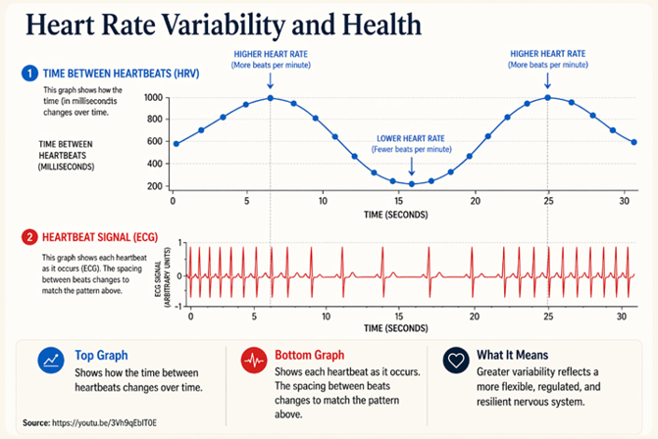
A heart that demonstrates healthy variability is generally associated with resilience, adaptability, emotional regulation, and physiological health. A heart that loses flexibility often reflects chronic stress, dysregulation, and diminished capacity to adapt effectively.
This is where shame becomes particularly important.
When individuals experience emotions such as appreciation, gratitude, compassion, love, and connection, heart rhythms tend to become more coherent and organized (McCraty, 2023). The heart is not beating more slowly or more quickly necessarily; rather, the rhythm itself becomes smooth and synchronized. Communication throughout the body becomes more efficient.
Negative emotional states often produce the opposite effect.
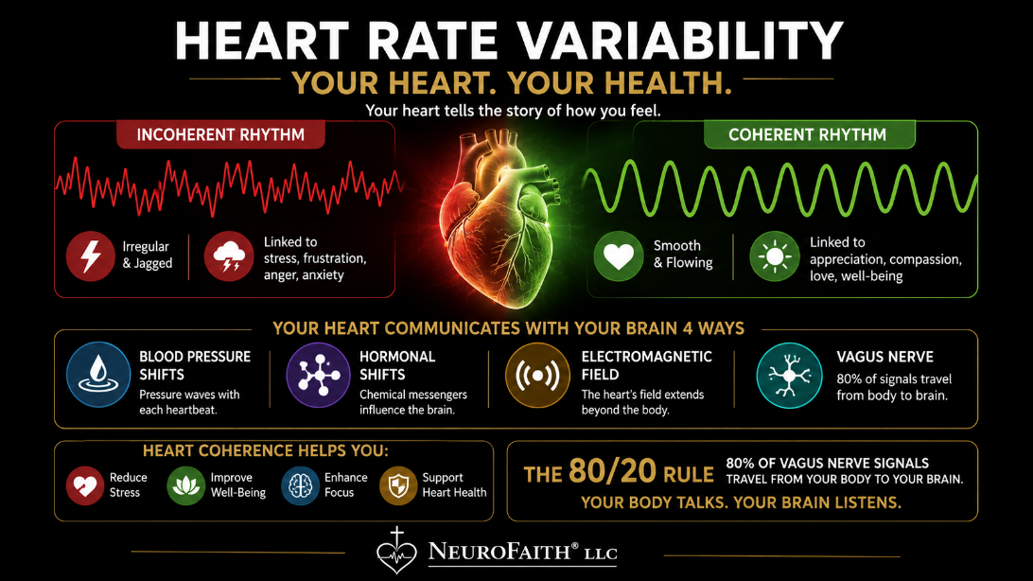
Fear, anxiety, anger, resentment, chronic stress, and shame create increasingly erratic and disordered patterns within heart rhythms. Over time, the heart loses some of its natural flexibility. The system becomes less adaptive and more reactive. The body remains prepared for danger even when no immediate threat exists.
Shame is particularly damaging because it is not simply an emotion. Shame is often a chronic state of self-condemnation. It repeatedly activates feelings of exposure, inadequacy, rejection, and disconnection. The body responds as though one of its most fundamental needs, the need for belonging, is under constant threat.
The result is a heart that rarely gets to rest.
Many people carrying significant shame live in a state of perpetual vigilance. They worry about what others think. They anticipate criticism. They replay conversations. They fear making mistakes. They become preoccupied with performance and approval. Although these experiences may appear purely psychological, they are simultaneously physiological. The heart participates in every moment of that struggle.
What makes this even more fascinating is that the heart is not simply responding to the brain. It is also communicating back to the brain.
According to McCraty (2023), communication between the heart and brain occurs through at least four major pathways. The first involves neurological communication through the vagus nerve and other components of the nervous system. The second involves biochemical communication through hormones and neurotransmitters. The third occurs through pressure waves generated by each heartbeat that influence blood flow and vascular activity throughout the body. The fourth involves the heart's powerful electromagnetic field, which can be measured several feet beyond the body.
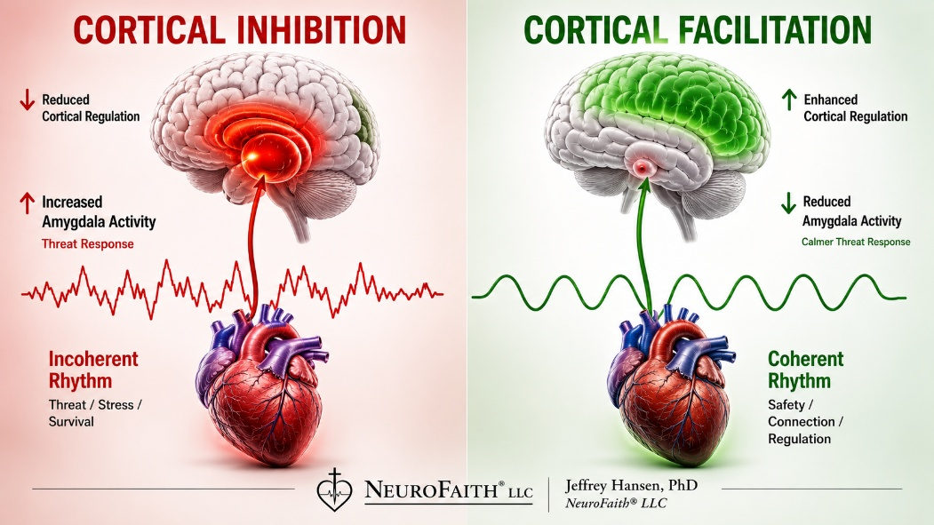
In other words, the conversation is constantly moving in both directions.
This insight becomes even more remarkable when we consider the vagus nerve itself. As previously discussed in our chapter on Polyvagal Theory, approximately 80 percent of the fibers within the vagus nerve carry information from the body toward the brain, while only about 20 percent carry information from the brain toward the body (Porges, 2017). Much of what the brain knows about our internal state is being reported upward from the body itself.
The implications are profound.
When shame becomes chronic, it does not merely influence thoughts. It influences what the body is communicating to the brain. The heart participates in the ongoing story of threat, safety, belonging, and connection. Over time, chronic dysregulation contributes to increased stress hormones, elevated inflammation, cardiovascular strain, sleep disruption, emotional instability, and diminished resilience (McEwen, 1998; Felitti et al., 1998).
This helps explain why trauma survivors often report feeling exhausted long after the traumatic events have ended. The body continues carrying the burden. The heart continues participating in the adaptation.
As Bessel van der Kolk (2014) famously observed, "the body keeps the score." I would add that the heart often keeps score as well.
The heart remembers rejection.
The heart remembers abandonment.
The heart remembers humiliation.
The heart remembers shame.
And because the heart remains in constant communication with the brain and nervous system, those memories continue shaping how we experience ourselves and the world around us.
Understanding this reality helps us appreciate that shame is far more than an emotional problem. It is a whole-person experience involving the mind, the heart, the nervous system, the body, and ultimately the stories we tell ourselves about who we are.
Which brings us naturally to the next question.
If trauma and shame influence the nervous system and alter the rhythms of the heart, what happens within the brain itself? How do these experiences shape memory, self-awareness, identity, and the internal narrative that follows us throughout life?
To answer that question, we must now turn to one of the most fascinating discoveries in modern neuroscience: the Default Mode Network.
The Brain Under Shame
Identity and the Default Mode Network


I
f shame were merely an emotion, it would be far easier to overcome. Emotions rise and fall. They come and go. Shame often does not. Instead, shame lingers in the background of our thoughts, coloring how we interpret experiences, relationships, failures, successes, and ultimately ourselves. Over time, shame becomes more than something we feel. It becomes part of the lens through which we view the world.
To understand why shame can feel so persistent, we must understand what it does to the brain.
As we have already seen, trauma and shame affect the entire human system. They influence the nervous system, alter the rhythms of the heart, shape our relationships, and affect how we experience safety and connection. The body continuously communicates this information to the brain through multiple pathways, including the vagus nerve, hormonal signaling, blood pressure changes, and the heart's electromagnetic field. The brain is constantly receiving these messages and attempting to make sense of them.
The human brain was designed by God to function as an integrated system. Psychiatrist Daniel Siegel describes integration as the healthy linking together of different parts of the brain into a coordinated and harmonious whole (Siegel, 2020). When the brain is functioning well, emotional centers communicate effectively with regulatory centers. Thoughts, emotions, memories, bodily sensations, and relationships work together in a balanced and adaptive manner. This integration allows us to think clearly, regulate our emotions, solve problems, maintain healthy relationships, and respond flexibly to life's challenges.
Trauma disrupts that integration.
When experiences of fear, rejection, neglect, humiliation, abuse, abandonment, or chronic stress occur repeatedly, the brain adapts in order to survive. This adaptation is not evidence of weakness. Quite the opposite. It reflects the remarkable ability of the brain to reorganize itself in response to adversity. The problem is that what helps us survive in one season of life often becomes a liability in another.
As we have already seen, trauma and shame are not experienced solely in the mind. They are carried throughout the body. Trauma lives in our muscles, our breathing, our posture, our nervous system, our heart rhythms, and the countless physiological processes that operate beneath conscious awareness. Shame does not simply tell us that something is wrong. It creates a felt experience of danger, inadequacy, rejection, and disconnection.
These experiences generate powerful emotional states that affect the entire body. The nervous system shifts toward protection. The heart loses coherence. Heart-rate variability becomes increasingly dysregulated. Stress hormones rise. The body begins sending continuous signals to the brain that danger may be present.
As discussed in the previous chapter, the heart and body communicate with the brain through multiple pathways, including the vagus nerve, hormonal signaling, blood pressure and vascular changes, and the heart's electromagnetic field (McCraty, 2023). The brain is constantly receiving this information and adjusting its activity accordingly.
When the body remains chronically activated through sympathetic arousal and HPA-axis activation, the brain tends to shift toward states of heightened vigilance, emotional reactivity, and threat detection. Thinking becomes narrower. Attention becomes focused on danger. The mind can feel chaotic, overwhelmed, and unable to settle.
Conversely, when overwhelming stress pushes the nervous system toward dorsal vagal shutdown, a very different pattern emerges. Rather than feeling anxious and activated, individuals often experience numbness, disconnection, exhaustion, brain fog, and emotional withdrawal. Thoughts become sluggish. Motivation decreases. The world may feel distant and unreal. Many trauma survivors describe this experience as feeling as though they are moving through molasses.
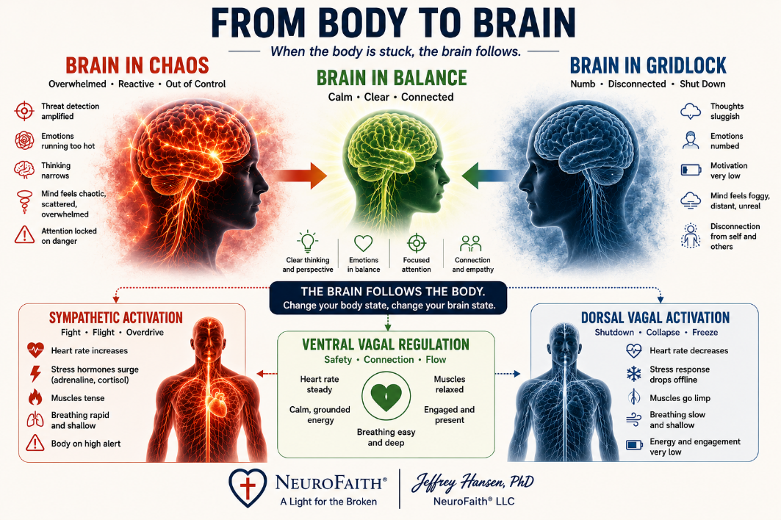
Neither of these states represents the brain functioning as it was designed to function. God designed the human nervous system to spend most of its time in a state of safety, connection, and regulation. From this ventral vagal state, we are able to think clearly, connect relationally, regulate our emotions, learn, create, and grow. The sympathetic and dorsal vagal systems were designed as temporary protective responses to danger, not permanent places to live.
Trauma and shame disrupt that design. Over time, the brain becomes increasingly organized around survival rather than connection, protection rather than growth. Understanding how this occurs requires us to examine several key brain systems involved in stress, emotional regulation, and self-awareness.
A child growing up in an unpredictable environment learns to scan constantly for danger. Facial expressions become important. Tone of voice becomes important. Conflict becomes important. The brain becomes highly skilled at anticipating potential threats. In many cases, these adaptations help the child navigate difficult circumstances. Yet years later, the same patterns can produce chronic anxiety, hypervigilance, emotional reactivity, and persistent self-doubt. The brain that once learned to survive now struggles to feel safe.
This process is closely tied to the body's stress response system. As discussed previously, when the brain perceives danger, it activates the hypothalamic-pituitary-adrenal (HPA) axis. The hypothalamus signals the pituitary gland, which in turn stimulates the adrenal glands to release cortisol and other stress hormones throughout the body. This response is extraordinarily useful during periods of genuine threat. It mobilizes energy, sharpens attention, increases vigilance, and prepares us to respond quickly to danger.
The difficulty arises when the alarm system never fully turns off.
Trauma and chronic shame can leave the brain and body living in a state of ongoing activation. Instead of experiencing brief periods of stress followed by recovery, the nervous system remains chronically vigilant. Cortisol levels remain elevated. The brain becomes increasingly efficient at detecting threat but increasingly less effective at recognizing safety. What was designed as a temporary survival mechanism gradually becomes a long-term operating system.
Over time, excessive exposure to stress hormones begins to affect the brain itself. Research has demonstrated that chronic cortisol elevation can impair memory formation, reduce neurogenesis within the hippocampus, contribute to emotional dysregulation, increase vulnerability to anxiety and depression, and interfere with higher-order cognitive functioning (Hansen et al., 2026; van der Kolk, 2014). Simply put, a brain living under chronic stress begins to organize itself differently than a brain living in safety.
One of the most significant consequences involves the balance between the brain's alarm systems and its regulatory systems. The amygdala, which plays a central role in threat detection and emotional learning, becomes increasingly reactive. At the same time, regions of the prefrontal cortex responsible for judgment, emotional regulation, impulse control, and perspective-taking become less influential. The result is a brain that becomes highly skilled at identifying danger but less capable of calming itself once the danger has passed.
This shift helps explain why individuals carrying significant trauma and shame often report feeling trapped in cycles of fear, anxiety, emotional overwhelm, or compulsive behavior. Their brains are not broken. Their brains are doing exactly what they were trained to do. The tragedy is that the systems designed to protect them have become overdeveloped, while the systems designed to regulate and reassure have become less accessible.
Neuroscientists sometimes refer to this pattern as hypofrontality, a condition in which the higher-order regulatory regions of the brain become less active and less capable of exerting control over more primitive emotional and reward-driven systems (Hilton, 2007; Didinger, 2018). In practical terms, it is as though the brain's brakes become weaker while the accelerator becomes stronger.
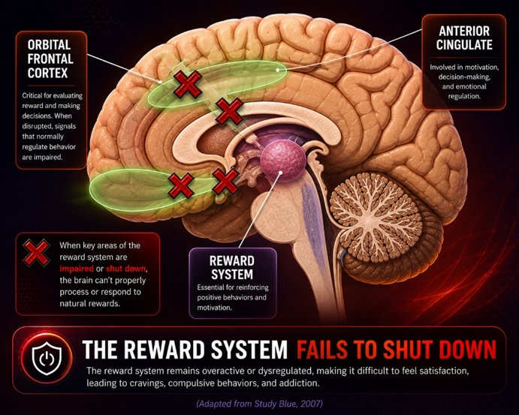
This phenomenon appears not only in trauma but also in addiction. Whether the source is chronic shame, developmental trauma, substance addiction, pornography addiction, or other compulsive behaviors, the result is often remarkably similar. The brain becomes increasingly organized around immediate relief and increasingly less capable of long-term regulation. The desire for comfort grows stronger while the ability to resist that desire grows weaker.
Understanding this dynamic brings us to one of the most important discoveries in modern neuroscience. If trauma and shame alter the brain's alarm systems, stress systems, and regulatory systems, what happens to the stories we tell ourselves about who we are? What happens to the internal narrative that quietly runs in the background of our minds every day?
To answer that question, we must explore a remarkable network within the brain known as the Default Mode Network.
The Default Mode Network: The Storyteller Within
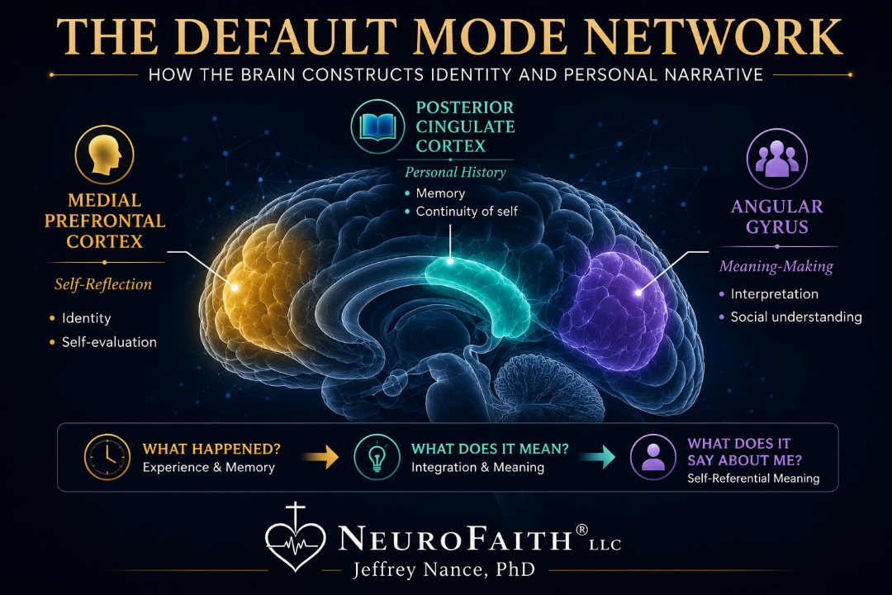
One of the most remarkable discoveries in modern neuroscience occurred almost by accident. For many years, neuroscientists focused on what happened in the brain when people were actively engaged in tasks. Researchers assumed that when the brain was resting, activity would simply decrease. Instead, they discovered a consistent network of brain regions that became highly active whenever attention turned inward. This discovery eventually led Marcus Raichle and his colleagues to identify what became known as the Default Mode Network, or DMN (Raichle et al., 2001).
The Default Mode Network is often described as the brain's "background mode." It becomes active when we are not concentrating on the outside world and instead turn our attention inward. When we reflect on the past, imagine the future, replay conversations, think about relationships, evaluate ourselves, or wonder what others think of us, the DMN is hard at work. In many ways, it functions as the brain's internal storyteller (Raichle et al., 2001).
This is not a bad thing. The DMN helps us learn from experience, maintain a sense of identity, imagine possibilities, empathize with others, and make sense of our lives. It allows us to build a coherent narrative of who we are and how we fit into the world around us. Without such a system, life would feel like a series of disconnected events rather than a meaningful story. The DMN helps us connect yesterday to today and today to tomorrow. It helps us understand where we have been, where we are, and where we hope to go.
Yet like many systems in the human brain, what serves us well under healthy conditions can become problematic when trauma enters the picture.
When Trauma Writes the Story
Tim Fletcher frequently teaches that developmental trauma does not merely create painful memories. It creates painful conclusions. When children are repeatedly exposed to neglect, criticism, abandonment, rejection, inconsistency, humiliation, emotional invalidation, or other forms of relational injury, they eventually begin trying to make sense of what is happening around them. Unfortunately, children rarely possess the developmental maturity necessary to accurately interpret these experiences. Rather than concluding that the adults around them are wounded, overwhelmed, emotionally unavailable, addicted, or dysfunctional, they often arrive at a much simpler and far more devastating explanation:
Something must be wrong with me (Fletcher, 2025).
Over time, these conclusions become deeply embedded beliefs that shape how individuals understand themselves and the world around them. Fletcher frequently identifies four core beliefs that emerge from developmental trauma as we have already stated but reiterate:
I am not lovable.
I am not safe.
I do not matter.
I am bad.
What makes these beliefs so destructive is that they do not remain isolated thoughts. They gradually become organizing principles through which life itself is interpreted. Every relationship, every disappointment, every criticism, every success, and every failure becomes filtered through these assumptions. The individual may not consciously recognize that these beliefs are operating, but they quietly influence perception in the background.
This is where the Default Mode Network becomes especially important.
The DMN is continuously involved in constructing and maintaining our autobiographical narrative. It helps us answer questions about who we are, how we fit into the world, and what our experiences mean. In healthy development, this process contributes to a stable and realistic sense of identity. However, when shame becomes woven into the story, the DMN may repeatedly return to the same painful conclusions.
The brain is not intentionally trying to create suffering. It is simply doing what it was designed to do. It learns from repetition. Experiences that occur frequently become familiar, and familiar pathways gradually become preferred pathways. Over time, the brain becomes increasingly efficient at returning to the thoughts, emotions, memories, and interpretations that have been rehearsed most often.
Neuroscientists often summarize this principle with the phrase, "neurons that fire together, wire together." Repeated thoughts strengthen neural pathways. Repeated emotional experiences strengthen neural pathways. Repeated interpretations strengthen neural pathways. Eventually, the brain no longer needs to consciously choose a particular conclusion because the pathway has become automatic.
This helps explain why shame can feel so convincing.
A child who repeatedly experiences rejection may eventually conclude, "I am not lovable." A child whose needs are consistently ignored may conclude, "I do not matter." A child raised in an unpredictable environment may conclude, "I am not safe." A child repeatedly criticized or shamed may conclude, "I am bad." Initially, these are interpretations of painful experiences. Over time, however, the interpretations begin to feel like facts.
The tragedy is not merely that painful events occurred. The tragedy is that the brain learned the wrong lesson from those events.
John Bradshaw (2005) understood this reality long before neuroscientists identified the Default Mode Network. In his groundbreaking work on shame, Bradshaw distinguished between healthy shame and toxic shame. Healthy shame reminds us that we are finite human beings. It encourages humility, dependence upon others, and an awareness of our limitations. Toxic shame, however, goes much further. Toxic shame convinces us that we ourselves are defective.
The shift appears subtle but changes everything.
Instead of believing, "I made a mistake," we begin believing, "I am a mistake."
Instead of believing, "I failed," we begin believing, "I am a failure."
Instead of experiencing shame as an emotion, we begin incorporating shame into our identity.
As these shame-based conclusions become increasingly embedded within our internal narrative, the Default Mode Network may begin rehearsing them automatically. New experiences are filtered through old assumptions. Compliments are discounted because they conflict with the established narrative. Failures are magnified because they seem to confirm it. Acceptance feels temporary. Rejection feels inevitable. The story becomes so familiar that it no longer feels like a story at all. It feels like reality.
Curt Thompson similarly argues that shame is fundamentally a relational wound (Thompson & Seybold, 2018). Human beings are created for connection, attachment, and belonging. When these needs are repeatedly injured, our brains adapt by preparing for further rejection. Shame teaches us that being fully known is dangerous. As a result, we hide parts of ourselves, perform for acceptance, and protect ourselves from vulnerability. Over time, isolation becomes woven into the narrative we carry about who we are.
The remarkable hope emerging from both neuroscience and Scripture is that these narratives are not permanent. The brain pathways shaped by shame are powerful, but they are not immutable. The same brain that learned fear can learn safety. The same brain that learned shame can learn grace. The same Default Mode Network that rehearsed narratives of defectiveness can gradually learn a different story.
Understanding the Default Mode Network helps us appreciate that shame is not simply an emotion we occasionally experience. It becomes part of the story we tell ourselves about who we are. And because those stories become biologically and neurologically reinforced through repetition, they can feel extraordinarily true even when they are profoundly false.
The good news is that truth can also be rehearsed. Connection can be rehearsed. Safety can be rehearsed. Love can be rehearsed. Over time, new experiences can begin reshaping old pathways, allowing a healthier and more accurate story to emerge.
One of the most remarkable discoveries in modern neuroscience occurred almost by accident. For many years, neuroscientists focused on what happened in the brain when people were actively engaged in tasks. Researchers assumed that when the brain was resting, activity would simply decrease. Instead, they discovered a consistent network of brain regions that became highly active whenever attention turned inward. This discovery eventually led Marcus Raichle and his colleagues to identify what became known as the Default Mode Network, or DMN (Raichle et al., 2001).
The Default Mode Network is often described as the brain's "background mode." It becomes active when we are not concentrating on the outside world and instead turn our attention inward. When we reflect on the past, imagine the future, replay conversations, think about relationships, evaluate ourselves, or wonder what others think of us, the DMN is hard at work. In many ways, it functions as the brain's internal storyteller (Raichle et al., 2001).
This is not a bad thing. The DMN helps us learn from experience, maintain a sense of identity, imagine possibilities, empathize with others, and make sense of our lives. It allows us to build a coherent narrative of who we are and how we fit into the world around us.
Yet like many systems in the human brain, what serves us well under healthy conditions can become problematic when trauma enters the picture.
When Trauma Writes the Story
Tim Fletcher frequently teaches that developmental trauma does not merely create painful memories. It creates painful conclusions. When children are repeatedly exposed to neglect, criticism, abandonment, rejection, inconsistency, or emotional injury, they often arrive at a devastating explanation: "Something must be wrong with me" (Fletcher, 2022, 2023).
From these experiences emerge a set of negative core beliefs that become deeply embedded in a person's sense of self:
I am not lovable.
I am not safe.
I do not matter.
I am bad.
These beliefs become the lens through which future experiences are interpreted. Over time, the story is repeated so frequently that it begins to feel like reality itself (Fletcher, 2025).
John Bradshaw described this process as toxic shame. Healthy shame reminds us of our limitations and our need for others. Toxic shame, however, goes much further. It transforms shame from something we feel into something we believe we are. Shame ceases to be an emotion and becomes an identity (Bradshaw, 2005).
Curt Thompson similarly argues that shame disrupts our experience of secure connection and belonging. Rather than feeling known and accepted, we begin preparing for rejection and hiding. The result is an internal narrative increasingly organized around fear, defectiveness, and isolation (Thompson & Seybold, 2018).
In this way, the Default Mode Network may become one of the primary pathways through which shame-based narratives are repeatedly rehearsed. The brain is not trying to harm us. It is simply following the pathways it has learned. Unfortunately, when those pathways are built around shame, the story being rehearsed is often profoundly distorted.
The tragedy is not merely that painful events occurred. The tragedy is that the brain learned the wrong lesson from those events.
"I am defective."
"I am unworthy."
"I do not belong."
Over time, these conclusions become part of the story the mind tells about the self. What began as an interpretation becomes a habit. What began as a habit becomes a narrative. What began as a narrative becomes an identity.


Calming the Storm
Restoring Safety to the Body and Heart


B
y this point in our journey, we have explored the origins of shame and examined the profound effects it can have on the body, the heart, the brain, and our sense of identity. We have seen how trauma, rejection, neglect, humiliation, abandonment, and loss can shape the stories we tell ourselves. We have explored how shame becomes more than an emotion. It becomes a lens through which we view ourselves and the world around us.
Understanding these realities is important, but understanding alone rarely produces healing.
At some point, every person who struggles with shame reaches the same crossroads. We begin asking a different question. Not where did this come from? Not why am I like this? Not what happened to me?
The question becomes:
How do I find my way home?
As I alluded to earlier in this book, I have my own story. The ideas we are about to explore are not merely concepts I learned through research studies, graduate training, or years spent helping others. They emerged from walking through my own storm and discovering firsthand that healing is often very different than we imagine.
For many years, I assumed healing began with insight. I believed that if I could understand my struggles, analyze them correctly, and think differently about them, I would eventually overcome them. As a psychologist, that seemed like a reasonable assumption. After all, thoughts matter. Beliefs matter. Understanding matters. Yet life has a way of teaching lessons that no textbook can fully convey.
Earlier in this book, I briefly shared a season of my life that nearly overwhelmed me. Multiple stressors converged in a relatively short period of time. My wife was recovering from cancer. My daughter was facing frightening medical concerns. My son was serving as a Marine in Iraq. Financial pressures mounted. Professional pressures accumulated. Individually, each challenge would have been difficult. Together, they became overwhelming.
At the time, I experienced the storm primarily as anxiety, fear, exhaustion, and despair. Like many people facing significant adversity, I responded by doing what had always worked for me. I pushed harder. I worked harder. I prayed harder. I attempted to reason my way through the distress. I believed that if I could simply be strong enough, disciplined enough, or faithful enough, I would eventually find my way through.
Instead, the harder I pushed, the worse things seemed to become.
Looking back now, I understand something I could not see then. What I experienced as an emotional and psychological crisis was actually a whole-person crisis. My body no longer felt safe. My nervous system had become trapped in survival mode. My heart was carrying tremendous physiological stress. My mind had become increasingly organized around danger, threat, and catastrophe. Every part of my system was working overtime to protect me, yet the very mechanisms designed to help me survive were now contributing to my suffering.
I was trying desperately to think my way out of a problem that my body was still living.
That realization became one of the most important turning points in my healing journey.
One of the greatest misconceptions in both psychology and popular culture is the belief that healing begins by changing our thoughts. Thoughts certainly matter. Beliefs matter. Stories matter. In later chapters we will spend considerable time examining the narratives shame creates and how those narratives shape our sense of identity. Yet before the brain can fully embrace truth, the body must first experience safety.
This is one of the most important lessons trauma research has taught us. Human beings do not merely think their way through life. We experience life through our nervous systems. Every moment, our bodies are scanning the environment, asking questions that rarely reach conscious awareness. Am I safe? Am I connected? Am I accepted? Am I in danger? Long before we consciously evaluate a situation, our nervous system has already begun responding.
When safety is present, we become capable of connection, curiosity, creativity, learning, and growth. We can reflect, adapt, engage, and move toward others. When safety is absent, however, the nervous system shifts into survival mode. Some of us become anxious, hypervigilant, reactive, and emotionally overwhelmed. Others move toward exhaustion, numbness, withdrawal, and disconnection. Many people cycle between these two extremes, oscillating between activation and shutdown. While these responses may look very different on the surface, they are united by a common purpose. The nervous system is attempting to protect us.
This understanding fundamentally changed the way I viewed myself and many of the people I serve. For years I had interpreted anxiety, fear, emotional overwhelm, and shutdown as evidence that something was wrong with me. What I eventually learned was far more compassionate. My nervous system was not my enemy. It was trying to help me survive.
The difficulty arises when survival becomes our default way of living. The strategies that once protected us remain active long after the original danger has passed. We continue scanning for threats that no longer exist. We remain guarded even when trustworthy relationships are available. We carry emotional burdens that our nervous system learned to hold years earlier, often without realizing how much energy those burdens continue to consume. What began as an adaptive response to adversity gradually becomes a way of life.
This is one of shame's most destructive effects. Shame keeps the nervous system organized around protection rather than connection. It teaches us to remain vigilant, self-critical, and guarded even when we deeply desire peace, intimacy, and belonging. Over time, these patterns become so familiar that we mistake them for our personality. We begin to assume that this is simply who we are rather than recognizing that these responses were learned in the service of survival.
For this reason, healing rarely begins with trying harder. It does not begin with greater willpower, harsher self-criticism, or simply deciding to think more positively. Healing begins by helping the body and heart rediscover a sense of safety. Before we can effectively challenge shame, rewrite our story, or reclaim a healthier identity, we must first learn to recognize the state we are in. Only then can we begin guiding ourselves toward the safety, connection, and regulation that make deeper healing possible.
Earlier in this book, we explored how trauma and shame affect the brain, the heart, the nervous system, and our sense of identity. Understanding these processes is important, but understanding alone is rarely enough. Healing requires action.
In NeuroFaith®, I often describe healing through the Four R's of Polyvagal-Informed Therapy: Recognize, Respect, Regulate, and Re-story. Together, these four steps provide a practical roadmap for moving from survival toward connection, healing, and wholeness.
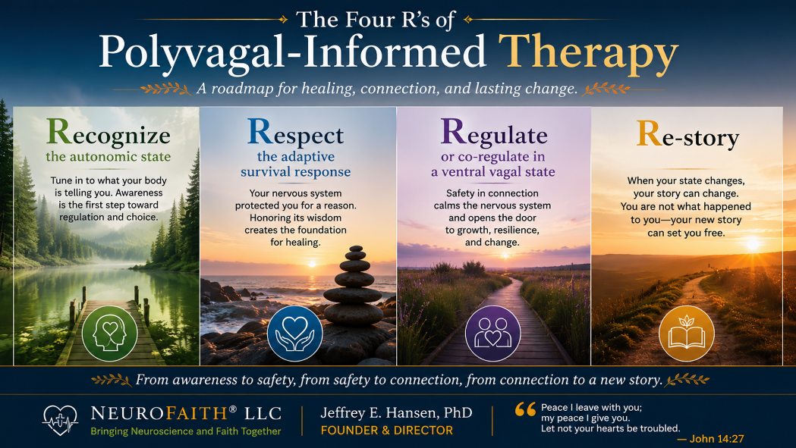
In this chapter, we will focus primarily on the first three R's: recognizing the autonomic state, respecting the adaptive survival responses that developed in the face of adversity, and learning practical ways to regulate the nervous system. These three steps are foundational because they help create the physiological conditions necessary for deeper healing to occur. Before we can effectively challenge the stories shame has taught us, the body must first experience greater safety, connection, and coherence.
The fourth R, Re-story, deserves its own chapter. Once the storm which is most notably in the body begins to settle, we become increasingly capable of examining the beliefs, narratives, and conclusions we have carried about ourselves for years. It is there that we will explore how shame shapes identity, how negative core beliefs become entrenched, and how healing allows us to begin writing a different story. The key here is that a settled body makes way for a more settled brain and mind that is more enabled to address the psychological and spiritual aspects of trauma and shame.
For now, our task is simpler but no less important. We begin by helping the body rediscover safety. We learn to recognize the storm, respect the storm, and regulate the storm. In doing so, we prepare the way for the deeper work that lies ahead.
Learning to Recognize the Storm
If healing begins with restoring safety to the body and heart, the obvious question becomes: How do we do that?
One of the greatest gifts that Polyvagal Theory provides is a map. Before discovering this framework, many people describe their experience in very general terms. They know they feel anxious, stressed, depressed, overwhelmed, exhausted, numb, or disconnected, but they often lack a deeper understanding of what is occurring within their nervous system. As a result, they frequently blame themselves for reactions that are actually rooted in biology.
Polyvagal Theory offers a different perspective. Rather than asking, "What is wrong with me?" it encourages us to ask, "What state is my nervous system in right now?"
This simple shift can be remarkably freeing.
As we discussed earlier, the autonomic nervous system tends to move through three broad states. When we feel safe and connected, we operate primarily from a ventral vagal state. In this state, we are capable of curiosity, connection, creativity, flexibility, and emotional balance. We can think clearly, engage with others, and respond thoughtfully to life's challenges.
When the nervous system perceives danger, however, it may shift into sympathetic activation. Anxiety increases. Muscles tense. Heart rate accelerates. Thoughts become organized around threat. We become vigilant, reactive, and focused on survival. Many people describe this experience as feeling overwhelmed, agitated, or emotionally flooded.
If the nervous system determines that escape or action will not resolve the threat, it may move toward dorsal vagal shutdown. In this state, people often experience exhaustion, numbness, hopelessness, brain fog, disconnection, and emotional withdrawal. Many trauma survivors describe this experience as feeling as though they are moving through molasses.
For years, I moved between these states without understanding what was happening. Sometimes I felt overwhelmed by anxiety and fear. At other times I felt exhausted and emotionally depleted. I interpreted these experiences as personal failures rather than physiological states. Once I began understanding the language of the nervous system, everything started to make more sense. I was not broken. My nervous system was doing exactly what it had been designed to do. The problem was that it had become stuck.
This realization led me to what I now think of as the Four R's of nervous system healing: Recognize, Respect, Regulate, and Re-story.
The First Step: Recognize the Autonomic State Se Are In.
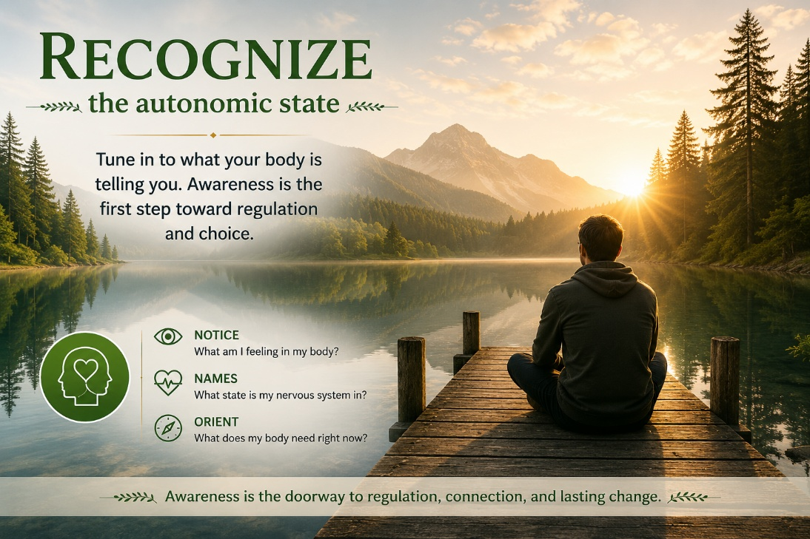
The first step toward calming the storm is learning to recognize the state we are in.
This may sound deceptively simple, yet it is one of the most important skills a person can develop. Most people spend years reacting to their nervous system without ever understanding it. They know they are anxious. They know they are angry. They know they are exhausted, discouraged, overwhelmed, or emotionally numb. What they often lack is a framework for understanding why these experiences occur and what those experiences are trying to communicate.
Prior to discovering Polyvagal Theory, I often viewed my own distress through a purely psychological lens. When I became anxious, I assumed something was wrong. When I became emotionally overwhelmed, I believed I simply needed to work harder, think differently, or exercise more discipline. What I did not understand was that my nervous system was constantly responding to signals of safety and danger, often long before I was consciously aware of what was happening.
Polyvagal Theory provides a language for understanding these experiences (Porges, 2011; Dana, 2018). Rather than asking, "What is wrong with me?" we begin asking a different question: "What state is my nervous system in right now?"
Am I activated and mobilized?
Am I shut down and disconnected?
Am I calm, connected, and engaged?
These questions may appear simple, but they fundamentally change how we relate to ourselves. The moment we begin recognizing our state, we create a small but important space between ourselves and our experience. We stop assuming that every thought, emotion, or impulse represents reality. Instead, we begin observing the state from which those thoughts and emotions are emerging.
This distinction becomes particularly important for individuals struggling with shame. When shame dominates our internal experience, we often conclude that our emotional state reflects who we are. Anxiety becomes evidence that we are weak. Exhaustion becomes evidence that we are failing. Emotional pain becomes evidence that we are somehow defective. Yet many of these conclusions are not objective truths. They are interpretations being generated by a nervous system attempting to navigate stress, threat, or overwhelm.
One of the most liberating realizations in my own healing journey was understanding that states are temporary, even when they feel permanent. The sympathetic state eventually settles. The dorsal vagal state eventually lifts. The nervous system is dynamic by design. What often keeps us trapped is not the state itself but our inability to recognize it for what it is.
Recognition creates awareness. Awareness creates options. And options create the possibility of change.
For this reason, learning to recognize the state we are in is not merely an intellectual exercise. It is one of the foundational skills of healing. Before we can calm the storm, we must first learn to identify the storm.

The Second Step: Respect the Autonomic State
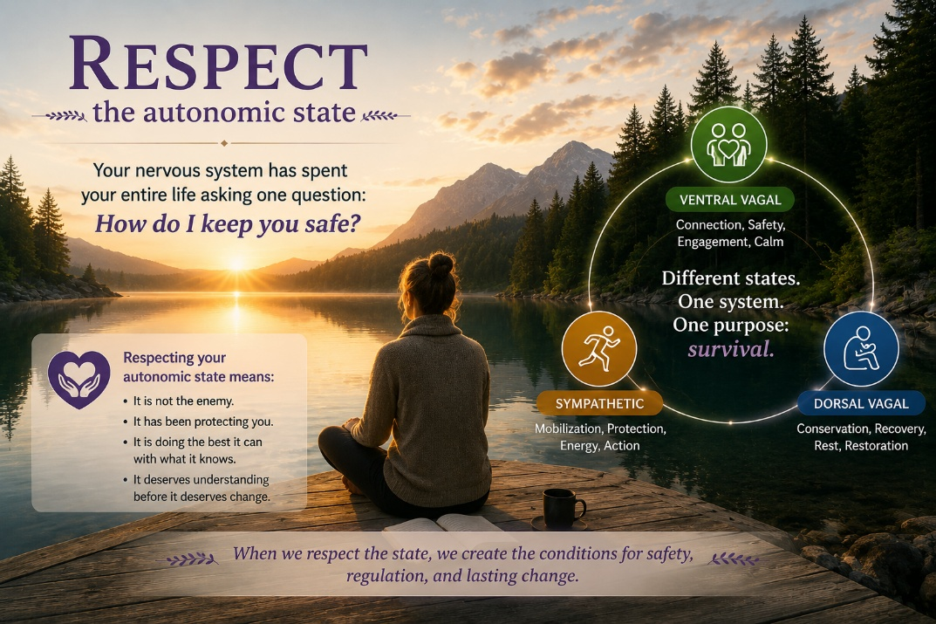
Recognizing the storm is an important first step, but recognition alone is not enough. Once we become aware of our autonomic state, we are faced with a second challenge that is often far more difficult: How do we respond to what we discover?
For many people, the answer is surprisingly harsh. We become frustrated with our anxiety, ashamed of our fear, impatient with our exhaustion, and critical of our inability to simply "get over it." Rather than responding to our distress with understanding, we often respond with judgment. In doing so, we add a second layer of suffering to the first. We are not only anxious, discouraged, overwhelmed, or disconnected; we are also ashamed that we are anxious, discouraged, overwhelmed, or disconnected.
This pattern is so common that many people hardly recognize it. Yet when I look back on my own storm, I can see how frequently I fell into this trap. As the pressures in my life mounted and my nervous system became increasingly overwhelmed, I interpreted my struggles as evidence that something was wrong with me. I believed I should have been handling things better. I thought I needed more discipline, more determination, more insight, or perhaps simply more faith. Like many people, I viewed my distress as a personal failure rather than as a physiological response to an extraordinary accumulation of stress.
Looking back now, I understand something very different. My nervous system was not failing. It was responding. Every anxious thought, every surge of fear, every moment of emotional exhaustion was occurring within a system that had become organized around survival. The problem was not that my nervous system was broken. The problem was that it no longer knew the danger had passed.
One of the most liberating insights within Polyvagal Theory is the recognition that the autonomic nervous system is fundamentally protective in nature (Porges, 2011; Dana, 2018). Long before we consciously evaluate a situation, our nervous system is constantly scanning for cues of safety and danger. When it perceives danger, it mobilizes resources designed to help us survive. Sometimes that means increased vigilance, anxiety, and activation. At other times it means withdrawal, numbness, exhaustion, and shutdown. While these states may feel very different, they share a common purpose. Both are attempts to protect us from perceived threat.
This perspective is especially important for individuals who carry significant shame. Shame has a remarkable ability to transform adaptive survival responses into evidence of personal defectiveness. Anxiety becomes proof that we are weak. Emotional exhaustion becomes proof that we are failing. Withdrawal becomes proof that we are inadequate. Over time, we stop seeing these experiences as temporary states and begin seeing them as reflections of our identity.
Yet what if we have been interpreting the signals incorrectly?
What if the anxious part of us is not trying to sabotage us but trying to protect us? What if the hypervigilant part of us developed because it learned that danger could appear without warning? What if the part that withdraws, shuts down, or disconnects is attempting to shield us from pain it does not yet know how to process?
These questions do not excuse unhealthy behaviors, nor do they suggest that we remain trapped in old patterns. Rather, they invite us to approach ourselves with a different posture. Instead of condemnation, we practice curiosity. Instead of judgment, we cultivate understanding. Instead of asking, "What is wrong with me?" we begin asking, "What happened to me, and what is my nervous system trying to accomplish?"
That shift is more powerful than many people realize. Human beings rarely heal through self-hatred. We rarely find peace by attacking ourselves. Shame may temporarily motivate change, but it almost never produces lasting transformation. Compassion, on the other hand, creates safety. And safety creates the conditions in which growth becomes possible.
This is where the work of psychologist Kristin Neff becomes particularly helpful. In her book Self-Compassion: The Proven Power of Being Kind to Yourself (Neff, 2011), she argues that many people speak to themselves in ways they would never speak to another human being. When a friend is struggling, we often respond with patience, kindness, and understanding. When we are struggling, we frequently respond with criticism, judgment, and shame. Self-compassion simply means extending to ourselves the same grace we would naturally offer to someone else who is suffering.
Unfortunately, self-compassion is often misunderstood. Some people confuse it with self-absorption, self-pity, or self-indulgence. It is none of those things. Self-absorption keeps our attention focused on ourselves. Self-compassion acknowledges our pain while helping us move through it. Self-pity keeps us stuck. Self-compassion helps us heal. It allows us to acknowledge our struggles honestly without defining ourselves by them.
From a Christian perspective, self-compassion should not feel foreign. Throughout the Gospels, Jesus consistently responded to suffering people with compassion. He moved toward the wounded rather than away from them. He offered mercy before correction and understanding before judgment. One of the most beautiful invitations in Scripture comes in Matthew 11:28, when Jesus says, "Come to me, all you who are weary and burdened, and I will give you rest."
Notice what Jesus does not say. He does not say, "Come to me once you have fixed yourself." He does not say, "Come to me once you are stronger, more disciplined, or less broken." He invites us to come as we are. The weary are welcomed. The burdened are welcomed. The struggling are welcomed.
I believe that invitation has profound implications for healing. If Christ meets us with compassion in our suffering, perhaps we should learn to do the same. If God responds to our weakness with grace, perhaps we should stop responding to our weakness with contempt.
As I continued my own healing journey, I gradually learned that respecting my nervous system did not mean agreeing with every reaction it produced. It did not mean surrendering to anxiety or accepting chronic shutdown as inevitable. It simply meant acknowledging that these responses developed for a reason. They had a history. They had a purpose. They represented attempts, however imperfect, to navigate pain, uncertainty, and fear.
That realization softened something within me. Instead of fighting my nervous system, I began learning from it. Instead of viewing it as an adversary, I began viewing it as an ally that had become overburdened and exhausted. The body God created was not trying to destroy me. It was trying to protect me. It simply needed help learning that safety was available again.
This is why respect is such an essential part of healing. Recognition helps us identify the storm. Respect helps us stop attacking ourselves for being caught in it. Together, they create the foundation for the next step in the journey. Once we understand the state we are in and learn to approach that state with compassion, grace, and curiosity, we can begin helping the body move toward regulation, coherence, and peace.

The Third Step: Regulate the Autonomic State

Once we begin recognizing and respecting our autonomic state, we can start helping the body return toward safety. This is where many people make an important discovery. Healing is not simply about understanding what happened to us. Healing is also about helping the body learn that the danger has passed.
Earlier in this book, we explored how trauma and shame affect not only the brain but also the heart. Through the emerging field of neurocardiology, researchers have demonstrated that the heart and brain are engaged in a continuous two-way conversation (McCraty et al., 2009). Through neural pathways, hormonal communication, blood pressure signaling, and electromagnetic activity, the heart is constantly informing the brain about the body's internal state.
What many people do not realize is that the quality of this communication changes depending upon our emotional state.
As previously noted, when we experience chronic fear, anxiety, shame, resentment, anger, or emotional distress, the rhythm of the heart becomes increasingly erratic and disorganized. Rather than producing a smooth and predictable pattern, the heart generates a chaotic rhythm. This chaotic information is continuously transmitted to the brain. In response, the brain becomes increasingly organized around threat detection and survival. Attention narrows. Perspective shrinks. Emotional reactivity increases. The world begins to look more dangerous than it actually is.
This creates a self-reinforcing cycle. A distressed brain contributes to a distressed body, while the distressed body continues sending distress signals back to the brain. Shame thrives in this environment because the entire system becomes organized around protection rather than connection.
Fortunately, the opposite is also true.
When we experience emotions such as gratitude, appreciation, compassion, hope, love, and connection, the rhythm of the heart begins to change. Rather than producing a chaotic pattern, the heart generates a smooth, organized, sine-wave-like rhythm known as coherence (McCraty et al., 2009). As coherence increases, the brain receives a very different message. Safety begins to return. Perspective broadens. Emotional flexibility improves. We become more capable of reflection, learning, problem solving, and meaningful connection.
This is one reason healing cannot occur through insight alone. The brain functions differently when it receives signals of safety than when it receives signals of threat. Earlier in this book we discussed the Default Mode Network and the tendency of shame to organize itself around negative core beliefs. Those deeply ingrained pathways often feel immovable. Yet as safety increases and coherence improves, the brain becomes more flexible. New experiences become possible. New interpretations become possible. New stories become possible.
One of the simplest ways to begin creating coherence is through intentional breathing. Slow, rhythmic breathing stimulates the vagus nerve and communicates safety throughout the nervous system. As breathing slows, heart rhythms often become more organized, and the brain gradually follows. Many people notice that after only a few minutes of intentional breathing, their thoughts become clearer, their emotions become less overwhelming, and their ability to think rationally improves.
One technique I frequently recommend is Heart Lock-In breathing. While there are several variations, the basic process is straightforward. Slow your breathing. Gently focus your attention on the area around your heart. Imagine the breath flowing through the heart. Then intentionally bring to mind feelings of gratitude, appreciation, compassion, love, or connection. The goal is not to force emotions that are not present. The goal is to create the physiological conditions in which coherence can emerge. As many people practice this technique, they notice a shift not only in their emotional state but also in their ability to think clearly and respond thoughtfully.
Gratitude deserves special attention. Earlier in the book we discussed how trauma and shame tend to organize attention around danger, loss, inadequacy, and threat. Gratitude does not deny those realities. Rather, gratitude broadens awareness beyond them. Gratitude helps the nervous system recognize that pain may be present, but pain is not the only thing present. The practice of gratitude often becomes one of the most powerful pathways toward coherence because it helps shift the entire system from protection toward connection.
Another powerful pathway to regulation is co-regulation.
Polyvagal Theory reminds us that human beings are biologically wired for connection (Porges, 2011; Dana, 2018). We do not regulate ourselves exclusively from the inside out. We also regulate through safe relationships. A calm spouse, trusted friend, therapist, pastor, mentor, or family member can help settle our nervous system simply through their presence. A warm facial expression, a gentle tone of voice, compassionate listening, and genuine acceptance all communicate safety to the nervous system in ways that words alone cannot. This wondrously helps to activate that beautiful God-designed vagus nerve which reaches out and settles every organ in the body and brings this peace back to the face to enhance even further social connection. And please appreciate that this is a time when it is so essential to be with people to radiate safety and to avoid those to do not.

This helps explain one of shame's greatest tragedies. Shame often drives us into isolation at precisely the moment we most need connection. It tells us to hide when healing requires being seen. It tells us to withdraw when our nervous system desperately needs the calming presence of safe people. And too much of this can destroy your live, or even worse, take your life.
For followers of Christ, perhaps the deepest form of co-regulation is found in our relationship with God Himself. Throughout Scripture, God repeatedly invites us to bring our fears, burdens, anxieties, and sorrows into His presence. Prayer, worship, meditation on Scripture, and quiet communion with Christ are not merely spiritual exercises. They are also experiences that help communicate safety to the nervous system. In many ways, Jesus becomes the ultimate secure attachment figure. He is the One who continually reminds us that we are not abandoned, not forgotten, and not alone.
Movement is another powerful regulator. Walking, exercise, stretching, hiking, gardening, and time spent outdoors all help restore flexibility to the nervous system. Earlier in the book we discussed movement as medicine. The body was designed to move. Movement helps discharge activation that accumulates through chronic stress and trauma while simultaneously creating opportunities for regulation and recovery.
For this reason, practices such as heart-focused breathing such as the Heart Lock-In® Technique described below, gratitude, prayer, worship, movement, time in nature, healthy relationships, and meaningful connection are far more than self-help techniques. They are biological interventions that help restore regulation throughout the entire system. Each time we practice them, we are teaching the body, heart, and brain a new lesson.
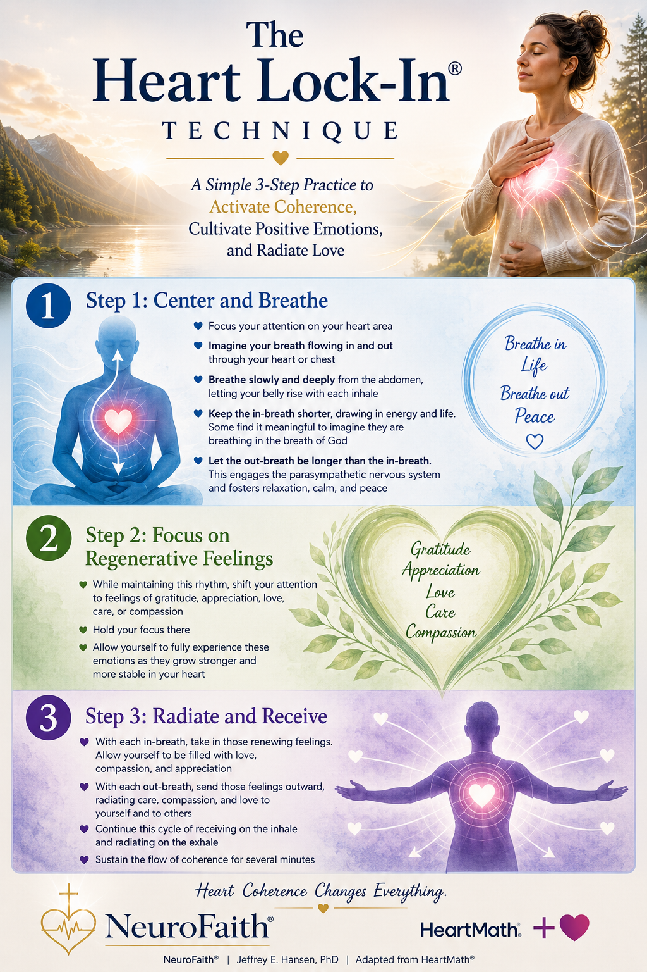
The danger is not here.
The storm is passing.
I am safe.
Over time, these experiences begin creating a new internal reality. The nervous system learns that it no longer needs to remain trapped in survival mode. The body softens. The heart becomes more coherent. The brain becomes more integrated. And as safety returns, we become increasingly capable of taking the next step in healing.
We become ready to examine the stories we have been carrying.
Only then are we prepared to begin the deeper work of restoration.

Restore What Shame Stole
Remembering Who You Were Created to Be


W
e have spent considerable time learning how trauma affects the body because trauma is experienced in the body. We have learned to recognize our autonomic state, respect it rather than judge it, and regulate it through connection, coherence, breathing, movement, prayer, and other restorative practices. These skills matter because a dysregulated nervous system has difficulty engaging in the deeper work of healing. Now that we have established greater safety and stability within the system, we are ready to turn our attention to the stories trauma and shame left behind.
As we have discussed throughout this book, trauma and shame do far more than create emotional pain. They shape the stories we tell ourselves about who we are, what we are worth, and what we can expect from other people and from life itself. Over time, these stories become so familiar that we stop recognizing them as interpretations and begin experiencing them as reality. What may have started as a painful conclusion drawn from a difficult experience gradually becomes a deeply held belief, and that belief begins influencing virtually every aspect of our lives.
The power of these beliefs cannot be overstated. The lies born from trauma and shame rarely remain confined to a single area of functioning. Instead, they spread throughout the entire system. They influence the way we view ourselves when we look in the mirror. They influence our relationships, our parenting, our marriages, our friendships, and our willingness to trust others. They affect the way we receive praise and the way we respond to criticism. They shape our expectations, our fears, our dreams, and our disappointments. They influence our conversations with others and, perhaps most importantly, our conversations with ourselves.
The influence of these beliefs extends even further. The lies we carry affect the way we pray, the way we read Scripture, and the way we relate to God. A person who secretly believes they are unlovable often struggles to fully receive love from others or from God. A person who believes their worth depends upon performance may find it difficult to embrace grace. A person who believes the world is fundamentally unsafe may approach relationships, opportunities, and even faith itself with chronic vigilance. In this way, the wounds of trauma and the lies of shame become woven into the fabric of daily life, quietly influencing thoughts, emotions, behaviors, relationships, and spiritual experience.
Perhaps this is why healing requires more than symptom reduction. It is not enough simply to feel less anxious, less depressed, or less overwhelmed. While those outcomes are important, they do not necessarily address the deeper narrative that continues operating beneath the surface. Lasting healing requires us to examine the stories we have been living from and determine whether they are actually true.
This work, however, is difficult when the nervous system remains chronically dysregulated. When the body is consumed with survival, the mind has little capacity left for reflection. When the heart is overwhelmed by fear, shame, anger, or grief, curiosity becomes difficult. When the nervous system is constantly preparing for danger, we tend to react rather than reflect. This is one reason we have spent so much time discussing regulation, coherence, connection, and the autonomic nervous system in previous chapters. Those skills are not the destination. They are the preparation.
As the body becomes more settled, the mind gains greater clarity. As the heart becomes more coherent, emotional reactivity decreases and thoughtful reflection becomes possible. As the nervous system experiences greater safety, we become less controlled by our protective responses and more capable of observing them. Rather than being swept away by every emotion, thought, or impulse, we gain the ability to step back and ask deeper questions. We become capable of exploring not only what happened to us, but how we adapted to what happened to us.
Internal Family Systems (IFS): Understanding Our Protective Parts
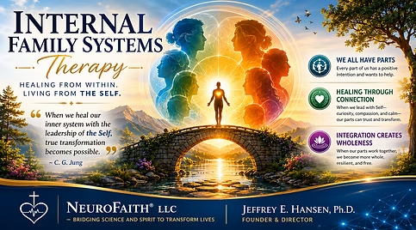
As we begin exploring the lies that trauma and shame have taught us, it is helpful to have a framework for understanding the ways people adapt to pain. One of the most insightful and compassionate models I have encountered is Internal Family Systems, often referred to simply as IFS. Developed by family therapist Richard Schwartz in the 1980s, IFS emerged from an observation that many people naturally describe their inner experience as if different parts of themselves are involved.
Most of us have experienced this phenomenon. We might say, "Part of me wants to trust, but another part is afraid." We might say, "Part of me wants to move forward, but part of me keeps holding me back." We may find ourselves caught between competing desires, emotions, or reactions and wonder why we feel so conflicted. Schwartz became increasingly interested in these internal experiences and eventually developed a model that helped explain them.
At its core, IFS proposes that the mind is not a single, unified voice but rather a system made up of different parts, each with its own experiences, concerns, fears, and responsibilities. Importantly, these parts are not signs of mental illness. They are normal aspects of human functioning. In many ways, they resemble members of a family, each carrying out different roles in an effort to help the whole system function.
One of the reasons IFS has become so influential is its deeply compassionate view of human behavior. Rather than asking, "What is wrong with this person?" it asks, "What happened to this person?" Instead of viewing problematic behaviors as evidence of weakness or dysfunction, it seeks to understand the protective purpose those behaviors may serve.
This perspective is particularly helpful when working with trauma and shame. As we have already discussed, trauma often leaves behind painful conclusions about who we are. A child who experiences rejection may come to believe, "I am unwanted." A child who grows up in chaos may conclude, "I am not safe." A child whose worth seems tied to achievement may conclude, "I am only valuable when I perform." These conclusions become burdens carried within the system.
According to IFS, some parts of us carry those burdens directly. Schwartz referred to these wounded parts as exiles. Exiles often carry feelings of shame, fear, loneliness, grief, rejection, abandonment, or inadequacy. Because these emotions can feel overwhelming, the rest of the system works hard to keep them out of awareness.
To accomplish this, other parts step into protective roles. The first group of protectors are often called managers. Managers attempt to prevent pain before it occurs. They may appear as perfectionism, people pleasing, achievement striving, excessive responsibility, self-criticism, control, or hypervigilance. Their goal is simple: keep the system safe by preventing the exile's wounds from being activated.
When those efforts fail and painful emotions begin breaking through, another group of protectors often emerges. These are known as firefighters. Whereas managers work proactively, firefighters work reactively. Their goal is to extinguish emotional pain as quickly as possible. Sometimes they do so through healthy means. At other times they rely on avoidance, emotional withdrawal, anger, compulsive behaviors, addictions, overeating, pornography, excessive work, or other strategies designed to numb distress. While their methods can be costly, their intention is usually protective. They are attempting to stop the pain.
One of the most powerful insights of IFS is that even the parts we dislike most are often trying to help us. The perfectionist is trying to help. The people pleaser is trying to help. The angry protector is trying to help. The avoider is trying to help. Even the addict, at some level, is often trying to help. Their methods may create problems, but their underlying purpose is usually protection.
For individuals struggling with shame, this realization can be profoundly freeing. Shame tells us that our struggles prove there is something fundamentally wrong with us. IFS suggests a different possibility. What if many of our struggles are not evidence of defectiveness but evidence of adaptation? What if the very behaviors we criticize most harshly developed as attempts to survive pain that once felt unbearable?
This shift moves us from condemnation to curiosity. Rather than attacking ourselves, we begin seeking understanding. Rather than asking, "Why am I like this?" we begin asking, "What has this part been trying to accomplish?" That question often opens the door to compassion, healing, and ultimately transformation.
At the center of the IFS model is what Schwartz calls the Self. The Self is not another part competing for control. Rather, it is the calm, compassionate, curious, courageous core from which healing emerges. According to Schwartz, when the Self is leading, people naturally exhibit qualities such as calm, curiosity, compassion, clarity, confidence, courage, creativity, and connectedness. These characteristics, often referred to as the Eight C's, represent the healthiest and most integrated functioning of the system.
From a NeuroFaith perspective, this concept is particularly meaningful. While IFS itself is not a Christian model, many believers recognize striking parallels between the qualities of Self-leadership and the fruits of the Spirit described in Galatians 5. Both point toward a life characterized by greater peace, compassion, wisdom, courage, and connection. Both move us away from fear and toward freedom.
As we continue this journey, our goal is not to eliminate parts of ourselves. Our goal is to understand them. We are not seeking to wage war against our defenses. We are seeking to understand why they developed and what burdens they have been carrying. Most importantly, we are seeking to uncover the stories around which those defenses were organized.
Let’s dig in for a deeper understanding of IFS.

Exiles: The Wounds We Carry
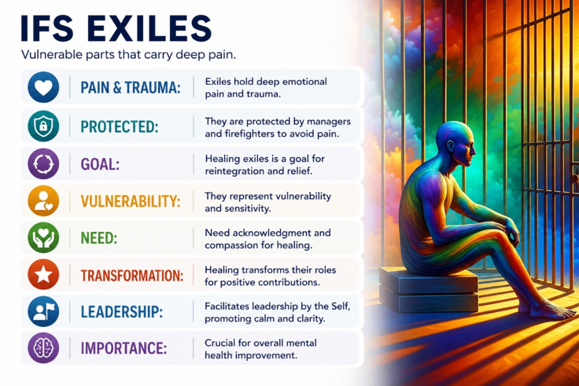
At the heart of the Internal Family Systems model lies a simple but profound observation: some parts of us carry pain that has never been fully healed.
Richard Schwartz referred to these wounded parts as exiles because they are often pushed out of awareness. Their emotions can feel so overwhelming, so painful, or so threatening that the rest of the system works hard to keep them hidden. Yet despite these efforts, exiles continue influencing our lives from behind the scenes.
Exiles often carry the emotional burdens associated with trauma, loss, rejection, abandonment, humiliation, neglect, loneliness, fear, and shame. They hold the memories, emotions, and conclusions that emerged during some of life's most painful moments. In many ways, exiles are the parts of us that remain frozen in those experiences, still carrying wounds that were never fully processed or healed.
Importantly, exiles do not merely carry memories. They often carry meanings.
This distinction is crucial.
A child who experiences rejection may not simply remember the rejection. The child may conclude, "I am unwanted."
A child who experiences chronic criticism may not simply remember the criticism. The child may conclude, "I am not enough."
A child raised in an unpredictable or chaotic environment may not simply remember feeling afraid. The child may conclude, "I am not safe."
Over time, these conclusions become burdens carried by the exile. The event itself may have ended years or even decades earlier, but the meaning assigned to the event continues living within the system. This is one reason trauma can remain so influential long after the original circumstances have passed.
As we discussed earlier in this chapter, trauma wounds the heart, but shame often interprets the wound. The interpretation becomes a story. The story becomes a belief. The belief becomes part of our identity.
Many people spend years attempting to manage symptoms without ever addressing the underlying burdens carried by these exiled parts. They work harder, achieve more, please others, avoid vulnerability, numb painful emotions, or criticize themselves relentlessly, all without realizing that deeper wounds continue operating beneath the surface.
As previously noted, one of the reasons IFS resonates so strongly with trauma survivors is that it provides a compassionate explanation for these experiences. Rather than viewing painful emotions as evidence of weakness, it recognizes them as signals that wounded parts of the system still need attention, understanding, and healing.
In my clinical work, I have found that many exiles carry remarkably similar burdens despite very different life histories. The details may differ, but the underlying themes often repeat themselves. Again and again, I encounter individuals carrying beliefs such as:
"I am not enough."
"I am not safe."
"I am unlovable."
"I do not matter."
"I am defective."
"I am alone."
"I must earn love."
"I must perform to have value."
“I can never be safe.”
These beliefs are not merely thoughts. They become organizing principles around which the rest of the system begins to operate. Protective parts emerge to prevent these wounds from being activated. Entire patterns of behavior develop around avoiding the pain associated with these burdens.
Understanding the exile helps explain why change can be so difficult. A person may intellectually recognize that they are loved, valued, and worthy of respect, yet still feel profoundly unworthy at an emotional level. Another may know they are safe in the present moment yet continue reacting as though danger is just around the corner. The issue is not a lack of intelligence or insight. The issue is that wounded parts of the system are still carrying burdens formed long ago.
The goal of healing is not to eliminate these parts. Nor is it to shame them for carrying pain. The goal is to approach them with compassion, curiosity, and courage. We seek to understand their stories, honor their experiences, and help them release burdens they were never meant to carry for a lifetime.
As we will soon see, however, exiles rarely remain unprotected. Whenever painful burdens exist within the system, other parts inevitably emerge to prevent those wounds from being touched. These protective parts often work tirelessly to keep the exile's pain out of awareness.
Schwartz (2023). referred to these protectors as managers and firefighters, and understanding their role helps explain many of the struggles people experience in daily life.
This is where Internal Family Systems provides a particularly valuable framework. Before we can effectively challenge the lies we have believed, we must first understand the protective strategies that developed around those lies. The perfectionism, people-pleasing, emotional withdrawal, achievement striving, anger, avoidance, numbing, and countless other adaptations we experience did not emerge randomly. Most developed for reasons. Most represent sincere attempts by the system to prevent further pain, rejection, abandonment, humiliation, or shame. Understanding these protective patterns is often the first step toward genuine restoration.
As we will see, healing is not accomplished by attacking our defenses. Healing begins by understanding them. Once we understand what our protective parts have been trying to accomplish, we can begin helping them release the burdens they have been carrying for years, sometimes decades. Only then can we fully examine the narratives that organized those burdens in the first place. Only then can we begin replacing the lies of shame with truth.
Ultimately, this chapter is about restoration. It is about identifying the stories that trauma and shame taught us, understanding the defenses that formed around those stories, and gradually recovering the truth about who we are. It is about bringing the body, heart, mind, and soul back into greater alignment. Most importantly, it is about remembering who we were created to be before shame convinced us otherwise.

Managers: Preventing the Pain
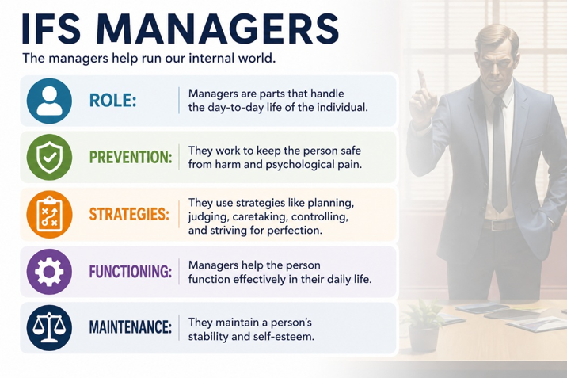
If exiles carry the wounds, managers work tirelessly to prevent those wounds from being activated.
Managers are proactive protectors. Their job is to anticipate danger and prevent situations that might trigger the pain carried by exiles. In many ways, managers function like highly vigilant guardians, constantly scanning the environment for potential threats and developing strategies to keep the system safe.
The challenge is that managers are often so effective and so socially acceptable that we rarely recognize them as protective parts. In fact, many managers receive praise and admiration from others. They may appear as achievement, responsibility, perfectionism, self-discipline, people pleasing, organization, productivity, or relentless preparation. From the outside, these traits often look like strengths. Indeed, many of them can be strengths.
The question is not whether the behavior is good or bad. The question is what is driving it.
A student who studies diligently because she enjoys learning may be operating from a very different place than a student who believes failure would prove she is worthless. A person who works hard because he enjoys his profession may be operating from a different place than someone driven by a desperate need to prove his value. The behavior may appear similar. The motivation is often very different.
Managers are frequently organized around the lies we discussed earlier in this chapter. If an exile carries the burden, "I am not enough," a manager may emerge through perfectionism or achievement striving. If the burden is, "I am not safe," a manager may become hypervigilant, controlling, or excessively prepared. If the burden is, "I am unwanted," a manager may develop people-pleasing behaviors designed to secure acceptance and approval.
Many of us spend years living primarily from our managers. We become identified with the achiever, the caretaker, the helper, the peacemaker, the perfectionist, or the responsible one. We may even build successful careers and meaningful lives around these adaptations. Yet beneath their competence often lies a frightened protector working tirelessly to keep deeper pain from surfacing.
One of the most common managers encountered in clinical practice is the inner critic. The critic constantly evaluates performance, points out shortcomings, and warns against mistakes. Although it may feel harsh and condemning, its intention is often protective. The critic believes that if it pushes hard enough, failure, rejection, humiliation, or abandonment can be avoided. Given the importance of this manager, we will discuss this protector in much more detail shortly.
Unfortunately, managers eventually encounter a problem. No matter how hard they work, they cannot eliminate pain entirely. Life remains unpredictable. Relationships remain imperfect. Losses still occur. Rejection still happens. Trauma leaves wounds that cannot simply be managed away.
When the burden carried by an exile begins breaking through despite the manager's best efforts, another group of protectors often takes over.
These protectors are known as firefighters.
Firefighters: Extinguishing Emotional Pain
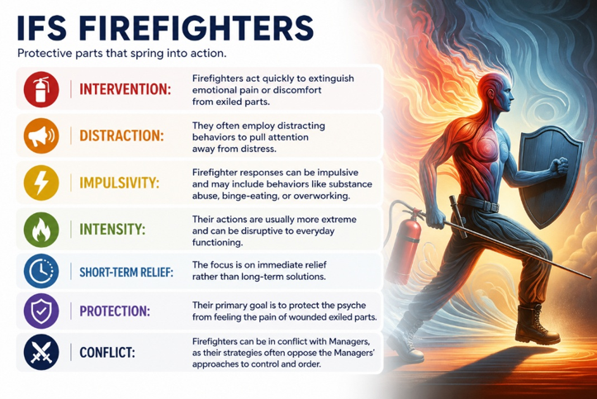
Where managers work to prevent pain, firefighters respond when pain is already present.
Their mission is simple: make the distress stop.
When an exile's burden begins surfacing and overwhelming emotions threaten to break through, firefighters rush into action. Unlike managers, who tend to be thoughtful, strategic, and future-oriented, firefighters are focused on immediate relief. They are not concerned with long-term consequences. Their priority is extinguishing emotional pain as quickly as possible.
This helps explain why many self-destructive behaviors can feel so compelling in the moment. Firefighters are not asking, "Will this help me six months from now?" They are asking, "How do I stop hurting right now?"
For some individuals, firefighters may appear as emotional withdrawal, avoidance, or dissociation. Others may find themselves turning to overeating, pornography, alcohol, drugs, compulsive spending, excessive gaming, endless scrolling, workaholism, or other forms of escape. Still others may respond through anger, emotional outbursts, impulsive decisions, or attempts to push people away before they can cause further hurt.
From the outside, these behaviors often appear irrational. Yet from the perspective of the firefighter, they make perfect sense. The system is experiencing distress, and the firefighter is attempting to provide relief.
This understanding does not excuse destructive behaviors, nor does it minimize the consequences they may create. Addiction destroys lives. Uncontrolled anger damages relationships. Avoidance prevents growth. Emotional numbing limits intimacy. These realities must be acknowledged honestly.
At the same time, healing requires us to understand the protective purpose these behaviors serve. Many people spend years attacking the firefighter while ignoring the exile that the firefighter is trying to protect. They focus exclusively on stopping the behavior without exploring the pain that fuels it.
Imagine a firefighter arriving at a burning building. We would never criticize the firefighter for responding to smoke while ignoring the fire itself. Yet this is often how we approach emotional struggles. We focus on the symptom while overlooking the wound.
Two particularly important examples of firefighter activity deserve special attention: substance use and suicidality.
For many individuals, alcohol and drug use function as powerful firefighter responses. When shame, trauma, loneliness, fear, or emotional pain become overwhelming, substances can offer temporary relief. They may numb distress, quiet intrusive thoughts, reduce anxiety, or provide a brief sense of escape from burdens that feel unbearable. This does not make substance use healthy, nor does it diminish the devastating consequences addiction can create. Yet understanding the protective intention behind the behavior often changes how individuals relate to themselves. Instead of viewing themselves solely as weak, defective, or morally flawed, they begin to recognize that a part of them has been desperately trying to protect them from emotional suffering. This shift often opens the door to greater self-compassion. The addiction remains destructive and must be addressed, but the individual can begin to understand that beneath the behavior is a firefighter attempting, however imperfectly, to extinguish emotional pain.
An even more extreme example is suicidality. In fact, Richard Schwartz's work with suicidal and self-injuring individuals played an important role in the development of the IFS model. From an IFS perspective, suicidal thoughts often emerge from a firefighter that sees death as the only way to end unbearable suffering. This understanding does not minimize the seriousness of suicide risk, nor does it suggest passivity in the face of danger. Safety must always remain the highest priority. At the same time, IFS teaches that directly battling with a suicidal part can sometimes intensify its desperation. Arguing, condemning, or attempting to overpower the part may leave it feeling even more isolated and misunderstood. Instead, therapists often seek to approach the suicidal firefighter with curiosity, respect, and compassion. They may ask the part if it would be willing to step back temporarily, take a side seat, or allow space for other parts to be heard while the underlying pain is explored. The goal is not to agree with the suicidal part's solution but to understand the suffering that gave rise to it. As the burdens carried by exiles begin to heal, the suicidal firefighter often discovers that its extreme role is no longer necessary.
Approaching these protective parts with curiosity and compassion is not simply an exercise in self-understanding. It is often essential for healing. Learning to see the protective intention beneath destructive behaviors frequently becomes the foundation for developing genuine self-compassion. In some situations, this perspective may even save a life. When individuals feel understood rather than judged, and when their protective parts no longer feel forced into a desperate battle for control, those parts may become more willing to step back, soften their extreme roles, and allow deeper healing to occur. The difference between fighting a protective part and befriending it can sometimes be the difference between a defense overwhelming the individual and that same defense stepping aside long enough for healing to begin. At times, it may be the difference between remaining trapped in unbearable suffering and discovering a pathway toward hope, recovery, and life itself.
One of the most transformative insights of IFS is that lasting change rarely occurs through self-condemnation. Change becomes possible when we begin understanding the fears, burdens, and wounds driving our behaviors. As we help exiles heal and managers relax their vigilance, firefighters often discover that they no longer need to work so hard.
Their job becomes easier because the pain they were trying to extinguish is finally receiving the attention it has needed all along.
This realization leads us to one of the most important questions in the healing process. If exiles carry wounds, managers prevent pain, and firefighters extinguish distress, who is it that can help lead the system toward healing?
To answer that question, we must turn our attention to what Richard Schwartz called the Self.

The Inner Critic: Shame's Most Convincing Voice

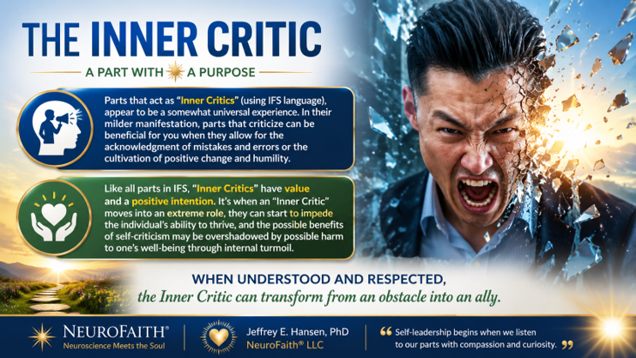
Among all the parts within the internal system, few are as influential or as misunderstood as the inner critic. Most people know its voice well. It is the voice that points out mistakes, highlights shortcomings, predicts failure, and reminds us of every way we fall short of our expectations. For some, it whispers quietly in the background. For others, it dominates the conversation, becoming a relentless source of self-judgment and emotional pain.
Because the critic can be so harsh, many people assume it is the enemy. Yet Internal Family Systems invites us to look more deeply. Like many protective parts, the critic usually developed for a reason. It often emerges in environments where mistakes, vulnerability, failure, or rejection felt dangerous. Over time, it learns that criticism may be safer than risk, perfection may be safer than failure, and constant vigilance may be safer than disappointment.
In this sense, the critic is often attempting to protect us. It believes that if it points out our flaws before others do, we will avoid embarrassment. If it pushes us hard enough, we will avoid failure. If it keeps us striving, we will avoid rejection. Its methods may be painful, but its intention is often protective.
Unfortunately, what begins as protection can gradually become oppression.
A healthy inner critic functions much like a coach. It provides feedback. It encourages growth. It helps us learn from mistakes and remain accountable to our values. Healthy feedback can be uncomfortable, but it ultimately serves our well-being.
Shame transforms the critic into something very different.
Instead of saying, "You made a mistake," it says, "You are a mistake."
Instead of addressing behavior, it attacks identity.
Instead of encouraging growth, it delivers condemnation.
This distinction is critically important because conviction and condemnation are not the same thing. Conviction invites us toward change. Condemnation convinces us that change is impossible. Conviction acknowledges our failures while preserving our worth. Condemnation uses our failures as evidence that we have no worth.
Many people living with trauma and shame cannot easily distinguish between these two voices. They have listened to the critic for so long that its accusations begin to feel like objective truth. Over time, the critic often becomes the mouthpiece for the very lies carried by exiles.
If the exile carries the burden, "I am not enough," the critic constantly points out inadequacies.
If the exile carries the burden, "I am unlovable," the critic highlights every perceived flaw.
If the exile carries the burden, "I am not safe," the critic becomes hypervigilant, scanning for potential mistakes and dangers.
In this way, the critic helps maintain the shame-based narrative that organizes much of the internal system.
From a Christian perspective, this distinction carries profound significance. Scripture repeatedly calls us toward repentance, growth, and transformation, but it does not invite us into self-condemnation. The voice of God may convict, correct, and guide, but it does not shame. It does not delight in humiliation. It does not define us by our worst moments.
This is why Revelation 12:10 describes Satan as "the accuser of our brothers and sisters." The language is striking. The enemy accuses. He attacks identity. He seeks to convince us that our failures define us and that our shame is permanent. God, by contrast, calls us toward truth, grace, and restoration.
Learning to work with the critic therefore requires wisdom. The goal is not to silence it entirely. The critic often carries valuable information. The goal is to help it step out of the role of prosecutor and return to the role of advisor. We learn to listen for feedback without surrendering to condemnation. We learn to receive correction without accepting shame.
As healing progresses, many people discover that the critic begins to soften. Its urgency decreases. Its attacks become less severe. It no longer needs to work so hard because the burdens it has been trying to manage are finally receiving attention and care. The exile is no longer alone. The protectors are no longer carrying impossible responsibilities. The system begins moving from fear toward trust.
And as shame loosens its grip, a different voice gradually becomes easier to hear—the voice of truth.
A Word of Caution: Do Not Move Too Fast
One of the most important lessons in trauma-informed care is that healing cannot be rushed.
When people first learn about exiles and begin to understand that buried wounds often lie beneath their symptoms, there is a natural temptation to go directly to the pain. Whether we are working with a trusted therapist, talking with a mentor, processing with a pastor, journaling on our own, or simply trying to understand ourselves better, many of us assume that the fastest route to healing is to immediately uncover and confront our deepest wounds.
Unfortunately, this approach can sometimes do more harm than good.
From an IFS perspective, protective parts exist for a reason. Managers and firefighters have often spent years, and sometimes decades, working tirelessly to keep overwhelming pain contained. They carry tremendous responsibility within the system. When we attempt to bypass these protectors and move directly toward exiles without first building trust and understanding, the protectors may perceive the process as dangerous.
As a result, the defenses often become more extreme rather than less extreme. Managers may increase self-criticism, perfectionism, control, anxiety, or emotional avoidance. Firefighters may intensify substance use, emotional numbing, dissociation, anger, self-harm, compulsive behaviors, or suicidal thoughts. What appears to be resistance is often a protective system working desperately to prevent us from becoming overwhelmed by pain that does not yet feel safe to experience.
In some cases, moving too quickly can significantly destabilize a person. Symptoms may worsen. Emotional distress may increase. Relationships may become strained. For vulnerable individuals, the consequences can be severe. What began as a sincere attempt to promote healing can unintentionally increase suffering.
For this reason, it is often wise to spend time getting to know and understanding protective parts before approaching exiles. Rather than attacking defenses or viewing them as obstacles, we can learn to approach them with curiosity, respect, and appreciation for the difficult jobs they have been carrying.
In many ways, the process resembles asking permission rather than forcing entry. As protectors begin to feel seen, understood, and respected, they often become more willing to relax their vigilance. They may step back, soften their roles, or allow greater access to the underlying pain they have worked so hard to contain.
Paradoxically, the safest and most effective path toward healing is often not to push harder toward the wound but to first understand the defenses surrounding it. When protectors trust that the system is no longer under threat and that the pain can be approached safely, healing tends to unfold more naturally. The goal is not to overwhelm the system but to help it feel secure enough that deeper healing becomes possible.
The Self: Remembering Who We Were Created to Be
After learning about exiles, managers, firefighters, and the inner critic, it can be easy to view the human personality as little more than a collection of wounds and defenses. One of the most hopeful contributions of Internal Family Systems is its recognition that something deeper exists beneath the burdens we carry and the protective strategies we develop.
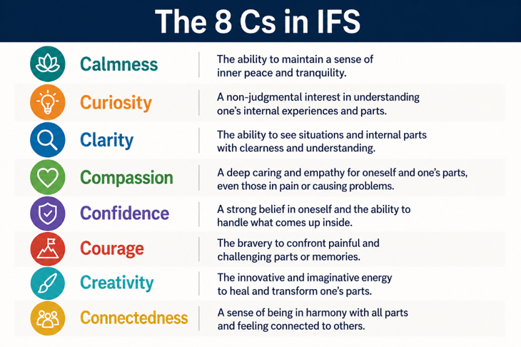
Richard Schwartz refers to this deeper center as the Self.
The Self is not another part competing for attention or control. It is not a manager striving for perfection, a firefighter seeking escape, or a critic pointing out flaws. Rather, the Self represents the calm, grounded center of our being from which healing naturally emerges. It is the place within us that remains capable of compassion even when we are hurting, curiosity even when we are afraid, and courage even when life feels uncertain.
According to Schwartz, when individuals are operating from the Self, they tend to demonstrate a consistent set of qualities. These include calm, curiosity, compassion, clarity, confidence, courage, creativity, connectedness, and coherence. Often referred to as the Eight C's, these qualities are not something we force or manufacture. They emerge naturally when fear begins to loosen its grip and protective parts no longer feel compelled to carry impossible burdens.

One of the reasons I have found this concept so compelling is that it resonates with what I have observed repeatedly throughout my clinical work. Beneath the anxiety, depression, addiction, trauma, anger, perfectionism, and shame that people bring into the office, there often remains something remarkably intact. Wounded, certainly. Buried beneath layers of protection, perhaps. Yet not destroyed.
Trauma can wound us, but it does not define us.
Shame can distort our self-understanding, but it does not determine our ultimate identity. Protective parts may dominate the system for a season, but they are not the deepest truth about who we are. Beneath the burdens remains a person capable of love, connection, wisdom, courage, and healing.
This perspective is especially important when working with shame. Shame constantly attempts to convince us that our struggles define us. It tells us that we are our failures, our addictions, our diagnoses, our weaknesses, or our wounds. It whispers that the most painful moments of our lives reveal who we truly are. Over time, many people begin to accept this narrative without question.
The Self offers a radically different perspective.
Rather than defining us by our wounds, it reminds us that there is something deeper than the wounds. Rather than defining us by our defenses, it reminds us that there is something deeper than the defenses. Rather than defining us by the lies we have believed, it reminds us that there is a deeper truth waiting to be rediscovered.
From a NeuroFaith® perspective, this is where the conversation becomes particularly meaningful. While Internal Family Systems is not a Christian model, many believers immediately recognize striking parallels between the qualities of Self-leadership and the fruits of the Spirit described in Galatians 5. Love, joy, peace, patience, kindness, goodness, faithfulness, gentleness, and self-control all reflect the kind of life that emerges when fear no longer dominates the system and when love becomes the organizing principle. Although the language differs, both perspectives point toward a life characterized by greater freedom, wisdom, compassion, courage, and connection.
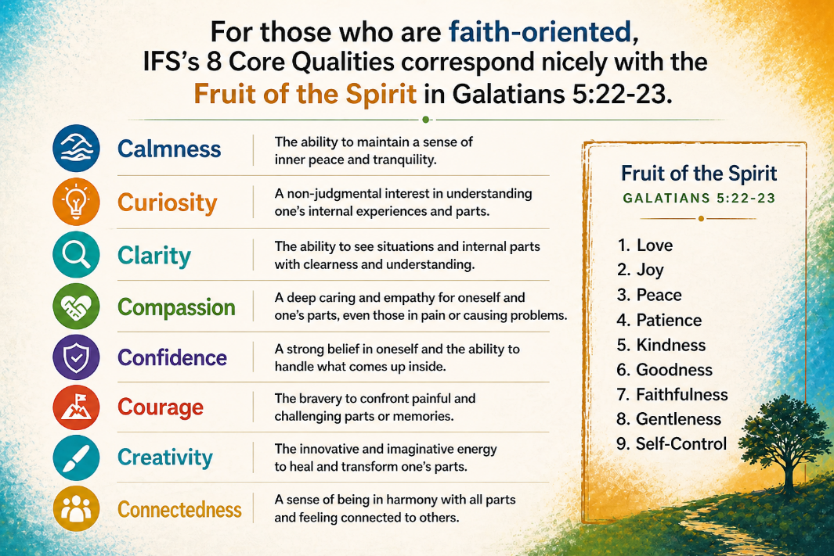
For Christians, however, our deepest identity extends even beyond the concept of Self. Scripture reminds us that we are created in the image of God, loved by God, known by God, and redeemed through Christ. Trauma may obscure that truth. Shame may challenge it. Pain may cause us to doubt it. Yet none of these experiences can erase it. The image of God may become difficult to see beneath the layers of hurt and self-protection, but it is never fully lost.
This understanding allows us to approach healing with both humility and hope. We do not have to hate our wounded parts, nor do we need to wage war against the protective strategies that helped us survive difficult seasons of life. Instead, we can begin approaching these parts with compassion, curiosity, and respect. As we do, we often discover that even the behaviors we dislike most about ourselves were originally attempts at protection. The perfectionist was trying to prevent failure. The people pleaser was trying to avoid rejection. The avoider was trying to protect us from pain. Even the critic, however harsh its methods, was often attempting to shield us from disappointment, humiliation, or abandonment.
As healing unfolds, these parts gradually discover that they no longer need to carry such heavy burdens. Exiles begin to experience what they have long needed: to be seen, understood, and cared for rather than hidden away in isolation. Managers learn that relentless striving and constant vigilance are not the only paths to safety. Firefighters no longer have to extinguish every painful emotion the moment it appears. Even the critic can soften, relinquishing its role as prosecutor and becoming a healthier source of feedback and accountability. The result is not the elimination of these parts, but a healthier relationship with them, one characterized by greater balance, trust, and internal harmony.
This process mirrors much of what we have discussed throughout this book. As the nervous system becomes more regulated, the heart becomes more coherent. As the heart becomes more coherent, the mind becomes more capable of reflection, discernment, and truth. As truth begins replacing the lies of shame, the soul finds greater freedom to rest in its God-given identity. Healing is not occurring in one dimension alone. Body, heart, mind, and soul are all moving toward greater integration and wholeness.
Perhaps this is one of the most hopeful insights offered by both psychology and faith. The deepest work of healing is not about becoming someone entirely different. It is not about constructing a new identity or manufacturing a better version of ourselves. Rather, it is about removing the burdens, distortions, and false narratives that have obscured who we have been all along. Beneath the wounds, beneath the shame, and beneath the protective strategies that once seemed necessary, there remains a person created in the image of God, worthy of love, capable of connection, and designed for relationship with Him and with others. In many ways, restoration is less about becoming someone new than it is about recovering someone familiar. It is the gradual rediscovery of the person God created us to be before trauma distorted the story and before shame convinced us otherwise.
This is the essence of restoration. Not becoming someone else but remembering who you were created to be.
A Personal Reflection
As I learned about Internal Family Systems, I found myself recognizing many of these dynamics within my own life.
Looking back, I can see that one of the deepest burdens I carried as a child was the belief that I was not safe. My father was a wounded man who struggled with significant anger and rage. To be clear, I do not believe he intended to harm me. Like many parents, he was carrying burdens of his own and did the best he could with what he had. Yet as a child, I internalized a message that the world was unpredictable and that safety could disappear without warning.
In response, my system adapted.
One of the ways it adapted was through a powerful manager. Achievement, performance, competence, and responsibility became ways of managing the underlying fear. If I performed well enough, prepared well enough, worked hard enough, and accomplished enough, perhaps I could stay ahead of the pain. In many ways, this manager served me remarkably well. It helped me succeed academically. It helped me serve in the military. It helped me build a career, care for patients, and navigate responsibilities that spanned decades.
For a long time, the manager was strong enough to keep the deeper wounds out of awareness.
But eventually life became too heavy.
As stress accumulated and multiple pressures converged, the burden I had spent years outrunning began catching up with me. When that happened, firefighters emerged. Alcohol became increasingly attractive because it offered temporary relief from the pain. Even more unsettling were occasional intrusive thoughts about simply escaping the suffering altogether. I did not want to die, but there were moments when the idea of making the pain stop became uncomfortably appealing. Looking back through the lens of IFS, I can see that these firefighters were not trying to destroy me. They were attempting to protect me from emotional pain that felt overwhelming.
What ultimately helped was not learning to hate these parts of myself. It was learning to understand them.
Through therapy, reflection, faith, and a great deal of hard work, I began exploring the deeper wounds beneath the defenses. I learned to approach those wounded places with greater compassion and honesty. I began challenging the false narratives that had organized so much of my life. Most importantly, I began reconnecting with the truth of who God says I am rather than who trauma and shame had convinced me I was.
The healing did not come from simply eliminating symptoms. It came from understanding the pain, processing the wounds, and gradually replacing old lies with truth. As that occurred, the managers no longer needed to work so hard. The firefighters no longer needed to provide escape. And I found myself moving closer to the person God had created me to be all along.
For me, this is where Internal Family Systems became far more than a theory. It became a language for understanding how pain, protection, healing, and grace had been interacting throughout my life for decades.
Repairing the Negative Narrative

Throughout this book, we have explored the profound ways trauma and shame affect the human experience. We have examined how trauma becomes embedded within the nervous system, influencing the body, the heart, the mind, and the soul. We have discussed the importance of learning to recognize, respect, and regulate our autonomic state, understanding that healing often begins with creating greater safety, coherence, and connection within the system.
As we have seen, a regulated nervous system creates the conditions for deeper healing. When survival no longer consumes all of our attention, we become increasingly capable of reflection, curiosity, and self-awareness. We are better able to observe our thoughts, emotions, reactions, and patterns rather than simply being controlled by them.
In the previous section, we explored Internal Family Systems and the protective parts that often emerge in response to trauma and shame. We examined how exiles carry painful wounds, how managers work to prevent those wounds from being activated, how firefighters seek relief when painful emotions break through, and how the inner critic attempts to protect us through judgment, vigilance, and self-correction. These parts developed for reasons. Each emerged in an effort to help us survive difficult experiences.
Yet as we began to explore, these protective parts are often organized around something deeper than the wounds themselves. More often than not, they are organized around the conclusions we drew from those wounds. They are protecting stories. They are protecting beliefs. They are protecting narratives about who we are, what we are worth, whether we are lovable, whether we belong, and whether we are safe.
This brings us to the next stage of healing.
In many ways, trauma and shame do not merely leave us wounded. They leave us believing things about ourselves that are no longer true. The wounds may have been real. The losses may have been real. The rejection may have been real. Yet the conclusions we drew about ourselves in response to those experiences are not always accurate.
In this section, we will look more deeply at the narratives trauma and shame often create. We will examine how those stories become embedded within our sense of identity, how they continue influencing our lives long after the original wounds occurred, and most importantly, how they can be challenged, revised, and ultimately replaced with truth.
The goal is not simply to understand the lie.
The goal is to recover the truth.
S can feel so permanent. It is not simply an emotion that appears from time to time. As previously noted, it becomes embedded within the brain's ongoing understanding of who we are. As Thompson (2023) describes, the Default Mode Network plays a central role in self-reflection, autobiographical memory, and identity formation. In many ways, it serves as the brain's narrative center, continually helping us answer questions such as: Who am I? Do I matter? Am I lovable? Do I belong? When shame becomes integrated into this system, experiences are filtered through assumptions of inadequacy, defectiveness, rejection, or insecurity. The narrative continually reinforces itself.
The tragic consequence is that even positive experiences often fail to penetrate the story. Love feels temporary. Acceptance feels fragile. Compliments feel suspicious. Success provides only brief relief before the familiar sense of inadequacy returns. Many individuals spend years attempting to change their behaviors while leaving the underlying narrative untouched.
This is one reason addiction can be so persistent. As Fletcher (2023) observes, recovery cannot stop with behavioral change alone. A person may achieve sobriety while continuing to believe they are worthless. They may stop acting out while remaining convinced they are defective. They may improve their relationships while still carrying profound shame. Until the underlying identity narrative is addressed, the deeper wound remains largely intact.
Healing therefore requires something more than symptom reduction. It requires something more than insight. It requires something more than behavior modification.
It requires the transformation of the story our mind tells about who we are.
Psychiatrist Curt Thompson brings an important relational and spiritual dimension to this discussion. In The Soul of Shame, Thompson and Seybert (2018) argue that shame is fundamentally a disruption of connection. Human beings are created for relationship. Our brains develop within relationships and are shaped by experiences of being seen, known, valued, and loved. When those experiences are absent, inconsistent, or distorted, the mind adapts by preparing for rejection. Shame teaches us that being fully seen is dangerous. The very thing we long for most—connection—becomes the thing we fear most.
Yet the same relational processes that contribute to injury can also contribute to healing. When we are seen, heard, understood, and accepted without condemnation, new possibilities emerge. New neural pathways begin to form. New interpretations become possible. The old narrative gradually begins to loosen its grip. Thompson's work reminds us that healing is not merely psychological. It is profoundly relational.
Recent advances in neuroscience provide further reason for hope. Bruce Ecker and his colleagues have described a process known as memory reconsolidation, which helps explain how long-standing emotional learnings can be transformed rather than merely managed (Ecker et al., 2012). For many years it was assumed that deeply ingrained emotional beliefs could only be compensated for or gradually weakened. Ecker's work suggests something far more encouraging. Under the right conditions, emotional learnings can become reactivated, opened to revision, and updated with new information.
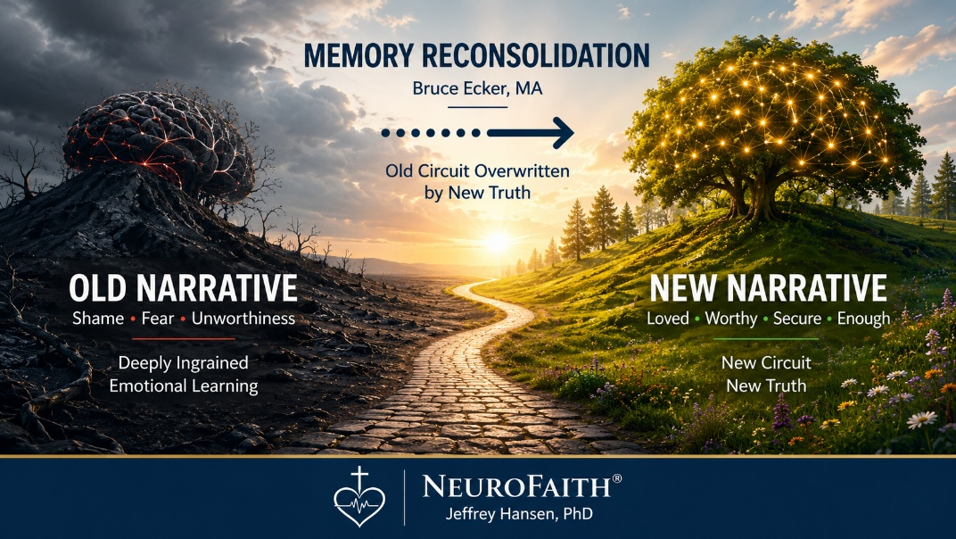
This has profound implications for trauma and shame. A person may have carried the belief, "I am unlovable," for thirty years. Another may have spent decades believing, "I am not enough," or "I am not safe." These beliefs become deeply embedded because they are reinforced by memory, emotion, relationships, and repeated experience. Over time they become part of the narrative architecture of the self. They no longer feel like beliefs. They feel like facts.
Yet when those beliefs are consciously brought into awareness, carefully examined, and exposed to contradictory experiences, the possibility of change emerges. The individual begins comparing the old story against new evidence. They examine it in the context of healthier relationships, corrective emotional experiences, increased self-awareness, and a more mature understanding of what actually happened. Rather than automatically accepting the narrative as truth, they begin evaluating it.
The conditions under which this process occurs are critically important. When the nervous system remains highly activated, fearful, or defensive, the brain's capacity for reflection and integration is significantly reduced. Survival takes priority over learning. Protection takes priority over growth. However, when the autonomic nervous system becomes more regulated, the heart becomes more coherent, and the individual experiences greater emotional safety, the mind becomes increasingly capable of considering new possibilities. This is one reason the NeuroFaith® model places such emphasis on regulation, coherence, connection, and safety. These are not merely symptom-management tools. They help create the conditions under which deeper transformation can occur.
Positive emotional experiences appear to play an important role as well. States such as gratitude, appreciation, compassion, love, connection, and hope help move the system away from protection and toward openness. When the body is settled, the heart is engaged, and the mind is receptive, individuals become better able to receive truths that previously felt inaccessible. They are no longer reacting exclusively from old wounds. They are able to evaluate the evidence with greater clarity.
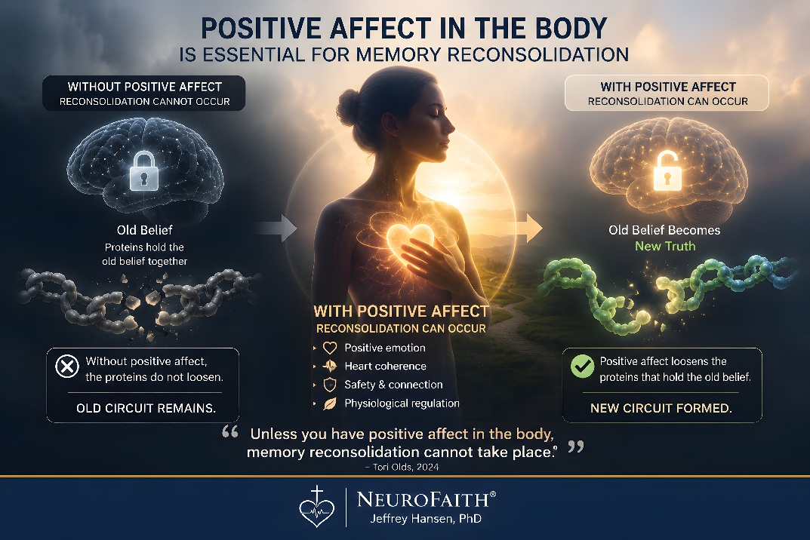
To underscore, the key is that the new truth is not enough by itself.
If all we do is introduce a new thought, a new belief, or even a new Scripture verse while the person's nervous system remains dysregulated, the old emotional learning remains intact. The new belief simply competes with the old belief. One circuit says, "I am loved." The other says, "No you're not." One says, "I am safe." The other says, "Danger is everywhere." The person oscillates between the two.
What Ecker's work suggests is that transformational change occurs when the old emotional learning is not merely challenged but rendered open to revision through reconsolidation (Ecker et al., 2012). Tori Olds (2024) does a beautiful job explaining this process. She describes how deeply embedded emotional learnings are maintained not simply by thoughts but by emotionally encoded expectations. If those emotional learnings are activated while the individual remains trapped in the same physiological and emotional state that originally encoded them, the old learning tends to remain intact. The brain simply rehearses the same pattern again.
This is where the body becomes critically important.
As we have discussed throughout this book, the body is not merely reacting to the brain. The body is constantly informing the brain. Through the autonomic nervous system, vagal pathways, hormonal signaling, and heart-brain communication, the body continually provides information regarding safety, danger, connection, and emotional state. When the body remains defensive, fearful, constricted, or dysregulated, the brain receives ongoing signals that reinforce protection. Under those conditions, openness to new learning is limited.
However, when the nervous system becomes more regulated, the heart becomes more coherent, and the individual experiences positive affect characterized by feelings such as gratitude, compassion, appreciation, connection, hope, or love, something different becomes possible. The system shifts from protection toward receptivity. The individual is no longer consumed by survival. The mind becomes more flexible. The emotional learning becomes more accessible. The old narrative can be examined rather than automatically believed.
From a NeuroFaith® perspective, this is one reason the body-based interventions discussed throughout this book are so important. Regulation is not simply about feeling better. Heart coherence is not simply about relaxation. These practices help create the physiological conditions under which deeper transformation can occur. They help prepare the nervous system to receive new information and integrate it into existing emotional networks.
Ecker and colleagues suggest that when an old emotional learning is activated and then paired with a contradictory experience that feels emotionally real, the neural encoding supporting that learning can become destabilized and available for revision (Ecker et al., 2012). Olds (2024) emphasizes that this process is not merely intellectual. The individual must experience the contradiction emotionally, not simply understand it cognitively. This is why positive affect matters so much. When the body experiences safety, connection, coherence, and openness, the emotional conditions necessary for reconsolidation become more available.
In practical terms, a person may intellectually know that they are loved while emotionally remaining convinced they are unlovable. If the new truth is introduced without a corresponding shift in physiological and emotional state, the old learning often remains dominant. The individual may briefly believe the new narrative only to find themselves returning to the old story when stress increases. The two narratives compete with one another, and the older, emotionally encoded learning frequently wins.
However, when the old narrative is activated within a context of safety, connection, positive affect, and relational support, the brain gains an opportunity to update the emotional learning itself. The person is no longer simply saying, "I am loved." They are experiencing love. They are no longer merely reciting, "I am safe." They are experiencing safety. They are no longer simply reading, "I praise you because I am fearfully and wonderfully made" (Psalm 139:14, NIV). They are beginning to experience that truth as emotionally believable.
This may help explain why Scripture repeatedly emphasizes not only truth but also love, peace, gratitude, joy, connection, and communion with God. These are not merely pleasant emotional states. They help create the conditions under which truth can move from intellectual knowledge into lived experience. The body settles. The heart opens. The mind becomes receptive. The old narrative loosens its grip. What once felt unquestionably true becomes open to examination. A new narrative begins to emerge.
In many ways, this is where the NeuroFaith® model, interpersonal neurobiology, memory reconsolidation, and Christian spiritual formation converge. Regulation prepares the system. Positive affect opens the system. Truth enters the system. Repeated experiences reinforce the truth. Gradually, the old narrative loses authority and a new narrative becomes increasingly believable.
From a Christian perspective, this creates a remarkable opportunity. As old narratives are brought into awareness, they can be examined not only through the lens of experience and relationship but also through the lens of Scripture. The question becomes more than whether a belief feels true. The question becomes whether it actually is true.
A person who believes they are worthless encounters the truth that they are created in the image of God. "So God created mankind in his own image, in the image of God he created them" (Genesis 1:27, NIV).
A person who believes they are abandoned encounters God's promise: "Never will I leave you; never will I forsake you" (Hebrews 13:5, NIV).
A person who believes they are defective encounters the declaration: "I praise you because I am fearfully and wonderfully made" (Psalm 139:14, NIV).
A person who believes they have no purpose encounters the reminder: "For we are God's workmanship, created in Christ Jesus to do good works" (Ephesians 2:10, NIV).
A person who believes they are beyond redemption encounters the truth that "if anyone is in Christ, the new creation has come" (2 Corinthians 5:17, NIV).
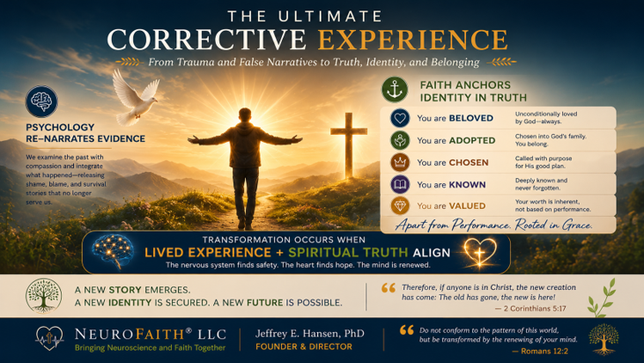
Importantly, these truths become transformative not merely because they are memorized but because they are experienced. As Scripture is encountered within the context of a regulated nervous system, positive emotional experience, healthy relationships, prayer, reflection, and corrective emotional experiences, the old narrative begins losing credibility. The new narrative gains strength. Gradually, the brain updates its understanding of reality.
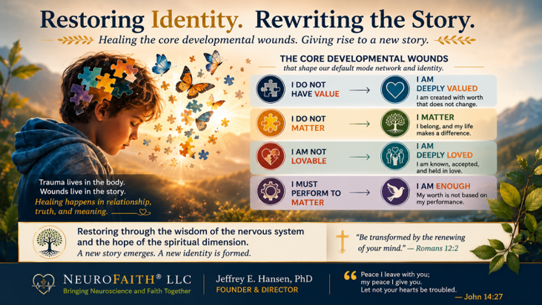
In many ways, this is what the Apostle Paul was describing when he wrote, "Do not conform to the pattern of this world, but be transformed by the renewing of your mind" (Romans 12:2, NIV). The renewing of the mind is not simply the acquisition of information. It is the gradual replacement of distortion with truth. It is the process through which old narratives lose their authority and new narratives become increasingly believable.
This process does not occur overnight. Narratives reinforced over years or decades rarely disappear after a single insight, a single therapy session, or a single prayer. Yet every experience of grace weakens shame's authority. Every experience of acceptance challenges rejection. Every experience of connection undermines isolation. Every experience of truth pushes back against distortion. Gradually, the old narrative loosens its grip, and a more accurate understanding of reality begins to emerge.
This is the heart of restoration.
We are not denying the past. We are not minimizing the wound. We are not pretending trauma never occurred. Rather, we are learning to separate the event from the interpretation, the wound from the identity, and the trauma from the conclusions shame attached to it. We are replacing distortion with truth. We are allowing a more accurate story to emerge.
The goal is not simply to understand the lie.
The goal is to recover the truth.

The Space in My Heart Where Gregg Once Lived


A Promise Kept
Earlier in these pages, I promised that before our journey together was over, I would return to the story of my identical twin brother, Gregg—and, to some extent, to my own.
I have now come to that place.
This was not an easy chapter to write. Some stories resist being put into words because the feelings they carry run deeper than language can easily reach. But this story needed to be told—not only because Gregg was my brother, my identical twin, my best friend, my closest confidant, and my forever encourager, but because our lives reveal something about the wounds we carry, the ways we learn to survive, and the very different paths those wounds can lead us down.
And so, dear reader, as promised, I return to my brother—and, to some extent, to me.
A Note from My Heart
This essay began as a chapter I was writing for my book, The Shadow of Shame. In the opening pages of that book, I made a promise that before our journey was over, I would return to the story of my identical twin brother, Gregg—and, to some extent, to my own.
But as I began to write this chapter, it rang so loudly in my heart that I knew I wanted to share it separately as well.
This is a deeply personal story about two identical twin brothers who carried many of the same wounds, learned many of the same ways of surviving, and yet ultimately traveled very different paths. It is also a story of toxic shame, achievement, tragedy, neuroscience, faith, and redemption.
I share it not so that you will feel sorry for either of us, but because perhaps something in our story may speak to something in yours.
And so, dear reader, as promised, I return to my brother—and, to some extent, to me.
The Wounds We Shared
Gregg and I both suffered from toxic shame as a result of our father's emotional and physical mistreatment. We learned the same core wounds: We were not safe. We were not good enough.
And so we adapted.
Our manager systems went into hyperdrive. We developed rigid, fixed, and unrelenting routines built around performance and achievement. We became overachievers, not simply because we were bright or ambitious, but because achievement became a way to feel safe. It became a way to be seen, a way to earn approval, perhaps even a way to convince ourselves, for a little while, that we were good enough after all.
For both of us, this really took hold in the fourth grade, when our family moved from the small coastal town of Point Reyes, California, back to Fort Collins, Colorado, where our father was pursuing a second doctorate, this time in pathology. The schools in Colorado were far more academically advanced than what we had experienced before, and suddenly our insecurities were exposed. We responded the way we had learned to respond: We worked harder. We achieved more. We demanded more of ourselves.
But the achievement came with tremendous emotional turmoil.
When Achievement Became Survival
By junior high, the compulsivity had intensified. We had to get straight A's. And we did. Nothing but straight A's. Not one B on a report card.
But perfection is a cruel master.
Even when the report card showed all A's, a single assignment that fell short of perfection could set us off into a state of intense anxiety. Our worth had become tied to achievement because achievement was how we were recognized by our father and by others. We had learned, deeply and dangerously, that what we accomplished determined whether we were worthy of being seen.
This continued into high school, where both of us achieved at very high levels. But somewhere along the way, a slight divergence began.
Where Our Paths Began to Diverge
Gregg was always the more naturally gifted of the two of us academically. He received the highest scholastic awards, particularly in mathematics, and he was an exceptional gymnast. He was named Athlete of the Year for our entire district, an extraordinary honor recognizing him not merely among gymnasts but among athletes across all sports.
I was, perhaps, second fiddle to Gregg in some of those areas, though I achieved considerably in my own right. But somewhere along the way, I began choosing relationship a little more often than achievement.
And I now believe that decision was the beginning of what saved me.
Gregg continued to soar. The United States Air Force Academy wanted him so badly that they flew him out for recruitment even without a congressional nomination, drawn not only by his extraordinary academic prowess but also by his excellence in gymnastics. He was exceptional in both worlds: a gifted scholar and a gifted athlete.
Later, he entered medical school. But by then, depression had begun nipping at his heels, and eventually he withdrew.
Still, he kept going. He trained as a mechanical engineer and later became a highly successful high-end builder in California. When the financial crisis struck, he closed that business and reinvented himself yet again, creating a successful career in forensic accounting.
He kept achieving. He kept performing. He kept moving.
But the wounds underneath had never healed.
The Wounds Beneath the Achievement
As Gregg entered midlife and then his later years, depression came and went, even as he continued to achieve. But the toxic shame remained. And by his mid-to-late sixties, those old wounds had grown louder and more merciless.
Erik Erikson described this stage of life as a confrontation between generativity and stagnation, a time when we begin to look back upon what we have done with the life we were given. But when Gregg looked back, his inner critic allowed him to see almost nothing good.
Despite all he had accomplished, it was never enough. Despite his brilliance, it was never enough. Despite the lives he had touched, the businesses he had built, and the obstacles he had overcome, it was never enough.
Because shame does not grade on accomplishment.
The inner critic that had driven him for so many years eventually turned mercilessly against him. Gregg fell into a deep well of despair and lost his will to endure. Later, he stopped eating. He became profoundly anhedonic, losing interest in nearly everything that had once given life meaning or pleasure. He became anorexic. And eventually, my identical twin brother died alone on the other side of the country.
I have had to live with that.
And I always will.
The Space in My Heart Where Gregg Once Lived
But those words hardly begin to capture the agony of what it means to live without Gregg.
He was not simply my brother. He was my identical twin, my best friend, my closest confidant, and my forever encourager. For 68 years, there was a person on this earth who had been there from the very beginning. Before either of us could speak, before memory itself, there was Gregg and there was me. We began this life together.
And then, suddenly, there was only me.
I miss the conversations that never really ended. Gregg and I could begin talking one day, leave a thought unfinished, and pick it up the next as if no time had passed. There were stories that needed no explanation, memories that belonged only to us, jokes that no one else could fully understand and that somehow became funnier simply because the other one was laughing.
Now those conversations remain unfinished.
The jokes we shared are still inside me, but there is no Gregg on the other end to laugh with me. There are memories I still carry, but the only other person who stood inside those memories with me is gone.
And that is one of the loneliest parts of grief that I know.
So much of my life that only Gregg had access to is now mine alone to hold. There were parts of me he knew simply because he had been there. I did not have to explain the childhood. I did not have to explain our father. I did not have to explain Point Reyes or Fort Collins, the straight A's, the fear of not being good enough, the striving, the laughter, the dreams, or all the countless ordinary moments that somehow become sacred only after the person who shared them with you is gone.
He knew.
And now I am the only one left to remember so much of it.
There are still times when something happens and my first instinct is to tell Gregg. A thought crosses my mind, something makes me laugh, something hurts, something wonderful happens, and somewhere inside me there remains that almost automatic movement toward my brother.
And then I remember. He is not there. There is now an empty space in my heart where Gregg once lived, a space no one else can ever occupy.
There is an agony in that which I do not know how to fully put into words. I am a psychologist. I have spent a lifetime studying human suffering, grief, trauma, resilience, and the mysterious ways in which we heal. But there are some losses that cannot be reduced to clinical language. There are some absences that cannot be resolved, only carried.
I carry Gregg. I carry his voice. His laughter. His encouragement. His brilliance. His wounds. His unfinished conversations. I carry the jokes that now have only one person left to remember why they were so funny.
And perhaps most painfully, I carry the part of myself that existed only when I was with him. I will forever mourn my brother. I will forever hear him in my heart. And my heart will always cry for him. But I would rather carry the pain of having loved Gregg than live a life in which I had never known what it was to have him as my brother, my identical twin, my best friend, my closest confidant, and my forever encourager.
He was here.
He mattered.
He was loved.
And he is missed beyond anything these words can ever fully say.
And Then There Was Me
But if I am going to tell you the truth about Gregg, I must also tell you more of the truth about me. My own journey was not simply a story of resilience or an easy turn toward faith. I, too, experienced my own tragedy. Mine came earlier, triggered by so many internal and external events that the resilience I had relied upon for so long was no longer strong enough to carry me. The ways I had learned to survive were failing. My nervous system was overwhelmed.
My values had to be reconsidered because I began to understand that our negative core beliefs are often tightly intertwined with our deepest values, with what we believe gives us worth, identity, and significance.
And I had valued performance. I had valued achievement, external accolades, big houses, beautiful properties, professional recognition, and all the other things I genuinely enjoyed and had worked hard to attain. There was nothing inherently wrong with those things. But somewhere along the way, I had allowed too much of my identity to become attached to them.
Beneath the accomplishments still lived the old core wound:
You are not good enough.
And so, I had to begin again.
Learning to Settle
My first step was not theological or intellectual. It was physiological.
I had to learn how to settle my autonomic nervous system, which had carried so much for so long. For years, I had lived largely in chronic sympathetic and HPA-axis activation, punctuated by occasional periods of dorsal vagal shutdown. I knew surprisingly little, experientially, about what it meant to live from a ventral vagal state of safety, connection, openness, and peace.
I had to learn to settle. I had to learn to listen to my body rather than constantly drive it. I had to understand that the nervous system I had once relied upon to push me toward achievement was also exhausted from years of trying to protect me.
My work with neurobiology helped me understand what was happening inside me, and slowly I began to discover that living was not the same thing as performing.
Life was not meant to be lived from a performative mindset, forever trying to silence a negative core belief by achieving enough to finally become worthy.
Because no achievement can heal the wound that says, I am not enough.
When Neuroscience Met Faith
For me, the deepest healing came when neuroscience and faith began to converge. I came to understand, not merely intellectually but in my heart, that my worth did not come from what I had achieved, what I owned, what degrees followed my name, or how others regarded me.
It came down to something that may sound almost too simple. Jesus loves me. Not because I performed well. Not because I earned it. Not because I achieved enough. Simply because I am His.
I came to understand that I was made for relationship with Jesus. I was made to define myself not by the relentless verdict of my inner critic, but by His love for me. I was adopted into His family. I was loved and valued so profoundly that God sent His Son to die for me.
These were truths I had known intellectually for years. But knowing something in your head is not the same as experiencing it in your heart, your body, and your nervous system.
And slowly, I began to find the peace Scripture had promised: “And the peace of God, which surpasses all understanding, will guard your hearts and your minds in Christ Jesus.” I found that peace. Not perfectly. Not without struggle. Not as a permanent state in which I never again feel anxiety, grief, or pain. But I found it deeply enough to know that it is real.
And why would I not want to share that with others? Why would I not want to share it with you, dear reader?
Because your life can go either way. I do not necessarily mean that you will lose your physical life as my brother did. But shame can steal something else from you. It can steal your joy. It can steal your peace. It can convince you to spend a lifetime performing for a worth that was never meant to be earned in the first place.
It can leave you living a life of defeat, which is precisely where the enemy wants you.
But that is not what God wants for you.
It Is Never Too Late
I know that somewhere along the way, Gregg made a decision to receive Jesus. And I can only trust and pray that this decision mattered eternally. Although he did not find the peace in this life that I so desperately wish he had known, I hold on to the hope that he has found that peace now.
And I look forward to seeing him again.
But there is another part of this story that matters deeply to me. My father, the same father whose own wounds led him to emotionally and physically mistreat his sons, found Christ in the last lap of his life.
And so did my grandfather.
These were two men who had carried wounds of their own and who, for much of their lives, had lived with deep differences between them. But in those final chapters, something beautiful happened. They found Christ, and they beautifully reconciled their differences.
That does not erase what happened. It does not undo the wounds or change the past. Grace does not require us to pretend that harm never occurred. But it reminds me of something I believe with all my heart:
It is never too late.
It is never too late for grace. Never too late for reconciliation. Never too late for a wounded heart to turn toward Christ. God works in His own time, and if we remain open to Him, no life is beyond redemption. No story has to end where it began.
My father and grandfather taught me that.
The father who once caused such pain was himself a wounded man. And his story, too, was still being written. So was my grandfather's. And in the last lap of their lives, grace entered the story in a way that allowed two wounded men to find Christ and find their way back to one another.
What a Reunion That Will Be
And so, yes, I hold on to the hope that one day, in God's time, I will see Gregg again. And I hope Dad and Grandpa will be there too, waiting at the gates of heaven. What a reunion that will be. No more shame. No more fear. No more wounds passed from one generation to the next. No more inner critics whispering that we were never good enough.
Only grace. Only forgiveness. Only love.
And I do not believe that God caused these tragedies. I do not believe that.
I believe God allows tragedy to occur and natural consequences to unfold. But I also believe that God lets no pain go unused, if we allow Him to redeem it. I do not want my pain to have been in vain. I do not want my loss to have been in vain. Nor do I want Gregg's pain, his life, or his loss to go untold.
I share our story not so that you will feel sorry for either one of us. I share it in the hope that perhaps it may touch your heart, help you make a choice a little differently, or invite you to lean more deeply into what I have written from my heart to yours in the pages of this book.
From My Heart to Yours
My prayer is that these pages will somehow write their love upon your soul. That they will point you toward healing of the body, healing of the mind, healing of the heart, and healing of the soul. And ultimately, that they will turn your heart toward Christ.
That is my prayer for you, dear brother or sister who has walked with me through these pages.
And perhaps, in that way, neither Gregg's pain nor mine will have been in vain.

Conclusion
The Light Beyond the Shadow


A
s we come to the end of this journey together, I find myself returning to a simple observation. Shame is far more powerful than most people realize, yet it is also far more vulnerable than it first appears. Throughout this book, we have explored how shame affects virtually every dimension of human experience. We have examined its origins, its relationship to trauma, its impact on attachment and relationships, and its influence on the stories we tell ourselves about who we are. We have explored the ways shame becomes embedded within the nervous system, influences the heart and the brain, and quietly shapes our expectations, perceptions, and behaviors. What begins as a painful experience often becomes a painful conclusion, and what begins as a conclusion can eventually become an identity.
For many people, this process unfolds so gradually that they never recognize it happening. The story becomes familiar. The narrative becomes automatic. The assumptions become unquestioned. Over time, shame ceases to feel like an interpretation and begins to feel like reality. The person no longer says, "I feel inadequate." Instead, they conclude, "I am inadequate." They no longer say, "I experienced rejection." They conclude, "I am unlovable." The distinction may appear subtle, but it is profound. One describes an experience. The other describes an identity.
Yet one of the most encouraging discoveries from both neuroscience and faith is that our deepest wounds do not have the authority to define us. Throughout this book, we have seen how the nervous system can learn patterns of protection and survival that persist long after the original danger has passed. We have explored how emotional learnings become embedded within the brain and how narratives become reinforced through repetition, memory, and experience. At the same time, we have also seen that the human brain remains remarkably capable of change. New experiences can create new pathways. Old emotional learnings can be revised. The nervous system can learn safety. The heart can learn coherence. Relationships can heal. Hope can return.
What I find particularly fascinating is that the more we learn about the brain, the nervous system, attachment, memory reconsolidation, and interpersonal neurobiology, the more we discover evidence of an extraordinary design. The body continually moves toward balance. The nervous system responds to safety and connection. The heart influences the brain in ways we are only beginning to understand. Positive emotional states help create conditions for learning and growth. Human beings heal most effectively within the context of healthy relationships. None of this appears accidental. Rather, it reflects a remarkable integration within the human system that points toward intentional design and purpose.
As a psychologist, I find these discoveries fascinating. As a Christian, I find them deeply reassuring. Again and again, modern science seems to uncover mechanisms that align with principles Scripture has described for centuries. Long before researchers spoke of neuroplasticity, the Apostle Paul wrote about the renewing of the mind. Long before attachment theory emerged, Scripture described the healing power of love, belonging, and relationship. Long before we understood the physiological consequences of fear and isolation, the Bible spoke of peace, connection, gratitude, and trust. The deeper we explore the science, the more we encounter evidence of a God whose design is both elegant and profoundly restorative.
Perhaps nowhere is this more evident than in the life of Christ Himself. Again and again throughout the Gospels, Jesus moved toward people who were carrying shame. He moved toward the outcast, the wounded, the rejected, the broken, and the fearful. He did not define people by their failures. He did not reduce them to their wounds. He consistently saw something deeper than the labels they carried and the stories they believed about themselves. In many ways, the ministry of Christ was a ministry of restoration. He restored dignity where shame had created humiliation. He restored connection where isolation had created loneliness. He restored hope where suffering had created despair.
This is important because healing ultimately involves more than understanding trauma. It involves more than understanding the nervous system. It involves more than learning psychological skills. Those things matter, and I believe they are valuable gifts. Yet healing also involves recovering a truer understanding of who we are. It involves separating the wounds we have experienced from the identity we have assumed. It involves recognizing that trauma may explain many things about our lives without possessing the authority to define them.
Over the years, I have sat with countless individuals who believed they were beyond healing. Many arrived convinced that their shame represented the most accurate thing about them. They believed they were too damaged, too broken, too wounded, or too far gone. Yet time after time, I witnessed something remarkable. When people experienced safety, connection, grace, truth, and courage, change became possible. The process was rarely instantaneous. More often it unfolded gradually, one conversation at a time, one insight at a time, one act of courage at a time. Yet the old narrative slowly began to loosen its grip. The story that had organized their suffering for years no longer seemed quite as convincing. A different story began to emerge.
That, ultimately, has been the purpose of this book. Not simply to understand shame, but to expose it. Not simply to examine trauma, but to heal from it. Not simply to identify the lies we have believed, but to recover the truth that shame has attempted to steal from us. The journey toward healing is rarely linear, and it is seldom easy. Yet it remains one of the most worthwhile journeys a person can undertake because it leads us back toward who we were created to be.
As I close, my prayer for you is not that you remember every concept discussed in these pages. I do not expect you to recall every study, every theory, every diagram, or every scientific explanation. My hope is much simpler. I hope you leave these pages with a deeper understanding of yourself, a greater compassion for your wounds, and a renewed confidence that healing is possible. Most of all, I hope you leave with a clearer understanding of the God who sees you, knows you, loves you, and calls you by name.
The psalmist reminds us, "He heals the brokenhearted and binds up their wounds" (Psalm 147:3, NIV). That promise remains as true today as it was when it was first written. The God who created the nervous system understands it. The God who created the heart understands it. The God who created the mind understands it. And the God who created you understands you.
Shame may have shaped part of your story, but it does not get to write the ending. That privilege belongs to the Author of life Himself. Through Christ, the possibility of restoration remains alive. Through Christ, healing remains possible. Through Christ, the wounded can become whole, the fearful can find peace, and the ashamed can step into the light.
The shadow is real.
But the light is greater.

References


Ainsworth, M. D. S. (1973). The development of infant-mother attachment. In B. Cardwell & H. Ricciuti (Eds.), Review of child development research (pp. 1–94). University of Chicago Press.
Ainsworth, M. D., Belhar, M. C., Waters, E., & Wall, S. (1978). Patterns of attachment: A psychological study of the strange situation. Lawrence Erlbaum Associates.
Alcoholics Anonymous World Services. (2001). Alcoholics Anonymous: The story of how many thousands of men and women have recovered from alcoholism (4th ed.). Alcoholics Anonymous World Services, Inc.
American Psychological Association. (2024). Stress in America™ 2024: Stress and anxiety continue to rise. https://www.apa.org/news/press/releases/stress/2024/reportfa
American Society of Addiction Medicine. (2011). Definition of addiction. https://www.asam.org/definition_of_addiction_long_4-11.pdf (accessed October 9, 2024).
Anderson, F. (2021). Transcending trauma: Healing complex PTSD with internal family systems. PESI Publishing.
Andreassen, C., & Fletcher, P. (2007). Early childhood longitudinal study, birth cohort (ECLS–B) psychometric report for the 2-year data collection (NCES 2007–084). National Center for Education Statistics, Institute of Education Sciences, U.S. Department of Education.
Aspen Institute. (2019). Lisa Miller presentation. https://www.youtube.com/watch?v=BzAVgMdCrjM (accessed July 11, 2025).
Ballantyne, J. C., & LaForge, K. S. (2007). Opioid dependence and addiction during opioid treatment of chronic pain. Pain, 129(3), 235–255. https://doi.org/10.1016/j.pain.2007.03.028 (accessed October 13, 2024).
Bandura, A. (1977). Social learning theory. Englewood Cliffs, NJ: Prentice Hall.
Barta, M. (2018). TINSA: Trauma induced sexual addiction. CreateSpace Independent Publishing Platform.
Bechtold, J., Simpson, T., White, H. R., & Pardini, D. (2015). Chronic adolescent marijuana use as a risk factor for physical and mental health problems in young adult men. Psychology of Addictive Behaviors, 29(3), 552–563. https://doi.org/10.1037/adb0000103 (accessed October 18, 2024).
Berman, M. G., Jonides, J., & Kaplan, S. (2012). Interacting with nature improves cognition and affect for individuals with depression. Journal of Affective Disorders, 140(3), 300–305.
Betkowski, B. (2007, February 23). 1 in 3 boys heavy porn users, study shows. Eurekalert.org. http://www.eurekalert.org/pub_releases/2007-02/uoa-oit022307.php (accessed June 7, 2018).
Blumenthal, J. A., Babyak, M. A., Doraiswamy, P. M., Watkins, L., Hoffman, B. M., Barbour, K. A., … & Sherwood, A. (2007). Exercise and pharmacotherapy in the treatment of major depressive disorder. Psychosomatic Medicine, 69(7), 587–596.
Bowlby, J. (1960). Attachment (Vol. 1 of Attachment and loss). Basic Books.
Braden, G. (2015a). Practice this technique to relieve daily stress: Three keys to heart-brain-earth harmony. https://www.youtube.com/watch?v=znOZ-peRiY0 (accessed March 10, 2024).
Braden, G. (2015b). Resilience from the heart. Hay House.
Braden, G. (2020, March 10). The science of heart-brain harmony with Gregg Braden. https://www.youtube.com/watch?v=2nsm8SCWjic (accessed March 10, 2024).
Briere, J., & Rickards, S. (2007). Self-awareness, affect regulation, and relatedness: Differential sequelae of childhood versus adult victimization experiences. Journal of Nervous and Mental Disease, 195(6), 497–503. https://doi.org/10.1097/NMD.0b013e31803044e2
Brownstein, M. J. (1993). A brief history of opiates, opioid peptides, and opioid receptors. Proceedings of the National Academy of Sciences, 90(12), 5391–5393. https://www.ncbi.nlm.nih.gov/pmc/articles/PMC46897/ (accessed October 13, 2024).
Butler, J. (1990). Gender trouble: Feminism and the subversion of identity. Routledge.
Cacioppo, J. T. (2013). The lethality of loneliness. TED Talk. https://www.youtube.com/watch?v=_0hxl03JoA0
Cacioppo, J. T., & Cacioppo, S. (2014). Social relationships and health: The toxic effects of perceived social isolation. Social and Personality Psychology Compass, 8(2), 58–72. https://doi.org/10.1111/spc3.12087 (accessed October 13, 2024).
Cacioppo, J. T., & Patrick, W. (2008). Loneliness: Human nature and the need for social connection. W. W. Norton & Company.
Cacioppo, J. T., Hughes, M. E., Waite, L. J., Hawkley, L. C., & Thisted, R. A. (2010). Loneliness as a specific risk factor for depressive symptoms: Cross-sectional and longitudinal analyses. Psychology and Aging, 25(2), 453–465.
Cacioppo, J. T., Hughes, M. E., Waite, L. J., Hawkley, L. C., & Thisted, R. A. (2014). Perceived social isolation makes me sad: 5-year cross-lagged analyses of loneliness and depressive symptomatology in the Chicago health, aging, and social relations study. Psychology and Aging, 25(2), 453–463. https://doi.org/10.1037/a0017216
Cacioppo, J. T., Sander, T., Nusbaum, H., & Bernston, G. (2006). Day-to-day dynamics of experience-cortisol associations in a population-based sample. Proceedings of the National Academy of Sciences, 103(45), 17058–17063. https://doi.org/10.1073/pnas.0605053103
Centers for Disease Control and Prevention. (2020). Antidepressant use among adults: United States, 2015–2018. https://www.cdc.gov/nchs/products/databriefs/db377.htm (accessed March 7, 2024).
Centers for Disease Control and Prevention. (2021). Youth Risk Behavior Surveillance System (YRBSS).
Centers for Disease Control and Prevention. (2024). QuickStats: Percentage of adults aged ≥18 years who reported being told they had depression, by year — National Health Interview Survey, United States, 2013–2023. Morbidity and Mortality Weekly Report (MMWR), 73(5), 105. https://www.cdc.gov/mmwr/volumes/73/wr/mm7305a6.htm
Centers for Disease Control and Prevention (CDC). (2010). Prescription painkiller overdoses: Use and abuse of methadone as a painkiller. Morbidity and Mortality Weekly Report, 59(30), 951–956.
Centers for Disease Control and Prevention (CDC). (2021). Drug overdose deaths in the U.S. top 100,000 annually. https://www.cdc.gov/nchs/nvss/vsrr/drug-overdose-data.htm (accessed October 13, 2024).
Centers for Disease Control and Prevention (CDC). (2022). Overdose prevention: Stimulant overdose. https://www.cdc.gov/drugoverdose/stimulants (accessed October 13, 2024).
Centers for Disease Control and Prevention (CDC). (2023). Provisional drug overdose death counts. https://www.cdc.gov/nchs/nvss/vsrr/drug-overdose-data.htm (accessed October 13, 2024).
Cigna. (2018). U.S. Loneliness Index: Survey of 20,000 Americans Examining Behaviors Driving Loneliness.
Cohen, S. R., Mount, B. M., Strobel, M. G., & Bui, F. (1995). The McGill quality of life questionnaire: A measure of quality of life appropriate for people with advanced disease. Palliative Medicine, 9(3), 207–219. https://doi.org/10.1177/026921639500900306
Compton, W. M., Conway, K. P., Stinson, F. S., Colliver, J. D., & Grant, B. F. (2006). Prevalence, correlates, and comorbidity of DSM-IV major depressive episode in the United States: Results from the National Epidemiologic Survey on Alcohol and Related Conditions. Journal of Clinical Psychiatry, 67(8), 1067–1074. https://doi.org/10.4088/JCP.v67n0803
Cooney, G. M., Dwan, K., Greig, C. A., Lawlor, D. A., Rimer, J., Waugh, F. R., … & Mead, G. E. (2013). Exercise for depression. Cochrane Database of Systematic Reviews, (9).
Cosgrove, L., & Krimsky, S. (2012). A comparison of DSM-IV and DSM-5 panel members' financial associations with industry: A pernicious problem persists. PLOS Medicine, 9(3), e1001190. https://doi.org/10.1371/journal.pmed.1001190
Dana, D. (2018). The polyvagal theory in therapy: Engaging the rhythm of regulation. W. W. Norton & Company.
Dana, D. (2020). Polyvagal exercises for safety and connection. W. W. Norton & Company.
Davies, J. (2013). Cracked: The unhappy truth about psychiatry. Icon Books.
Davies, J. (2013). The making of DSM-III: A diagnostic manual's conquest of American psychiatry. Oxford University Press.
Davies, J. (2016). Dr. James Davies: The origins of the DSM. https://www.youtube.com/watch?v=6JPgpasgueQ (accessed March 6, 2024).
Davies, J. (2019). Sedated: How modern capitalism created our mental health crisis. Atlantic Books.
Delahooke, M. (2019). Beyond behaviors: Using brain science and compassion to understand and solve children’s behavioral challenges. PESI Publishing.
Di Forti, M., Quattrone, D., Freeman, T. P., Tripoli, G., Gayer-Anderson, C., Quigley, H., … & Murray, R. M. (2019). The contribution of cannabis use to variation in the incidence of psychotic disorder across Europe (EU-GEI): A multicentre case-control study. The Lancet Psychiatry, 6(5), 427–436. https://doi.org/10.1016/S2215-0366(19)30048-3 (accessed October 18, 2024).
Dispenza, J., & Braden, G. (2019). Brain and heart gratitude. https://www.youtube.com/watch?v=znOZ-peRiY0 (accessed June 6, 2020).
Doan, A. (2012). Hooked on games. F.E.P. International.
Donevan, M., & Mattebo, M. (2017). The relationship between frequent pornography consumption, behaviors, and sexual preoccupancy among male adolescents in Sweden. Sexual & Reproductive HealthCare, 12, 82–87.
Duignan, B. (2023). Judith Butler. Encyclopedia Britannica. https://www.britannica.com/biography/Judith-Butler (accessed April 22, 2025).
Duman, R. S., & Monteggia, L. M. (2006). A neurotrophic model for stress-related mood disorders. Biological Psychiatry, 59(12), 1116–1127.
Dunn, E. C., Nishimi, K., Powers, A., & Bradley, B. (2018). Developmental timing of trauma exposure and emotion dysregulation in adulthood: Are there sensitive periods when trauma is most harmful? Journal of Affective Disorders, 227, 869–877. https://doi.org/10.1016/j.jad.2017.10.045
Ecker, B., Ticic, R., & Hulley, L. (2012). Unlocking the Emotional Brain: Eliminating Symptoms at Their Roots Using Memory Reconsolidation. Routledge.
Edinger, K. (2023). The cult of gender ideology: How critical theories captured institutions and confused a generation. Veritas Press.
Em, Dr. (2019a). The Trojan unicorn: Queer theory and paedophilia (Vol. 1). Self-published.
Em, Dr. (2019b). The Trojan unicorn: Queer theory and paedophilia (Vol. 2). Self-published.
Erickson, K. I., Voss, M. W., Prakash, R. S., Basak, C., Szabo, A., Chaddock, L., … & Kramer, A. F. (2011). Exercise training increases size of hippocampus and improves memory. Proceedings of the National Academy of Sciences, 108(7), 3017–3022.
Felitti, V. J., & Anda, R. F. (2009). The hidden epidemic: The impact of early life trauma on health and disease. https://www.theannainstitute.org/LV%20FINAL%202-7-09.pdf (accessed August 3, 2019).
Felitti, V. J., Anda, R. F., Nordenberg, D., Williamson, D. F., Spitz, A. M., Edwards, V. J., Koss, M. P., & Marks, J. S. (1998). Relationship of childhood abuse and household dysfunction to many of the leading causes of death in adults: The adverse childhood experiences (ACE) study. American Journal of Preventive Medicine, 14(4), 245–258. https://doi.org/10.1016/S0749-3797(98)00017-8
Filipowicz, W., Bhattacharyya, S. N., & Sonenberg, N. (2008). Mechanisms of post-transcriptional regulation by microRNAs: Are the answers in sight? Nature Reviews Genetics, 9(2), 102–114. https://doi.org/10.1038/nrg2290 (accessed October 19, 2024).
Fletcher, T. (2025). Complex trauma and identity restoration [Manuscript in preparation]. RE/ACT Recovery Education for Addictions and Complex Trauma.
Fletcher. T. (2025). Healing from Complex Trauma. Tim Fletcher Co. | Understanding and Overcoming Complex Trauma (accessed November 2, 2025).
Fletcher, T. (2022). Tim Fletcher – Trauma and addiction. Bing Videos. (accessed July 11, 2025).
Foubert, J. (2017). How pornography harms: What today’s teens, young adults, parents, and pastors need to know. LifeRich Publishing.
Foucault, M. (1976). The history of sexuality, Volume I: An introduction (R. Hurley, Trans.). Pantheon Books.
Fradd, M. (2017). The porn myth: Exposing the reality behind the fantasy of pornography. Ignatius Press.
Fraga, M. F., Ballestar, E., Paz, M. F., Ropero, S., Setien, F., Ballestar, M. L., … & Esteller, M. (2005). Epigenetic differences arise during the lifetime of monozygotic twins. Proceedings of the National Academy of Sciences, 102(30), 10604–10609. https://doi.org/10.1073/pnas.0500398102
Frances, A. (2013). Essentials of psychiatric diagnosis: Responding to the challenge of DSM-5. Guilford Press.
GBD 2017 Disease and Injury Incidence and Prevalence Collaborators. (2018). Global, regional, and national incidence, prevalence, and years lived with disability for 354 diseases and injuries for 195 countries and territories, 1990–2017: A systematic analysis for the Global Burden of Disease Study 2017. The Lancet, 392(10159), 1789–1858. https://doi.org/10.1016/S0140-6736(18)32279-7
Goldman, H. (2014). Regular exercise changes the brain to improve memory and thinking skills. Harvard Health. https://www.health.harvard.edu/exercise-and-fitness/exercise-can-boost-your-memory-and-thinking-skills (accessed March 14, 2024).
Grisel, J. (2019). Never enough: The neuroscience and experience of addiction. Anchor Books.
Grisel, J. (2022). https://www.youtube.com/watch?v=GtosSWrYAHM (accessed October 16, 2024).
Haidt, J. (2024). The anxious generation: How the great rewiring of childhood is causing an epidemic of mental illness. Penguin Press.
Hall, W., Stjepanović, D., Caulkins, J., Lynskey, M., Leung, J., Campbell, G., & Degenhardt, L. (2019). Public health implications of legalising the production and sale of cannabis for medicinal and recreational use. The Lancet, 394(10208), 1580–1590. https://doi.org/10.1016/S0140-6736(19)31789-1 (accessed October 18, 2024).
Hansen, J. E., & Heverly, E. (2025). NeuroFaith®: A light for the broken. NeuroFaith® LLC.
Hansen, J. E. (2021). The storm within us and the pathway to peace. Center for Connected Living, LLC.
Hansen, J. E., & Doan, A. P. (2023). Digital drugs and the search for connection. Center for Connected Living, LLC.
Hari, J. (2015, June). Everything you think you know about addiction is wrong. TED Talk. https://www.ted.com/talks/johann_hari_everything_you_think_you_know_about_addiction_is_wrong
Hari, J. (2018). Lost connections: Uncovering the real causes of depression—and the unexpected solutions. Berryville Graphics.
Hawkins, D. R. (2014). Letting go: The pathway of surrender. Hay House Inc.
Hawkins, D. R. (2020). The map of consciousness explained: A proven energy scale to actualize your ultimate potential. Hay House Inc.
Hawkins, D. R. (2020). Power vs. Force: The hidden determinants of human behavior (Rev. ed.). Hay House Inc.
Healey, D. (2021). ISSM webinar on post-SSRI sexual dysfunction. https://www.youtube.com/watch?v=yFxMeoaIc3c (accessed March 8, 2024).
Hedegaard, H., Miniño, A. M., Spencer, M. R., & Warner, M. (2021). Drug overdose deaths in the United States, 1999–2020. NCHS Data Brief, 428, 1–8.
Hedegaard, H., Miniño, A. M., Spencer, M. R., & Warner, M. (2022). Drug overdose deaths in the United States, 2001–2021. NCHS Data Brief, 457, 1–8. https://nida.nih.gov/research-topics/trends-statistics/overdose-death-rates
Hedegaard, H., Miniño, A. M., & Warner, M. (2021). Drug overdose deaths in the United States, 1999–2020. National Center for Health Statistics. https://doi.org/10.15620/cdc:112340 (accessed October 13, 2024).
Heijmans, B. T., Tobi, E. W., Putter, H., Blauw, G. J., Susser, E. S., Slagboom, P. E., & Lumey, L. H. (2008). Persistent epigenetic differences associated with prenatal exposure to famine in humans. Proceedings of the National Academy of Sciences, 105(44), 17046–17049. https://doi.org/10.1073/pnas.0806560105
HeartMath® Institute. (2020). About us. https://www.heartmath.org/about-us/ (accessed June 6, 2020).
Heverly, E. (2024). 12 Step with Christian focus. Shared with permission by personal communication.
Horowitz, M., & Taylor, D. (2024). Deprescribing guidelines for psychiatric medications. John Wiley & Sons.
Huberman, A. (2021). The effects of cannabis on the brain and body. https://www.youtube.com/watch?v=UCbqfBAhmPY (accessed October 18, 2024).
Huberman, A. (2022). Understanding dopamine and motivation. https://www.youtube.com/watch?v=DkS1pkKpILY (accessed October 12, 2022).
ISAA Counseling. (2024). Breaking down the 6 Fs of IFS. https://issacounseling.com/breaking-down-the-6-fs-of-ifs (accessed March 2, 2024).
Indiana University Bloomington Libraries. (2023). Queer Theory. https://libraries.indiana.edu/queer-theory
Jefferies, A. L. (2012). Canadian Paediatric Society, Fetus and Newborn Committee. Kangaroo care for the preterm infant and family. Paediatrics & Child Health, 17(3), 141–146. https://www.ncbi.nlm.nih.gov/pmc/articles/PMC3287094/ (accessed June 3, 2020).
Jenuwein, T., & Allis, C. D. (2001). Translating the histone code. Science, 293(5532), 1074–1080. https://doi.org/10.1126/science.1063127 (accessed March 16, 2024).
Johansson, A., & Hagnell, O. (1980). Prevalence of depression in a Swedish community 1947–1972: The Lundby study. Scandinavian Journal of Social Medicine, 8(4), 179–187. https://doi.org/10.1177/140349488000800405
Kain, K. L., & Terrell, S. J. (2018). Nurturing resilience: Helping clients move forward from developmental trauma. North Atlantic Press.
Kaiser Family Foundation. (2001). Generation Rx.com: How young people use the Internet. https://www.kff.org/wp-content/uploads/2001/11/3202-genrx-report.pdf
Kanter, J. (2007). John Bowlby, interview with Dr. Milton Senn. Beyond the Couch: The Online Journal of the American Association for Psychoanalysis in Clinical Social Work, 2. http://www.beyondthecouch.org/1207/bowlby_int.htm (accessed May 5, 2020).
Kasser, T. (2003). The high price of materialism. MIT Press.
Kendell, R. E., & Jablensky, A. (2003). Distinguishing between the validity and utility of psychiatric diagnoses. American Journal of Psychiatry, 160(1), 4–12. https://doi.org/10.1176/appi.ajp.160.1.4 (accessed October 19, 2024).
Kingston, D. A., Malamuth, N. M., Fedoroff, P., & Marshall, W. L. (2009). [Details incomplete].
Koenig, H. G., McCullough, M. E., & Larson, D. B. (1997). Attendance at religious services, interleukin-6, and other biological parameters of immune function in older adults. International Journal of Psychiatry in Medicine, 27(3), 233–250. https://doi.org/10.2190/40NF-Q9Y2-0GG7-4WH6
Kolodny, A., Courtwright, D. T., Hwang, C. S., Kreiner, P., Eadie, J. L., Clark, T. W., & Alexander, G. C. (2015). The prescription opioid and heroin crisis: A public health approach to an epidemic of addiction. Annual Review of Public Health, 36, 559–574. https://doi.org/10.1146/annurev-publhealth-031914-122957 (accessed October 13, 2024).
Koob, G. F., & Volkow, N. D. (2016). Neurobiology of addiction: A neurocircuitry analysis. The Lancet Psychiatry, 3(8), 760–773. https://doi.org/10.1016/S2215-0366(16)00104-8 (accessed October 13, 2024).
Kosten, T. R., & George, T. P. (2002). The neurobiology of opioid dependence: Implications for treatment. Science & Practice Perspectives, 1(1), 13–20. https://ojp.gov/ncjrs/virtual-library/abstracts/neurobiology-opioid-dependence-implications-treatment (accessed October 13, 2024).
Kronen, S. (2006). [Commentary cited in Tinker, 2020].
Kurtz, E. (1979). Not-God: A history of Alcoholics Anonymous. Hazelden Publishing.
Laible, D. (2011). Does it matter if preschool children and mothers discuss positive versus negative events during reminiscing? Links with mother-reported attachment, family emotional climate, and socioemotional development. Social Development, 20(2), 394–411. https://doi.org/10.1111/j.1467-9507.2010.00598.x (accessed October 19, 2024).
Lambert, N., Negash, S., et al. (2009). A love that doesn’t last: Pornography consumption and weakened commitment to one’s romantic partner. [Details incomplete].
Langevin, R., Hebert, M., Allard-Dansereau, C., & Bernard-Bonnin, A. C. (2016). Emotion regulation in sexually abused preschoolers: The contribution of parental factors. Journal of Traumatic Stress, 29(2), 180–184. https://doi.org/10.1002/jts.22082
Laura, B. (2008). Epigenomics: The new tool in studying complex diseases. Nature Education, 1(1), 178. https://www.nature.com/scitable/topicpage/epigenomics-the-new-tool-in-studying-complex-694/ (accessed June 11, 2020).
Lev-Ran, S., Roerecke, M., Le Foll, B., George, T. P., McKenzie, K., & Rehm, J. (2014). The association between cannabis use and depression: A systematic review and meta-analysis of longitudinal studies. Psychological Medicine, 44(4), 797–810. https://doi.org/10.1017/S0033291713001438 (accessed October 18, 2024).
Levine, P. A. (2008). Healing trauma: A pioneering program for restoring the wisdom of your body. Sounds True.
Lewis, M. (2015). The biology of desire: Why addiction is not a disease. Public Affairs.
Lewis-Fernández, R., & Aggarwal, N. K. (2013). Culture and psychiatric diagnosis: A DSM-5 perspective. American Psychiatric Publishing.
Lewis-Morrarty, E., Degnan, K. A., Chronis-Tuscano, A., Henderson, H. A., Pine, D. S., & Fox, N. A. (2015). Infant attachment security and early childhood behavioral inhibition interact to predict adolescent social anxiety symptoms. Child Development, 86(2), 598–613. https://doi.org/10.1111/cdev.12336
Lobaczewski, A. M. (2006). Political ponerology: A science on the nature of evil adjusted for political purposes (L. Harrison, Trans.). Red Pill Press.
Louv, R. (2005). Last child in the woods: Saving our children from nature-deficit disorder. Workman Publishing.
Lyons-Ruth, K. (1996). Attachment relationships among children with aggressive behavior problems: The role of disorganized early attachment patterns. Journal of Consulting and Clinical Psychology, 64(1), 64–73. https://doi.org/10.1037/0022-006X.64.1.64
MacLean, P. D. (1990). The triune brain in evolution: Role in paleocerebral functions. Plenum Press.
Main, M., & Solomon, J. (1986). Discovery of an insecure-disorganized/disoriented attachment pattern. In T. B. Brazelton & M. W. Yogman (Eds.), Affective development in infancy (pp. 95–124). Ablex Publishing.
Malamuth, N., Addison, T., & Kross, M. (2000). Pornography and sexual aggression: Are there reliable effects and can we understand them? Annual Review of Sex Research, 11, 267–291.
Marcuse, H. (1965). Repressive tolerance. In R. P. Wolff, B. Moore Jr., & H. Marcuse (Eds.), A critique of pure tolerance (pp. 81–117). Beacon Press.
Marmot, M., Stansfeld, S., Patel, C., North, F., Head, J., White, I., … & Smith, G. D. (1991). Health inequalities among British civil servants: The Whitehall II study. The Lancet, 337(8754), 1387–1393.
McCraty, R. (2023). The science of HeartMath®. https://www.heartmath.org/research/science-of-the-heart (accessed March 10, 2024).
McCraty, R., Atkinson, M., Tomasino, D., & Bradley, R. T. (2009). The coherent heart: Heart-brain interactions, psychophysiological coherence, and the emergence of system-wide order. Integral Review, 5(2), 10–115.
McCraty, R., & Childre, D. (2010). Coherence: Bridging personal, social, and global health. Alternative Therapies in Health and Medicine, 16(4), 10–24.
Merck Manual. (2019). Overview of the autonomic nervous system. https://www.merckmanuals.com/home/brain,-spinal-cord,-and-nerve-disorders/autonomic-nervous-system-disorders/overview-of-the-autonomic-nervous-system (accessed August 20, 2019).
Miller, L. (2021). The awakened brain: The new science of spirituality and our quest for an inspired life. Random House.
Miller, A. H., & Raison, C. L. (2016). The role of inflammation in depression: From evolutionary imperative to modern treatment target. Nature Reviews Immunology, 16(1), 22–34.
Monbiot, G. (2014, October 14). The age of loneliness is killing us. The Guardian. https://www.theguardian.com/commentisfree/2014/oct/14/age-of-loneliness-killing-us (accessed September 8, 2019).
Moncrieff, J. (2023). Dr. Joanna Moncrieff: Chemical imbalance—Truth or myth? MH360°. https://www.youtube.com/watch?v=FdbX5JstwgA (accessed March 8, 2024).
Moncrieff, J., Cooper, R. E., Stockmann, T., Amendola, S., Hengartner, M. P., & Horowitz, M. A. (2023). The serotonin theory of depression: A systematic umbrella review of the evidence. Molecular Psychiatry, 28(8), 3243–3256. https://doi.org/10.1038/s41380-022-01661-0
Moore, L. D., Le, T., & Fan, G. (2013). DNA methylation and its basic function. Neuropsychopharmacology, 38(1), 23–38. https://doi.org/10.1038/npp.2012.112 (accessed March 16, 2024).
National Coalition for the Protection of Children & Families. (2010). http://en.wikipedia.org/wiki/Internet_pornography_statistics#cite_note-Internet_Usage_bsecure-4 (accessed October 19, 2024).
Neff, K. D. (2011). Self-compassion: The proven power of being kind to yourself. William Morrow.
NIH Record. (2021). Meth overdose deaths surge. https://nihrecord.nih.gov (accessed October 13, 2024).
National Institute on Alcohol Abuse and Alcoholism. (2024). Drinking levels and patterns defined. https://www.niaaa.nih.gov/alcohol-health/overview-alcohol-consumption/moderate-binge-drinking (accessed October 9, 2024).
National Institute on Drug Abuse. (2022). Trends & statistics. https://nida.nih.gov/research-topics/trends-statistics
New York Times. (2018, January 31). The Dutch famine: How starvation scarred genes and babies. The New York Times. https://www.nytimes.com/2018/01/31/science/dutch-famine-genes.html (accessed June 9, 2020).
Newman, A. E. (2017). Poor attachment and the socioemotional effects during early childhood (Master’s thesis, California State University, San Bernardino). https://scholarworks.lib.csusb.edu/etd/554 (accessed October 19, 2024).
NIH Genetics Home Reference. (2020). How genes work: Proteins. https://ghr.nlm.nih.gov/primer/howgeneswork/protein (accessed June 10, 2020).
NIV: The Holy Bible, New International Version. (1973, 1978, 1984, 2011). Biblica, Inc.
NLT: New Living Translation. (2006). Tyndale House.
Ogasa, O., & Goddam, S. (2011). A billion wicked thoughts: What the world’s largest experiment reveals about human desire. New York, NY.
Olds, T. (2024). Memory reconsolidation: The science behind therapeutic breakthroughs [Video]. YouTube. Bing Videos
O’Sullivan, L., Byers, E., Brotto, L., Majerovich, J., & Fletcher, J. (2016). Longitudinal study of problems in sexual functioning and related sexual distress among middle to late adolescents. Journal of Adolescent Medicine and Health. https://pubmed.ncbi.nlm.nih.gov/27320034/ (accessed October 19, 2024).
Paris, J., & Phillips, J. (Eds.). (2013). Making the DSM-5: Concepts and controversies. Springer.
Peter, J., & Valkenburg, P. (2009). Adolescents’ exposure to sexually explicit Internet material and notations of women as sex objects: Assessing causality and underlying processes. Journal of Communication, 59, 407–433. https://doi.org/10.1111/j.1460-2466.2009.01422.x (accessed October 19, 2024).
Peter, J., & Valkenburg, P. (2016). Adolescents and pornography: A review of 20 years of research. The Journal of Sex Research. https://doi.org/10.1080/0022449.2016.1143441
Pizzol, D., Bertoldo, A., & Foresta, C. (2016). Adolescents and web porn: A new era of sexuality. International Journal of Adolescent Medicine and Health, 28(2), 169–173. https://doi.org/10.1515/ijamh-2015-0003
Porges, S. W. (2011). The polyvagal theory: Neurophysiological foundations of emotions, attachment, communication, and self-regulation. W. W. Norton & Company.
Porges, S. W. (2017). The pocket guide to polyvagal theory: The transformative power of feeling safe. W. W. Norton & Company.
Porges, S. W., & Furman, S. A. (2011). The early development of the autonomic nervous system provides a neural platform for social behavior: A polyvagal perspective. Infant and Child Development, 20(1), 106–118. https://doi.org/10.1002/icd.688
Porges, S. W., & Porges, S. (2023). Our Polyvagal World: How Safety and Trauma Change Us. W. W. Norton & Company.
Porter, K. (2019). Cannabis: It’s complicated. https://www.youtube.com/watch?v=fdguiE_dTu0 (accessed October 18, 2024).
Proven Men Ministries. (2014). Pornography survey and statistics. http://www.provenmen.org/2014pornsurvey/ (accessed July 28, 2019).
Ratey, J. J. (2008). Spark: The revolutionary new science of exercise and the brain. Little, Brown Spark.
Rectenwald, M. (2022). The great reset and the struggle for liberty: Unraveling the global agenda. Encounter Books.
Reich, W. (1945). The sexual revolution: Toward a self-governing character structure. Farrar, Straus and Giroux.
Raichle, M. E., MacLeod, A. M., Snyder, A. Z., Powers, W. J., Gusnard, D. A., & Shulman, G. L. (2001). A default mode of brain function. Proceedings of the National Academy of Sciences, 98(2), 676–682. https://doi.org/10.1073/pnas.98.2.676
Riemersma, J. (2020). Altogether you: Experiencing personal and spiritual transformation with internal family systems therapy. Pivotal Press.
Riemersma, J. (2024). Move toward healing with IFS. https://jennariemersma.com/move-toward/ (accessed March 3, 2024).
Roberts, T. (2008). Pure desire. Bethany House Publishers.
Ropelato, J. (n.d.). Internet pornography statistics. Top Ten Reviews, TechMediaNetwork. https://www.ministryoftruth.me.uk/wp-content/uploads/2014/03/IFR2013.pdf (accessed October 19, 2024).
Rothschild, B. (2017). Autonomic nervous system: Precision regulation chart. Amazon.
Rudd, R. A., Aleshire, N., Zibbell, J. E., & Gladden, R. M. (2016). Increases in drug and opioid overdose deaths—United States, 2000–2014. MMWR Morbidity and Mortality Weekly Report, 64(50–51), 1378–1382. https://doi.org/10.15585/mmwr.mm6450a3 (accessed October 13, 2024).
Salmassi, M. (2013, June 19). Almost 70 percent of Americans take at least one prescription medication, study finds. Partnership to End Addiction. https://drugfree.org/drug-and-alcohol-news/almost-70-percent-of-americans-take-at-least-one-prescription-medication-study-finds
Sapolsky, R. M. (1992). Stress, the aging brain, and the mechanisms of neuron death. MIT Press.
Sapolsky, R. M. (2002). A primate’s memoir. Vintage.
Schaffer, H. R., & Emerson, P. E. (1964). The development of social attachments in infancy. Monographs of the Society for Research in Child Development, 29(3), 1–77.
Schwartz, J., & Brennan, B. (2013). There’s a part of me… Oak Park, IL: Trailheads Press.
Schwartz, R.C. (2023). Introduction to the internal family systems model. Louisville, CO: Sounds True. (Original work published 2001).
Schwartz, R.C. (2023). You are the one you’ve been waiting for: Bringing courageous love to intimate relationships. Louisville, CO: Sounds True. (Original work published 2008).
SCRIBD. (2012, June). The digital divide: How the online behavior of teens is getting past parents. McAfee.com. http://www.cil.cnrs.fr/CIL/IMG/pdf/digital-divide-study.pdf (accessed July 28, 2019).
Siegel, D. J. (2020). The developing mind: How relationships and the brain interact to shape who we are (3rd ed.). Guilford Press
Shields, A., & Cicchetti, D. (1997). Emotion regulation among school-age children: The development and validation of a new criterion Q-sort scale. Developmental Psychology, 33(6), 906–916. https://doi.org/10.1037/0012-1649.33.6.906 (accessed October 19, 2024).
Shonkoff, J. P. (2015, May 5). Take the ACE quiz and learn what it does and doesn’t mean. Harvard University Center on the Developing Child. https://developingchild.harvard.edu/media-coverage/take-the-ace-quiz-and-learn-what-it-does-and-doesnt-mean
Simonetto, D. A., Oxentenko, A. S., Herman, M. L., & Szostek, J. H. (2012). Cannabinoid hyperemesis: A case series of 98 patients. Mayo Clinic Proceedings, 87(2), 114–119. https://doi.org/10.1016/j.mayocp.2011.10.005 (accessed October 18, 2024).
Skinner, K. (2011). Can pornography trigger depression? Psychology Today. https://www.psychologytoday.com/us/blog/inside-porn-addiction/201111/can-pornography-trigger-depression (accessed September 11, 2019).
Snyder, C. R. (1991). The will and the ways: Development and validation of an individual-differences measure of hope. Journal of Personality and Social Psychology, 60(4), 570–585. https://doi.org/10.1037/0022-3514.60.4.570
Snyder, C. R. (Ed.). (2000). Handbook of hope: Theory, measures, and applications. Academic Press.
Spencer, M. R., Miniño, A. M., & Warner, M. (2022). Drug overdose deaths in the United States, 2001–2021. NCHS Data Brief, 457, 1–8. https://dx.doi.org/10.15620/cdc:122556
Stanley, T. H. (1992). The fentanyl story. Journal of Pain and Symptom Management, 7(3), 146–149. https://jpain.org/article/0885-3924(92)90162-7/fulltext (accessed October 13, 2024).
Strahl, B. D., & Allis, C. D. (2000). The language of covalent histone modifications. Nature, 403(6765), 41–45. https://doi.org/10.1038/47412
Strawbridge, W. J., Shema, S. J., Cohen, R. D., & Kaplan, G. A. (1997). Frequent attendance at religious services and mortality over 28 years. American Journal of Public Health, 87(6), 957–961. https://doi.org/10.2105/AJPH.87.6.957
Ströhle, A. (2009). Physical activity, exercise, depression and anxiety disorders. Journal of Neural Transmission, 116(6), 777–784.
Suitable My Nature. (2014). Epigenomics: The new tool in studying complex diseases. Nature. https://www.nature.com/scitable/topicpage/epigenomics-the-new-tool-in-studying-complex-694/ (accessed July 11, 2020).
Sun, C., Bridges, A., Johnson, J., & Ezzell, M. (2016). Pornography and the male sexual script: An analysis of consumption and sexual relations.
The neurobiology of romantic love. (2018). https://sexinfo.soc.ucsb.edu/article/neurobiology-romantic-love (accessed October 2, 2019).
Thompson, K. L., & Hannan, S. M. (2014). Fight, flight, and freeze: Threat sensitivity and emotion dysregulation in survivors of chronic childhood maltreatment. Personality and Individual Differences, 69, 28–32. https://doi.org/10.1016/j.paid.2014.05.005.
Thompson, C (2025). Curt Thompson MD | The Center for Being Known (accessed November 2, 2025).
Thompson, C., & Seybert, J. (2018). The Soul of Shame: Retelling the Stories We Believe About Ourselves. Two Words Publishing, LLC.
Thompson, Tiller, W. A., McCraty, R., & Atkinson, M. (1996). Cardiac coherence: A new, noninvasive measure of autonomic nervous system order. Alternative Therapies in Health and Medicine, 2(1), 52–65.
Tinker, T. (2020). Ideological origins of identity politics. Theopolis Institute Press.
Udermann, B. E. (2000). The effect of spirituality on health and healing: A critical review for athletic trainers. Journal of Athletic Training, 35(2), 194–197.
University of Lancaster. (2020). Ethics of epigenetics. https://www2.le.ac.uk/projects/vgec/highereducation/epigenetics_ethics/introduction (accessed June 9, 2020).
U.S. Army Chaplain Corps. (2018). Lisa Miller lecture. https://www.youtube.com/watch?v=6QLuBtkaKxA (accessed July 11, 2025).
U.S. Food and Drug Administration. (2004). FDA MedWatch—Antidepressant drugs: Updated labeling includes warnings about increased risks of suicidal thinking and behavior in young adults ages 18 to 24. https://www.fda.gov/Drugs/DrugSafety/InformationbyDrugClass/UCM096273
Van der Kolk, B. A. (2014). The body keeps the score: Brain, mind, and body in the healing of trauma. Viking.
Verywell Mind. (2019). What is attachment theory? https://www.verywellmind.com/what-is-attachment-theory-2795337 (accessed May 2, 2020).
Vettese, L. C., Dyer, C. E., Li, W. L., & Wekerle, C. (2011). Does self-compassion mitigate the association between childhood maltreatment and later emotion regulation difficulties? International Journal of Mental Health and Addiction, 9(5), 480–491. https://doi.org/10.1007/s11469-011-9340-7
Volkow, N. D., Baler, R. D., Compton, W. M., & Weiss, S. R. (2014). Adverse health effects of marijuana use. The New England Journal of Medicine, 370(23), 2219–2227. https://doi.org/10.1056/NEJMra1402309 (accessed October 18, 2024).
Volkow, N. D., & McLellan, A. T. (2016). Opioid abuse in chronic pain—misconceptions and mitigation strategies. The New England Journal of Medicine, 374(13), 1253–1263. https://psnet.ahrq.gov (accessed October 13, 2024).
Walsh, M. (2017). The devil’s pleasure palace: The cult of critical theory and the subversion of the West. Encounter Books.
Watkins, P. C., Woodward, K., Stone, T., & Kolts, R. L. (2003). Gratitude and happiness: Development of a measure of gratitude, and relationships with subjective well-being. Social Behavior and Personality, 31(5), 431–451. https://doi.org/10.2224/sbp.2003.31.5.431
Webroot. (2019). Internet pornography by the numbers: A significant threat to society. https://www.webroot.com/us/en/resources/tips-articles/internet-pornography-by-the-numbers (accessed October 19, 2024).
Whitaker, R. (2010). Anatomy of an epidemic: Magic bullets, psychiatric drugs, and the astonishing rise of mental illness in America. Crown.
Whitaker, R. (2023). Long-term effects of antidepressant medication. https://www.youtube.com/watch?v=FY-5npruTGc (accessed March 6, 2024).
Whitaker, R., & Cosgrove, L. (2015). Psychiatry under the influence: Institutional corruption, social injury, and prescriptions for reform. Palgrave Macmillan.
Wilson, G. (2014). Your brain on porn. Commonwealth Publishing.
Wolff, V., Armspach, J. P., Lauer, V., Rouyer, O., Bataillard, M., Marescaux, C., & Geny, B. (2013). Cannabis-related stroke: Myth or reality? Stroke, 44(2), 558–563. https://doi.org/10.1161/STROKEAHA.112.671347 (accessed October 18, 2024).
Yehuda, R., Schmeidler, J., Wainberg, M., Binder-Brynes, K., & Duvdevani, T. (1998). Vulnerability to posttraumatic stress disorder in adult offspring of Holocaust survivors. American Journal of Psychiatry, 155(9), 1163–1171. https://doi.org/10.1176/ajp.155.9.1163

About the Author


Jeffrey E. Hansen, Ph.D. is a clinical psychologist specializing in addiction and trauma, with degrees from the University of California, Berkeley and the University of Arkansas. He brings over four decades of clinical experience, including service as an active-duty psychologist in the U.S. Army and later with the Defense Health Agency. He previously served as Clinical Director of Holdfast Recovery and AnchorPoint, faith-centered treatment programs for addiction and trauma recovery.

Dr. Hansen is the founder of NeuroFaith®, an integrative model combining neuroscience, trauma-informed care, and Christian spirituality. He now focuses on writing, training, and consulting with organizations and providers nationwide to advance the NeuroFaith® approach. He is the author of nine books and is active in national conversations on protecting children and adolescents from overly reductive and prematurely medicalized approaches to care.

He lives in Arizona with his wife, their three dogs, stays closely connected with his children and granddaughter, and enjoys time on the open road riding his BMW R1250RS.

