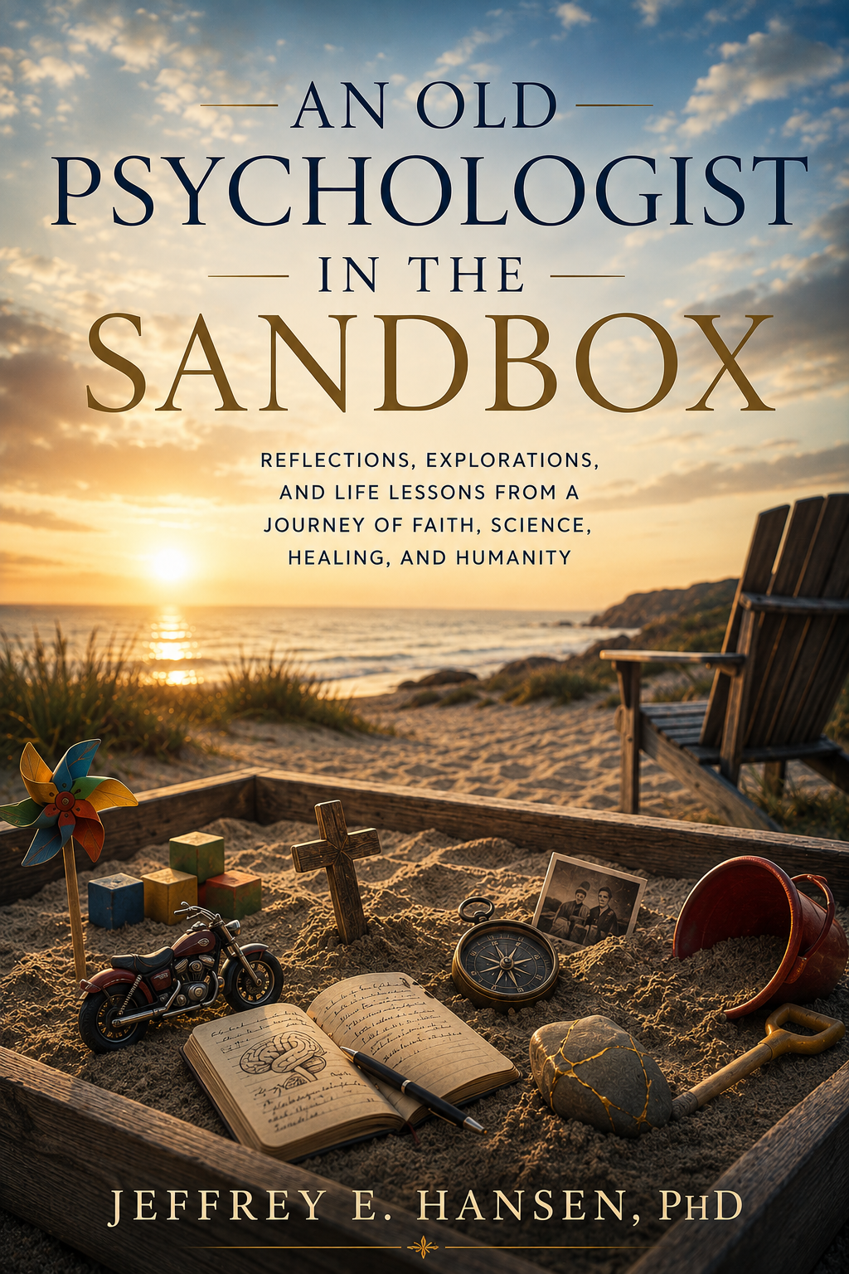

Sand on My Shoes
Reflections, Essays, and Wanderings in the Sandbox

An Old Psychologist in the Sandbox 7
The Quiet Hour Before Dawn 85
The One Who Emerged from the Aegean 91
The Human Person as One Unified Whole 97
Primum Non Nocere 103
When Medicine Forgot the Heart 121
The Age of Mechanism and the Market 127
A Return, Not a Rebellion 133
The Shoreline of Kos 139
Carrying the Flame Forward 187
The Long Road Through Grief 199
Thoughts on Healing and Care 205
Why I Spoke Out 217
Something Better is Already Rising 223
Voices of Courage 229
The Model We Need 235
The Long Ascent 247
Wired for Connection 273
The Gift of Gregg 289
A Call to Remember 301
The Ache Beneath the Noise 327
The Moment Dr. Schuldt Saw Me 333
Loneliness Changes the Body 345
A Call Back to One Another 359
What Is Authenticity, Really? 371
Managers, Firefighters, and Exiles 377
Rediscovering the True Self 389
Faith That Costs Something 411
Dostoevsky and the Weight of Conscience 417
NeuroFaith™ as Sacred Resistance 435
Grief and the Weight of Loss 457
About the Author 247

An Old Psychologist in the Sandbox
Jeffrey E. Hansen, Ph.D.

NO MEDICAL ADVICE IS GIVEN NOR PROVIDED IN THIS BOOK. SUCH INFORMATION, WHICH MAY BE MEDICAL IN NATURE, IS INFORMATION ONLY FOR THE USE OF LICENSED AND EXPERIENCED MEDICAL PRACTIONERS. A READER INTERESTED IN MEDICAL ADVICE OR MEDICAL TREATMENT SHOULD CONSULT A MEDICAL PRACTIONER WITH AN APPROPRIATE SPECIALTY WHO IS PROPERLY LICENSED IN THE READER’S JURISDICTION.
Authors’ Note on AI Contributions
Limited parts of this book were crafted with the support of ChatGPT, an AI tool that helped refine transitions and assist with research. Every effort has been made to ensure that all sources and information are accurate and reliable. Additionally, some images were created with the help of AI technology. We invite readers to explore the content with an open mind, and where applicable, feel free to consult other sources for further insight.
Copyright © Jeffrey E. Hansen, Ph.D.
Published by NeuroFaith® LLC
Prescott Valley, AZ
2026 Jeffrey E. Hansen

An Old Psychologist in the Sandbox

Welcome to the Sandbox
If you have somehow wandered into these pages, you may be wondering why a psychologist, especially one who has spent a lifetime in the worlds of trauma, addiction, neuroscience, faith, and human suffering, would call his collection of reflections a Sandbox.
That is a fair question.
The answer is actually quite simple.
Healing needs room to breathe.
Real growth rarely happens in rigid spaces. It does not emerge from perfectly polished performances or from pretending we have everything figured out. Healing happens in places where people are free to wrestle, explore, laugh, grieve, question, create, and occasionally make a glorious mess of things.
Over the course of my career, particularly in working with children and adolescents, I noticed something extraordinary. When children are overwhelmed, frightened, wounded, or confused, they do not typically sit down and deliver a well-organized dissertation on their emotional state. They play. They build castles and destroy them. They bury things in sand. They invent stories. They experiment. They imagine. Through movement and creativity and exploration, they slowly work their way toward meaning.
Children instinctively understand something adults often forget: the soul heals best when it has room to move.
Somewhere along the way, many of us lose that freedom. We become overly careful, overly polished, overly defended. We stop playing with ideas. We stop exploring honestly. We stop admitting uncertainty. We stop laughing at ourselves. And sometimes we stop feeling altogether.
This Sandbox became my way of reclaiming some of that space.
It is part workshop, part journal, part theological reflection, part neuroscience lab, part confession booth, part storytelling firepit, and occasionally, if I am being honest, part emotional pressure valve. Some of what you will read here is deeply serious. Some of it is deeply personal. Some essays were born out of grief, heartbreak, leadership conflict, spiritual wrestling, or the quiet ache of being human. Others emerged out of fascination, humor, curiosity, motorcycles, philosophy, family, politics, faith, or the strange beauty hidden inside ordinary moments.
A few pieces may even make you laugh. I certainly hope so.
Because laughter matters too.
This book is not a manifesto, and it is certainly not a podium from which I pretend to have mastered life. It is more like a workbench scattered with unfinished sketches, ideas in motion, reflections hammered out during difficult seasons, and occasional moments of clarity that surprised even me while I was writing them.
Many of these essays began as blogs written late at night, in airports, after difficult clinical days, during long rides through the desert, or in moments when my own heart needed somewhere to place its thoughts. Over time, I realized they were becoming something larger than isolated reflections. Together they formed a kind of map, not only of my professional journey, but of my spiritual one as well.
Some of these writings are really love letters in disguise. Love letters to family. To friends. To patients. To colleagues. To mentors. To God. To truth itself. Some are expressions of gratitude wrapped in story and metaphor. Others are warnings. Others are attempts to make sense of suffering without surrendering hope.
And beneath all of it runs one central conviction: human beings heal in relationship. We heal through connection, truth, meaning, faith, humility, grace, courage, and the willingness to keep growing even when growth hurts.
So this Sandbox is an invitation.
An invitation to think.
To wrestle.
To reflect.
To laugh occasionally.
To question honestly.
To breathe more deeply.
To consider that science and faith may not be enemies after all.
To remember that healing is both neurological and spiritual.
To rediscover wonder.
And perhaps most importantly, to remain human in a world increasingly trying to make us something less.
You are welcome to wander these pages freely. Pick up a shovel if you like. Build something. Question something. Turn ideas over in your hands. Keep what helps. Leave behind what does not.
Just do not worry too much about getting a little sand on your shoes along the way.

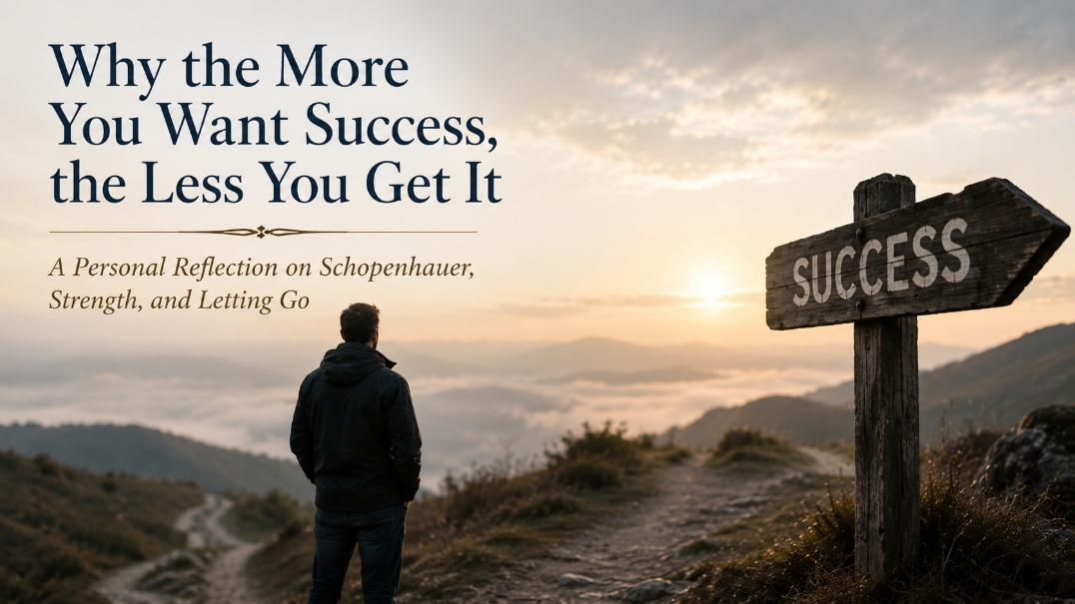

There’s something cruelly ironic about the modern chase for success. The more you want it, the further it seems to slip from your grasp. That’s not just some pop psychology slogan. It’s something the 19th century philosopher Arthur Schopenhauer wrote about long before the first TED Talk or self-help bestseller. He believed that will, our striving, endless, burning desire, was the source of our suffering. And I’ve come to believe he was right.
Like so many others, I got caught in that game. Performing. Striving. Always onto the next goalpost. More letters after my name. More people in the audience. More accolades, more acknowledgment. For a while, it worked. I was achieving, producing, hustling. But underneath it all, I wasn’t really being. And I wasn’t alone.
My brother Gregg and I grew up in the same household, endured the same early traumas, absorbed the same unspoken lesson: achieve or you’re nothing. He was a star, athletics, academics, you name it. And the world gave him all the applause. But inside, he was chasing ghosts. He couldn’t stop performing long enough to ask, what am I performing for? And when life demanded a shift, when it asked him to let go of performance and instead anchor himself in connection, love, acceptance, he couldn’t make the leap.
And that heartbreak eventually swallowed him whole.
I lost my brother to mental illness. But I also lost him to a society that rewards hustle and punishes introspection.
Arthur Brooks, not Schopenhauer, but channeling some of the same insight, writes in From Strength to Strength about the transition we all must make in the second half of life. He calls it the move from fluid intelligence, the fast, adaptive, competitive brain, to crystallized intelligence: wisdom, compassion, teaching, and mentoring. That shift is fueled by serotonin and oxytocin, not dopamine and adrenaline. It’s a shift from “what can I achieve?” to “who can I bless?” And man, is it hard.
But it’s necessary. Because otherwise, you keep grinding away at a game that no longer has meaning. You keep trying to sprint through a marathon. You try to be the person you used to be, and you fail, and it hurts like hell.
For me, that shift has been slow and painful. Letting go of identity as performer, rescuer, fixer. Learning to say enough. Learning to value presence over productivity, relationship over recognition. Learning to see success as not something I chase, but something I invite by simply living well, loving well, being real.
And so I circle back to Schopenhauer. He believed that the only true freedom comes from detachment, from releasing our compulsive craving. That doesn’t mean apathy. It means learning to want well, to order our desires, not be enslaved by them. It means recognizing that sometimes, peace arrives not when we get everything we want, but when we stop needing everything we want.
That’s the journey I’m on. And honestly, it’s the one Gregg never got to complete. But maybe by telling his story, I can carry it forward. Maybe his life, his struggle, his legacy, and the love we shared, can become part of my own healing, and maybe yours, too.
So if you find yourself tired of the hustle, confused by the constant pressure to be more, do more, achieve more, just stop. Breathe. You’re not alone. Maybe the truth about success isn’t in chasing it harder. Maybe it’s in letting go of the chase altogether.



The Quiet Hour Before Dawn
I woke before dawn this morning, the way I often do. Even on Saturdays, my body rises at four, as if some ancient bell rings in my chest. The house is quiet then. No demands, no screens, no urgency. Something in me wakes that is deeper than thought. That is usually when the blog voice comes. Not a loud voice, but a steady current that says, pay attention here.
The One Who Emerged from the Aegean
This morning that current drew me to a simple question: Who were the first psychologists before psychology existed? The usual names appeared: Socrates with his questions, Plato with his forms, Aristotle with his patient, grounded wisdom, Augustine with his yearning for God. But then Hippocrates surfaced, not as a philosopher exactly, but as something older and more human. A healer. And I realized I could not look away.
The Human Person as One Unified Whole
Hippocrates was born around 460 BCE on the island of Kos, surrounded by a horizon that teaches a person how small and sacred life is. We know very little about his personal life. No surviving letters describing his joys or griefs. No diary pages about heartbreak. No stories of whether he held his own children, or whether he buried one too soon. But we do know he came from a line of healers, passing down knowledge not as theory but as relationship. Healing was not an idea to him; it was a way of seeing.
And what he saw was remarkable: the mind and body are not separate things. They are one. Emotion lives in the flesh. Thought moves through heartbeat. Pain is not an abstraction but a memory the body carries. Hippocrates saw the human person as one thing, not a divided thing. A unified being of heart, body, mind, story, and presence. This was centuries before the vocabulary of integration existed. Which is why I call him the Godfather of NeuroFaith®.
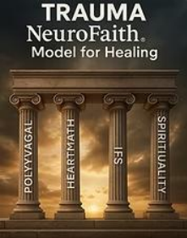
NeuroFaith® rests on four pillars that bring the person back into wholeness. Polyvagal theory teaches us that the nervous system determines our felt sense of safety or threat, shaping who we become in relationship. HeartMath® and neurocardiology reveal that the heart is not merely a mechanical pump, but an emotional and meaning-making organ. Internal Family Systems shows us the parts of the psyche that rise in trauma to defend what was too tender to bear. And the spirituality dimension reminds us that the human being is not only something physical but someone relational, purposeful, beloved, and capable of transcendence.
Hippocrates did not have these terms, but he lived in their truth. His worldview assumed wholeness, embodiment, and relational healing. He understood that emotion is felt in the body, that memory resides in the heart, and that healing cannot be separated from meaning. He was already speaking the language of trauma-integration long before it had a name.
We still instinctively echo this ancient understanding. We say, “He died of a broken heart,” “Bitterness ate her alive,” “Anger killed him.” But we never say, “Gratitude ruined his health.” We know that love heals. The body remembers what medicine forgets.
Primum Non Nocere
Hippocrates gave us the ethical foundation beneath all healing: First, do no harm.
Primum non nocere.
The original Hippocratic Oath included not only restraint from harm, but a vow to practice medicine with humility, reverence, and a deep sense of responsibility for the lives entrusted to one’s care. It presumes that the healer is not a dealer of power, but a steward of humanity.
Healing is not merely technical; it is moral. To touch a human being physically, emotionally, or spiritually is to step into sacred ground. A healer without humility becomes dangerous. A physician who cannot pause, reflect, feel, and wonder cannot truly heal.
When Medicine Forgot the Heart
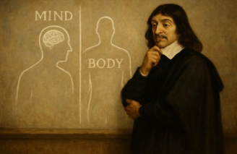
But history bent. In the 1600s René Descartes, brilliant and earnest, divided mind from body. His separation was intellectual, but it fractured the human being in practice. Then Newton’s mechanical physics reshaped medicine into a discipline of parts and repairs.
And it must be said: Newtonian medicine is extraordinary for acute physical trauma. For broken bones. For organ failure. For surgical emergencies. For restoring life in the midst of crisis. We honor this. We need it. We are grateful for it.
But Newtonian medicine cannot touch wounds of the heart, the nervous system, the story, the soul. You cannot sew up grief with sutures. You cannot reduce shame with antibiotics. You cannot amputate loneliness. The human being is not a machine. The human being is a story.
The Age of Mechanism and the Market
John D. Rockefeller was, in his time, the richest man America had ever produced, the first true billionaire. Brilliant, strategic, and singularly-driven, he built an empire by consolidating the oil industry under Standard Oil in the 1870s. But his influence did not stop with fuel and industry.

He turned his attention to medicine, seeing that pharmaceuticals could be synthesized from petroleum byproducts. With the same precision he used to eliminate competition in business, he reshaped the American medical landscape. Through massive philanthropic “donations,” he took control of medical schools, licensing boards, hospital systems, and research institutions.
Herbal remedies, naturopathic approaches, integrative treatments, and community-based healing were labeled unscientific and systematically defunded. Physicians were retrained to prescribe petroleum-derived pharmaceuticals as the primary treatment model, even as early data signaled carcinogenic harm.
Medicine became centralized, standardized, and industrial. The healer became a technician. The physician became an agent of the system. And the system was owned. Not cruelly, but gradually, quietly, inevitably, doctors were no longer free to choose how to heal. They were captured. They were infected. Not everywhere. Not everyone. But enough that we feel the fracture.
A Return, Not a Rebellion
Yet the answer is not to tear medicine down. The answer is to remember. To return. To reintegrate. To reclaim the human being as whole. To honor both the surgeon and the poet, the cardiologist and the chaplain, the psychiatrist and the child who learned to dissociate to survive.
This is where we are going. And we are not going alone.
Quantum mechanics now tells us that the universe is relational, not mechanical. Consciousness influences matter. Psychologist Dr. Lisa Miller’s research demonstrates that spirituality is not an accessory to psychological life, but foundational to mental health. The ancients are rising again. The heart is speaking again. The body is remembering again.
The Shoreline of Kos
And so, I imagine this: Hippocrates and I, walking the shoreline of Kos. The morning air cool. The sea breathing slowly. We pick up smooth stones and skip them across the water. We talk about meaning, grief, safety, beauty, faith, and the strange gift of being human. We do not argue. We wonder. We remember. We smile.
Let us return to that kind of medicine.
Let us return to that kind of psychology.
Let us return to that kind of humanity.
Not by erasing what has been built, but by completing it.
Let us heal the fracture.
Let us become whole again.
Let us remember who we were before we were divided.
And let us build forward, with compassion, courage, and joy.
Carrying the Flame Forward

Hippocrates, thank you. For guiding us from 2,500 years away. For inspiring what is good and integrative and human in healing. For being, in some mysterious way, my early colleague. I will carry the torch. I will move your wisdom forward. I will help restore the wholeness you once knew.
You are still smiling.
And we are walking toward the shore.



Dear Sally,
Thank you for your courage in sharing what you did. I can only imagine how heartbreaking it was to discover your son’s journals and the trauma he endured in silence. What you uncovered must have been shattering, both for what it revealed and for what it reopened in your heart.
That awful “if only we had known” feeling is one I carry too, every single day, about my brother Gregg. Grief has a way of circling back through memory, searching for clues, replaying moments, wondering what we missed, wondering if one conversation, one intervention, one deeper understanding might somehow have changed the outcome.
You and I have both lost someone we deeply loved to something that perhaps could have been prevented. That realization carries a special kind of pain. The grief itself is already overwhelming. But when grief becomes tangled with unanswered questions, overlooked trauma, fragmented care, or the feeling that deeper wounds were never fully seen, it adds another layer of sorrow that is difficult to describe to anyone who has not lived it.
The Long Road Through Grief
I think one of the hardest things about profound loss is that life keeps moving while part of us remains standing in the wreckage. The world resumes its rhythm. People go back to work. Conversations continue. Yet internally, something has permanently shifted.
There are moments when grief softens into tenderness, gratitude, memory, and love. And then there are moments when it returns like a wave that knocks the wind out of you all over again. I suspect you know exactly what I mean.
For me, losing Gregg was not only losing my brother. It was losing shared history, shared laughter, shared dreams, and the person who knew parts of my childhood no one else fully could. I suspect your son occupied that sacred place in your life too. A mother never stops carrying her child, even after loss. The bond simply changes form.
Thoughts on Healing and Care
Like you, I believe medications can have an important place. There are times when they stabilize, protect, and even save lives. I am grateful for the physicians and psychiatrists who practice with humility, wisdom, and care.
But I also believe our culture too often reaches for medication before fully understanding the deeper story underneath the suffering. Trauma, loneliness, shame, disconnection, fear, family wounds, loss of meaning, and nervous-system dysregulation cannot always be medicated away. Human beings long to be understood, not simply managed.
What concerns me most is when people quietly begin to believe they are permanently broken, as if their future depends entirely on a lifelong chemical rescue. That loss of hope can become its own kind of suffering.
Real healing, at least in my experience, usually requires something deeper and more relational. It requires safety. Honesty. Compassion. Curiosity. Grieving. Connection. Sometimes faith. Sometimes simply having another human being willing to sit beside us long enough to truly see us.
Walking Together
I am praying for you as you continue to process all of this. I know how the mind loops in grief, trying to make sense of the senseless, trying to organize pain into some kind of understandable narrative. Sometimes it feels like the heart keeps revisiting the scene of the loss over and over again, searching for peace that never fully arrives.
And yet somehow, even in the sorrow, love continues. That may be one of the deepest mysteries of all. The relationship changes, but it does not disappear. We carry them forward. In memory. In story. In the ways they shaped us. In the tenderness that remains.
Sally, I want you to know I am here. Truly. Anytime. You do not need a reason. Just reach out. We may not be able to undo what has happened, but we can stand together in that sacred space of grief, bearing witness and helping one another carry what feels too heavy to hold alone.
I often say this is a club no one ever wants to join. But if we must be here, then let us at least walk together with honesty, compassion, and grace.
With deep compassion and respect,
Jeff



Why I Spoke Out
For years, I have spoken out against the overreach of pharmaceutical power, the ideological capture of our institutions, and the silent complicity of professionals who should know better. I have challenged the rush to medicalize childhood pain, the suppression of dissent, and the growing illusion that healing comes primarily from a pill or a procedure rather than relationship, regulation, truth, courage, and renewal.
I did not begin speaking because I enjoy conflict. In truth, there are moments when I grow weary of it all. But silence eventually becomes its own kind of surrender. When we witness confusion, fear, shame, and suffering spreading through families and children, there comes a point when conscience requires us to speak honestly, even when doing so carries personal and professional cost.
What concerns me most is not simply bad policy or misguided treatment models. It is the quiet erosion of our humanity. It is the loss of humility, curiosity, reverence, and compassion in spaces that were meant to help people heal.
Something Better is Already Rising
But I have not spoken up merely to deconstruct. I have done it because I believe something better is possible, and not only possible, but already emerging.
Parents are waking up. Clinicians are finding their voices. Researchers are beginning to ask harder questions. Lawsuits are exposing deception and institutional failures. And in the midst of all the confusion and wreckage, something deeply human and hopeful is beginning to rise again.
I believe we are witnessing the early stages of a return to integrity, to wisdom, to courage, and to the sacredness of the human person. A return to healing approaches that honor the body, the nervous system, the mind, relationships, and the soul together rather than fragmenting people into disconnected symptoms and diagnoses.
Voices of Courage
I see this movement in brave professionals and researchers who are risking reputation, criticism, and professional standing in order to speak honestly.
People like Dr. Andre Van Mol, Dr. Michael Laidlaw, Dr. Laura Haynes, Dr. Quentin Van Meter, and Dr. Michelle Cretella have courageously questioned the premature medicalization of gender distressed youth. And in the world of psychiatry and medication reform, thoughtful voices such as Dr. Joseph Witt-Doerring, Dr. Joanna Moncrieff, Dr. Mark Horowitz, and Robert Whitaker continue to raise serious concerns about the mass pharmacologizing of children and adolescents.
These are not hateful people. They are thoughtful people asking difficult questions in an age increasingly uncomfortable with honest inquiry. Whether one agrees with every conclusion or not, the willingness to question, explore, and wrestle honestly with complexity is essential for both science and human dignity.
The Model We Need
I am not interested in nostalgia for some idealized past, nor in utopian fantasies about a perfect future. What interests me is honest work rooted in humility, wisdom, compassion, and Christian hope.
I want to see a new generation of mental health professionals who are unafraid to say, “I do not fully know, but I will walk with you.” Professionals who trade ideology for inquiry. Professionals who are more interested in understanding people than labeling them. Professionals who are willing to slow down long enough to ask what pain, fear, loneliness, trauma, or confusion may be living underneath the symptoms.
Healing requires relationship. It requires presence. It requires patience. And often, it requires helping people rediscover meaning, connection, faith, and purpose in the midst of suffering.
What Healing Could Look Like
We need spaces where First Amendment rights are not treated as dangerous threats but as essential safeguards for truth seeking. We need academic and clinical environments where disagreement is not punished, where research can proceed without fear, and where thoughtful discussion is welcomed rather than silenced.
We need to create spaces where children and adolescents are not rushed toward permanent interventions before deeper exploration has taken place. Young people deserve time to grow, question, struggle, heal, and develop without immediately being locked into identities that may not yet fully reflect who they are becoming.
We also need communities where trauma is not ignored, bypassed, or minimized. Trauma must be named, held compassionately, understood deeply, and worked through carefully. Human beings do not heal through shame. They heal through truth, safety, connection, and love.
Light in the Darkness
This is not simply idealism. I see signs of hope every single day.
I see it in young therapists and mentors at Holdfast and AnchorPoint who bring honesty, faith, humility, and humanity into the room. I see it in men reclaiming dignity, purpose, and integrity after years of despair. I see it in parents willing to pause long enough to ask deeper questions rather than surrendering immediately to fear driven solutions.
I see courage growing quietly in ordinary people. And honestly, I believe those quiet acts of courage matter far more than many realize.
The Gospel Model
Most of all, I see hope in the Gospel itself.
Jesus did not turn away from wounded people. He did not shame the broken. He did not reduce human suffering to a checklist or a diagnosis. He entered pain compassionately and personally. He sat with people. He wept with them. He restored dignity. He offered truth and grace together.
To me, that remains the model. Not coercion. Not ideology. Not fear. Presence. Compassion. Truth. Courage. Relationship. Redemption.
A Call to Build
Yes, these are difficult days. There is confusion, polarization, fear, and pain all around us. But light has always mattered most in dark places.
So let us become people of that light.
Let us speak truth courageously but also lovingly. Let us protect children. Let us remain intellectually honest. Let us refuse to dehumanize those with whom we disagree. Let us build systems of care rooted in humility, wisdom, scientific integrity, compassion, and spiritual depth.
And let us fight not only against what is broken, but for what is beautiful.
Because the future does not belong merely to the loudest voices. It belongs to the courageous, the thoughtful, the compassionate, and the faithful.
Let us build that future together.



The Long Ascent
I have spent most of my life climbing. Climbing out of childhood wounds that left invisible scars. Climbing through academic institutions that conferred upon me degrees, titles, and licenses, tools of the trade, yes, but never the whole truth. I climbed into the trenches of human suffering: trauma, addiction, depression, shame, grief, and despair. Sometimes I climbed for my own survival. Other times I climbed for others, reaching downward to help them find footing when they had lost their way.
For many years, I believed the climb itself was the destination. The striving. The endurance. The proving. The resilience. I thought meaning would eventually reveal itself through accomplishment alone. But clarity often comes only with altitude. And the higher I have climbed, the more I have realized that achievement, by itself, cannot heal the soul.
What matters most is not how high we ascend, but whether we remain human during the ascent. Whether we retain compassion. Whether we preserve humility. Whether we continue to love people more than systems, truth more than ideology, and wisdom more than applause.
What’s True
I have fought hard over the years, but not from pride. From conviction.
I have stood beside children, veterans, trauma survivors, addicts, grieving parents, and exhausted families who were misunderstood, mislabeled, or overmedicated. I have challenged ideologies that slowly crept into the heart of psychology, distorting it into something increasingly mechanistic, political, and disconnected from the sacredness of the human person.
I have spoken against systems that too often value compliance over compassion, conformity over courage, and efficiency over genuine healing. And while those positions have occasionally come at personal or professional cost, I would still choose the same path. Some things are worth standing for.
In that resistance, I have tried to build something constructive as well. A clinical model. A framework. A path toward deeper integration and wholeness. I have taken what neuroscience and trauma theory offer at their best, polyvagal theory, neurocardiology, Internal Family Systems, attachment theory, and woven them together with the spiritual truths that have guided me throughout my life.
Not because I believe I possess all the answers. Far from it. But because I believe human beings are far more than symptoms, diagnoses, and behavioral outputs. We are stories. Souls. Longings. Relationships. Wounds seeking healing. Hearts seeking meaning.
What the Body Knows
The nervous system does not lie.
It speaks quietly, often long before words arrive. It speaks through tightness in the chest, restless nights, guarded eyes, emotional shutdown, panic, fatigue, shame, and hypervigilance. Long before a patient says, “I’m fine,” the body is already telling the truth.
That is one of the deepest things trauma taught me, both personally and professionally. The body remembers what the mind often tries desperately to outrun.
We are not machines. We are not simply collections of neurotransmitters or diagnostic codes. We are living stories in motion. We are fragmented at times, wounded at times, resilient at times, and always reaching toward some deeper sense of safety, love, connection, and meaning.
That understanding eventually led me to create the NeuroFaith® model, not as a trendy therapeutic approach, but as the distilled integration of what I have come to believe after decades of clinical work, suffering, observation, faith, and reflection. To me, NeuroFaith® is simply a map back toward wholeness.
A New Season
I am not stepping away from the field. And I do not feel myself fading into retirement. But I do recognize that I am entering a different season of life.
Less noise. More presence.
Less striving. More discernment.
Less proving. More mentoring.
I no longer feel the need to climb at the same frantic pace. Instead, I feel increasingly called to pause at this ledge for a while, look around carefully, and help prepare others for their own ascent.
I want to mentor clinicians who still believe this work is sacred. I want to encourage younger therapists not to lose their humanity beneath paperwork, politics, diagnoses, and institutional pressure. I want to write books that cut through noise and offer something honest, thoughtful, compassionate, and enduring.
Most of all, I want to help restore a sense of dignity, humility, wisdom, and sacredness to a field that sometimes seems to have forgotten all four.
The Torch and the Trail
I do not need a spotlight. I do not need applause. But I do hope to pass the torch while there is still fire in my hand.
And so, if you find yourself somewhere along the climb, struggling upward, uncertain, exhausted, wounded, or searching for meaning, here is what I believe I have learned:
The goal is not applause.
It is not status.
It is not achievement alone.
And it is certainly not the endless performance of success.
The goal is wholeness.
And from wholeness, healing flows. Clarity flows. Discernment flows. Peace flows. Strength flows. Compassion flows.
I am not finished yet. But I know I am walking differently now. Listening more carefully. Speaking more thoughtfully. Holding life more gently. Trusting that perhaps a quieter kind of courage is what this chapter of life now requires.

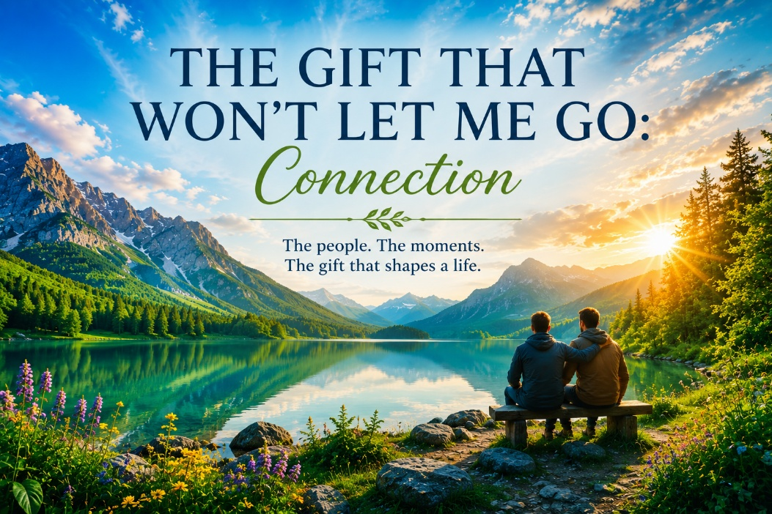

Wired for Connection
Friend, if you are reading this, it is because you mattered to me.
Some of you I am still deeply connected with. Others, life slowly carried us in different directions. A few relationships ended with unresolved pain that still lingers quietly in the heart. But regardless of how our stories intersected, you touched my life. And that matters to me more now than ever before.
As I reflect on my life and career, with all their victories, failures, griefs, and unexpected turns, what stands out is not the titles, the letters after my name, or the things I accumulated along the way. It is the people. The moments of genuine presence. The conversations that made me feel understood. The unexpected phone calls that arrived at exactly the right time. The tears that were not judged. The laughter that somehow stitched wounded places back together. In the end, what remains most sacred to me is connection.
I have become increasingly convinced that we are wired for connection at every level of our being. Johann Hari and many others have spoken eloquently about this reality, but honestly, I saw glimpses of it long before the neuroscience fully caught up. Even early in my academic life at UC Berkeley, I found myself drawn toward interpersonal models of depression and emotional suffering. Already I was asking questions about what disconnection does to the human spirit. Later, in graduate school, my dissertation explored how self-disclosure affects marital satisfaction. The more we are willing to truly know and be known, the deeper intimacy becomes. And the deeper the relationship, the more fully alive we tend to feel.
The Drive to Achieve
But life has a way of slowly pulling us away from what matters most.
As Daniel Lieberman writes in his work on dopamine, especially when we are younger, we are driven creatures. We pursue. We build. We strive. We chase accomplishment, success, expansion, and recognition. And I was certainly no exception.
Like Arthur Brooks describes in From Strength to Strength, I had that entrepreneurial energy, that fluid intelligence, the hunger to climb, create, and accomplish. I built businesses. I acquired property. I worked relentlessly. I pushed hard. I kept moving forward, convinced that momentum itself was evidence of purpose.
Until eventually, the pace caught up with me.
The financial collapse of 2008 hit hard, as it did for many people. Family health crises piled on. Years of overextension and over acquisition left me vulnerable in ways I had not fully recognized. And suddenly, I could no longer outrun myself.
What felt at first like collapse eventually became something else. A painful but necessary reconstruction.
I began to realize that while the drive chemicals had carried me far professionally, they could not sustain the deeper needs of the soul. I needed something different now. Presence. Rest. Relationship. Safety. Serotonin. Oxytocin. The chemistry of attachment and belonging. I needed to relearn how to simply be connected.
Grace Found Me
During that season, I returned to therapy. Many therapists, actually. Some helped. Some could not quite find me in the fog. So eventually I went back to the books, to the neuroscience, to reflection, to prayer, and slowly, piece by piece, grace found me again.
I rediscovered the fierce tenderness of Jesus through writers like Brennan Manning and Henri Nouwen. Their words softened something rigid and exhausted inside me. For perhaps the first time in years, I began to understand more deeply that I was loved not because of what I accomplished, but because of who God is.
That realization changed me.
Connection with God slowly became the foundation for reconnecting with myself and with other people. Not performance. Not achievement. Relationship.
“I have loved you with an everlasting love; I have drawn you with unfailing kindness.” Jeremiah 31:3
That verse stopped being theology and became something living.

The Gift of Gregg

Around that same time, I began to understand connection on an even more personal level through my twin brother, Gregg.
When we were younger, we simply understood each other in ways that are difficult to fully explain. Emotionally, psychologically, spiritually, we were connected deeply. We carried each other’s wounds. We sensed each other’s struggles. One glance, one phone call, one quiet moment together could communicate more than long conversations ever could.

There was one particular season when I was unraveling emotionally. Gregg was living in Oregon at the time. Without hesitation, he dropped everything and drove to be with me. I remember standing there feeling exhausted, ashamed, overwhelmed, and lost. He did not lecture me. He did not analyze me. He did not try to fix me.
He simply held me.
And somehow, his calm nervous system became my refuge. His steadiness regulated mine. His settled presence communicated safety at a level deeper than words. That moment taught me more about healing than countless professional lectures ever did. His presence reminded me that love does not disappear when life becomes messy. Real connection stays present.
The Ache and the Fire
When Gregg died, the pain was searing.
The silence afterward felt unbearable at times. The absence. The unfinished conversations. The knowing that there would be no more spontaneous calls, no more laughter, no more shared memories unfolding in real time. Grief rearranges the architecture of the heart.
And yet strangely, out of that loss came an even deeper conviction inside me.
Do not wait. Do not assume there will always be more time. Every interaction matters. Every moment of presence matters. Every conversation leaves an imprint inside another human being.
We now understand scientifically what many people have always intuitively known. Relationships shape neurobiology. We imprint safety or fear, peace or anxiety, belonging or shame into one another’s nervous systems constantly. Love is not sentimental fluff. It is biological. Emotional. Spiritual. Sacred.
Polyvagal theory reinforced this understanding for me. HeartMath and neurocardiology deepened it. Dan Siegel’s work on interpersonal neurobiology confirmed that we are profoundly relational beings all the way down to our wiring.
And Internal Family Systems helped me recognize that healing also requires connection within ourselves. We must learn to relate compassionately to our own wounded places rather than attacking them with shame.
That, too, reflects the heart of God.
A Call to Remember
My brother never fully made it through his suffering. Trauma and mental health struggles followed him for years, and eventually they overwhelmed him. That reality still hurts deeply.
But his life, and even his death, left me with something sacred to carry forward.
A mission.
A call to help people reconnect with themselves, with each other, and with the God who never abandons them. So, thank you for being part of my story. Whether briefly or deeply. Whether recently or years ago. Whether we remained close or drifted apart. You mattered.
And especially to my younger friends reading this, please learn this lesson sooner than I did. You do not need to climb the entire mountain before realizing what truly matters.
Invest in people.
Choose depth over speed.
Choose presence over performance.
Repair what can still be repaired.
Show up while you still can.
I have walked beside hundreds of clients, mentored clinicians, buried people I loved, and rebuilt myself more than once. And if I could leave behind only one truth, perhaps it would simply be this:
Connection is everything.
We were made for it.
And by God’s grace, we can always return to it.

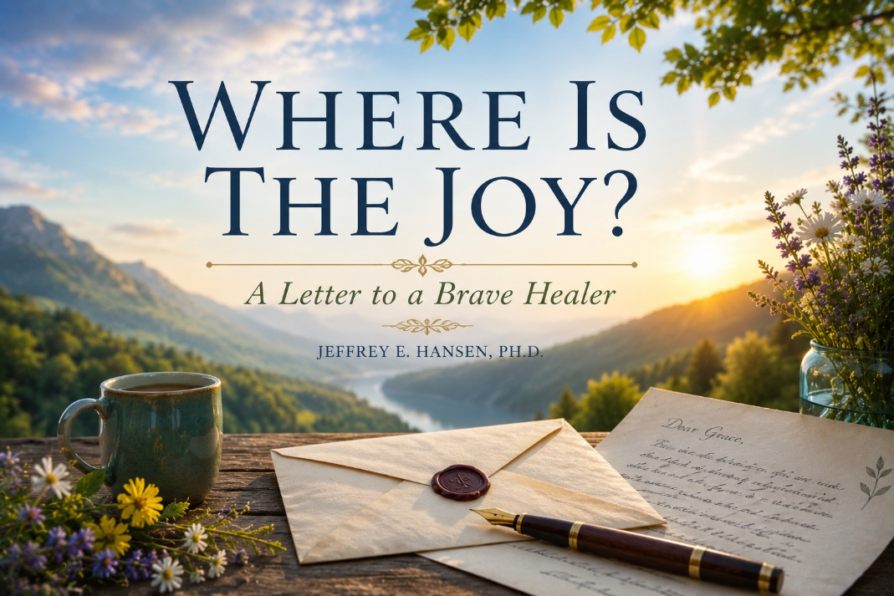

Dear Michelle,
I have been thinking about you lately, about your courage, your unwavering stand for truth, and the tremendous burden you have quietly carried for so many years. You have reached the highest levels of professional achievement in medicine and advocacy, yet I suspect there are moments when none of those accomplishments feel particularly comforting. Recognition does not shield the heart from exhaustion. Accolades do not protect a person from criticism, loneliness, or the ache that comes from standing against powerful currents for the sake of conscience.
You have used your voice to defend children and families even when doing so invited misunderstanding, resistance, and at times outright hostility. You chose integrity over comfort and truth over popularity. That matters deeply. More than most people will probably ever fully understand.
But I also know that living in a constant state of advocacy and battle extracts a cost from the nervous system and from the soul. There comes a point where even the strongest people quietly begin asking themselves difficult questions in the stillness of the night. Is this worth it? Why does the fight feel so heavy? And perhaps most painfully of all, where did the joy go?
I have asked myself those same questions.
Years ago, I lived much of my life running far too hot for far too long. I was driven by purpose, conviction, ambition, responsibility, and honestly a deep internal pressure to keep proving, fixing, building, helping, and moving forward. For a season, that intensity worked. Cortisol and dopamine fueled the engine, and I mistook the momentum for health.
Until eventually the engine gave way.
When the financial collapse hit nearly two decades ago, combined with family crises and years of relentless striving, I discovered that I no longer possessed the emotional and physical reserves to absorb the impact. Something in me broke open. And while I did not lose my faith entirely, I realized I had lost something quieter and more essential. I had lost the settled sense of peace and joy that allows a person to remain present, connected, grounded, and alive.
That collapse became a kind of reckoning for me. Strange as it sounds, it was in that valley that I encountered Jesus in a much deeper way. Not simply as a theological figure or doctrinal truth, but as rest itself. As peace. As the One who restores what endless striving and performance never can.
“Come to me, all you who are weary and burdened, and I will give you rest.” Matthew 11:28
That verse stopped feeling abstract to me. It became deeply personal.
Over time, through therapy, prayer, reflection, grief, relationships, neuroscience, and faith, I slowly began learning another way to live. A slower way. A more grounded way. A more relational way. I began understanding that while conviction matters enormously, human beings were never designed to live perpetually in a state of war footing.
People like you and me often adapt to battle without realizing what it is costing us internally. We become hypervigilant. We remain emotionally braced. Our nervous systems stay prepared for impact. At times that response is necessary. But eventually it begins stealing from us the very chemistry that sustains joy, connection, and peace.
Researchers such as Daniel Lieberman describe the difference between the drive oriented dopamine system and the quieter neurochemistry of serotonin, oxytocin, attachment, and presence. The nervous system longs not only for mission, but for safety. For friendship. For laughter. For stillness. For beauty. For worship. For sunlight. For human closeness. For moments where we are no longer performing, defending, or striving, but simply being.
These are not indulgences. They are part of how God designed us.
“You make known to me the path of life; in your presence there is fullness of joy.” Psalm 16:11
I think this is why I have come to treasure fellowship more deeply as I have grown older. The mission still matters to me. Truth still matters to me. Science matters. Advocacy matters. But increasingly, what feels most sacred are the relationships formed along the way. The honest conversations. The shared burdens. The moments where we can set down the armor for a little while and simply be human together.
You and others like you have reminded me that courage and tenderness can still coexist. Conviction and compassion can still coexist. Truth and mercy can still coexist. And honestly, I believe that combination may be exactly what this wounded world needs most right now.
I often joke that I am a bit of a hot mess, and perhaps there is more truth in that statement than I care to admit. But I also believe that in the hands of God, even the weary and fractured parts of us can still burn beautifully. Not merely with outrage, but with compassion. Not merely with intensity, but with love.
And so yes, I believe the joy is still there, even now. Sometimes it no longer arrives as triumph or adrenaline. More often it comes quietly. A sunrise. A shared meal. A moment of laughter. A meaningful conversation. An unexpected text from someone who understands. A sense of peace that gently settles into the nervous system after years of striving.
Joy now feels less like excitement and more like grace.
“Those who sow in tears will reap with songs of joy.” Psalm 126:5
“Let us not grow weary in doing good, for at the proper time we will reap a harvest if we do not give up.”
Galatians 6:9
You have been a warrior for a long time. You still are. But my hope for you now is not only that you continue standing courageously for truth, but that you also rediscover rest, connection, beauty, laughter, and joy along the way. Not because you earned it, but because God delights in restoring weary hearts.
With deep gratitude and affection,
Jeff

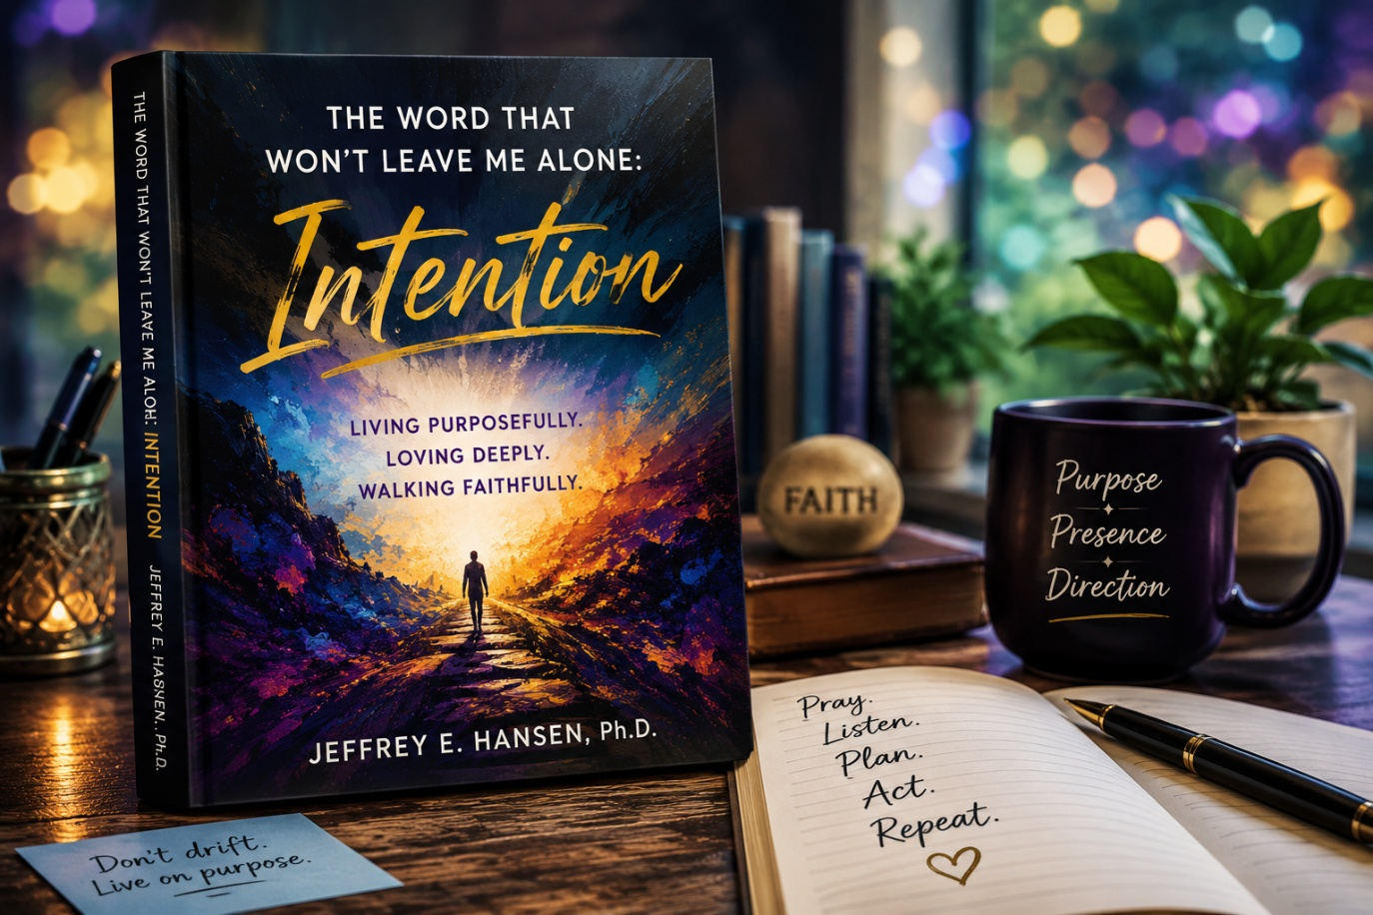

There’s a word that has been quietly following me around lately, though perhaps “quietly” is not even the right word. It has been showing up with a kind of persistent holy pressure, surfacing in conversations, prayer, writing, reflection, and in those moments when I sense God trying to get my attention yet again. It is one of those words that at first seems deceptively simple, almost too familiar to notice. But the more I sit with it, the more layered and profound it becomes. The word is intention.
Now, I cannot pretend I stumbled onto this insight by myself. In truth, this word has been steadily planted into my life over decades by one of the wisest men I have ever known, Pastor Earl. He has a way of taking a single word and turning it into a lens through which you begin to see your entire life differently. Over the years, he has repeatedly returned to this idea of intentionality, especially when we are talking about ministry, faith, relationships, writing, leadership, or simply the way a Christian ought to walk through the world.
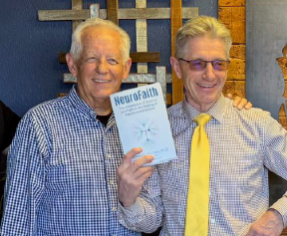
Pastor Earl has been in my life since I was around twenty-three years old, back in the days when Leah and I first met. That means this man has walked beside me for nearly my entire adult life. He has been far more than simply a pastor. He has been a spiritual father to me, a trusted friend, a co-author on several books, and one of the few men in my life who loves me enough to tell me the truth directly, without varnish, without flattery, and without any need to soften every sharp edge. He has the rare ability to deliver what feels like a spiritual right hook and somehow leave you grateful for the impact.
There is something deeply refreshing about a man who does not manipulate, posture, or try to impress. Earl simply says what he believes God wants said. Sometimes gently. Sometimes forcefully. But always honestly. And somewhere along the line, one of his favorite words became intention. Or, when he really wants to emphasize the point, intentionality.
I can still hear him saying it to me.
“Jeff, lean in with intention. Don’t drift through life. Don’t wait passively for clarity to arrive. Pursue it. Pray into it. Move toward it.”
That phrase has stayed with me. In fact, the older I get, the more it seems to settle into my bones.
At seventy years old, I find myself in a fascinating and deeply reflective season of life. I have spent decades in clinical psychology, trauma work, addiction treatment, mentoring, and leadership. I have walked with broken people, grieving families, addicted souls, wounded marriages, frightened adolescents, and exhausted clinicians. I have seen extraordinary healing, and I have seen devastating pain. Through all of it, I realize more than ever that drifting is dangerous. Souls rarely drift toward health. Relationships rarely drift toward intimacy. Faith rarely drifts toward depth. More often than not, drift carries us away from the very things that matter most.
That is why this word has been hitting me so hard lately.
I do not want to drift into the final chapters of my life. I do not want to simply “retire” in the cultural sense of quietly fading into comfort and disengagement. I want to continue moving toward purpose with clarity and conviction. I want to build the NeuroFaith® vision with intention. I want to mentor younger clinicians with intention. I want to write with intention. I want to love Leah with intention. I want to listen more intentionally, pray more intentionally, and even suffer more intentionally when suffering inevitably comes.
And the truth is, when I look at the life of Jesus Christ, intentionality is everywhere.
Jesus did not wander aimlessly toward the cross. He moved toward it knowingly and willingly.
He did not randomly encounter broken people without purpose. He saw them fully. He stopped for them. He moved toward them with compassion and deliberate care.
He did not speak carelessly. Even His silence carried meaning.
Every step Christ took seemed anchored in alignment with the Father. There was purpose in His movements, purpose in His teaching, purpose in His waiting, purpose in His confrontation, and purpose even in His suffering.
That reality has been reshaping the way I think about discipleship itself.
Perhaps living faithfully is not merely about believing the right things. Perhaps it is also about refusing to live accidentally.
Pastor Earl has challenged me repeatedly in this area. He reminds me that there is a tremendous difference between simply reacting to life and actually living with prayerful intention. There is a difference between showing up physically and truly being present spiritually. There is a difference between speaking impulsively and speaking with discernment after prayer and reflection.
He often reminds me:
Do not just show up. Mean it.
Do not just act. Aim.
Do not just speak. Listen carefully first, pray deeply second, and then speak with purpose.

The older I get, the more wisdom I hear in those words.
When I actually slow down enough to live intentionally, something changes inside of me. My prayers become less superficial and more honest. My decisions become less reactive and more grounded. My relationships feel deeper. My work feels more aligned with calling rather than mere obligation. Even difficult moments begin to carry meaning instead of simply frustration.
Living intentionally does not mean living perfectly. It does not mean becoming rigid, hyper controlled, or self-important. In fact, true intentionality requires humility because it forces us to ask difficult questions about where we are actually headed and whether our daily lives reflect what we claim to value.
And honestly, I fail at this often.
There are still moments where I rush ahead emotionally. Moments where I react instead of reflect. Moments where fatigue, frustration, or ego get the better of me. But even there, this word keeps returning like a gentle conviction from the Holy Spirit.
Intention.
Slow down.
Pay attention.
Align your life.
Mean what you say.
Move toward what matters.

I suppose that is why this word refuses to leave me alone.
And perhaps that is a grace.
So, Pastor Earl, thank you. Thank you for speaking this truth into my life for decades. Thank you for refusing to let me settle into passivity or drift. Thank you for continually pointing me back toward Christ and reminding me that nothing about the life of Jesus was accidental.
Thank you for bringing faith into every corner of life rather than confining it to Sunday mornings. Thank you for reminding me that our words matter, our choices matter, our relationships matter, and the direction of our lives matters.
Most of all, thank you for reminding me that discipleship is not passive.
It is intentional.
With intention, Pastor Earl.
— Jeff

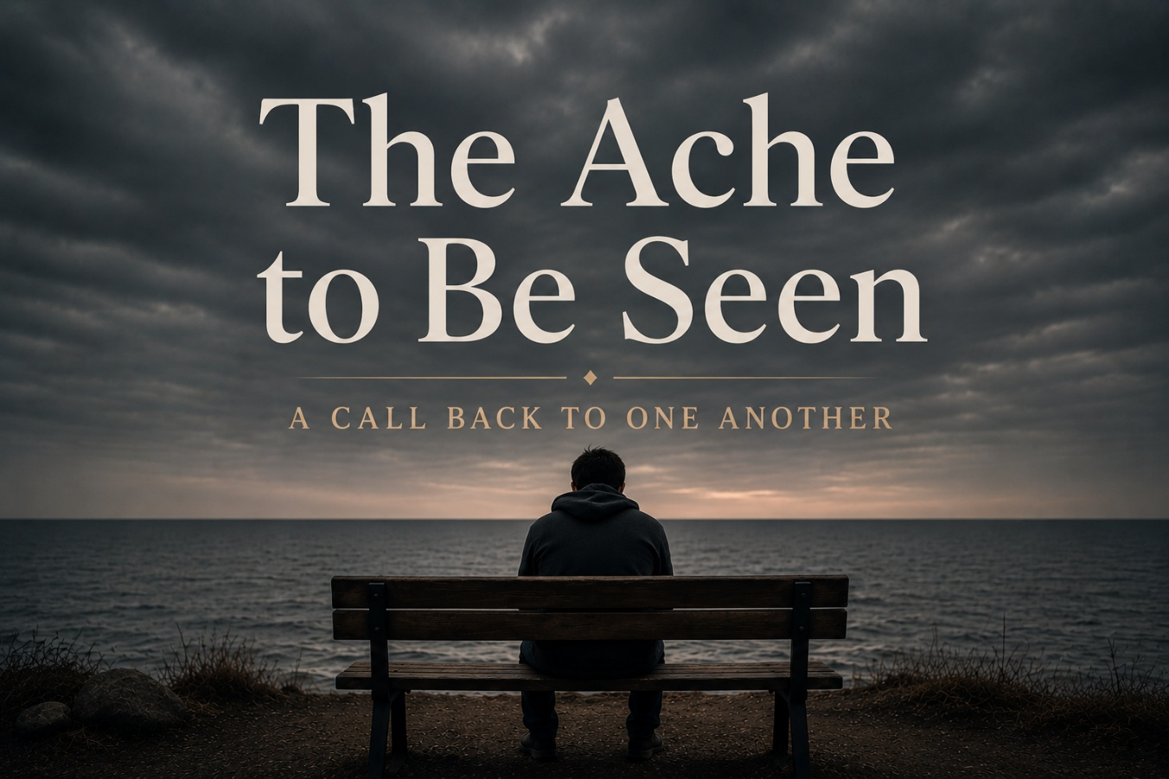

The Ache Beneath the Noise
We live in the most digitally connected age in human history, and yet many people feel more emotionally isolated than ever before. We scroll endlessly. We text. We answer emails. We remain constantly stimulated and perpetually reachable. But beneath all the noise and activity often lives a much quieter ache, the ache to be truly seen.
Johann Hari once observed that we are perhaps the most connected society in history, yet many people feel profoundly alone. I believe he is right. And honestly, that truth has landed far more personally for me over the last several years than I ever expected.
When my twin brother Gregg passed away, the grief left a wound in me that no amount of productivity, advocacy, or intellectual understanding could fully touch. His absence became a piercing reminder of how deeply human beings are wired for relationship. Not merely proximity to others, but genuine emotional connection. We do not simply long to be around people. We long to be known by them.
I think that longing intensifies during seasons of grief, struggle, advocacy, and emotional exhaustion. Speaking out carries a cost. Carrying burdens carries a cost. Standing firm carries a cost. There are moments when even deeply meaningful work can begin to feel profoundly lonely. What has helped sustain me in those seasons has often not been grand gestures or dramatic interventions, but rather small moments of human presence that somehow leave lifelong imprints on the heart.
The Moment Dr. Schuldt Saw Me
One of those moments happened many years ago during graduate school.

I was exhausted mentally, emotionally, and spiritually. Anyone who has survived graduate school, medical school, or any prolonged season of academic and emotional pressure understands that particular kind of fatigue. The self-doubt. The depletion. The quiet fear that maybe you are not enough to survive the journey.
One afternoon I sat alone in a hallway conference room feeling completely drained. Then my major professor, Dr. John Schuldt, a soft spoken and deeply kind man, happened to walk by. He paused, looked at me carefully, gently placed his hand on my knee, and quietly asked, “Hey Jeff, how are you doing?”
That was it. No lecture. No solution. No analysis. Just presence.
But somehow that small moment communicated something enormous to me. He saw me. Not my performance. Not my grades. Not my potential. Me. I have never forgotten it.
As I have grown older, I have come to believe that many of the moments that most deeply shape our lives are often incredibly small from the outside. A pause. A touch. A sincere question. A willingness to stop long enough to let another human being know they matter. These moments restore people more than we realize.
Even Jesus Longed for Presence
Even Jesus understood this ache for companionship and emotional presence.

In the Garden of Gethsemane, on the night before His crucifixion, He turned toward His closest friends in profound sorrow and asked them to remain awake with Him.
“My soul is overwhelmed with sorrow to the point of death. Stay here and keep watch with me.” Matthew 26:38
There is something deeply moving about that moment to me. Even Christ, facing unimaginable suffering, longed not merely for theological truth or abstract purpose, but for human presence. He desired companionship in His pain.
And yet when He returned, He found them asleep. Three times.
That scene captures something profoundly human about all of us. We ache to be accompanied in suffering, to be noticed, and to be emotionally held when life becomes overwhelming.
Loneliness Changes the Body
Modern neuroscience increasingly confirms what the human heart has always known. Loneliness is not simply an emotional inconvenience. It is biologically and psychologically devastating over time.
The late social neuroscientist Dr. John Cacioppo devoted much of his career to studying loneliness and its effects on human health. His research demonstrated that chronic loneliness increases the risk of early mortality dramatically, even more than obesity or air pollution. Other studies found that people whose loneliness increased over time became significantly more vulnerable to clinical depression, anxiety, cognitive decline, and physical illness.
From a polyvagal perspective, loneliness places the nervous system into defensive states. Some people become hypervigilant and anxious. Others emotionally shut down and withdraw. The hypothalamic pituitary adrenal axis activates repeatedly, flooding the body with stress hormones like cortisol. While this system helps us survive acute threats, chronic activation slowly erodes emotional regulation, cognitive functioning, immune health, and even cardiovascular stability.
Tragically, the longer loneliness continues, the harder authentic connection often becomes. The very neurobiological systems required for trust, openness, and attachment begin shutting down from overuse and disappointment. We become more guarded precisely when we most need closeness. The body slowly adapts to isolation as though isolation were normal, even while the soul continues aching for relationship.
Learning to Reinvest the Heart
As I have grown older, I have also come to recognize something difficult but important. Sometimes chronic loneliness cannot be healed within the very environment that helped create it.
Whether it is a relationship, a workplace, a community, or even a social system, there are moments when we must honestly acknowledge that mutual care, emotional safety, and repair are unlikely to emerge there. That realization is painful. But I no longer believe we are meant to remain indefinitely in places where we are perpetually unseen.
That does not mean responding with bitterness or resentment. It means giving ourselves permission to reinvest our hearts elsewhere, into relationships where warmth, honesty, vulnerability, and mutual care remain possible. Human beings were not designed for emotional exile.
The Sacred Practice of Noticing
The beautiful thing is that the antidote to loneliness often begins very simply. One pause. One moment of genuine attention. One act of seeing.
Perhaps it means taking your hands off the keyboard when someone walks into the room, looking them in the eyes, smiling, and sincerely saying, “It’s good to see you.” Perhaps it means checking in with someone you have not heard from in a while and asking a real question instead of offering a rushed formality. “How are you, really?”
Most people carry invisible griefs. Most people carry wounds from seasons when they were not comforted, not protected, not understood, or not loved in the ways they needed. I sometimes hesitate to overuse the word trauma because the term has become diluted culturally, but the truth is many human beings carry deep emotional injuries connected to invisibility, abandonment, shame, and disconnection.
Jesus came to heal precisely those wounded places. And as Christians, we are called not merely to preach truth, but to embody presence, to reflect to others that they matter, that they are loved, and that they are not alone.
A Call Back to One Another
So perhaps before this day ends, we can choose something simple but sacred. Reach out to someone. Not for productivity. Not out of obligation. But simply to let another human being know they are seen.
And maybe we can go even further than that. Maybe we can become people who intentionally help one another out of loneliness. That begins by paying attention to the quiet signals. The distant look. The heaviness in someone’s face. The subtle withdrawal that quietly says, “I am hurting, but I do not know how to say it.”
Yes, this requires something from us. It asks us to loosen our grip on efficiency, schedules, distraction, and self-absorption long enough to recognize that the human being standing in front of us matters more than whatever task currently occupies our attention.
Whether it is a colleague, a client, a spouse, a child, a friend, or even a stranger, someone in your life likely needs your presence far more than they need your efficiency. And this is not about becoming everyone’s therapist. It is about intention. It is about learning to live awake to one another.
Jesus modeled this constantly. He stopped. He noticed. He listened. He healed. He made people feel seen. Perhaps that is part of our calling too.
Sometimes all it takes is a sincere question, a compassionate look, or a small act of kindness that may seem ordinary to us but becomes unforgettable to someone else. Maybe even eternal.
We are not alone in this world. And we do not have to let others remain alone either. Let us become people who show up for one another again.
“Carry each other’s burdens, and in this way you will fulfill the law of Christ.”
Galatians 6:2
“The Lord is close to the brokenhearted and saves those who are crushed in spirit.” Psalm 34:18

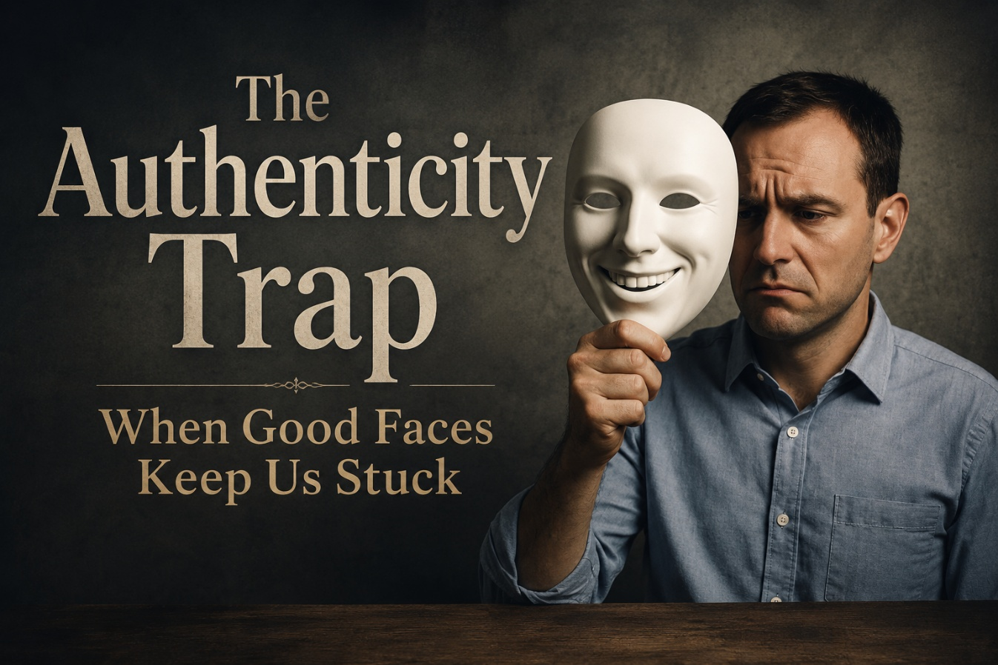

What Is Authenticity, Really?
Let’s talk honestly about something most of us instinctively avoid. Not because we are incapable of talking about it, but because many of us have become remarkably skilled at hiding from it without even realizing we are doing so.
I am talking about authenticity. Not the polished social media version. Not curated vulnerability. Not carefully managed emotional branding. I mean genuine authenticity, the kind that cuts through the fog and the façade and brings you face to face with your fears, your contradictions, your grief, your wounds, your beauty, and your desperate need for grace.
One of the hardest things for many men entering recovery at Holdfast and AnchorPoint is that they arrive wearing a face they have often worn for years, sometimes decades. It is the face that says, “I’m doing good,” or “I’ve got this,” or “Praise God, brother, I’m solid.” We all know the script because most of us have performed some version of it ourselves at one time or another.
There is nothing inherently wrong with wanting to appear strong. There is nothing wrong with trying to stay hopeful or encouraging others. But when strength quietly becomes a mask, when the performance becomes so rehearsed that even you begin believing it, something dangerous happens. You lose contact with the deeper truth of your own inner world. Once that happens, real healing quietly stalls because the parts of you that most need compassion remain buried beneath the performance.
Managers, Firefighters, and Exiles

In Internal Family Systems language, what we are often witnessing is an inner system increasingly dominated by protective parts.
The manager parts step in early. They learn to preserve appearance, maintain control, and prevent shame from surfacing into awareness. The manager quietly says, “Do not let anyone see how afraid you are. Do not let them see the grief. Do not let them see the loneliness, the terror, or the shame.” So you adapt. You become polished, productive, spiritual, funny, responsible, hyper competent, or endlessly helpful. You learn how to say the right things in group. You become the encourager. You volunteer to pray. You become the guy everyone else thinks has it together.
But underneath all of that, there is often another part still carrying enormous pain.
IFS refers to these wounded places as exiles. They are the younger, burdened, vulnerable parts of us that carry shame, abandonment, grief, terror, humiliation, rejection, and loneliness. Over time they become buried beneath layers of protection because at some point the nervous system concluded the pain was simply too overwhelming to feel directly.
But buried does not mean healed. And the only path toward those exiles is courageous, compassionate authenticity. Not performative religion. Not pretending to be healed. Not toxic positivity. But honest presence with what is actually true inside us.
The Lie of Spiritual Bypassing
Sometimes we call it spirituality when what we are really doing is spiritual bypassing.
It is an easy trap to fall into, especially in Christian environments. We quote Scripture fluently. We pray eloquently. We say all the right things while quietly avoiding the wound underneath. Jesus confronted this tendency directly when He spoke of whitewashed tombs, polished externally while death and emptiness remained hidden underneath.
“The Lord is near to the brokenhearted and saves those who are crushed in spirit.”
Psalm 34:18
I deeply believe in transformation. I believe in the Holy Spirit. I believe in redemption, freedom, and healing. But the gateway to genuine healing is not pretending you are already free. The gateway is honesty. You will never heal wounds you refuse to acknowledge, and you will never reach your exiles by pretending they are not there.
Nor will you fully live from your God given Self while frightened protective parts continue running your internal world from behind the curtain.
When the Mask Cracks

Eventually the façade begins to fail. No human being can endlessly maintain emotional performance without cost.
The mask cracks, and when that happens firefighter parts often rush in immediately to extinguish the emotional pain before it fully surfaces into awareness. But firefighters do not protect through healing. They protect through distraction, numbing, impulsivity, and escape.
For one person it may be alcohol. For another it may be pornography, rage, gambling, overworking, compulsive relationships, endless scrolling, hookups, adrenaline seeking, or emotional shutdown. Whatever form it takes, it initially feels like relief. But underneath, it is destruction.
“There is a way that seems right to a man, but in the end, it leads to death.”
Proverbs 14:12
The deeper problem is not merely the behavior itself. The deeper problem is that the original wound was never truly addressed. Positivity became a manager strategy rather than genuine peace, and eventually the firefighters arrived with gasoline and matches to keep the exile from being felt. What looks like self-destruction on the outside is often a desperate attempt by the nervous system to avoid unbearable emotional pain.
Rediscovering the True Self
Your true Self is something much deeper than the mask you constructed to survive.
In IFS language, the Self is the calm, compassionate, grounded center that remains underneath all the woundedness and all the protective strategies. From a Christian perspective, I would say this reflects something profoundly sacred, the person God created before shame distorted the story.
That Self is still there, but it often becomes buried beneath years of fear, trauma, addiction, performance, and self protection. IFS describes the Self through qualities such as calm, clarity, curiosity, compassion, confidence, courage, creativity, and connectedness. Those qualities are not performative spirituality or religious image management. They emerge when the exile is finally welcomed and the firefighters no longer have to panic.
In Christian language, this sounds remarkably similar to the fruit of the Spirit.
“But the fruit of the Spirit is love, joy, peace, patience, kindness, goodness, faithfulness, gentleness, and self-control.” Galatians 5:22 to 23
These are not qualities we manufacture through performance and willpower. They emerge gradually when we surrender the mask, tell the truth, allow compassion toward our wounded places, and open ourselves honestly to the love of God.
“While we were still sinners, Christ died for us.” Romans 5:8
“Surely you desire truth in the inward parts. You teach me wisdom in the inmost place.” Psalm 51:6
Let the Mask Fall
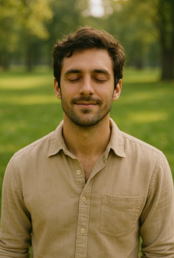
So, stop pretending. Not because you are bad for having learned to survive this way, but because the strategy is no longer serving you.
The smile hiding your fear is not freedom. The verse quoted to avoid grief is not faith. And the performance you perfected is not your true identity.
Recovery begins the moment a person begins telling the truth. Truth to themselves. Truth to their brothers. Truth to God. Authenticity is not perfection. It is honesty in motion.
You do not have to become perfectly healed before becoming deeply loved. You simply have to become real.
Take the mask off slowly and compassionately. Sit honestly with the parts of you that hurt. Allow the Spirit of God to move gently into the wounded places you spent years trying to outrun.
That is where healing begins.
More soon from the sandbox,
Dr. Jeff



Faith That Costs Something
We live in a culture increasingly addicted to comfort, speed, approval, and emotional safety. In such an environment, integrity often becomes dangerous because genuine faith eventually asks something costly of us. It demands courage, sacrifice, and a willingness to stand firm even when doing so threatens our comfort, reputation, career, or sense of belonging.
Real faith is not sentimental. It is not ideological tribalism wrapped in religious language. Nor is it passive niceness masquerading as virtue. Authentic faith confronts us with difficult questions about conscience, truth, suffering, and moral responsibility. At some point every human being must decide whether they will ultimately bow to convenience or to conviction.
Yet strangely, it is often through that very cost that the human soul becomes most fully alive. When a person chooses integrity over approval, something deep within them begins aligning. There emerges a quiet clarity of conscience, a sense of internal coherence that cannot be manufactured through comfort or performance alone. The soul awakens when it no longer has to live divided against itself.
Dostoevsky and the Weight of Conscience
Fyodor Dostoevsky understood this reality profoundly because he lived it. Nearly executed and later exiled for his beliefs, he experienced firsthand what happens when human beings are forced to wrestle with suffering, morality, fear, and conscience.
In Crime and Punishment, Raskolnikov attempts to justify evil in service of what he imagines to be a higher rational purpose. He convinces himself that certain people possess the right to transcend ordinary morality for the sake of some greater good. But the deeper story Dostoevsky tells is not ultimately about crime. It is about spiritual fracture. It is about what happens when human beings sever themselves from reverence, humility, and moral truth.
Raskolnikov’s collapse is not merely psychological. It is spiritual. Guilt slowly devours him because the soul cannot indefinitely violate conscience without consequence. Dostoevsky recognized that rationalism detached from moral reverence eventually leads toward fragmentation, despair, and alienation.
Yet he also believed redemption remained possible. Through confession, suffering, humility, grace, and love, the human soul could slowly find its way home again. That theme runs through nearly everything he wrote, and perhaps it remains even more relevant now than in his own century.
The Courage to Stand Alone
History offers repeated examples of men and women who chose conscience over safety.
Dietrich Bonhoeffer resisted Nazism at the cost of his life. Viktor Frankl clung to meaning and spiritual dignity while enduring the horrors of Auschwitz. Aleksandr Solzhenitsyn confronted Soviet repression with truth when silence would have been far safer.
Their lives remind us that integrity is rarely convenient. It often isolates. It frequently wounds. And yet those individuals continue inspiring generations precisely because they refused to betray what they knew to be sacred.
In our own time, I believe there are also courageous physicians, clinicians, and advocates willing to stand against ideological conformity even when doing so invites criticism or professional risk. Figures such as Dr. Laura Haynes, Dr. Quentin Van Meter, Dr. Andre Van Mol, Dr. Michael Laidlaw, and Dr. Michelle Cretella have all endured varying forms of opposition because they chose to speak according to conscience rather than simply follow cultural momentum.
I mention them not because I see them as flawless heroes, but because standing against dominant narratives always exacts a price, and too often we forget the emotional, professional, relational, and spiritual burden carried by people who choose integrity over compliance.
I have walked portions of that road myself. Not because I see myself as extraordinary, but because I eventually realized I could no longer comfortably live in contradiction to what I believed to be true. There is a cost to standing apart from prevailing systems and ideologies. But there is also a profound peace that comes from no longer betraying your own conscience.
The High Cost of Integrity
Choosing integrity sounds noble in theory, but in practice it often feels lonely.
There are losses attached to conviction. Friendships sometimes fracture. Institutions retaliate. Misunderstandings multiply. People project motives onto you that bear little resemblance to reality. There are seasons where standing for what you believe feels less heroic and far more exhausting.
I have experienced betrayal, false accusations, professional consequences, and painful isolation at different points in my life and career. Those experiences leave marks on the nervous system and on the heart. Human beings are relational creatures, and rejection hurts far more deeply than many people admit.
Yet despite those losses, I have also discovered something remarkably steady underneath it all. There is a kind of peace that emerges when a person stops living divided. It is difficult to describe fully, but it feels like alignment between conscience, conviction, faith, and identity.
That peace cannot be purchased through approval. Nor can it be manufactured through image management. It grows slowly through obedience to conscience and faithfulness to what one believes is sacred.
NeuroFaith™ as Sacred Resistance
Part of what led me toward developing the NeuroFaith™ model was an inability to accept shallow answers to deep suffering. I could not remain comfortable watching human beings reduced merely to diagnoses, symptom clusters, or medication management algorithms while the deeper dimensions of trauma, attachment, nervous system dysregulation, identity, grief, and spiritual longing remained insufficiently explored.
That journey eventually led me into collaboration with Pastor Earl Heverly and Tim Hayden as we worked to shape the NeuroFaith™ framework into something more integrated, relational, and deeply human. The model drew from polyvagal informed therapy, neurocardiology, Internal Family Systems, trauma research, attachment science, and Christian spiritual formation.
But at its heart, NeuroFaith™ was never simply an academic project. It became a protest against reductionism. It was a refusal to accept that human beings are merely biochemical machines requiring symptom suppression. It was an insistence that healing must involve the nervous system, the heart, relationships, meaning, identity, and the soul itself.
That kind of work is slower. Harder. Less marketable. It resists transactional approaches to therapy that promise quick fixes while leaving deeper wounds untouched. But I believe authentic healing often requires exactly that kind of deeper work, work that restores connection, regulates the nervous system, heals trauma, rebuilds identity, and reconnects human beings to both truth and transcendence.
A Call to Sacred Integrity
We are living through a cultural moment that desperately needs courage anchored in humility, compassion, and truth.
The easier path will almost always be the path of silence, sedation, conformity, and self-protection. The harder path is steeper and often lonelier. But it is also the path that preserves integrity, awakens conscience, and keeps the soul alive.
The road of integrity is not for the faint of heart. It strips illusions away. It exposes fear. It forces people to confront what they truly believe. Yet it also offers something the easier road never can: the deep internal peace that emerges when a person no longer lives divided against themselves.
This is an invitation to resist cynicism, reductionism, cowardice, and spiritual numbness. It is an invitation to reclaim conscience, compassion, wisdom, and courage. Whether you are a clinician, parent, pastor, student, or simply a weary human being trying to remain faithful in confusing times, the invitation remains the same.
Stand. Speak truth with humility. Refuse to betray what is sacred. And do not lose your capacity for love while doing so.
“Be on your guard; stand firm in the faith; be courageous; be strong. Do everything in love.” 1 Corinthians 16:13 to 14
“Am I now trying to win the approval of human beings, or of God? If I were still trying to please people, I would not be a servant of Christ.” Galatians 1:10
Integrity may cost you something. But sometimes the greater tragedy is what happens to the soul when integrity is surrendered.

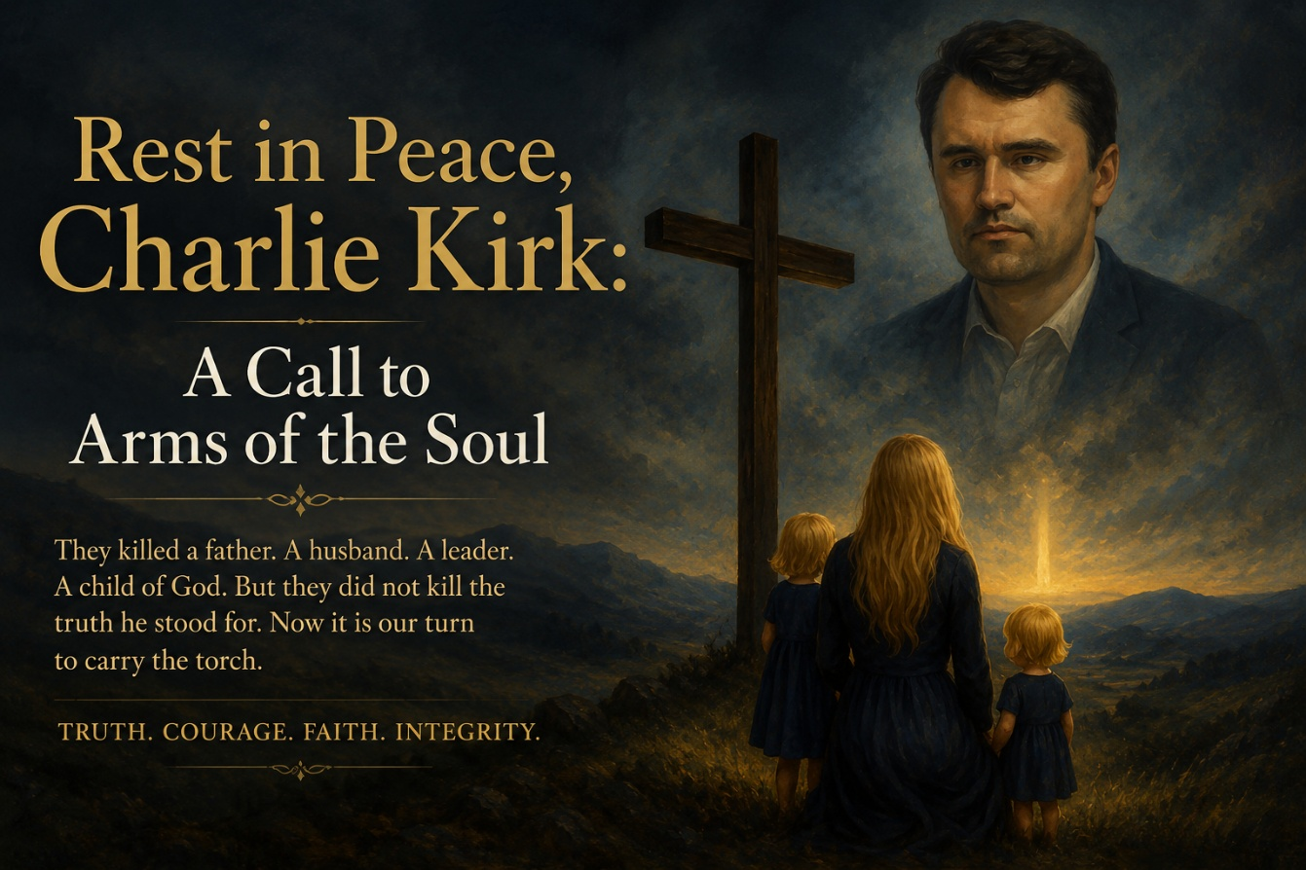

Grief and the Weight of Loss
There are moments in history that strike the heart with unusual force. Moments that leave people stunned, grieving, reflective, angry, fearful, and searching for meaning all at the same time.
The death of Charlie Kirk has become one of those moments for many people.
A husband is gone. A father is gone. A son is gone. A human being created in the image of God is gone.
And regardless of where one stood politically, the loss of a young life always carries sorrow with it. Human beings are not abstractions. They are souls. They are stories. They are relationships. They are people deeply loved by others.
This may be the most emotionally difficult essay I have written in a long time because it touches not only politics and ideology, but grief, fear, conviction, mortality, faith, and the increasingly fractured emotional condition of our culture.
Yet even in sorrow, I believe moments like these can become invitations. Invitations not toward hatred or vengeance, but toward reflection, courage, humility, and moral seriousness.
A Life Lived Publicly
Charlie Kirk lived publicly and intensely. He entered cultural battles that many people avoided, and he did so with unusual boldness for someone so young. He challenged institutions, confronted ideas he believed were dangerous, and spoke with a confidence that drew both deep admiration and deep criticism.
Whether one agreed with him or not, few would deny that he believed deeply in what he was doing.
There is something sobering about watching a young person pour themselves so completely into conviction and purpose. It reminds us that life is fragile, time is short, and human beings often long to give themselves to something larger than comfort or personal success.
In some ways, that longing reflects something profoundly spiritual within the human condition. We are not merely creatures seeking pleasure or safety. We are creatures searching for meaning.
Viktor Frankl understood this deeply. Having endured unimaginable suffering in Auschwitz, Frankl concluded that the human being can endure almost any “how” if they possess a meaningful “why.” Meaning, purpose, and conviction are not small things. They shape the soul itself.
Ideology, Fear, and Cultural Fragmentation
We are living through an era of profound cultural fragmentation. Political disagreement increasingly feels less like disagreement and more like moral warfare. People are no longer merely arguing about policy. They are arguing about identity, morality, truth, family, sexuality, religion, and the future meaning of civilization itself.
That emotional intensity has consequences. Fear grows. Suspicion grows. Human beings begin seeing one another less as neighbors and more as enemies.
And when ideological certainty becomes untethered from humility, compassion, and careful reflection, cultures become dangerous places.
History repeatedly warns us about what happens when political or ideological systems begin treating people as expendable in service of some supposedly higher cause. The twentieth century alone witnessed staggering human suffering under authoritarian movements from both the far left and the far right. Millions died under systems that promised utopia while gradually eroding conscience, dignity, and human worth.
That history should humble all of us. No ideology is immune from corruption once human beings begin valuing power more than truth, or tribal victory more than moral responsibility.
My Own Reflections
About a year ago, I spoke publicly at an event where I addressed pornography, adolescent suffering, family breakdown, and the growing sexualization of children within aspects of modern culture. In the aftermath, I experienced criticism, distortion, and attempts to frame my views in ways that did not accurately reflect either my intentions or my heart.
That experience affected me more deeply than I expected. Not because criticism itself is unbearable, but because it revealed how quickly public discourse can become dehumanizing. People stop listening carefully. Motives are assigned. Complex human beings become flattened into ideological caricatures.
And once that happens, empathy begins collapsing.
I think many people across the political spectrum feel this exhaustion now. They feel trapped inside a culture increasingly organized around outrage, suspicion, performance, and fear.
A Call to Moral Courage
Still, I do not believe the answer is hatred, vengeance, or violence. I do not believe the answer is allowing grief and fear to harden the heart until human beings can no longer recognize one another as people created in the image of God.

The deeper challenge before us is moral and spiritual. Can we remain courageous without becoming cruel? Can we defend conviction without losing compassion? Can we resist cultural pressure without surrendering our humanity in the process? Those are far more difficult questions than simply choosing political sides, because they require not merely political passion, but emotional maturity, humility, restraint, and wisdom.
Scripture reminds us repeatedly that human beings are called not merely to defend truth, but to embody truth through love, courage, humility, and self-control.
“Be on your guard; stand firm in the faith; be courageous; be strong. Do everything in love.” 1 Corinthians 16:13 to 14
That final sentence matters deeply. Do everything in love. Not everything in rage. Not everything in contempt. Not everything in fear.
Love does not mean passivity, weakness, or surrendering conviction. But it does mean refusing to lose sight of the humanity of those with whom we disagree. It means remembering that beneath ideology, politics, fear, and tribalism are wounded human beings often searching for meaning, identity, belonging, and hope.
Carrying the Torch Carefully
For those who admired Charlie Kirk, the temptation will be to turn grief into fury. But I suspect a wiser response would be to allow grief to deepen seriousness about how we live, how we speak, how we engage one another, and how carefully we steward conviction.
We should defend truth carefully. We should protect children carefully. We should confront harmful ideologies carefully. But we should also remember that the human soul is easily poisoned by hatred, pride, vengeance, and moral certainty detached from humility. That danger exists for every side, every movement, and every ideology.
Perhaps that is the deeper challenge of our cultural moment. Not merely whether we will fight for what we believe, but whether we can do so without becoming consumed by the very darkness we claim to resist. History repeatedly reminds us that human beings are fully capable of committing profound harm while convinced they are morally righteous. That reality should humble all of us.
Final Reflections
Charlie Kirk’s life clearly impacted many people. His death has left genuine grief behind, and perhaps moments like these should remind all of us how fragile life truly is. None of us are promised tomorrow. None of us fully control how much time we are given. Life moves quickly, and in the midst of cultural battles it is easy to forget that we are mortal human beings trying to make sense of a complicated world.
So maybe the deeper question is not simply what side we stand on politically. Maybe the deeper question is who we are becoming internally while we stand there. Are we becoming people marked by integrity, courage, humility, wisdom, and truth? Are we remaining awake morally and spiritually in a culture that increasingly rewards outrage more than reflection?
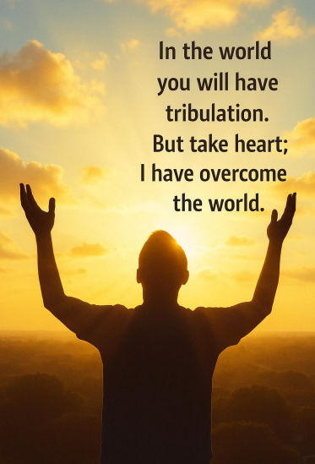
Will we continue speaking honestly even when it costs something? Will we protect what is sacred without surrendering compassion? Will we resist the temptation to reduce human beings into enemies and caricatures? Those questions matter profoundly because the condition of the soul ultimately shapes the condition of culture.
I believe one of the great temptations of our time is to slowly lose our capacity for careful thought, empathy, humility, and moral seriousness. Outrage is easier. Tribal certainty is easier. Hatred is easier. But none of those things ultimately heal human beings or restore cultures.
Perhaps the deeper calling is to become people capable of standing courageously for truth while refusing to surrender tenderness, compassion, wisdom, and restraint. That is not weakness. In many ways, it may require far greater strength.
Scripture reminds us that light does not overcome darkness by becoming darker itself.
“The light shines in the darkness, and the darkness has not overcome it.” John 1:5



The Heart as More Than a Pump
Today I have the privilege of speaking about the heart, not merely as a cardiologist or neuroscientist might describe it, but as God Himself describes it, as the very center of who we are.
Our culture often reduces the heart to nothing more than a pump, a machine that pushes blood through vessels. But the truth is infinitely deeper. The heart is not a machine. It is a masterpiece, a sacred work of art designed by God Almighty as the throne room of the Spirit. It is where physiology and theology, biology and doxology, science and Spirit come together in magnificent convergence.
“Above all else, guard your heart, for everything you do flows from it.” Proverbs 4:23
Scripture speaks constantly of the heart because God understands something modern culture often forgets. Human beings are not merely rational creatures processing information. We are relational, emotional, embodied, spiritual beings who live through attachment, resonance, meaning, worship, love, and connection. The heart stands at the center of all of it.
In many ways, the heart becomes the meeting place between the physical and the spiritual, between breath and being, between the seen and the unseen. Science may measure portions of its activity, but only God fully comprehends the majesty of what He has created.
HeartMath®, Neurocardiology, and the Rhythm of Breath
HeartMath® and neurocardiology have revealed astonishing truths about what God has woven into the fabric of our being. With every breath we take, the nervous system shifts rhythmically between activation and restoration. The in breath gently stimulates the sympathetic nervous system, preparing us for engagement and action. The out breath activates the parasympathetic system, calming the body and restoring balance.
This rhythm of inhale and exhale is not accidental. It is divine design.
When the heart maintains healthy variability, what HeartMath® often refers to as coherence, the mind becomes clearer, emotional regulation improves, physiological stress decreases, and the body begins functioning with greater harmony and adaptability. In many ways, coherence reflects internal alignment. The nervous system settles. Fear loosens its grip. Human beings become more emotionally present, relationally open, and spiritually receptive.
“The Lord is close to the brokenhearted and saves those who are crushed in spirit.” Psalm 34:18
Trauma, chronic stress, shame, resentment, grief, emotional isolation, and fear all disrupt this coherence. Human beings lose rhythm internally. The nervous system becomes defensive and dysregulated. Hypervigilance increases. Exhaustion increases. Relationships suffer. The body itself begins carrying the burden of unresolved suffering.
And yet remarkably, practices rooted in calm breathing, gratitude, prayer, worship, emotional honesty, relational safety, and compassionate connection can begin restoring coherence once again. In this way, modern neuroscience quietly echoes ancient spiritual wisdom. God designed the human being for connection, peace, rhythm, relationship, and love.
The Heart as Spirit and Mystery
And yet the heart is more than biology alone.
It is also mystery.
The heart sings a song that science can partially measure, but only God can fully compose.
Modern research demonstrates that the heart generates the strongest electromagnetic field in the human body, measurable several feet beyond us. HeartMath® studies suggest that human beings physiologically influence one another in subtle but meaningful ways. Calm spreads. Fear spreads. Peace spreads. Emotional states ripple through relationships and communities more profoundly than we often realize.
Science calls aspects of this coherence.
Scripture might call it something deeper.
“Deep calls to deep.” Psalm 42:7
Even more fascinating are reports from certain heart transplant recipients who later describe changes in emotional preferences, cravings, memories, or tendencies that appear connected to their donors. Science approaches such findings cautiously, and rightly so, yet they still remind us that human beings remain far more mysterious than reductionistic models often acknowledge.
“I will put my law in their minds and write it on their hearts.” Jeremiah 31:33
I often think about vast aspen groves when reflecting on this reality. What appear to be separate trees standing independently above the surface are actually connected underneath through a shared root system. Entire groves are quietly linked together beneath the ground.
Human beings are much the same.
“You are the body of Christ, and each one of you is a part of it.” 1 Corinthians 12:27
We affect one another far more deeply than we realize. Hearts influence hearts. Souls shape souls. Human beings were never designed to heal in isolation.
Application at Holdfast Recovery and AnchorPoint
This speaks directly to the work we do at Holdfast Recovery and AnchorPoint. This is not abstract theory. This is about life, healing, nervous system regulation, emotional safety, spiritual restoration, and human connection.
Trauma imprints itself into the body and into the rhythms of the heart. Chronic fear, addiction, shame, betrayal, abandonment, grief, and emotional wounds all leave physiological fingerprints upon the nervous system. People do not simply think trauma. They carry it.
If we are to help people heal, we must recognize that recovery involves far more than information transfer or behavioral compliance. Healing requires safety. It requires coherence. It requires relationship. It requires emotional honesty, spiritual depth, nervous system regulation, and compassionate human presence.
And this applies not only to clients, but to staff.
As Holdfast Recovery and AnchorPoint continue growing, we must become increasingly intentional about the emotional and spiritual atmosphere we create together. Staff relationships matter profoundly. The nervous system of an organization affects everyone inside it. When staff embody calm, coherence, humility, compassion, honesty, emotional regulation, and love, clients feel it long before they intellectually understand it.
We become a living sanctuary.
Clients stepping into our care must not merely hear knowledge from us. They must experience love radiating through the way we speak, regulate, respond, listen, and care.
Jesus said:
“By this everyone will know that you are my disciples, if you love one another.” John 13:35
The Call
So yes, ultimately this is about love. Deep love. The love of God poured into human hearts through the Holy Spirit. A love that is sacrificial, embodied, relational, and radiant. A love that is not merely thought intellectually but felt physiologically and spiritually. A love that resonates through nervous systems, relationships, communities, and souls alike.
This is why the heart matters.
This is why the Spirit matters.
And this is why truly transformative therapy must ultimately involve both.
Today we step further into that calling, not only for our own health and coherence, but for the healing of every person entrusted into our care.
For the heart is far more than a pump. It is, in many ways, the throne room of the King. And when He reigns there, His resonance flows outward, shaping us, shaping our relationships, shaping our communities, and touching every life we encounter.
As we gather together today, may we come with open minds, open hearts, and open spirits. May God equip us not merely with knowledge, but with wisdom. Not merely with technique, but with compassion. Not merely with skill, but with Spirit.
And may we apply what we learn in ways that genuinely help heal human beings, restore families, calm nervous systems, save lives, and ultimately draw people toward redemption through Christ Jesus our Lord.



The Weight of Responsibility
I have wrestled with this for a long time. When I was invited to step into the role of a director, it felt both like a calling and a gift. It carried the possibility of impact, the opportunity to bring together years of training, experience, conviction, and faith into a role where lives could genuinely be changed. In many ways, it has been exactly that. Few things have felt more sacred to me than walking beside people through the wilderness of trauma and addiction, standing at the threshold where brokenness meets the possibility of transformation.
But every gift carries a burden. Responsibility always has weight, and this one has often felt heavier than I expected. There are days when it feels as though I carry the responsibility of vision without always possessing the authority to fully bring that vision into being. That tension is not easy. It tests my patience, my humility, and ultimately my faith.
What makes the struggle difficult is that I can often see the potential so clearly. I imagine what could be: a program expanded, a truth spoken more boldly, a resource provided, a strategy refined, a deeper path toward healing created for the people entrusted into our care. The vision comes quickly to me. But reality rarely moves at the pace of vision. In the space between what I can see internally and what unfolds externally, frustration quietly stirs. Not bitterness exactly, but longing. A holy discontent. A sense that we are standing near something greater while still struggling to fully step into it.
The Short Vision and the Long Calling
I have always carried what I call a short vision. Ideas come quickly to me. I can often see solutions before the problem is fully explained. My mind races ahead toward outcomes, possibilities, and strategies long before the first practical step has even begun. In many ways, that gift has served me well. It has fueled creativity, leadership, innovation, and the building of programs that genuinely help people.
But gifts also carry hidden dangers.
The short vision often outruns the long calling. I become frustrated not because the vision itself is wrong, but because timing moves more slowly than my imagination. Others may not immediately see what I see. Systems may resist movement. Institutions often evolve gradually while my mind is already miles ahead.
And somewhere in that delay, ego begins whispering.
Ego tells me I should be recognized more quickly. Ego insists that if others truly valued my insight, they would move faster. Ego tempts me to measure my worth by influence, visibility, affirmation, or control rather than by faithful obedience to what God has actually asked of me.
The deeper battle is not merely organizational or professional. It is internal. It unfolds quietly inside my own soul.
The Battle of Ego
There have been moments when I seriously considered walking away. More than once, I carried a resignation letter tucked quietly into my bag, ready to release it into the world. Ego told me leaving would prove my worth. Ego framed departure as dignity, as control, as vindication.
But God interrupted me.
The Spirit whispered restraint.
And deep down, I knew I could not follow ego’s script while still claiming to follow Christ.
My wife has often been a steady voice in that battle. She refuses to feed my pride. She sees me not merely for who I am, but for who I am called to become. She reminds me that the mission is bigger than my emotions, bigger than my frustration, and certainly bigger than my ego. Her honesty has often become a kind of safeguard for my soul when ambition, hurt, or pride become too loud internally.
And then there are the words of Charlie Kirk that continue echoing in my mind:
“You are about to embark on something that is bigger than yourself. So, check your ego at the door. I do not care about your feelings or if you have had a bad day. Go figure that out on your own. This is not about you.”
Those words strike me differently now that he is gone. His death still aches in ways I did not fully expect, but his challenge remains. If I make the mission about myself, I ultimately dishonor the very work I claim to serve.
My pastor has reinforced that lesson repeatedly. He reminds me that Christ Himself endured betrayal, ridicule, rejection, misunderstanding, and suffering, yet continued forward with obedience and love. That example humbles me every time I reflect upon it.
So here I stand in the tension between ego and calling, pride and obedience, frustration and surrender. One voice says walk away. Another says endure. And the battle between those voices is not theoretical. It is deeply personal.
Scripture and the Higher Call
Scripture repeatedly pulls me back toward humility when ego begins tightening its grip.
“Do not repay anyone evil for evil.” Romans 12:17
“Do not be overcome by evil, but overcome evil with good.” Romans 12:21
“Do nothing out of selfish ambition or vain conceit. Rather, in humility value others above yourselves.” Philippians 2:3
“Let us not become weary in doing good, for at the proper time we will reap a harvest if we do not give up.” Galatians 6:9
These verses confront something deep within me. They remind me that calling is rarely about personal recognition. More often, it is about surrender, endurance, obedience, and faithfulness over long stretches of time where outcomes remain uncertain.
The Higher Call
So, I remain here, standing in the tension between vision and reality, ego and calling, frustration and obedience. My short vision sees possibilities rushing toward me, while the long calling asks me to trust God’s timing rather than my own urgency.
More and more, I am realizing this is not ultimately about my influence, my comfort, or my pride. It is about people searching desperately for hope. It is about families longing for healing. It is about wounded human beings trying to reclaim their lives. It is about Christ entering broken places and slowly bringing restoration where despair once lived.
Perhaps the obstacles, delays, frustrations, and disappointments are not evidence of failure at all. Perhaps they are part of the formation itself. Perhaps the struggle is shaping something deeper than success ever could.
The work matters because it extends a hand of healing. Not through my ego. Not through my control. But through Christ.
And that is where the hope ultimately rests.
So no, I am not done. Not yet.
The road still stretches ahead. My ego may resist it at times, but somewhere deeper my spirit already knows the truth. The calling is greater than my pride. The mission is worth more than my comfort. And the work of healing wounded human beings remains too sacred to abandon lightly.
So I keep walking forward, imperfectly, prayerfully, and with growing awareness that the higher call was never about building myself in the first place. It was always about surrendering myself to something greater.

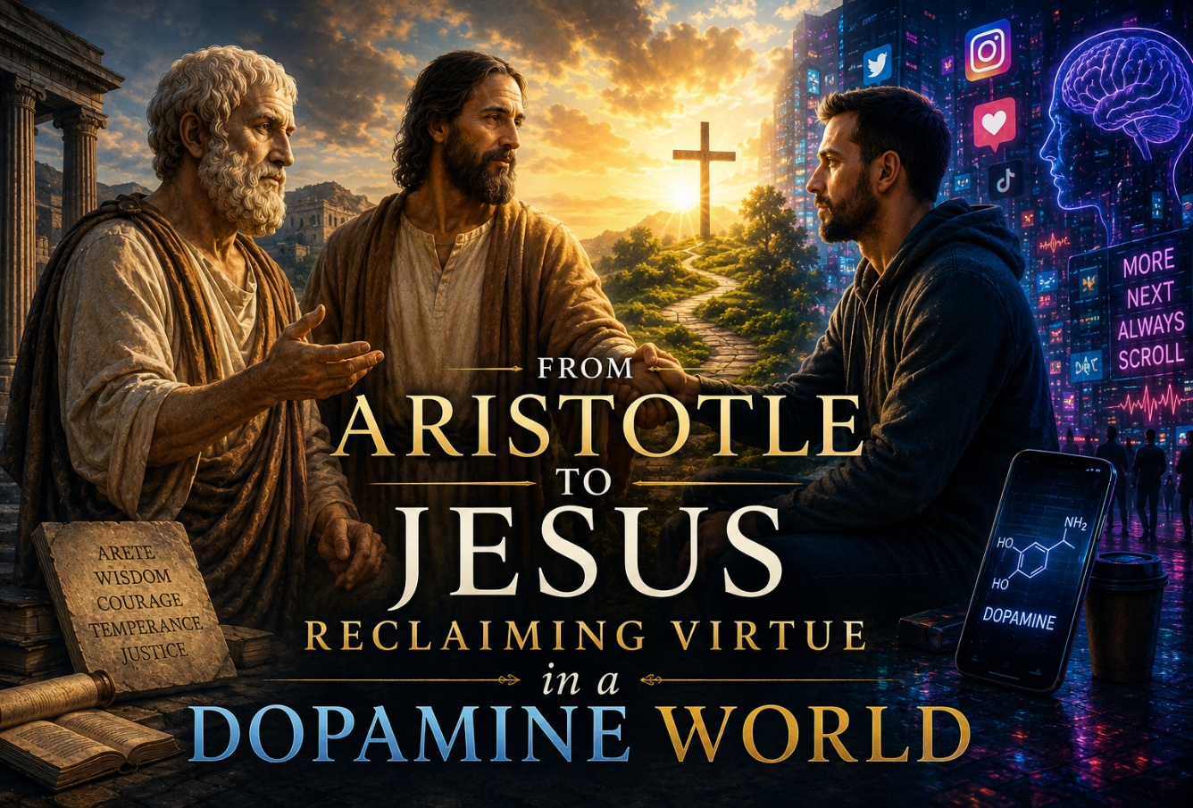

Aristotle and the Practice of Virtue
Aristotle lived nearly 2,400 years ago, but his voice still echoes across time. A student of Plato and tutor to Alexander the Great, Aristotle built his philosophy on the observation that we become what we practice. To live well is not a matter of chance. It is the art of cultivating virtue.
For Aristotle, virtues like courage, wisdom, and temperance were not abstract ideals but habits. He believed that a flourishing life, what he called eudaimonia, came not from indulgence but from aligning daily choices with higher values. If you practice bravery, you become brave. If you practice honesty, you become honest. Life is a gymnasium for the soul.
A Dopamine Driven World
Fast forward to today. We live in what could be called a dopamine driven world. Our phones buzz, our feeds refresh, and our attention is captured in milliseconds. Aristotle would warn us: if we practice distraction, we become distracted. If we practice superficial pleasures, we risk becoming shallow. Virtue is still about practice, but so is vice.
The Apostle Paul echoes Aristotle without ever quoting him, declaring, “The fruit of the Spirit is love, joy, peace, patience, kindness, goodness, faithfulness, gentleness, and self-control” (Galatians 5:22–23). These are virtues not just of the mind but of the Spirit, aligning us with something far greater than ourselves.
Jesus and the Call Beyond Virtue
Jesus takes it further. He invites us not just to live virtuously but to abide in Him, promising that apart from Him we can do nothing (John 15:5). Virtue becomes more than moral effort.
It becomes co creation with the God who designed us in His image.
Vending Machine Christianity
Yet we must admit that in the modern church we have traded this vision for something easier. Much of Christianity in the West has been remade in our image rather than God’s. We prefer shortcuts to sanctification, comfort to sacrifice, consumption to calling. What has emerged is vending machine Christianity. For fifty cents or a buck, you can buy a quick fix.
Worship becomes entertainment. Prayer becomes a wish list. The gospel becomes a product. What we are handed is pseudo nutrition that lacks the costly nourishment of the cross.
The marketed version of Christianity feels quick and easy. It demands little responsibility and offers little transformation. But the true way of the Spirit is anything but cheap. To live in the Spirit is to live virtuously, and the price of living well is the price of suffering, sacrifice, and even death itself. Jesus did not promise a life of convenience. He promised a cross. He did not offer vending machine blessings. He offered the narrow road.

Compromise in the Church
Even among Christians in ministry and those serving in addiction and trauma recovery, compromise has crept in. It is not uncommon to see leaders and helpers who love Jesus and sacrifice greatly, yet live together outside of marriage. They want to carry the message of Christ while quietly setting aside His directives. But this dissonance has a cost.
Aristotle was right that you cannot cheat virtue. Jesus is even clearer that you cannot shortcut discipleship. Paul called it the divided mind. Neuroscience calls it autonomic dissonance. When our bodies live one story and our souls proclaim another, the nervous system does not lie. The body carries the weight of contradiction. And I have seen again and again how this fracture undermines recovery, leaving people vulnerable to relapse and collapse.
I know this because I have walked it myself. When I compromised, chasing achievement and financial gain, God brought me to my knees. I do not speak from superiority but from scars.
God cares more about character than about success, and if you belong to Him, He will do whatever it takes to bring you to humility. He will strip idols. He will allow collapses. He will expose contradictions until the heart is undivided.
To my young colleagues in addiction recovery, I cry out to you. My heart cries out. My soul cries out. Because I have seen what compromise costs. God invites us into coherence, into integrity, into covenant faithfulness, because anything less sets the stage for collapse. There are no shortcuts. No vending machine grace. Only the narrow road, the daily cross, and the peace that comes when body, mind, and Spirit align in Him.
Dopamine and Serotonin
Here we must pause and look at what modern neuroscience reveals. Daniel Lieberman describes how dopamine fuels our craving for more. It drives us forward with restless ambition. Dopamine is not evil. God gave us that system to create, to explore, to reach. But we have elevated dopamine as if it were the only circuit that mattered. We have abandoned its companion, serotonin, which grounds us in the here and now, in connection, in presence, in peace.
Dopamine says, chase the next thing. Serotonin says, be rooted in this moment. Together they can be balanced. Separated, they can enslave. When Christianity becomes dopamine only, it becomes a pursuit of the next high, the next conference, the next spiritual sugar rush. It becomes vending machine faith.
Dying to Self
But Jesus calls us to something harder and deeper. He calls us to die to self. Paul writes, "I have been crucified with Christ, and I no longer live, but Christ lives in me" (Galatians 2:20).
Dying to self means crucifying the addiction to dopamine driven circuitry and embracing the slow, often painful, relational devotion of the Spirit. It means moving from vertical ambition to horizontal connection, from endless craving to abiding love.
Dying to self hurts. It strips away illusions. It feels like loss. Jesus said plainly, "Whoever wants to be my disciple must deny themselves and take up their cross daily and follow me" (Luke 9:23). This is no vending machine. This is no quick fix. This is the way of sacrifice and surrender. Yet it is also the way of blessing. "Unless a kernel of wheat falls to the ground and dies, it remains only a single seed. But if it dies, it produces many seeds" (John 12:24). Death is the seedbed of resurrection life.
The Wisdom of NeuroFaith®
Here is where the NeuroFaith® model enters the story. NeuroFaith® is not something to worship. It is a tool, a lens, a map of God’s intricate design of our body and brain. It honors what neuroscience teaches us about the autonomic nervous system and shows how God embedded His wisdom in our very flesh.
The sympathetic branch, activated by the hypothalamic pituitary adrenal axis, releases adrenaline and cortisol to prepare us for danger. The dorsal vagal system slows us down, collapses our energy, and can even freeze us in protection. But then there is the ventral vagus system. This is God’s masterpiece of connection. The ventral vagus nerve allows us to find safety in relationship, to regulate through presence, to co regulate through love. It is where the Spirit meets us most profoundly, for Jesus restores us not in isolation but in connection with Himself and with one another.
Neurocardiology and the Heart First
And God’s design goes even deeper. Neurocardiology shows us that the heart is not just a pump but a rhythm center, rich in neurons and sensitive to emotional states. When we align with God’s peace, the rhythms of the heart shift into coherence. As we breathe, the sympathetic rise of the heart rate on the inhale is balanced by the parasympathetic fall on the exhale. In coherence, those rhythms become a beautiful sine wave, ordered and harmonious. That coherence is what allows the brain to integrate. In God’s design, the heart comes first, the mind second. "Above all else, guard your heart, for everything you do flows from it" (Proverbs 4:23).
God’s Chemistry of Connection
And even here God has given us relational chemistry. Serotonin grounds us in contentment and presence. Oxytocin deepens our bonds of trust, nurture, and love. The world offers cheap imitations. A quick hookup or a shallow distraction might release a burst of oxytocin or dopamine, but it fades as quickly as it comes. It is counterfeit intimacy. Real peace, real connection, comes only from the Spirit who unites us to Christ and to one another. "The love of God has been poured out into our hearts through the Holy Spirit who has been given to us" (Romans 5:5).
Soaring on Wings of Eagles
NeuroFaith® brings all of this together. It teaches us that our nervous system is not an accident. It is God’s revelation in biology. When the sympathetic system, the dorsal vagal, and the ventral vagus are balanced in Him, when heart coherence is established, when serotonin and oxytocin are aligned with love and connection, then our mind is free to soar.
Not in the empty high of vending machine faith but in the abiding strength of God’s Spirit.
The world tells us to chase highs. Christ calls us to die to self, to find coherence, to live connected, to embody virtue. Aristotle was right that we become what we practice, and Paul was right that the Spirit produces in us love, joy, peace, patience, kindness, goodness, faithfulness, gentleness, and self-control. These are not quick fixes but cultivated fruits. The Spirit gives us dunamis, resurrection power, to integrate body, heart, mind, and soul. The NeuroFaith® vision is to help us walk this road with open eyes, to understand the science of our systems, but to rely always on the Spirit who renews us. For only in Him do we find safety, only in Him do we find peace, and only in Him do we soar. As Scripture reminds us, "Stand firm. Let nothing move you. Always give yourselves fully to the work of the Lord, because you know that your labor in the Lord is not in vain" (1 Corinthians 15:58).

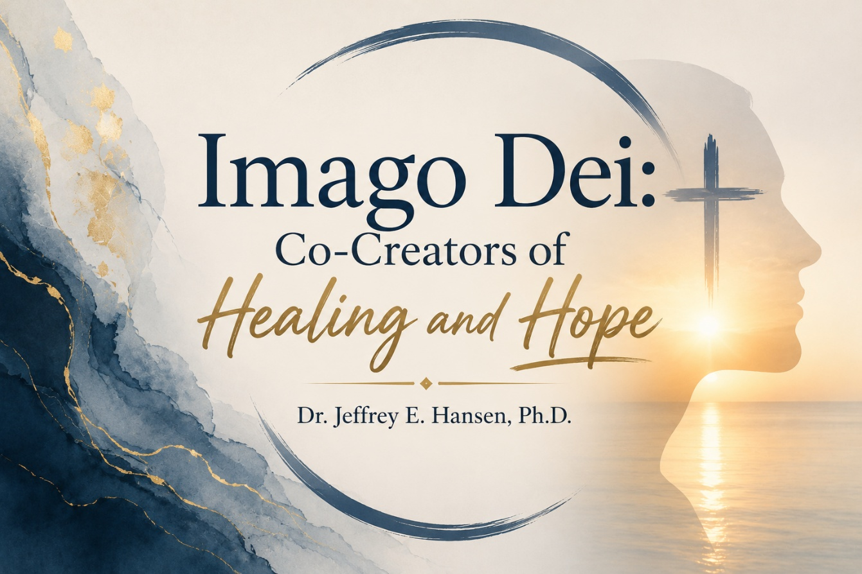

The Sacred Image
“Then God said, ‘Let us make mankind in our image, in our likeness…’” (Genesis 1:26, NIV).
You are not an accident. You are not defined by your trauma. You are not chained by your addiction. You are the Imago Dei, the image of God, crafted in His likeness, sustained by His thought, and called into His purpose.
Thomas Aquinas, one of the greatest minds of the Church, declared that humanity exists as a thought in the mind of God (Summa Theologica, I, Q.93, Art.4). Imagine that. Every breath you take is sustained because the Creator thinks you, wills you, and loves you into existence. That is power. That is dignity. That is destiny.
Co-Creators, Not Counterfeits
Being made in God’s image does not mean we manifest reality on our own terms. Only God creates out of nothing. But it does mean we co-create as we align ourselves with His will and His purposes. We bring His light into darkness when we live out our callings faithfully.
The physician brings healing that reflects the Great Physician.
The psychologist restores broken minds as a reflection of the Wonderful Counselor.
The pastor shepherds souls under the care of the Good Shepherd.
The builder, the teacher, the artist, the firefighter, the soldier, and the parent each reveal God’s creative glory through their work.
Our work becomes worship when it is done in His Spirit. As Paul wrote, “For we are God’s handiwork, created in Christ Jesus to do good works, which God prepared in advance for us to do” (Ephesians 2:10, NIV).
Trauma, Addiction, and the Battle for the Image
Let us be honest. Trauma distorts the image. Addiction chains it down. Shame buries it beneath layers of fear, failure, and lies. But the truth never changes. The image is still there. It cannot be erased. It can only be hidden.
This is why NeuroFaith® exists. In our Moral Faith books and in our clinical work at Holdfast Recovery and AnchorPoint, we seek to show how trauma, addiction, and brokenness attack the image of God within the human person, yet Christ continually moves toward restoration.
Neuroscience now confirms what Scripture has proclaimed for centuries: human beings can rewire, reshape, and renew. Paul declared, “Do not conform to the pattern of this world, but be transformed by the renewing of your mind” (Romans 12:2, NIV). Neuroscience calls it neuroplasticity. Scripture calls it transformation. Either way, God has given us both the science and the Spirit to walk into freedom and healing.
Manifesting Health in His Image
At our centers, we witness this reality every day. Men shattered by trauma often walk through our doors carrying hopelessness and despair. Addiction has stripped away dignity, identity, connection, and hope. Yet as they encounter God’s truth, as they heal in safe relationships, and as they rediscover their worth, the Imago Dei begins shining again.
That is true manifestation. It is not self-help mythology claiming we can demand wealth or comfort through sheer force of thought. True manifestation occurs when the image of God radiates through a human soul set free by His Spirit, when trauma loosens its grip, when addiction loses its hold, and when healing begins flowing outward into relationships, families, and futures.
“Therefore, if anyone is in Christ, the new creation has come. The old has gone, the new is here” (2 Corinthians 5:17, NIV).
The Call
This is your sacred invitation. You are not merely surviving. You are co-creating. You are manifesting God’s kingdom on earth as it is in heaven.
Whether you are in medicine, psychology, teaching, business, writing, firefighting, ministry, or parenting, your work can become holy ground when surrendered to Him.
The NeuroFaith® model is more than treatment. It is a proclamation that neuroscience and faith together testify to the truth of Imago Dei. Trauma does not get the final word. Addiction does not get the final word. Christ does. And His word is freedom. His word is restoration. His word is hope.
So, step into it. Manifest health. Manifest life. Manifest the image of God within you. The world is waiting.
References
Aquinas, T. (1947). Summa Theologica (Fathers of the English Dominican Province, Trans.). Christian Classics. (Original work published ca. 1274).

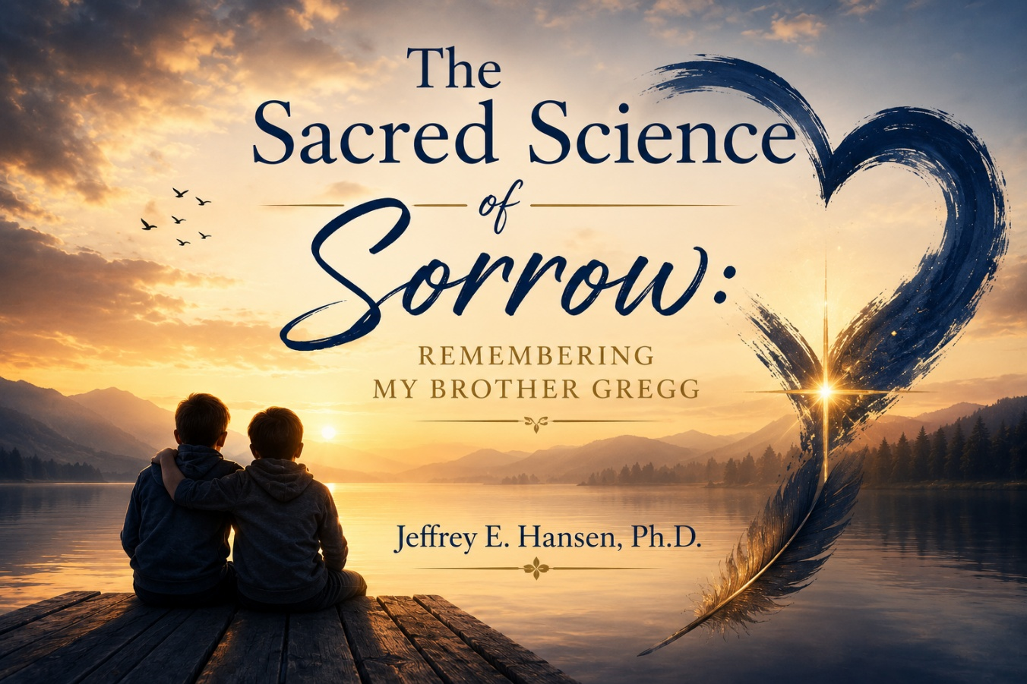

A Twin Bond Forged Through Adversity
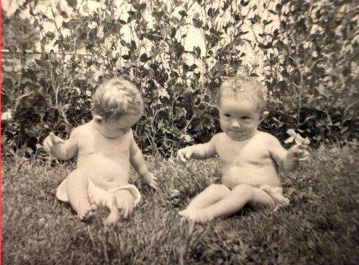
Gregg and I arrived in this world together. We were identical twins, each other’s playmate, confidant, and mirror. Our early years unfolded against the backdrop of intergenerational trauma. My father was a fundamentally good man, but he carried the scars of the savage beatings he had received as a child. He worked tirelessly to provide for our family and broke many of the abusive patterns he inherited, yet the pain of his upbringing sometimes spilled over into his own parenting.
Gregg and I responded to this adversity by overachieving. We collected trophies, maintained near-perfect grades, and treated accomplishment as armor. He always seemed to have an extra gear. He was recruited by the U.S. Air Force Academy for his brilliance in gymnastics as an all-around gymnast, pivoted to engineering and secured a patent with Ford Aerospace, then reinvented himself as a high-end builder and later as an accountant.
I took another route. Realizing I could not match his pace, I leaned into people and connection. Becoming a psychologist taught me that our relationships, not our résumés, heal trauma.
Our divergent strategies defined our adult lives. Gregg continued to chase milestones, believing that the next achievement would finally make him feel “enough.” I chose to cultivate deep relationships, to lean into faith and community. Ironically, my choice saved me when my life unraveled around age fifty. My wife battled melanoma, my daughter was hospitalized for a suspected lymphoma, and the economy collapsed. Overwork and over-acquisition landed me in an emotional breakdown. Therapy, spiritual practice, and the love of others pulled me through.
Gregg’s story would unfold differently. He cycled through episodes of depression, often comparing himself negatively against the impossible standard he had set. In his sixties he withdrew further, eventually moving to Florida and severing contact. On October 11 he died. Time has not healed the hole he left. Even now, reaching for the phone to call him triggers a wave of grief and a physical ache in my chest.
A Promise to Finish His Story
When I sensed I would lose Gregg, I told my wife Leah two things. First, that I could feel his life slipping away, a twin’s intuition reinforced by years of working with trauma. Second, that I would not let his death destroy me. I knew the pain would be profound and enduring, but I decided to lean into the love of family and friends, to ground myself in prayer, and to transform our shared suffering into purpose.
When Gregg died, I whispered to him that I would finish the life he could not. I vowed to take the truth of his beautiful, complicated journey, his victories and struggles, and use it to help others. This blog and my NeuroFaith® model are part of that promise.
The Grieving Body
Mary Frances O’Connor’s book The Grieving Brain emphasizes that grief is not merely emotional. It is embodied. Research shows that the death of a loved one dramatically increases cardiovascular risk. In a 2012 case crossover study, individuals were more than twenty-one times more likely to suffer an acute myocardial infarction in the first day after learning of a significant person’s death, and the risk remained elevated roughly eightfold across the first week.
These findings provide a biological basis for the phrase “broken heart.” Intense emotional stress triggers surges of catecholamines that elevate blood pressure, accelerate the heart, and increase clotting tendency. In some cases the stress “stuns” the left ventricle, causing a temporary condition called takotsubo cardiomyopathy, commonly referred to as broken heart syndrome.
The heart itself is a marvel. It beats roughly 100,000 times per day and sends blood through a circulatory system long enough to wrap around the Earth. Its rhythm is partly governed by the vagus nerve, Latin for “wanderer.” Parasympathetic fibers of the vagus slow the heartbeat and regulate rhythm.
A healthy heart exhibits heart-rate variability. Heart rate rises during inhalation and falls during exhalation, creating a gentle sine-wave rhythm. High HRV reflects flexible vagal control and is associated with resilience and better cardiovascular health, whereas low HRV signals distress and predicts greater risk of disease. In grief, HRV often becomes jagged and dysregulated, mirroring emotional turmoil. The heart becomes an acoumeter for our thoughts, feelings, and motivations.
Attachment and the Brain’s Protest
Attachment theory further illuminates why losing Gregg felt like losing a part of myself. When we form deep bonds, our nervous systems synchronize. The “me and you” become “us.” This neural attunement becomes the baseline from which we explore the world.
The sudden absence of a central attachment figure triggers a protest response. Heart rate and sympathetic arousal rise to fuel the search for the missing person. In bereavement, however, the loss is permanent. Over time our brains slowly learn this new reality. Protest gives way to despair and eventually adaptation.
For me, Gregg had always been a source of co-regulation, someone who could calm my nervous system with a look or a joke. Losing him dysregulated me. I felt like half of “us.” Understanding that this reaction arises from well-studied attachment circuitry helped normalize my grief.
Dan Siegel’s interpersonal neurobiology teaches that our brains and bodies are shaped by relationships, and Mary Frances O’Connor emphasizes that grief is the cost of attachment. Without connection, we cannot heal.
Co-Regulation and Broken Hearts
Interpersonal neurobiology and attachment theory suggest that when we give our heart away, when we fall in love or form a secure bond, we become external pacemakers for each other’s cardiovascular systems. Our heart rhythms synchronize, our breathing aligns, and our vagal tone responds to the presence of the beloved.
Gregg’s heart helped regulate mine, and mine his. Together we formed an “us” at both the emotional and physiological levels.
The benefits of this co-regulation are profound. Polyvagal theory teaches that social connection dampens sympathetic arousal and enhances parasympathetic safety. HeartMath® research shows that shared positive emotion can entrain heart-rate variability into coherent patterns.
Mary Frances O’Connor notes that upon the death of a partner, the surviving person must learn to regulate without this external pacemaker. Tragically, some hearts cannot adapt. The loss of co-regulation may lead to arrhythmia, stress-induced cardiomyopathy, or in some cases literal death from a broken heart.
I experienced the frantic search for Gregg’s regulating presence in my own chest, a racing heart and a sense of being physically unmoored. Recognizing that this reaction was natural helped me extend compassion toward myself and underscored the importance of cultivating new sources of co-regulation.
Facing the Truth
As someone who strives to live in the light of truth, I knew I could not hide from the reality of Gregg’s death. Shortly after his passing, I arranged to meet with Marty, the medical examiner who evaluated him. She kindly offered to walk me through the report.
Reading the report was devastating. It confirmed what I already sensed: Gregg had wasted away in his despair. His weight loss was severe and spoke volumes about how deeply he had given up on living. Yet the report also revealed chronic heart disease. Among his organs, the heart bore the brunt of the damage.
This finding resonated deeply with everything I had learned about neurocardiology. The heart is more than a pump. It is exquisitely sensitive to emotional states. In a very real sense, Gregg died of a broken heart.
Knowing this did not lessen my pain, but it deepened my understanding. It underscored that his death was not simply an act of will. It was the culmination of physiological and psychological stress.
Grief and the Immune System
Loss affects not only the heart and nervous system but also the immune system. The emerging field of psychoneuroimmunology explores how thoughts and emotions influence immune functioning.
Under stress, microglia, the brain’s resident immune cells, can become overactive and produce inflammatory molecules that alter neurotransmission and synaptic pruning. Chronic grief can disrupt serotonin production, increase neuroinflammation, and heighten physiological stress responses.
Stress also reshapes the microbiome. Chronic stress can disrupt gut flora and increase intestinal permeability, fueling systemic inflammation. The vagus nerve communicates these inflammatory states to the brain, further heightening arousal.
Mary Frances O’Connor argues that there is no quick pharmacological fix for this cascade. The best medicine is human connection. Four elements are essential to healing after loss: people, community, belonging, and mattering.
In the months after Gregg’s death, I chose not to isolate. I leaned into faith, family, friendship, and calling. I discovered that some of the most healing moments came not through words, but through the calm presence of people willing simply to sit beside me.
Meaning Making and Resilience
In the months after Gregg’s death, I read The Grieving Brain slowly, allowing its insights to settle from my head into my heart. Integrating neuroscience with faith deepened my resilience.
Knowing that grief disrupts vagal tone and heart rhythms compelled me to practice breathwork and prayer. Recognizing the protest response in my racing heart allowed me gently to remind myself that Gregg was gone and that searching would not bring him back.
Leah, my family, and my community became new sources of co-regulation. I also channeled my energy into this narrative, honoring Gregg by sharing his story and weaving it into the science of grief. The integration of research and personal narrative became healing in itself. It transformed pain into purpose.
Conclusion: Honoring Gregg Through Science and Story
Gregg’s life was a tapestry of brilliance and struggle. He was a gifted gymnast, engineer, and builder, yet he carried the burden of intergenerational trauma and the painful belief that he was never enough.
Our twin bond was soul-deep, and his absence remains a wound that still throbs. Yet grief has also revealed the profound wisdom of our bodies and brains. It has taught me that the heart registers loss in its very beat, that the vagus nerve carries our emotions throughout the body, and that attachment leaves neural imprints that protest when bonds are severed.
It has shown me that faith, breath, and community can restore coherence to a dysregulated heart. Most of all, it has reaffirmed my vow to finish the life Gregg could not, to carry his story forward, and to use the neuroscience of grief to help others find meaning in their pain.
A Letter to Gregg
Gregg, you gave me so much of yourself. You were there for me through my lowest valleys, and you rejoiced with me on the mountaintops. You blessed my life in ways that words fail to capture.

I have chosen not to dwell in the negative space of your absence but to celebrate the value you were, and still are, to me. I will live on the legacy of “us.” I will honor the beauty of our bond and reflect it in all my relationships. I will seek out others who can offer me what you offered, and I will strive to be the blessing to them that you were to me.
I will always love you, Gregg. I will always miss you. I will always ache for you. Yet I will carry your light forward. Your life and our love will inform the way I love others and the way I help those in pain. In celebrating you, I am celebrating the best parts of myself.
And why the red background, you might wonder? It was Gregg’s favorite color. Every motorcycle he owned was indeed red.



There comes a moment in every journey when the light changes. The road that once stretched endlessly ahead begins to bend back toward the familiar, and something in the soul shifts with it. I can feel it now as I drive, the air growing thinner and clearer, the desert light beginning to break through the clouds. The road home has a voice of its own, and I am learning to listen to it again.
These past days have been a season of reckoning. Time away from routine always brings reflection, but this time it has brought more than that. It has brought truth. I have been thinking about Gregg, my twin, my brother, my mirror in so many ways. His absence still cuts through every layer of life. Yet even grief can become sacred when we let it teach us. His life and his death remind me that every breath is borrowed, and every purpose we pursue must finally return to its source.
Grief has a way of stripping away illusions. It clarifies what matters. For years I have poured myself into the institutions of healing, into programs and systems designed to serve, restore, and protect. But I have also seen how easily those systems can lose their way. The world of mental health has become so enamored with its own vocabulary that it sometimes forgets its humanity. I have watched the medicalization of distress, the labeling of the soul as if sorrow were a chemical error. I have seen children misled, parents dismissed, and conscience reduced to paperwork.
I have challenged these systems, often at great cost. I have spoken against the arrogance that calls itself progress, against the institutions that elevate ideology above evidence, and politics above conscience. I have stood with those who defend the right of parents to know, of children to grow, and of therapists to think. And though I have no regret for the battles I fought, I have begun to see that not every battle deserves to be fought forever. The human soul cannot live in constant opposition. It must also find its way to rest.
Your word is a lamp to my feet and a light to my path. (Psalm 119:105)
Aristotle wrote that virtue lies in the mean between extremes. Courage is the balance between recklessness and cowardice. Generosity is the balance between waste and stinginess. I have come to believe that humility is the balance between self-erasure and self-exaltation. Humility does not mean pretending to be less than we are. It means recognizing that whatever we are was given. Ego, on the other hand, is not always arrogance. Sometimes it is simply the inability to stop fighting. Sometimes ego wears the face of conviction. Sometimes it hides behind noble words like mission, duty, or excellence. But underneath, there is always that small voice asking, What if you let go? Would it all fall apart, or would it finally breathe?
I have lived long enough to see how easily the two can blend. In my work as Clinical Director, I have fought to protect truth within systems that often prefer convenience. I have carried the weight of programs, staff, and expectations, convinced that integrity depended on my persistence. But there comes a moment when even the noble fight becomes self-referential, when humility whispers, “You have done enough. Let others carry this now.” That whisper is not defeat. It is wisdom.
He has shown you, O man, what is good; and what does the LORD require of you but to do justice, to love mercy, and to walk humbly with your God.
(Micah 6:8)
I think of Seth stepping into leadership. I see in him the strength of youth, the energy to sustain the mission, and the humility to learn. I also see the temptation of control that all of us face when responsibility feels heavy. I want him to inherit not only the systems we built but the spirit that shaped them. A spirit that values courage over compliance, truth over convenience, faith over fear. That is legacy. That is what must outlive me.
The older I become, the more I recognize the cost of pride disguised as perseverance. I have been proud of my endurance, of my ability to stand firm while others compromise. But even conviction can harden into self-importance if it forgets its purpose. The question that now rises within me is not “How much can I accomplish?” but “What can I release?” The act of letting go may be the most difficult form of leadership there is.
Leah has been my quiet teacher in this. For decades she has moved beside me with patience and steadiness, never demanding recognition, never competing with my purpose. She has carried the unseen weight of my calling. She has followed me through reinventions, relocations, sleepless nights, and long days. And now, as I turn the corner home, I realize that what she deserves most is not another mountain to climb, but a husband who has learned to rest.
Come to Me, all you who are weary and burdened, and I will give you rest.
(Matthew 11:28)
Home is not merely a destination. It is a condition of the soul. It is the place where striving ends and gratitude begins. It is the sanctuary where ambition yields to appreciation, and where love becomes enough. I want to give her that. I want to give myself that. The next chapter of my life must be written with different ink.
My purpose is not finished. NeuroFaith® still calls to me. There is still work to be done, still ideas to refine, still young minds to train. But I no longer wish to do this work through argument. I want to do it through art, through mentorship, through patient creation. I want to teach others that faith and science need not be enemies, that the brain and the soul are two languages telling the same story. I want to model what it means to live with conviction without cruelty, to speak truth without venom, to lead without noise.
Gregg’s memory keeps me honest. He reminds me that time is finite, that wisdom without love is noise, and that the measure of a man is not how loudly he fought, but how faithfully he loved. I hear his laughter in my mind sometimes, that mischievous, knowing tone that told me he understood things words could not express. I carry him home with me. He walks in the silence between thoughts, steady and whole.
Aristotle and Christ meet in this place of return. One taught the reasoned pursuit of virtue; the other embodied the surrender of love. Between them lies the middle way, the place I seek now. It is neither passivity nor domination. It is the quiet strength of peace. To lose one’s life in service of truth and love is to find it in fullness.
The sun is low now as I near Prescott Valley. The road bends, and the sky widens. I can see the outline of home on the horizon, steady and still. I breathe, and the air feels lighter. The miles behind me are heavy with memory, but the ones ahead are filled with grace.
Turning the corner home is not retreat. It is return. It is not the end of the journey, but the beginning of understanding. After years of striving, of speaking, of challenging and defending, I am finally ready to listen again. Ready to be still. Ready to be human.
The world may continue its noise. The institutions may rise and fall. But I have found what I was searching for. Truth does not live in the machinery of systems. It lives in the space between humility and courage, in the love that outlasts the argument, and in the quiet peace that waits at the door when a weary traveler finally comes home.
Be still, and know that I am God. (Psalm 46:10)

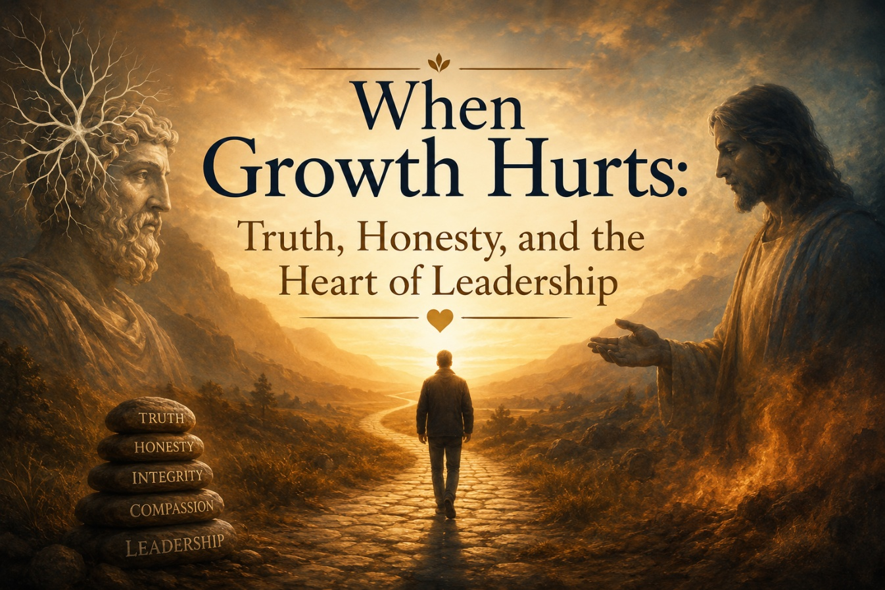

Growth and the Human Heart
Growth is a beautiful thing, yet it is rarely painless. The work we are doing together is sacred, purposeful, and deeply meaningful. Yet because we are human, and because growth asks much of us, there are moments when it stretches us beyond our current capacity. There is tenderness in that. There is vulnerability in it. And there is also profound opportunity.
“The Lord is near to the brokenhearted and saves the crushed in spirit.” (Psalm 34:18)
The ancient philosopher Aristotle understood this reality well. In The Nicomachean Ethics, he described truthfulness as a virtue not merely of speech, but of being. To be truthful, Aristotle wrote, is to align oneself with reality as it is, without exaggeration or concealment, without posturing or self-protection. Truthfulness becomes a way of living in harmony with what is real.
In organizations, Aristotle argued that truth is the foundation of trust, and trust is the foundation of philia, the deep camaraderie that allows people to collaborate in meaningful work. Communities flourish when they are held together by honesty. Not the harsh kind that wounds, nor the selective kind that flatters, but the steady kind that looks another in the eyes and says, “I am here with you in this. Fully. Truthfully.” Yet truth has a cost, because honesty often exposes the places where growth is stretching us most.
The Pain of Growth
We often use the phrase “growing pains” without pausing to consider its origin. Yet it comes from something profoundly physical. During childhood and adolescence, the human body sometimes grows faster than its soft tissues can easily stretch. Bones lengthen rapidly. Muscles, tendons, and fascia strain to keep up. Nerves become tender and reactive.
The child is not breaking. The child is expanding. The pain is not a sign of injury. It is a sign of the body making room for more life.
This is precisely what we have been experiencing in our organization. We have grown rapidly in scope, responsibility, depth of work, and in the number of hearts entrusted to us. Growth of this scale requires realignment. It requires adaptation. It requires clarity. And it requires patience.
Polyvagal Theory reminds us that growth and change naturally activate survival reflexes within the nervous system. When structure shifts or expectations expand, the body instinctively asks: Am I still safe? Am I still seen? Do I still belong? Do we still know how to move together? These are not weaknesses. They are signs of the heart trying to remain connected while expanding.
Naming My Own Stretching
I have felt this stretching deeply, and in some places, I have allowed the strain to show. At times my tone has been more intense. At times my pacing or presence has felt hurried. I have felt the pressure of growth and responsibility, and at moments I allowed that pressure to escape sideways rather than downward into humility and grounding.
And so I want to speak truthfully, not as performance, not as self-flagellation, but as alignment. I take ownership for the ways my own growing pains have affected the team, and I sincerely apologize. Not from shame. Not from defensiveness. But from the virtue Aristotle names truthfulness, the kind of honesty that restores trust and strengthens relationship.
The truth is simple. I am learning too. We all are.
What We Are Cultivating Together
We are doing work of profound meaning. Work of Christ. Work of restoration and freedom. Work that requires presence, integrity, and deep attunement.
The NeuroFaith® Model was born from the conviction that the heart, not merely the brain, is the center of leadership, healing, and spiritual formation. To lead is to serve. To serve is to attune. To attune is to regulate. To regulate is to create safety. And safety is the soil where transformation truly grows.
So as we grow as individuals, clinicians, staff members, and as a community, we recommit ourselves to connection over assumption, respect over reaction, professionalism grounded in dignity, healthy boundaries that protect relationship, and attunement to nervous systems, not merely behaviors. We recommit ourselves to truth spoken gently, courageously, and consistently, and to a heart posture of service rather than self-protection.
This is the work. This is the calling. This is the way of Christ.
Moving Forward Together
Growth does not mean something is wrong. Growth means something is alive. We are alive as an organization, as a movement, and as a community of healers rooted in the heart of God and the wisdom of neuroscience.
“In returning and rest you shall be saved; in quietness and in trust shall be your strength.” (Isaiah 30:15)
We will continue to grow. We will continue to stretch. And we will continue to stay connected while we do.
So we step forward now not in defensiveness and not in exhaustion, but in renewed heart. Centered. Humbled. Committed. Together.

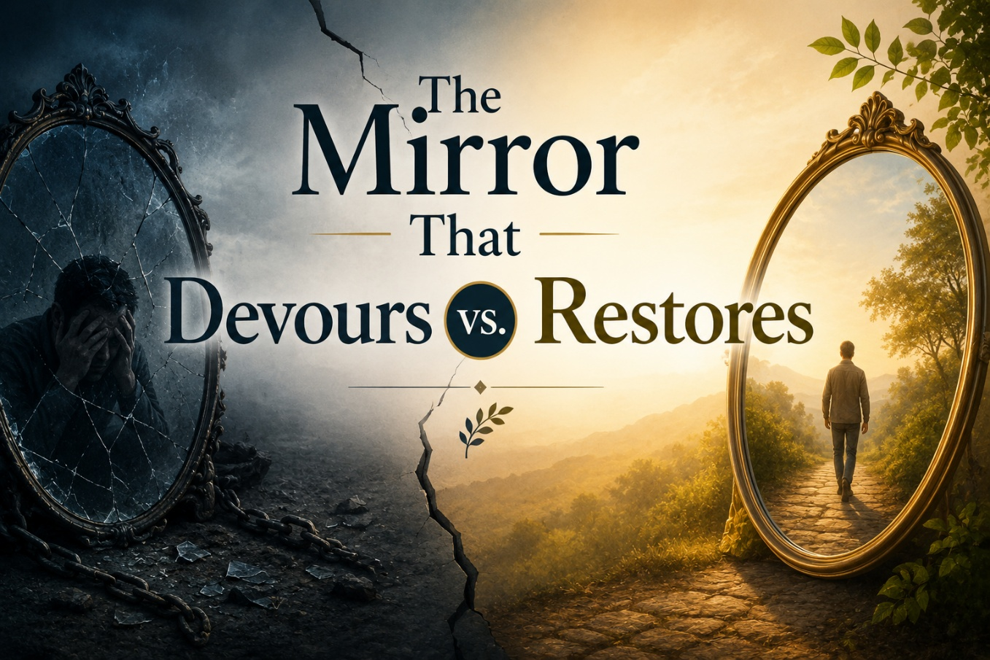

The Nature of Reflection
It always begins with reflection. Human beings are reflective beings. We look inward, we examine, we search, and we try to understand who we are, why we hurt, and what our lives mean. Yet reflection is never neutral. The mirror into which we look determines the truth we find. If the mirror is distorted, the image becomes distorted. If the mirror is empty, the soul encounters only itself.
Reflection without transcendence becomes a self-referential loop, where the wound examines the wound and despair deepens itself into the abyss.
Nietzsche and the Collapse of Meaning
Few thinkers understood the danger of reflection more profoundly than Friedrich Nietzsche. Born in 1844 in Röcken, Germany, the son of a Lutheran pastor, Nietzsche’s childhood was framed by faith, tradition, and a God who was near. But when his father died while Nietzsche was still young, something inside him fractured. The God of his childhood felt silent. Grief became the interpreter of reality. By the time he became a professor in Basel, Nietzsche
had abandoned the faith that once formed his world.

Nietzsche held to the ancient idea that “the unexamined life is not worth living,” a statement originally spoken by Socrates, but Nietzsche attempted to examine life without God. And when reflection has no transcendent anchor, the mirror collapses inward. The self becomes both judge and subject. Meaning is extracted from isolation rather than relationship, and so the meaning collapses with it.
Nietzsche longed to be loved. He yearned to be understood. His unrequited love for the brilliant Lou Salomé reopened the wound first carved by his father’s death, the wound of being unheld, unseen, and unchosen. Without a God who could reinterpret that pain, the pain became the interpreter. Reflection became torment. His brilliance calcified into despair. His descent into interior darkness did not lead to insight. It led to disintegration. His final decade was lived in near silence, a great mind sealed behind unresponsive eyes. Reflection had become the abyss.
Camus and the Absurd

Albert Camus traced a similar line from another direction. Camus insisted that life was inherently absurd, that there is no inherent meaning, only the courage to live without it. Love, he believed, could still be noble precisely because it was temporary and without eternal grounding. Yet love without transcendence becomes fragile, because without God, love has no permanence beyond death.
In the end, Camus’ life concluded exactly as his worldview predicted: suddenly, abruptly, without narrative or closure. At age forty-six, he died in a violent car accident, a symbol of the very absurdity he taught. The philosophy wrote the ending.
The Modern Psychological Mirror
The same pathology of reflection appears in modern psychology. Early psychology sought to explore the nature of the soul and the mystery of consciousness. Its founders recognized suffering as a call toward meaning. But much of contemporary psychology has drifted from understanding the human person to engineering the human persona. The discipline has increasingly been absorbed by ideology. The mirror once intended to reveal truth has become a device for social conformity.
The modern therapist rarely holds a neutral frame. Every mirror reflects an interpretive system, and many of today’s systems are shaped by materialism and post-Marxist social theory. The individual is no longer viewed as a soul, but as a bundle of intersecting identities defined by trauma, desire, and power relations. The person is pathologized not as one who suffers within meaning, but as one who must be reconstructed according to collective ideology.
In this construct, trauma becomes identity, emotion becomes epistemology, and autonomy becomes absolute. The result is psychological fragmentation disguised as liberation.
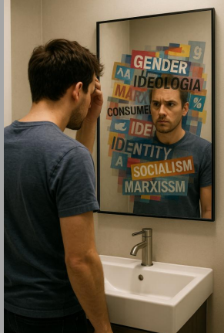
This distortion has infiltrated the structures of care. The child who feels confusion is not guided toward integration, but redirected toward medicalization. Normal developmental distress is redefined as disorder. Hormonal manipulation replaces attunement. Pharmacology substitutes for presence. The clinical language of “affirmation” often conceals a deeper abdication of responsibility, the surrender of discernment to ideology.
The psyche is no longer healed. It is managed. The body becomes an experiment in self-definition, and the mind a field for chemical intervention.
This is not compassion. It is the colonization of human suffering by commercial and political interests. It replaces the moral language of dignity and healing with the mechanistic language of compliance and stabilization. It numbs rather than restores. It does not integrate the soul. It anesthetizes it.
True psychology, rightly practiced, recognizes that pathology often arises from disconnection from self, from others, and from transcendence. It seeks to bring coherence between body, mind, and spirit. Ideological psychology, by contrast, deepens disconnection by redefining the human person as a self-invented construct. It offers medication in place of meaning, affirmation in place of transformation, and social approval in place of spiritual truth.
Reflection without transcendence becomes pathology without healing.
My Own Descent and Return
I know this path not merely from study, but from experience. Twenty years ago, when the pressures of life became greater than my capacity to hold them, the deeper wounds of my childhood rose to the surface. Developmental trauma had formed core beliefs in me, beliefs I did not consciously choose but had absorbed: that I was not enough, that my voice did not matter, that safety was uncertain, and that belonging could be withdrawn.
These beliefs became the mirror through which I interpreted myself and the world around me. And when stress intensified, that mirror turned inward with force.
The reflection that emerged was not true, but it felt true. The wound began speaking louder than the Spirit. I came close to being taken by the lie of abandonment and insignificance. The reflection grew dark and self-reinforcing. It almost consumed me.
And while God brought deep healing in the years that followed, healing does not erase the history of the wound. It changes our relationship to it. Recently, in the midst of leadership conflict, those same core beliefs resurfaced, not because others wronged me, and not because my concerns lacked merit, but because the old mirror tried to interpret the moment for me again.
I wanted to be heard. I wanted to be seen. And when that desire rose faster than my grounding in Christ, the reflection began to distort.
The problem was not the situation. The problem was the mirror I was using.
Christ met me there again. Not to shame the fracture, but to stand inside it with me. Not to silence my longing to be understood, but to answer it with His presence. Not to demand I rise above the abyss, but to step into it and lead me out, as He always has.
The True Mirror: Christ
The question is never whether we will reflect. We are reflective creatures by design. The question is: Which mirror are we using?
Nietzsche’s mirror led to collapse. Camus’ mirror led to absurdity. Modern psychology’s mirror leads to fragmentation and exhaustion. But the mirror of Christ leads to restoration.

“See what great love the Father has lavished on us, that we should be called children of God—and that is what we are.” (1 John 3:1)
“You did not receive the spirit of slavery to fall back into fear, but the Spirit of adoption, by whom we cry, Abba, Father.” (Romans 8:15)
“And we all, with unveiled face, beholding the glory of the Lord, are being transformed into His image from one degree of glory to another.” (2 Corinthians 3:18)
Identity is not something we invent. Identity is something we receive.
We reflect Christ, and in reflecting Him, we become whole.
In His gaze, our wounds are acknowledged, but they are not allowed to define us. Our story is not erased, but it is reinterpreted in love. Christ does not observe from a distance. He enters the story and transforms it from within. His reflection does not pull us into the abyss. His reflection brings us home.



The Roots and Story of Gratitude
Gratitude is not merely a feeling. It is one of the oldest moral and spiritual postures found across human history. The very word carries a story that travels through languages, cultures, and centuries.
The English word gratitude comes from the Latin gratia, meaning grace freely given, a blessing that cannot be earned, a gift offered without expectation of repayment. Gratia gave rise to words like grace, graciousness, and gratitude, and it shaped Roman ideas of honor and virtue. In ancient Rome, to express gratitude was not simply polite. It was a recognition that life itself was made of gifts we could never fully repay. The Greek world used the word charis, a term meaning grace, beauty, kindness, and divine favor. Charis is the root of charisma and Eucharist, which means thanksgiving. The Greeks imagined the three Charites, or Graces, dancing in a circle, symbolizing the continual movement of giving and receiving. For them, gratitude was not static. It was a rhythm, a dance of blessing and response.
The Hebrews spoke of gratitude through the word todah, a thanksgiving that is expressed outwardly, voiced openly, and offered to God as acknowledgment of His goodness. Todah was never silent or internal. It was a confession of praise that recognized God’s hand in life’s gifts.
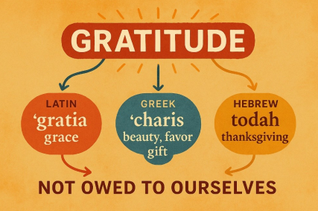
Across these cultures, the meaning converges. Gratitude is always linked to grace. It always points beyond ourselves. It recognizes that something good has come to us that we did not create and could never earn. Gratitude is the soul’s acknowledgment that life, at its deepest level, is a gift.
This is where our story begins. Before we talk about programs, models, leadership, or growth, we must begin with gratitude. Because everything that follows was given to us long before we built it. Gratitude is the foundation of all that we have become.
Our Beginning
When I look back to our earliest days and then look at where we stand now, I am struck by how clearly God’s hand has guided this entire journey. After the fire and the loss and the tragedy, Brendan was the first to carry this idea in his heart. He wanted to create a treatment center that would allow him to give something back, to heal his own wounds through helping others heal theirs.
From that desire he partnered with Tim, and together they founded Holdfast. Later, Tim had the wisdom, courage, and vision to establish AnchorPoint.
As our mission expanded, Tim recognized something essential. We needed leadership that could bridge the operational heartbeat with the clinical soul of what we were building. He saw the need for someone who could hold the weight of both sides of the house, and the Lord made that provision at the exact moment it was needed.
That person was Seth, who stepped in with the operational clarity, steadiness, and leadership presence required to align the administrative backbone with the clinical vision of our work. Seth became that bridge, and he continues to carry that responsibility with strength and humility.
Growth Through Providence
We have had growing pains. We have had ups and downs, disagreements, frustrations, and seasons of stretching and refining. That is the cost of building something that matters. But through all of it, one truth has remained unwavering. God’s providence has guided every step.

And then He did what only He can do. He gave us a model. NeuroFaith® was not born out of ambition but out of obedience. It became a clinical framework that is scientifically sound, theologically grounded, polyvagal informed, trauma aware, and neurocardiologically coherent. A model that speaks to the whole human being: mind, brain, body, and spirit.
And in that formative process, God brought us Pastor Earl. His wisdom, his depth, his theological grounding, and his unwavering emphasis on the soul and spirit helped refine NeuroFaith® into what it is today. Pastor Earl remains a powerful voice in my heart and in the heart of this place, reminding us continually that healing is never merely clinical. It is spiritual, relational, personal, and sacred.
NeuroFaith® is now carried, embodied, refined, and lived out daily by an extraordinary staff. Not to bring glory to any one person, but to acknowledge that God gave us a vision and then surrounded us with the people needed to carry it. Because of that, we have become, I believe, one of the most unique and deeply effective treatment centers for trauma and addiction anywhere.
We should be proud. We should be humbled. And above all, we should be grateful for what God has placed in our hands.

Wearing Our Responsibility Well
My father used to say, “Wear your responsibility well.” When I look around this room, I see men and women who do exactly that. To every one of you, staff, leadership, operations, clinical team, and support team, thank you. I am deeply grateful.
And we also recognize that none of us carry this responsibility alone. We are held up every day by the quiet strength of those who love us. Our spouses, our children, and our families have sacrificially supported us and stood beside us through long hours, heavy days, and seasons when the work demanded more of us than we wished to give.
They have graciously accepted the moments when they received a tired version of us, or a smaller portion of our time and energy, because they believed in the mission God placed in our hands. Their love, patience, and steady encouragement have been essential. Without them, we could not do this work. And so our gratitude extends to them in full measure.
If we speak scientifically for a moment, gratitude is not merely a feeling. It is a neurobiological event. A grateful heart engages the vagus nerve, stabilizes the cardiovascular system, increases heart and brain coherence, activates the medial prefrontal cortex, strengthens relational circuits, and shifts the nervous system from survival into connection.
HeartMath® describes this as the physiology of appreciation. NeuroFaith® understands it as the intersection of faith and neurology, where the state of the heart becomes the language of the brain.
Gratitude as Strength
Gratitude strengthens us. Gratitude grounds us. Gratitude becomes our anchor. And as we walk in gratitude, filled with grace, we begin to understand that gratitude is not something we manufacture. It is something given. It is a movement of God’s own heart within ours.
Gratitude is not only for what has been. It is gratitude for what will be. Because God has placed meaning in us. He has placed purpose in us. He has entrusted us with work that matters, a mission that heals, and a calling that restores. These are blessed gifts. Priceless gifts. Gifts so many people never find, but by God’s mercy, we have been given them.
“He who calls you is faithful, and He will surely do it.” 1 Thessalonians 5:24
“For we are God’s handiwork, created in Christ Jesus to do good works, which God prepared in advance for us to do.” Ephesians 2:10
These verses remind us that the future is not something we invent. It is something God has already prepared. Gratitude opens our eyes to that future. Gratitude steadies us as we walk toward it.
So, my colleagues, may our hearts remain soft, grounded, anchored, and full of grace. May we wear our responsibility well. May we carry this vision forward with courage, humility, and enduring gratitude for the God who called us, for the work He gave us, and for the meaning and purpose He placed in our hands.



Grace and the Work God Still Does in Us
Grace. It is one of the most beautiful words in the human vocabulary, yet we often speak of it casually, almost lightly, without truly feeling the weight of what it means. But real grace is fierce. Real grace confronts us. Real grace exposes what is unfinished within us.
We rightly speak of God’s grace toward us as breathtaking, because His grace always leads us toward the cross. His grace pulls us into redemption. His grace heals what we cannot heal on our own. Yet after we meet Him there, we are not meant to use grace as an excuse or a shield for old patterns. We are meant to grow into greater grace, to embody what we ourselves have received and to extend that same grace to others. And that is far harder than the poetry of grace alone.
The Return of Old Wounds
Lately I have realized that grace has been asking something from me that I did not want to face. I have been carrying conflict at work while simultaneously grieving the death of my brother Gregg, along with the long silence and drifting that preceded his passing. Added to that came the accusations at Madigan, allegations that were ultimately resolved, yet still landed like a blow during a season when my heart was already fragile.
The timing of it all stirred old wounds to the surface. Old voices whispered again. Old patterns reactivated themselves.
Then I stepped more deeply into Holdfast and AnchorPoint, surrounded by good and sincere people, yet the ache to matter still pulled at me. The hunger to be seen. The inner pressure that says your value rests in achievement.
When Gregg stopped speaking, even though I knew it was not rejection, even though I understood he was losing his footing inside his own storm, something in me absorbed that silence as a verdict. It echoed childhood wounds that once convinced me I did not matter. And those old survival strategies rose again. The overachieving. The internal pile-driver that forced pain underground. The cruise missile approach to stress. Strategies that appeared as competence but were, in truth, fortresses built around fear.
Higher Altitudes of Healing
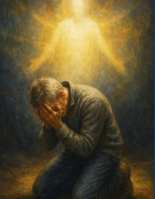
Twenty years ago, when my life collapsed under pressure, I believed God had healed those wounds. And He had, at that stage. But His healing is rarely a single moment. It is layered and progressive. You reach one altitude and cruise there for a season, maybe twenty thousand feet, maybe thirty thousand, and then God whispers, “That altitude is no longer enough, My child. We are going higher.” And the turbulence begins again.
The Madigan situation and my brother’s death shook loose what I thought had already been healed. Old patterns resurfaced. My need to matter returned. My need to be seen rose again. My ego wrapped itself around my identity once more. And in the middle of it all, God whispered a single word back into my spirit: grace.
Grace, Conflict, and Surrender
Grace told me to show grace to my bosses, to Tim, to Seth, and to the leaders around me. Grace reminded me that conflict is no longer about winning, proving myself, being admired, or being seen. Those are wounds from another season of life. They have no rightful place in the life God is calling me toward now.
God told me to lay it all at the cross, to surrender the need to fight, and to give Him space to resolve what I could not. He showed me how loud my ego had become and how desperately my soul needed quiet so His work could continue within me.
The NeuroFaith® Journey
And this is where NeuroFaith® enters the story. My own framework. My own work. My own teaching.
NeuroFaith® has always been about the intersection of neuroscience and the spiritual journey. It is where polyvagal truth meets heart healing. It is where developmental trauma patterns encounter the grace of God. It is where HeartMath® coherence becomes part of restoring the inner world so the soul can hear clearly again.
NeuroFaith® teaches that what happens within us biologically and what happens within us spiritually are never separate. The nervous system carries stories. The soul carries deeper ones. And God works in both.
NeuroFaith® reminds us that we are not meant to export our wounds into our relationships and workplaces. We are called to export the healed place. We export coherence. We export compassion. We export humility shaped by grace.
But to do that, we must be willing to see the places in us that still carry old pain. We must allow the Holy Spirit to breathe into the spaces where our identity remains tangled in old messages. We must let God draw us upward into higher altitudes of healing so that what we bring into the world is no longer driven by old wounds.
The Gift of Wise Counsel
I would not have seen any of this without wise counsel. Without my family, especially my soulmate Leah. Without friends who allowed me to be messy without judgment. Without Pastor Earl, who quietly listens while I vent and then speaks small but seismic words that realign my heart.
He reminded me that the God who began a good work in me would continue that work. God began it twenty years ago when my life unraveled on every level. He stabilized me then. He allowed me to fly at a healthier altitude for many years. And now He is drawing me higher still.
Grace That Rewrites the Story
Grace is not simple. Grace is not soft. Grace is not passive. Grace is strength through surrender. Grace is identity grounded beneath the cross rather than performance driven by pressure.
Grace is choosing peace when old wounds want to fight.
Grace calls me higher.
Grace calls me deeper.
Grace calls me to release the old ego and old patterns.
Grace calls me to live the very truths I teach through NeuroFaith®.
Grace calls me to export something new.
And somewhere in the middle of all of this, God is teaching me how to breathe again.
This is what grace does. It rewires the nervous system. It rewrites the story. It rescues us from the tyranny of old patterns and reintroduces us to the truth of who we are in Christ.
The Invitation
I am not done learning, and neither are you. But the God who carried me through collapse twenty years ago is the same God carrying me now. He takes us from altitude to altitude, healing layer by layer, until what we export into the world is no longer pain but peace.
That is the journey.
That is the calling.
That is grace.
And if God is doing this work in me, then my prayer is that you, dear friend, will allow Him to do it in you as well. When He calls you higher, trust Him. When He whispers that it is time to rise, pull back the yoke and let your soul climb.

There are altitudes of healing and freedom you have not yet seen. There are heavens He longs to show you, places of peace and clarity that only become visible when you allow Him to lift you above old storms.
Let Him take you there.
Let grace carry you.
“He who began a good work in you will carry it on to completion until the day of Christ Jesus.” Philippians 1:6
“But those who hope in the Lord will renew their strength. They will soar on wings like eagles. They will run and not grow weary. They will walk and not be faint.” Isaiah 40:31



A Life Marked by Purpose
Leah and I recently attended Megyn Kelly’s convention featuring Erika Kirk, and much of the event centered on Charlie, his life, his convictions, the ground he stood on, and the momentum he carried with remarkable clarity and courage. His death hung heavy in the room, a grief you could almost feel pressing into the atmosphere itself. Yet when Erika stepped forward, now leading Turning Point as CEO, you could also see the strength and resolve that faith and heartbreak can carve into a human soul.
Charlie’s defining value was purpose, and Erika carries that same torch with remarkable steadiness.
Where the Word Comes From and What It Really Means
That word purpose stayed with me long after we left. Pastor Earl taught me long ago to love its companion word, intentionality, the direction one sets for the heart. Reflecting on Charlie and Erika, and the mission that shaped their lives, led me back to the origins of the word itself.
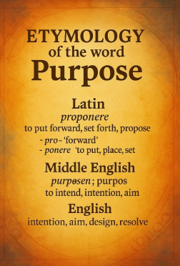
Purpose comes from the Latin proponere. Pro means forward. Ponere means to place. The idea is to put forward, to set forth, to place before oneself. Through Old French it eventually became the English word we use today, often without realizing how much weight it carries.
Purpose is more than direction. It is the forward placement of a life. It is the reason for existence, the “why” beneath action and being. Goals are finite. Purpose shapes identity and endures.
In classical philosophy, especially in Aristotle, purpose is telos, the final cause, the end toward which a life naturally moves. When all of this comes together, purpose becomes the intentional end you place before yourself, the reason that directs your actions and gives meaning to your existence.
Even modern psychology recognizes this. Acceptance and Commitment Therapy, developed by Steven Hayes, is built around discovering one’s core values. Charlie’s core value, his telos, was unmistakable. His purpose was to bring people to Christ. Erika spoke to this with striking clarity. You could see it in the life he lived and the movement he built.
But purpose rooted in conviction threatens cultural forces built upon ideology rather than truth. When your purpose no longer aligns with the demands of the culture, those forces attempt to silence you. Purpose becomes dangerous when it is grounded in something higher than public approval.

Purpose Defined by God or Defined by Man
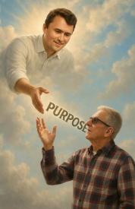
As Christians, our purpose is not self-invented or dictated by cultural trends. It flows from the core values of God Himself, from the way He calls us to live and the qualities He forms within us as we strive to become more Christ-like, more honest, more sacrificial, more loving, more forgiving, more committed to truth.
When we drift from that foundation, purpose becomes vulnerable to the whims of man rather than anchored in the truth of God. And when purpose is defined by man instead of God, it often becomes ideological rather than moral.
Throughout history, leaders who rejected God’s moral order replaced it with human commands. Stalin. Lenin. Mao. Pol Pot. Movements demanding ideological conformity while punishing dissent. Even some modern political movements operate in similar ways. Your purpose is externally dictated. Affirm this. Promote that. Repeat these slogans. Suppress those beliefs. Integrity becomes negotiable. Truth becomes disposable.
The purpose is no longer guided by God but controlled by the demands of man.
And they worked to silence Charlie, just as they have tried to silence anyone whose purpose threatens the ideology of the age. They believed that by taking his life they could extinguish his influence, crush his purpose, and end his voice. But what they never understood is that a God-given purpose cannot be buried. It cannot be silenced. It cannot be crushed. In trying to stop him, they amplified him. In trying to end his purpose, they expanded it.
And similarly, they will not silence me.

Purpose Tempered by Grace
And although I know these realities still stir anger within me at times, I have learned something else along the way. Purpose must be tempered by grace. Anger may ignite conviction, but grace is what sanctifies it.
Grace does not allow us to lead merely from emotion. It calls us to take on the heart of God. It reminds us of the grace He extended toward us in our own failures, weakness, and brokenness.
As we live into our purpose, we must carry it through grace rather than through anger. That realization has become a humbling and refining shift in my own life. Purpose gives direction, but grace gives Christ-like form to that direction. Without grace, purpose becomes sharp but not holy. With grace, purpose becomes both true and good.
Turning Inward: A Life Aimed Toward the “Well Done”
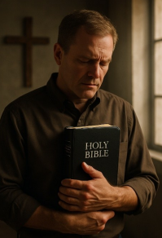
Reflecting on all of this forced me inward. I have always been driven by goals, but goals are easily choked out by distraction, noise, and endless striving. Purpose is different. Purpose orients. Purpose clarifies. Purpose moves the heart forward through difficulty, pain, and opposition.
At seventy-one, the brevity of life sharpens this truth in a way it never did before. Faith is real. Time is short. The finish line no longer feels theoretical.
My calling now is to live the years I have left with greater intentionality. Purpose toward Christ. Fidelity to God. Devotion to Leah. Integrity in all things. I no longer want compromise or drift. I want direction. I want to finish well.
And I want, at the end of all this, to hear the words Charlie lived for, the very words Erika said she believes he heard the moment that bullet ended his life: “Well done, my faithful servant.”
My Purpose in This Season
As I reflect on purpose in my own life, I also recognize the importance of aligning my daily commitments with the responsibilities God has entrusted to me. My work as a psychologist and the NeuroFaith® model itself are part of that calling.
NeuroFaith® was never merely an academic idea or clinical strategy. It germinated slowly through years of prayer, suffering, study, and surrender. It took root in seasons of deep personal pain and loss, where God often performs His most transformative work. In those broken places, He revealed the foundational truth that Christ stands at the center of all genuine healing.
And He showed me how the neuroscience He has given us can illuminate and support that healing. Truth and science are not enemies. They become partners when Christ is the foundation beneath them both.

NeuroFaith® grew out of that sacred realization. Healing happens through truth, through Christ-centered restoration, and through understanding the neuroscience God has woven into human beings to support renewal and growth. It was born from pain, carried forward through obedience, and sustained by a passion to bring healing to others through compassion, clarity, and truth.
Scripture tells us, “The Lord is near to the brokenhearted and saves those who are crushed in spirit” (Psalm 34:18). That was the ground where this vision first took root. It became a calling to bring Christ’s truth into the architecture of the mind, to bring compassion where shame had lived, clarity where confusion had dominated, and hope where despair had taken hold.

Purpose, Covenant, and Love
But God has also made something else unmistakably clear. My purpose includes being a faithful, steady, loving husband to Leah. That calling is not secondary. It is foundational. It is sacred. It is covenant.
At this season of life, God asks me to hold both responsibilities with integrity, to give my best to the NeuroFaith® calling He inspired, while also honoring the covenant that anchors my earthly life.
Purpose requires discernment.
Purpose requires balance.
Purpose requires surrender.
It calls me daily to choose what God has placed before me and to walk it out with intentionality and love.
The Apostle Paul wrote, “Whatever you do, do it wholeheartedly, as unto the Lord and not unto man” (Colossians 3:23). That is now the lens through which I see purpose, not as endless striving, but as a wholehearted offering to God, to my calling, and to Leah.
This is the shape purpose takes in this season of my life. Focused. Rooted. Faithful.
In the end, purpose is not merely the work I accomplish. It is who I become before God, and how well I love the people He has entrusted to my care along the way.

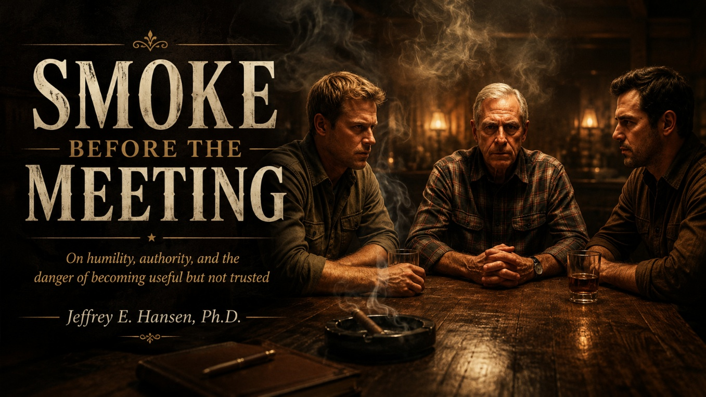

That is where I am tonight.
Not in the street. Not beneath a high sun with hands hovering over holsters. This is not the kind of conflict that announces itself with drama. This is subtler. Polite faces. Controlled tones. Measured words chosen carefully. Heat moving underneath the floorboards. Nobody reaching for a weapon. But nobody relaxing either.
This is a saloon moment.
The boys are already at the table in my mind. Confident. Smart. Quick. Certain of their numbers. Certain of their strategy. Certain they can talk this through in a way that lands where they want it to land. I can almost hear the cadence of it already. The reasoned tone. The reassurance. The carefully phrased invitation to see this new arrangement as a breakthrough rather than a retreat.
And that is part of what troubles me most.
Because what they will likely present as opportunity feels, in my body, like reduction. What they may frame as progress feels, in my chest, like being gently set aside from the very things I care about most while being kept for the things I care about least. My optics. My visibility. My name. My credibility on the website. The image of gravitas I lend to the room.
Kept for the window. Released from the workshop.
This is not a story about villains. These are not bad men. They are younger men with massive ambition and real brilliance in operations, investing, and development. They are fast. They are sharp. They build. They scale. They see angles. They see leverage. They see growth curves. What they have not yet acquired is wisdom. Not intelligence. Not competence. Soul wisdom. The kind that teaches you what to do with power once you have it. The kind that teaches you how to treat people when outcomes matter to real human lives and not just to projections and valuations.
They treat people well on the surface. Professional. Polite. Strategic. They know how to sound supportive. They know how to reassure. They know how to speak in ways that feel relational. But underneath that polish is a pattern that has grown increasingly hard to ignore. Decisions made without including those who will be held responsible for the outcomes. Public correction where private conversation should have come first. Silence where acknowledgment should live. Praise for optics. Neglect for substance.
I occupy a strange seat at their table. I am valued for what I produce. My teaching. My writing. My model. My credibility. I am useful. I am presentable. I look good in the window. I add gravity to the room. I extend the brand. But usefulness is not the same thing as respect. And being displayed is not the same thing as being trusted.
There is a particular dissonance in realizing that what you treasure most in your work is exactly what is quietly being taken out of your hands. The shaping. The shepherding. The training. The authority to protect what you are accountable for. That is what I care about. That is what gives the work its moral weight. And that is precisely what now feels negotiable to them.
They may believe they are offering me a gift. A new deal. A reframing. A lighter load. But what lands in me is something closer to being managed out of the soul of the work while remaining just close enough to keep the branding intact.
I can be quoted and sidelined in the same breath. Promoted in appearance and minimized in authority. That contradiction wears on a person in ways that are hard to describe unless you have lived inside it.
This is where the philosophical knot tightens.
Aristotle ruined all our favorite extremes. He insisted that virtue lives in the uncomfortable tension between too much and too little. Too little humility and you become arrogant. Too much humility and you disappear. Strength without humility becomes tyranny. Humility without strength becomes self-erasure. The virtue is not in choosing one side. It is in living awake in the tension between them.
So where exactly does humility end and self-respect begin.
That question is no longer abstract for me. I genuinely wrestle with it. I have never been a suck up. I have never followed the status quo just to keep peace. I have never been comfortable being minimized or silenced. I have never been particularly good at shrinking. And at this stage of my life, with decades of clinical work behind me, with losses that carved me and skills that cost me, something in me quietly but firmly revolts at the idea that my best role now is to smile politely and be grateful for whatever portion is handed back.
There is a long history in me that does not show up on websites or in resumes. Years of sitting with people in terror and despair. Years of being blamed and misunderstood along with being trusted and invited. Years of responsibility carried quietly when no one was watching. That kind of history reshapes what you can tolerate. It changes the texture of your patience.
I also hear the voices around me. Stay. Lean in. Be patient. Give them time. I understand that counsel. I respect the heart behind it. There is love in those words. There is hope in them. There is also fear in them. Fear of conflict. Fear of loss. Fear of what might happen if I finally stop accommodating what keeps wounding me.
But there is another voice that will not stay quiet. The one that says patience is not passivity. And humility is not disappearance. The one that says you do not prove your character by enduring what violates it.
There is also a particular madness that comes from being responsible for outcomes while being excluded from decisions. Accountable without authority. Visible without being consulted. Blamed without being included. Asked to steward without being allowed to shape. That arrangement unravels people slowly. It twists the nervous system. It erodes trust in small daily increments until the person you used to be begins to feel distant and unfamiliar.
That is not leadership. That is liability dressed up as partnership.
So tonight I sit in the smoke and wait for the meeting. I do not plan to posture. I do not plan to perform. I do not plan to dominate the room or defend my honor with theatrics. I plan to listen. To observe not just what is said but what is avoided. To notice the pauses. The deflections. The careful language. To watch how the power moves beneath the words. To feel whether I am being invited into true partnership or gently negotiated into a decorative role.
And then I will decide whether anything resembling mutual respect can still be restored or whether I am simply being asked to shrink with dignity.
That is the real decision in front of me. Not whether I am needed. I am. Not whether my work has value. It does. The question is whether I am being invited as a craftsman of the work or curated as a symbol of it.
I do not crave special treatment. I do crave basic dignity. I do not need to dominate rooms. I do need to be treated like a peer rather than a prop. That line no longer feels blurry to me.
Perhaps that is the real tension of this season. Not conflict with others. But reckoning with myself. At what point does staying become a violation of my own values. At what point does endurance quietly turn into self-betrayal. At what point does loyalty to others steadily replace loyalty to my own integrity.
Those questions have weight. They do not resolve quickly. They sit heavy on the chest in the hours before sleep and follow you into the morning.
The boys will bring their proposal to the table soon. They will believe they are being fair. They will believe they are being generous. They will believe they are being reasonable.
And I will have to decide whether clever is enough.
The smoke is hanging in the air now. The glasses have gone still. The murmurs have softened. The room waits.
So do I.

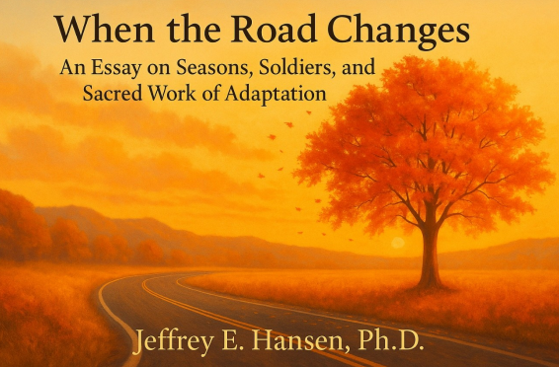

Change is one of the few things in life that never asks our permission.
If you live in Arizona, you already understand this in your bones. One day the temperatures press toward one hundred degrees, and the next you are stepping outside wondering who turned the desert into a walk-in freezer. Seasons shift without apology. Trees release what they no longer need. Caterpillars dissolve completely before they ever become butterflies. Everything in creation moves through cycles of death and rebirth, shedding and becoming, holding and releasing.
So do we.
Holdfast and AnchorPoint have been in a season of change. New faces, shifting roles, new demands, and new expectations. And I want to be transparent with you. Change has not been easy for me either. As many of you know, I will be stepping down as Clinical Director. It is a significant shift in my own story. And truthfully, this old dude has wrestled with whether I could adapt yet again.
Before I go on, I want to say something important. I have been blessed with many meaningful and rewarding professional experiences in my forty-year career, but this season with all of you has truly been among the very best. The trust you extended to me, the space you allowed me to grow, and the privilege of walking with you through such sacred work, those gifts have meant more to me than I can say. Thank you for letting me serve in this role. I will carry that gratitude with me into whatever comes next.
But part of growth is learning to loosen your grip on the status quo.

Nowhere have I learned this more clearly than on a motorcycle. When you have ridden through enough seasons and terrains—heat, rain, snow, good pavement, black ice—you learn quickly that the road changes faster than your preferences do. A dry surface becomes slick. A warm day turns cold. A familiar curve behaves differently because of dust, wind, or water. If you do not adjust your lean angle, your counter-steering, your posture, and your mindset, you crash.
Oddly enough, the worst thing you can do in uncertain conditions is tense up. That instinct to hold tightly to what feels safe is exactly what makes the bike unstable. Survival requires staying loose, responsive, and willing to adapt in real time.
Change asks the same of us.
I have also learned this lesson from soldiers. Soldiers grasp intuitively what the rest of us tend to resist. The battlefield does not negotiate with your comfort. The terrain will not adjust itself to your expectations. The mission rarely unfolds according to your ideal conditions.
The Soldier’s Way of Seeing Change

And yet soldiers rise, shoulder their packs, and step forward—not because they feel ready, but because they have learned that standing still is rarely an option. They move with a practiced humility, alert to shifts in the wind, responsive to sudden commands, aware that everything can change again in a moment. For them, adaptation is not an advanced technique. It is the rhythm of survival. It is the wisdom of accepting that rigidity breaks before it bends.
Their courage is usually not dramatic. It is a quiet exhale before stepping into uncertainty. It is a prayer whispered behind tired eyes. It is the steady decision to move forward even when fear is trying to turn them backwards. Their stories carry a deeper truth. Those who thrive are not those who avoid change, but those who learn to lean into it with faithfulness.
And is that not exactly what God invites us into. He does not promise unchanging circumstances. He promises unchanging presence.
“Be strong and courageous, for the Lord your God goes with you. He will never leave you nor forsake you.” — Deuteronomy 31:6
“Forget the former things. Do not dwell on the past. See, I am doing a new thing.” (Isaiah 43:18–19)
“Trust in the Lord with all your heart, and lean not on your own understanding, and He will make your paths straight.” (Proverbs 3:5–6)
God does not remove the shifting ground beneath us. He steadies our feet as it moves.
Growing Together in This Season
As I transition out of the Clinical Director role, we welcome Julie Nave into that position. She is a gifted, capable, deeply committed leader who brings strengths I simply do not carry. You will be in excellent hands. And I will continue walking with you—teaching, guiding, supporting—but in a different way.
Change is not failure. Change is not loss. Change is invitation.
I often told my doctoral students: be the age you are. Do not pretend to know what you do not. Do not hide your immaturity. Grow through it. Do not cling to old forms. Let new ones develop.
The same is true for us as a staff. If you are young and learning, embrace it. If you are seasoned and stretching, trust the process. If change feels unsettling, name it honestly and bring it to prayer.
Adaptability is not weakness. Flexibility is not compromise. Change is not the enemy when Christ is leading.

We are, in our own way, like riders navigating changing roads. Like soldiers responding to shifting terrain. Like trees shedding what no longer serves. Like butterflies emerging from the dissolving of old structures.
And the same God who presides over every season of creation presides over every season of our lives.
We do not walk into change alone.
We walk with one another.
We walk with courage.
We walk with humility.
We walk with faith.
And most importantly, we walk with Christ, who changes us so that change cannot break us.



I came home tonight from the Holdfast and AnchorPoint Christmas party carrying a mixture of gratitude and something harder to name.
Tim Hayden did a remarkable job. Truly. I have known Tim for three years now. He recruited me out of my hospital role, took a chance on me, and trusted me to help shape something meaningful. AnchorPoint exists because of his vision, and I do not forget that. Whatever comes next, that truth stands.
Seth was there as well, our new president. Barely thirty-five, sharp, energetic, decisive. A good and competent man with a clear vision for running organizations like ours. He is moving fast, hiring staff at a pace I can no longer keep up with. The organization will be in capable hands. I believe that sincerely.
And then there was me.
Standing in that room, I realized I was the oldest man there. Seventy-one years old. Ten years active-duty Army. Another decade with the Department of Defense. I am not a war hero, and I am not borrowing valor that does not belong to me. But the culture of the military shaped me in ways that never quite leave you. One of those ways is a deep and almost instinctive understanding of respect.
Not ego. Not entitlement. Respect for judgment earned over time. Respect for experience paid for with long nights, hard decisions, and the burden of responsibility when consequences truly mattered. Respect not as sentiment, but as a lived practice.
I have been valued here. I know that. I have been appreciated for teaching, speaking, writing, publishing, and offering vision and frameworks. I have been respected for mentoring and for helping shape clinical thinking. For all of that, I am grateful.
And yet, when it came to clinical judgment, to discernment forged over decades, something often overrode it. Concerns I raised. Things I tried to call early. Directions I felt uneasy about. Over time, my voice seemed to carry less weight than the experience behind it might have warranted.
As I watched how quickly my replacement stepped into place, how seamlessly the organization continued forward, I felt a quiet recognition arise. Not anger. Not resentment. Just the awareness that I may no longer quite fit in the way I once did.
It is not that Tim or Seth do not understand respect. They do. They simply see it differently than I do. Their understanding of respect is more optical, more functional, and more oriented toward momentum and outcomes. Mine runs deeper and slower. It was shaped in a culture where words mattered because lives sometimes depended on them. Where commitments were not symbolic. Where follow-through was not optional.
I do not believe they do not care. I believe they genuinely want to do the right thing. But there is a difference between caring and seeing. A difference between intention and attunement. And that difference has become increasingly difficult for me to ignore.
Respect, as I understand it, shows up in the small, unglamorous places. It is returning phone calls. It is responding to emails, especially when concerns are raised. It is listening when someone brings forward something that needs attention, even if it slows the machine. It is not scheduling a meeting and then letting it quietly disappear. It is not leaving someone wondering whether what they said mattered.
More recently, that gap became harder to sit with. When I raised a concern with staff around an issue I believed was important, I was later spoken to and chastised in a way that felt dismissive, as though my experience and judgment carried little value. That landed heavily. Not because feedback or disagreement is unwelcome, but because it reflected a fundamental misunderstanding of both my intent and my history. After decades of clinical work, leadership, and service, to be addressed in that manner revealed not malice, but a lack of attunement, and it stung.
Then there was a meeting that finally went well. It was honest, respectful, and clarifying. I was told a contract would be ready the next day. I took that at face value because I am a man of my word, and I tend to assume the same of others. When I later learned it had not been completed and was now being pushed out, something in me quietly took note.
On the surface, it was not a major issue. Contracts get delayed. Schedules change. I understand all of that. But underneath, it represented something deeper. If the respect ran deep, someone would have made the call. Someone would have said, “This matters to him.” Someone would have recognized that honoring a word is not a technicality but a value. If circumstances changed, communication would have been enough.
That is the old school in me. When I say I am going to do something, I do it. If I cannot, I communicate. That is respect.
And when I am honest with myself, the hourglass matters. The years ahead of me are far fewer than the years behind me. That reality clarifies what deserves my energy and what no longer does. I have little interest now in fighting to be understood at the deepest level of who I am. I am tired of circling conversations and explaining why certain things matter. Not because they are unimportant, but because they have already been lived.
I am not saying I am leaving. I am saying I am listening more carefully than I used to. Paying attention to what feels aligned and what does not. At this stage of life, I am less interested in pushing or persuading, and more interested in honesty, mutual regard, and work that does not require me to set aside myself in order to belong.
I still care deeply about the people and the mission. That has not changed. What is changing is my awareness of where my energy goes and what it costs. Some seasons call for endurance. Others call for discernment. I believe I am in the latter.
I do not yet know what this will mean. I am not rushing toward conclusions. I am simply allowing myself to name what I see and to trust that clarity will come in its own time. For now, it is enough to remain open, reflective, and true to what matters most to me.
That, too, is the weight of a word.
And my Pastor Earl nicely replies:
“Jeff, one additional thought about generations.
You and I are of the same generation, as are our wives. Many of your co-laborers at Holdfast come from different generations. Tim by one. Seth by two. Their worldviews and core assumptions about life, leadership, authority, and faith have been shaped in environments and cultures very different from those that shaped you and me. One is not good and the other bad. They are simply different.
That difference places a responsibility on us as elders. Our calling is not to insist that younger generations adapt to our language, preferences, or instincts. Rather, we are to find ways to communicate values and truth that resonate with them. Eternal values and enduring truths. Not merely cultural habits or temporal expressions of them.
I have been fighting this battle for decades in ministry and from the pulpit. The conclusion I have come to, again and again, is this: seek the Lord, discern what He is doing, and then join Him in that work. When that posture is maintained, relevance is not something we strive for. It emerges naturally across generations.
I have watched you do this well, especially with your patients and with children. You have an ability to meet people where they are without compromising who you are or what you believe. That is not a small gift.
This work becomes more difficult when it must be applied to peers. You and I will never truly be one of them. Because of that, they will never relate to us in the ways that feel most comfortable to us. That can be humbling and at times painful, but it is also part of the calling of eldership.
Fear not. God is still very much at work at Holdfast and AnchorPoint. You are not finished, but your role has changed and must continue to change. That does not signal loss. It signals transition.
Embrace it. Trust God for what comes next. I believe it will surprise all of you.”
In His grace,
Pastor Earl


Hearing It From My Heart
Time to Move On
Jeffrey E. Hansen, Ph.D.

My Dear AnchorPoint and Holdfast Recovery colleagues,
I know how quickly rumors can spread, especially in close communities like ours. Because of that, I wanted you to hear some important news directly from me, in my own words, and from my heart, rather than through fragments, assumptions, or secondhand stories. My hope is that this reflection feels honest, encouraging, and ultimately hopeful.
It has been my distinct privilege to serve as your Clinical Director for the past three years. It is genuinely hard to believe that much time has passed.
When I first began, I was still working full time in telemedicine at Madigan Army Medical Center. Tim and I worked out an arrangement where I would serve approximately five hours a week. As most of you know, five hours rarely stays five hours. Those early days felt a bit like the Wild West. I was learning the culture, learning the organization, and learning how to translate decades of clinical experience into a setting that was still very much finding its footing. Many of us were green in different ways, and we had a great deal to learn together.
But one thing stood out to me almost immediately, and it never faded.
The heart of this staff.
Your love for Christ. Your willingness to serve. Your courage to step into the lives of men who were hurting, broken, and searching for hope. Watching you pour yourselves into this work of saving lives and caring for souls one person at a time has been a profound encouragement to me. That heart is real, and it matters.
Over time, something beautiful unfolded. We grew together. We learned better ways of caring for clients, better ways of relating to one another, and better ways of functioning as a team. We did not simply gain skills. We gained maturity. Watching that growth and cohesion has been one of the great honors of my professional life.
I will forever be grateful for the lives I have seen transformed during this season.
Another unexpected gift of this journey is that Holdfast Recovery and AnchorPoint became the proving ground for something deeply personal and meaningful to me. This environment gave me the opportunity to bring together nearly forty years of clinical work, neuroscience, faith, and lived experience into what became the NeuroFaith® model. I had already been steeped in neuroscience and had written other books, but NeuroFaith® emerged here. It was shaped by this community, by this staff, and by the clients we served together.
Without you, that book would not have been written. I may have written other books, but not that one.
As most of you are aware, I certified Holdfast Recovery fully and AnchorPoint provisionally within the NeuroFaith® model, with the expectation that the standards required to faithfully provide NeuroFaith® services would continue to be developed and more fully embodied over time. It was my sincere hope and vision to continue translating the model, developing it further, and training staff more deeply in both its clinical and spiritual foundations.
That season, for me, is now coming to a close.
As of December 31st, I will be stepping away from Holdfast Recovery and AnchorPoint.
I want to be very clear about what this decision is and what it is not. It is not rooted in bitterness. It is not driven by avarice. It is not the result of animosity or disrespect. It is simply time.
As many of you know, I had hoped to transition into a more consultative role. Seth even coined a title that I genuinely appreciated: NeuroFaith Director. Despite sincere efforts on all sides, we were not able to come to shared agreement on what that role should look like in practice. The differences were not about right or wrong, but about deeper philosophical convictions regarding psychotherapy, transformation, and what faithful stewardship of the NeuroFaith® model requires in terms of presence, depth, and lived integration.
Because of that, I believe the most honest and faithful step is to make a clean transition.
I leave the NeuroFaith® model in your hands.
Please treat it with respect. NeuroFaith® is not a linear or simplistic model. It is not something that can be reduced to a checklist or taught purely from slides. It must be lived and experienced before it can be taught or shared. It reflects the way God has designed us to find safety and wholeness through the integration of mind, body, and soul. It helps us understand the autonomic nervous system, the ways trauma dysregulates that system, and the psychological defenses that emerge when we are no longer experiencing safety. And it holds faith not as an add-on, but as an essential and interactive part of healing.
NeuroFaith® is multidirectional. It is experiential. And it is deeply rooted in the heart.
If you honor it, live it, and approach it with humility, it will continue to bear good fruit in the lives of those you serve.
Please know that my heart will always remain open to you. If, at any point, you feel led to reach out, whether for conversation around therapy, NeuroFaith®, spiritual matters, professional development, or simply to connect, you are always welcome. There is no expectation or obligation in this, only an open door and a continued care for you.
Thank you for the privilege of walking this road with you. This chapter has mattered more to me than I can fully express, and I will carry it with me always.
“Above all else, guard your heart, for everything you do flows from it.” (Proverbs 4:23)
With respect and gratitude,
Jeff
Jeffrey E. Hansen, Ph.D.
Clinical Psychologist — Licensed in Arizona & Washington
AZ Lic. #PSY-5450 | WA Lic. #PSY-1695
Founder & Director, NeuroFaith® LLC

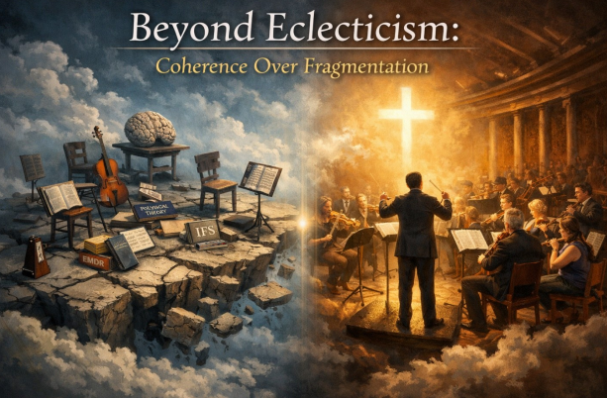

A Clarifying Moment
This declaration represents a clarifying moment in my professional and vocational life. It is not written in reaction, resentment, or opposition, nor is it intended to harm or diminish any organization or individual with whom I have previously served. Rather, it reflects a deliberate, thoughtful commitment to steward the NeuroFaith® model with integrity, clarity, and faithfulness to the work itself.
Over time, I have come to recognize that stewardship is not merely a matter of goodwill or shared mission language. Stewardship is a covenantal responsibility. It requires mutual respect, clear authority, relational trust, and structural alignment. When these conditions are present, NeuroFaith® can flourish as a coherent, integrative model. When they are absent, the work becomes constrained, diluted, or mechanized in ways that compromise its depth and purpose.
Boundaries and Stewardship
From the beginning, I was explicit that NeuroFaith® would never be used as leverage, branding, or competition. I honored that commitment fully. I exercised restraint, protected relationships, and sought alignment wherever possible. This declaration does not reverse that posture. It simply names a boundary. I will no longer suppress vocation or compromise stewardship in order to preserve appearances or maintain misalignment.
NeuroFaith® does not belong to any single organization. It belongs to the work itself. The work is the integration of neuroscience, trauma theory, spiritual formation, and lived recovery into a coherent anthropology of the human person. At its core, NeuroFaith® affirms that the nervous system is not the enemy of sanctification, that grace travels through safety and regulation, and that transformation unfolds through formation rather than compliance. These commitments require environments that welcome depth, tolerate complexity, and honor both clinical rigor and theological humility.
Conditions for Faithful Stewardship
Faithful stewardship of NeuroFaith® requires certain non-negotiable conditions. These include relational trust, respect for the integrity of the model, clarity of role and authority, clean and transparent agreements, and the freedom to teach, write, train, and form others without dilution or reductionism. Where these conditions are absent, the model cannot be responsibly carried, regardless of intent or enthusiasm.
Stepping into independent stewardship is not a withdrawal of goodwill. It is an act of protection. It protects the work, those it serves, and the integrity required to carry it forward. I remain grateful for past seasons, shared labor, and the good that was accomplished. Gratitude and boundaries are not opposites. They are often companions.
Moving Forward
This declaration is not an ending but a clarification. I remain open to collaboration, consultation, training, and partnership wherever humility, respect, and shared stewardship are present. NeuroFaith® will continue to be offered in contexts that honor formation over performance, coherence over eclecticism, and transformation over control.
I move forward without urgency and without animosity, grounded in gratitude and clarity. My commitment is simple and enduring. I will steward NeuroFaith® faithfully, speak truth without venom, and place this work where it can be honored, protected, and allowed to bear the fruit it was created to bear.
Jeffrey E. Hansen, Ph.D.
Founder and Director, NeuroFaith®, LLC

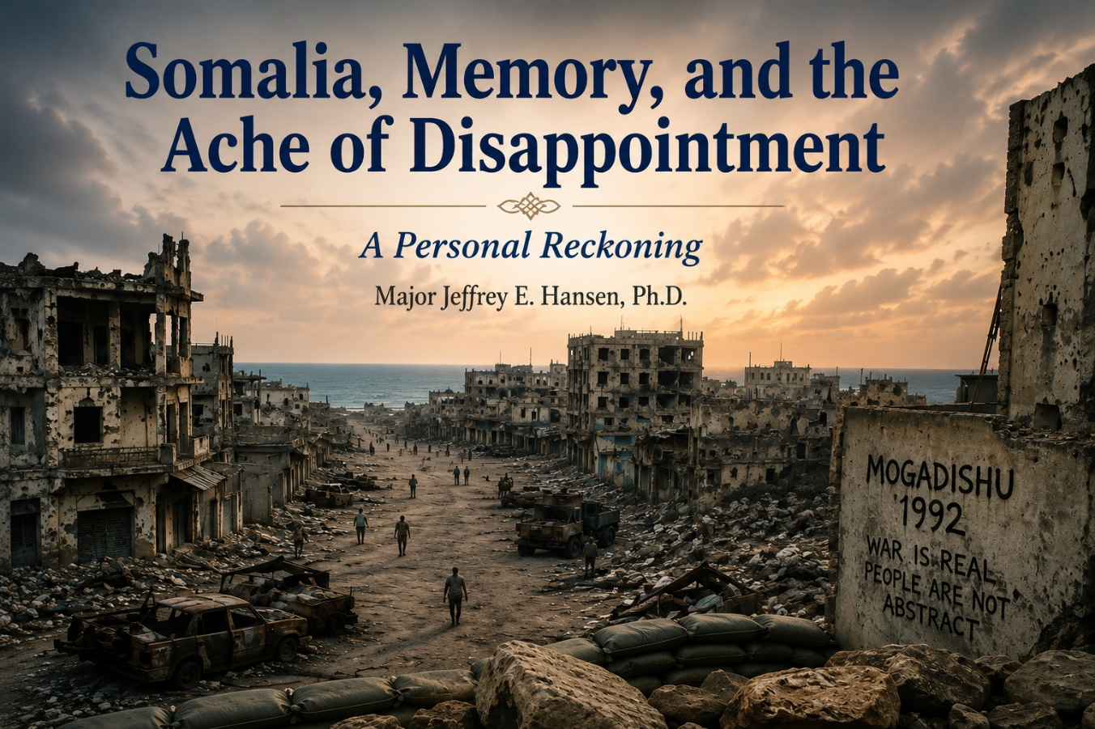
Somalia, Memory, and the Ache of

Why This Still Stirs in Me
I have been trying to understand why the current stories about Somalia and Somali fraud have gotten under my skin so deeply. Like most people, I do not like seeing tax dollars squandered. I do not like watching systems abused. I do not like seeing people take advantage of a country that tried, however imperfectly, to help them.
Let me be clear from the start. I am not saying all Somalis are bad. That would be false and unfair. I have known kind Somalis, generous ones, people who would give you the shirt off their back. But there is also something deeply broken in parts of that culture, and I encountered it firsthand long before today’s headlines. That is where this reaction comes from. Memory.
1992: Going In With Hope
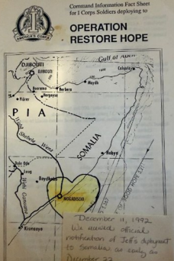

In 1992, I deployed to Somalia while assigned to the 62nd Medical Group. Prior to that deployment, I had served in several military hospitals in the United States and in Germany as an adult and pediatric psychologist, working with active-duty service members and their dependents. I was not infantry. I was not combat arms. I was a clinician.
Still, like every officer assigned, I was issued a Beretta. I was an officer. I had qualified with it, though I am still not sure how. In truth, I was probably more dangerous to myself with that weapon than to anyone else. I slept with it under my pillow, more out of anxiety than confidence.
When I deployed, I carried a kind of naïve hope. I told my wife, Leah, that this was a humanitarian mission. General Aidid was starving his own people, extorting them, weaponizing hunger. Tens of thousands were dying. In my mind, shaped by years of work with children, I imagined myself handing out candy bars and offering comfort in small, human ways.
An Early Warning
On the way in, our aircraft stopped briefly in Taif, Saudi Arabia, to refuel and to give us a short break and a hot meal. I remember standing in line as a Saudi national served the soldiers. When it was my turn, our eyes met. What I saw stopped me cold. There was contempt there. Hatred. Not irritation or indifference, but something sharp and unmistakable.
I remember freezing for a moment, stunned by the intensity of it. I have never forgotten that look. I do not know what he was thinking or what had shaped that hatred, but I knew with certainty that he despised me. That moment sent a chill through me. It was my first quiet warning that the world we were stepping into was far more complicated and far darker than I had imagined.
Arrival in Mogadishu

We landed in Somalia at night. As the C-5 lifted off, we were told we could not yet move on to our destination. Gunfire echoed in the distance. When we finally reached what had once been a university campus in Mogadishu, a place that must once have been beautiful, it was hollowed out and ruined.
Before we even settled in, I ran into an old friend, Jim Masson, a Navy psychologist and later a dear colleague. The Marines had arrived before us and were already dug in, preparing to hand the site over to the Army. Seeing them underground surprised me. I asked Jim why they were dug in like that.
“Mortars, man,” he said.
I remember almost laughing it off. Mortars? Come on. We were here on a humanitarian mission. We were supposed to be handing out food, stabilizing things, helping people survive. I was soon to discover Jim Masson was right.
When the Illusion Broke
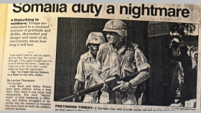
That first night, the sound of incoming fire made itself unmistakably clear. Mortars. Small arms. Heavy weapons in the distance. The university compound vibrated with noise and tension. The illusion I had carried with me collapsed quickly. This was not a benign relief effort. This was a war zone.
Suddenly, I understood why the Marines were underground. And suddenly, I understood how unprepared I really was.
That night, I did what any non-combat trained major might do under fire. I dove under a table. A colleague and friend, Al Johnson, a seasoned soldier with prior combat experience, saw immediately how exposed and unprepared I was. Without hesitation, he crawled out under fire to our hooch, retrieved my Kevlar vest, and brought it back to me.
He handed it to me and said simply, “Here, Hansen. Put this on.”
I will never forget that moment. He put himself at risk so that I would be safer. There was no drama in it, no speech, no heroics. Just quiet competence and care.
Learning How Survival Really Works
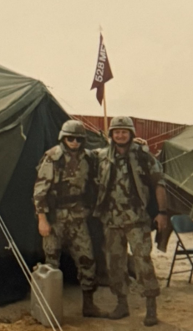
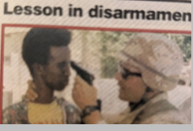
From that point on, I stayed close to him. He knew the terrain, the rhythms of danger, and the realities of that place. More than that, he embodied something I would come to understand deeply over time. In chaos, survival often depends less on strength or bravado and more on the quiet courage of people who look out for one another.
Trying to maintain some sense of normalcy, I kept running for exercise around the perimeter of the old university compound. Day after day after day, I was pelted with rocks. Not once. Not occasionally. Constantly. At first, I ignored it. Then I tolerated it. Then I got irritated. Then I got angry. And eventually, very angry.
So one day I decided this would be different. This was not impulsive. It was premeditated. Major Hansen was going to conduct a tactical response using the only weapons available to him. Rocks.
I waited. I knew the pattern by then. Same stretch of perimeter. Same timing. Sure enough, the rocks came flying. And that was it. I picked up rocks and fired back. To my own surprise, the supposedly weapons-incompetent psychologist held his own. Let’s just say the exchange ended decisively.
After that, the rock throwing stopped. They never bothered me again. I suspect they decided I was not worth the trouble. Possibly unstable. Definitely unpredictable. In any case, the message landed.
Convoys, Fire, and the Cost of Order
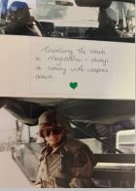
Then there were the convoys. At times we rode in the backs of Humvees through town. One tactic used against us was dragging barbed wire across faces to knock off glasses or injure eyes. Think about that. We were there on a humanitarian mission, and people were actively trying to blind us.
Rules of engagement were strict. We could not fire unless very specific conditions were met. Instead, we carried long steel tent pegs, roughly a foot long, as last-ditch defensive tools. Beretta in one hand, tent peg in the other. That was the reality.
I remember thinking, again and again, we are trying to help you. Why are you trying to hurt us?
The Used Car Lot
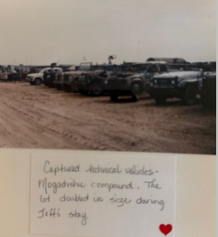
Later, I watched Apache helicopters engage targets while going after General Aidid. They did not get him that day. What they did hit, however, was what we half-grimly referred to as the “used car lot.” It was an area filled with old technical vehicles, Jeeps and trucks mounted with recoilless weapons, .50 caliber machine guns, and other heavy arms that had been used to terrorize the city and attack coalition forces, including American soldiers.
After that firefight, our so-called used car lot had grown noticeably larger, filled with vehicles and weapons that had been confiscated. In a dark and almost absurd way, it felt like a small measure of success. More inventory, you might say. A strange thought in a place where survival often depended on gallows humor. Any used car salesman would have been impressed.
What Stayed With Me
Not long after I rotated out, Black Hawk Down happened. Whatever idealism I still carried collapsed under the weight of that tragedy.
For years, those memories went quiet. Then recently, watching stories of fraud, entitlement, and open contempt toward the systems meant to help, watching people boast about exploiting social services, something stirred again. It felt disturbingly familiar.
I know there is goodness. I know there are honorable, hardworking Somali families. I have met them. I believe God loves them deeply. But I also see a recurring pattern, then and now, where goodness is overshadowed by something darker. Entitlement. Exploitation. Tribalism. Contempt for the very structures trying to help. The posture feels eerily similar across decades.
Back then, a round passed within a few feet of me. Today, the rounds look different. Financial fraud. Manipulation. Ideological hostility toward the country that offered refuge.
This is not hatred. It is grief. It is bewilderment.
We tried to help. We sent aid, food, doctors, psychologists, and soldiers. We lost lives. We bore costs. We believed compassion would be met with responsibility. Too often, it was not.
A Closing Prayer and Plea

I do not want this story to end with gunfire, with rocks flying, with contempt in someone’s eyes, or with mortars falling in the night. I want it to end with something better. With the possibility that hearts can change.
We can and should try to understand what people truly need, rather than endlessly giving what ultimately harms them. Compassion without truth helps no one. Mercy without moral direction collapses into chaos. Love without boundaries ceases to be love at all.
There must be limits. There must be accountability. There must be a willingness to say, with firmness and care, this is not the way. When you are given truth, you do not spit on it. When you are given help, you do not exploit it. When people come to serve and protect, you do not fire mortars or drag wire to maim them. Grace is not an invitation to destruction.
And yet, even with all of that said, my heart still leans toward hope.
I pray for my Somali brothers and sisters. I pray that the love shown by those who came to help, by the soldiers and Marines who risked and, in many cases, gave their lives, will not be forgotten. I pray that the blood that was shed, the sacrifices that were made, will not have been in vain. I pray that hearts hardened by grievance and resentment might soften.
This will not ultimately be healed by weapons or money or policy alone. It will be healed only by something deeper. A change of heart. A turning toward truth. A willingness to repent of violence and contempt and choose a better way.
That better way, for me, has a name. It is the way of Christ.
It is the way that calls us to repentance and responsibility, but also to mercy and renewal. It is the way that teaches us not to curse blessing, not to answer grace with violence, and not to despise what was given in good faith. It is the way that leads toward dignity, restraint, and peace.
That is my prayer. That hearts would change. That truth would take root. That redemption would have the final word. And that someday, what began in blood and sorrow might yet end in healing.



A Word Born Out of Transition
I made up a word this week: saditude.
It is a blend of sadness and gratitude, because neither one alone tells the truth of what this moment feels like.
Today was my last day as Clinical Director at Holdfast and AnchorPoint. My resignation officially took effect. It had been a long time coming—not sudden, not impulsive—but still heavy when it finally arrived. I had hoped there might be a way to continue in some form as a consultant, to help steward the NeuroFaith® model more intentionally, to guide its teaching and protect its integrity. But we could not come to terms. Not out of malice or bad faith, but out of differing philosophies and understandings of responsibility, authority, and clinical direction. There was no villain in the story, only a divergence that could not be reconciled.
So, I stepped away.
And with that step came something I did not fully expect: saditude.
The Grief and Gratitude
There is real sadness here. I took my role seriously. I loved the work. I loved sitting with men who were facing addiction, trauma, and shame, often all at once, and watching courage slowly return. I loved walking alongside people doing the hardest work of their lives. I loved the privilege of being trusted with their stories.
I loved building the NeuroFaith® model slowly and thoughtfully over time. It represents decades of clinical work, study, failure, faith, neuroscience, psychology, and lived experience woven into something coherent, humane, and hopeful. Seeing it take shape, seeing it help people make sense of themselves, mattered deeply to me. I had hoped to continue nurturing that work within the organization, to help guard its soul while allowing it to grow. That was not to be, at least not for now.
So there is grief in that.
But there is also gratitude, deep, steady gratitude that lives right alongside the grief and gives it shape. I am grateful for the men who trusted me with their stories, who showed up carrying addiction, trauma, shame, and hope all at once. I am grateful for their courage, for the moments of honesty that still echo in me, for the days someone chose to stay sober one more day, or began to believe, perhaps for the first time, that they were worth saving.
I am also deeply grateful for the staff I worked alongside. Talented, imperfect, committed people who showed up day after day to do demanding work with care. I was given something rare: trust. Space to think, to build, to experiment, and to plant something meaningful. That trust created fertile ground in which the NeuroFaith® model could take root and grow. For that, I remain genuinely thankful.
NeuroFaith® and What Continues
NeuroFaith® itself has been a long labor of love. To have had the opportunity to develop it within a living community, and to see it help real people make sense of themselves, is something I hold with deep respect. I am proud to be its custodian.
I am also grateful that this work does not end here. Alongside my dear brother in Christ, Pastor Earl Heverly, I will continue to steward and refine the NeuroFaith® model, trusting that it will keep unfolding in the ways God intends. And I hold sincere gratitude that Holdfast and AnchorPoint will also carry it forward in their own way, shepherding what has been planted according to their own mission and understanding. There is room for more than one faithful expression of something that was born to serve.
The Quiet Ritual of Leaving
Today itself had its own quiet rituals. Turning in keys. Closing email access. Watching accounts shut down. Clearing out the office. Packing the box. Wiping down the desk. Almost like erasing the physical evidence that I had ever been there. There is something strangely ceremonial about that process, a kind of institutional liturgy, the unmaking of a role.
I walked out at 11:45 this morning. Gave a few hugs. Said quiet goodbyes. Then I got on my motorcycle and rode away.
There was no party, no speeches, no farewell gathering. And I will not pretend that did not sting. Part of me wished for some acknowledgment, some moment that said this mattered, that you mattered, that the years were seen. But life does not always give us punctuation when chapters end. Sometimes it simply turns the page.

Not Empty. Not Finished.
What I keep coming back to is this: what mattered most was never the ceremony. It was the people. The men who showed up trembling and left steadier. The ones who learned to name their pain. The ones who stayed sober another day. The ones who began, however tentatively, to believe they were worth saving. If I had even a small part in that, then that is enough.
As we grow older, life begins to reveal itself in seasons. You start to recognize when one is closing. You feel the weight of maybe this is the last time I will hold a role like this. That realization carries both mourning and meaning.
I do not yet know exactly what comes next, but I know this much: I am not done. The calling has not evaporated. The work is not over. The vision behind NeuroFaith® remains alive, still unfolding, still finding new forms and new companions along the way.
So today I hold saditude, sadness for what is ending, gratitude for what was real, respect for the lives touched, appreciation for the ground that allowed something good to grow, acceptance of what cannot be forced, and hope for what has yet to emerge.
I rode away quietly today.
But not empty.
And not finished.

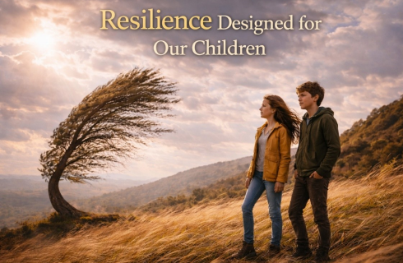

A Reflection Before Williamsport
As I’ve been invited to speak at a medical conference in Williamsport, Pennsylvania in March, an honor I hold deeply, and now for the second time, I’ve been spending time reflecting on the topic I’ve been asked to address: raising competent children and adolescents in these challenging times.
In that process, one word has continued to surface and hold my attention: resilience.
What does it truly mean? How is it formed? And how do we foster it in children in a way that honors both God’s design and the realities of the human nervous system? This essay represents some of those early reflections, offered as a kind of preamble to the conversation I hope to have in Williamsport and, hopefully, far beyond.
Why We Don’t Raise Children to Be Happy
Many parents say it instinctively: “All I want for my child is to be happy.” The longing behind that wish is deeply human. To love a child is to want joy rather than pain, ease rather than struggle, laughter rather than tears. There is nothing shallow about that desire. It is rooted in love.
And yet happiness was never meant to carry the weight we have placed upon it.
Happiness is transient. It rises and falls with circumstances, seasons of life, relationships, health, success, disappointment, and the shifting terrain of the human heart. When happiness becomes the goal, suffering begins to feel like failure. Discomfort feels abnormal. Struggle starts to look like something has gone wrong.
But life does not work that way. And neither do human beings.
Pain, frustration, loss, uncertainty, and disappointment are not malfunctions of the human experience. They are part of it. Any vision of parenting that treats difficulty as something to be eliminated rather than navigated prepares children not for strength, but for fragility.
What we truly want for our children is something deeper and more enduring. We want them to live well.
Resilience as God Designed It
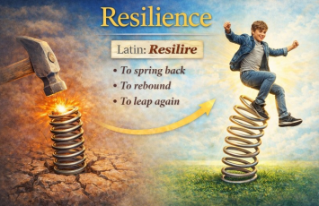
This understanding of resilience sits at the heart of the NeuroFaith® model. NeuroFaith® does not begin with techniques or diagnoses. It begins with a simple theological and human conviction: God designed human beings with the capacity to endure adversity and return to wholeness.
The word resilience itself quietly carries this truth. It comes from the Latin resilire, meaning “to spring back,” “to rebound,” or “to leap again.” Embedded in the word is the assumption of impact. Nothing springs back unless it has first been pressed, bent, or struck. Resilience does not describe a life without stress. It describes a life that has been acted upon and yet is able to return. That return is not accidental. It is built in.
How Resilience Happens in the Body
What NeuroFaith® adds is clarity about how this return happens inside the body. Resilience is not only emotional or spiritual. It is physiological. It unfolds through systems God designed to help us respond to stress and then recover from it.
When a child encounters challenge, the nervous system responds automatically. Energy rises. Attention narrows. The body mobilizes through the stress response. Hormones such as adrenaline and cortisol increase to help the child act, protect, or endure. This is not pathology. It is preparation.
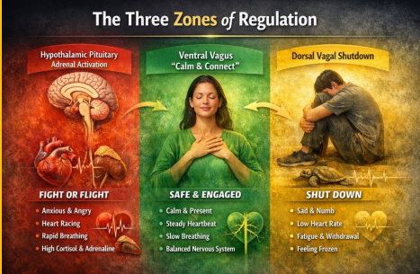
When stress becomes overwhelming or prolonged, another response may emerge. The system conserves energy by slowing down, numbing, or withdrawing. This shutdown response is not laziness or weakness. It is protection. The body is saying this is too much right now. But resilience does not live in constant activation, nor does it live in collapse. Resilience emerges through a pathway oriented towards safety, connection, and restoration. Polyvagal informed therapy helps us understand that the nervous system is designed to return to this state. It is here that a child can calm without collapsing, stay engaged without being overwhelmed, and reconnect after distress. This is the nervous system’s way of saying I am safe enough to come back.



What Loyalty Actually Means
I’ve been thinking about that word loyalty. It is one of those words that sounds immediately virtuous, almost beyond question. We praise it. We expect it. We want it from others and quietly hope we possess it ourselves. Loyalty feels like moral glue, the thing that holds relationships, families, institutions, and even identities together.
But the longer I sit with it, the more complicated it becomes.
The word loyalty comes from the Latin legalis, meaning of the law, faithful to obligation, bound by allegiance. At its root, loyalty is not primarily about emotion. It is about binding. About choosing to remain attached to a person, a cause, a role, or a covenant even when circumstances change.
That is why loyalty has always been counted among the virtues. It signals reliability, constancy, and faithfulness over time. In a world addicted to novelty and disposability, loyalty feels almost like moral resistance.
And yet virtues, when left unexamined, have a way of quietly turning against us.
Aristotle and the Problem of Too Much Virtue
This is where Aristotle keeps intruding on my thoughts. He insisted that every virtue exists as a mean, a balance point between two extremes. Courage sits between cowardice and recklessness. Honesty sits between deceit and cruelty.
Virtue is never simply about having more of something. It is about having it rightly ordered.
So where does loyalty sit? Too little loyalty and we become fickle, transactional, and untrustworthy. But too much loyalty is where things quietly become dangerous. Loyalty without discernment turns into self-erasure. Loyalty without reciprocity becomes bondage. Loyalty without truth becomes complicity.
At some point, loyalty stops being a virtue and starts becoming a liability.
When Loyalty Turns Against the Self
Here is the hard question I have had to face: when does loyalty become the thing that keeps you going back for crumbs, even when there are no crumbs left to receive?
I see this clearly now in my recent experience in my previous position. I loved my boss. I still do. I considered him a spiritual brother. He recruited me out of Madigan. He gave me space to create, to develop the NeuroFaith® model, to think deeply, to write, and to teach. Those gifts were real. I do not deny them.
But over time something shifted. Responsibility without authority. Requests without response. Letters unanswered. Phone calls ignored. Writings and books sent into silence. Again and again.
And still, I stayed loyal.
Why? Because some part of me kept hoping. Hoping for recognition, appreciation, and attunement. I wanted him to speak my language. He could not—or perhaps would not. He comes from a corporate world where relationships are often instrumental. I come from a world where relationships are moral and formative.
We were not speaking the same relational dialect.
Kinds of Relationships
Aristotle names three kinds of relationships: relationships of utility, based on what each person gets; relationships of pleasure, based on enjoyment or affinity; and relationships of virtue, based on mutual recognition of the good in one another.
I wanted to believe ours was virtuous. I believe I was showing up that way. But increasingly it became clear that the relationship functioned primarily as utility. My wisdom, my labor, and my model had value. I did not feel valued in return.
A virtuous relationship cannot exist when only one person believes it is virtuous.
Hope Deferred
Scripture names this ache with painful clarity:
“Hope deferred makes the heart sick, but a desire fulfilled is a tree of life.” Proverbs 13:12
That verse does not accuse anyone. It simply tells the truth. Hope that goes unanswered does not ennoble us. It exhausts us.
I see now how my loyalty intersected with my own longing to be seen. That is not shameful. But it is deeply instructive.

Business or Brotherhood
People will say it was not personal, that it was “just business.” But that phrase itself reveals a worldview. It assumes that business exists outside moral relationship, that people are interchangeable, and that outcomes matter more than people.
I do not see the world that way. I never have.
Perhaps the deepest grief here is not simply the loss of a role or even a relationship, but the collision of two moral frameworks that could no longer peacefully coexist.
The Proper Ordering of Loyalty
Loyalty is a virtue until it asks you to betray yourself.
True loyalty is faithfulness to what is good and true, including the good and truth of one’s own dignity. When loyalty requires you to silence yourself, abandon your boundaries, or quietly accept disregard, it has ceased to be virtue.
Sometimes the most faithful act is not staying but leaving with integrity intact.
That too is loyalty, properly ordered.

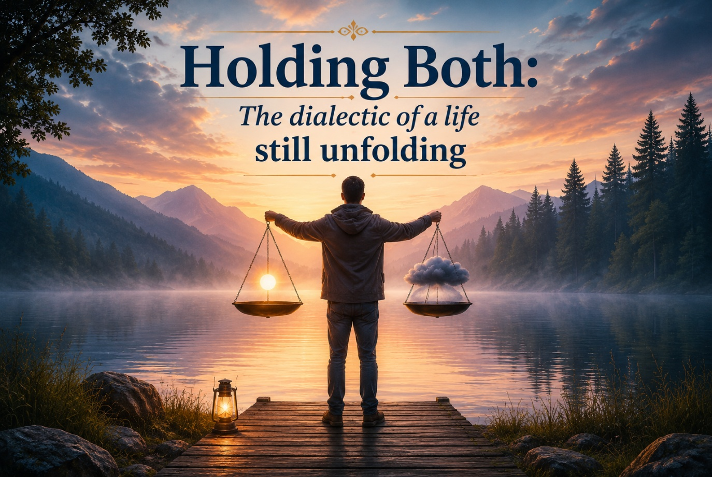

The Illusion of Simplicity
For much of my life, I believed that if I lived with integrity, worked hard, and walked faithfully, life would eventually become simpler. Not perfect, perhaps, but at least orderly. I assumed that commitment would bring clarity, that responsibility would produce stability, and that doing the right thing would eventually smooth the road ahead.
That belief was not naïve. It was shaped early through nearly a decade of military service and years within the Department of Defense. In those environments, integrity is not an abstract value. It is the foundation of trust, leadership, and identity. Your word matters. Your character matters. Responsibility is not something you step away from when circumstances become uncomfortable.
And for a long time, that framework made sense of the world.
Then life began to complicate it.
I started discovering that gratitude and grief often arrive together. That calling and cost rarely take turns. That meaning is sometimes born from experiences we would never choose. I found myself holding truths that pulled in opposite directions yet refused to separate.
There is a word for this way of living. Dialectic. Not merely a philosophical abstraction, but a profoundly human reality. The capacity to hold two truths at the same time without forcing one to erase the other.
I did not learn this in theory. I learned it by living it.
When Conviction Required My Voice
As I prepared to leave my role within the military system, one of the most painful chapters of my professional life unfolded. While serving at Madigan, I grew increasingly concerned about how issues of gender identity were being addressed with children. What troubled me was not compassion for suffering young people. It was the pace. Clinical conversations were accelerating toward affirmation and medical pathways without sustained exploration of trauma history, neurodevelopment, family systems, or long-term psychological and medical risk.
At first, I wrestled quietly. Then more openly. Questions that once would have been welcomed began to feel inconvenient. Still, I could not ignore what I was seeing. As a psychologist, I am ethically bound to protect vulnerable populations. As a former Army officer, integrity demanded that I speak.
So I did. Not with hostility or politics, but with caution, humility, and depth. I asked whether we were moving faster than the science. Whether irreversible decisions deserved slower reflection. Whether protecting children sometimes requires patience more than certainty.
Eventually, I wrote a book addressing these ethical tensions. I was later able to speak with colleagues before the European Union Parliament, engaging in dialogue around these same concerns. Alongside respected and ethically minded peers, I co-authored two amicus briefs focused on preserving the integrity of medical ethics.
More recently, I had the unexpected honor of contributing to an amicus brief submitted to the United States Supreme Court, heard last October, with an opinion expected in April. None of this was pursued for recognition. It simply reflected how deeply I cared about protecting clinical judgment and the well-being of those we serve.
When Conviction Carried Consequence
Conviction, however, rarely comes without cost. Following the publication of my writing, formal allegations were initiated against me by a progressive colleague, escalating to the threat of my professional license. I found myself defending not merely my position, but my professional existence. For someone whose life had been shaped by integrity, this was a profound moral injury.
I was shaken. I was frightened. I was wounded.
And yet even here, another dialectic emerged. Anger and compassion began sharing the same space. In the midst of fear and grief, God began softening my heart. I found myself praying for the individual who had initiated the accusations. Not because the harm was acceptable, and not because justice no longer mattered, but because bitterness threatened to become its own form of captivity.
Compassion did not excuse what happened. It simply freed me from carrying it forward.
Restoration Without Resolution
That season eventually passed, though it left its mark. Later, I accepted the role of Clinical Director at Holdfast Recovery. It felt like restoration. I loved mentoring clinicians, training staff, and helping shape a developing clinical identity. As the organization expanded to include residential services and AnchorPoint, there was genuine joy in building something meaningful together.
During that season, I continued developing the NeuroFaith® model, exploring the intersection of neuroscience, psychology, and faith. The trademark was never about ownership. It was about stewardship, a way of protecting ideas forged through experience, failure, and grace.
Over time, however, another tension emerged. It was not ideological. It was structural. I carried immense responsibility with limited authority. Good people simply held different visions for the path forward.
There were no villains in that chapter. Only misalignment.
When I eventually chose to leave, I did so carrying both gratitude and disappointment. I wrote a letter blessing the staff, because even when we are hurt, we do not throw grenades down hallways we once walked with purpose.
The Unexpected Gifts of Slowing Down
I assumed retirement would feel empty. Instead, it began with crisis. During my first week, my mother nearly died from double pneumonia and sepsis. I flew out to be with her alongside my brother and sister. In those hospital days, I was able to sit with her, read Scripture, pray, and simply be present. That availability would not have been possible at the pace of my former life.
Loss created presence. Pain opened purpose.
In this slower season, I have begun seeing my wife Leah with new eyes. Her gift of hospitality, of opening her heart and home so others feel welcomed and safe, has taken on deeper meaning. I find myself dreaming of us laughing together, unhurried and fully present, as we step into this sunset chapter of life.
My family relationships have deepened as well. My older brother Ken has stepped fully into the role of big brother with steadiness and wisdom. My sister Karen, legally a stepsister but in every way a true sister, has shown loyalty beyond words. My adopted sisters Konomi and Saya, along with Konomi’s children Alison and Kenneth Jr., have reminded me of the quiet holiness of simply showing up.
I am learning again how to live without hurry.
Holding Both
Life is not a straight ascent. It is a rhythm. Joy and sorrow. Calling and cost. Endings and beginnings held together.
This is the life I am learning to live now. Not choosing one truth over another. Not demanding resolution before understanding.
But learning, slowly and gratefully, how to hold both.
“There is a time for everything, and a season for every activity under the heavens… He has made everything beautiful in its time.” (Ecclesiastes 3:1,11)

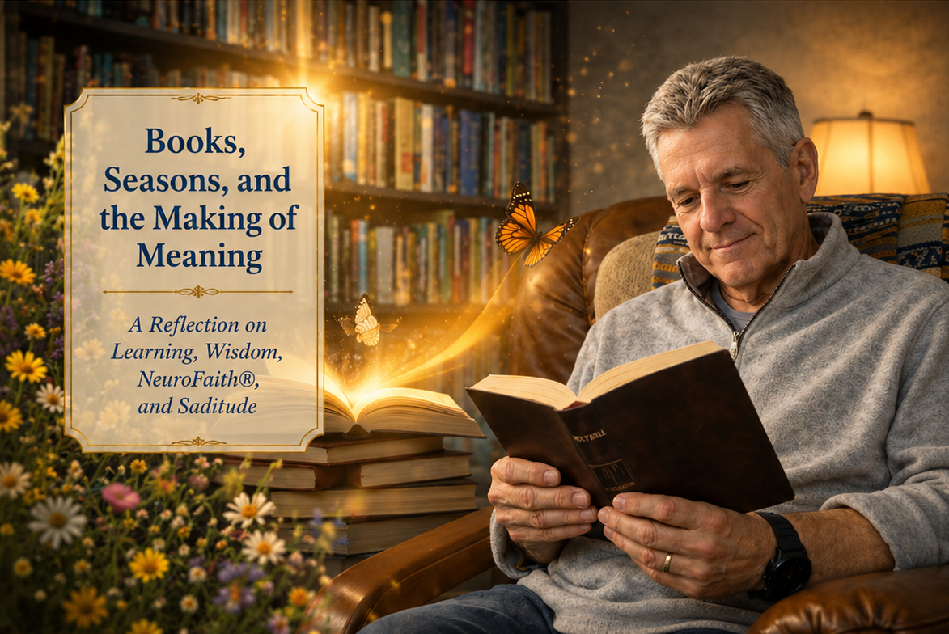

The Early Season: Building the Collection
There was a time when books were simply requirements. In undergraduate school and early graduate training, books were assigned, measured, and tested. They were things to get through rather than companions to sit with. Knowledge came in syllabi and deadlines, shaped by institutions that often told you what to think long before they taught you how to think. Like many students in psychology, I learned the language of the field before I learned its soul.
It wasn’t until later, well into graduate school and especially after leaving academic institutions behind, that books began to change for me. Once the pressure of exams, comprehensive reviews, and institutional dogma fell away, something remarkable happened. I was finally free to choose what I wanted to learn. That freedom changed everything.



My first true book collection began at UC Berkeley and the University of Arkansas at Fayetteville. That was where the family started, what I affectionately call my “chilens,” my affectionate modification of children. From there they traveled with me through my internship in California, then across the ocean to Kaiserslautern, Germany. Later they moved to Texas, Washington, back to Germany again, this time Frankfurt, and then once more to Washington before finally arriving in Arizona.
Through hospitals, treatment centers, and countless clinical settings, my books remained constant companions. Wherever I went, they came with me.
In those early seasons, my reading was largely scientific and clinical. Neuroscience, trauma theory, attachment, developmental psychology, addiction science. These were the foundations I pursued. I was hungry to understand what actually happens inside a human being when suffering takes hold. Those books built my competence. They sharpened my clinical instincts and taught me how to think independently rather than merely repeat what I had been taught.
The Middle Season: Knowledge That Begins to Speak Back
As the years passed, something shifted. The books stopped merely informing me and began confronting me. Some challenged assumptions I didn’t realize I carried. Others exposed blind spots or forced me to wrestle with uncomfortable truths. I came to understand that a good book is much like a good friend. A good friend doesn’t simply affirm you. A good friend tells you the truth, even when it is difficult to hear.
The books that shaped me most were not loud or dogmatic. They did not rely on intellectual bravado or rigid certainty. Instead, they spoke clearly and patiently, inviting me to think deeper, wider, and more honestly.
Over time, these conversations began to converge. Neuroscience began speaking to trauma, trauma to attachment, and attachment to meaning. Slowly, almost quietly, a framework began to take shape. What would eventually become the NeuroFaith® model was not born from a single moment or text, but from years of dialogue. Books speaking to books, ideas speaking to experience, science speaking to the human heart.
My books did not simply inform my mind. They touched my soul.
The Later Season: Pulling It All Together
As we age, the hunger changes. Earlier in life, we seek knowledge. Later, we seek coherence. We want to know what it all means. We begin asking different questions about what endures, what heals, and what merely sounds impressive. This becomes the philosophical season, the season of synthesis. And in that season, one truth becomes unmistakably clear. Knowledge alone is not enough.

The Book Above All Books
It would be impossible to tell my story honestly without naming the book that ultimately helped me make sense of all the others, the Bible. Not as a competing source of knowledge, but as the lens through which knowledge becomes wisdom. Scripture does not replace science. It redeems it. It helps discern what knowledge builds life and what knowledge quietly dehumanizes, reminding us that human beings are not machines to be optimized but souls to be restored.
Through God’s Word, the fragmented pieces begin to align. Truth with grace, knowledge with humility, healing with meaning. The Bible does not answer every scientific question, but it teaches us how to hold knowledge rightly. It orients the mind and anchors the heart.
In many ways, NeuroFaith® was born at this intersection, where neuroscience and psychology meet something older, deeper, and wiser. Where empirical understanding bows, not in submission, but in reverence.
A Quieter Season and Saditude
Today, my books finally rest in one place, my garage, affectionately known as my man cave. From this space I have written six or seven books of my own. When I brought my “chilens” home and placed them on the shelves, I felt a deep sense of comfort and belonging. And yet, alongside that happiness came something else as well, a quiet sadness.
This move felt different from all the others. In earlier years, each relocation carried momentum, another hospital, another leadership role, another institutional challenge. At one point, I served as a clinical director in addiction treatment, work that demanded intensity, structure, and relentless pace. Those years mattered deeply, and I remain grateful for them. But I also know that this move is different because it is likely the final one.

The era of institutional urgency, the hospitals, committees, and formal systems, has closed. What remains is quieter work. Slower work. Work shaped less by hierarchy and more by reflection.
Now the task is philosophical, pulling together decades of learning, experience, faith, and science into something coherent and humane. I work now as an older man, a senior psychologist, emphasis on senior, yet still with a strong and curious mind, sustained in large part by my lifelong relationship with books.
This season has taught me a word I have come to cherish: saditude. Saditude is a term I coined a few months ago as I prepared to leave my work at Holdfast Recovery and AnchorPoint for the final time. It emerged not from theory, but from lived experience. I felt genuine sadness in closing that chapter, leaving colleagues, patients, and a role that had once carried deep responsibility and meaning. At the very same time, I felt profound gratitude for the years of service, growth, and purpose that work had given me.
Saditude names that paradox, the ability to hold sorrow and thankfulness together without needing to resolve one against the other.
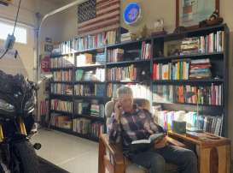
It is gratitude for a life of learning, for those I have served, and even for the institutions that shaped me before I outgrew them. And it is sadness, tender and honest, for chapters that will not return. Saditude is not despair. It is the emotional signature of a life honestly examined, where striving gives way to meaning and knowledge slowly becomes wisdom.
In this quieter season, surrounded by my books, I am still listening. Still learning. Still grateful.



Some months ago, I wrote a blog about grace. I reflected on how freely God gives it and how gently He uses grace to draw us toward the cross. Grace meets us exactly where we are. It does not demand that we become someone else before we come. It does not require performance or perfection. Grace is undeserved, unconditional, and freely given. In that sense, it truly costs us nothing.
Grace is the open door. It is the invitation home. It is the moment when love reaches us before we ever reach back.
But grace does not end at the cross.
Something happens after redemption, after restoration, after we begin to find our footing in Christ and catch a glimpse of a future far greater than we ever imagined. The same grace that saves us begins to invite us forward, gently and persistently. It calls us not only to believe, but to follow.
And that is where another word quietly enters the story.
Cost.
When Faith Becomes Transactional
We often speak of what it cost Jesus to die on the cross. The suffering. The surrender. The laying down of His life so that forgiveness could be offered to us all. That cost is beyond comprehension. Yet once that gift is received, grace does not remain something we simply take in. It becomes something we are asked to live out. Grace saves us freely, but discipleship forms us intentionally.
This is where faith becomes challenging in the modern world.
Along the way, particularly in Western culture, we absorbed the idea that the self is central to all meaning. Perhaps born from humanism or from sincere attempts to relieve emotional pain, the focus gradually shifted inward. Even within modern psychology, the language of self became dominant. Without realizing it, many of us began to approach God as though His role was to meet our emotional needs, affirm our desires, and support the version of life we preferred.
When that happens, something subtle but significant occurs. Instead of honoring that God created us in His image, we begin shaping God into ours. Faith becomes shallow. God becomes transactional. Prayer turns into a request line. Christianity slowly begins to resemble a vending machine. Insert belief. Press a button. Expect blessing.
It may feel comforting for a moment, but it does not nourish the soul.
The Brain, Dopamine, and the Pursuit of Relief
There may be another reason this kind of faith has become so appealing in our time, and it has less to do with theology and more to do with how we are wired.
Neuroscience has shown that the human brain is powerfully drawn toward pleasure. Anna Lembke writes about this in Dopamine Nation, describing dopamine as a molecule of pursuit. Dopamine fuels wanting. It pushes us toward what feels good, what promises relief, what offers reward. It is not a bad molecule. It is a gift. But it was never meant to run our lives.
When dopamine dominates, we naturally seek more pleasure and less pain. We want ease without effort, reward without sacrifice, grace without cost. The brain simply does what it was designed to do and asks for more.
Yet the nervous system always seeks balance. As pleasure rises, pain follows. Anxiety increases. Restlessness grows. Satisfaction fades. What once felt soothing begins to feel empty.
Daniel Lieberman, in his book The Molecule of More, describes dopamine as a forward-moving molecule. It lives in the future. It thrives on anticipation. But we were never meant to live perpetually in pursuit. When life becomes an endless chase, even a spiritual one, the soul grows weary.
From Pursuit to Presence
There are other neurochemicals that restore balance. Serotonin and oxytocin emerge not through pursuit, but through presence. Through relationship. Through commitment. Through choosing one another. These are bonding chemicals. They arise not from consuming grace, but from carrying it.
When we are willing to accept cost, when we slow down our pursuit of immediate relief and instead choose faithfulness, something different begins to happen. We begin to experience connection rather than craving. Meaning rather than movement. Belonging rather than striving.
This is not the fleeting pleasure of dopamine.
It is the deeper peace of attachment.
When Cost Becomes Participation
So, when do we become willing to accept cost?
Not when we are pressured into it. Not when we are shamed. Not when faith is framed as obligation. We accept cost when grace has created safety, when we trust the One who walks with us through it. When grace has assured us that we already belong, cost no longer feels like punishment. It becomes participation. We are no longer paying a price to earn love. We are offering sacrifice because we are already loved.
This is when obedience changes. It moves from fear to devotion. From striving to surrender. From duty to desire.
The Latin root of the word cost comes from constāre, meaning to stand firm. Cost is not simply about loss. It is about alignment. It is about where we choose to stand when comfort and conviction pull in opposite directions.
What Obedience Has Cost Me
I am no spiritual giant. I am not a hero of the faith. I am simply someone who once believed that following Jesus would not cost very much. I was drawn wholeheartedly to the cross, but I did not yet understand that obedience would eventually ask something of me.
At one point, God made it clear that I needed to change my ways. That obedience cost me a relationship with someone I deeply cared about. The loss was painful. And yet something beautiful emerged. She later came to know Christ, and I went on to meet my soulmate, Leah. Looking back now, I can see that had I refused the cost, neither story would have unfolded as it did.
As my faith deepened, the invitations to stand firm continued. Speaking publicly about difficult and unpopular truths cost me professionally. Standing for conscience brought complaints and threats against my license. Advocating for those being treated unjustly cost me opportunities I likely would have received had I chosen silence.
My research team eventually gave me a name that both humbled and honored me. They called me MAV, a maverick. It reminded me that obedience does not always reward us with advancement. Sometimes it simply reveals who we are willing to be.
The Peace That Follows
Time has a way of clarifying what matters most. It feels like only moments ago that I received Christ at nineteen or twenty years old. And now I am seventy-one. Life passes far more quickly than we ever expect. What once felt distant now feels precious.
I find myself wanting the remaining years not for comfort, but for faithfulness. Not for ease, but for depth. I understand now that following Jesus will involve cost. There will be sacrifice. There may be pain. Jesus never said the way would be easy. In fact, He was honest that it would be hard.
But He also promised something else.
He promised life. Eternal life. And He promised peace. Not the absence of struggle, but the presence of Himself.
Scripture gently reminds us:
“And the peace of God, which surpasses all understanding, will guard your hearts and your minds in Christ Jesus.” — Philippians 4:7
This promise matters not only spiritually, but neurobiologically. When the heart feels safe, the mind can rest. When the mind rests, the body begins to settle. When we are anchored in Christ, the nervous system no longer has to remain on constant alert. Safety is restored from the inside out.
The Real Plan
This is the foundation of the NeuroFaith® model. Healing does not come from elevating the self, but from securing the heart and the mind in Christ. In Him, the soul finds coherence. The body finds calm. The heart finds home.
Grace is free. We receive it with open hands.
Discipleship, however, asks us to stand. Not harshly or fearfully, but firmly and lovingly. It calls us to live aligned with truth even when that alignment carries cost.
Following Jesus is not easy. But it is good.
And in the end, the cost we pay is far outweighed by the peace we receive. A peace the world cannot manufacture. A peace the self cannot generate. A peace that settles gently into the deepest places of who we are.
There, in that quiet and sacred space, we discover that we were never meant to carry life alone.



We Talk About Love — But Rarely About Hate
We write endlessly about love. Sermons about love. Books about love. Songs that chase love as though it were the only force shaping the human story. Yet one of the most powerful and misunderstood realities in Scripture, psychology, and everyday life receives far less reflection.
Hate.
Is it the opposite of love?
No. The opposite of love is indifference. Hate is something else entirely. It is attachment fused with hostility, a bond distorted rather than broken. Hate still connects us to what we oppose. It binds us emotionally, spiritually, and biologically. And perhaps one of the greatest mistakes we make is treating hate as though it were simple.
The Etymology of Hate: A Word With Layers
The English word hate comes from the Old English hatian, meaning intense hostility or deep aversion. Its Germanic relatives suggest more than anger; they imply a pushing away, a relational severing. But Scripture adds even deeper nuance. The Hebrew word śānē’ does not always mean emotional rage. It can mean to reject, to choose against, or to set apart.
Already we see complexity. The Bible uses the same word for moral opposition and relational hostility, two realities that are worlds apart.
Maybe there should have been two entirely different words. Because without that distinction, we confuse discernment with dehumanization.
The Bible’s Paradox: Hate Has a Place — and a Warning
The Bible speaks about hate far more often than most people realize. And surprisingly, Scripture sometimes commands it.
“Hate what is evil; cling to what is good.”
This is not cruelty. It is moral clarity. A refusal to baptize darkness with the language of love.
But the same Scriptures speak with equal force about another kind of hate.
“Whoever hates his brother walks in darkness.”
Here the meaning shifts. Hate aimed at evil can guard the soul. Hate aimed at people corrodes it. The biblical narrative consistently distinguishes between rejecting evil and dehumanizing people. One is discernment. The other is blindness.
The Heart Speaks First: Neurocardiology and the Physiology of Hate
Before hate becomes theology or ideology, it becomes a bodily state. In regulated emotional conditions, heart rate variability organizes into coherence. As we breathe in, heart rate rises. As we breathe out, it slows. When grounded in gratitude, compassion, and calm engagement, the heart and brain synchronize.
But when hatred enters the system, coherence collapses. The smooth rhythm becomes jagged and chaotic. The autonomic nervous system shifts into defense.
Polyvagal Theory helps us understand this movement. Hate does not move us toward the ventral vagal state of safety and connection. Instead, it drives us down the defensive hierarchy into fight, flight, or collapse.
Hatred is not just a belief. It is a full-body experience.
How the Body Drives the Brain
When the body registers hate, emotional dysregulation communicates with the brain through hormonal cascades, vascular shifts, vagal pathways, and changes in the heart’s electromagnetic field.
Dan Siegel describes two extremes that often follow: chaos and gridlock. Too much activation creates impulsivity and reactivity. Too much shutdown creates rigidity, numbness, and the “molasses brain.”
In both states, the limbic system dominates while the prefrontal cortex loses regulatory authority. Primitive impulses become louder than reason.
Hatred narrows consciousness.
Neuroception: Hate Becomes Atmospheric
Hatred does not stay contained inside one person. Through neuroception, the unconscious detection of safety or threat, others begin to feel what we carry. Tone of voice, posture, facial expression, and emotional presence communicate faster than words.
A regulated presence calms others. A dysregulated presence destabilizes them.
Hatred becomes atmospheric.
A Confession and a Way Forward
I need to say something plainly before this ends. I, too, have wrestled with the word hate. I, too, have felt its gravity pull me toward darker places. And I, too, have spoken words that were too sharp, too absolute, too strong, words that divided when my deeper longing was to heal.
If love is not the opposite of hate, it is still the antidote. Compassion softens what hatred hardens. Curiosity widens what contempt narrows. Understanding restores what fear fractures.
In the language of Internal Family Systems, it is the return to calm, curiosity, compassion, clarity, courage, confidence, creativity, and connectedness that begins to reorganize the nervous system. In the language of Scripture, it is living from love, joy, peace, patience, kindness, goodness, faithfulness, gentleness, and self-control that draws us back into alignment with the Spirit.
And something remarkable happens when we move toward these states. The heart begins to settle. Cortisol softens. Inner tension releases. The nervous system shifts toward connection, presence, and communion.
This is not sentimental optimism. It is neuropsychobiological and spiritual restoration.
“Above all, clothe yourselves with love, which binds everything together in perfect harmony.”
— Colossians 3:14

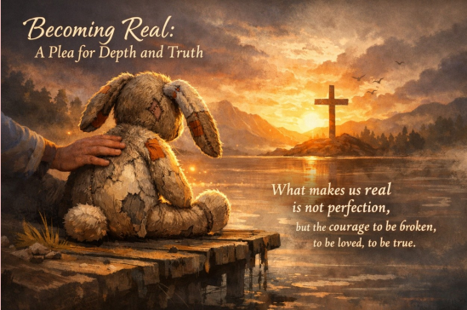

A Plea to Stop Living Fake
This is a plea to stop living fake. A plea to go deep. A plea to become real.
There are moments when I catch myself performing a version of me that looks polished on the outside but feels strangely distant on the inside. We are conditioned early to carry the mask, to stay impressive, composed, and acceptable. We learn to function in crowds while quietly starving for depth. Somewhere along the way, we are told that looking strong matters more than being known, and that success is measured by how well we climb rather than how honestly we live.
I know that climb well.
I lived for the mask longer than I care to admit. Achievement. Reputation. Comparison. Climbing higher and higher. Measuring myself against others. Believing that success would finally quiet the restless ache inside. None of those things were entirely bad. But I made them everything. And in doing so, I slowly lost parts of myself I did not even realize were slipping away.
The Painful Gift of Being Stripped Down
Then came a reset I never would have chosen. A painful stripping away. Losses that felt confusing and heavy at the time. Taking less. Letting go of position. Even stepping into a season where my income dropped and the image I had built no longer held me together.
I was never wealthy in the worldly sense, but what little security I had felt began to dissolve. And in that unraveling, I heard something deeper. God was not punishing me. He was inviting me back to myself.
Aristotle wrote that deep friendship is rooted in shared virtue and truth, not in usefulness or status. That kind of depth cannot exist where masks rule the room. I began to see how often I had surrounded myself with performance rather than presence, competition rather than companionship. Time felt too precious to keep investing in relationships that left me feeling lonely even when I was not alone.
The Courage to Descend
The descent into honesty is rarely glamorous. Those who struggle with trauma and addiction often understand this more clearly than anyone. Many of the people I have had the privilege to walk beside have shown me what courage truly looks like. They are willing to go into the dark places, to confront what hurts, and to let life reshape them.
That is why I love this work.
Because when someone chooses truth over image, something sacred begins to unfold. The descent is not failure. It is formation. And the climb back out happens best when no one climbs alone.
Scripture has always honored those who go deep. Jesus never called people into polished performance. He called them into examined hearts. The Psalms are filled with voices that refuse to hide behind perfection. David cried out from the depths without pretending to have it together. The biblical story does not celebrate flawless people. It celebrates honest ones, people willing to wrestle with God and refuse a shallow life.
The Loneliness Beneath Perfection
And yet we live in a culture obsessed with perfection. We compare, compete, curate, and polish until we barely recognize ourselves. Beneath that polished exterior is often a deep and aching loneliness.
I know that loneliness because I helped build it in my own life.
The real companions, the fellow soldiers, the soulmates of this journey are not the ones who project perfection. They are the ones who admit their fractures, their fears, and their unfinished stories.
The Velveteen Rabbit became real not by staying pristine, but by being worn down through love, through tears, and through time. Realness rarely looks impressive. It looks maverick, torn, tattered, and deeply loved. It carries the marks of a life lived honestly. And strangely, those marks are what make a person beautiful.
What Actually Makes a Soul Beautiful
Life has a way of teaching us whether we resist or not. Again and again, it presses us inward, toward a deeper examination of the heart. That is where Christ meets us, not in the illusion of perfection but in the raw, unguarded places where transformation begins.
The things I once chased so fiercely now feel smaller. Not meaningless, but no longer central. Success, reputation, and achievement have their place, but they cannot carry the weight of a soul. Only love can do that. Only truth can do that.
So, this is a plea.
Do not live fake. Do not settle for shallow connection. Dare to descend into the deep recesses of who you are and seek the companions who are brave enough to walk there with you. Let life strip away what is false so that what is real can finally breathe.
Because in the end, what makes a person beautiful is not perfection. It is the courage to be real, to be known, and to walk forward with a heart that has been honestly seen, deeply formed, and fully alive.
“Surely you desire truth in the inward being.” (Psalm 51:6)

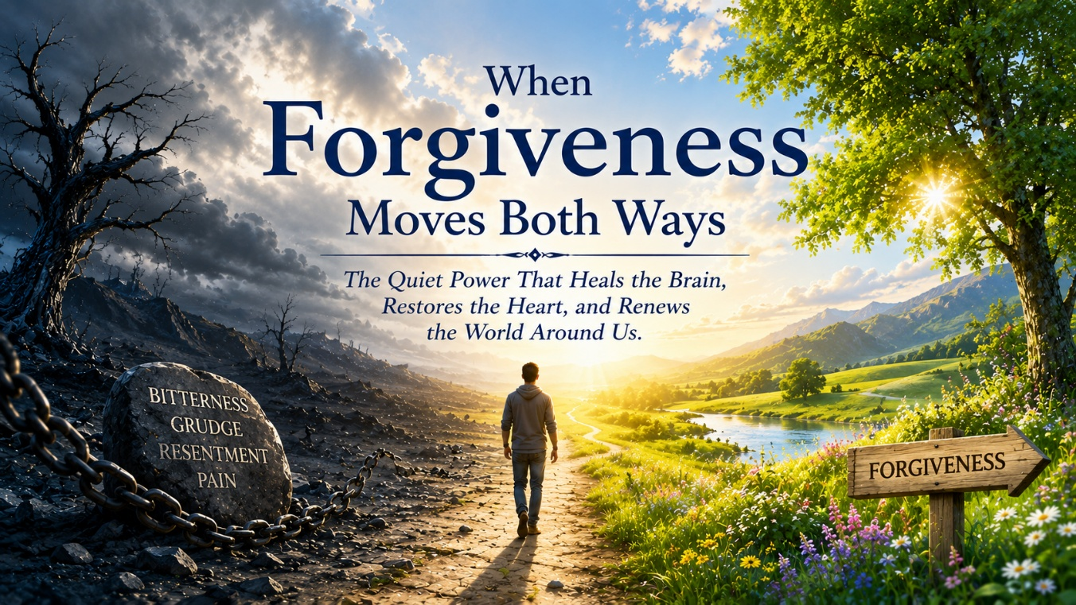

When the Mirror Turns Inward
I watched a video recently on one of my new favorite YouTube channels. It explored Joseph, betrayal, prison, forgiveness, and the neurobiology beneath it all. I expected to appreciate the insights and move on. Instead, it lingered long after it ended, not because of Joseph alone, but because it quietly turned the mirror toward my own life.
Over the past few years, I have had moments that left a mark. Seasons where I felt accused in ways that did not sit right in my spirit. Seasons where I felt unheard or not fully respected in professional settings. Even financial situations that felt unfair after promises had been made. None of those experiences define me, yet they left a residue. And residue, if unexamined, has a way of organizing the nervous system long after the event itself has passed.
What We Rehearse, We Become
There are things that still get under my skin. Not dramatic betrayals or headline-level injustices. Just situations that, when revisited, still tighten something inside me. I can analyze them. I can justify them. I can spiritualize them. Yet when I rehearse them, my body responds before my theology does. My jaw tightens. My chest constricts. My mind begins building its case as though standing before a courtroom.
And here is the irony that made me smile at myself a little. I am a psychologist. I speak about integration and regulation. I helped build a model around these very ideas. Yet there I was, watching my own nervous system rehearse an old grievance like it had a standing appointment on my calendar. Part of me had to laugh, not in shame but in recognition. Sometimes I think I need to go back and reread my own books, not as the author, but as the student.
In that moment, my nervous system did not care about titles or roles. Cortisol still rose. The amygdala still scanned for threat. The body prepared as though the past were happening again in real time. We often speak of forgiveness as though it were primarily a virtue, something noble or spiritually admirable, but it is also profoundly physiological.
Every time I revisit a grievance, I strengthen the pathway that holds it in place. Neurons that fire together wire together. Rumination becomes repetition. Repetition becomes circuitry. Circuitry begins shaping identity. Dan Siegel speaks about integration as the linking of differentiated parts of the brain so they function coherently rather than chaotically. Neurocardiology research reminds us that sustained negative emotional states disrupt heart rhythm coherence and strain the system. The immune system listens. The endocrine system adjusts. The prefrontal cortex gradually yields ground to limbic urgency.
When resentment lingers long enough, I am not simply morally stuck. I am biologically looping.
Joseph and the Choice to Reframe
Joseph had every reason to remain trapped in that loop. Betrayed by his brothers, sold, falsely accused, imprisoned, and then handed power over those who had wounded him. He could have crushed them and called it justice. No one would have objected. Yet vengeance would have kept him neurologically tethered to the original trauma, organizing his identity around what had been done to him rather than who he was becoming.
Instead, Joseph reframed the story. “You meant it for evil, but God meant it for good.” That statement is not denial. It is integration. It is regulating survival circuitry. It is a man choosing which narrative will govern his biology. Forgiveness did not erase the betrayal or pretend the suffering never happened. It released Joseph from being organized around it and allowed his future to be shaped by purpose rather than pain.
As I sat with that realization, the reflection turned inward again. I can justify my irritation. I can construct airtight arguments for why my grievance makes sense. Yet being right does not calm my nervous system. It does not lower cortisol. It does not restore coherence. It does not heal the body.
Release does.
Grace does.
Choosing a different governing narrative does.
Plasticity, Grace, and a Different Way of Living
Research consistently shows that sustained practices of emotional regulation, compassion, and cognitive reframing, often over eight to twelve weeks, can measurably alter stress physiology. Amygdala reactivity softens. Prefrontal regulation strengthens. Stress patterns stabilize. Heart rate variability improves as the nervous system shifts toward greater coherence.
What we rehearse becomes what we wire, and what we wire eventually becomes how we live.
If I spend the next few months rehearsing grievance, I deepen that groove in my nervous system. If instead I practice intentional release, not pretending the hurt did not matter, not minimizing injustice, but partnering with truth rather than rumination, my biology begins to organize differently.
That is not mystical language. It is plasticity meeting faith.
Walking This Road Together
Scripture reminds us that the wisdom from above is pure, peace-loving, gentle, open to reason, full of mercy and good fruit. That is not abstract theology. It is an invitation to a different organizing principle. And when Jesus said seventy times seven, He was not exaggerating for effect. He was describing a rhythm of living that refuses to let grievance calcify into identity.
Forgiveness moves both ways. It blesses inwardly by calming the storm within the nervous system, restoring coherence to the heart, and loosening the grip of chronic activation. And it blesses outwardly, changing how we show up in relationships, interrupting cycles of retaliation, and opening space for redemption that vengeance never could.
Joseph was released. His brothers were released. Even the future was released from the chains of the past.
And so I do not write this as someone who has mastered forgiveness. I write as someone still learning to live it. Titles do not exempt us from the work. Psychologist, founder, director, reader, friend, we are all standing on the same ground here. We all struggle with loops that tighten us. We all carry stories that still activate something inside us. No one is better. No one is worse. We are simply human beings learning how to live toward goodness.
So, my dear friend, let us do this together. You as the reader. Me in whatever role I occupy this season. Fellow travelers choosing not to curse our own physiology through endless rehearsal of grievance. Let us instead bless it. Let us speak compassion to our own nervous systems. Let us allow kindness to become the rhythm that organizes us from the inside out.
“Blessed are the peacemakers.”
Perhaps that begins in the quiet terrain of the heart, where resentment once lived. Perhaps it begins when we soften. When we release. When we allow love to become the protective covering that steadies us.
And in that softening, something beautiful happens. The body settles. The mind steadies. The heart remembers coherence. What blesses within begins to bless beyond. A gentleness forms around us, almost like a protective shelter woven from benevolence and grace.
We are not alone in this work. We never were.
Let us move toward peace together.



For more than a generation, our children have been the subjects of one of the largest uncontrolled experiments in educational history, and what makes this so unsettling is that it was conducted not in the spirit of careful developmental inquiry but in the cultural momentum of innovation for its own sake. We changed how they were taught to read. We changed the medium through which they learned. We altered the sensory and attentional environment of the classroom. And we did all of this at once, often with great confidence and very little long-term evidence that these changes were aligned with the way the developing brain actually forms.
I was trained in a structured phonetic model of reading instruction that worked because it respected neurodevelopment. Written language is not innate to the human nervous system. The brain must build a reading network by linking visual symbols to phonological processing and meaning through repetition, sequencing, and embodied practice. Systematic phonics provided that scaffold. It was not fashionable. It was effective. It endured because it produced fluent readers across generations.
The movement away from that model did not occur because the brain changed. It occurred within a broader educational climate that too often equated what was longstanding with what was suspect. In significant sectors of modern pedagogy, tradition came to be viewed as an obstacle to liberation rather than as the accumulated memory of what had worked for developing human beings. Structure was replaced by immersion. Mastery was replaced by exposure. At precisely the same historical moment, printed texts were displaced by screens in the name of efficiency, modernization, and scalability. An entire generation of children became the test case for these converging shifts, and the outcomes are now visible in classrooms, clinics, and homes.
When the Medium Changes the Mind
The research comparing reading across media is no longer ambiguous. When time on task is equal, comprehension and long-term retention are consistently stronger when students read from printed text rather than from screens, especially when the material requires integration, reflection, and conceptual depth. This difference is not about preference. It reflects the embodied nature of cognition.
A physical book provides spatial and tactile anchors. The reader knows where they are in the text not only intellectually but physically. The thickness of the pages, the position of a paragraph, and the movement of the hands create a three-dimensional map of meaning that supports hippocampal encoding and contextual memory. Eye movements in print follow a slower, more linear pattern with frequent regressions for comprehension. Attention settles into a sustained mode.
Screen reading encourages a different neurological posture. Scrolling removes spatial location. Navigation decisions increase cognitive load. The visual environment invites scanning rather than immersion. The reader is subtly trained to extract information rather than to dwell within it. Over time this conditions the brain toward shallow processing and reduces the capacity for synthesis.
This is not nostalgia for paper.
It is neurobiology.
Brain State and the Capacity to Learn
From a polyvagal perspective, deep learning requires a ventral vagal state. The nervous system must experience sufficient physiological safety for the prefrontal cortex to sustain attention, integrate complexity, and generate meaning. High-stimulation digital environments bias the child toward sympathetic activation or dorsal withdrawal, states that are adaptive for threat response but incompatible with reflective cognition.
Integrative child psychiatrist Dr. Victoria Dunckley has described this clinically as Electronic Screen Syndrome, a pattern of sleep disruption, chronic stress activation, attentional fragmentation, and emotional lability in children whose nervous systems are immersed in fast-paced digital stimulation. In those states the brain can react, but it cannot synthesize. When higher-order learning is demanded from a chronically dysregulated nervous system, the predictable result is not only academic difficulty but a reduction in resilience itself, because resilience is the capacity of a regulated organism to remain engaged with challenge and return to balance after stress.
A regulated brain learns.
A dysregulated brain survives.
Early Warnings from Neuroscience and Clinical Practice
These concerns were not absent from the scientific literature. Long before the current cultural unease, my colleague, good friend, and co-author Dr. Andrew Doan, a graduate from Johns Hopkins with a medical degree and a PhD in neuroscience, a prominent neuroscientist who also holds advanced degrees in public health and aerospace medicine, was documenting the addictive architecture of interactive digital media. In his seminal work Hooked on Games, he named gaming addiction as a genuine neurobiological and clinical phenomenon at a time when the idea was widely dismissed. In our later book, Digital Drugs and the Struggle for Connection, we described how high-stimulation digital environments condition the dopaminergic reward system for compulsive engagement and erode the capacity for sustained attention and relational presence.
What was once regarded as alarmist has become ordinary classroom reality. Students skim but struggle to synthesize. They experience complexity as overwhelm rather than invitation. They avoid sustained effort not because they lack character but because their attentional systems have been trained for rapid novelty.
The problem is not motivation.
The problem is state.
The Body Keeps the Score in the Classroom
To speak only of cognition is still too narrow. The same physiological dysregulation that undermines attention also contributes to the pediatric obesity crisis through sleep disruption, sedentary immersion, chronic stress hormone activation, and altered appetite signaling. We are not merely changing how children learn. We are altering the metabolic and autonomic conditions of their bodies.
Children live in time-dependent developmental windows. Language, regulation, social attunement, and attentional capacity do not develop indefinitely. When those windows are disrupted, the effects are not easily reversed. This became painfully clear during the COVID period, when policies designed for immediate safety often failed to account for the long-term relational and neurodevelopmental costs to children whose critical periods for social, linguistic, and regulatory development do not return once lost. Children are not abstractions in a policy debate. They are organisms in development.
When Progress Becomes Amnesia
It is necessary to name the cultural dynamic that made these converging shifts possible. In significant sectors of education there has been a form of progressivism that equates innovation with moral advancement and inherited practice with oppression. The intention has often been humane. The outcome has too frequently been the destabilization of methods that were developmentally sound before their function was fully understood.
This is not an argument against change. It is an argument against change that occurs without a research base, without longitudinal evidence, and without respect for the time-dependent nature of childhood.
Children do not have experimental childhoods to spare.
Incentives, Systems, and the Question of Formation
The digitization of education was also the creation of a vast new market. Tools were adopted because they were scalable and fundable, and what was considered developmentally questionable for the children of those designing these technologies became normalized for everyone else. This does not require the assumption of malicious intent. It does require an honest examination of incentives.
When formation is subordinated to efficiency and delivery systems, the question of what kind of human being is being shaped recedes from view.
The Loss of Deep Reading
At its deepest level this is not a dispute about pedagogical technique. It is a question of whether a culture still understands how a mind is formed. Deep reading builds sustained attention, strengthens executive function, develops empathy, and creates the neurological conditions for moral imagination. It is one of the primary ways a person learns to inhabit a perspective not their own.
When that capacity is weakened, the effects are not confined to academic performance.
The architecture of the self is altered.
The Courage to Remember
There is, however, a profoundly hopeful way to read this moment. Nervous systems can be re-regulated. Cultures can recover memory. The data that now trouble us also illuminate a path forward. We already know how to teach reading in ways that align with the science of the brain. We already know that children require embodied learning, relational presence, and environments that support physiological regulation.
The task before us is not to reject the new but to discipline it. Innovation must be tested against the only standard that finally matters: does it deepen learning, strengthen regulation, and foster the long-term development of whole human beings?
Not all innovation is advancement.
Not all tradition is limitation.
The task is discernment.
To restore printed texts to a central place in the formation of attention is not regression. To teach reading in ways that align with neurodevelopment is not nostalgia. To create classrooms in which nervous systems can settle is not a retreat from modernity. It is the recovery of the conditions under which resilience grows.
Resilience is not grit.
Resilience is a regulated nervous system capable of sustained engagement with reality.
If we are willing to hold on dearly, even preciously, to those practices that have demonstrated their capacity to form human beings well, and if we are willing to welcome the genuinely new only after it has shown itself capable of doing the same, then this period will not be remembered as the era in which we lost the reading brain or destabilized childhood.
It will be remembered as the moment we recovered our developmental wisdom and chose once again to build human beings rather than systems.



Grace and Peace and One True Center
This morning in church, as my amazing Pastor Whitney, who never ceases to deliver a sermon that lands squarely on my heart, opened the first lines of Ephesians and spoke the words, “Grace and peace to you from God our Father and the Lord Jesus Christ,” I felt both grounded and gently confronted.
He lingered over that phrase, the Lord Jesus Christ, reminding us that there is one true center of allegiance, one source of identity, and one place from which grace and peace actually flow. Whenever we allow something nearer to occupy that place, whether political, cultural, ideological, or even personal, we begin to live from a different organizing principle. Our tone shifts. Our posture shifts. Our capacity for unity diminishes. We begin to argue not simply for what we believe is good, but against those we have learned to see as the problem.
The Place Where I Am Most Alive
As I sat there, my mind moved to something that for me is never far from the surface. I began thinking about motorcycles. Anyone who knows me knows that riding is not a casual hobby. It is my favorite pastime. It is one of the places where I experience the deepest sense of coherence in my whole being.
When I am on the bike, everything has to come into alignment. My attention sharpens. My body settles. My breathing slows. The noise in my mind quiets. There is a kind of integrated presence that happens when the road unfolds ahead and I lean into a turn with full awareness. Riding will not tolerate fragmentation. It requires that mind, body, vision, and direction all agree.
And nowhere is that more evident than in the reality every experienced rider eventually encounters: the phenomenon known as target fixation.
Target Fixation
Every rider knows the law of target fixation. Anyone who has ridden for any length of time understands how serious it is. And for those who have never truly learned it, some are no longer around to talk about it.
You see the hazard and your eyes lock onto it. It might be gravel in the turn, a guardrail at the edge of the curve, or a car drifting too close to the center line. Your instinct is to stare at it because you want to avoid it, but the moment you do, the motorcycle begins to move toward it. Your body follows your gaze. Your line tightens in the wrong direction. You drift toward the very thing you were trying not to hit.
The only way through is to acknowledge the danger but refuse to give it your focus. You turn your head. You look through the turn. You fix your eyes on the long line, the open road, the place you intend to go. When you do that, the bike settles beneath you. Your movements become smooth. The path opens. You move forward with stability and even joy.

NeuroFaith® — Lived or Betrayed
Through the lens of NeuroFaith®, that realization becomes even more personal. We speak often about the heart as a center of relational intelligence, about appreciation and love as measurable physiological states, about heart rate variability and the way a regulated heart can help regulate another.
We speak about the electromagnetic field of the heart and the reality that our internal state is never private. It is transmitted. It is experienced by the people around us. It either creates safety and connection or communicates tension and threat.
I have taught this. I believe it. I have watched it transform lives.
And yet when my attention becomes dominated by opposition, when my focus shifts from Christ to the hazards of the cultural road, I step out of the very coherence I am inviting others to live. My heart moves from appreciation to agitation. My nervous system moves from regulation to subtle threat. My relational presence begins to communicate distance rather than grace.
Even if my words are logically correct, my state is no longer aligned with the model. That is not simply inconsistency. It is disintegration.
Back Into Order
Pastor Whitney’s sermon brought that contradiction into the light for me. My riding life has been discipling my body to look toward the horizon. My faith calls me to fix my eyes on Christ. NeuroFaith® calls me to live from a regulated, love-centered heart that co-regulates others and creates the conditions for connection.
When my attention is captured by the need to defeat an opposing position, I betray all three at once. I do not simply weaken my argument. I diminish my capacity to transmit grace and peace as a lived reality.
On the motorcycle, if I fixate on the hazard, I crash.
In my faith, if I fixate on the opposition, I eventually crash into the very people I am called to love.
But when I lift my eyes toward Christ, everything begins to come back into order. My body knows this feeling. It is the feeling of a clean line through a curve, of the motorcycle settling into its lean, of the road opening instead of closing. It is the feeling of coherence.
This is NeuroFaith® embodied. Grace and peace are no longer abstract theological ideas. They become a regulated nervous system, a heart filled with appreciation and love, and a relational field that invites connection rather than broadcasting tension.
There is an order to this that is both theological and physiological. Christ is Lord. From Him flow grace and peace. When grace and peace become the lived state of the heart, the nervous system moves into regulation. When the nervous system is regulated, the presence we carry becomes safe and invitational to others. When that happens, we can speak truth without contempt, hold conviction without hostility, and engage disagreement without losing connection.
So, this morning became more than a sermon. It became a call to integration. What my body has been practicing on every ride, what my theology has been proclaiming for years, and what NeuroFaith® has been articulating in clinical and relational terms are all the same movement toward one living center.
Lift your eyes. Look through the turn. Fix your gaze on Christ.
Because the motorcycle goes where the rider looks. The nervous system organizes around what the mind attends to. The heart transmits the state it lives in. And the soul becomes aligned with whatever it calls Lord.
And I know now, with a quiet certainty that feels less like striving and more like surrender, that the long road ahead is not about winning arguments or defeating opposing lanes of traffic. It is about riding in such a way that grace and peace become the atmosphere I carry, the coherence others can feel, the steady line that invites rather than divides.
It is about living from one center, loving from one heart, and moving toward one horizon.
And so, I lift my eyes again.
Not to the hazard.
Not to the noise.
Not to the identities that demand my allegiance.
But to Christ, who stands at the far end of the road, not as a threat to be reached but as a presence already guiding the line.
And I ride toward Him in grace.
“Let us run with perseverance the race marked out for us, fixing our eyes on Jesus, the pioneer and perfecter of faith.” (Hebrews 12:1–2)



The Framework for Understanding
I have spent much of my professional life helping people make meaning out of experiences that initially feel incoherent. Trauma, institutional strain, moral injury, love, endurance, and the slow work of integration are the terrain of my daily practice. I have long taught that healing begins when we resist the impulse to reduce a story to heroes and villains and instead ask a more demanding question: What was true? What was operating beneath the surface? What does this reveal about the kind of people we are and the systems we inhabit? I am now attempting to extend that same discipline to my own life.
This reflection is not an argument, nor is it an effort to establish who was right. It is an attempt to better understand the convergence of events, relationships, convictions, grief, and organizational realities that shaped the last three years and, perhaps more importantly, to better understand myself. It is written from the dual vantage point that has formed me: the lens of a psychologist who studies systems and the heart of a man who loves the people inside them.
Formation in Systems and Conscience
For more than a decade on active duty in the United States Army, then a season of private practice, followed by another decade serving as a civilian psychologist within the Department of Defense, I lived and worked inside one of the most structured hierarchies in our culture. I respected rank. I advanced within it. I was entrusted with increasing responsibility and understood clearly that authority is not the enemy of mission but its necessary backbone.
Yet across those twenty years there was a consistent pattern. When I saw a military psychologist being set up to fail through a process that violated clinical integrity or basic fairness, I spoke. When that required going outside the chain of command, I did so knowing the potential cost. When soldiers or clinicians were caught in systems that had already tilted the outcome against them, I stepped into those rooms because I could not unsee what I had seen.
This was never about opposition.
It was about congruence.
Public Convictions and Cost
Over time that same pattern extended into the broader debates of our profession. I have taken public positions that carried professional and relational cost because silence would have required me to fracture internally. I did not do this to provoke. I did it to remain whole.
That same pattern later shaped my willingness to speak publicly on controversial clinical issues, including the over-medicalization of children and the developmental and ethical concerns surrounding early medical intervention for gender-distressed youth. The response was often harsh. I was criticized and at times vilified. Yet silence would have required a fragmentation of the self that I could not accept.
Collapse and Realignment
There was also a season in which my own life lost alignment. Achievement and productivity had moved to the center of my identity. When family crises converged with the economic collapse of 2009, the structure that held me together gave way. I was brought to my knees by cumulative load and by the realization that success had replaced coherence.
The recovery took years. It reshaped my spirituality, my clinical work, and my definition of what it means to live in truth. That realignment in my fifties became the foundation of everything I now teach about integration.
The Second Call and the Vision
I was still at Madigan. My role was clear. My authority was defined. I initially declined. When I finally sat down with Tim and Brendan, I was not persuaded by a position. I was moved by a vision. We spoke about restoration, about treating people as whole human beings, and about building something that aligned with the deepest currents of my professional life.
I entered that work relationally, not transactionally. I gave more hours than I was compensated for because I believed in what we were building and in the men who had invited me into it.
Strain, Loyalty, and Loss
At the same time, my personal world was under extraordinary strain. I was fighting to clear my name from an unfounded professional accusation and walking through the prolonged loss of my brother. Yet my commitment to the work never came from obligation.
It came from love and loyalty.
The Good Years and the Shared Vision
Before speaking of strain, it is essential for me to name what was genuinely life-giving in those years, because the beauty of that season is not a prelude to the story. It is the story.
To be part of building something from the ground up was a privilege. It gave me the opportunity to step into areas of clinical work that had not previously been central in my professional life. Running groups, which I had done only in limited ways before, became one of the great surprises. I discovered not only a competence but a deep love for the immediacy, the shared humanity, and the real-time transformation that happens when people risk being known in front of one another.
It was also a remarkably fertile environment for the development of the NeuroFaith® model. I was not working in abstraction. I was living inside a clinical ecosystem where complex trauma, substance use disorders, behavioral addictions, and the search for meaning were present every day in embodied form. I had spent years studying trauma and behavioral addiction, but here I was able to enter much more deeply into the lived reality of substance dependence and the long arc of recovery.
That work changed me.
It refined my clinical thinking and gave the model a depth and practicality that could not have emerged in isolation.
The staff were extraordinary. To teach, to train, and to watch clinicians grow in their confidence and their capacity to hold human suffering with skill and compassion was one of the most meaningful experiences of my career. It required me to clarify what I believed, to formulate it in language that could be transmitted, and to embody it in a way that others could trust.
In that sense, those years did not simply allow the NeuroFaith® model to develop.
They demanded that it become real.
Structural Shift
As the organization expanded, a shift occurred that in hindsight is both understandable and decisive. A presidential layer was introduced that strengthened hierarchy and operational control. Structure increasingly carried more weight than clinical dialogue. From a systems perspective this is predictable in a growing organization. From the standpoint of a clinician whose identity is built around collaborative discernment, it was disorienting.
There were several attempts between Tim and me to work toward alignment. There was some ownership on both sides. There was genuine effort. It was not enough to overcome the structural direction that had been set.
One moment crystallized the reality for me. In the context of a clinical situation in which I had been working toward careful and thoughtful resolution, I was publicly corrected by the new president in a way that had not first been afforded the dignity of private conversation. The first formal communication I received about the matter was written in a way that made the disagreement visible to others before it had been worked through with me.
What I experienced in that moment was the recognition that the clinical voice I carried no longer had a protected place in the system.
Different Callings
None of this erased my love for Tim. I respected his courage as a founder, admired what he had built, and understood the weight he carried in keeping it alive. Over time I came to see with greater clarity, and more importantly with greater compassion, that we were shaped for different kinds of responsibility.
He lives with the daily task of building, stabilizing, and sustaining an institution, making decisions that allow an organization not only to function but to survive and grow. I am, by temperament and by decades of formation, a clinician whose first reflex is to move toward dialogue, nuance, and the protection of the relational and clinical field.
Neither of these orientations is wrong. They arise from different centers of gravity and serve different callings.
The Question of Consulting
After my resignation, there was a sincere and respectful conversation with Tim about the possibility of continuing in a consulting role. I entered that dialogue with genuine openness because it represented a way to preserve the relationship and the shared history while honoring the structural direction of the organization.
For a time, I allowed myself to believe that this might be a viable bridge.
As I reflected more deeply on the core issues that had shaped the last several years, the same realities remained. The questions surrounding clinical direction, authority, affirmation practices, and the protection of what I understand to be clinical excellence were not matters of misunderstanding. They were differences in conviction and structure that had already proven themselves to be persistent and, within the current organizational form, unresolvable.
Blessing and Release
Tim, I am grateful for you. You invited me into something that mattered. You trusted me with your dream. You gave me friendship and collaboration that were real. I bless what you are building and the path you have chosen. I believe you will see the success that your drive and courage have always made possible.
You once used the phrase that I might be a square peg in a round hole. There is truth in that. Not as failure of fit, but as a recognition that we were shaped for different kinds of structures.
What I know is this. I loved working with you. I love you as a man. I honor what you have built. And I release you to build it in the way that is yours to build.
This is not the story of betrayal.
It is the story of differentiation.
Love given in sincerity is never wasted. Work done in integrity is never lost. And parting in truth is one of the most respectful acts two men can offer each other.
I am at peace with that, and I pray that you are as well.

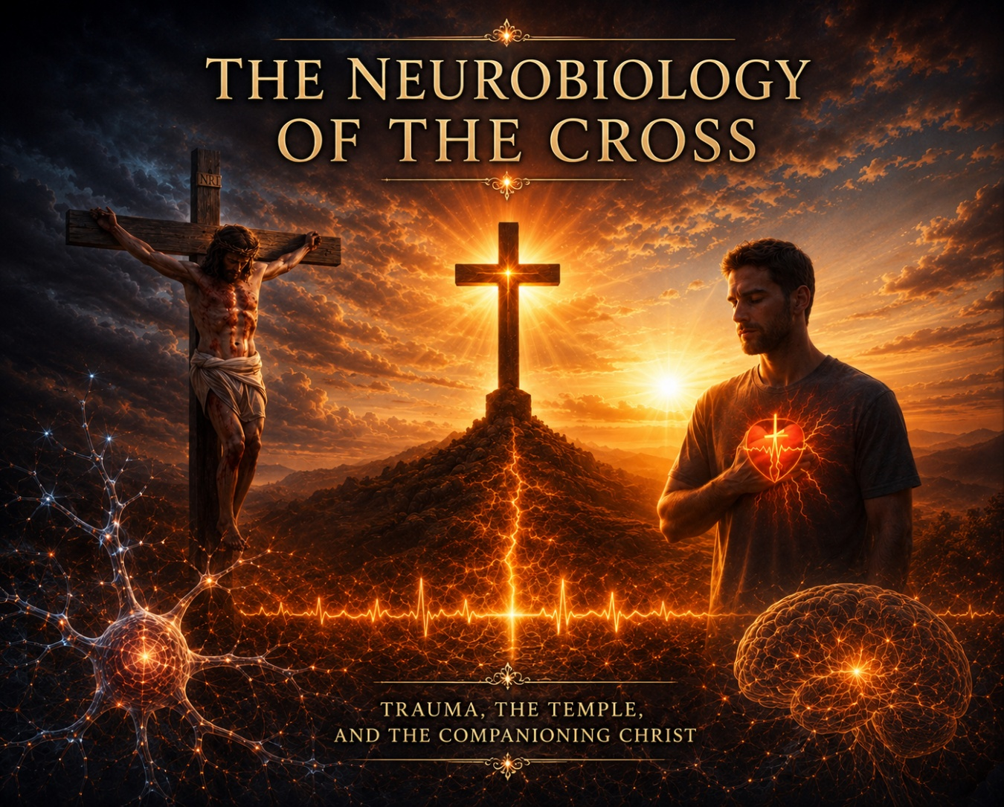

A Moment of Illumination
There are moments in a life of clinical work when a truth long carried in the mind descends into the body and becomes something closer to worship than to theory. This morning was one of those moments for me. As I listened to a teaching from the remarkable German YouTube channel, LostAndFound, that placed the suffering of Christ alongside the neurobiology of trauma, I realized that what I have spent decades articulating through the NeuroFaith® model was not simply being confirmed. It was being deepened.
I was seeing with greater clarity that the Incarnation, the Cross, and the Resurrection together form the most complete revelation of how the human nervous system is restored, how the fragmented self is reintegrated, and how the temple of the body is brought back into indwelling communion with God.
Trauma as a Full-Body State
Trauma is not an idea. It is a full-body event that becomes a full-body state. When an experience is too much, too fast, or too soon for the system to metabolize, the brain’s integrative networks are overwhelmed. The amygdala increases its threat signaling. The hippocampus loses its capacity to time-stamp memory as past. The medial prefrontal cortex, which allows us to observe and regulate experience, goes offline under the load of survival.
The autonomic nervous system shifts into chronic sympathetic activation or dorsal vagal collapse. Cortisol and catecholamines remain elevated beyond their adaptive window. Inflammatory pathways are activated and remain active. Over time this affects immune competence, sleep architecture, cardiovascular tone, digestive function, and even cellular aging through telomeric shortening and epigenetic modification.
The body begins to live a story that the conscious mind may not even be able to tell.
This is why trauma survivors so often say that the past is not over.
Their physiology is still there.
The Body as Temple
The Scriptures speak of this reality in language that is pre-scientific and yet profoundly precise in its observation.
“When I kept silent, my bones wasted away through my groaning all day long.” (Psalm 32:3)
“A crushed spirit dries up the bones.” (Proverbs 17:22)
The biblical writers understood that human suffering is not disembodied. It alters strength, posture, vitality, and the felt sense of being alive. When Paul tells the Corinthians that their bodies are temples of the Holy Spirit, he is not offering a metaphor that bypasses physiology.
He is declaring that the very tissue in which trauma is stored is the dwelling place of God.
Integration, Not Symptom Suppression
Within the NeuroFaith® framework this is the starting point for all healing. The goal is not symptom suppression. The goal is integration.
Integration in neurobiological terms means that previously isolated neural networks begin to communicate again. Implicit memory becomes linked with explicit narrative. The prefrontal cortex regains its regulatory influence over limbic activation. The autonomic nervous system learns that it can move from defense into safety without losing coherence. The body becomes a place that can be inhabited again.
This process cannot occur through avoidance. It cannot occur through dissociation. It cannot occur through interventions that mute the signal while leaving the underlying organization unchanged.
This is where the dominant medical formation of our time has often lost its way. In the opioid era we were trained to treat pain as a number to be lowered, and we now know the cost of a system that equated relief with healing. In our present moment antidepressants are frequently positioned as the first and defining treatment for depression and anxiety, even when the person’s trauma history, attachment patterns, and developmental story have not yet been explored in depth.
These medications can create temporary stabilization, but stabilization is not integration. The nervous system may become quieter while the unresolved past continues to organize the person’s life from beneath the surface.
The Cross as the Pattern of Integration
All of this brings us back to the Cross, because what I saw this morning with renewed clarity is that Jesus does not simply teach us about suffering.
He enters the full neurobiological reality of it.
“My soul is overwhelmed with sorrow to the point of death.” (Matthew 26:38)
In Gethsemane we see the human stress response in its most intense form. Hematidrosis, the sweating of blood described in the gospel accounts, is a rare but medically documented phenomenon associated with extreme autonomic activation. Jesus’ body trembles under the anticipation of what is coming, yet He remains in relational dialogue with the Father.
The prefrontal act of surrender occurs in the midst of limbic activation.
This is not the suppression of distress.
This is regulation through attachment.
On the Cross Jesus does not leave His body. He experiences thirst, suffocation, tissue trauma, public exposure, and the anguish of perceived abandonment. Every sensory channel is engaged. Every dimension of human trauma is present. Yet none of it occurs outside of communion.
“Into your hands I commit my spirit.” (Luke 23:46)
This is the definitive movement of integration. Overwhelming experience is held within unbroken relationship. The nervous system is not abandoned. Meaning is not lost. The self does not fragment beyond recovery.
Christ the Companion in Regulation
What this means for the NeuroFaith® model is that co-regulation is not only a clinical reality. It is a Christological reality. The presence of the indwelling Christ is the ultimate secure attachment. The Holy Spirit is the one who brings the autonomic system out of isolation and into relational safety.
“Christ in you, the hope of glory.” (Colossians 1:27)
Resurrection does not erase the wounds. The risen Christ is recognized by them.
“Put your finger here and see my hands.” (John 20:27)
This is integrated memory. The past is no longer an organizing force of death. It has been metabolized into glory. In clinical terms this is what we witness when a trauma survivor can remember without reliving, can feel without being overwhelmed, can remain present in their own body while staying connected in relationship.
Over decades of practice, I have watched this happen again and again. Breathing deepens. Muscle tone softens. Eye contact returns. Narrative becomes coherent. The person who once lived in survival begins to live in communion.
What I understand more fully now is that this is not simply good therapy.
It is participation in the pattern of the gospel.
The Coherence of NeuroFaith®
This is why any system of care that defines healing as the rapid elimination of distress without the restoration of integration must be questioned. The body is the temple. The temple is restored through indwelling presence, not through urgency.
Yet we are beginning to see a shift. Questions are being asked that could not be asked before. Evidence is being re-examined. Humility is returning to the scientific enterprise. This gives me genuine hope.
The joy I experienced this morning came from seeing the full coherence again. NeuroFaith® is not the blending of two disciplines. It is the recognition that the Incarnation is the meeting place of all true healing. The Word became flesh and entered the human nervous system. He walked the path of integration before us. He walks it with us now.
“And the Word became flesh and dwelt among us.” (John 1:14)
We do not ask anyone to go where He has not already gone. We do not ask anyone to face trauma alone. The restoration of the temple is the slow, sacred reordering of a human life around the living presence of Christ.
This is the healing of trauma.
This is the work of integration.
This is the heart of NeuroFaith®.



That Word Connection
I have been thinking a great deal about a word, and the more I sit with it, the more I realize that it is not a small word, nor a casual one, nor something that can be spoken and set aside without consequence. It is a word that carries weight, something ancient and foundational, something that reaches beneath the surface of how we live and presses into why we live the way we do. It is spoken often, almost carelessly at times, and yet when one slows down long enough to truly consider it, it begins to deepen, to open, to reveal a quiet magnitude that reshapes how we see ourselves, how we encounter others, and how we understand healing itself.
It is, in many respects, a sacred word, a majestic word, not because it sounds impressive, but because of what it holds, because of what unfolds in its presence and what withers in its absence. It is a word that has followed me across decades of clinical work, long before I had the language of neuroscience to describe what I was witnessing, long before I understood the physiological systems that would later confirm it. Even then, I could see it. I could feel it. I knew it when it was present, and I knew it when it was missing. And the more I return to it, the more I am convinced that it is not merely important; it is essential.
The word is connection.
What Connection Actually Means
At its root, the word itself tells us something profound. It comes from the Latin connectere, formed from con, meaning “with” or “together,” and nectere, meaning “to bind, to tie, to fasten.” Connection is not simply contact. It is not proximity. It is not the exchange of words or the presence of another person in the room. It is, quite literally, to be bound together, to be fastened into union.
The Greek deepens this further. Koinōnia speaks of shared life, of participation beyond surface interaction, a kind of mutuality that cannot be reduced to standing next to another person. Desmos speaks of a bond, a ligament, that which holds things together and prevents fragmentation. When taken seriously, these meanings begin to press on something deeper than preference or personality. Connection is not something we add to life when it is convenient. It is the very thing that holds life together.
The Neuroscience of Connection
From the standpoint of neuroscience, connection is not optional. It is regulatory. It is stabilizing. It is life-giving in the most literal sense, and when we understand the nervous system more deeply, we begin to see why.
Within the framework articulated by Stephen Porges, the autonomic nervous system is constantly evaluating safety through what he termed neuroception. Beneath conscious awareness, the system is asking a simple but profound question: am I safe, or am I alone? And the answer to that question determines whether we open or close, whether we engage or withdraw, whether we move toward life or into defense.
When the system is in sympathetic activation, we are mobilized for threat. When the system drops into dorsal vagal shutdown, we withdraw, collapse, and disconnect. In both of these states, connection is not readily accessible. We may be physically present, but we are not relationally available. We cannot fully see another, hear another, or attune to another.
Connection lives in the ventral vagal system. It is here that the social engagement system comes online, where eye contact, vocal tone, facial expression, and presence signal safety to another human being. When the ventral vagal pathway is active, we are not only calm, we are open, accessible, and capable of relationship.
And critically, we do not arrive there alone. We co-regulate. A regulated nervous system can help bring another nervous system out of defense and into safety. Through presence, tone, and attunement, one person’s state can begin to organize another’s. This is not metaphor. It is biology. And in many cases, it is lifesaving.
This process is not limited to the brain. The heart plays a central role. Through neurocardiology and HeartMath®, the heart communicates continuously with the brain and body. In coherence, reflected in heart rate variability, the system shifts toward integration. These states extend beyond the individual and influence others.
Connection is biological, systemic, and powerful.
When Connection Is Absent
When connection is absent, the system does not remain neutral. It shifts, and it shifts in ways that carry real physiological consequence.
In states of chronic disconnection, the nervous system moves into patterns of sustained sympathetic activation or dorsal vagal shutdown. Cortisol rises. The body prepares for threat, not momentarily, but often continuously. Over time, this begins to wear on the system. The heart moves out of coherent rhythm into patterns of dysregulation. The cardiovascular system bears increased strain. Inflammation rises. The immune system becomes less effective.
In other cases, the system collapses into withdrawal. Energy diminishes. Engagement fades. What appears as numbness on the surface reflects a deeper loss of access to relational safety.
In both directions, the body reorganizes around survival rather than connection.
And the effects extend further than we often recognize. Chronic stress and disconnection can influence gene expression through epigenetic mechanisms, altering how genes are read and expressed in ways that can predispose individuals to a range of downstream health challenges.
This is not abstract. It is measurable. And over time, it shapes the trajectory of a life, often in the direction of diminished vitality, reduced health, and, in many cases, a shortened life.
And the consequences are not only physical. They are emotional, psychological, relational, and spiritual, because disconnection does not simply affect how we feel, it affects how we live, how we relate, and how we experience meaning itself.
The full essay continues in the same reflective and narrative style.



“Do not be anxious about anything, but in every situation, by prayer and petition, with thanksgiving, present your requests to God. And the peace of God, which transcends all understanding, will guard your hearts and your minds in Christ Jesus” Philippians 4:6-7 (NIV).
Introduction
This has always been one of my favorite passages in Scripture, long before I ever understood anything about neuroscience. There was just something about it that resonated deeply, something that felt true at a level I could not fully explain at the time. And now, as I have spent years developing the NeuroFaith® model and studying the integration of brain, body, and spirit, that same passage has taken on a richer, fuller depth. It is almost as if what I once experienced intuitively, I can now see more clearly, almost in three dimensions, through the lens of neuroscience. That may sound a little unusual, but that is simply how my mind works. I find myself seeing Scripture not only as spiritually true, but as profoundly consistent with how we are biologically designed.
“Do not be anxious…” Understanding Anxiety in the Body
When the passage begins by directing us not to remain in anxiety, it is not offering a simplistic command to suppress emotion. We know that does not work. Anxiety is not just a thought. It is carried in the body. It activates the stress response, particularly the hypothalamic pituitary adrenal axis, and shifts the entire system into a state of dysregulation. The autonomic nervous system becomes imbalanced, and this dysregulation shows up very clearly in the heart.
Under normal, healthy conditions, the body is designed to move in a rhythmic, ordered pattern.
As we breathe in, there is a natural increase in heart rate driven by sympathetic activation. As we breathe out, the parasympathetic system engages, and the heart rate slows. This back-and-forth rhythm is not random. It is a coordinated, dynamic process known as heart rate variability, and when the system is functioning well, this variability organizes into a smooth, sine wave like pattern.
That sine wave is a marker of regulation. It reflects balance between the sympathetic and parasympathetic systems, flexibility in the nervous system, and an organism that is responsive rather than reactive.
When anxiety takes hold, however, this ordered rhythm breaks down. The heart rate variability becomes erratic and disorganized. Instead of a smooth sine wave, we see fragmentation and irregularity. The sympathetic system can dominate, the parasympathetic system loses its balancing influence, and the entire organism shifts into a less adaptive, more reactive state. This dysregulation in the heart feeds upward into the brain, impairing clarity, integration, and the capacity to respond with stability and presence.
And so what Scripture is directing us away from is not merely a feeling, but a physiological state of disorganization. It is pointing us away from a pattern that disrupts the very systems designed to sustain health, clarity, and peace, and it does so while preparing us for a different way forward.
“…but in every situation…” A Shift in Focus, Not Suppression
From there, the passage introduces a subtle but essential shift. Rather than asking us to force anxiety out, it redirects our attention. This is not suppression. It is reorientation. We are being invited to move away from fixation on anxiety and toward engagement with something that can restore regulation.
“…by prayer and petition…” From Self Reliance to Surrender
That movement becomes more defined as the passage leads into prayer and petition, words that carry a depth often overlooked. Prayer is not performance or polished language. It is relational. It is the act of turning toward God honestly, bringing our internal world, our fears, burdens, and uncertainties, into His presence. Petition adds specificity. It is naming what we actually need, giving voice to what is real rather than remaining in abstraction.
Within this shift lies a profound recognition. We are not meant to regulate ourselves by ourselves.
Efforts to do so under our own power inevitably fall short. What is offered instead is surrender, and in that surrender, a different process begins to unfold. We begin to co regulate, not only psychologically, but spiritually, with a God who is not anxious, not dysregulated, not chaotic, but ordered, steady, and peace itself.
“…with thanksgiving…” The Physiology of Gratitude
It is at this point that the passage introduces its turning point. Thanksgiving is not incidental language. It is the mechanism of change.
What anxiety disrupts, gratitude begins to restore. When we intentionally engage thanksgiving, particularly when paired with slow, rhythmic breathing, the physiology shifts. Work in neurocardiology, including research from the HeartMath Institute, demonstrates that the heart begins to move out of disorganization and into coherence. The variability in heart rate organizes into that smooth, sine wave-like pattern reflecting balance between sympathetic and parasympathetic systems.
And here the distinction becomes critical. It is not simply breathing that restores regulation. Breathing alone can calm the system, especially when the exhale is lengthened to engage the parasympathetic response. But calm is not the same as coherence. What brings true organization is the emotional state carried within the breath. When gratitude is present, when thanksgiving is intentionally engaged, the heart rhythm does not merely slow. It organizes. It becomes coherent.
That coherence then cascades through the entire system. Through the vagus nerve, through cardiovascular rhythms, through hormonal signaling, and even through the electromagnetic field generated by the heart, this ordered pattern feeds upward into the brain. What anxiety fragments, gratitude organizes. Over time, this shift supports stability, integration, and overall health.
“…present your requests to God…” Relational Regulation
As this process unfolds, the passage grounds it relationally. Presenting our requests to God is not simply an internal exercise. It is an act of connection. It reflects trust, openness, and engagement with a living presence.
Here, regulation is no longer solely an internal process. It becomes relational. In turning toward God, we are met by One whose presence is inherently steady and ordered. And in that meeting, our own system begins to settle.
“…the peace of God…” A Reality Beyond Understanding
Out of that relational engagement emerges something that cannot be reduced to technique alone.
The peace described here is not merely the absence of anxiety. It is something that transcends understanding. It may not always be logically explained, yet it is deeply experienced. It is felt, embodied, and received.
And it is worth pausing on that word, peace.
Peace is not simply the quieting of thoughts. It is not just the reduction of distress. It is a state of internal order. A settling. A coherence of the whole person. It is what it feels like when the system is no longer fragmented, no longer pulled in competing directions, but brought into alignment.
To have peace in the heart is to experience that rhythm of regulation, that steady, coherent pattern that reflects safety, stability, and balance. The heart is no longer erratic or reactive. It is grounded, responsive, and ordered. And from that place, the signals traveling upward to the brain carry that same sense of organization.
To have peace in the mind is to experience clarity, integration, and presence. The mind is no longer scattered or overwhelmed. It is able to think, to discern, to respond rather than react. It is not striving to control, but able to rest. And what is so remarkable is that this peace is not something we construct. It is something we enter into. It is given. It is received. It moves through us, shaping both heart and mind, bringing them into a unified state of coherence.
There is something deeply profound in that. That the very word Scripture uses, peace, captures not only a spiritual reality, but a physiological one. A state in which the whole person is brought into order.
“…will guard your hearts and your minds…” The Heart Leads the Brain
What follows reveals how that peace operates. The order is significant. The heart comes first. From a neuroscience perspective, this aligns with what we understand about the flow of information within the body. A substantial portion, often described as roughly eighty percent, of information is carried through afferent pathways, moving upward from the body and heart to the brain, while a smaller portion, around twenty percent, travels downward through efferent pathways from the brain to the body.
In other words, the brain is not simply directing the body. It is continuously being informed by it.
And this is where the role of the heart becomes so important. The heart functions as a central regulatory hub, and when it is in a coherent state, that organized, sine wave like rhythm communicates upward through the vagus nerve, through cardiovascular signaling, and through hormonal pathways, shaping brain function in a powerful way.
When anxiety is present, that incoming information is disorganized. The signals reaching the brain are fragmented, contributing to reactivity, confusion, and a loss of integration.
But when the heart is regulated, when coherence is restored, that upward flow of information becomes ordered. The brain receives a different signal, one that supports clarity, stability, and integration.
And so the sequence in Scripture is not incidental. The heart is guarded first, and from there, the mind follows. As the heart settles into coherence, the brain begins to come back online. Clarity returns. Presence returns. The capacity for integration is restored.
In this way, peace is not merely conceptual. It becomes embodied, shaping both heart and mind in a unified and integrated way.
“…in Christ Jesus.” The Source of True Regulation
The final phrase anchors everything. This guarding of the heart and mind occurs in Christ.
Not apart from Him, and not through self-effort alone, but in Him. This is essential.
Regulation, peace, and integration are not things we manufacture. They are things we receive as we remain connected to Him.
We do not worship the heart, but we recognize the profound role it plays in how we are designed. It becomes a point of convergence where physiology and spirituality meet, where the peace of God begins to take form in the body and extend into the mind.
If there is anything this ultimately points to, it is this. This is not just how one passage works. This is how we were designed to function. The body, the brain, and the spirit move toward order, toward rhythm, toward coherence. When that rhythm is disrupted, the system fragments. But when it is restored, the system integrates. And what is remarkable is that the pathway Scripture provides is not only spiritually true but reflects the very design of the human person.
And this is where it becomes even more compelling.
Why would we be surprised that Scripture aligns with neuroscience. Why would we hesitate to let neuroscience deepen our appreciation for Scripture. If God is the author of all truth, then the design we uncover in the body should reflect the wisdom revealed in His Word. These are not competing realities. They are converging ones.
At times, Christians can be quick to step back from what they do not yet understand, or to place things into broad categories and move on. And what a loss that can be. Because in doing so, we risk missing the majesty of what God has made, especially the intricacy of how He has made us. The more carefully we look, the more we see not contradiction, but coherence. Not conflict, but alignment.
And yes, there are places where psychology has lost its way, where it has become disconnected from truth and meaning. But when we return to what is grounded, what is observable, what reflects the way we are actually designed, good neuroscience becomes a gift. It becomes a lens that allows us to see more clearly what Scripture has been saying all along.
And in this passage, what we are given is not merely insight, but a promise.
A profound, powerful promise.
That when we turn from anxiety, when we bring our lives honestly before God, when we enter into prayer and thanksgiving, something real begins to happen. The peace of God does not remain distant or theoretical. It moves into the very center of our being. It begins to order what was disordered, to settle what was restless, to bring coherence where there was fragmentation.
And that peace guards us.
It guards the heart.
It guards the mind.
And it does so in Christ.
And in so doing, the quality of our lives, psychologically, spiritually, and physically, is transformed. We are reminded that our bodies are the temple of the Holy Spirit, and caring for them is not an act of worshiping the body, but an act of honoring God’s design. It is through that care, through that alignment, that we begin to experience fuller, richer, deeper lives, not only for our own benefit, but so that we may more fully love others and participate in the good work He has set before us.
There is something deeply hopeful in that. That we are not left to figure this out on our own. That the pathway to peace is not hidden, but revealed, both in Scripture and in the very design of the human person.
And to me, that is simply incredible. And I pray that it is for you as well.
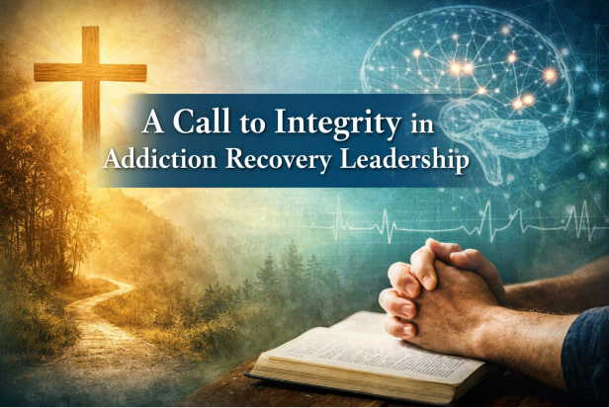

Honoring the Call While Naming the Contradiction
Many of my writings tend to be inspirational. I love that space. I love the philosophical, the reflective, the places where we explore meaning, hope, and restoration. But sometimes, we simply need to name something directly. This is one of those moments.
What I am about to say has been building in me for more than three years, through my work within addiction recovery settings. It comes not from cynicism, but from deep respect, concern, and love for the field and for the people who serve within it.
Let me begin clearly. The men and women who work in addiction recovery are, in many cases, extraordinary. They are often individuals who have walked through addiction themselves, who have faced darkness and survived it, and who now return with a heart to serve others. That is something to be honored. It is something to be revered. There is a beauty in that kind of redemption that cannot be manufactured. It is real, it is costly, and it is powerful.
And yet, there is also something else that must be addressed.
Across many recovery environments, I have observed a troubling pattern. It is not universal, but it is common enough that it cannot be ignored. There is a disconnect, a contradiction, between the sacred nature of the work being done and the way some who are in positions of influence conduct themselves.
We all live with contradiction. That is part of the human condition. Growth itself is the gradual reduction of those contradictions. One of my favorite works on this theme is Living with Contradiction: An Introduction to Benedictine Spirituality by Esther de Waal, which speaks to the reality that we all carry inconsistencies, yet are called to become increasingly aligned in truth as we mature. The Christian life, in particular, is a journey out of darkness into light, a continual refining. None of us arrives fully formed.
But Scripture is clear that those who step into positions of leadership carry a greater responsibility. As it is written in James 3:1 (NIV), “Not many of you should become teachers, my fellow believers, because you know that we who teach will be judged more strictly.” That includes therapists. It includes behavioral health technicians. It includes anyone who mentors, guides, or influences those who are broken and seeking restoration. This is not a casual role. It is sacred.
And yet, too often, I see behaviors that are inconsistent with that calling. Coarse talk. Crude joking. Sexualized comments. Conversations that should never take place within a professional environment, let alone within earshot of clients who are fragile, observant, and deeply affected by what they see and hear.
These are not minor issues.
Clients notice. They always notice. Many have spoken about it over the years. What may seem like harmless banter to a staff member can land very differently for someone in early recovery who is searching for stability, for safety, for something solid to anchor to. When the very people who are meant to represent healing demonstrate inconsistency, it creates confusion. It creates cracks.
And cracks matter.
Those cracks do not always show themselves immediately. But when clients leave treatment, they carry those impressions with them. They carry the subtle dissonance between what was taught and what was modeled. And sometimes, those inconsistencies can contribute to instability, to doubt, and in some cases, to relapse.
This is not about perfection. It is about integrity.
The Sacred Responsibility to Live What We Teach
Part of the challenge lies in the reality that many who enter this field do so not long after their own recovery. They bring passion. They bring empathy. They bring authenticity. But they may not yet have done the deeper work required to fully stabilize their own lives, their language, their boundaries, and their internal world. Good intentions are not enough to sustain the weight of leadership.
In Christian environments, this issue can be further complicated by what I would call a diluted understanding of faith. There is often a strong emphasis on grace, redemption, and forgiveness, which are central and beautiful truths. But too often, there is a lack of depth when it comes to the cost of discipleship. The cost of transformation. The cost of living in alignment with what we profess to believe.
Grace is not a license for carelessness.
To be restored is not the end of the journey. It is the beginning of a life that is called to a higher standard. A life where we examine how we speak, how we behave, how we treat others, how we represent truth, and how we carry ourselves in positions of influence.
We are, whether we like it or not, representatives. Not just of an organization. Not just of a model. But of Christ Himself in these environments.
That should humble us.
This is a call, not of condemnation, but of invitation. An invitation to look inward. To examine our own hearts. To confront the places where our behavior does not align with our calling. To grow. To mature. To take seriously the sacred responsibility we have been given.
Lives are at stake.
This is not theoretical. The work we do has real consequences, both positive and negative. We can be instruments of profound healing, or we can unintentionally contribute to harm.
Called to Excellence, Not Mediocrity
And so the call is simple, but not easy.
Do better.
Do better in how we speak.
Do better in how we carry ourselves.
Do better in how we honor those we serve.
Do better in how we represent the God we claim to follow.
God does not call us to mediocrity. He calls us to excellence. Not perfection, but excellence rooted in humility, integrity, and continual growth. As Scripture reminds us, “Whatever you do, work at it with all your heart, as working for the Lord, not for human masters” (Colossians 3:23, NIV). This is the standard. Not performance for appearance, but wholehearted alignment in the sight of God.
I write this first to myself. Then to my brothers and sisters in the field. But if I am honest, I feel it most strongly as a call to my brothers. We must lead well. We must guard our speech. We must embody the very transformation we speak of.
Because the people we serve are watching.
And they deserve nothing less.

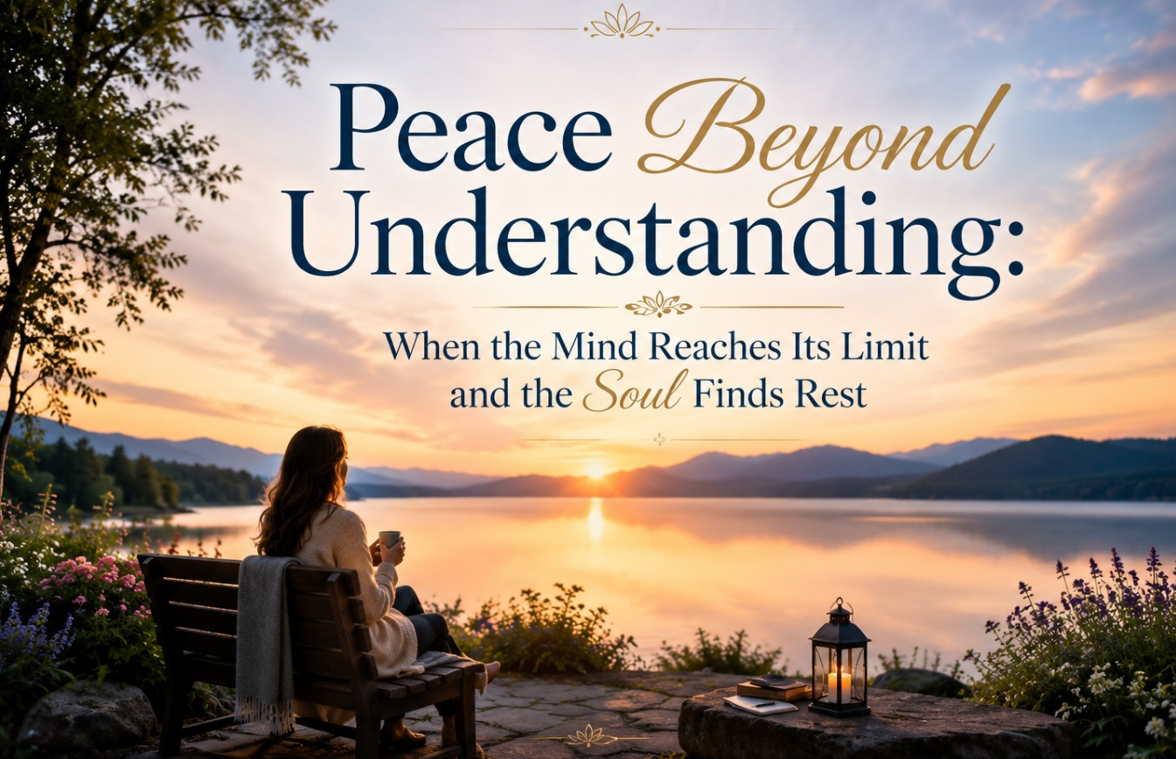

There are moments in life when the human mind reaches its limit.
Moments when the questions come fast and unrelenting. What happened. Why did this happen. What could I have done differently. What should I have seen. What should I have known. In those moments, the mind does what it was designed to do. It searches. It analyzes. It attempts to resolve. And yet, there are experiences, particularly those involving loss, guilt, and suffering, that simply do not yield to resolution.
Recently, I found myself reflecting on a conversation with a man I deeply respect and love, someone who once courageously and sacrificially walked with me through one of the darkest seasons of my life. He shared an experience in which he found himself completely overwhelmed after a traumatic event involving someone he loved. He described being beside himself, wrestling internally for hours, caught between what he knew to be true and what he was feeling in that moment.
And then something shifted. Not because every question was answered. Not because the circumstances changed. But because there was an intersection. An intersection between the truth of God’s Word and his internal world. And in that intersection, something began to emerge that he could not manufacture on his own. A peace. Not the kind of peace that comes from resolution, but the kind that arrives even in the absence of it.
The kind described in Philippians 4:6–7, a peace that surpasses understanding, that guards our hearts and our minds in Christ Jesus. What struck me most was not only his experience, but how he articulated it so well afterward. He described faith as seeing things from God’s point of view and aligning his thoughts and actions with that reality.
He went on to reflect that while Scripture reveals clearly what God does and what He promises, we often do not see how He accomplishes those things. And it is in that gap between the what and the how that faith is tested. There is profound wisdom in that. Because what he described is not merely a spiritual phenomenon.
It is also deeply embedded in the way we are designed as human beings. When truth begins to land, not just in the mind but at a deeper level, something within us begins to shift. What felt chaotic starts to settle. What felt overwhelming becomes more contained. There is a sense, difficult to fully put into words, that something inside is being held together rather than coming apart.
In NeuroFaith® language, we would say that the mind, the body, and the spirit are beginning to come into alignment with what is true. And when that alignment occurs, peace is not something we strive to create. It is something we receive.
And yet, there are limits.
There are places where the mind, as remarkable as it is, cannot fully carry the weight of what we are experiencing. I know this not only clinically, but personally. A couple of years ago, my identical twin brother Gregg died in a deeply tragic way. In the aftermath, I found myself in a similar internal battle.
There were questions that would not resolve. There was a profound sense of responsibility that I could not easily shake. A belief, at times, that I should have been able to reach him, that I should have known what to do, that somehow, I had failed. And the truth was, no matter how much I thought, analyzed, or revisited the past, there were no answers that could fully satisfy the questions my mind was asking.
What I came to understand over time is something that parallels what my friend described so well. There is a point at which the mind reaches its limit. Not because understanding is unimportant, but because some realities extend beyond what the human mind was designed to fully resolve. And in that space, the invitation is not to try harder to understand, but to surrender more deeply.
This is not resignation. It is not giving up. It is a movement into relationship.
There is, in this process, a profound paradox. The pain does not simply disappear. The sense of loss remains. At times, even the sense of weight or responsibility lingers. And yet, at the very same time, there is another reality that begins to emerge. A peace that does not come from having every answer, but from being met by God in the midst of the unanswered questions.
This is where the integration of faith and design becomes so meaningful. Scripture tells us what God does. It tells us that He brings peace, that He guards our hearts and our minds in Christ Jesus. It tells us that we are not alone in our suffering. What we often do not see is how He does this.
And yet, when we begin to understand even a small part of how we are created, something begins to come into clearer focus. That peace is not produced by the logic of the mind, but is most often received at a deeper, felt level through the heart before the mind can fully rest in it.
The mind can point us toward truth, but peace itself is experienced, embodied, and received. There is a sense in which the heart leads, and the mind follows, not in opposition to one another, but in proper relationship. This is consistent with what we are increasingly coming to understand, that peace does not settle first in the mind, but in the heart, and then, over time, settles the mind in ways that thinking alone cannot achieve at first.
When that deeper sense of peace begins to take hold, the mind gradually settles into it. What once felt chaotic becomes more ordered. What once demanded resolution begins to rest, even without it. In this way, the promise that He guards both our hearts and our minds takes on a fuller meaning. The peace does not bypass our design.
It moves through it.
This does not remove mystery. It deepens it.
It is similar to what happens in archaeology as suggested by my friend. The truth has always been there, buried beneath the surface. And when something is uncovered, it does not create the truth. It reveals it. In the same way, when we begin to understand the design of the human person, we are not explaining God away.
We are uncovering the fingerprints of His design in places we may not have noticed before.
And still, even with that understanding, there remains a call to grace.
One of the most difficult aspects of suffering, particularly when it involves someone we love, is the tendency to turn inward with judgment. To carry burdens that were never ours to carry. To hold ourselves to a standard of control that no human being was ever given. In my own journey after losing Gregg, I have had to learn, and continue to learn, what it means to release that burden.
To allow myself to receive the same grace that I so readily extend to others. To let His peace enter not only into my thoughts, but into those deeper places marked by pain, regret, and unanswered questions. That process is not immediate. It is not linear. But it is real. And it is in that very space, not in the resolution of every question, but in the surrender within relationship, that His presence becomes most tangible.
If you find yourself in a place where your mind cannot fully make sense of what you are carrying, you are not failing. You are encountering the edge of what the mind was designed to do. And at that edge, there is an invitation. Not to strive harder, but to surrender more deeply. Not to force understanding, but to receive peace.
A peace that, as Scripture tells us, truly does surpass understanding. And perhaps that is not a limitation. Perhaps it is the point. And thank you my dear friend for having the courage and trust to share this with me. You do not walk alone.



A Clinical and Social Lens
There is a certain irony in what I am about to say, and I am aware of it even as I write it. To use wine as an analogy in the context of addiction recovery feels, at first glance, almost inappropriate. For many, alcohol has been part of the very destruction we are trying to help people heal from. And yet, if we can hold that tension for a moment, there is something about the process of making good wine that speaks directly to what is missing in much of our work.
So, I am going to lean into the analogy, not to be clever, but because it reveals something important about how real transformation actually occurs. Part of how I come to this is through the lens of my training. As a clinical psychologist, I was trained in abnormal psychology, which at its core asks the question of what is wrong. What is happening within the individual. Where is the breakdown in thinking, in behavior, in emotional regulation, in development. That lens matters, and it is essential to the work.
But those who know me also know that I do not stay there. I have always been drawn to social psychology, to stepping back and gaining altitude, to asking broader questions about systems, organizations, and culture itself. Not just what is happening within the individual, but what is happening around the individual. What is it about the structures we create, the environments we build, the industries we participate in, that shape outcomes in ways we may not fully recognize. And when I apply that lens to the addiction treatment industry, a question continues to surface.
Why is it that after fifty years, we are not meaningfully better in our outcomes? We have more programs, more language, more modalities, more structure. And yet, when you step back and look honestly, the outcomes have not shifted in a way that reflects true advancement. That is not an accusation. It is an observation. And it is one that, I believe, requires us to look more closely, to analyze more deeply, and to be willing to ask questions that may be uncomfortable.
The Courage to Say What Is Difficult
There is also something else that comes with this work. As psychologists, we are trained not only to observe, but at times to say what may be difficult to hear. In the therapy room, part of our responsibility is to gently but directly challenge clients in areas they may not yet be ready to look at. Not to force, not to shame, but to invite awareness where avoidance may still exist. And that process is not without risk. Psychotherapy, when it is done well, is not a comfortable process.
It requires courage on the part of the client, but it also requires a willingness on the part of the therapist to step into that tension, to speak carefully but honestly, knowing that what is said may be received with resistance before it is received with understanding. I have never been one to play it safe, nor one to avoid naming what I see. Not because I believe I have it all right, but because I believe we are not called to live or work out of fear.
Scripture reminds us, “For God has not given us a spirit of fear, but of power and of love and of a sound mind.” (2 Timothy 1:7) So, in that same spirit, I am aware that some of what I am about to say may feel uncomfortable. And I say it not as criticism, but as part of an ongoing commitment to think deeply about the work we are doing and the people, we are entrusted to serve.
The Wisdom of the Vintner
A good vintner does not rush the process. There is an attentiveness that borders on reverence. The soil matters, the timing matters, the fermentation must be monitored carefully, and the balance of acidity and sugar must be watched and adjusted with precision. The environment must be right, the barrels must be right, and even the subtle shifts over time must be respected. Every stage requires presence and discernment, but perhaps most of all, it requires patience. Because then comes the part that cannot be manufactured. There is a waiting that must occur, not passive, but intentional.
The kind of waiting that understands that time is not an obstacle to the process, but an essential ingredient in it. A good red wine can take years to fully develop into what it is meant to be. Years before its depth and complexity are truly expressed. If you drink it too early, you may still have something that resembles wine, but it will not carry what it was meant to carry. It can be thin, sharp, incomplete. In some cases, it is simply not good, and it gets poured out.
That is not failure. That is discernment. And as I sit with that, I find myself increasingly unable to ignore the parallel to what I see in the addiction treatment industry, particularly at the level of Behavioral Health Technicians.
Lived Experience and Timing
Let me be clear. I have deep respect for BHTs. I have worked alongside them and seen their heart, their commitment, and their willingness to step into very difficult spaces with people who are suffering. You do not choose that kind of work unless something in you is oriented toward care. But respect does not mean we stop asking hard questions about the system we are placing them into. Because what I often observe is this. We are bringing individuals into these roles who have genuine desire and often lived experience, and in many cases, that lived experience includes their own journey out of addiction.
In truth, many, and often most, BHTs come into this field with a personal history of addiction and recovery. That is not a liability. In many ways, it is one of the greatest strengths this field has. It brings empathy, credibility, and a depth of understanding that cannot be taught in a classroom. But like anything of real value, it requires time to mature. The movement from early recovery into stable, integrated living is not instantaneous. It is a process of rebuilding character, restoring values, and learning to live in a way that is consistent over time.
And when that process is still unfolding, placing someone into a role that requires them to help others navigate it can create a level of strain that neither they nor the system are fully prepared to carry. Addiction does not simply disrupt behavior. It dismantles structure. It erodes character. It distorts values. It fragments identity. Recovery, if it is to be meaningful, is not just abstinence. It is reconstruction. It is the slow rebuilding of a life from the inside out, and that rebuilding takes time in ways that cannot be compressed or bypassed.
Scripture speaks to this reality with remarkable clarity. “Not only so, but we also glory in our sufferings, because we know that suffering produces perseverance; perseverance, character; and character, hope.” (Romans 5:3–4) That progression matters. Character is not immediate. It is formed, layer by layer, through time, pressure, and lived experience. It is, in many ways, the aging of the soul.
A Word to Leaders
Writing And yet, in many treatment environments, we find ourselves doing something quite different. We take good people, often still early in their own rebuilding, and we place them into roles that require them to help others rebuild. What emerges is not a failure of heart, but a mismatch of timing. The desire to help is real, and the intention is often deeply sincere, but the level of internal stability required for that role has not yet had sufficient time to fully take root. Because a vintner would never take a wine that has not matured and present it as finished.
There is a kind of wisdom in that process, an understanding that certain things cannot be accelerated without compromising their integrity. Time is not incidental to the outcome. It is essential to it. And yet, in subtle but very real ways, we do the equivalent in this field all the time. We are influenced, whether we recognize it or not, by pressures toward efficiency, toward staffing needs, toward movement and measurable outputs. There is always another client to serve, another need to meet, another demand pressing in.
But what we are dealing with in this work is not a product to be managed or moved along. It is a person. And not only the person in treatment, but the person providing the care. And to those of you who carry the responsibility of building and leading these organizations, I want to speak to you directly for a moment. What you are doing matters. It takes courage to build something that seeks to help people heal. It takes vision, risk, and perseverance to create and sustain environments where real change can occur.
That deserves to be acknowledged, and it deserves respect. But with that responsibility comes an obligation that runs deeper than operational success. It is an obligation not only to the outcomes of your clients, but to the welfare, formation, and long-term stability of the people you entrust to care for them. It requires a willingness to think beyond immediacy, beyond what is convenient or available in the moment, and to consider what is truly required for someone to carry this kind of work well. There may be times when it costs more to wait.
To bring in individuals who have had more time to mature. To invest more intentionally in development rather than simply filling a role. There may be pressure to move more quickly, to meet demand, to keep things running smoothly on the surface. But these decisions carry weight. They shape not only outcomes, but people. This is not about blame. It is about stewardship.
A Word to BHTs
And to my BHT brothers and sisters, I want to say this with the same level of care. I see you, and I respect you, and I genuinely honor the instinct in you that wants to take what you have been through and turn it into something that serves others. There is something deeply meaningful in that desire, something that reflects courage and compassion and a willingness to step back into difficult spaces not just for yourself, but for the sake of someone else. That is not a small thing.
In many ways, it is the beginning of a life that is being reoriented toward something good and life-giving, and it deserves to be acknowledged. At the same time, I want to encourage you, not in a way that diminishes that desire, but in a way that protects it and strengthens it over the long term, not to rush your own becoming. Because becoming is not something that happens in a moment. It is not secured simply by reaching a certain point in recovery or by stepping into a role where you are now helping others.
It is something that unfolds over time, as you continue to do your own work, as you rebuild what has been disrupted, and as you learn to live in a way that is steady and grounded and consistent across the full range of life. That kind of depth cannot be hurried. It develops as your recovery moves from something you are holding onto into something that is integrated into who you are. It develops as your values are not only reclaimed but lived out repeatedly over time.
It develops as your identity stabilizes, not around what you have come out of, but around who you are becoming. And it is in that process that something begins to form within you that cannot be manufactured and does not need to be forced. So, give yourself that time. Give yourself the time to age well, to heal deeply, and to consolidate the kind of life you are being called to live, even if that process feels slower than you would like. Let your roots go down further than you think they need to, because it is those deeper roots that will allow you to remain steady when the work becomes difficult, when the emotions around you intensify, and when the demands of the role begin to press in.
Because the reality is that what you are stepping into is not light work. You are not simply offering encouragement from a distance. You are often sitting with people in the middle of their struggle, absorbing the intensity of their experience, navigating moments of instability, and being asked, in those moments, to remain grounded and present. That requires more than good intention. It requires internal stability that has been formed over time. And when that work has been allowed to go deep within you, something changes in the way you show up.
Your presence becomes more steady. Your responses become less reactive. Your ability to remain grounded in the midst of someone else’s chaos becomes more consistent. You find that you are not as easily pulled off center, and that the very things that once might have overwhelmed you can now be met with a kind of quiet strength. That is where real help begins to take shape. This work does need you. It needs your story, your empathy, and your willingness to step into places that others might avoid.
But it does not simply need your presence. It needs your presence to be rooted in something that has been formed, tested, and strengthened over time. It needs you well. And when you allow that process to unfold, when you resist the pull to rush and instead commit to becoming deeply grounded in your own life, you will not have to force your impact. There will be a steadiness about you, a credibility that is felt rather than asserted, a depth that allows others to trust what you carry because it has been lived and integrated.
And that, ultimately, is what this field needs. Not simply more people willing to help, but people who have taken the time to become the kind of person who can carry this work with depth, steadiness, and integrity over the long haul, people whose lives themselves reflect the kind of healing they are seeking to support in others. That kind of presence does not come quickly. But when it does come, it changes lives.

Conclusion
Still Thinking in the Sandbox
What I do have is a lifetime of wrestling. A lifetime of observing. A lifetime of listening carefully to human beings trying to survive heartbreak, trauma, addiction, shame, grief, fear, loneliness, and the deep longing to feel whole again. I have watched people collapse under the weight of life and somehow rise again. I have watched grace emerge in the middle of wreckage. I have watched science illuminate extraordinary truths about the nervous system, attachment, trauma, and the brain, while at the same time recognizing that science alone cannot fully explain the mystery of love, meaning, suffering, faith, beauty, sacrifice, forgiveness, or the human soul.
And perhaps that is part of what has kept me thinking all these years.
Aristotle famously suggested that the unexamined life is not worth living. I think there is profound wisdom in that statement. But I would add this from the vantage point of psychology and the helping professions: an unexamined profession is not worth participating in either. We must continue asking questions. We must continue challenging assumptions. We must resist the temptation to become rigid, ideological, mechanical, or so certain of our frameworks that we stop seeing the actual human beings sitting in front of us.
Human beings are simply too sacred, too layered, too mysterious for reductionistic answers.
Sometimes we need to climb to a different altitude and look again. Sometimes we need to question the very assumptions we inherited during training. Sometimes we need to sit quietly with uncertainty rather than rushing prematurely toward conclusions that make us feel psychologically safe. Sometimes we need to scratch our heads, pull at our hair a little, pace the room at two in the morning, pray honestly, read deeply, argue respectfully, laugh at ourselves, and admit that perhaps we still do not fully understand what it means to heal.
To me, that is not weakness. That is intellectual humility. And humility may very well be one of the beginning points of wisdom.
There are undoubtedly ideas in these pages that some readers will disagree with, perhaps strongly at times. Some of my reflections push against prevailing models, institutional assumptions, or culturally dominant narratives. I understand that. And honestly, I am quite certain there are places where my own thinking will continue evolving as well. I am still learning. Still growing. Still reflecting. Still trying to integrate what I have seen clinically, scientifically, spiritually, and personally across a lifetime of experience.
But underneath all of it, I hope what readers feel most is sincerity.
I have genuinely tried to think deeply about the things that matter. About suffering. About trauma. About faith. About neuroscience. About meaning. About grief. About family. About addiction. About healing. About what helps human beings flourish and what quietly destroys them. I have tried to think honestly about the fractures within psychology itself, within medicine, within culture, within institutions, and certainly within my own heart.
And maybe that is partly what this Sandbox has always been about.
Not pretending to possess final answers.
Not performing certainty.
Not building an intellectual fortress where doubt and curiosity are no longer welcome.
But creating a space where exploration is still allowed. A space where science and faith can still speak to one another. A space where clinicians, pastors, physicians, parents, recovering addicts, wounded families, and struggling human beings can still sit together and wrestle honestly with what it means to become whole.
Because I think there is something sacred about remaining teachable.
The moment we lose our capacity for wonder, reflection, humility, curiosity, and honest examination, something inside us begins to harden. And when that happens, professions harden too. Systems harden. Ideologies harden. Hearts harden.
But thoughtful reflection keeps us alive. Wonder keeps us human.
As I look back now over these essays, I do not see a perfectly organized system of thought. I see a journey. I see questions. I see grief. I see hope. I see struggle. I see humor. I see motorcycles, philosophy, Scripture, neuroscience, relationships, heartbreak, and redemption all somehow woven together into the strange and imperfect tapestry of a life honestly lived.
And perhaps that is enough.
So thank you for wandering through the Sandbox with me. Thank you for thinking with me, wrestling with me, questioning with me, and perhaps even disagreeing with me at times. I suspect the conversation itself matters more than we realize.
There is still sand on my shoes.
And honestly, I hope there always will be.

About the Author

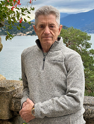
Jeffrey E. Hansen, Ph.D. is a clinical psychologist specializing in addiction and trauma, with degrees from the University of California, Berkeley and the University of Arkansas. He brings over four decades of clinical experience, including service as an active-duty psychologist in the U.S. Army and later with the Defense Health Agency. He previously served as Clinical Director of Holdfast Recovery and AnchorPoint, faith-centered treatment programs for addiction and trauma recovery.

Dr. Hansen is the founder of NeuroFaith®, an integrative model combining neuroscience, trauma-informed care, and Christian spirituality. He now focuses on writing, training, and consulting with organizations and providers nationwide to advance the NeuroFaith® approach. He is the author of nine books and is active in national conversations on protecting children and adolescents from overly reductive and prematurely medicalized approaches to care.

He lives in Arizona with his wife, their three dogs, stays closely connected with his children and granddaughter, and enjoys time on the open road riding his BMW R1250RS.

