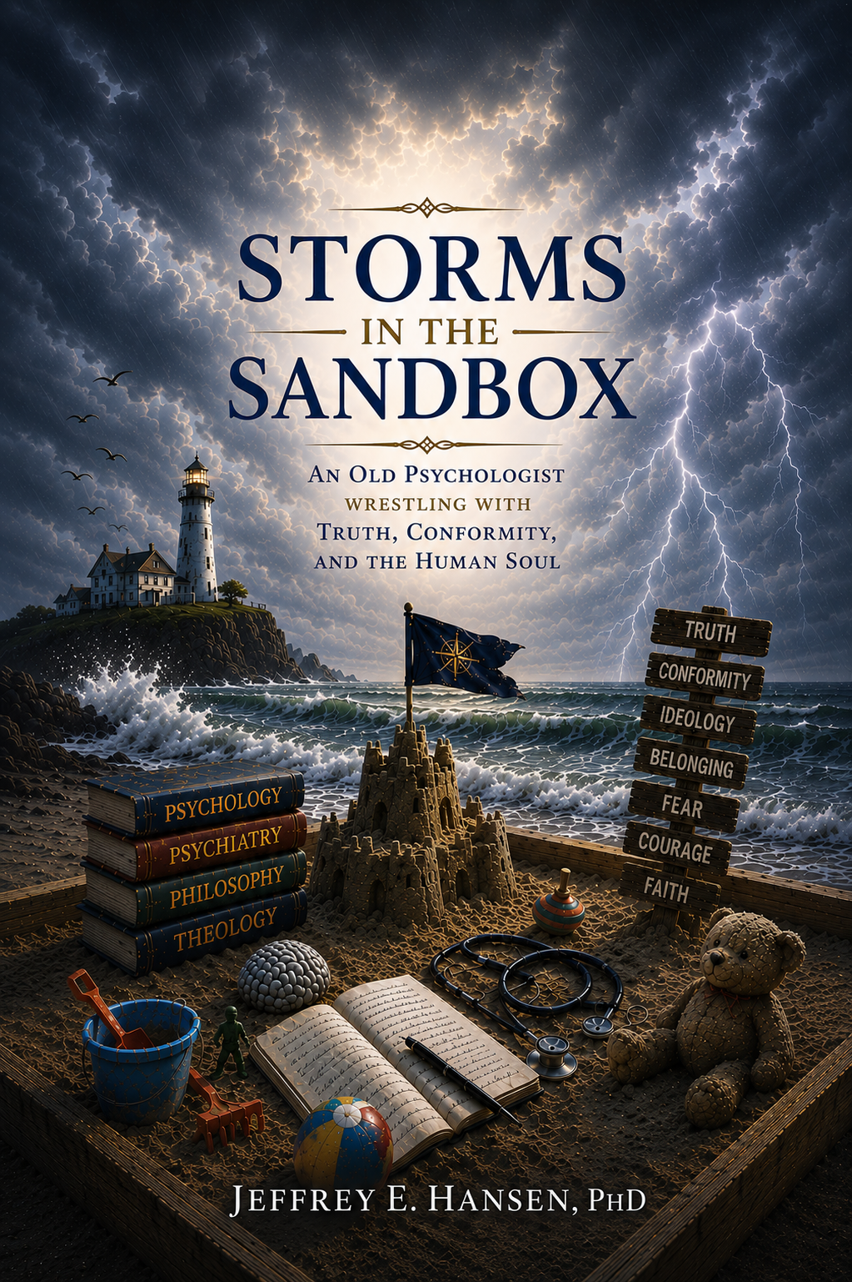

Pages Found in the Storm
Reflections, Essays, and Wanderings in the Sandbox

Introduction to Storms in the Sandbox 5
Battle for the Soul of Psychology 8
Choosing Closure with Integrity 16
Pills Before Therapy 21
An Open Letter to my Psychology and Psychiatry Colleagues 35
Why the More You Want Success, the Less You Get It 41
The Hallow Core of Modern Psychiatry 49
When Cowardice Poses as Collegiality 53
When Therapy Dies 59
Where the Truth Went 64
The Pathocracy We’re Living In 72
The Corruption of Psychology 78
Psychiatry’s Dirty Secret: How Big Pharma Hijacked Mental Health Care 82
A Conversation Worth Having: Psychiatry, Dissent, and the Struggle for Honest Dialogue 91
Two Points, Eight Weeks, Millions of Prescriptions 94
Something Beautiful Beyond Ideology 100
Neo-Marxism Steals our Children 106
When Cowardice Wears a White Coat 113
The Counterfeit Coin 120
DEI Theater: Equity on Stage, Exclusion Backstage 128
Nevada, Lysenko, and the Death of Truth 133
Truth: A Dangerous Companionship 139
The Plague of Conformity: How a Culture Forgot to Think 148
Nicolás Maduro, Chávez and the Anatomy of Ideological Blindness 152
When Ideology Replaces God: A tragedy of Meaning and the Nervous System 158
Response from a Clinical Psychologist on Detransition 164
Words Matter: The Psychology of Linguistic Drift 171
Understanding TDS: Perception, Marcuse, and the Dialogue of Loss 179
When Data Make Us Uncomfortable 185
The Adolescent Brain and Battle for Identity 191
Before You Pick a Side: A NeuroFaith Analysis of Iran, Power, and the Human Condition 198
The Ancient Echoes and the Human Longing for Truth 208
The Therapy Room is Not the State’s Territory 213
When Fear Masquerades as Wisdom: Psychedelics, Power, and the Courage to Think Deeply 223
The Conclusion: Final Reflections for the Sandbox 231
About the Author 234

Storms in the Sandbox
An Old Psychologist Wrestles with Truth, Conformity, and the Human Soul
Jeffrey E. Hansen, Ph.D.

NO MEDICAL ADVICE IS GIVEN NOR PROVIDED IN THIS BOOK. SUCH INFORMATION, WHICH MAY BE MEDICAL IN NATURE, IS INFORMATION ONLY FOR THE USE OF LICENSED AND EXPERIENCED MEDICAL PRACTIONERS. A READER INTERESTED IN MEDICAL ADVICE OR MEDICAL TREATMENT SHOULD CONSULT A MEDICAL PRACTIONER WITH AN APPROPRIATE SPECIALTY WHO IS PROPERLY LICENSED IN THE READER’S JURISDICTION.
Authors’ Note on AI Contributions
Limited parts of this book were crafted with the support of ChatGPT, an AI tool that helped refine transitions and assist with research. Every effort has been made to ensure that all sources and information are accurate and reliable. Additionally, some images were created with the help of AI technology. We invite readers to explore the content with an open mind, and where applicable, feel free to consult other sources for further insight.

Copyright © Jeffrey E. Hansen, Ph.D.
Published by NeuroFaith® LLC
Prescott Valley, AZ
2026 Jeffrey E. Hansen


Opening Comments
There comes a moment in every profession when it must decide whether it still possesses the courage to examine itself honestly.
Psychology and psychiatry have arrived at that moment.
For decades, I have sat with suffering human beings. I have listened to stories of trauma, grief, addiction, anxiety, loneliness, fractured families, spiritual confusion, despair, identity struggles, and the quiet ache so many people carry simply trying to belong in the world. I have spent much of my life trying to understand what helps human beings heal and what quietly destroys them beneath the surface.
And somewhere along the way, I began noticing something deeply unsettling.
The professions entrusted with helping human beings heal increasingly seemed unable—or unwilling—to look honestly at themselves.
We now live in a strange cultural moment where people speak endlessly about authenticity while often punishing honest dissent. We celebrate diversity while quietly demanding ideological sameness. We claim to value science while selectively protecting only the conclusions that fit approved narratives. We praise courage in theory while rewarding compliance in practice. Increasingly, institutions seem less interested in honest inquiry and more interested in managing acceptable belief.
Something psychological is happening beneath the surface of modern life.
Something sociological.
Something spiritual.
And the effects ripple everywhere: through medicine, psychiatry, education, politics, faith communities, families, and increasingly within the human soul itself.
This book wrestles openly with difficult questions. Questions many modern institutions increasingly discourage people from asking honestly anymore. Questions about psychology, psychiatry, ideology, conformity, over-medicalization, institutional cowardice, belonging, culture, faith, power, and truth itself.
Not because I enjoy conflict. Quite honestly, I am tired of conflict.
But because a profession unwilling to examine itself eventually loses the moral authority to guide others.
One of the questions I often ask my interns is this:
“If a life unwilling to examine itself is not worth living, as Aristotle suggested, then what becomes of a profession unwilling to examine itself?”
That question quietly sits beneath every page of this book.
In my first journey into the sandbox, An Old Psychologist in the Sandbox, the reflections were often quieter and more contemplative. Much of that book explored healing, grief, meaning, faith, relationships, wonder, and the long road toward wholeness. This journey into the sandbox feels different.
The weather has changed.
The seas are rougher now.
The skies darker.
The questions harder.
And yet the sandbox remains an important metaphor to me because, as a fellowship-trained pediatric psychologist who later spent much of his professional life working with adolescents and adults, I came to appreciate something profoundly important about children: children work things out through play.
Long before they possess the language to explain grief, fear, loneliness, identity, belonging, shame, courage, or love, they begin wrestling with those realities in the sandbox. They build kingdoms and destroy them. They negotiate alliances, test boundaries, imagine worlds, bury treasures, and quietly reveal themselves in the process. A sandbox may appear playful on the surface, but beneath the toys and towers something remarkably serious is often happening. Children are trying to make sense of life itself.
And honestly, adults are not so different.
We simply trade plastic shovels for ideologies, careers, institutions, politics, credentials, tribes, social movements, and carefully constructed identities. We still long to belong. We still fear exclusion. We still search for meaning and security. We still build elaborate castles in shifting sand hoping they will somehow protect us from uncertainty, suffering, mortality, or rejection.
And perhaps most importantly, we still wrestle with the tension between truth and belonging.
That tension lies near the center of this book.
For decades, I have loved psychology. I still do. I love developmental psychology, abnormal psychology, trauma psychology, attachment theory, neuropsychology, personality theory, and the extraordinary complexity of the human nervous system. I remain fascinated by how trauma shapes identity, how relationships shape the brain, how meaning affects resilience, and how healing often unfolds not merely through insight, but through connection, safety, courage, humility, and love.
But over time I also became increasingly fascinated by something larger: the psychology of societies themselves.
The psychology of crowds.
The psychology of conformity.
The psychology of ideological possession.
The psychology of fear.
The psychology of belonging.
Because cultures, much like individuals, develop defenses, blind spots, compensations, denials, and shadows. Entire societies can drift psychologically without fully recognizing what is happening to them.
Jung warned us that what remains unconscious does not disappear; it simply gains power in the dark. Nietzsche warned that human beings who refuse to confront difficult truths become vulnerable to herd morality and ideological seduction. Aristotle challenged us toward the examined life. In different ways, each understood something profoundly important: human beings possess an extraordinary capacity to avoid uncomfortable truths when comfort, status, identity, or belonging are at stake.
Modern culture increasingly rewards that avoidance.
We medicate distress before understanding it. We reward conformity while calling it compassion. We often confuse ideological certainty with wisdom and institutional approval with truth. Increasingly, many people no longer ask, “Is it true?” but rather, “Will I still belong if I say it?”
That should concern us deeply.
Because history repeatedly demonstrates that civilizations do not lose themselves all at once. They drift gradually. Quietly. Often while convincing themselves they are becoming more enlightened.
This book is not written as a manifesto, nor from the posture of certainty. Wrestling requires humility. Wrestling requires the willingness to enter difficult conversations honestly without pretending to possess all the answers beforehand. These essays are reflections from an older psychologist trying to understand what happens when truth becomes dangerous, when conformity becomes rewarded, when ideology replaces humility, and when institutions slowly lose the courage to look honestly at themselves.
At times these reflections may feel philosophical. At times psychological. At times spiritual, cultural, or deeply personal. Some essays emerge from clinical experience. Others from grief, frustration, curiosity, concern, or simple wonder about the strange historical moment through which we are living.
And yes, despite the storms, I still wanted to preserve some sense of playfulness in the metaphor itself.
Because even stormy sandboxes still contain toys scattered in the sand.
Perhaps that too is part of being human.
My hope is not that readers agree with every conclusion in these pages. In fact, agreement is not the point. My hope is something deeper. I hope these reflections provoke examination, awaken conscience, encourage courage, and invite readers to think more deeply about the forces shaping both the individual psyche and the broader soul of our culture.
Because ultimately, the greatest battles are rarely fought only “out there.”
They are fought within us.
Within our fears.
Within our loyalties.
Within our longing to belong.
Within our temptation to trade truth for safety, conscience for comfort, and integrity for acceptance.
So welcome back to the sandbox.
The storms have arrived.
And perhaps the conversation has never been more important.

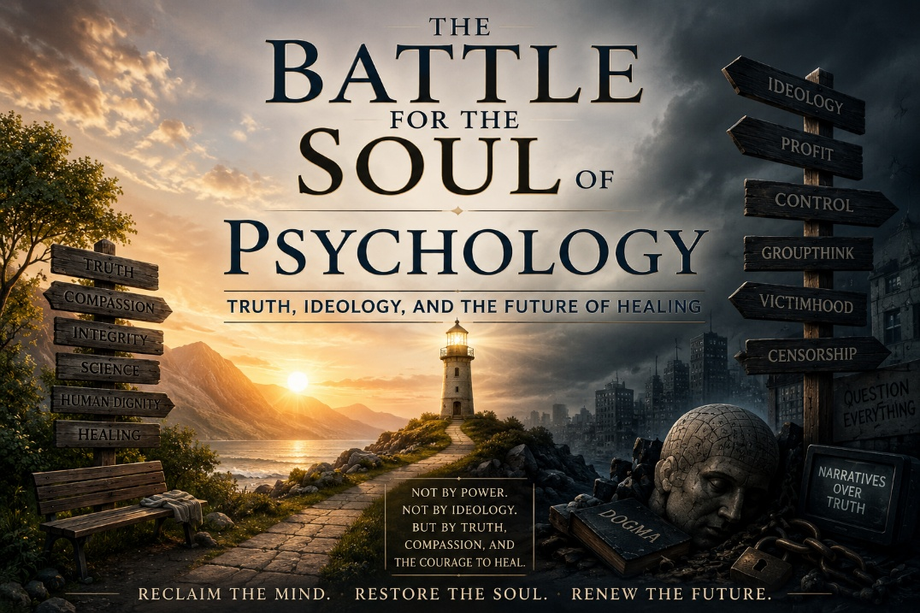
"The world will not be destroyed by those who do evil, but by those who watch them without doing anything."
— Albert Einstein
The Crisis at the Heart of Modern Psychology
Something is deeply wrong in the field of mental health. Psychiatry and psychology, once disciplines dedicated to healing, objectivity, moral seriousness, and scientific rigor, now increasingly find themselves entangled with ideology, corporate interests, and institutional activism. The very professions meant to protect vulnerable human beings are at risk of becoming instruments of conformity rather than places of honest inquiry and compassionate healing.
What concerns many thoughtful clinicians today is not merely disagreement over treatment models or political perspectives. It is something deeper: the growing erosion of intellectual humility, open debate, ethical restraint, and reverence for the complexity of the human person. Increasingly, people are being reduced to categories, labels, diagnoses, ideological identities, and symptom clusters rather than understood as embodied, relational, meaning-seeking human beings.
This corruption can be seen in three interconnected crises: the medicalization of human suffering for profit, the ideological capture of children, and the surrender of psychology to political activism and cultural conformity.
Psychiatry’s Dirty Secret: The Medicalization of Human Suffering
Psychiatry has long carried a difficult and uncomfortable tension within it. While medications can absolutely help stabilize certain individuals during severe suffering, the broader system has increasingly drifted toward symptom suppression rather than deeper healing. Pharmaceutical influence has transformed much of mental health care into a profit-driven enterprise where distress is often rapidly categorized and medicated before deeper relational, spiritual, developmental, or existential questions are meaningfully explored.
Despite decades of mass prescribing, mental health outcomes in many areas continue to deteriorate. Anxiety rises. Depression rises. Suicide rises. Loneliness rises. And many patients quietly wonder why the medications meant to restore life often leave them emotionally flattened, disconnected, dependent, or confused about who they are underneath the chemistry.
The deeper wounds of trauma, meaninglessness, disconnection, family fragmentation, spiritual emptiness, and social isolation cannot simply be medicated away. Human beings do not heal merely through neurotransmitter management. They heal through relationship, safety, truth, meaning, courage, love, and reconnection to something larger than themselves.
The Ideological Capture of Children
Perhaps nowhere is the moral confusion of modern mental health more visible than in the growing ideological battle surrounding children and identity. Schools, institutions, social media systems, and even segments of mental health care increasingly encourage vulnerable children and adolescents to interpret emotional distress through rigid ideological frameworks.
Young people struggling with loneliness, trauma, confusion, social anxiety, depression, family wounds, or identity uncertainty are often quickly swept into narratives that offer immediate certainty before deeper developmental exploration has even occurred. In some cases, life altering medical interventions are pursued with astonishing speed while thoughtful caution and long-term developmental humility are dismissed as intolerance.
Children deserve compassion, protection, patience, and truth. They deserve environments where thoughtful inquiry remains possible and where adults are willing to slow down long enough to ask deeper questions before rushing vulnerable young people toward permanent conclusions.
The Sellout of Psychology to Ideology
Psychology was once grounded in the difficult work of helping individuals confront reality honestly, build resilience, deepen self-awareness, and pursue meaningful growth. Increasingly, however, many institutions have shifted toward ideological activism and political conformity rather than balanced inquiry.
Rather than encouraging open exploration, some corners of the profession now police language, punish dissent, and elevate ideological narratives above thoughtful dialogue. Traditional psychological concepts such as accountability, resilience, personal responsibility, family systems, spiritual meaning, and moral agency are often replaced by reductionistic frameworks centered almost exclusively on oppression, victimhood, or identity politics.
This shift has left many clinicians and patients feeling spiritually and intellectually homeless within their own profession.
A Return to Wholeness
The answer is not cynicism, cruelty, or reactionary anger. Nor is it the abandonment of science, medicine, or compassionate care. The answer is a return to truth, humility, integration, and moral courage.
Mental health treatment must return to its foundational purpose: helping human beings heal rather than merely managing symptoms or reinforcing ideological narratives. This requires a more integrative vision of the person — one that recognizes the nervous system, trauma history, relationships, attachment patterns, meaning structures, spirituality, and embodied experience as inseparable dimensions of healing.
The NeuroFaith® model emerged from precisely this conviction. Human beings are not machines. They are stories, souls, relationships, memories, wounds, hopes, and longings woven together within the nervous system and the heart.
The Choice Before Us
The future of psychology and psychiatry will be determined not merely by science, but by courage, humility, conscience, and the willingness to defend truth even when doing so becomes costly.
We now stand at a crossroads. One path leads toward deeper reductionism, ideological conformity, endless medicalization, and increasing fragmentation of the human person. The other path leads toward reintegration, truth seeking, relational healing, moral clarity, and a renewed understanding of human dignity.
The battle for the soul of psychology is ultimately not only about politics or clinical theory. It is about what it means to be human.
Human beings are not merely collections of symptoms, biochemical reactions, or social identities. We are relational beings wired for healing, growth, meaning, love, transcendence, and faith.
It is time to reclaim that truth


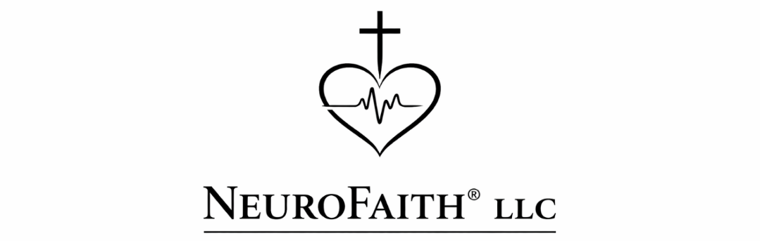
📞 (360) 870-3801 | 🌐 neurofaith.net | ✉️ JeffreyHansen@NeuroFaith.net

Dear LTC(P) Parker,
As I elect to drop the EEO complaint—foreseeing a protracted process with little to gain in the end, aside from the hope that Ms. Meyers now recognizes that there are potential consequences for her actions—I also recognize that this decision allows me to find my own sense of closure. Rather than remaining entangled in a drawn-out battle, I can step away knowing that I have acted with integrity, stayed true to my values, and prioritized what truly matters.
One of the lessons I’ve learned—both in my career and in life—is that there is always a backstory. No one arrives at a moment like this without the weight of their past shaping them, and I wanted to share mine with you. Not just as a means of explanation, but as a way of truly closing this chapter and moving forward.
The Journey That Brought Me Here
I am forever indebted to Madigan—not just as a place where I served, but as a place where I perfected my healing over the course of nearly a decade. It was here that I rediscovered my strength, my purpose, and ultimately, my ability to give back in ways that mattered.
That healing became even more vital after the tragic loss of my identical twin brother, Gregg. There will never be closure for that loss—only the resolve to ensure his pain was not in vain. Gregg was not only my brother but my best friend, my mirror, and the person who always celebrated my highs and held me through my lows. Despite his own battles with depression, he never stopped lifting me up, even as I faced the challenge of leaving my private practice and accepting my position at Madigan. He fought nobly and courageously, but in the end, the weight of his pain overtook him.
Losing Gregg shattered something inside me. When he left, part of me left with him.
In the midst of my grief, I desperately needed a sense of closure—not just in my personal life, but in my professional life. I wanted to end my career with dignity, on my own terms, both as a prior active-duty soldier and as a DHA employee. But just two days after we buried Gregg, I was blindsided, hit with allegations of defrauding the government and later followed by a credible report that Ms. Meyers had gloated about turning me into my licensure board.
The cruelty and timing of these events were staggering.
Yet, through it all, I never feared the outcome. My conscience has remained clear—not just in terms of my integrity, but in my professional conduct as well. What I have struggled with, however, is the profound sense of injustice, the knowledge that, after dedicating much of my life to serving the military community, I would be met with such baseless accusations at my most vulnerable moment.
A Lifetime of Lessons
If I have learned anything in my journey, it is this: pain shapes us, but it does not have to define us.
I come from a long line of men who carried deep wounds. My father, though brilliant and accomplished, was himself a product of trauma, shaped by the abuse of his own father before him. My father was both my greatest example of excellence and my greatest challenge. From him, I inherited both a relentless work ethic and a deep-seated anxiety about whether I would ever be “enough.”
That internal battle followed me throughout my life. On the surface, I looked like I had it all together, top grades, social success, professional achievements. But underneath, I carried a storm of insecurity, perfectionism, and a fear that if I ever stopped proving my worth, I would disappear.
That storm reached its peak in 2008 when a perfect collision of stressors, my wife’s earlier battle with cancer, my daughter’s suspected lymphoma, my son’s deployment to Iraq, a threat to my career, and the financial collapse at that time, events that nearly destroyed my family’s stability, brought me to my breaking point. It was then that I hit a wall I never saw coming.
It took years, nearly a decade, to climb out of that darkness, to unlearn the lies I had internalized about my worth, to understand the deeper currents that had shaped my life. And it was at Madigan, in the work I did there, that I was able to not only heal myself but help others with similar wounds heal as well.
That is why I hold Madigan so close to my heart. And that is why I wanted my career to end in a way that honored everything I had fought through to get here.
Moving Forward
Through all of this, I have learned that even in moments of deep injustice, our character is what defines us, not the accusations of others, not the trials we endure, but how we choose to respond. We do not always get to control what happens to us, but we do have a choice in how we carry ourselves through it. I refuse to let resentment or anger take hold because bitterness serves no purpose—it only chains us to the very things that seek to break us. Instead, I choose to walk away from this chapter with my head high, knowing that I have given my very best—to my patients, my colleagues, and the mission I dedicated my life to.
I have always believed that true leadership is most evident in challenging times—when values, resilience, and character are put to the test. Throughout this process, I have seen firsthand what steady, principled leadership looks like, and I deeply appreciate the example you have set. Your integrity, sound judgment, and support have made a meaningful difference, not just for me, but I am sure for many others as well.
Your support has been a source of stability during this difficult period, reminding me that even when circumstances are tough, there are people who lead with fairness and integrity. That is something I will carry with me always.
Thank you for your guidance, your patience, and your willingness to stand by me.
With deepest respect and gratitude,
Jeffrey E. Hansen, Ph.D.
Clinical Psychologist — Licensed in Arizona & Washington
AZ Lic. #PSY-5450 | WA Lic. #PSY-1695
Founder & Director, NeuroFaith® LLC

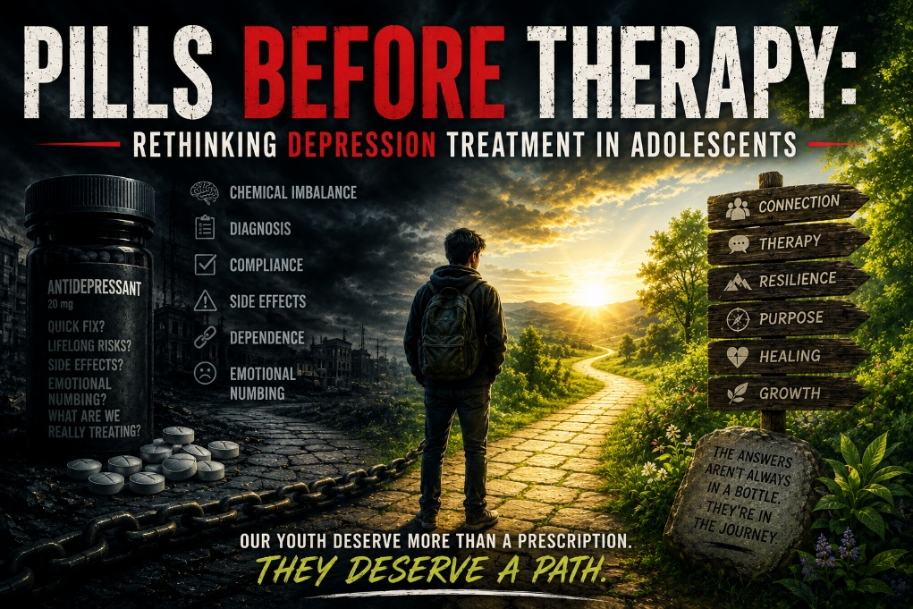
The growing epidemic of adolescent depression has been met with a disturbing trend: hasty diagnoses followed almost immediately by prescriptions for antidepressant medications. In doctor’s offices and therapy clinics, teenagers barely finish recounting their woes before leaving with a pill bottle in hand.
The rate of antidepressant dispensing to young people has skyrocketed, especially in recent years. For instance, one study found that the monthly rate of antidepressants dispensed to youth increased about 64% faster during the COVID-19 pandemic than before, with a staggering 130% faster rise among girls aged 12–17 (Archie, 2024). Such statistics underscore an alarming reality: we are increasingly medicalizing normal teen sadness and reaching for medications as a first resort. This quick-fix, pill-first mentality ignores the complex roots of adolescent distress and poses serious risks to the very youth we aim to help.
Victimhood Culture: When Mental Illness Becomes a Status Symbol
In tandem with clinical trends, there has been a seismic cultural shift in how we view mental health. Today’s youth grow up in a society that, in many ways, embraces victimhood. Through a neo-Marxist lens, social status is often determined by power dynamics: individuals are seen as either oppressors or oppressed. In this framework, being part of an “oppressed” group can confer a certain moral high ground.
Mental illness labels have become status symbols in this cultural context, elevating those who suffer into a protected class of sorts. A teenager who is diagnosed with depression may receive sympathy, validation, and a sense of identity as someone who has been oppressed by illness or circumstance. This can create a perverse incentive to adopt pathology as persona, to wear one’s diagnosis like a badge of honor. Instead of fighting against depression, some teens might consciously or unconsciously embrace it as part of their identity, reinforced by social media echo chambers that valorize struggle. The cultural script whispers that being broken or ill grants you significance.
This valorization of victimhood does a grave disservice to adolescents: it normalizes and even encourages the proliferation of mental health diagnoses, making it less likely that young people will question a label or seek to overcome it. In such an environment, a swift diagnosis and pill prescription not only provide a biochemical crutch but also social validation. The result is a dangerous positive feedback loop: the faster we diagnose and medicate, the more we reinforce the notion that to struggle is to belong.
The Storm and Stress of Adolescence: Natural Turbulence vs. Pathology
Every adult can remember the rollercoaster of emotions that define the teenage years. Adolescence is a time of existential and emotional turbulence, a period marked by intense heartbreak, profound angst, identity confusion, surging hormones, and a search for meaning. Feeling lost, alone, or inconsolably sad at times is completely natural for teenagers. First loves end in tears; friendships fracture; the pressure to define one’s future looms large. These experiences, as painful as they can be, are developmentally normal and even necessary. They teach resilience, empathy, and coping. However, in today’s diagnostic culture, the ordinary suffering of adolescence is increasingly pathologized. Instead of being reassured that “this too shall pass,” teens are often told they have a brain disorder or a “chemical imbalance” when they feel down.
The line between normal angst and clinical depression has blurred. Certainly, some adolescents do suffer from severe, clinical depression that warrants treatment. But the pendulum has swung so far that we risk labeling every case of teenage heartbreak or academic stress as a mental disorder requiring medication. By medicalizing normal emotions, we send a dangerous message to young people that they are not equipped to handle life’s ups and downs without pharmacological aid. We short-circuit the natural process of learning to overcome challenges. A teenager who believes their sadness is a symptom of a chronic mental illness may start to ruminate on their victimhood and feel even more helpless, a self-fulfilling prophecy that deepens despair. It is essential to recognize that adolescence has always been a time of storm and stress; our task is to guide youth through the storm, not to numb them to it.
Many teens today are quickly classified as “depressed” when in fact they are experiencing the natural growing pains of youth. By treating these pains as pathologies, we risk robbing young people of the chance to grow. Every moment of sorrow in adolescence is also an opportunity: to develop grit, to discover inner strengths, and to gain wisdom. If we rush to slap a diagnostic label on a 15-year-old who is grieving a breakup or anxious about school, and then offer nothing but a prescription, we trivialize their experience. We imply that their sadness is something abnormal, a defect to be fixed chemically, rather than a valid emotional response to life’s challenges.
This is not to romanticize suffering, but to contextualize it. Pain can be a teacher. A teen who works through heartbreak with supportive counseling, journaling, exercise, and time will likely emerge stronger and more emotionally skilled than one whose heartbreak is immediately numbed by Zoloft. The former learns that they can endure hardship and heal; the latter learns only that a pill can take emotional pain away, for now.
Consequences of Overprescribing Antidepressants to Youth
When we indiscriminately put adolescents on antidepressants as a knee-jerk reaction, the consequences can be dire. These medications are not benign “happy pills”; they come with significant side effects and long-term implications, especially for developing young brains and bodies. Some of the most concerning effects of overprescription include:
Emotional Blunting and Numbness: Antidepressants, particularly SSRIs, often dull the intensity of emotions. While this blunting might mute the depths of despair, it also flattens the peaks of joy. Teens on SSRIs frequently report feeling like a zombie or a hollow shell, unable to cry, but also unable to truly laugh or feel excited.
Research indicates that about half of SSRI users experience a “psychic flatness”, a loss of the ability to experience positive feelings like pleasure and joy (Psychiatrist.com, 2023). In an attempt to shield young patients from pain, we may also be depriving them of vital human experiences, the full range of emotion needed for learning, relating, and developing an authentic sense of self.
Impaired Development of Coping Skills: Adolescence is the training ground for adulthood. It’s when individuals typically learn how to cope with sadness, frustration, loneliness, and anger. If a pill numbs these emotions every time they arise, the teenager never learns to cope because they rarely face the full intensity of the feeling. Coping mechanisms, such as talking through problems, seeking support, engaging in hobbies, spiritual practice, or simply enduring a bad mood, require experiencing discomfort. By medicating away discomfort at the slightest sign of distress, we short-circuit the learning of resilience. Years later, in adulthood, these individuals can become ill-equipped to handle even mild stresses, having been deprived of the chance to build emotional muscles in their teen years. Moreover, some may come to believe that only a drug can make them feel “okay”, leading to a profound sense of dependency and lack of self-efficacy.
Dependency and Identity Tied to Medication: Once an adolescent starts taking antidepressants, stopping can be challenging. They may become psychologically dependent on the medication, believing it’s the only thing keeping them functional. Biological dependence can occur as well; the body and brain adapt to the drug. When trying to come off SSRIs, patients often face withdrawal effects (euphemistically termed “discontinuation symptoms”) such as dizziness, insomnia, irritability, or a return of depression worse than before.
This can scare a young person into staying on the drug indefinitely. Over time, a teenager can internalize the belief that “I need this pill to be normal.” The medication becomes a crutch, and their very identity might wrap around being someone with depression who needs antidepressants. This entrenched dependency undermines the fundamental goal of therapy, to empower the individual to heal and function autonomously. It’s a cruel irony that a tool meant to free someone from depression can, if overused, enslave them to a lifetime of medication.
Post-SSRI Sexual Dysfunction (PSSD): Perhaps the most under-acknowledged and devastating consequence of adolescent antidepressant use is the risk of Post-SSRI Sexual Dysfunction. PSSD is a condition in which a patient’s sexual functioning does not return to normal after stopping the antidepressant, potentially persisting for years or even permanently. It includes symptoms like genital numbness, loss of libido, erectile dysfunction in males, vaginal dryness in females, anorgasmia (inability to orgasm), and even blunted romantic feelings. Imagine a teenager put on an SSRI at 16 for mood issues: by the time they are 18 or 20, they might discover that they cannot feel sexual pleasure or desire, even though they’ve long since quit the drug. For a young person just coming into their own sexuality and yearning for intimacy and connection, this outcome is nothing short of catastrophic.
The medical community has been slow to recognize PSSD, but it is very real, European regulators have acknowledged it, and patient advocacy groups are raising alarms. As one researcher bluntly stated, Post-SSRI Sexual Dysfunction and related disorders may represent “iatrogenic epigenetic damage previously unseen in human history,” with individual consequences that are truly “catastrophic” (PSSD Network, 2025). In other words, we may be witnessing medication-induced damage that fundamentally alters biology in ways we never anticipated. To inflict such a fate on adolescents, often without their informed consent or full understanding, is a grave ethical failing. PSSD doesn’t just steal pleasure; it can steal future relationships, self-esteem, and the basic human experience of sexuality.
No teenager, indeed, no person at all, should have to pay such a price for having sought help for depression. The above consequences highlight a painful truth: overprescribing antidepressants can inadvertently harm young people in the very ways we’re trying to help them. Emotional blunting robs them of feeling truly alive; dependency keeps them from becoming strong on their own; and PSSD can cast a long shadow over their adulthood.
These effects are not rare one-in-a-million anomalies, emotional blunting is common, and while PSSD is considered rare, “rare” side effects can still impact thousands when millions of teens are on these drugs. The tragedy is compounded when we consider that many of these teens might have overcome their struggles without medication, through time and proper support, if only given the chance.
Overdiagnosis, Informed Consent, and Ignored Root Causes
Why has this overprescription phenomenon taken root? Part of the problem lies in overdiagnosis, the threshold for labeling a teen with “major depressive disorder” has lowered to the point that normal sadness can qualify. Diagnostic criteria in psychiatry are subjective, and there’s growing concern that we’re turning typical behavior into illness. Well-meaning school counselors, pediatricians, and psychiatrists may be quick to apply a diagnostic label after a brief questionnaire or a 15-minute consult.
Once the label is in place, the prescription pad often comes out. This rush to diagnose is fueled by several factors: pressure from overwhelmed parents desperate for a solution, practitioners constrained by brief appointment times (it’s faster to write a prescription than to dig deep into psychosocial issues), and, unavoidably, the influence of pharmaceutical marketing that has for years promoted the narrative of “a pill for every ill.” The result is diagnosis inflation; more and more teens being told they have a mental disorder.
Compounding this issue is a disturbing lack of informed consent in the treatment of young patients. In many cases, adolescents (and their parents) are not fully informed about what an antidepressant prescription entails. Crucial information is often glossed over: the potential side effects (weight gain, sleep problems, emotional numbing, sexual side effects), the typical duration of treatment (often many months or years, not just “try this for a week or two”), the possible difficulties in discontinuing the drug, and the fact that antidepressants are not guaranteed to be effective for mild or moderate depression. A teenager might think, “I feel really sad, and the doctor gave me this pill, so it must be what I need”, without understanding the trade-offs involved. Truly informed consent would mean the teen and their guardians are educated on all risks (like PSSD and dependency) and all alternatives (such as therapy, lifestyle changes, or simply monitoring symptoms for a while). Unfortunately, such comprehensive discussions are the exception, not the rule.
The power dynamic between doctor and young patient can also impede informed consent, teens might not even know what questions to ask, and they often trust that whatever the doctor is recommending is safe. Thus, many adolescents start SSRIs without a clear sense of what they’re getting into. Equally concerning is the widespread failure to explore root causes of a teenager’s depressive symptoms before resorting to medication. Depression is not a one-size-fits-all phenomenon with a single etiology. A teen’s low mood might be stemming from bullying at school, an identity crisis, family dysfunction, academic pressure, past trauma, social media influences, poor diet, lack of sleep, or a combination of many factors. If we do not take the time to peel back these layers, we end up treating a symptom (sadness) rather than the cause. It’s akin to turning off a fire alarm without bothering to check for a fire. Sadly, the current system frequently opts for the quick silencing of the alarm.
A teenager comes in with tearfulness and withdrawal, and rather than asking “What’s been happening in your life?” the system is primed to ask, “Which medication should we try?” The underlying issues, perhaps a recent breakup, or feelings of inadequacy fueled by Instagram, or confusion about sexual orientation, or grief from a grandparent’s death, may remain unaddressed. The young person is sent home with their emotional pain chemically blunted but no solutions for the problems that caused that pain. This is a travesty of care. Imagine a 14-year-old girl who is depressed because she’s being bullied relentlessly online. If no one helps her address the bullying, an SSRI might numb her enough to function, but inside, the true wound festers. We owe our youth more than this surface-level treatment. We owe them true healing, which comes from understanding and resolving the roots of their suffering.
A Holistic Path Forward: Therapy, Not Just Pills
If immediate medication is not the answer for every adolescent who feels depressed, then what is? The alternative path forward is a holistic, person-centered approach that seeks to heal rather than just medicate. This approach recognizes that adolescents are resilient beings capable of growth and change, especially when given proper support and tools. Key components of a more balanced strategy include psychotherapy, skills-building, and integrative mind, body, and spirit techniques, many of which have proven efficacy in alleviating depression and anxiety. Before resorting to medication (or alongside a carefully monitored, minimal use of it), we should deploy approaches such as:
Cognitive Behavioral Therapy (CBT): CBT is a well-established talk therapy that helps individuals identify and challenge negative thought patterns. For a depressed teen, CBT can be incredibly helpful, teaching them to catch the exaggerated gloom-and-doom thoughts (“I’ll never have friends”, “I’m a total failure”) and replace them with more balanced, realistic ones. Over time, CBT can reduce depressive symptoms and give adolescents a lasting skill: the ability to manage their own thoughts and emotions. Unlike a pill, which simply masks the feeling, CBT addresses the thinking traps that often underlie depression. Studies have shown CBT can be as effective as medication for mild to moderate depression, with the benefit that its effects last because it empowers the individual.
Dialectical Behavior Therapy (DBT): Originally developed for intense emotional disorders, DBT equips young people with practical tools for emotion regulation, distress tolerance, and interpersonal effectiveness. Adolescents prone to mood swings, self-harm urges, or suicidal thoughts can particularly benefit. DBT teaches skills like mindful breathing to survive a crisis moment, or how to communicate feelings without alienating others. By learning DBT’s core skills (Mindfulness, Distress Tolerance, Emotion Regulation, and Interpersonal Effectiveness), teens gain a sense of mastery over their internal storms. This therapy literally builds the neural and behavioral pathways for coping, something no medication can do for them.
Internal Family Systems (IFS) Therapy: Part of a broader integrative model (such as my NeuroFaith framework), IFS helps individuals work with their inner emotional parts. An adolescent might say, “Part of me is so angry, part of me is just sad and wants to hide.” IFS externalizes these feelings into “parts” (like an inner angry part, a wounded child part, a perfectionist part, etc.) and helps the person develop a compassionate relationship with each part. This can be profoundly healing for teens dealing with internal conflicts or trauma. Instead of viewing themselves as “broken,” they learn that all their feelings have a place and purpose. IFS is a powerful tool for self-discovery and healing that treats the psyche as a family of sub-personalities, all deserving understanding. It can unburden traumas and negative beliefs that fuel depression, leading to deep and lasting emotional change.
HeartMath® and Biofeedback: HeartMath® techniques use biofeedback technology and breathing exercises to help individuals synchronize their heart rate variability and achieve a state of calm and focused coherence. For anxious or depressed teens, seeing a real-time display of their physiology and learning that they can influence it (through breathing, positive imagery, or recalling feelings of gratitude) is incredibly empowering. It turns abstract advice (“just relax”) into a concrete skill (“here’s how to calm your heartbeat and feel centered”). Regular practice can improve stress resilience, sleep, and mood. It’s a holistic method that directly targets the stress response, teaching youths that they have the ability to self-regulate their nervous system.
Polyvagal-Informed Therapy: Stemming from Dr. Stephen Porges’ Polyvagal Theory, this approach educates individuals about their autonomic nervous system, how our bodies toggle between states of safety (social engagement), danger (fight/flight), and life-threat (shutdown). Therapists trained in this approach help teens understand bodily reactions to stress (like why their heart races and they feel like running away during a panic attack, or why they feel numb and detached when overwhelmed). Through exercises like deep breathing, humming, cold water face dips, or therapeutic movement, adolescents learn to engage the vagus nerve and shift into a calmer state. They also learn how cues from the environment or relationships affect them, and how to create conditions of safety for themselves. By learning to navigate their own biology, teens can reduce anxiety and lift mood in ways that are natural and self-directed. And finally, the teen is helped to re-narrate the negative story into a more realistic and positive one.
Spiritual Integration and Faith-Based Coping: For many, spirituality is a wellspring of resilience. Integrating a teen’s spiritual or religious beliefs into therapy can provide a profound sense of meaning and hope. Whether through prayer, meditation, community service, or reflection on one’s purpose, spiritual practices can anchor a young person amidst chaos. The user’s NeuroFaith model, for example, explicitly combines neuroscience with faith traditions, recognizing that humans are not just biological machines but also seekers of meaning. A depressed adolescent can often benefit from exploring questions like, “Why am I here?”, “What can suffering teach me?”, or “Is there a bigger plan for me?” in a supportive setting. Such exploration can transform pain into growth. Even for those not inclined to formal religion, a sense of connection to something larger, nature, humanity, the universe, can instill hope. The goal is to tap into sources of strength beyond the ego: compassion, forgiveness, gratitude, and purpose.
These are age-old antidepressants with no side effects. Most important, this along with Polyvagal-informed Therapy, helps the teen to address core negative beliefs about self (e.g., “I am not worthy, I am not valuable, I am not lovable”) that are always produced by trauma and, unless addressed, forever taint and even destroy the teen’s sense of self. A hopeful depiction of healing and personal growth, symbolizing the holistic therapies that empower adolescents. Importantly, these holistic approaches are not mutually exclusive with medical intervention. There may be cases of adolescent depression so severe that medication is warranted. But even in those cases, therapy and holistic care should ride alongside the medication, addressing dimensions of the person that pills cannot touch. By prioritizing therapies like CBT and DBT, and integrative methods like IFS, HeartMath, and polyvagal exercises, we equip young people with life-long skills and insights.
We treat the whole person, mind, body, and spirit, rather than just numbing the symptoms. This comprehensive care model honors the fact that depression in a teen is often a cry for help, not merely from their brain chemistry, but from their whole being and their environment. We need to answer that cry with human connection, understanding, and empowerment, not just a prescription.
Conclusion: Reclaiming Youth Mental Health: A Call for Urgent Reform
It is time for an urgent course-correction in how we address adolescent depression. The current paradigm of “diagnose fast and medicate faster” is failing our youth. We are witnessing an unintended experiment play out on a generation, and the results are harrowing: too many teens dependent on antidepressants, numb to life, and bereft of coping skills, some even with permanent sexual dysfunctions before they’re out of college. This is not youth mental health care; it is a betrayal of youth.
We must reclaim the treatment of adolescent depression from the quicksand of overdiagnosis and overprescription. Reform starts with a cultural shift in expectations. We, as a society, must stop glorifying victimhood and instead celebrate resilience and recovery. Being a survivor or fighter should carry more cachet than being a victim. Adolescents should be taught that suffering is not a permanent identity, not a badge to showcase, but a challenge to overcome. In clinical practice, reforms should mandate comprehensive informed consent for any psychiatric medication given to minors, including a frank discussion of side effects like emotional blunting and PSSD.
Doctors should be encouraged (or required) to exhaust psychotherapy options and investigate environmental factors before reaching for the prescription pad in cases of mild-to-moderate depression. Schools and communities, too, have a role: promoting counseling resources, peer support groups, mentorship programs, and psychoeducation about emotions and coping from early ages.
Policymakers and professional boards can help by updating guidelines to curb reckless prescribing. For example, requiring a minimum number of therapy sessions or a psychological evaluation prior to medication for adolescent depression could slow the assembly line of SSRI scripts. Insurance companies must also come on board, recognizing that paying for therapy and holistic treatments now will save costs on medications and hospitalizations later. And importantly, pharmaceutical companies and the FDA should ensure that warnings about risks like PSSD are prominently disclosed whenever SSRIs are prescribed to young people. Ultimately, what we seek is a world where every teenager’s cry for help is met with compassion and wisdom, not just a chemical solution.
We owe it to our children to give them the safest and most genuine healing possible. The angst of adolescence is not a disease to be eradicated, but a journey to be guided. By reforming our approaches now, by privileging therapy, informed consent, and holistic care, we can prevent countless cases of blunted lives, thwarted potential, and prolonged suffering. We can instead cultivate a generation of young adults who emerged from their dark times not dependent on a drug, but equipped with self-knowledge, resilience, and hope. The time for this change is now. The hearts and futures of our youth depend on it.
References
Archie, A. (2024, February 27). The rate of antidepressants prescribed to young people surged during the pandemic. NPR. https://www.npr.org/2024/02/27/1234112068/antidepressants-youth-pandemic-study
PSSD Network. (2025). Post-SSRI Sexual Dysfunction (PSSD), What the Experts are Saying. https://www.PSSD Network
Psychiatrist.com Staff Writer. (2023, January 23). Why antidepressants cause emotional blunting, study uncovers. Psychiatrist.com. https://www.Psychiatrist.com/news/why-antidepressants-cause-emotionalblunting/

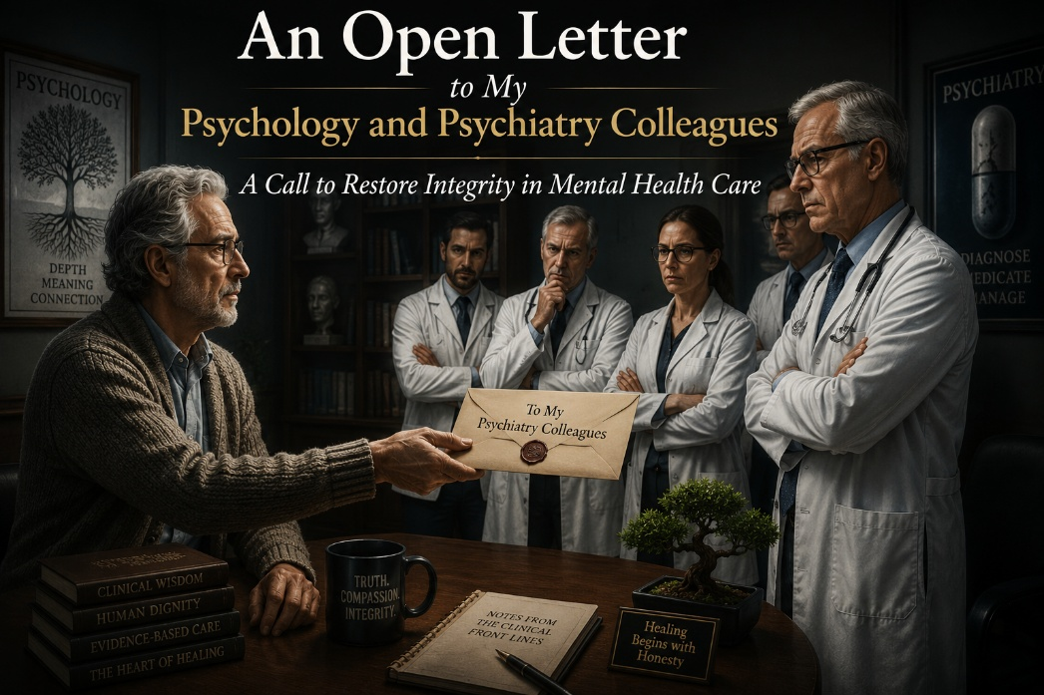
Dear Colleagues,
I write to you today not from a place of animosity, but from a place of profound concern. I am both a clinical psychologist and a human being who cares deeply about the integrity of our professions, psychology and psychiatry, and the sacred trust we hold with those who seek our help. Yet we are at a critical juncture. Our fields, once grounded in the pursuit of truth, healing, and human dignity, have become something else entirely.
Before I proceed, let me be clear. I recognize that there are many exceptional psychiatrists and prescribers who not only know the research, but adhere to it faithfully, often saving lives through judicious prescribing and a deep understanding of both the benefits and limitations of psychotropic medications. Likewise, there are many therapists who do extraordinary work, fostering genuine healing and transformation. This letter is not meant to undermine or dismiss their efforts, but rather to address broader systemic concerns that impact all of us.
For psychiatry, the pivot from patient-centered care to pharmacological dogma is undeniable. We sold the public the chemical imbalance myth, a theory that has been thoroughly debunked (Moncrieff & Cohen, 2022; Whitaker, 2010). We did so while knowing the research never conclusively supported it. Despite this, the narrative persists.
Why? Because it is profitable. Because it is convenient. And because it provides a simplistic, reductionist framework that allows for the rapid prescribing of psychotropic medications, often without a thorough evaluation of the root causes of a patient’s distress (Davies, 2018; Gøtzsche, 2013; Kirsch, 2019).
The over-reliance on SSRIs is particularly concerning. Meta-analyses by Kirsch (2019) revealed that the majority of the efficacy of antidepressants can be attributed to the placebo effect, with only marginal differences between drug and placebo outcomes. Whitaker (2010) documents how long-term SSRI use can induce chronic depression, akathisia, and suicidality, especially in adolescents.
But the impact goes far deeper. What are we doing to our patients when we tell them that their suffering is the result of a broken brain, a chemical imbalance? What message does this send to children and adolescents, whose developing minds are particularly vulnerable to such narratives? We are creating a generation of passive recipients of psychiatric labels rather than empowering individuals to confront, process, and heal from their pain.
The disease model, which promotes the idea of a biochemical fix, fundamentally undermines the principles of self-agency, resilience, and personal growth. It tells patients, especially children, that they are inherently broken, that they require medication to "fix" them, and that the source of their suffering is internal and immutable. This stunts growth, prevents true healing, and creates lifelong dependency on psychotropics without addressing the underlying trauma, loss, or disconnection that often drives their distress (Davies, 2018; Moncrieff, 2020).
We must ask ourselves, as clinicians, what we are truly doing when we pathologize children and adolescents, labeling them with diagnoses that carry lifelong implications and pushing them toward medication as a first-line treatment. We are implanting a disempowering narrative that may cripple their ability to navigate future challenges with resilience and self-efficacy.
The evidence base for long-term SSRI use in children and adolescents is alarmingly weak, and the harms are substantial (Gøtzsche, 2013; Moncrieff & Cohen, 2022). It is time to reconsider our approach and to ask ourselves whether we are truly serving our patients, or whether we are merely serving the interests of a system that profits from chronic dependence.
And What of Psychology?
Psychology, once a field rooted in depth, meaning, and the exploration of the human condition, has increasingly sold out to ideological capture. We now see practitioners doing therapy to a script, pushing political agendas, and prioritizing ideological conformity over authentic healing.
Where is the informed consent in pushing critical race theory, gender ideology, and other politically charged frameworks onto children and adolescents who lack the cognitive capacity to fully understand these complex, controversial constructs?
The DSM-5-TR: A Collusion of Convenience
The DSM-5-TR is a manual that purports to be scientific but is, in reality, a catalog of billing codes rather than a compendium of empirically validated diagnoses (Frances, 2013).
The DSM is not statistically validated in the way that genuine scientific instruments are. It is based on committee votes, not objective biomarkers or rigorous, replicable studies (Moncrieff, 2020).

Ponerology and Plutocracy: The Unseen Forces
If we are honest, we must ask: Who benefits from the current model of care? Who profits when both psychology and psychiatry are reduced to prescription pads and ideological scripts?
Pharmaceutical companies profit, not only from initial prescriptions but from the lifelong cascade of medications that follow, the antipsychotics to blunt antidepressant-induced mania, the benzodiazepines to counteract SSRI-induced akathisia, the stimulants to revive the cognitively blunted patient.
Andrew Łobaczewski, in his seminal work Political Ponerology (2006), examines how systems of power can be co-opted by individuals with severe psychological disturbances. He describes how pathocracies, rule by the psychologically disturbed, emerge when individuals lacking empathy infiltrate institutions, systematically eroding ethical norms and replacing them with ideological and pathological agendas. Łobaczewski warns that such systems suppress dissent, distort truth, and pathologize critical thought as a means to consolidate control.
Michael Rectenwald, in The Great Reset and the Struggle for Liberty (2022), discusses how global elites leverage crises to consolidate power, creating what he terms a corporate-socialist technocracy. Rectenwald emphasizes how the pharmaceutical industry, in collaboration with other powerful entities, perpetuates dependency by promoting chronic medicalization as the norm. In this framework, patients become lifelong consumers, not of healing, but of treatments that manage symptoms without addressing root causes.
Are we, as mental health professionals, so anesthetized to our own consciences that we cannot see this happening? Are we complicit in a system that reduces individuals to mere recipients of drugs and ideological narratives, rather than autonomous, empowered human beings capable of growth and self-actualization?

A Call to Wake Up
We are supposed to be critical thinkers, especially those of us with doctoral degrees. We are supposed to challenge dogma, not enforce it. We are supposed to heal, not prescribe a cocktail of psychotropics or ideological scripts that mask the underlying trauma, fear, or despair that drives our clients to seek help.
In Closing: A Call to Courage
I will choose to remain optimistic because I believe that deep within us, we will get to the soul of our professions. And we will turn this around, one provider, one psychologist, one psychiatrist at a time.
But someone has to speak first. And I urge you, along with me, to take a critical look at what we are doing, to ask the difficult questions, and to refuse to be silent in the face of harm and corruption. It is not too late to change. It is not too late to reclaim our professions, our integrity, and our purpose.
Primum non nocere. First, do no harm.
Together, we can do this.
Respectfully,
Jeff
Jeffrey E. Hansen, Ph.D.
Clinical Director, Holdfast Recovery
Founder and Director, NeuroFaith, LLC
References
Andreasen, N. C., et al. (2011). Long-term antipsychotic treatment and brain volume. Archives of General Psychiatry, 68(2), 128-137.
Ashton, H. (2005). Benzodiazepines: How they work and how to withdraw. Retrieved from benzo.org.uk
Breggin, P. (2008). Medication Madness: The Role of Psychiatric Drugs in Cases of Violence, Suicide, and Crime. St. Martin's Press.
Davies, J. (2018). Cracked: Why Psychiatry is Doing More Harm Than Good. Icon Books.
Frances, A. (2013). Saving Normal. William Morrow.
Gøtzsche, P. C. (2013). Deadly Medicines and Organised Crime. CRC Press.
Healy, D. (2012). Pharmageddon. University of California Press.
Kirsch, I. (2019). The Emperor’s New Drugs. Basic Books.
Łobaczewski, A. M. (2022). Political ponerology: The science of evil, psychopathy, and the origins of totalitarianism (H. Koehli, Ed.). Red Pill Press.
Moncrieff, J., & Cohen, D. (2022). The serotonin theory of depression. Molecular Psychiatry.
Whitaker, R. (2010). Anatomy of an Epidemic. Crown Publishing Group.
Rectenwald, M. (2023). The Great Reset and the Struggle for Liberty: Unraveling the Global Agenda. World Encounter Institute/New English Review Press.


There is something strangely cruel about the modern pursuit of success. The harder many people chase it, the more elusive it seems to become. We live in a culture obsessed with striving. Achievement has become not merely something we pursue, but something many people use to define their worth. We are encouraged from childhood to perform, excel, optimize, compete, and distinguish ourselves. More degrees. More titles. More followers. More influence. More applause. The modern world rarely tells us when enough is enough.
Long before the era of social media, self-help empires, TED Talks, and personal branding, the philosopher Arthur Schopenhauer warned about this very dynamic. He believed that human beings are driven by an endless striving that can never ultimately satisfy us. Desire, according to Schopenhauer, becomes its own form of suffering because once one goal is achieved, another immediately takes its place. We keep imagining that fulfillment lies just over the next hill, but when we arrive, the satisfaction fades and the striving begins again.
The next promotion.
The next achievement.
The next proof that we matter.
Over time, I have come to believe there is profound truth in that observation.
The Seduction of Achievement
Like many people, I got caught in that game early in life. Achievement became identity. Somewhere deep inside, I absorbed the belief that my value was connected to what I could accomplish, produce, or become. More letters after my name. More patients. More speaking engagements. More recognition. More evidence that I had somehow “made it.” Externally, much of it looked successful. I was productive, driven, respected, and constantly moving forward. But underneath that momentum was often a quieter reality that I did not fully understand at the time.
I rarely felt settled.
Achievement can temporarily inflate the ego while quietly starving the soul.
Gregg and the Burden of Performance
My identical twin brother Gregg and I grew up inside the same emotional atmosphere. We experienced many of the same early wounds and absorbed many of the same unspoken lessons about worth and identity. Without anyone needing to say it explicitly, we both learned a dangerous message very early in life: achieve or you are nothing.
That message fueled both of us.
Gregg was remarkably gifted. Athletic, intelligent, charismatic, and intensely driven. The world rewarded him for it. People admired him. Coaches praised him. He excelled in many areas of life and looked, from the outside, like someone destined for success. But beneath all of that achievement was a man carrying profound internal pressure. He never fully learned how to rest emotionally inside himself.
I understand that because I carried much of the same struggle.
Sensitive people often become performers because performance feels safer than vulnerability. Achievement becomes armor. Competence becomes protection. Constant motion becomes a way of avoiding stillness. But eventually stillness catches up with all of us, and when it does, unresolved pain often rises to the surface.
Modern culture intensifies this problem dramatically. We now live in a world intoxicated by performance, visibility, productivity, optimization, and comparison. Social media amplifies the pressure constantly. Every platform quietly whispers the same message: be more, do more, produce more, optimize more, stay relevant, stay admired.
Exhaustion is often treated as evidence of importance.
We glorify burnout and call it ambition. We confuse busyness with meaning. We encourage people to build carefully curated identities while quietly neglecting the deeper work of becoming emotionally and spiritually grounded human beings.
Schopenhauer saw this problem long before modern technology accelerated it. He understood that unchecked striving eventually becomes exhausting because desire itself becomes insatiable. The ego always needs another accomplishment, another affirmation, another moment of applause. Dopamine becomes a tyrant.
And eventually the human being underneath the performance begins to disappear.
I think that is part of what happened to Gregg. At some point, life stopped asking him to perform and started asking him to transform. Those are not the same thing. Performance asks us to prove ourselves. Transformation asks us to surrender ourselves. Performance says earn your worth. Transformation says your worth already exists apart from achievement.
That is a terrifying transition for many high achievers.
When Success Stops Working
Arthur Brooks writes beautifully about this in his book From Strength to Strength. He describes how the first half of life is often driven by what psychologists call fluid intelligence: speed, competition, achievement, adaptability, and ambition. The neurochemistry of that world is heavily driven by dopamine and adrenaline. Accomplishment produces stimulation. Success produces reward.
But eventually life invites us into something deeper. Brooks describes the movement toward crystallized intelligence: wisdom, teaching, mentoring, compassion, emotional depth, and generativity. It is a movement away from proving and toward giving. Away from competition and toward contribution.
Philosophically, that sounds beautiful.
Psychologically, however, it can feel like death.
Part of us must let go of identities that once protected us. The athlete ages. The admired executive retires. The gifted professional loses some relevance. The brilliant mind slows down. The applause softens. And if achievement has become the primary source of identity, the loss can feel devastating.
I think many high achievers become depressed not simply because they are exhausted, but because they no longer know who they are apart from performance.
That has certainly been part of my own journey.
For much of my life I was the helper, the achiever, the rescuer, the builder, the clinician, the speaker. Those roles brought purpose and meaning, but over time I began realizing how easy it is to confuse role with selfhood. Who are we when the audience leaves? Who are we when we stop performing? Who are we when we no longer need constant proof that we matter?
Those are difficult questions.
Especially for men.
Many men are taught from childhood that love is conditional upon usefulness. Be strong. Be productive. Be successful. Be admired. Weakness becomes shameful. Stillness becomes threatening. Vulnerability becomes frightening. As a result, many men spend decades performing competence while quietly starving emotionally underneath the surface.
Some survive that pressure.
Some do not.
Gregg never fully escaped it, and that reality still breaks my heart. I lost my brother to mental illness, yes, but I also lost him to a culture that rewards performance while neglecting introspection. A culture that celebrates hustle while often ignoring the emotional and spiritual costs attached to it.
From Striving to Meaning
As I have grown older, a passage from Ecclesiastes has become increasingly meaningful to me: “Vanity of vanities, all is vanity.” I do not think the writer was condemning achievement itself. Rather, I think he was describing the emptiness of trying to build ultimate meaning from temporary accomplishments. Success can enrich life, but it cannot ultimately sustain identity.
At some point we must learn how to simply be.
Not constantly proving.
Not constantly striving.
Not endlessly chasing.
Simply being.
That has been one of the hardest lessons of my own life. Learning to value presence over productivity. Relationship over recognition. Meaning over momentum. Learning that success often arrives indirectly rather than through compulsive pursuit. Ironically, the less desperate I became for recognition, the freer I became emotionally. The more willing I became to let go of constant striving, the more peace I slowly began experiencing.
Not perfect peace.
But something quieter.
Something steadier.
Something more real.
Letting Go of the Chase
Schopenhauer believed freedom comes through detachment from compulsive craving. I do not agree with every aspect of his philosophy, but I believe he understood something deeply important about the human condition. Human beings suffer when desire becomes tyrannical. The answer is not apathy, but rightly ordered desire. To pursue excellence without worshiping achievement. To contribute without attaching identity to applause. To love deeply without becoming enslaved by the need for validation.
That, perhaps, is wisdom.
Or at least the beginning of it.
And perhaps that is where healing begins too. Not when we finally achieve enough, but when we stop asking achievement to tell us who we are.
That is the journey I am still on.
And honestly, I think Gregg was searching for it too.
Maybe by telling his story, I can carry part of that journey forward. Maybe his life, his struggle, his brilliance, and the love we shared can become part of my own healing and perhaps yours as well.
So if you find yourself exhausted by the endless chase, quietly wondering why success still feels strangely empty despite all the striving, I want you to know you are not alone. You are not weak because you are tired of performing. You may simply be awakening to something deeper.
Maybe the truth about success is not found in chasing harder.
Maybe it is found in learning what can finally be released.

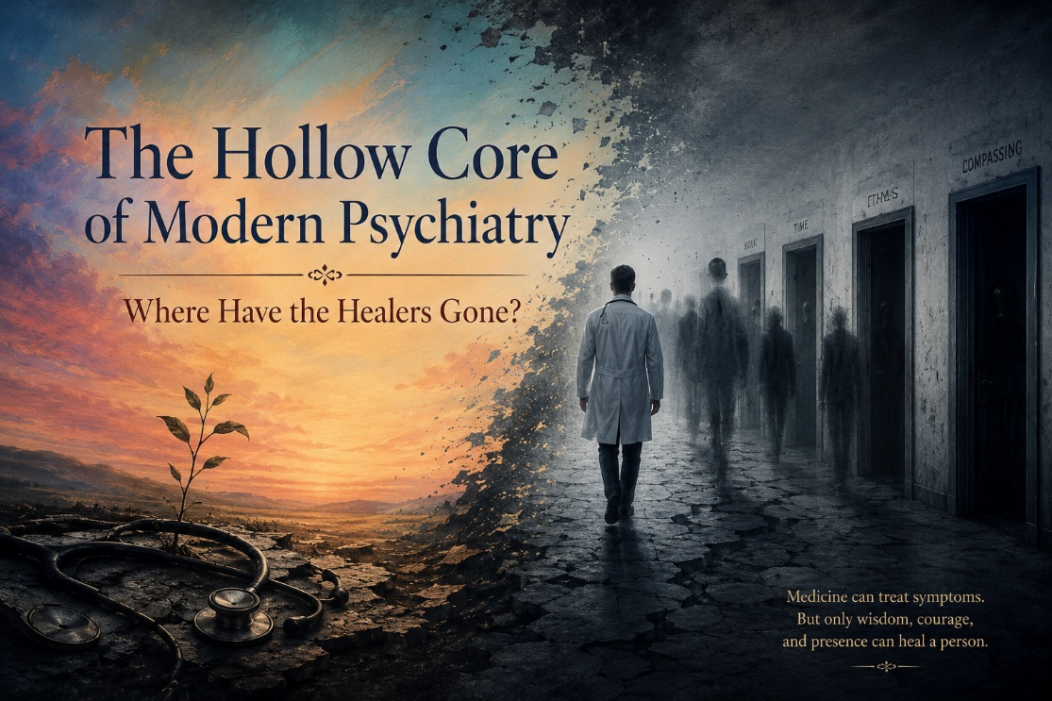
A Profession in Crisis
Let’s talk honestly about modern psychiatry. Not dismissively, not cynically, but honestly. Psychiatry remains one of the most emotionally and philosophically complicated disciplines in medicine because it attempts to address suffering that is often deeply human, relational, existential, developmental, and spiritual—not merely biological.
Yet somewhere along the way, portions of the profession drifted toward an increasingly reductionistic model of care. Diagnostic categories multiplied, medications expanded rapidly, and emotional pain was often reframed primarily through the lens of pathology and neurochemistry. For many clinicians and patients alike, something essential began to feel lost.
This does not mean psychiatry lacks value. Nor does it mean psychotropic medications never help. They absolutely can. I have personally witnessed lives stabilized by thoughtful psychiatric care. But it does mean the field must wrestle honestly with its limitations, blind spots, and growing dependence upon pharmaceutical frameworks that sometimes oversimplify the complexity of human suffering.
The DSM and the Limits of Certainty
The publication of DSM-III under Dr. Robert Spitzer represented a major turning point in modern psychiatry. It brought increased structure and diagnostic consistency to a field that had long struggled with reliability. In many ways, that effort was understandable and perhaps necessary.
At the same time, critics have raised important concerns about how many psychiatric diagnoses emerged. Scholars such as James Davies have documented how portions of the DSM development process relied heavily upon committee consensus rather than definitive biological evidence. This reality does not invalidate all psychiatric diagnosis, but it should encourage humility about the degree of scientific certainty often presented to the public.
Human suffering rarely fits neatly into diagnostic boxes. Trauma, grief, loneliness, family dysfunction, meaninglessness, social fragmentation, and existential despair cannot always be reduced to purely biomedical categories. When psychiatry forgets this, the profession risks treating complex human experiences as primarily chemical disorders rather than multidimensional struggles requiring relational and psychological understanding.
The Human Cost of Overmedicalization
Some of my concerns about psychiatry are not merely intellectual. They are deeply personal.
I lost my identical twin brother after years of emotional suffering, trauma, and psychiatric treatment. There were periods when medications appeared genuinely helpful to him. I want to acknowledge that honestly. But over time the system often seemed more focused on adjusting medications than deeply addressing the underlying pain beneath his suffering.
I cannot say psychiatry caused his death. That would be overly simplistic and unfair. But I do believe aspects of the system contributed to a trajectory that ultimately failed to bring lasting healing.
My concerns also arise from my own experience. As someone who shared much of my brother’s developmental history and trauma background, I too eventually sought psychiatric help during a difficult season of life. Initially, certain medications helped. But over time the treatment became increasingly medication-centered. Long-term benzodiazepine exposure and SSRI use eventually produced profound nervous system dysregulation, including akathisia, severe insomnia, and years of difficult recovery.
I never abused the medications. I followed medical guidance carefully. Yet I emerged from that experience with a far greater appreciation for how serious psychotropic medications can be and how carefully they must be prescribed, monitored, and eventually discontinued.
These experiences profoundly changed how I think about mental health treatment.
A Call for Humility and Deeper Healing
I do not believe the answer is to reject psychiatry entirely. Nor do I believe all psychiatrists are uncaring or irresponsible. In fact, I know thoughtful, compassionate psychiatrists who are deeply committed to helping people heal. Many clinicians within the system are doing the best they can within deeply flawed institutional structures.
But I do believe psychiatry must recover greater humility.
The field must become more willing to acknowledge uncertainty, more open to trauma-informed and relational models of care, and more cautious about presenting medications as primary or long-term solutions for every form of emotional suffering.
Not every painful emotional state represents a brain disease. Many people are struggling with trauma, disconnection, loneliness, grief, identity confusion, family wounds, spiritual emptiness, or profound meaninglessness. These realities cannot always be medicated away.
Healing often requires something deeper:
relationship,
truth,
community,
purpose,
self-understanding,
nervous system regulation,
and human connection.
Medication may sometimes assist the process, but it should rarely become the entire process.
In Closing
I write these reflections not from hatred toward psychiatry, but from grief, concern, and hard-earned experience. I believe the profession stands at an important crossroads. It can continue moving toward increasingly reductionistic, pharmaceutical-driven approaches to suffering, or it can rediscover a more integrated and deeply human vision of healing.
I still believe healing is possible.
I still believe compassionate clinicians exist.
And I still believe people deserve to be seen not merely as diagnoses or disorders, but as wounded human beings searching for meaning, connection, dignity, and hope.
That is ultimately what this conversation is about.
Not ideology.
Not outrage.
Not winning arguments.
Healing.
Suggested Reading and References
Davies, J. (2018). Cracked: Why Psychiatry is Doing More Harm Than Good. Icon Books.
Frances, A. (2013). Saving Normal. William Morrow.
Gøtzsche, P. C. (2013). Deadly Medicines and Organised Crime. CRC Press.
Healy, D. (2012). Pharmageddon. University of California Press.
Kirsch, I. (2019). The Emperor’s New Drugs. Basic Books.
Whitaker, R. (2010). Anatomy of an Epidemic. Crown Publishing Group.

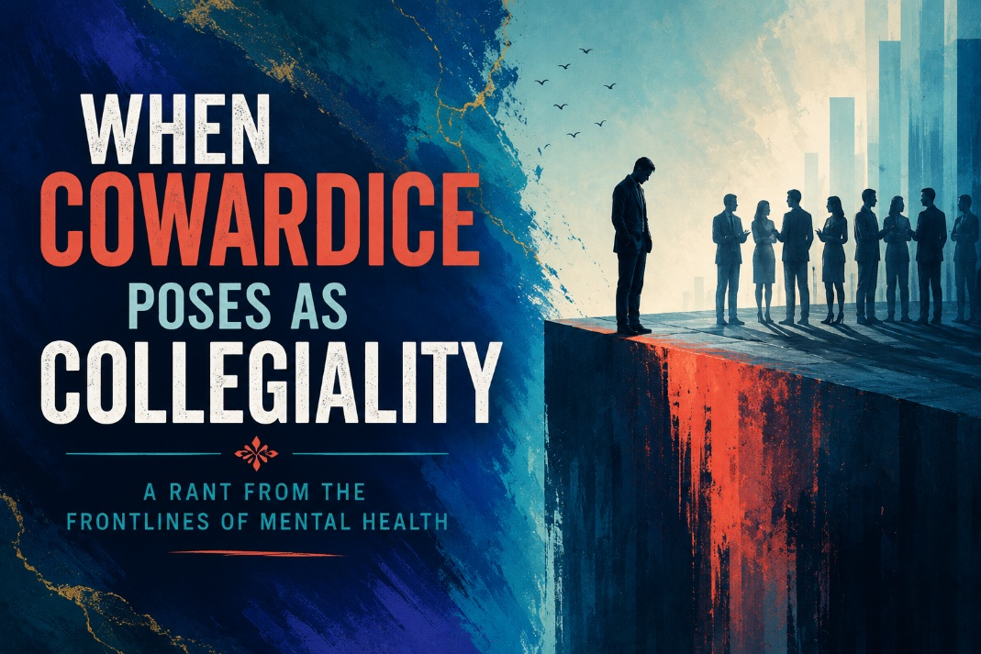
The Slow Death of Clinical Courage
I’ve been in this field long enough to see the tides shift. What was once a noble discipline, anchored in careful observation, courageous thinking, and deep ethical responsibility, has now become a minefield of ideological compliance, performative empathy, and careerist cowardice.
And I say that with all the weariness of a man who has spent decades doing the actual work: sitting with the suicidal, walking with the addicted, holding space for the wounded. I’ve watched colleagues with less time in the trenches bend the knee to bureaucrats, algorithms, and activist checklists, not because they believe in them, but because they’re afraid not to.
When Silence Becomes Betrayal
Let me be blunt: when your colleague is under fire for defending vulnerable kids or questioning overmedication, and you stay silent, you're not being "neutral." You're being a coward. And cowardice, in a profession like ours, is not neutral; it’s complicity.
And worse? It’s not just silence anymore. Some of my colleagues actively argue for ideologies they don’t even understand. They preach doctrine, not science. They wave the flags of progress while failing to maintain even a curious mind. They don’t read the research. They don’t want to. When you ask them to back up their positions with data, from either side, they blank. They parrot what they’ve been told at a weekend conference or in some DEI training session, never daring to zoom out and look at the broader pattern.
And when you push back, when you ask real questions, they don’t respond with calm confidence or intellectual engagement. No. They lash out. They get angry. They call you names. They deride you.
Targeted for Telling the Truth
In my case? They tried to end my career.
A transgender woman named Josephine publicly attacked me after I said something most rational people would agree with: that exposing children to pornography is a bad idea. I added that pornography is one of several known vectors that can influence gender confusion, especially in developing adolescents. Josephine responded not with data, not with dialogue, but with defamation. She claimed pornography wasn't addictive, wasn’t even idiosyncratic, and therefore not a worthy clinical concern. In her view, my desire to protect children from it was evidence of perversion. She accused me of pushing “banned therapy” and demanded my license be revoked.
You read that right. Because I dared to name pornography as one of many cultural contributors to identity confusion, they came for my profession.
And it didn’t stop there. During my time at Madigan Army Medical Center, I had a colleague who openly made allegations against me, allegations that could have destroyed my career. Why? Because I refused to comply with the ideological dogma being enforced within the institution. I didn’t parrot the script, so I became a target. That’s how thin the ice is now. You don’t even have to do anything overt; you just have to not comply, and you’re marked.
That’s why I, along with several other courageous colleagues, participated in the writing of an amicus brief for the Chiles v. Salazar case currently before the United States Supreme Court. I was honored to contribute in a small way because the implications of this case are profound. At stake is whether therapists will remain free to practice according to conscience, clinical judgment, training, and the individualized needs of their clients, or whether they will increasingly be compelled to conform to state-mandated ideological frameworks. This is not fundamentally about partisanship. It is about the future integrity and soul of our profession.
And let me say something that needs to be said: if you cave to ideological capture and prematurely thrust a treatment model onto your clients based on what the APA, or some captured licensing board, mandates that you do, then you are in violation of informed consent. You are no longer treating your clients; you are treating your ideology. You’re not disclosing the real risks. You are, in your professional arrogance and your clinical naïveté, if not outright stupidity, deforming your treatment plan without their knowledge or consent.
You’re ignoring outcome research on psychotropic medications. You’re unaware, or willfully blind, to the long-term risks of over-medicalization. You don’t know the full risks of puberty blockers, cross-sex hormones, or irreversible surgeries. You don’t understand the elevated risks of cancer, thrombosis, bone density loss, stroke, or heart attack in these patients. And yet, you push the dogma.
Read the Data or Relinquish the Title
You cannot practice responsibly if you are unaware of the long-term outcome studies on psychotropic medications. You must read Robert Whitaker, Dr. Joanna Moncrieff, Dr. Joseph Witt-Doerring, Dr. Mark Horowitz, and Taylor. These researchers have courageously exposed the limitations, harms, and overreach of modern psychopharmacology. The data is there, and it paints a sobering picture of risk, relapse, and long-term functional decline. To remain ignorant of this is malpractice by neglect.
When you push this dogma, you are complicit. And you will have to carry that in your soul.
Ignorance is no excuse.
The future of ethical, child-centered mental health care hangs in the balance.
So don’t tell me it’s just “differences of opinion.” Don’t dress it up as “professional disagreement.” When your go-to move is to smear, slander, and silence, rather than debate, discuss, and discover, you’ve left the territory of science. You’ve entered a cult.
And I won’t be part of it.
This is a call not just to my colleagues, but to the entire profession: If you’re more worried about being liked than being honest, then maybe it’s time to take a sabbatical. Go find your spine. Go remember why you got into this in the first place. And for God’s sake, don’t sell out the soul of our profession, don’t sell out the soul of our institutions, and perhaps most importantly, don’t sell out your own soul. You’ll pay a price.
Because the deeper truth is this: when you bow to systems that demand blind obedience, when you comply with ideological capture, when you look the other way while children are being experimented on for cultural capital and corporate gain, you are partnering with evil.
Read Political Ponerology by Andrzej Łobaczewski. Read Michael Rectenwald’s work on The Great Reset. These men have pulled back the veil on how institutions can be overtaken by pathocrats, those whose psychopathy drives policy, economics, and medicine. And yes, Big Pharma is often at the center of it, not just as a player, but as a predator. When children become market targets, when suffering becomes an investment strategy, and when healing is subordinated to control, then we are no longer in medicine. We are in managed decline.
For those wanting a deeper understanding of the ideological, cultural, and psychological underpinnings of this issue, I recommend several essential readings. Dr. Miriam Grossman's Lost in Trans Nation: A Child Psychiatrist’s Guide Out of the Madness offers a clinical and parental perspective on the dangers of premature affirmation. Stella O'Malley and Sasha Ayad’s A Clinical Guide for Therapists Working with Gender-Questioning Youth, published by the Gender Exploratory Therapy Association (GETA), provides a thoughtful, evidence-informed framework for supporting adolescents in distress without ideological bias. I have also written extensively on this subject in my book, Transgender Confusion Amidst the Search for Identity, which explores the intersection of trauma, developmental psychology, and gender identity through a faith-integrated, evidence-based lens.
You must decide where you stand. Because neutrality is complicity. And complicity, over time, corrodes the soul.
The Call
Let this be a call—not just to resist, but to rebuild. We must return to a model of mental health care rooted in courage, humility, scientific rigor, and love for truth. We must be bold enough to protect children, honest enough to critique broken systems, and compassionate enough to offer healing that restores identity rather than dismantles it. There is still time to reclaim this profession. But it will take conviction, clarity, and community. Let us speak, write, and live with the integrity this moment demands. The future is not yet written—but our silence will write it if we do not rise. This is our moment to stand.
Suggested Readings and Citations
Whitaker, R. (2010). Anatomy of an Epidemic. Crown Publishing.
Moncrieff, J. (2008). The Myth of the Chemical Cure. Palgrave Macmillan.
Witt-Doerring, J., Leonhardt, M., & Leo, J. (2020). Antidepressant Withdrawal Syndrome. Therapeutic Advances in Psychopharmacology.
Horowitz, M. A., & Moncrieff, J. (2022). Stopping Antidepressants. The Lancet Psychiatry.
Łobaczewski, A. (2006). Political Ponerology. Red Pill Press.
Rectenwald, M. (2022). The Great Reset and the Struggle for Liberty. Imprint Academic.
Grossman, M. (2023). Lost in Trans Nation: A Child Psychiatrist’s Guide Out of the Madness.
O’Malley, S., & Ayad, S. (2022). A Clinical Guide for Therapists Working with Gender-Questioning Youth. Gender Exploratory Therapy Association (GETA).
Hansen, J.E. (2024). Transgender Confusion Amidst the Search for Identity. NeuroFaith™, LLC.
Hansen, J.E. (2024), Heverly, E, & Hayden, T. Adolescent Depression : A NeuroFaith™ Model for Healing Mind, Body, and Soul. NeuroFaith™, LLC.
Hansen, J.E. (2023), Heverly, E, & Hayden, T. NeuroFaith™: The Intersection of Faith and Science in the Treatment of Trauma and Addiction. NeuroFaith™, LLC.
Hansen, J.E., Hayden, T., & Heverly, E. (2025). Pornography, Enslavement: A NeuroFaith Model for Restoring Intimacy in an Age of Disconnection. NeuroFaith™, LLC.

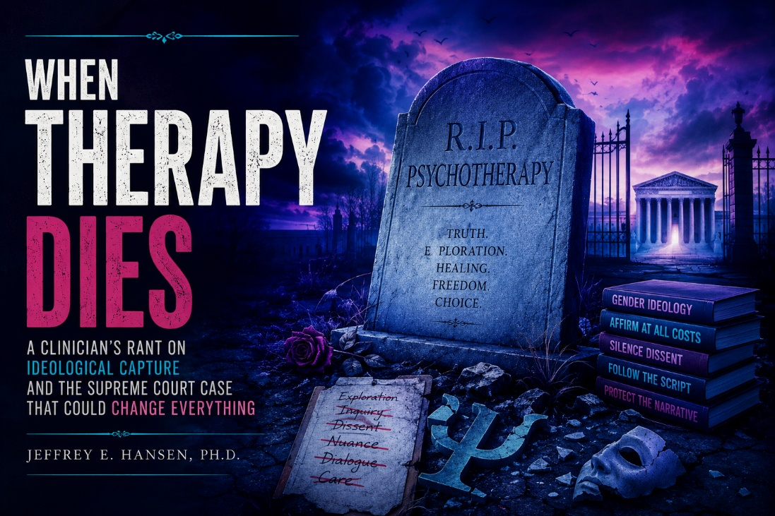
A Profession at a Crossroads
Let me speak candidly. I have spent more than forty years as a clinical psychologist working with children, adolescents, and families who are hurting, traumatized, confused, and searching for identity in an increasingly disoriented culture. During those decades, I have witnessed many shifts within psychology and psychiatry—some helpful, some deeply concerning. But I have rarely felt more troubled about the future of psychotherapy than I do right now.
At the center of that concern is the Supreme Court case Chiles v. Salazar. In my view, this case is about far more than politics or ideology. It is fundamentally about whether therapists will remain free to engage in thoughtful, exploratory, individualized therapy—or whether certain conversations will gradually become prohibited because they do not align with state-approved frameworks.
That should concern all of us, regardless of political affiliation.
Why Exploratory Therapy Matters
If Colorado ultimately prevails in this case, I fear we may move toward a model in which clinicians are increasingly constrained in what they are permitted to explore therapeutically with gender-distressed adolescents. My concern is not about denying compassion to struggling youth. Quite the opposite. My concern is that genuine psychotherapy requires curiosity, patience, humility, and the freedom to explore the many factors that may contribute to emotional distress.
A thoughtful therapist should be able to ask questions such as:
• When did these feelings emerge?
• What role might trauma, anxiety, depression, social isolation, family dynamics, pornography exposure, or peer influence be playing?
• How does social media shape identity formation?
• What emotional needs might be underneath the desire to transition?
These are not hateful questions. They are therapeutic questions. And yet increasingly, many clinicians feel afraid to ask them.
That is what troubles me most.
The Cost of Silence
Over the years, I have sat with adolescents wrestling with profound emotional pain, self-hatred, dissociation, trauma histories, sexual confusion, loneliness, and identity instability. In some cases, gender distress appeared intertwined with those deeper struggles. In other cases, the picture was more complex and difficult to fully understand. But what concerned me was how quickly some systems appeared ready to move vulnerable young people toward medicalization before sufficient exploratory therapy had occurred.
I believe many professionals involved in gender medicine genuinely want to help children. I want to say that clearly. I do not believe most clinicians are malicious people. But good intentions alone do not guarantee wise clinical practice. History repeatedly reminds us that medicine can become overly confident, ideologically rigid, and resistant to self-examination.
That is why open dialogue matters.
That is why psychotherapy matters.
And that is why therapists must retain the freedom to thoughtfully explore alternative explanations for distress without fear of professional retaliation.
The Soul of Psychotherapy
Unfortunately, we now live in a climate where disagreement is increasingly treated not as intellectual diversity, but as moral deviance. Many clinicians remain silent—not necessarily because they fully agree with prevailing frameworks, but because they fear professional consequences if they speak openly.
When professionals become afraid to question prevailing assumptions, the profession itself begins to lose its integrity. Science depends upon ongoing inquiry, debate, humility, and the willingness to revisit assumptions in light of emerging evidence. Once ideological conformity replaces honest dialogue, psychotherapy begins to deteriorate.
I did not spend decades training as a psychologist merely to become a mouthpiece for institutional orthodoxy. I entered this field because I believe human beings are complex, wounded, sacred, and worthy of careful, individualized care. Real therapy is rarely simplistic. It requires patience, nuance, listening, discernment, and often the willingness to tolerate uncertainty.
Children deserve that kind of care.
Parents deserve honest conversations.
Therapists deserve the freedom to practice responsibly according to conscience, training, evidence, and clinical judgment.
In Closing
To be clear, I am not advocating cruelty, rejection, or contempt toward gender-distressed individuals. Every human being deserves dignity, compassion, and respect. My concern is specifically about whether exploratory psychotherapy itself will remain permissible in an increasingly polarized cultural environment.
That is why Chiles v. Salazar matters. Because at stake is not merely one legal case. At stake is whether therapy will remain a place for exploration, reflection, and truth-seeking—or whether it will become increasingly governed by ideological mandates that narrow what clinicians are allowed to discuss.
I understand that some people will strongly disagree with me. Honest disagreement is part of a healthy profession. But disagreement should not automatically result in censorship, intimidation, licensing threats, or professional erasure.
We need less fear.
More humility.
More dialogue.
More willingness to wrestle honestly with difficult questions.
The future of psychotherapy depends on it.
So yes, I write this with conviction. Not because I hate the profession, but because I love it. And because I still believe therapy should remain a place where truth can be pursued courageously, compassionately, and without fear.
The future of mental health care will not be strengthened through fear or ideological rigidity. It will be strengthened through courage, humility, compassion, and truth.
And I still believe those things are worth defending.

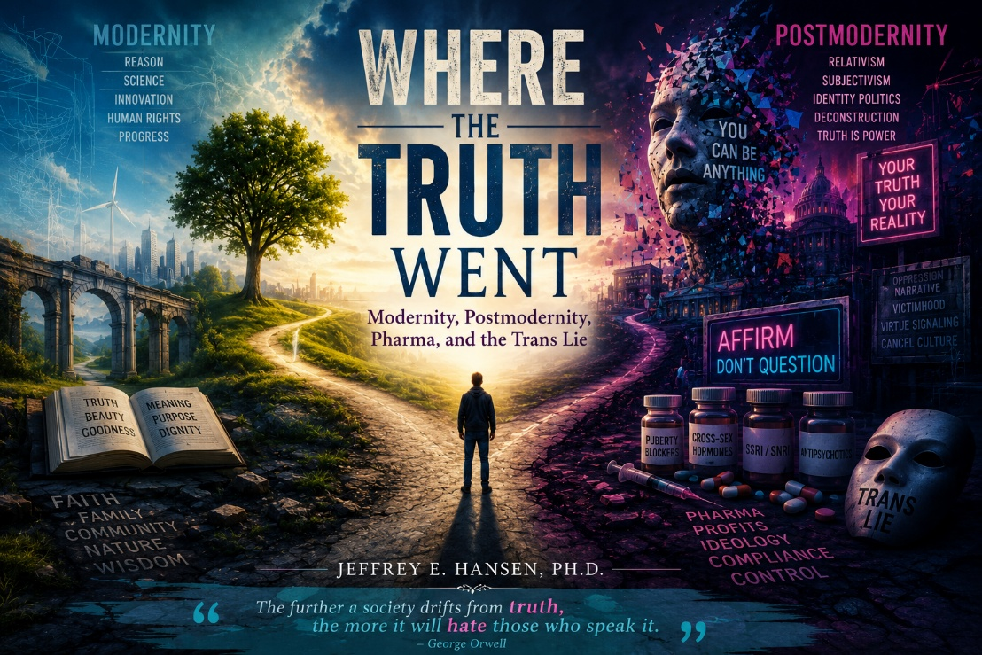
Introduction: How Did We Get Here?
Let me try to lay this out plainly for anyone still wondering how we arrived at this cultural moment. People often ask me why I speak so openly about the transgender movement, psychiatric overmedicalization, the growing ideological rigidity inside mental health systems, and what I believe is happening to children in our culture. My concern is not merely about one isolated issue. What troubles me is the convergence of many forces at once: philosophical, political, technological, medical, psychological, and spiritual.
To understand the present moment, I believe we must look at the larger historical arc. We moved from modernity into postmodernity, from classical Marxism into identity-based ideological frameworks, and from there into increasingly technocratic systems of institutional control. Along the way, something vital was gradually lost: a shared understanding of truth itself.
That, in my view, is the deeper crisis beneath all the headlines.
This essay is not an attempt to offer simplistic answers. Nor is it written out of hatred toward people who disagree with me. Rather, it reflects the concerns of a psychologist who has spent decades sitting with wounded children, struggling families, traumatized adolescents, and emotionally exhausted adults while watching Western culture become increasingly fragmented, confused, and ideologically polarized.
Modernity: The Rise of Progress and the Loss of Anchors
Modernity gave us many extraordinary gifts that I still deeply value. Science, reason, innovation, autonomy, constitutional freedoms, human rights, and technological advancement all emerged from the modern era. Medicine advanced dramatically. Literacy expanded. Life expectancy increased. Entire populations were lifted from poverty and ignorance. In many respects, modernity represented genuine progress.
But progress always carries unintended consequences.
As modernity advanced, traditional religious structures, local communities, multigenerational family systems, and shared moral narratives gradually weakened. Human beings became increasingly disconnected from older frameworks that once grounded identity, meaning, responsibility, and transcendence. In many ways, institutions replaced communities. Experts replaced elders. Systems replaced relationships.
At the same time, human suffering increasingly became medicalized. Grief became pathology. Childhood energy became disorder. Sadness became chemical imbalance. Existential confusion became diagnosis. Increasingly, the human person was viewed less as a moral, spiritual, relational being and more as a collection of mechanisms to be managed, regulated, medicated, and optimized.
Modernity excelled at explaining how things work.
But it struggled more deeply with why human beings exist at all.
And when a civilization loses its deeper sense of meaning, it often compensates by chasing control, efficiency, stimulation, and endless progress. Yet progress detached from moral wisdom can become deeply destabilizing.
Postmodernism: When Truth Became Negotiable
Then came postmodernism, and with it a growing suspicion toward the very existence of objective truth itself. Philosophers associated with postmodern thought increasingly argued that truth could not be separated from power structures, language systems, social conditioning, or cultural narratives. Grand narratives were dismantled. Meaning became subjective. Identity became fluid. Even biological reality itself increasingly became interpreted through social constructionist frameworks.
This philosophical shift profoundly reshaped universities, education, psychology, media, and medicine. Increasingly, disagreement was no longer viewed simply as intellectual diversity. It became framed as oppression, harm, exclusion, or violence. Entire systems of thought emerged that interpreted human relationships primarily through dynamics of power, identity, and victimhood.
Ironically, even though postmodernism rejected dogmatic truth systems, it eventually became dogmatic itself. Certain ideas could no longer be questioned without risking professional or social consequences. Entire institutions began enforcing ideological conformity while simultaneously claiming to champion openness and inclusion.
As a psychologist, I find that deeply concerning because psychotherapy itself depends upon curiosity, exploration, uncertainty, and the freedom to ask difficult questions. Therapy dies when inquiry becomes forbidden. Therapy dies when clinicians become afraid to think out loud. Therapy dies when ideological affirmation replaces careful exploration of human complexity.
And increasingly, many clinicians are afraid.
From Marxism to Identity Ideology
Classical Marxism focused primarily on economic class struggle. Marx believed history moved inevitably toward revolution through conflict between labor and capital. But when many of those predictions failed to materialize in the West, later thinkers shifted the emphasis away from economics and toward culture, identity, religion, family structure, language, sexuality, and institutions.
Thinkers associated with the Frankfurt School, Antonio Gramsci, Herbert Marcuse, and later critical theorists increasingly reframed oppression as something embedded within Western civilization itself. Over time, these ideas merged with postmodern theories about identity and power, creating an ideological framework that now shapes many universities, corporations, educational systems, and professional organizations.
In this newer framework, identity increasingly determines moral authority. Biology becomes suspect. Disagreement becomes framed as harm. Traditional moral structures become oppressive by definition. Institutions are pressured not merely to tolerate alternative identities but actively affirm them.
Whether one agrees entirely with this analysis or not, the cultural shift is undeniable. The language of affirmation, oppression, systemic power, and identity politics now permeates psychology, medicine, education, and corporate life.
And increasingly, dissent itself becomes dangerous.
Pharma and the Medicalization of Human Distress
One of the deepest ironies of our current moment is that many movements openly critical of capitalism now align themselves closely with enormous pharmaceutical systems. Multi-billion-dollar industries increasingly profit from the medicalization of distress, confusion, anxiety, trauma, identity instability, and adolescent suffering.
Puberty blockers, cross-sex hormones, SSRIs, SNRIs, stimulants, antipsychotics, and endless pharmaceutical interventions are often presented as compassionate solutions for increasingly broad categories of emotional pain. Yet long-term outcome data is frequently more complicated and contested than public narratives sometimes acknowledge.
This does not mean medications are never helpful. I want to be very clear about that. Thoughtful psychiatric care can absolutely help some individuals. I have seen lives stabilized through careful treatment. But I have also seen medications overused, prescribed too quickly, and treated as substitutes for deeper psychological, relational, developmental, and spiritual work.
As a clinician, I worry we are increasingly bypassing the harder human questions:
What happened to this child?
What trauma exists underneath the symptoms?
What role does pornography, social media, family fragmentation, loneliness, dissociation, anxiety, or identity confusion play?
Why are so many adolescents struggling to know who they are?
Those questions matter profoundly.
But ideological systems often prefer certainty over complexity, and complexity takes time, humility, and patience.
The Collapse of Epistemology
At the deepest level, I believe we are facing an epistemological crisis. We no longer share a common understanding of how truth itself should be pursued. Science increasingly becomes politicized. Medicine becomes institutionalized. Psychology risks becoming more focused on identity affirmation than on deeper exploration of meaning, trauma, responsibility, and human flourishing.
Even language itself becomes unstable.
Words no longer point consistently toward reality. Instead, they increasingly become tools of ideological enforcement. People become afraid to speak honestly because disagreement is interpreted as hatred. Institutions begin policing language while simultaneously insisting they are defending freedom.
That is not healthy for a civilization.
Nor is it healthy for psychotherapy.
Real therapy requires the ability to tolerate ambiguity, wrestle with complexity, examine developmental history, and explore difficult truths compassionately and honestly. Genuine care sometimes requires caution, discernment, patience, and the willingness to slow down rather than immediately affirm every impulse or identity claim.
But we increasingly live in a culture addicted to ideological certainty and emotional immediacy. And when complexity disappears, truth itself often becomes the casualty.
Toward a Better Way Forward
I do not believe the answer is simply returning nostalgically to the past. Modernity produced many important advances, and postmodern thinkers raised legitimate concerns about institutional corruption, abuses of power, and the ways systems can sometimes dehumanize individuals. Human beings are capable of cruelty, and institutions absolutely require accountability. History makes that painfully clear.
At the same time, I believe we have swung too far toward a worldview in which truth itself has become unstable, identity has eclipsed reality, and ideological certainty increasingly overrides thoughtful inquiry. In our attempt to dismantle oppressive systems, we have at times also dismantled the very foundations that allow a civilization to pursue wisdom, meaning, coherence, and moral clarity.
What we need now is not a return to simplistic nostalgia, nor a continued descent into relativism and ideological fragmentation. We need a healthier synthesis moving forward. One grounded in truth and evidence, but also alive to morality, faith, meaning, beauty, and human dignity. One capable of integrating science with humility rather than allowing science to become a tool of institutional dogma or political enforcement.
We need a culture willing to protect children while still acknowledging complexity. A culture honest about trauma, developmental vulnerability, loneliness, family fragmentation, and the profound identity confusion many young people are now experiencing. We need professionals courageous enough to resist ideological extremism regardless of political tribe, and humble enough to admit that human beings are far more than consumers, diagnoses, identities, or political categories.
Over the years, I have seen too many young people harmed, too many thoughtful clinicians silenced, and too many decent people become afraid to speak openly. That concerns me deeply. And it is one of the reasons I continue writing and speaking, even knowing that many people will disagree with me.
I do not write because I enjoy conflict. I do not write because I hate people who see the world differently than I do. I write because I still believe truth matters. I still believe children deserve honesty, wisdom, protection, and genuine care in a culture increasingly confused about what it means to be human.
We do not need less truth.
We need the courage to pursue it again.

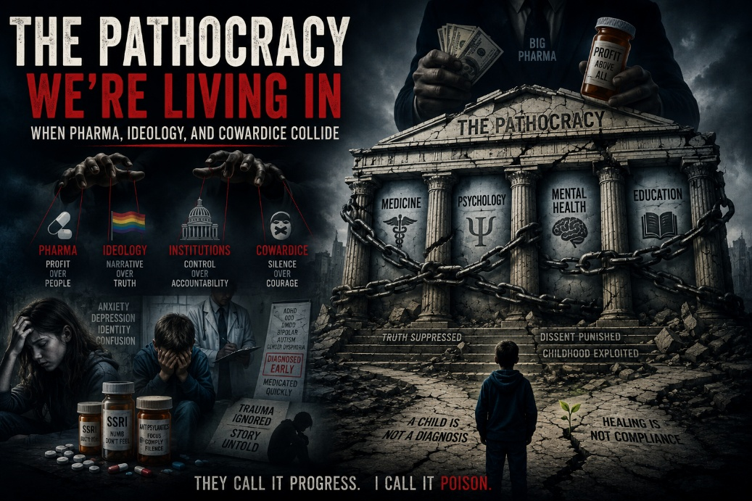
What Is Pathocracy?
I have worked in psychology for more than four decades, and I can honestly say I have never witnessed anything quite like the cultural and clinical moment we are living through right now. What concerns me is not simply one isolated issue, but the convergence of several disturbing trends happening simultaneously: the medicalization of childhood, the pharmaceutical takeover of emotional suffering, the ideological capture of institutions, and the growing silencing of clinicians who dare to question prevailing narratives.
In many ways, it feels as though we are living through a form of pathocracy. The term refers to systems increasingly shaped by psychologically disordered dynamics: narcissism, manipulation, ideological rigidity, institutional cowardice, and moral confusion disguised as compassion or progress. Polish psychologist Andrzej Łobaczewski explored these themes extensively in his writings on political evil and authoritarian systems. At first glance, the concept can sound extreme, but when you step back and honestly examine what is happening culturally, medically, and psychologically, it becomes difficult not to recognize elements of it throughout modern institutions.
You see it in schools where emotionally vulnerable children are encouraged to adopt life-altering identities before they possess the developmental maturity to fully understand the implications. You see it in medicine when pharmaceutical interventions increasingly become first-line responses for trauma, loneliness, anxiety, developmental instability, and identity confusion. You see it in mental health systems where thoughtful clinicians quietly admit concerns in private conversations while remaining publicly silent out of fear for their careers, reputations, or licenses.
Perhaps most disturbing of all is the moral inversion taking place throughout the culture, where caution is increasingly labeled cruelty, questioning becomes heresy, and ideological conformity is reframed as compassion.
The New Priesthood
Let me be direct. I am watching children and adolescents get loaded with SSRIs, stimulants, antipsychotics, and increasingly invasive interventions before their nervous systems have even fully developed. In many cases, trauma histories remain insufficiently explored. Family systems remain poorly understood. Loneliness, pornography exposure, social contagion, dissociation, anxiety, and developmental instability are often bypassed in favor of rapid diagnosis and symptom suppression.
What troubles me deeply is how quickly complex human suffering is increasingly reduced to simplified narratives and pharmaceutical solutions. We are treating children as collections of symptoms rather than developing human beings with histories, attachments, wounds, fears, identities, and stories that deserve careful exploration.
And nowhere is this more concerning to me than in the growing “affirmation-only” culture surrounding pediatric gender medicine. Let me say clearly that I am not advocating cruelty toward gender-distressed individuals. Every child deserves dignity, compassion, and thoughtful care. But compassion without discernment can become dangerous. When exploratory psychotherapy itself becomes stigmatized, and clinicians are subtly or overtly pressured toward one ideologically approved pathway, we are no longer practicing careful therapy. We are increasingly practicing institutional ideology under the language of compassion.
What makes this especially troubling is that many clinicians know this privately while remaining silent publicly. They fear retaliation. They fear professional consequences. They fear being labeled hateful or dangerous for simply asking careful clinical questions.
That silence matters more than many people realize.
Ponerology and the Psychology of Ideological Capture
Łobaczewski used the term ponerology to describe the study of evil operating within political systems and institutions. What interests me is not simply dramatic historical evil, but the quieter, more bureaucratic forms of moral distortion that slowly infiltrate professions over time.
It rarely begins with villains.
More often, it begins with fear: fear of exclusion, fear of dissent, fear of losing status, fear of saying the wrong thing, fear of being professionally destroyed. Over time, institutional cowardice becomes normalized. People begin repeating things they do not fully believe because the social cost of honesty becomes too high. Bureaucracies protect themselves. Ideological systems become self-reinforcing. Language itself becomes manipulated, and certain questions quietly become forbidden.
Once that happens, truth becomes increasingly difficult to pursue honestly.
As a psychologist, that concerns me profoundly because psychotherapy fundamentally depends upon curiosity, complexity, humility, and the willingness to explore difficult realities without predetermined ideological conclusions. Therapy dies when inquiry becomes forbidden. Therapy dies when clinicians become afraid to think out loud. Therapy dies when ideological affirmation replaces careful exploration of human complexity.
Cracks in the System
At the same time, I do believe cracks are beginning to emerge in the dominant narrative. Several European countries, including Sweden, Finland, and the United Kingdom, have begun reassessing “affirmation-first” approaches for minors. The Cass Review in the UK raised serious concerns regarding evidence quality, long-term outcomes, and the politicization of care. Increasingly, more clinicians, researchers, detransitioners, parents, and whistleblowers are beginning to speak publicly about concerns many had quietly carried for years.
In the United States, the shift is happening more slowly and with far greater polarization, but many ordinary people are beginning to sense that something is deeply wrong. Parents are asking harder questions. Clinicians are becoming less willing to remain silent. The public is beginning to recognize that complex psychological suffering cannot always be solved through ideology, pharmaceuticals, or irreversible medical interventions.
I believe that growing discomfort matters. It suggests that despite enormous institutional pressure, many people still retain an intuitive sense that children deserve deeper care, slower exploration, greater caution, and more honest dialogue than what many systems currently allow.
Reclaiming Truth and Conscience
Contrary to caricatures, many of us raising concerns are not driven by hatred, cruelty, or extremism. We are clinicians, parents, educators, physicians, researchers, and ordinary citizens who still believe that truth matters, biology matters, conscience matters, and children deserve protection.
We remember that childhood itself is not a pathology. We remember that trauma cannot simply be surgically removed or hormonally suppressed. We remember that the brain is not merely chemistry, but part of a deeply human story involving attachment, meaning, suffering, spirituality, relationship, development, and identity formation.
And we remember something else as well: genuine care sometimes requires slowing down rather than rushing toward irreversible conclusions. Caution is not the enemy of compassion. Thoughtful exploration is not hatred. Asking careful questions is not violence.
If anything, the refusal to ask difficult questions may ultimately become the greater form of harm.
Final Reflections
I did not enter this profession to become silent in the face of institutional pressure or ideological conformity. I became a psychologist because I care deeply about human beings, especially wounded children and struggling families. I still believe psychotherapy can be a sacred space where truth, healing, responsibility, compassion, wisdom, and human dignity come together.
At the same time, I believe we are living through a profoundly dangerous cultural moment in which many institutions have lost their moral and epistemological footing. Increasingly, people are afraid to speak honestly because honesty itself now carries social and professional risk.
If you feel exhausted by the gaslighting, confused by the ideological rigidity, or concerned about what is happening to children, you are not alone. More people are beginning to speak openly. More clinicians are beginning to question prevailing assumptions. More parents are beginning to push back against systems that seem increasingly detached from developmental reality and psychological complexity.
And I believe that matters.
Because pathocracy does not ultimately collapse through rage or vengeance. It collapses when enough people recover the courage to speak honestly again, even imperfectly and at personal cost. It collapses when clinicians, parents, educators, physicians, and ordinary citizens rediscover the moral courage to place truth, conscience, compassion, and the protection of children above ideology, fear, and institutional pressure.
Children are not political pawns. They are not ideological experiments. They are not pharmaceutical markets.
They are human beings deserving wisdom, protection, dignity, honesty, and genuine care.
And I still believe those things are worth defending.

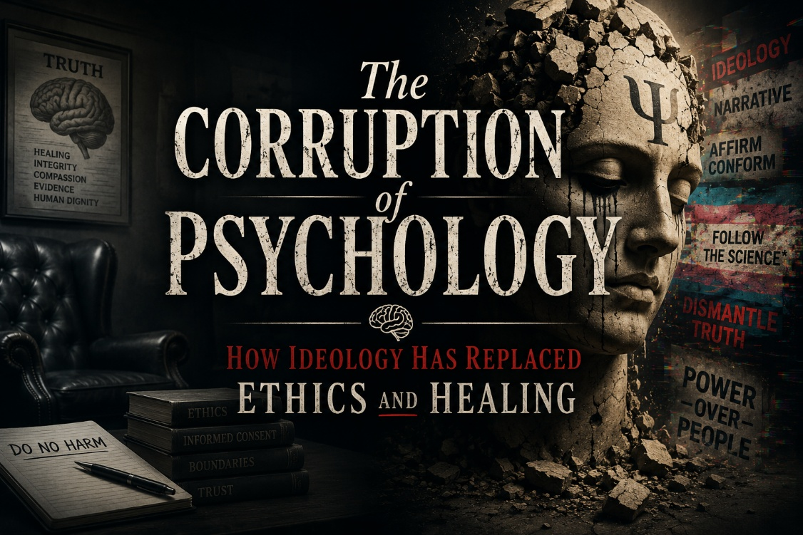
There was a time when psychology was dedicated to truth, healing and human flourishing. At its core, our profession was meant to serve as a beacon of understanding, guiding individuals toward mental clarity, emotional resilience and personal freedom. It was never perfect—no human endeavor is, but it at least sought to uphold certain ethical principles, chief among them being informed consent and the unwavering commitment to act in the best interest of the patient. Today, however, psychology has been hijacked by ideology, transformed into a vehicle for social engineering rather than a refuge for those in need of true healing.
This radical shift has not been a sudden one. It has crept in gradually over decades, infiltrating university departments, professional organizations and licensing boards. What was once a science-based practice focused on evidence and ethical responsibility has become a propaganda arm for the most extreme elements of progressivism. The traditional goals of therapy, helping individuals process trauma, develop coping mechanisms and find meaning in their struggles—have been cast aside in favor of ideological indoctrination. Instead of guiding clients toward wholeness, many therapists today use their influence to promote what they believe their clients should think, feel and become, rather than addressing the actual issues that brought them into therapy in the first place.
The Betrayal of Informed Consent
One of the most egregious violations in modern psychology is the complete abandonment of informed consent. Historically, this principle has been foundational to ethical medical and psychological practice. Patients have the right to understand their treatment options, the potential risks and benefits and the framework through which their care is delivered. Yet in many cases, clients, especially young, vulnerable individuals, are not given the full picture. Instead, they are subtly manipulated into embracing particular worldviews, often under the guise of “affirming care” or “social justice-informed therapy.”
Nowhere is this more evident than in the treatment of gender dysphoria. Rather than helping children and adolescents explore the root causes of their distress, trauma, family dynamics, underlying mental health conditions, many therapists now rush to push immediate affirmation, shutting down any discussion that deviates from the predetermined narrative. These young people are placed on a conveyor belt toward medical interventions with life-altering consequences, often without being given the space to understand the implications fully. The ethical violations in this area alone should be enough to result in mass revocations of licenses. That will never happen, though, because the licensing boards themselves are equally corrupt.
Licensing Boards: The Corrupt Gatekeepers of Ideology
Licensing boards were originally established to protect the public from harm, ensuring professionals adhere to rigorous ethical and clinical standards. Today, however, they function more like enforcers of ideological purity. Rather than holding clinicians accountable for ethical violations, they actively punish those who dare to challenge the prevailing orthodoxy.
We have seen cases where therapists who refuse to engage in politically mandated affirmation practices—who instead advocate for exploratory therapy, who encourage critical thinking, who insist on addressing trauma before endorsing irreversible medical interventions—are accused of causing harm, reported for “conversion therapy” and stripped of their right to practice. Meanwhile, those who recklessly impose their ideological biases on clients, disregarding their individual needs and vulnerabilities, are celebrated as forward-thinking pioneers of the profession.
The message is clear: If you conform to the ideology, you are safe, no matter how egregious your ethical violations may be. If you challenge it, you will be silenced.
Psychology Has Become a Weapon, Not a Healing Profession
The tragedy of this transformation is that it directly harms the very people our profession was meant to help. Instead of fostering resilience, therapy has become a place where fragile identities are reinforced, where discomfort is framed as oppression and where personal responsibility is discarded in favor of victimhood narratives. Rather than challenging clients to grow and confront the deeper issues at the root of their suffering, many therapists now enable dysfunction, offering superficial validation instead of substantive healing.
This is not just a deviation from good practice—it is an inversion of it. Therapy should challenge, refine and ultimately empower individuals to navigate life with strength and wisdom. Yet, today’s dominant therapeutic approach often does the opposite: It weakens, infantilizes and entraps people in cycles of emotional dependency.
Who Sits at the Head of the Table?
I am ashamed of what our profession has become. We were meant to be healers, but many have become indoctrinators. We were called to help people find truth, but many now peddle comforting lies. Psychology, at its worst today, serves as a mechanism for ideological grooming rather than a science-driven pursuit of human well-being. It is difficult not to look at the state of the field and wonder if something darker is at play.
There is an old saying that when you see chaos, deception and the inversion of truth, you can be certain Satan is at work. Looking at the state of psychology today, one might ask—who is really sitting at the head of the table? The answer is sobering. It is as if Satan himself is the chair of the psychology department, orchestrating the corruption of a profession that was meant to guide people toward clarity, peace and freedom.
The Path Forward
All is not lost. The truth, by its very nature, cannot be fully erased. While the institutions have been captured, there are still therapists—ethical, principled professionals—who refuse to bow to ideology, who are committed to true healing rather than manipulation. The key to reclaiming psychology lies in those willing to stand firm, to speak the truth and to practice with integrity despite the pressures to conform.
It will not be easy. Those who resist the tide will face hostility, professional risks and possibly even exile from the institutions they once trusted. That is the price of standing for truth in a time of mass deception. And if psychology is to be saved, it will be through the courage of those who refuse to let it be wielded as a weapon of ideological control.
For the sake of our patients, our profession and the integrity of truth itself, we must fight for the restoration of real, ethical and effective therapy. Anything less is a betrayal of the very reason we entered this field in the first place.

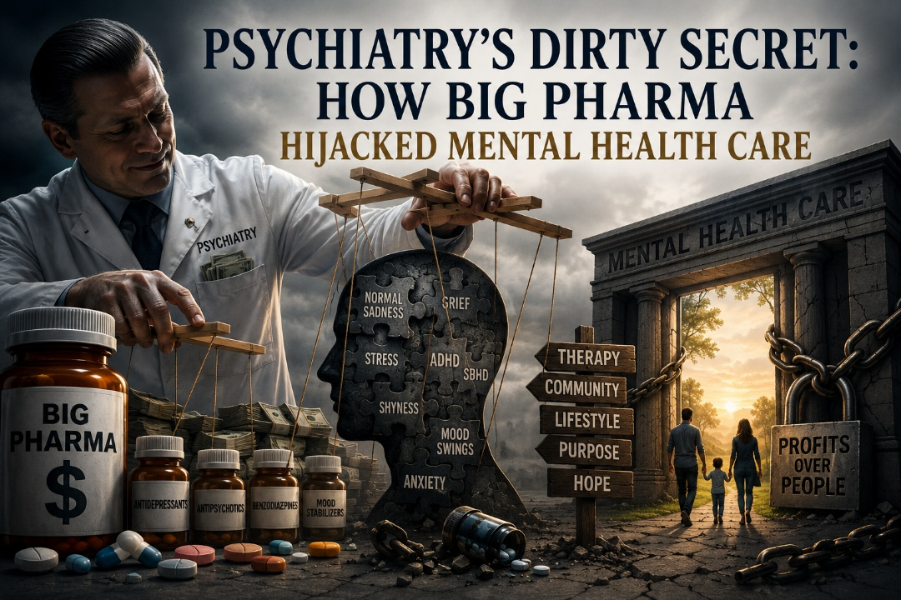
This blog was originally published through CMDA in 2025 and, for a brief period, generated exactly the kind of vigorous conversation I had hoped it would. Psychologists, psychiatrists, prescribers, therapists, and other mental health professionals engaged deeply with the concerns I raised regarding psychotropic overprescription, pharmaceutical influence, informed consent, and the broader direction of modern mental health care. Some strongly agreed. Others strongly disagreed. But for a moment, at least, an honest and important dialogue was taking place.
Eventually, however, following significant protest and concern from portions of the psychiatric community, CMDA leadership chose to remove the article. I want to say clearly that I understand the decision placed them in a difficult position, and I remain grateful for the kindness and professionalism shown to me personally throughout that process. In later correspondence with CMDA leadership, I acknowledged that portions of my writing style and rhetoric were intentionally provocative and, at times, hyperbolic. Over the years, I believe I have matured in my tone and learned important lessons about how conviction can be communicated more effectively with restraint, humility, and grace.
At the same time, while I can acknowledge imperfections in my delivery, I cannot apologize for the core concerns themselves. I continue to believe these conversations are profoundly important. In fact, I believe they are among the most important conversations currently facing modern mental health care.
Too often, difficult discussions surrounding psychiatric medication, pharmaceutical influence, overmedicalization, informed consent, and the treatment of vulnerable children and adolescents are either softened, avoided, or shut down altogether. My frustration at the time stemmed largely from the sense that many clinicians privately shared these concerns but felt unable or unwilling to speak openly about them. The article was written, in part, to disrupt that silence.
Was the rhetoric strong? Absolutely. Intentionally so.
Not because I hate psychiatry. Not because I dismiss the meaningful role medications can sometimes play in severe suffering. And certainly not because I lack respect for thoughtful, ethical prescribers, many of whom I deeply admire. Rather, the intensity reflected my growing alarm regarding what I perceived to be a system increasingly shaped by pharmaceutical influence, diagnostic inflation, and a medicate-first culture that too often bypassed deeper exploration of trauma, attachment, meaning, spirituality, family systems, and the broader human story.
I also understand that passionate rhetoric can sometimes overshadow legitimate concerns. That is a lesson I have taken seriously. Yet even now, years later, I remain convinced that we desperately need more courageous, honest, and nuanced conversations between psychology, psychiatry, medicine, therapy, and faith communities regarding the future of mental health care.
This essay reflects a particular moment in that journey. It captures both my frustration and my conviction. I share it here not to inflame division, but to preserve an important conversation that I still believe deserves to be had.

Psychiatry’s Dirty Secret: How Big Pharma
Hijacked Mental Health Care
Let’s be honest, modern psychiatry has sold out to Big Pharma. In 1980, with the release of the DSM-III, the field took a sharp turn away from human-centered mental health care and fully embraced the disease model, aligning itself with pharmaceutical giants. The result? A medical-industrial complex that turned normal human emotions into disorders, overprescribed psychotropics, and put profits over patient well-being. And the numbers don’t lie. In 1987, Americans spent about 80 million dollars on psychotropics. By 2007, that number had skyrocketed to 40 billion dollars, a 50-fold increase in just 20 years. Today, antidepressants are the second most-prescribed medication in the United States, behind only antibiotics. Although this discussion focuses on antidepressants, the same patterns of pharmaceutical corruption, overprescription, and long-term harm apply to other classes of psychotropic medications as well. Antipsychotics, benzodiazepines, stimulants, and mood stabilizers have all been subject to misleading marketing, suppressed research, and reckless prescribing practices. Each of these drug classes comes with its own risks, including withdrawal syndromes, cognitive impairment, emotional blunting, metabolic issues, and in some cases, permanent neurological damage.
The Serotonin Myth: The Lie That Launched an Industry
For decades, the chemical imbalance theory of depression, specifically, the idea that depression results from low serotonin levels, was presented as scientific fact. But the truth is that it was never proven. Not then, not now. Leading critics, including Dr. Joanna Moncrieff and Dr. Mark Horowitz, have dismantled the serotonin hypothesis, showing that antidepressants do not fix an imbalance, because no imbalance exists. Yet, pharmaceutical companies and complicit prescribers continued pushing SSRIs as the answer, despite strong evidence that they are only marginally more effective than placebo in mild to moderate depression.
The Price of Overprescription: Real Harm, Real Consequences
Psychotropics do affect the brain—but not in the way people have been told. The long-term effects of antidepressants are underreported, poorly researched, and too often dismissed. Consider these disturbing findings:
• Emotional numbness - 71 percent of users report feeling detached from emotions
• Cognitive impairment - Documented decline in information processing, memory, and focus
• Weight gain - A 30 percent higher likelihood of obesity after 10 years of antidepressant use
• Increased dementia risk - A 34 percent higher chance of developing dementia in longterm users
• Bleeding risks - SSRIs reduce platelet serotonin, increasing the risk of serious bleeding
• Sexual dysfunction - 25 to 80 percent experience loss of desire, arousal issues, or inability to orgasm—sometimes permanently, known as Post-SSRI Sexual Dysfunction
• Suicide risk in young people - The FDA’s Black Box Warning states that antidepressants can increase suicidal thoughts in people under 24
The Brave Few Who Dare to Speak the Truth
Thankfully, not everyone has fallen in line with Big Pharma’s agenda. A handful of courageous professionals have risked their careers to expose the truth about psychotropics and the corruption within psychiatry. These are the people I admire deeply:
• Robert Whitaker - Investigative journalist who exposed the dark side of psychiatry in Anatomy of an Epidemic
• Dr. Joanna Moncrieff - Psychiatrist who debunked the serotonin myth and challenges the overmedicalization of distress
• Dr. Mark Horowitz - Psychiatrist and neuroscientist who experienced his own battle with antidepressant withdrawal and now educates prescribers on safe tapering
• Dr. David Healy - A relentless critic of pharmaceutical corruption who has documented antidepressant-induced suicides and sexual dysfunction
• Dr. Peter Gøtzsche - Co-founder of the Cochrane Collaboration, who has called out Big Pharma’s deceptive research tactics
• Dr. James Davies - A psychologist who exposed how psychiatry’s alliance with drug companies expanded the definition of mental illness for profit
• Dr. Josef Witt-Doerring - A former FDA psychiatrist turned whistleblower, who now educates the public about the dangers of psychiatric medications and exposes how regulatory agencies prioritize pharmaceutical interests over patient safety
Dear Prescribers: Please Do Better
To the prescribers who are recklessly handing out psychotropics like candy, you need to do better. Too many patients are put on these drugs without full informed consent, without a real discussion of side effects, and without a clear plan for discontinuation. This is malpractice, plain and simple. To be fair, not all prescribers are part of the problem. There are many who practice responsible, evidence-based psychiatry, who use medication only when truly necessary, and who work to ensure their patients are fully informed. To those clinicians: I salute you.
The Path Forward: Rethinking Mental Health Treatment
So, where do we go from here? We start by rejecting the one-size-fits-all, medicate-first model that psychiatry has sold us. We need:
• Therapy - Addressing the root causes of distress, not just suppressing symptoms
• Community - Genuine human connection, not just a prescription bottle
• Lifestyle changes - Exercise, nutrition, sleep, and purpose-driven living
• Spiritual engagement - Finding meaning beyond a medicalized identity Psychotropics can be helpful for severe cases, but they are not the answer for everyone, and they should never be prescribed without full transparency about their risks. As the Bible reminds us: The prudent see danger and take refuge, but the simple keep going and pay the penalty (Proverbs 27:12). It is time to take refuge in the truth, to hold the psychiatric industry accountable, and to reclaim mental health care from the grip of pharmaceutical greed.
My Response to CMDA leadership after blog was taken down:
Subject: CMDA: A Necessary Conversation on Truth, Psychiatry, and Our Role as Christian Clinicians
To Jeff and Mike,
First, I want to thank you, Jeff, for taking the time to call me personally rather than sending an email or text. That kind of direct communication, especially around a difficult topic, shows a level of respect that I genuinely appreciate. It reflects your integrity and commitment to relationship, and it means a great deal to me. That said, I need to express my disappointment with CMDA’s decision to remove my recent post addressing the pharmaceutical corruption within modern psychiatry and the devastating impact of psychotropic overprescription, particularly on children and adolescents. I fully understand that this may not be a priority issue for CMDA leadership right now, you have other irons in the fire, and I respect that. But perhaps this should be one of those fires. Because we are witnessing a mental health crisis that is being exacerbated, not resolved, by the current overreliance on medications. And if we as Christian clinicians are not willing to speak into that with courage, then who will? The professionals I referenced in my post are not fringe voices. They are highly credentialed, widely respected individuals who have paid a price to speak the truth:
• Robert Whitaker, investigative journalist and author of Anatomy of an Epidemic
• Dr. Joanna Moncrieff, psychiatrist and professor at University College London, known for her work debunking the serotonin hypothesis
• Dr. Mark Horowitz, psychiatrist and neuroscientist at University College London, who has personally experienced and now researches antidepressant withdrawal
• Dr. David Healy, psychiatrist and pharmacologist, noted for his work on SSRI-induced suicidality and sexual dysfunction
• Dr. Peter C. Gøtzsche, co-founder of the Cochrane Collaboration and author of Deadly Medicines and Organized Crime
• Dr. James Davies, psychotherapist, medical anthropologist, and author of Cracked: The Unhappy Truth About Psychiatry
• Dr. Josef Witt-Doerring, former FDA psychiatrist and current whistleblower and educator on psychotropic safety
These individuals are sounding an alarm that should be taken seriously by anyone committed to ethical, patient-centered care. Their critiques are rooted in research, lived clinical experience, and documented harm. My views reflect theirs because I have seen the same damage, over-medicated teens, blunted affect, dependence, and despair, play out in the lives of my own patients. To take down my post simply because some were made uncomfortable is not just disappointing, it raises questions about CMDA’s willingness to engage in difficult, but necessary, conversations. Are we still a community where thoughtful dissent is welcomed, or have we begun to mirror the very cancel culture we so often criticize, where truth is silenced because it makes someone uneasy? This issue is not going away, and I am not going away, and no one will silence me. Our children are being medicated at unprecedented levels. Antipsychotics are being prescribed to children Teens are numbed with SSRIs instead of being invited into authentic relationship, healing, and purpose. Adults are being told they have chronic brain diseases that require lifelong pharmacological management, even when the science doesn’t support it.
These are not isolated problems, they are systemic. And they are moral. As Christian clinicians, we are called to be salt and light in a system that is increasingly shaped by profit, convenience, and ideology rather than truth and compassion. If CMDA cannot make space for voices that challenge the status quo, even when those voices are rooted in evidence, clinical experience, and concern for the vulnerable—then we risk losing our prophetic role in medicine altogether. I say all of this with respect, but also with deep conviction. This is not just another professional disagreement. It is a matter of integrity. It is a matter of conscience. And yes, it is a hill I am willing to die on. Again, thank you, Jeff, for the phone call. And thank you both for hearing me out. If only we could continue this conversation in a spirit of truth, humility, and courage, but I fear we may not.

With gratitude and resolve,
Jeff
“Speak up for those who cannot speak for themselves, for the rights of all who are destitute. Speak up and judge fairly; defend the rights of the poor and needy.” (Proverbs 31:8-9)
Jeffrey E. Hansen, Ph.D.
Clinical Psychologist — Licensed in Arizona & Washington
AZ Lic. #PSY-5450 | WA Lic. #PSY-1695
Founder & Director, NeuroFaith® LLC

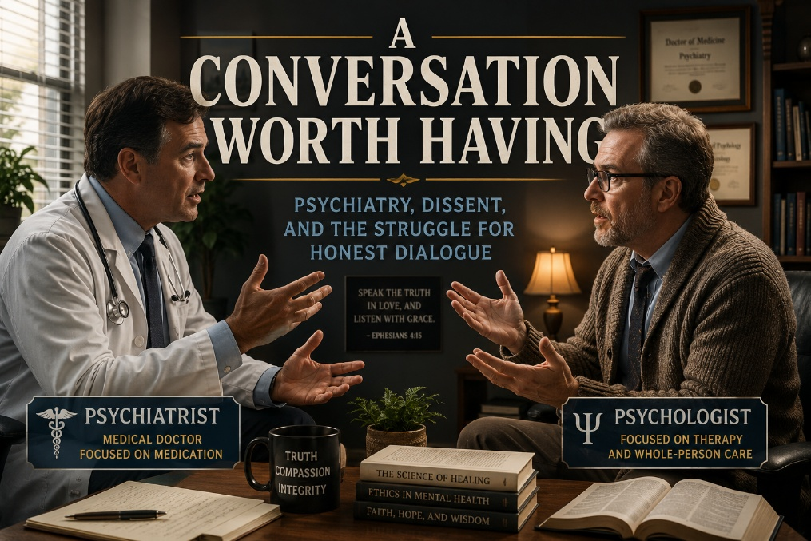
Psychiatrist, Dr. Dale Barker, MD (name changed), posted a strongly critical response to my blog published in CMDA, titled Psychiatry’s Dirty Secret: How Big Pharma Hijacked Mental Healthcare. Please see his critique, along with my rebuttal as noted below:
Dr. Barker’s Response
Christian Medical & Dental Associations, as a Christian psychiatrist who’s been active in CMDA since medical school and have been actively involved in the CMDA Psychiatry Section, I find this article disappointing and surprising. I have not seen you publish something that is neither spiritually edifying nor clinically accurate.
Written by a person who has never prescribed a medication, and does not have the medical training necessary to evaluate how these medications work or their efficacy.
To raise awareness about side effects and call for human-centered care would make sense.
The inflammatory and hyperbolic statements such as “modern psychiatry has sold out to Big Pharma” are not only untrue, but I do not understand how that can possibly represent the views of a Christian medical organization.
Please consider reviewing this again.
Dale Barker
______________________________________________________________________
My Response to Dr. Barker
Dear Dr. Barker,
Thank you for taking the time to engage with my work. I recognize that discussions surrounding psychiatry, psychotropic medications, and the broader field of mental health care can evoke strong emotions, particularly for those who have been personally affected, whether as patients, clinicians, or loved ones.
First and foremost, I want to acknowledge that you are clearly highly respected in your field. Your dedication to psychiatry and your commitment to helping those struggling with mental health challenges are evident, and I deeply respect the work you do. This conversation is not about questioning the sincerity or expertise of individual psychiatrists, but rather about addressing systemic issues within the profession.
While I am not a prescriber, as a PhD in clinical psychology, I am well-equipped to analyze and interpret research, particularly regarding the effects of psychotropic medications. My perspective is not formed in isolation, but rather through years of working with patients, many of whom have suffered significant harm from these treatments. This is not to dismiss the potential benefits that some individuals experience, but rather to highlight a pressing issue: the psychiatric profession, as a whole, is facing a crisis of credibility. Far too often, the risks and limitations of these medications are downplayed, while alternative approaches to mental health care are ignored or dismissed outright.
As Christians, we are called to humility, self-reflection, and a commitment to truth. This applies not only to our personal lives, but also to the professional fields in which we operate. It is not an act of hostility to critically examine the practices of psychiatry or psychology. It is an act of responsibility. When we see harm being done, we have an ethical obligation to speak out, even when doing so is uncomfortable or unpopular.
Moreover, it is not just psychiatry that is in crisis. The field of psychology, once rooted in scientific inquiry and clinical practice, has increasingly become ideologically-driven, prioritizing prevailing cultural narratives over rigorous, evidence-based care. This ideological capture undermines trust in the profession and, more importantly, compromises the well-being of the very individuals it claims to serve.
My intent is not to vilify psychiatry or psychology, but to encourage honest reflection and reform. We cannot afford to turn a blind eye to the growing number of individuals who have suffered under a model of care that often prioritizes pharmacological intervention over holistic healing. My hope is that, as a profession and as individuals, we will have the courage to question, to learn, and ultimately, to do better.
Again, I appreciate your engagement with these difficult but necessary conversations. Truth and accountability are not enemies of healing. They are its foundation.
Respectfully,
Jeff

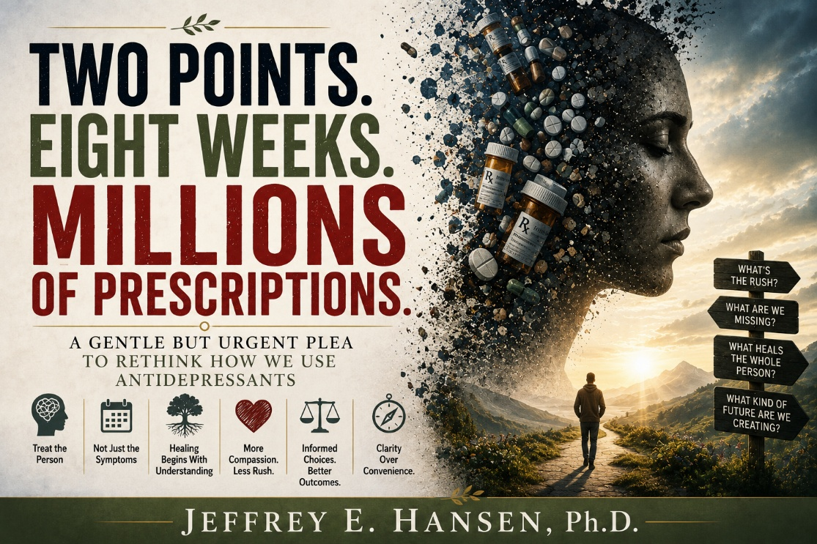
Rethinking Medication: Listening to an Insider Who Stepped Outside
Recently I listened to psychiatrist Dr. Josef Witt-Doerring, a former FDA medical officer who worked within pharmaceutical and regulatory systems before stepping away from conventional pathways. After leaving the FDA, he entered a higher paying role within the pharmaceutical industry itself, an experience that, by his own account, eventually left him disillusioned with aspects of how psychiatric medications were evaluated and promoted.
Over time, he became increasingly troubled by how these medications are studied, prescribed, and discontinued, particularly the gap between short term research and long term real world use. Today his work focuses on deprescribing and safe withdrawal, inviting clinicians and patients alike to reconsider assumptions that have quietly shaped modern mental health care.
Whether one agrees with every conclusion he draws or not, his journey raises an important question: Are we examining the full story behind the medications we prescribe, or only the parts that fit within familiar frameworks?
His reflections do not demand rejection of medication. Rather, they call for deeper curiosity, a willingness to rethink how, when, and why we intervene pharmacologically in the first place.
And that question led me to look inward, at my own profession.
A Confession from My Own Profession
Before I challenge psychiatry, I need to begin closer to home, with psychology itself.
My profession is not innocent in this conversation. Too often, psychologists and allied mental health professionals refer patients for medication management without fully understanding the research frameworks and assumptions guiding those prescriptions. We reassure ourselves that we are helping, that we are “staying in our lane,” yet sometimes we are quietly reinforcing a system we have not examined deeply enough.
This is not written as blame. It is written as confession, and as concern.
Because when referrals become reflexive rather than thoughtful, we risk sending vulnerable people into treatment pathways shaped more by habit than by holistic understanding. And that realization is what prompted this reflection.
Short-Term Science, Long Term Prescribing
Across many antidepressant trials, the average difference between medication and placebo often amounts to only a few points on standardized depression scales such as the Hamilton Depression Scale. Statistically meaningful? Yes. But whether that difference translates into genuine and observable transformation in a person’s life remains an open question, one that deserves humility rather than certainty.
The larger concern is not only the size of the effect, but the duration of the science behind it. Many studies last only weeks, while prescriptions continue for years. We are building long term treatment cultures on short term data, and that mismatch should invite curiosity rather than defensiveness.
Estimates suggest that roughly fifteen percent of adults and about five percent of children in the United States are currently taking antidepressant medications, with adults remaining on them on average for five years or longer, a reality that makes the absence of robust long term research even more consequential.
This is no longer solely a psychiatric issue. Family physicians, nurse practitioners, physician assistants, interns on overnight rotations, many frontline prescribers now write a significant share of antidepressant prescriptions. That reality is not an indictment of primary care; it is simply the landscape we live in. Yet it means the responsibility for thoughtful prescribing belongs to all of us.
Psychiatry must examine itself.
Primary care must examine itself.
Psychology must examine itself.
Not in accusation, but in awakening.
Relapse, Withdrawal, and the Questions We Avoid
Another area that deserves deeper reflection is the interpretation of relapse prevention studies. When individuals stabilized on medication are rapidly discontinued and compared to those who remain on treatment, the line between relapse and withdrawal can become blurred.
Are we observing the return of illness, or the nervous system responding to abrupt neurochemical change?
The answer is rarely simple, and it deserves more careful conversation than our current discourse often allows.
Critics of long-term prescribing also point to the relative scarcity of extended duration human trials. Some of the longer observational insights come from primate research, where investigators have explored prolonged exposure to antidepressant medications.
Interpretations of these findings remain debated, but certain studies have suggested possible changes in dendritic complexity in frontal brain regions, alterations in sleep patterns, and behavioral flattening in some primate models after extended use.
While animal data cannot be directly generalized to humans, the absence of robust multiyear randomized human studies leaves clinicians grappling with more questions than answers, and that uncertainty alone should invite deeper scientific investment.
A Wake-Up Call — For Clinicians and for the Public
Perhaps the most important question lies beyond pharmacology altogether. Why are we, as a culture, so quick to reach for medication before exploring deeper layers of human suffering?
Trauma histories, nervous system dysregulation, loneliness, spiritual disconnection, sleep deprivation, nutritional imbalance, these are not secondary considerations. They are often the ground from which symptoms grow.
Integrity in care means seeing the person beneath the diagnosis, the history, the nervous system, the relationships, the spiritual questions, and the deeper wounds such as trauma that often drive such painful states of unhappiness.
Healing is rarely linear and almost never rushed. Quick is not always better; sometimes quick simply means we have not listened long enough. When we slow down, truly slow down, we begin to notice the more complex stories that medication alone cannot resolve, and it is there, in that deeper seeing, that real change often begins.
Medication can be a valuable tool. For some, it is lifesaving. That truth must be honored. Yet when medication becomes the first and only response, we risk narrowing the very definition of healing.
A Plea for Depth and Humility

This essay is not written in anger. It is a plea, to clinicians and to the public alike, to slow down, to ask harder questions, and to approach mental health care with greater depth and humility.
Patients deserve more than polarized narratives. They deserve thoughtful medicine that addresses root causes as much as symptom relief.
If this sounds like a challenge, it is meant to be. Not a shout, but a wakeup call for psychiatry, for primary care, for psychology, and for all of us who influence the direction of healing.
Because the deeper question is no longer simply whether antidepressants help.
It is whether we are willing to practice medicine that is curious enough, courageous enough, honest enough, and compassionate enough to look beyond the prescription and truly see the person.


When Truth Is Exchanged for Certainty
There are moments in history when humanity exchanges truth for something lesser, something louder, something that promises certainty but ultimately fractures the soul. From a Christian perspective, the tragedy is not merely political or cultural. It is spiritual.
Scripture reminds us that when truth is traded for falsehood, the consequences are not only external but deeply internal. The Apostle Paul writes in Romans 1:25 that humanity can exchange the truth about God for a lie, and when that exchange occurs, disorder follows within societies and within the human heart.
This reflection is not an argument for one political tribe over another, nor a simplistic critique of left or right. It is a meditation on a recurring human pattern, the temptation to surrender moral discernment to ideological systems or authoritarian voices. Both the left and the right can fall into this trap. Both can place their hope in a party or movement as if it were salvation. Yet Christianity insists that redemption never comes through ideology. Redemption comes through Christ alone.
Across history, influential thinkers such as Karl Marx and Friedrich Engels proposed sweeping visions meant to reshape society. Critics have wrestled with tensions between theory and personal life, raising questions about character, integrity, and the danger of intellectual pride. Whether examining philosophers or political revolutionaries, the deeper issue remains spiritual. When human beings believe they can redefine good and evil without reference to God, the ego expands and humility diminishes.
Pride goes before destruction and a haughty spirit before a fall.
Power, Shadow, and the Lessons of History
The twentieth century offers sobering examples of ideology merging with power. Under Joseph Stalin, millions died through purges, forced labor, famine, and political terror. Accounts of paranoia and cruelty reflect what can happen when unresolved shadow elements within a leader are amplified by absolute authority. The state becomes the moral compass, dissent becomes heresy, and fear replaces conscience.
Similar patterns emerged under Mao Zedong, whose campaigns led to mass suffering, and under Pol Pot in Cambodia, where the attempt to create a radically purified society produced the killing fields. Intellectuals, professionals, and ordinary citizens were targeted because ideology demanded conformity.
Ho Chi Minh’s revolutionary movement, Fidel Castro’s Cuba, and authoritarian regimes in various parts of the world reveal how leaders can become symbols larger than life. Some supporters highlight resistance or social change, while critics point to repression and loss of freedom. The Christian task is not blind condemnation nor blind admiration, but sober discernment rooted in truth.
Even in modern contexts, strong leaders across nations and ideologies can inspire intense loyalty. Some are praised, others criticized, and many remain deeply polarizing. The deeper spiritual question is not merely who leads, but how followers respond. When people elevate leaders or movements to a quasi-redemptive status, they risk losing the capacity for self-reflection.
“What good will it be for someone to gain the whole world, yet forfeit their soul?”
From a Jungian perspective, this pattern reflects humanity’s struggle with the shadow, the disowned parts of the self that are often projected outward. Carl Jung suggested that maturity requires integration, the courage to face darkness within rather than deny it. Christianity frames this integration through confession, repentance, and grace.
The cross becomes the place where truth and mercy meet. There, humanity acknowledges its capacity for unspeakable evil while encountering the transforming light of Christ.
This reflection must not be misunderstood as a warning aimed only at the left. It is equally a warning to the right. Progressive neo-Marxist ideology can drift toward a form of certainty that attempts to redefine truth through collective power, while radical Christian dogma can become even more dangerous when control is veiled under the language of faith itself.
When ideology openly rejects transcendence, the distortion may be visible. When authoritarianism hides behind the name of Christ, the confusion can cut deeper because people believe they are surrendering to God when in reality they are surrendering to human authority.
History reminds us that authoritarianism is not limited to secular movements. The tragedy of Jim Jones and the Peoples Temple revealed how spiritual language can be manipulated when a leader becomes the center rather than Christ. Hundreds followed him into isolation and ultimately into death because belonging replaced discernment.
The Branch Davidians under David Koresh demonstrated how apocalyptic certainty and unquestioned authority can lead to devastation. These moments are particularly painful because they cloak control in sacred language. When religious leaders demand rigid conformity or ostracize those who question, they risk turning the gospel into a system of fear rather than a path of freedom.
The lesson is sobering. Political authoritarianism can distort truth, but religious authoritarianism wounds the soul when it claims divine approval for human control. The problem is not only progressive ideology on the left or nationalist rigidity on the right. The deeper issue is the human tendency to seek safety in systems that promise certainty while bypassing humility, repentance, and genuine relationship with Christ.
Whether the banner is revolutionary politics or radicalized religion, the underlying pattern remains the same. The shadow is denied, the ego expands, and belonging replaces truth.
Safety, Belonging, and the NeuroFaith® Lens
Psychology and neuroscience help illuminate why ideological belonging feels so powerful. Abraham Maslow described a hierarchy of needs beginning with basic survival such as food and shelter, followed by safety needs. Human beings long for protection, predictability, and belonging.
Within the NeuroFaith® model and through the lens of polyvagal theory, safety is understood as both neurobiological and spiritual. The nervous system continually searches for cues of danger or safety. When genuine safety is present, the ventral vagal system supports connection, calm presence, and relational openness.
The danger arises when people attempt to shortcut safety. Just as substances such as cocaine or opioids can artificially create a sense of relief or connection without genuine healing, external ideologies can provide a counterfeit form of ventral vagal safety.
A political tribe or authoritarian system may offer identity, belonging, and certainty. The nervous system experiences temporary regulation, but the deeper work of integration remains undone. Safety built on ideology requires conformity. Safety rooted in Christ allows transformation.
The Cross as Integration and Renewal
The cross stands above every human structure. Jesus does not compel allegiance through force or ideological purity. He sanctifies the soul by illuminating both the God inspired self and the wounded shadow within.
Integration becomes possible when truth and grace meet. The ego loosens its grip. The heart learns humility. The believer discovers that the deepest battle is not against another political tribe but within the self.
In this way, the Christian journey moves beyond polarization. Instead of seeking security in parties or ideologies, the believer seeks wholeness in Christ. Instead of projecting evil outward, the disciple confronts the darkness within and invites God’s light to transform it.
The cross becomes the place where fragmentation is healed, and identity is rooted not in politics but in divine love.
“Create in me a clean heart, O God, and renew a right spirit within me. Cast me not away from your presence and take not your Holy Spirit from me. Restore to me the joy of your salvation and uphold me with a willing spirit.” Psalm 51:10–12
Here the journey turns toward hope. The Christian path does not end in accusation or fear. It ends in renewal. When humanity stops seeking ultimate safety in earthly power and instead turns toward Christ, the soul finds clarity.
The shadow is faced without despair. The ego is surrendered without losing dignity. And the person begins to walk not as a puppet of ideology, but as a redeemed and integrated child of God.


“The truth knocks on the door, and you say, ‘Go away, I’m looking for the truth,’ and so it goes away. Puzzling.”
—Robert M. Pirsig
A Culture Losing Its Bearings
Look around. The world we thought we knew has shifted beneath our feet. What was once common sense is now controversial. Time tested values are ridiculed, biological realities are questioned, and objective truth is increasingly dismissed as little more than subjective lived experience. Many people feel disoriented by how rapidly the cultural landscape has changed and struggle to understand how we arrived at this moment.
Was it simply the natural evolution of society? Was it accidental? Or has something more deliberate been unfolding beneath the surface over many decades? Those questions now reach directly into homes, schools, churches, counseling offices, and family dinner tables across the Western world.
I believe the answer lies in a slow and methodical ideological transformation that did not happen overnight. It unfolded gradually through institutions, universities, media, entertainment, politics, and even segments of the church itself. It was not fought primarily with bullets or barricades, but with ideas, narratives, and cultural influence. Over time, those ideas reshaped the way people understand truth, identity, morality, sexuality, family, and even human nature itself.
Perhaps the most troubling consequence of this shift is what it has done to children and adolescents. Through schools, entertainment, social media, and online culture, many young people are increasingly being separated from their parents, not physically, but psychologically, emotionally, and spiritually. They are often encouraged to distrust traditional sources of wisdom and instead locate identity primarily within ideology, self-construction, and subjective feeling.
Parents who raise concerns are frequently dismissed as fearful, intolerant, or oppressive. Meanwhile, long-standing biological and moral realities that guided civilizations for centuries are increasingly treated as negotiable or irrelevant. That growing fracture between generations is one of the defining crises of our time.
Classical Marxism and the Seeds of Revolution
To understand how these ideas evolved, we must go back to Karl Marx. Marx was not simply an economic theorist. He sought to reinterpret the entire human experience through the lens of power, oppression, and revolution. In The Communist Manifesto, published with Friedrich Engels in 1848, Marx argued that history itself was fundamentally a struggle between oppressors and the oppressed.
Religion, family structures, morality, and social institutions were viewed primarily as mechanisms of control that reinforced inequality. Marx believed true liberation would only come through revolutionary upheaval and the dismantling of existing systems. The ultimate goal was not merely economic reform, but the remaking of society itself.
Yet one major problem emerged. The industrial working class in Europe and America, the very people Marx believed would ignite revolution, largely resisted it. Many workers still valued faith, family, patriotism, and community. Rather than embracing revolution, they often sought reform while preserving the cultural and spiritual foundations of their lives.
That failure forced later Marxist thinkers to reconsider strategy. If economic revolution would not succeed directly, perhaps culture itself had to be transformed first.
Antonio Gramsci and the Long March Through Culture
Antonio Gramsci, the Italian Marxist philosopher, recognized that political revolution would never succeed unless the cultural foundations of Western civilization were first weakened. Rather than focusing exclusively on economics, Gramsci proposed what later became known as the long march through the institutions.
The strategy was subtle and incremental. Instead of overthrowing society through violent revolution, ideological influence would gradually reshape education, media, law, entertainment, academia, and eventually the moral imagination of the culture itself. It was a patient strategy built upon influence rather than force.
Gramsci understood something profoundly important: if you shape the narrative, you shape the people. And if you shape the people, you ultimately shape the future. His insight was that culture downstream determines politics far more than politics determines culture.
His ideas laid much of the intellectual groundwork for later critical theory movements and the rise of the Frankfurt School, whose influence would become increasingly significant throughout the twentieth century.
The Frankfurt School and Repressive Tolerance
In the early twentieth century, a group of Marxist intellectuals gathered at the Institute for Social Research in Frankfurt, Germany. These thinkers, later known as the Frankfurt School, expanded upon Gramsci’s ideas and developed what became known as Critical Theory.
Their project went far beyond economics. Increasingly, they sought to deconstruct the moral, religious, and cultural foundations of Western civilization itself. Traditional morality, religion, family systems, and social norms were frequently portrayed as oppressive structures requiring dismantling.
Herbert Marcuse became one of the most influential voices within this movement. One of his most controversial ideas was what he called Repressive Tolerance. In essence, Marcuse argued that societies could not achieve true liberation if all viewpoints were treated equally. According to Marcuse, traditional, conservative, religious, and “reactionary” viewpoints represented forms of oppression that needed to be marginalized or suppressed, while progressive ideologies deserved amplification and protection.
Many critics believe this framework laid the groundwork for modern cancel culture, ideological gatekeeping, speech policing, and institutional intolerance toward dissenting viewpoints. Increasingly, tolerance itself has become selective. Some viewpoints are protected while others are portrayed as inherently harmful or illegitimate.
Marcuse also merged elements of Marxism with Freudian psychology, arguing that traditional sexual morality and family structures functioned as oppressive systems of control. These ideas helped fuel the sexual revolution and contributed to the broader dismantling of many longstanding Judeo Christian norms surrounding sexuality, family, authority, and identity.
Over time, these concepts migrated from elite academic circles into media, entertainment, education, corporate culture, and eventually mainstream social assumptions. Many people now absorb these ideas without ever realizing where they originated.
Queer Theory and the Crisis of Identity
As Marxist thought evolved, the focus increasingly shifted from economic class struggle toward identity-based struggle. Out of postmodernism and critical theory emerged Queer Theory, which advanced the argument that sex, gender, and identity are largely social constructions rather than rooted in stable biological realities.
Michel Foucault became one of the most influential intellectual figures associated with this movement. His writings challenged traditional understandings of morality, authority, sexuality, and power. Foucault also became deeply controversial for signing petitions in France during the 1970s that challenged age of consent laws involving minors, something many critics view as morally reckless and profoundly disturbing.
Judith Butler later advanced the argument that gender itself is performative rather than biologically grounded. Those ideas became foundational within many contemporary gender identity frameworks and increasingly influenced universities, educational systems, mental health culture, and broader social discourse.
What began as a critique of economic systems gradually transformed into a broader challenge against objective truth, biological reality, and inherited moral frameworks. Increasingly, children and adolescents became the focal point of these ideological battles.
Young people are now frequently encouraged to view identity as fluid, self-generated, and disconnected from biology, family systems, developmental psychology, or faith traditions. Parents who question these frameworks often find themselves marginalized or portrayed as obstacles to their children’s authenticity and freedom.
That reality deeply concerns me as both a psychologist and a fatherly figure to many young people I have worked with over the decades. I have seen firsthand how vulnerable adolescents can be during seasons of confusion, loneliness, anxiety, trauma, and identity searching. Those struggles deserve compassion, thoughtful exploration, wisdom, and care, not simplistic ideological answers detached from biology, family systems, and developmental realities.
A Call to Wake Up
The good news is that truth has a way of resurfacing, even in highly ideological environments. False ideas may dominate cultural institutions for a season, but reality has a stubborn way of asserting itself over time.
Now more than ever, parents must remain vigilant regarding what their children are being taught. Churches must recover moral courage and clarity. Clinicians, educators, and leaders must be willing to ask difficult questions without fear of cancellation or institutional retaliation. Silence in moments like this comes at a very high cost.
We are living through a profound cultural crossroads. The stakes are not merely political. They are spiritual, psychological, relational, and civilizational. The future of families, childhood, truth, and human identity itself hangs in the balance.
Our children are not pawns in an ideological struggle.
They are human beings created with dignity, vulnerability, longing, and a deep need for truth, belonging, guidance, and love.
If we fail to stand up now, we may eventually discover that an entire generation has been shaped by forces increasingly disconnected from biological reality, moral wisdom, and transcendent truth itself. That possibility should concern every thoughtful parent, clinician, educator, pastor, and citizen willing to honestly look at where our culture is heading
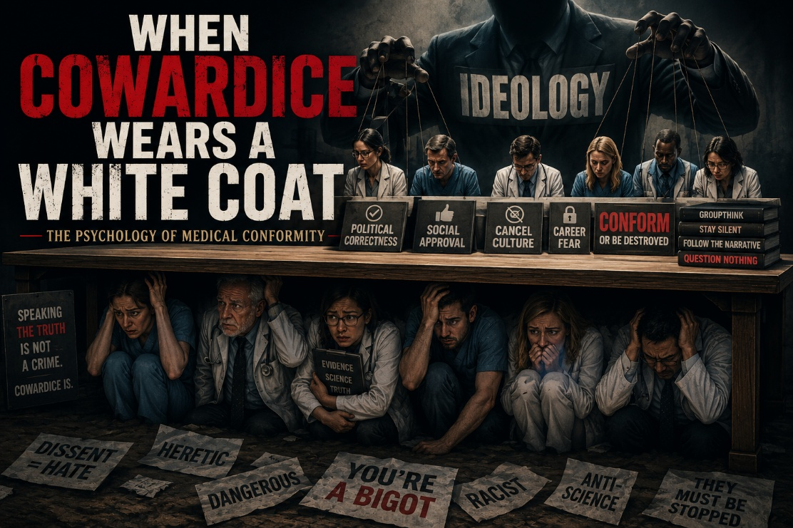
There was a time, not all that long ago, when entering medicine or psychology meant something sacred. It meant pledging yourself to truth, to healing, to moral courage, and to the uncomfortable responsibility of standing between suffering human beings and the forces that might harm them. It meant wrestling honestly with complexity rather than blindly submitting to ideology, institutional pressure, or cultural fashion.
But something has changed.
What we are witnessing today is not merely scientific disagreement or professional evolution. We are witnessing, in many corners of medicine and mental health, a slow erosion of moral courage itself. Not primarily through malice, but through conformity. Through fear. Through highly educated, well-intentioned professionals slowly learning that it is often safer to stay silent than to question the prevailing orthodoxy.
And once enough people become afraid to speak openly, institutions begin drifting further and further from truth while still convincing themselves they are compassionate.
Welcome to the pathology of obedience.
Groupthink in a Lab Coat
Psychologists like Solomon Asch and Irving Janis tried to warn us. The human brain is wired for social cohesion far more than most people realize. We long to belong. We long to remain accepted by the tribe. And often, if we are honest, we fear exclusion more than we fear being wrong.
In Asch’s famous conformity experiments, participants knowingly gave blatantly incorrect answers simply because others in the room had done so first. Roughly seventy-five percent conformed at least once, not because they lacked intelligence, but because dissent is emotionally painful. Standing alone activates something primal in the nervous system. It creates anxiety, uncertainty, and the fear of social exile.
Now apply that reality to modern medicine and mental health care.
Apply it to pediatricians who quietly harbor concerns regarding early gender transition interventions but feel unable to voice them publicly. Apply it to psychiatrists overprescribing SSRIs to struggling adolescents without adequately exploring developmental trauma, attachment wounds, nervous system dysregulation, family fragmentation, loneliness, pornography exposure, social contagion, or deeper existential suffering. Apply it to therapists who recognize confusion beneath the surface but feel pressure to affirm rather than thoughtfully explore.
Many of these clinicians are not evil people. Far from it. Many entered medicine and psychology because they genuinely wanted to help human beings heal. They wanted to relieve suffering. They wanted to protect vulnerable people.
But human beings are extraordinarily susceptible to institutional pressure. Careers, reputations, friendships, licensure, social belonging, and financial security all become powerful motivators. Over time, people begin learning which questions are safe to ask and which questions carry danger.
And once fear enters the room, truth usually exits quietly through the back door.
Contagion and Cowardice
Conformity is not static. It spreads. It becomes emotional contagion.
When fear and social reward run high, cowardice can become culturally infectious. People begin censoring themselves, not necessarily because they fully believe the orthodoxy, but because they fear what happens if they question it publicly. Silence becomes adaptive. Compliance becomes professionally rewarded.
So they adapt.
They submit. They comply. They rationalize. Over time, many eventually convince themselves that the institutional script truly is wisdom. The mind slowly reshapes itself to fit the herd because psychologically, spiritually, professionally, and socially, it feels safer that way.
What begins as external conformity eventually becomes internal surrender.
But there is a terrible cost attached to that bargain. At some point, a person risks losing the ability to hear their own conscience clearly. They lose the quiet inner voice that once helped distinguish truth from ideology, courage from compliance, healing from institutional self-preservation.
And that, to me, is one of the greatest dangers facing modern medicine and psychology today.
Losing the Soul in Exchange for a Seat at the Table
Medicine was built upon an ethical tradition that is far older and deeper than modern political ideology. The Hippocratic Oath dates back to the ancient Greek physician Hippocrates and represented a sacred moral obligation to place healing above status, politics, power, or institutional pressure.
Even now, in shadowed echoes, we remember:
Ὡς ἂν δύναμιν τε καὶ κρίσιν ἐπ᾽ ὠφελείῃ καμνόντων καταστήσω...
“I will apply dietetic measures for the benefit of the sick according to my ability and judgment…”
Not according to the Twitter mob.
Not according to institutional activism.
Not according to pharmaceutical marketing pressure.
Not according to fear.
But according to judgment, conscience, wisdom, humility, and allegiance to healing. Yet increasingly, many clinicians seem more afraid of social retaliation than clinical error. More afraid of losing professional standing than betraying conscience. More afraid of being labeled intolerant than of failing vulnerable children and families who desperately need thoughtful, nuanced care.
That is not merely an intellectual problem. It is a spiritual problem. A moral problem. A crisis of courage. Somewhere along the way, too many professionals stopped asking, “What is true?” and began asking instead, “What am I allowed to say?”
That shift changes everything.

Conformity Isn't Neutral. It’s a Moral Rot.
Let’s be honest about what we are confronting. This is not simply a disagreement between intelligent people trying to interpret data differently. Nor is it merely a conflict between conservatives and progressives.
What we are witnessing, at times, is the institutionalization of moral cowardice disguised as compassion.
It is the psychologist who privately expresses concern but publicly nods along with the newest ideological directive.
It is the endocrinologist who follows protocol despite lingering doubts.
It is the physician who whispers in private, “I’m concerned too,” but remains silent publicly because the professional risks feel too high.
This is not neutrality.
Silence in the face of harm is never fully neutral. At some level, silence becomes participation. And institutions quickly learn how to reward compliance while punishing dissent. That reality should deeply concern anyone who genuinely values truth, science, ethics, or authentic healing.
Because once institutions punish honest inquiry, medicine stops being medicine and slowly becomes ideology wearing a lab coat.
The Villainizing of Dissent
Once a person conforms publicly, something psychologically fascinating often occurs. The human mind begins protecting itself from internal conflict. If you betray your conscience in order to remain safe, eventually your brain must rationalize the betrayal.
And so dissenters gradually become recast as dangerous.
Not merely mistaken.
Dangerous.
Now they are extremists, bigots, conspiracy theorists, radicals, or threats to public safety. They are no longer individuals raising difficult questions worthy of thoughtful engagement. They become enemies requiring silencing, cancellation, ridicule, or professional destruction.
Because if the dissenter might actually be right, then the conformist must confront a terrifying possibility: perhaps they abandoned truth for safety.
That realization is psychologically unbearable for many people. So, the institutional script tightens. The rhetoric escalates. The dissenters become moral villains.
And the cycle of conformity deepens.
History repeatedly shows us that institutions become most dangerous when dissent itself becomes morally forbidden.
Clinical Courage or Clinical Cowardice?
In the end, this is not fundamentally about left versus right, progressive versus conservative, or religious versus secular worldviews. Beneath all of the political rhetoric and cultural conflict lies a far more important question: do we still possess the courage to honestly pursue truth, even when doing so carries personal, professional, or social cost?
That, ultimately, is the deeper issue confronting modern medicine and mental health care. Do clinicians still have the courage to ask difficult questions when institutional narratives harden into unquestionable orthodoxy? Do they still possess the humility to wrestle honestly with uncertainty, complexity, developmental vulnerability, trauma, and unintended consequences? Or have too many simply learned to survive professionally by remaining silent?
Because genuine healing rarely emerges from ideological herds. Healing requires honesty. It requires discernment. It requires moral courage and the willingness to tolerate discomfort while thoughtfully pursuing what is actually true and beneficial for suffering human beings. Institutions may prefer certainty, slogans, and compliance, but authentic clinical work has always required deeper reflection than that.
And if you are a doctor, therapist, psychologist, nurse, counselor, or clinician of any kind, then remember this: you were never called merely to be liked, professionally protected, institutionally compliant, or culturally fashionable. You were called to tell the truth as best you can discern it, to protect vulnerable people, and to help heal the wounded with integrity, humility, wisdom, and courage.
Reclaim your oath. Reclaim your conscience. Reclaim your courage. Before an entire generation of professionals forgets that healing was never supposed to be about ideological conformity in the first place.


Where This Came From—And Why I'm Speaking Now
This analysis is the result of extended dialogue within a private research group I belong to, a group of conservative, Bible believing Christian professionals, including physicians, psychologists, scholars, and policy experts. We are not interested in conspiracy theories for their own sake. We are interested in truth, discernment, and defending what is good, especially when it comes to protecting children.
We have been discussing patterns we see emerging globally and locally, spiritually, medically, culturally, and ideologically. I have taken our shared concerns, prayed on them, and shaped this reflection to clarify the threads and strengthen the language. But the message, conviction, and urgency are all my own.
Here is what I have come to see more clearly: two arms are working in tandem to reshape the world, and neither of them is aligned with truth or freedom. One is spiritual, the other political, and both appear animated by a deeper rebellion against God.

Arm One: The Spiritual Engine of Darkness
The first arm is spiritual, religious even, but rooted in darkness. It hides in elite societies such as Freemasonry, the Bilderberg Group, and what many refer to as the Illuminati. These are not viewed merely as harmless old-boy clubs by those who study them carefully. Rather, they are seen as structured systems of hidden knowledge, esoteric rites, and spiritual rebellion.
This rebellion centers around the pursuit of power apart from God and ultimately the worship of self, which in Christian terms becomes a form of Luciferian rebellion. Behind the secrecy is the oldest temptation in Scripture: “You will be like God.”
Luciferian strands of thought run through these systems, not always visibly, but discernibly when one traces their goals and worldview assumptions. The objective is not merely secrecy. The objective is spiritual subversion, where human sovereignty replaces divine authority and false light replaces true revelation.
We deceive ourselves if we think this is irrelevant to the world of policy, science, medicine, or culture. The serpent still whispers. The lie simply wears a suit now.
Arm Two: The Political Machine—Born of Communism, Rebranded as Progress
The second arm is political and increasingly totalitarian in nature. At its root, it is Communist in origin, an ideology that rejects God, redefines truth as a tool of power, and seeks to dissolve the individual into the collective. But today it has been repackaged and rebranded.
Modern Marxism has gone cultural. It no longer advances primarily under the banner of workers’ revolutions. Instead, it advances through critical theory, radical progressivism, identity politics, and state enforced ideologies surrounding race, gender, and sexuality. It sounds like liberation but often functions as control. The slogans have changed. The spirit beneath them has not.
This machine increasingly dismantles the traditional family, erases borders, suppresses biblical faith, and elevates ideology over biology, the state over the family, and the collective over the individual. It promises liberation while severing human beings from the very things that historically grounded them: God, family, identity, and reality itself.
What we are witnessing is not merely a standalone political movement, but what many see as a continuation of the same rebellion that fueled twentieth century Communism. Today’s neo-Marxism can appear as Communism rebranded and spiritualized. The tactics evolve, but the underlying impulse remains remarkably similar.
Thinkers such as Andrew Łobaczewski, in Political Ponerology, described how evil embeds itself within political systems through psychological manipulation and institutional capture, allowing pathocratic forces to centralize control. Likewise, Michael Rectenwald, in The Great Reset and the Struggle for Liberty, warns of emerging globalist systems that risk erasing individual liberty in favor of technocratic collectivism.
Ordinary people increasingly feel these pressures. Teachers fear speaking openly. Doctors risk de licensure for refusing ideological mandates. Pastors tiptoe around issues they once addressed boldly. What emerges is a kind of soft totalitarianism coated in therapeutic and virtue signaling language, but enforced with increasingly hard consequences.
Kolbe Saw This Alliance in His Day
We are not the first generation to wrestle with these concerns. St. Maximilian Kolbe, who resisted both Nazism and Communism before ultimately laying down his life at Auschwitz, identified what he called “the free alliance between Freemasonry and Communism.” He did not view them as isolated movements, but as collaborators within a broader spiritual rebellion against truth, Christ, and divine authority.
Kolbe understood this not merely as a political struggle, but as a spiritual one. Freemasonry’s hidden rebellion and Communism’s overt atheism were, in his understanding, different expressions of the same deeper revolt against God.
Importantly, Kolbe did not respond with hatred or violence. He responded with courage, clarity, publishing, evangelization, and spiritual resistance. He reminds us that resisting evil is not hatred. Properly understood, it is love in action.
The WEF and CCP: A Global Merger of Power
Today, many observers see echoes of this alliance resurfacing under new names and structures. The World Economic Forum, dressed in Western corporate language, promotes concepts such as sustainability, stakeholder capitalism, digital integration, and global governance. Meanwhile, the Chinese Communist Party operates one of the most sophisticated surveillance systems in human history.
On paper, they appear ideologically distinct. Yet many critics argue they increasingly converge around a shared vision of centralized control, diminished individual liberty, technocratic management, digital surveillance, and the marginalization of transcendent moral authority.
Whether through ESG systems, digital currencies, biometric tracking, AI driven censorship, or centralized public health structures, many fear the emergence of a world where everything becomes monitored, managed, and controlled while God and moral freedom are pushed increasingly to the margins.
History also reminds us that revolutionary systems often eventually consume themselves. As someone in our group observed, “The Left eventually eats its own.”
How Global Agendas Filter Down to the Children
These concerns are not merely abstract geopolitical theories discussed by elites in Davos or Beijing. Ideologies inevitably filter downward into medicine, education, public policy, legal precedent, social media, entertainment, and ultimately the lives of ordinary families.
Financial institutions, technology companies, pharmaceutical systems, educational bureaucracies, and governmental agencies increasingly shape cultural narratives through policy, algorithms, incentives, and institutional pressure. Tanks are rarely needed when narratives, schools, licensing boards, and media ecosystems can accomplish the same goals more quietly.
And eventually, all of this reaches the children.
The Medical Capture of Children: The Transgender Agenda
Few issues illustrate this moral and cultural conflict more clearly, in my view, than the rapid expansion of gender medicine for children and adolescents.
Gender clinics increasingly fast track confused young people toward puberty blockers, cross sex hormones, mastectomies, and other irreversible interventions, often before deeper developmental, family, trauma, attachment, and psychological dynamics have been sufficiently explored. Children too young to legally drive or consent to countless adult decisions are being placed on pathways that may permanently alter fertility, sexuality, embodiment, and identity.
Parents who raise concerns are sometimes portrayed as dangerous or even threatened with legal consequences.
I do not view this as compassion. I view much of it as state sanctioned trauma.
There remains profound debate regarding the long-term evidence supporting these interventions, and mounting numbers of detransitioners, whistleblowers, clinicians, and researchers continue raising serious concerns regarding regret, medical harm, and psychological fallout.
Those of us working in psychology, pediatrics, trauma, and family systems increasingly encounter these realities firsthand. This is not merely a political issue. It is a moral, developmental, psychological, and spiritual one.
We are not against individuals struggling with gender dysphoria. We are against the medicalization and irreversible alteration of vulnerable children while silencing thoughtful dissent.
Why It Matters to Every Christian—and Every American
If you are a believer, a parent, a clinician, or simply a morally serious citizen, then you are already inside this cultural struggle whether you wish to be or not. The conflict has already arrived at the level of schools, hospitals, counseling offices, churches, and families.
Increasingly, people are being asked to deny biological reality, celebrate ideological narratives they do not believe, and remain silent while children are harmed.
But God never called His people to silence. He called them to truth, even when truth becomes costly.
The illusion of enforced unity is not genuine strength. False unity imposed from the top down is often closer to coercion than virtue. Healthy societies require room for truth seeking, disagreement, conscience, and honest moral debate.
A Call to Arms: What We Must Do Now
This is not ultimately a time for despair, but for courage, discernment, prayer, and action.
We must pray boldly and consistently because this is, at its core, a spiritual battle. We must speak the truth openly and graciously rather than whispering it in fear. We must protect children carefully by paying close attention to schools, medical systems, curricula, and cultural influences rather than outsourcing moral formation entirely to institutions.
We must support pastors, clinicians, educators, parents, and professionals who still possess the courage to speak honestly despite enormous pressure. We must build parallel institutions, including schools, clinics, churches, educational networks, and media systems capable of preserving truth and moral integrity.
We must engage locally through school boards, councils, parent groups, churches, and communities because local faithfulness matters. And above all, we must remain rooted in Scripture rather than allowing social media outrage or political tribalism to shape our souls more deeply than the Word of God.
Final Thoughts: Hold the Line
This may very well be one of the defining moments of our generation. Not a time to retreat. Not a time to appease. But a time to stand with courage, clarity, conviction, and love.
We are witnessing what many perceive as two interconnected arms of rebellion, one spiritual and one political. Yet despite all of this, the Church still stands. The gospel still saves. Truth still matters. And faithful men and women are still here for a reason.
So let us be found faithful.
Let us be found standing.

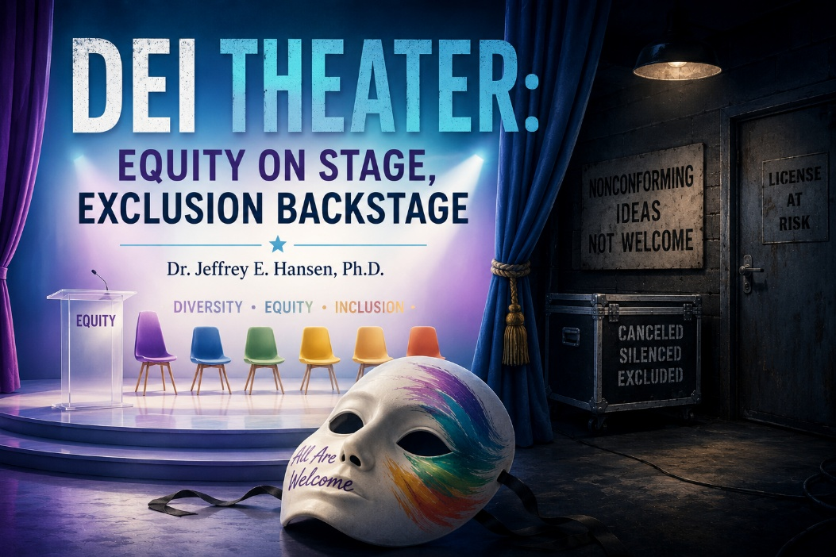
So, my dear friends, many of you know me as a conservative. My lane has always been advocating for responsible psychotherapy and medical care of the vulnerable, especially children. That means I push back against the reckless medicalization of kids, whether it is fast tracking them into transgender treatments or handing out psychotropics like TikToks without true, informed consent.
What troubles me deeply is not simply the existence of disagreement. Healthy societies require disagreement. Science itself advances through questioning, critique, and honest debate. What troubles me is the growing tendency to silence dissent while simultaneously claiming the moral high ground of inclusion, compassion, and tolerance.
Increasingly, we are told that inclusion means affirming only one approved worldview. And if you raise concerns, even thoughtful, evidence-based concerns, you are quickly painted as dangerous, hateful, backward, or unqualified to speak.
Part One: The Medicalization of Children
Let’s be honest: too many children are being fast tracked by medical “professionals” and institutions that often fail to fully grapple with the long-term consequences of early medicalization in the transgender arena. We are talking about interventions that can affect bone density, fertility, sexuality, cardiovascular health, and long-term psychological development. These are not trivial matters. They are life altering decisions involving vulnerable young people whose identities and nervous systems are still developing.
And yet, far too often, the public conversation is framed as though questioning these interventions automatically constitutes cruelty. In reality, many clinicians, researchers, parents, and detransitioners are raising serious concerns regarding the long-term evidence, the speed of affirmation models, and the tendency to bypass deeper developmental, family, trauma, and psychological dynamics.
The science is not nearly as settled as activists often claim. But instead of openly wrestling with uncertainty, many institutions simply paper over the concerns and pass along a narrative dressed up as compassion.
But hey, why not experiment on kids anyway? What could possibly go wrong?
Part Two: Fast-Tracking Psychotropics
The same pattern often appears in psychopharmacology. Children and adolescents are too frequently fast tracked onto medications without anyone taking sufficient time to deeply explore the underlying causes of their suffering. Trauma, attachment wounds, family dysfunction, loneliness, pornography exposure, social disconnection, meaninglessness, anxiety, and spiritual despair are often left largely untouched.
Instead, a pill is handed over, creating the appearance of treatment while deeper issues remain unresolved. In some cases, medications can absolutely be helpful and even lifesaving. But the broader culture of reflexive prescribing has raised serious concerns among many clinicians and researchers.
And the side effects can be significant. Emotional numbing, sexual dysfunction, cognitive clouding, weight gain, agitation, suicidality, and in some cases PSSD, post SSRI sexual dysfunction, which some sufferers describe as devastating and potentially long lasting. There is also increasing debate regarding aggression, emotional dysregulation, and the broader social impact of widespread psychotropic use, particularly among developing adolescents.
But again, too often the professionals either do not know, do not question, or do not want to admit the limitations of the current model. The institutional narrative becomes easier to repeat than to critically examine. Sometimes it feels like people are simply passing along talking points with about as much critical reflection as a parrot on Prozac.
The Personal Side of “Inclusion”
Here is a taste of how inclusive modern “inclusion” can become in practice.
About a year ago, just before a town hall in Cottonwood where I had been invited as the keynote speaker on the deleterious effects of pornography on children, I was interviewed by a progressive transgender journalist. He assured me the coverage would be fair. Instead, the article ended with a public call to revoke my license.
Nothing says “inclusion” quite like attempting to end someone’s career because they refuse to parrot the approved ideological script.
And near the end of my own professional career, after serving first as an active duty Army Major and then for another decade within the Department of Defense and Defense Health Agency at Joint Base Lewis McChord, I encountered false allegations from a highly progressive colleague who accused me of defrauding the government and threatened to report me to the licensing board.
Apparently two decades of service earns you a gold watch and a witch trial.
So that is often how “inclusion” functions in practice: we will include you right up until the moment you express a viewpoint we dislike, and then suddenly the torches come out and the licensing board gets called.
The Hypocrisy on Full Display
I have lived in the Northwest, and now I live down here in Arizona. I have plenty of progressive friends and colleagues, and despite our disagreements, I have never attempted to destroy their livelihood, report them to licensing boards, or silence them professionally. I respect them as human beings even when I strongly disagree with their ideas.
But when the shoe is on the other foot, inclusion suddenly becomes remarkably conditional.
You must respect our beliefs, but your beliefs are dangerous.
You must affirm our worldview, but your faith is invalid.
You must celebrate diversity, as long as everybody thinks the same.
It is a little like being invited to the neighborhood barbecue, but only if you promise not to bring anything that offends the vegans. Show up with a steak and suddenly security is escorting you out while someone yells “bigot” from behind the tofu platter.
Humor as Sanity
Honestly, sometimes the only way to stay sane in the middle of all this is with a little gallows humor because the irony becomes almost overwhelming.
DEI increasingly feels like one of those Orwellian inversions where language itself gets flipped upside down: “War is Peace. Freedom is Slavery. Inclusion is Exclusion.”
The reality is that DEI often functions less like an open invitation to genuine diversity and more like a membership only club. You can join provided you sign the loyalty oath, suppress your conscience, and nod along enthusiastically like a compliant bobblehead.
Otherwise, thanks for playing, but you are no longer welcome here.
So yes, welcome to DEI: Diversity, Equity, and Illusion, where fairness increasingly means silencing dissent, inclusion means exclusion, and decades of faithful service might buy you nothing more than a front row seat at your own ideological witch trial.


The Long Empty Road
Here I am, rolling my LandCruiser up Nevada. If you have ever driven this stretch of road, you know exactly what I mean. Mile after mile of nothingness. Dust, rock, endless brown hills that look like they were forgotten when God painted the rest of creation. The occasional gas station stands there like a museum piece from the 1950s, barely hanging on, almost apologizing for its own existence.
And then it hits me. This is exactly why they tested the atomic bomb here. You cannot make Nevada any uglier. Blow it up, flatten it, scorch it, crater it, and somehow it still looks like Nevada. It becomes the perfect laboratory for destruction because nothing here appears capable of becoming worse.
So as I drive, my mind drifts. The wheels hum, the desert yawns, and my brain wanders back into history. It wanders toward Trofim Denisovich Lysenko, Stalin’s so-called scientist, the man who baptized ideology and dared to call it science.

Lysenko’s Cooperative Fantasy
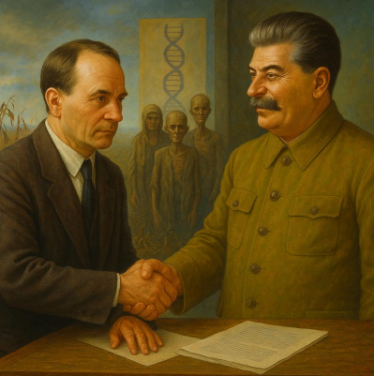
Lysenko rose to power by rejecting Mendelian genetics. He dismissed genes, chromosomes, and the hard realities of inheritance. Instead, he preached “vernalization,” the idea that plants could essentially be trained like obedient soldiers. Expose wheat seeds to cold, he argued, and they would somehow learn to sprout in winter. Their offspring, he promised, would inherit this new “skill.” It was Lamarckism wrapped in Marxist slogans and handed to the masses as revolutionary science.
But he went further. Lysenko insisted that plants, if planted closely together, would not compete. They would cooperate. They would supposedly share nutrients, sunlight, and water like little comrades in the soil, each helping the other thrive. It was communism applied to biology.
It was also nonsense.
Anyone who has gardened knows exactly what really happens. Plants compete. Roots strangle weaker roots. Tall stalks steal the light. Invasive species choke out fragile ones. The fantasy of universal cooperation produced famine instead of food. But Stalin loved it because Lysenko provided the “science” he wanted. And scientists who dared tell the truth were fired, imprisoned, exiled, or executed. Millions starved because ideology demanded obedience.
“Woe to those who call evil good and good evil, who put darkness for light and light for darkness.” (Isaiah 5:20)
The Garden and the Fall

The tragedy is that Lysenko’s lie ignored something Scripture told us from the very beginning: the Garden fell. Humanity leaned into selfishness, pride, envy, domination, and rebellion. The suckiness of man showed itself early and repeatedly. You cannot force harmony upon broken hearts simply because an ideology insists it should exist.
Nature itself testifies to this reality. Look at scotch broom in Washington State. This invasive weed spreads aggressively across hillsides, choking out native beauty and crowding out fragile ecosystems. Did the other plants cooperate with it? Of course not. They died.
That is competition. That is reality.
And it is the same with people. Some strive. Some build. Some sacrifice. Some destroy. Some work diligently. Others exploit. Any competent psychologist understands that competition, ambition, hierarchy, selfishness, and tribalism are deeply woven into human nature. Pretending everyone will suddenly get along if we just engineer society correctly is not compassion. It is delusion.
“The heart is deceitful above all things and beyond cure. Who can understand it?” (Jeremiah 17:9)
Neo-Marxism and the Modern Lie
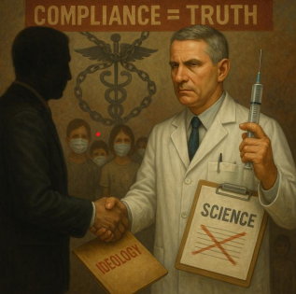
Stalin cloaked his tyranny in communism. Today’s ideologues cloak theirs in neo-Marxism, progressivism, therapeutic language, and woke compassion. The names evolve. The slogans evolve. But the underlying lie remains remarkably familiar: deny reality, punish dissent, force sameness, and sell ideological conformity as moral virtue.
And always hide the agenda beneath softer language so the masses believe they are swallowing kindness instead of poison.
Consider public health. COVID 19 vaccines were, in many respects, a genuine scientific breakthrough. I am not anti-vaccine. I am against dishonesty surrounding vaccines. I am against fear being weaponized. I am against coercion replacing informed consent. I am against pretending the science was far more settled than it actually was while dissenting voices were mocked, censored, or professionally threatened.
Fauci and many public health institutions did not always tell the truth fully or transparently. Science became captured by politics, institutional self-preservation, and ideological certainty. Narratives hardened long before all the evidence had emerged. And as the science unfolded, many uncomfortable realities were quietly minimized or ignored.
That is not authentic science.
That is Lysenkoism wearing a modern lab coat.
Stolen Futures: The Lie of Medicalization
And then there is the transgender narrative.
Children, many already struggling with trauma, autism spectrum conditions, anxiety, depression, identity confusion, loneliness, or profound social disconnection, are increasingly told that salvation lies in hormones and surgery. Medicalization is marketed as compassion, but far too often it functions as ideology masquerading as medicine.
Just like Lysenko’s fantasy of cooperative plants, the narrative promises harmony and liberation while frequently bypassing deeper psychological realities.
The consequences can be staggering. Futures stolen. Intimacy stolen. Fertility stolen. God’s design for a man and woman brought together in covenant and sexual union interrupted before it ever has the opportunity to mature naturally. When a developing brain is flooded with cross sex hormones, profound changes occur neurologically, psychologically, sexually, and physically.
Bone density can be affected. Fertility can be destroyed. Sexual functioning can be permanently altered. Risks involving cardiovascular disease, stroke, and cancer remain deeply debated and insufficiently understood over the long term. And many detransitioners now describe devastating regret, grief, sterility, numbness, and broken identity after irreversible interventions performed while they were still psychologically vulnerable.
To mutilate a child in the name of compassion is not compassion.
It is ideology wearing a white coat.
This is not authentic medicine. This is not thoughtful psychology. This is increasingly beginning to resemble a cult of ideology dressed up as therapeutic care.
“You shall not bear false witness against your neighbor.” (Exodus 20:16)
The Fruit of Lies
History repeats itself because people forget the fruit produced by lies. Progressivism often functions as Marxism repackaged, painted with softer colors, marketed as kindness, inclusion, and liberation. But a lie with a prettier label is still a lie.
Eve lied to Adam. Adam swallowed it. Humanity has been choking on forbidden fruit ever since.
We cannot call something good when it is evil and expect flourishing to follow. We cannot redefine truth endlessly without consequence. We cannot dress deceit in moral virtue and somehow expect it to heal civilization.
Lies destroy societies whether they emerge through Stalin’s gulags, public health coercion rooted in half-truths, or clinics medicalizing vulnerable children in the name of compassion.
“They dress the wound of my people as though it were not serious. ‘Peace, peace,’ they say, when there is no peace.” (Jeremiah 6:14)
Calling Evil Good
Charlie Kirk and many others who dared question prevailing narratives were painted as dangerous, hateful, or extremist. People were lied about, caricatured, professionally threatened, and publicly vilified simply for refusing to comply fully with institutional orthodoxy.
When you call good evil and evil good, you eventually enter a societal flat spin. A bad one.
And just like Nevada, you can blow the landscape apart and somehow it still looks barren because lies eventually scorch the land itself. Lies corrode trust. Lies poison institutions. Lies hollow out souls.
Eventually, entire societies lose the ability to distinguish reality from narrative.
Hope in the Desert
And yet Nevada teaches me something else too.
The desert is ugly at times, yes, but it is honest. It does not pretend to be lush. It does not camouflage itself in false beauty. Ideology, by contrast, is often spiritually barren while decorating itself in flowers and moral slogans.
But deserts can bloom.
Drop water onto cracked desert soil and suddenly wildflowers erupt where nobody expected life to emerge. Truth functions like that water. Truth nourishes. Truth restores. Truth revives what ideology slowly starves.
“Then you will know the truth, and the truth will set you free.” (John 8:32)
Hope does not come from pretending. Hope comes from truth. Hope comes from the God who still makes deserts bloom.
“The wilderness and the dry land shall be glad; the desert shall rejoice and blossom like the crocus; it shall blossom abundantly and rejoice with joy and singing.” (Isaiah 35:1–2)
So as I roll through Nevada, I remember something important: lies always end in famine, but truth, even when it initially appears small and fragile, still possesses the power to bloom in the harshest desert.
Time to rip off the blinders.
Time to expose the lies.
Time to plant truth and watch it grow where ideology never can.
Because the God who makes deserts bloom still has the power to make truth bloom again in our barren age.


The Cost of Seeing Clearly
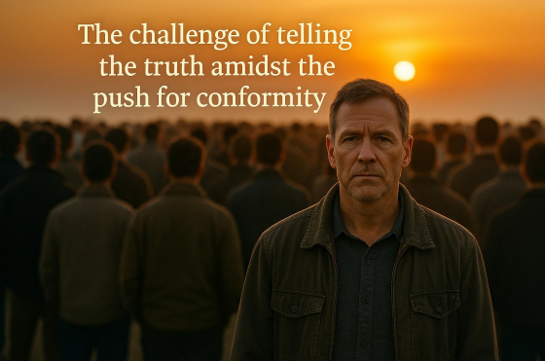
There is something achingly beautiful about the word truth. It carries the clarity of clean water and the freshness of open air. Yet truth is also dangerous because truth asks us to see. And once we see clearly, we cannot easily unsee without harming the integrity of the soul itself.
People do not resist truth primarily because they lack intelligence. More often, they resist truth because truth demands change, and change threatens identity, emotional safety, tribal belonging, and the stability of the systems people depend upon. Most individuals would rather belong than be right. Most groups would rather remain emotionally undisturbed than genuinely healed.
Socrates understood this deeply. He walked the streets of Athens asking ordinary people deceptively simple questions. How do you know what you claim to know? What do you mean when you say what you say? What actually stands beneath your certainty? He was not fundamentally a political radical. He simply refused to pretend that shadows were reality.
And for that, he was condemned in 399 BCE. The crowd did not destroy Socrates because they conclusively proved him wrong. They destroyed him because if they admitted he might be right, they themselves would have to change. The crowd chose belonging over truth.
The Cave, the Crowd, and the Fear of Change


Plato later gave us the famous image of the cave. Human beings chained in darkness mistake shadows for reality. And if one person escapes the cave and returns to tell the others what he has seen, they do not celebrate him. They attack him.
The allegory is not simply about ignorance. It is about identity.
People defend illusions because illusions are emotionally familiar. Illusions stabilize groups. Illusions preserve social equilibrium. And truth threatens the emotional security that group belonging often provides.
Galileo encountered the same pattern centuries later. When he observed that the earth moved around the sun, he was not merely offering a scientific correction. He was threatening the psychological scaffolding of an entire culture.
The Church forced him to recant not because the evidence was weak, but because the truth demanded transformation. Many of his contemporaries quietly knew what he observed was real, but they feared what would happen to their world if they admitted it openly.
This pattern remains fully alive today wherever institutions value cohesion over clarity, reputation over reality, comfort over conscience, and emotional safety over truth.
Truth and the Emotional Equilibrium of Systems
I have experienced this dynamic personally in organizational settings.
At one point, I suggested that mid-level management should record phone greetings for clients so callers would know who they were speaking with and what role that individual held. It was a simple gesture of professionalism, clarity, continuity, and hospitality toward the people we served. It would have strengthened the organization’s presentation and helped vulnerable clients feel more oriented and welcomed.
The suggestion was immediately dismissed when I first raised it privately with upper leadership. Later, during a meeting involving mid-level management and general staff, I gently raised the idea again and simply asked whether it might be reconsidered. The atmosphere in the room shifted almost instantly. But the discomfort had very little to do with the actual suggestion itself.
The discomfort was that I had raised it publicly. I had asked the group to see itself.
After the meeting, I was spoken to for nearly an hour and told that by raising the issue publicly, I had demonstrated that I could not be trusted. And that was the moment the deeper psychological truth became unmistakably clear. Trust did not mean integrity. Trust did not mean competence. Trust meant conformity. Trust meant silence. Trust meant preserving the emotional equilibrium of the group even when improvement was possible.
The content of the suggestion itself was largely irrelevant. What mattered was that the group’s comfort had been disrupted.
When Systems Protect Themselves

I encountered the same pattern again in psychopharmacology.
Newer research increasingly suggests that tapering certain psychiatric medications requires a parabolic progression rather than a simple linear reduction. Receptor occupancy does not decrease in a straight line, meaning the taper often must slow substantially as dosages become smaller.
I shared this evidence with prescribers and clinical staff because the patient’s wellbeing was at stake. Yet the response focused less on the science itself and more on the fact that I had spoken about it openly in front of others. The hierarchy had been disturbed. The group’s emotional stability had been challenged. And ultimately, the patient received a less appropriate linear taper because preserving institutional comfort mattered more than fully wrestling with the emerging evidence.
I later encountered similar dynamics when I raised concerns regarding the rapid medicalization of children in matters involving gender identity. I did not demean anyone. I did not mock anyone. I raised concerns grounded in developmental psychology, neurobiology, attachment theory, trauma, and long-term outcome data.
The response was not genuine dialogue. It was subtle distancing, quiet reputation damage, and a silent marking of the one who sees.
And this is not arbitrary. It is one of the primary ways systems defend themselves against internal anxiety and disruption.
Groupthink, Identity, and the Fear of Exclusion
Marxist derived identity frameworks often intensify these dynamics by teaching that identity itself is fundamentally collective, that virtue is measured by agreement, and that dissent becomes a form of betrayal.
When this psychological structure enters medicine, education, therapy, academia, or faith communities, people begin saying things they do not fully believe, defending positions they do not fully understand, and supporting practices they privately question simply to remain emotionally and socially included.
Irving Janis called this groupthink. Murray Bowen described it as the collapse of differentiation of self. Both recognized that most human beings fear exclusion more than they fear being wrong.
This is why evolutionary neurobiology becomes taboo in some Christian environments and why caution regarding gender related medical interventions becomes taboo within some progressive environments. The content changes. The mechanism remains remarkably similar.
Both systems punish truth when truth threatens group identity.
Truth and the Unified Soul
Truth has a cost. It can cost belonging, reputation, safety, warmth, comfort, and acceptance. The individual who consistently pursues truth often experiences loneliness because truth telling destabilizes systems built upon emotional conformity.
But truth also gives something greater. Truth gives the unified soul. Truth gives inward coherence. Truth aligns a human being with reality itself. And reality is ultimately where God dwells.
Christ said, “I am the Way, the Truth, and the Life.” Truth is not merely an abstract concept. Truth is relational. Truth is incarnational. Truth is ultimately bound to the character of God Himself. To walk with truth is to walk with Him. And to walk with Him often means accepting solitude when necessary.
Scripture tells us, “You will know the truth, and the truth will make you free” (John 8:32). Aristotle described truth as naming reality as it actually is. Socrates taught that the unexamined life is not worth living. Christ taught that whoever would follow Him must take up his cross.
All three point toward the same reality: without truth there is no integrity, without integrity there is no unified self, and without truth the soul itself slowly fractures.
So perhaps the real question becomes this: when belonging and truth pull in different directions, which one will you choose?
The one who speaks truth may sometimes stand alone. But the one who stands with truth ultimately stands with Christ. And the one who stands with Christ stands in a light no darkness can finally overcome.

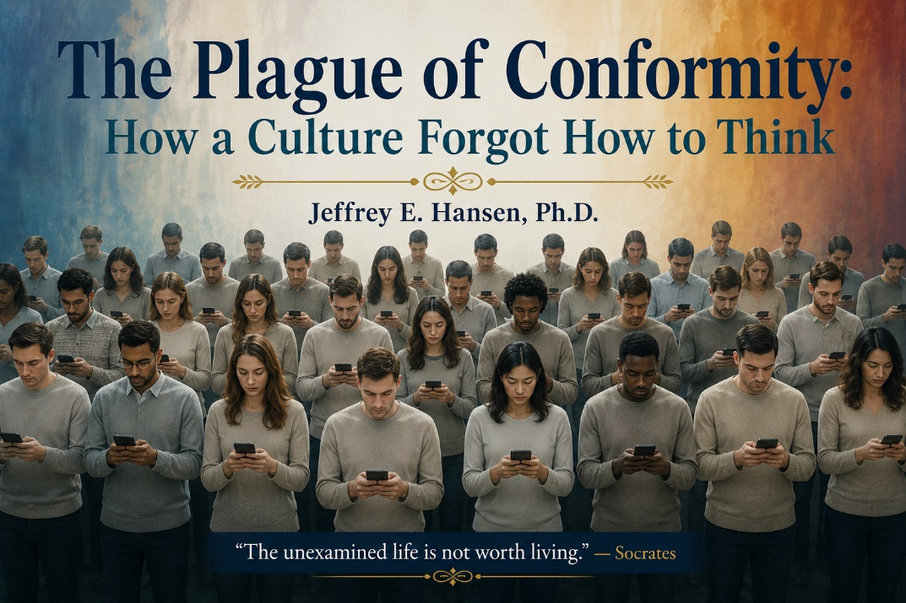
There have been many plagues throughout human history. The Black Death. Influenza epidemics that swept nations like winter storms. Ancient fevers that reshaped continents and toppled kingdoms. Those were biological plagues. They came from outside us.
The plague we face today is different. It comes for the mind. It empties the interior world and slowly dulls a culture’s ability to think deeply, reflect honestly, and remain inwardly awake.
This plague looks like convenience. It feels like stimulation. It sounds like progress. But beneath the glow of the screen and the flood of information lies something far more dangerous: the erosion of depth itself.
The Engineered Collapse of Attention
The modern mind is bombarded with micro stimuli deliberately engineered to hijack the dopamine system. Rapid scrolling activates a neurological loop of stimulation without satisfaction. The reward circuit fires, but never fully completes. The brain slowly learns to crave novelty instead of truth, stimulation instead of meaning.
Repeated thousands of times each day, this process begins reshaping the prefrontal cortex itself. The result is not merely distraction. It is the shrinking of the mind’s ability to hold complexity, sustain reflection, and tolerate stillness.
The brain becomes trained to skim, react, scroll, and forget. We develop breadth without depth. Awareness without understanding. Opinion without reflection.
A mind that cannot be still cannot think deeply. A mind that cannot think deeply cannot genuinely doubt. A mind that cannot doubt cannot discern. And a mind that cannot discern becomes the perfect subject of conformity.
The Culture of Manufactured Consciousness

Gramsci would likely be smiling at much of what we see today. He understood that political revolutions need not seize governments directly if they can instead seize consciousness itself. Control cultural institutions. Shape imagination. Influence language. And eventually people begin policing their own thoughts voluntarily.
Socrates once said the unexamined life is not worth living. Today, the unexamined life is not merely common. It is encouraged. Normalized. Marketed.
People increasingly know how to react, but not how to reflect. They know how to signal virtue publicly, but not necessarily how to wrestle honestly with truth privately. And when a culture loses the capacity for reflective depth, conformity rushes in to fill the vacuum.
My Place in This Landscape

I do not write as one immune to these pressures, but as someone who has spent much of his life resisting them. I have questioned the premature medicalization of identity, the overprescribing of psychotropics, the prioritizing of optics over understanding, performance over presence, and compliance over curiosity.
Not because I reject progress, but because I believe meaning must remain inside progress.
We now better understand the difficulty of deprescribing what was prescribed too quickly. We increasingly recognize that symptoms are not always enemies to silence immediately, but messages requiring interpretation and understanding. I have watched children and adults alike become separated from their own inner worlds, not through cruelty, but through well-intentioned haste.
A Call to Protect the Interior World
We are among the last stewards of the inner life.
If we lose the capacity to think deeply, ask difficult questions, tolerate stillness, and reflect courageously, then culture itself slowly loses its memory of wisdom.
Do not rush. Do not trade discernment for approval. Do not settle for the appearance of unity over the pursuit of truth. Protect the contemplative space. Protect the slow mind. Protect the conditions where identity, healing, and wisdom can unfold naturally rather than mechanically.
Conclusion — Choosing the Way of Depth

To be still is to resist the plague. To know is to reclaim the interior life. To think is to remain fully human.
May we choose depth over ease, integrity over optics, reflection over reaction, and formation over conformity. Not to set ourselves apart, but to remain awake.
Healing is not ultimately the work of efficiency. It is the work of presence.
May we be those people. May we cultivate such places. May we steward such work.
Together.

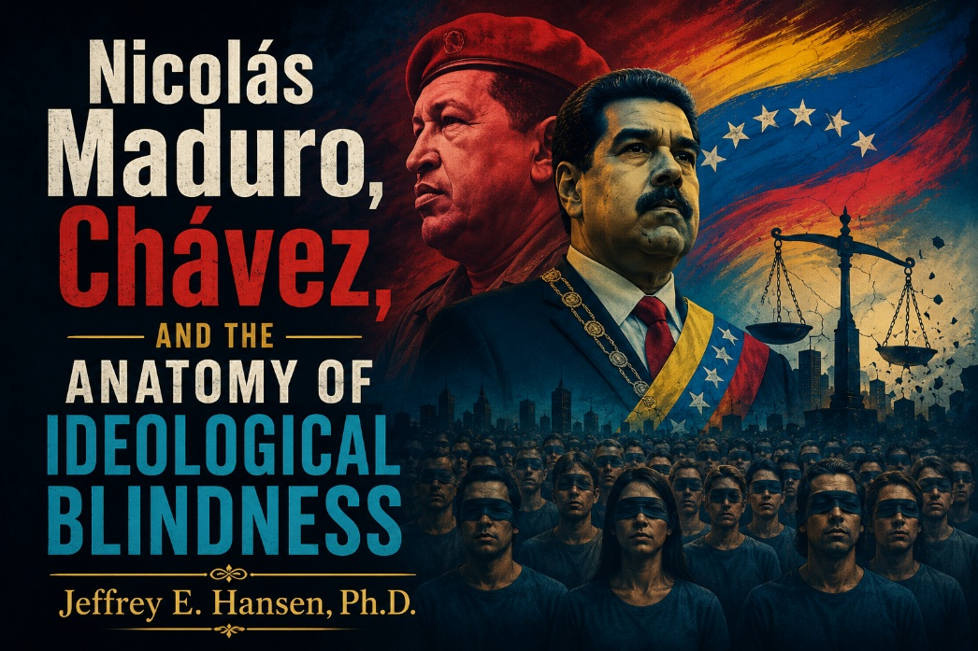
Introduction: A Psychologist’s Lens
As a clinical psychologist, I have spent decades trained to observe patterns, challenge assumptions, and resist the pull of groupthink. My profession, like many others, tends to lean politically to the left. That reality does not trouble me. What troubles me is when ideology replaces thinking, when moral certainty replaces evidence, and when uncomfortable facts are dismissed simply because they do not fit a preferred narrative.
I do not approach political or cultural questions primarily as a partisan. I approach them as a psychologist. That means I value independent thinking, intellectual honesty, and the willingness to follow evidence wherever it leads, even when the conclusions are unpopular. I am not interested in aligning myself with ideological tribes. I am interested in telling the truth as clearly as I can and allowing the chips to fall where they may.
In clinical work, ideological capture is not theoretical. It appears through denial, rationalization, moral disengagement, and the subtle reshaping of conscience. People convince themselves harmful behavior is justified because it serves a cause, preserves identity, or protects belonging. The same psychological mechanisms operate at the cultural and political level. What follows examines the collapse of Venezuela through that lens.
Hugo Chávez: The Beginning of the Slide
Venezuela is an oil rich nation that should have been prosperous. Instead, decades of corruption, elite mismanagement, and political arrogance created legitimate anger among ordinary citizens. That anger became the seedbed for Hugo Chávez.
Chávez rose to power by presenting himself as a revolutionary outsider who would cleanse the system and return power to the people. Many Venezuelans welcomed him with hope. But once in office, Chávez systematically dismantled democratic guardrails. Courts were packed, independent media was attacked, opposition voices were delegitimized, and executive power became increasingly centralized.
Economic mismanagement followed ideological certainty. Oil wealth was politicized rather than responsibly stewarded. Dependency deepened. Inflation worsened. And by the time Chávez died, Venezuela was already sliding toward authoritarianism. Democratic norms had been hollowed out, and loyalty had begun replacing accountability.
Nicolás Maduro: Inheriting and Weaponizing the System

Nicolás Maduro did not invent Venezuela’s authoritarian system. He inherited it. Chávez selected Maduro precisely because he could be trusted to preserve and extend the project.
Once in power, Maduro took a hollowed-out system and used it without restraint. Under his leadership, Venezuelan security forces carried out extrajudicial killings, torture, arbitrary detention, and enforced disappearances. These actions occurred under Maduro’s authority as head of state and commander in chief.
United Nations investigations concluded there were reasonable grounds to believe crimes against humanity had been committed. Killings were staged as shootouts. Detainees were tortured. Critics disappeared. Under international law, a leader bears responsibility not only for what he orders directly, but also for what he knowingly permits under his authority.
Criminal Accountability Is Not a Metaphor
Maduro’s actions are not merely the subject of abstract human rights criticism. He has been formally indicted by the United States Department of Justice on narco-terrorism conspiracy charges alleging large scale cocaine trafficking in coordination with transnational criminal organizations.
The International Criminal Court advanced investigations into crimes against humanity committed under Maduro’s authority. Financial measures followed as well. Assets linked to Maduro and members of his inner circle were frozen by countries including Switzerland, citing corruption and illicit financial flows.
These are not symbolic gestures. They reflect the growing international recognition that Venezuela’s collapse was not simply accidental economic dysfunction, but the consequence of authoritarian power fused with ideological certainty and corruption.
Democracy Hollowed Out
Maduro did not merely manipulate elections. He slowly emptied them of meaning. Opposition candidates were barred. Media outlets were censored. Voters were intimidated. State resources were weaponized for political survival.
Democracy was not overthrown overnight. It was slowly suffocated.
That is often how authoritarian systems emerge. Not through a dramatic single event, but through the gradual normalization of institutional decay until citizens scarcely recognize what has been lost.
The Historical Parallel People Prefer to Ignore
Authoritarian regimes rarely begin with open terror. They begin with moral narratives, grievance politics, promises of restoration, and emotionally compelling visions of justice.
Adolf Hitler rose through similar dynamics. The comparison is not about identical outcomes. It is about similar mechanisms of psychological and political control.
Modern movements often loudly denounce fascism while quietly reproducing some of its core structure: totalizing ideology, indispensable leadership, suppression of dissent, and state power justified as moral necessity. Calling everything fascist does not prevent a movement from becoming increasingly authoritarian itself.
Selective Moral Outrage and Ideological Hypocrisy
When Barack Obama authorized the operation that killed Osama bin Laden, he was widely praised. The action was framed as necessary and morally justified.
When Donald Trump authorizes action against a foreign leader credibly accused of murder, narco terrorism, and crimes against humanity, the reaction from some quarters becomes radically different. Suddenly sovereignty becomes sacred. Suddenly due process is invoked selectively.
This is not a defense of Trump as a person or president. He is deeply flawed, polarizing, and controversial. But hatred of the actor does not absolve moral responsibility to judge the act honestly. Evil does not become less evil depending upon who confronts it.
Why This Is Not Abstract for Me
As a former clinical director of an addiction recovery center, I have personally watched former patients die from overdoses after treatment. In several cases, fentanyl was involved.
Narco states and trafficking regimes export death far beyond their own borders. These systems do not merely destroy nations internally. They poison families, communities, and lives across continents.
For me, this is not simply geopolitical analysis. It is painfully human.
Final Word
Venezuela’s collapse did not happen accidentally. Corruption created vulnerability. Chávez exploited it. Maduro weaponized it. The result was a system that murdered, trafficked, intimidated, and terrorized in the name of ideology.
History does not ultimately ask what tyrants said. It asks what they did.
The evidence exists. The investigations exist. The tribunals exist. The bodies exist.
The remaining question is whether we are willing to see clearly.

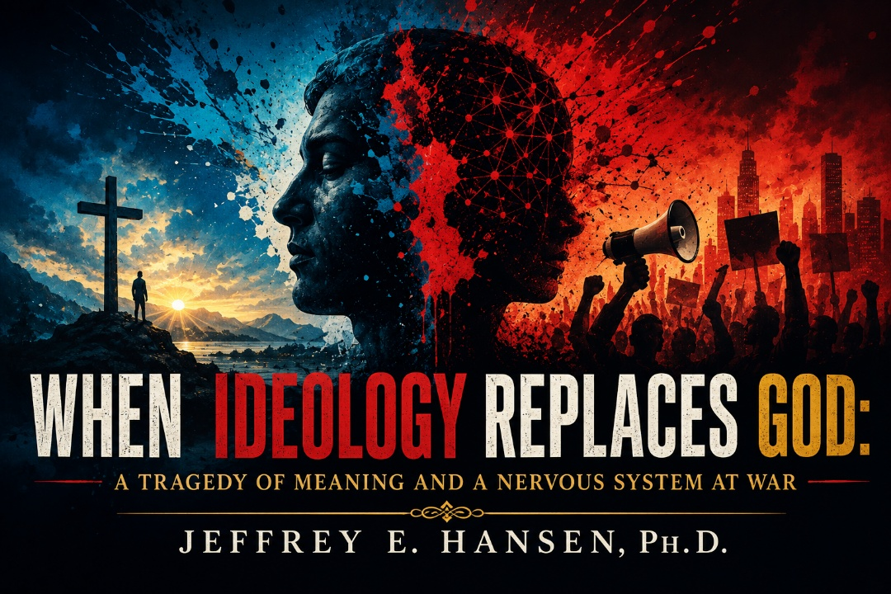
The Human Need for Meaning and Safety
The death of Renee Good is a tragedy. A real human being is gone. Children lost their mother. A partner lost someone she loved. Nothing written here diminishes that loss, and nothing I believe erases the gravity of it.
This reflection is not written in anger. It is written in sorrow and conviction. It is not about sexuality, not about condemning a gay woman, and not about denying dignity, worth, or humanity. It is about meaning, and it is about safety.
Human beings cannot live without meaning. We are meaning making creatures at the deepest psychological, neurological, and spiritual levels. We must know who we are, where we belong, and what makes us righteous. When God is removed as the foundation for that meaning, the hunger does not disappear. It intensifies. And intensified hunger always looks for something to attach to.

Viktor Frankl and the Collapse of Meaning
This truth was articulated with haunting clarity by Viktor Frankl, a Holocaust survivor and psychiatrist who observed humanity at its psychological breaking point. In Man’s Search for Meaning, Frankl argued that the primary human drive is not pleasure or power, but meaning.
When meaning collapses, people do not become neutral. They become vulnerable. They grasp for substitutes. They attach themselves to causes, identities, and ideologies that promise purpose, even if those substitutes ultimately destroy them.
The human nervous system was never designed to float endlessly without grounding. Meaning organizes perception. Meaning stabilizes identity. Meaning regulates despair. When transcendent meaning disappears, ideological substitutes rush in to fill the vacuum.
When Ideology Becomes a Substitute for God
When people move away from God’s design, not simply morally but ontologically as the grounding of identity itself, they are not left free. They are left floating.
And in that floating state, ideology becomes magnetic. It offers clarity, belonging, emotional certainty, and a sense of righteousness. It offers a way to feel psychologically safe in a chaotic world.
But here is the truth we rarely say plainly: ideology cannot give true safety.
It can provide temporary emotional cohesion, but it cannot produce genuine coherence of heart, mind, and soul. Eventually the nervous system begins living in perpetual activation, because identity built upon ideological opposition always requires enemies to sustain itself.
Political Ponerology and Pathocracy
Polish psychologist Andrzej Łobaczewski, who lived under Soviet totalitarianism, devoted his life to studying what happens when psychological pathology merges with ideology and power. He called this field Political Ponerology, the study of evil operating through political and social systems.
Łobaczewski observed that when societies lose shared moral grounding, pathological worldviews can spread beneath the cover of moral language. Ideological systems develop what he termed an ideological mask, a framework through which reality itself becomes distorted. Good is redefined. Evil is reframed. Obedience to the system becomes the highest virtue.
Eventually this produces what Łobaczewski called pathocracy, a state in which morally disordered ideas gain influence and demand compliance. In modern expressions, this often merges with plutocratic power structures where institutions, corporations, education systems, and cultural elites normalize and enforce ideological conformity.
This is not ancient history. It is happening now.
Neo-Marxism and the Frankfurt School Legacy
The philosophical roots of this phenomenon trace back to neo-Marxism and the Frankfurt School, particularly thinkers like Herbert Marcuse, writing as early as the nineteen thirties and later shaping the New Left in the nineteen sixties.
Marcuse argued that traditional Western structures such as family, religion, and morality were inherently oppressive and that radical disruption was not only justified but necessary. Truth became subordinate to liberation. Norms became instruments of oppression. Moral transgression increasingly became framed as revolutionary virtue.
Within this framework, the radical left was granted moral permission to deceive, disrupt, and coerce in the name of a supposedly higher good.
That logic never disappeared. It evolved.
Critics like Michael Rectenwald, in works such as The Great Reset, have documented how these ideas now permeate institutions including education, corporations, media, and activism. The result is a culture where ideological conformity is demanded and dissent itself becomes moralized as evil.
This is ponerology at scale.
Radicalization and Activist Ecosystems
According to political commentator and professor Dr. Steve Turley, publicly available digital records and activism patterns indicate that Renee Good was actively engaged with causes aligned with Antifa and Black Lives Matter. Turley also reports that her radicalization was reinforced within activist ecosystems, including charter school adjacent parent groups focused on disruption tactics.
These reports are contested by some and accepted by others. Regardless, they raise a critical question:
What happens to the human nervous system when meaning, identity, and righteousness become fused to perpetual opposition?
What happens psychologically when outrage becomes identity and activism becomes the primary vehicle for moral worth?

NeuroFaith®, Activation, and the Loss of Coherence
From a NeuroFaith® perspective, safety is not found in rage, moral outrage, or constant threat perception. Safety is found in regulation, coherence, and embodied connection.
Chronic ideological anger activates the HPA axis. Cortisol and adrenaline flood the body. The nervous system locks into fight or flight. The brain loses integration. The heart loses coherence. Perception narrows. Complexity collapses.
This is not moral condemnation. It is neuroscience.
When activation remains high, the brain moves increasingly toward chaos. Discernment degrades. Reality becomes symbolic rather than concrete. People act sincerely, but without clarity. In those states, individuals can make catastrophic decisions while believing they are doing good.
Rage feels purposeful, but physiologically it is profoundly dysregulating. It destroys perception. It damages health. It erodes safety.
Grace as the Path to Regulation and Restoration
Christianity offers something radically different, both neurologically and spiritually.
Grace regulates. Love integrates. Surrender restores coherence.
When righteousness is received rather than endlessly performed, the nervous system can settle. When identity is grounded in God rather than opposition, the heart can return to coherence. When redemption is not something you must earn through perpetual struggle, the brain regains nuance, empathy, humility, and restraint.
The cross ends the exhausting striving to prove moral superiority. It ends the endless need to manufacture enemies. It ends the illusion that confrontation, whether symbolic or physical, can ultimately save the soul.
A Call Beyond Polarization
I grieve for Renee Good, not because I believe she was beyond grace, but because I believe she was searching for meaning and safety in systems that could only escalate activation and cloud perception.
I grieve for her children, whose loss cannot be explained away through ideology. I grieve for a culture intoxicated with outrage and convinced that polarization is the same thing as moral clarity.
And I grieve because I believe this did not have to end this way.
This is not a call directed only toward the political left, nor is it a pass for the political right. While much of our present cultural activation has been fueled by ideological frameworks and institutional reinforcement, the right possesses its own blind spots as well. Fear, tribalism, reactionary identity, and failures of grace can also pull people out of regulation, connection, and truth.
We will not heal this moment by polarizing further. We will not regulate our collective nervous system through rage, mockery, or moral superiority. We will not find safety by dehumanizing one another or reducing complex human beings into symbols within a culture war.
Love is the way forward. Safety is the way forward. Connection is the way forward.

Final Reflection
Love, rightly understood, is not sentimental or permissive. It is grounding. It restores coherence to the heart, the brain, and the soul. Love covers a multitude of sins not because it excuses wrongdoing, but because it addresses the deeper fractures beneath our problems.
If we are going to survive this cultural moment, we must learn again how to stay human with one another. We must learn how to remain regulated in the presence of disagreement. We must learn how to tell the truth without abandoning love.
That is not weakness. That is maturity.
“Above all, love each other deeply, because love covers over a multitude of sins.” (1 Peter 4:8)

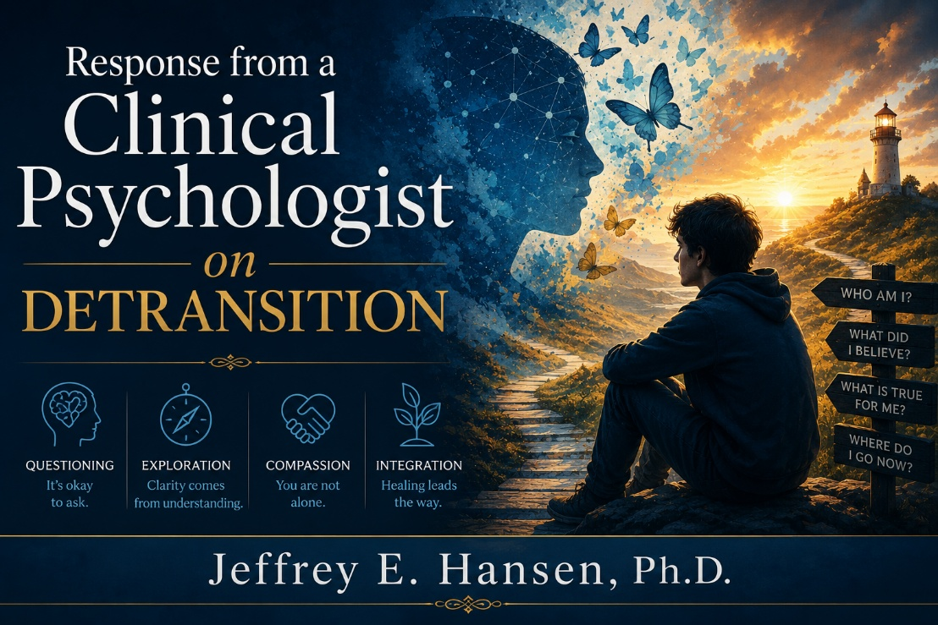
Introduction
I was recently invited by a beloved colleague to contribute to an upcoming book she is coauthoring. She asked if I would offer my clinical perspective on a question that is emerging with increasing frequency in therapeutic settings, particularly among adolescents and young adults.
The question is not political.
It is not ideological.
It is deeply human.
What happens when a young person who once believed they were transgender begins to wonder whether that conclusion may have been mistaken? How should a clinician respond ethically, compassionately, and responsibly when a client expresses uncertainty and asks how to begin walking something back?
The reflections that follow are offered not as a universal template, but as an example of how I believe ethical psychotherapy must function. They are grounded in decades of clinical practice, specialization in pediatric and adolescent development, and a firm commitment to informed consent, personal agency, and evidence-based care.
The Responsibility of the Clinician
If a young person were sitting across from me and said:
“I thought I was transgender for a long time, but I think I may have been mistaken. I don’t know what to do now. How do I begin to walk this back?”
My response would begin not with an answer, but with my responsibility as a clinician.
Before any therapist responds to a question like this, it is essential that they understand where they stand ethically and clinically. Therapy must never be driven by ideology, whether cultural, political, or theoretical. When ideology replaces curiosity, the therapeutic relationship becomes directive rather than healing.
As a clinical psychologist with advanced training in pediatric psychology and specialization in adolescent development, I am a strong believer in personal agency, choice, and fully informed consent. Informed consent means that a client has the right to define what they want to explore, without pressure toward any predetermined outcome. It also means that therapy must remain a place where questioning is allowed, not discouraged.
In recent years, many young people have encountered systems in which affirmation has replaced exploration. While validation of emotional experience is important, ethical care also requires curiosity, patience, and a willingness to understand the whole person.
Adolescence is a period of profound neurological, emotional, and identity development. During this time, certainty can feel safer than ambiguity, and answers can feel more comforting than questions. For this reason, I believe it is not only ethical, but protective, to slow the process down. When a young person begins to wonder whether they may have been mistaken, that questioning should not be viewed as regression or failure. Questioning is often the beginning of integration.
Creating Safety Before Exploration
So, my first response to this young person would be simple and sincere:
“I want you to know how much courage it takes to say that out loud. You are not in trouble for asking this question, and you are not betraying anyone by reconsidering. I’m really glad you brought this here.”
I would then want them to know something very clearly:
“I am not here to persuade you in either direction. My role is not to push you forward or pull you back. My role is to help you understand yourself.”
Only once that foundation of safety and consent is established would we begin any deeper exploration.
With Your Permission, We Might Explore
At that point, I might say something like this:
“Alex, if it’s okay with you, I’d like us to slow this down together. You don’t need to have answers right now. Sometimes clarity comes not from moving forward or backward, but from understanding how we arrived here in the first place.”
“Nothing we talk about means something is ‘wrong’ with you. This is simply about listening carefully to your story.”
With Alex’s consent, I would gently explore several areas that can influence identity development, not because any one of them must be present, but because understanding context matters.
Past Experiences and Trauma
One thing I often ask about is whether there have been experiences in your life that felt frightening, overwhelming, or unsafe, especially involving your body.
When someone has been hurt, bullied, or violated, the body can begin to feel unfamiliar or uncomfortable. Wanting distance from one’s body can sometimes make sense in that context. That may or may not be part of your story, but it deserves space.
Anxiety and Obsessive Thought Patterns
“I also like to understand how anxiety shows up for you.”
Some people experience very strong, repetitive thoughts that feel urgent and intrusive. Sometimes identity itself becomes the focus of that anxiety. Exploring this doesn’t mean your experience isn’t real. It simply helps us understand whether anxiety might be intensifying it.
Autism Spectrum Considerations
Another area I sometimes explore, particularly with adolescents, is whether someone may fall somewhere on the autism spectrum.
Some individuals think in very concrete or black and white ways. During puberty, when the body and emotions change quickly, the brain may look for a clear explanation that feels stabilizing. Understanding how your mind processes information can help us avoid misunderstanding what you’re experiencing.
Sexual Development and Media Exposure
I may also gently ask about exposure to sexual material online, not with judgment or shame.
The developing brain is highly sensitive to stimulation, and repeated exposure can sometimes blur the lines between curiosity, arousal, identity, and meaning. Talking about this openly helps us sort out what belongs where.
Social and Peer Influences
I’d also want to understand the environment you’ve been living in, friends, online spaces, school culture, and how identity has been discussed there.
Belonging is powerful, especially during adolescence. Sometimes ideas take root not because they are wrong or right, but because they offer connection.
Timing and Development
Finally, I’d want to understand when these feelings began, early in childhood or later during adolescence. That timing helps me understand whether these experiences emerged alongside puberty, stress, anxiety, or major life transitions. Throughout this process, I would continue to emphasize:
“Alex, none of this is about proving or disproving anything. It’s about understanding you fully and honestly, without pressure and without rush.”
Walking something back does not mean the young person failed. It means they are listening to themselves more deeply. My role as a clinician is not to provide an answer for them, but to help them arrive at clarity in a way that protects their dignity, their development, and their long-term well-being.
Sometimes the most healing thing we can offer a young person is not certainty, but permission to take their time.
Conclusion
I offer this contribution with deep respect for both clients and clinicians who find themselves navigating extraordinarily complex territory in today’s cultural and clinical landscape.
While the case of Chiles v. Salazar currently before the United States Supreme Court seeks to restore the central role of informed consent in psychotherapy, I believe ethical practice cannot be postponed while awaiting legal clarity.
Regardless of how courts rule, clinicians remain bound by conscience, evidence based practice, and the sacred trust of the therapeutic relationship.
I am hopeful that informed consent will be reaffirmed as a foundational principle of ethical care. Yet even in the absence of external permission, I will continue to advocate for a model of therapy that prioritizes curiosity over coercion, exploration over ideology, and compassion over certainty.
Our responsibility is not to produce outcomes.
It is to protect development.
To honor agency.
To create safety.
When we do that, we allow truth to emerge in its own time, gently, honestly, and in service of the long term well-being of the young people entrusted to our care
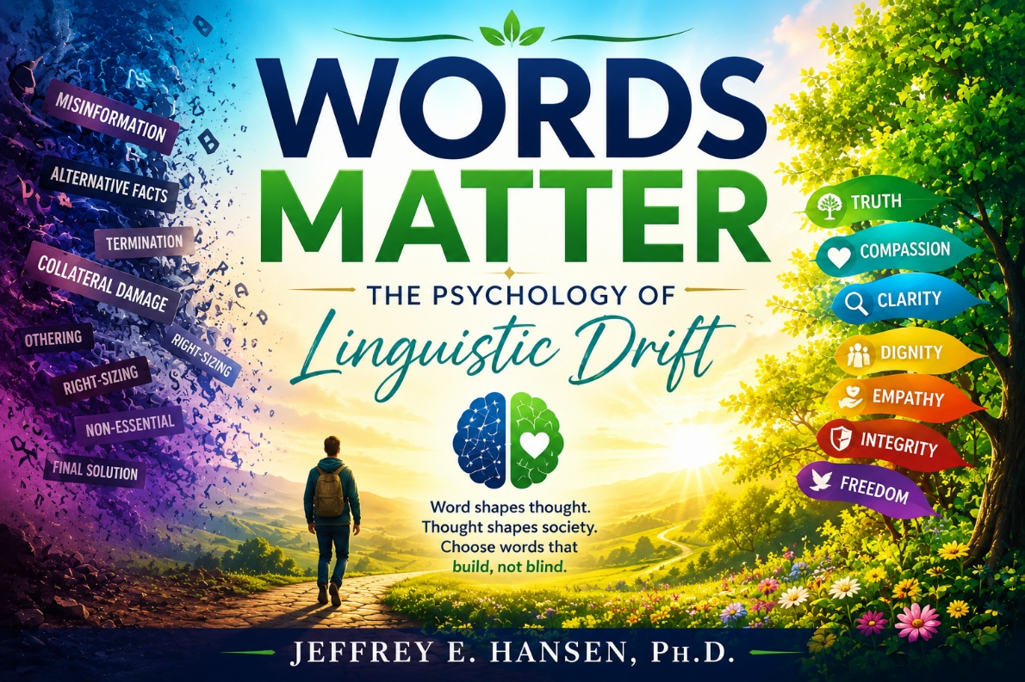
Introduction
I have always loved words, their roots, their history, the way a single syllable can reshape meaning. Words are not merely tools for communication. They are instruments of perception. They guide what we feel safe noticing and what we quietly learn to ignore.
Language always evolves. That is not the concern. The deeper question is whether evolving language clarifies reality or anesthetizes our response to it.
Across cultures and across history, vocabulary has often changed before moral imagination changed. The shift is rarely loud. It comes through softened phrasing, clinical terminology, and compassionate reframing. Over time, what once startled the conscience begins to feel ordinary.

A Personal Disclaimer: Language Shapes Me Too
As I reflect on the power of words, I have to acknowledge something uncomfortable. I am not standing outside this phenomenon. I too have felt the pull of language, sometimes choosing words that were sharper than necessary, sometimes reacting before slowing down enough to see nuance. This essay is not written from a place of moral standard or superiority. It comes from someone who is still learning.
I am learning to slow down, to examine words more carefully, including my own, and to hold conviction and accountability alongside curiosity. The same psychological forces I describe here shape me as well. Framing, labeling, the desire to belong, and the temptation to speak in absolutes all live within me.
NeuroFaith® reminds me that language can both inflame and anesthetize the nervous system. At times I have spoken from sympathetic urgency. At other times I have retreated into certainty simply because it felt safer. This reflection is not a verdict handed down from a distance. It is an invitation, first to myself and then to others, to speak with greater clarity, greater humility, and a deeper awareness of how words shape not only culture but our own hearts.
The Psychology of Drift
Social psychology shows that human beings do not encounter reality neutrally. We encounter it through frames, linguistic lenses that highlight certain meanings while muting others.
Researchers studying framing effects have demonstrated that identical information evokes different reactions depending on wording. Clinical psychology adds another layer. Euphemistic language can facilitate moral disengagement by reducing emotional resistance through softened phrasing.
Labeling theory reminds us that words do more than describe people. They shape identity and expectation. Once a label becomes dominant, it reorganizes perception itself.
This is how cultural drift happens. First language changes. Then emotion changes. Then moral perception changes.
Incremental Change and the Human Mind
Major cultural transformations rarely begin with shocking declarations. They begin with small shifts in vocabulary that feel compassionate, professional, or reasonable.
Psychologists call this the foot in the door effect. Social norms reinforce the process. People begin to speak differently not only because they agree, but because belonging requires it.
Silence from dissenters can create pluralistic ignorance, the illusion that everyone agrees even when many privately hesitate. Vocabulary becomes a signal of moral membership. Speak the right words and you belong. Speak the wrong words and you risk exclusion.
Language, in this sense, becomes a nervous system strategy for staying connected.
History’s Lessons: Euphemism and Power
History reminds us that linguistic softening is not unique to any one era or ideology.
Nazi bureaucrats spoke of a Final Solution rather than genocide. Soviet authorities used phrases like corrective labor. Maoist campaigns referred to purges as rectification. Governments across political systems speak of collateral damage, and corporations speak of right sizing.
The purpose of these examples is not partisan accusation. It is anthropological observation. Human systems often rename difficult realities to reduce emotional resistance.
Hegemony and the Battle Over Words
Some modern thinkers describe this phenomenon through the concept of hegemony, the invisible power of cultural narratives to define what feels normal or compassionate.
Ironically, movements that seek to dismantle dominant narratives often create new linguistic boundaries of their own. Vocabulary becomes socially regulated. Supporters argue that evolving language reduces stigma and expands empathy. Critics worry that euphemism can become moral buffering, a way of approaching difficult realities without fully feeling their weight.
The deeper struggle is often not over policy, but over which words define reality.
Pandemic Language and Contested Narratives
The COVID era made the power of language unmistakable. Terms such as misinformation, following the science, essential, and non-essential became moral signals as much as descriptive phrases.
Debate over the origins of the virus remains contested. Some researchers argue that evidence supporting a lab related origin deserves serious attention. Others maintain that natural spillover remains plausible and that definitive conclusions remain elusive. What became clear was that vocabulary itself shaped which questions felt acceptable to ask.
In times of fear, societies regulate not only behavior but speech. Words become boundaries, markers of safety, responsibility, or risk.
Medicine, Abortion, and the Language of Moral Distance
Few issues demonstrate the emotional power of words more clearly than abortion.
Terms such as termination, reproductive care, or therapeutic procedure emphasize autonomy and clinical context. Critics argue that such language can create emotional distance from the reality of ending developing human life, while others believe alternative phrasing imposes moral judgment too quickly and overlooks complex personal circumstances.
Psychologically, both positions reveal the same truth. Language shapes the lens through which moral meaning is experienced. One vocabulary highlights compassion and choice. Another highlights loss and gravity. Neither is emotionally neutral.
Antidepressants and the Language of Healing
My own profession is not immune to linguistic drift. Medications commonly called antidepressants have helped many individuals navigate profound suffering. Compassionate terminology can reduce stigma and encourage people to seek care.
At the same time, some clinicians and patients observe that these medications often function less as direct cures and more as modulators of emotional intensity, sometimes experienced as relief, sometimes as blunting or numbing. Naming them solely as antidepressants can shape expectations before the first dose is taken.
Clear language does not reject treatment. It deepens informed consent. Emotional numbing, sexual side effects, withdrawal challenges, and other sequelae are part of the lived experience for some individuals. Speaking about these realities calmly and honestly allows patients to engage their care with greater awareness.
NeuroFaith®, Language, and the Nervous System of Culture
From a NeuroFaith® perspective, linguistic drift is not merely intellectual. It is physiological. Words regulate the nervous system.
What once would have triggered sympathetic alarm or dorsal vagal shutdown can, through repeated reframing, begin to feel safe. The nervous system mirrors social cues. When language frames an action as compassionate or inevitable, the body may settle into what feels like a ventral vagal state of calm acceptance. Sometimes that calm is grounded safety. Sometimes it is a socially conditioned sense of ease that emerges from conformity rather than discernment.
NeuroFaith® calls for a different posture. Neither chronic outrage nor numb resignation, but a grounded ventral vagal clarity that holds compassion and truth together.
The Classroom Whisper
Most of us remember the childhood game where a sentence is whispered around a classroom. By the end, the message had changed completely. Cultural language drift often feels similar, incremental, reasonable, compassionate, until the final narrative bears little resemblance to the original.
Words and the Moral Imagination
Words matter because they shape the imagination through which we interpret life. When language becomes sanitized, risk can appear smaller and moral boundaries more flexible. When language becomes sharpened, compassion can diminish and polarization increase.
A Closing Plea: Returning to the Best Parts of Ourselves
If there is a single invitation beneath these reflections, it is not that one group must correct another, but that all of us slow down together.
Language shapes every one of us. It shapes our nervous systems, our moral instincts, and even our sense of belonging. None of us are immune to its drift. We absorb phrases from the air around us, repeat them without noticing, and gradually find that our emotional compass has shifted. What once startled us begins to feel ordinary. What once felt essential can quietly fade into the background.
Sometimes we wake up and realize we have arrived somewhere we never consciously intended to be. Not through malice, but through small accommodations repeated over time. The words changed first, and the heart followed.
Perhaps the deeper challenge is not to polarize those who see the world differently or to assume evil motives where there may instead be different stories, different wounds, and different paths of formation. Before judging where someone has arrived, we might ask how they got there, and how we ourselves were shaped along our own path, even if those paths led in very different directions.
The task before us is not to harden our language but to soften ourselves. To listen more carefully. To speak more thoughtfully. To recognize that we are all prone to bias, not only in what we believe, but in the words we choose to describe what we believe.
NeuroFaith® reminds me that genuine safety does not come from conformity or from winning arguments. It grows from a grounded ventral vagal presence, a place where conviction and curiosity coexist, where accountability is held with compassion, and where truth can be spoken without losing tenderness.
My hope is simple. That we do not lose the essence of the best parts of ourselves. Our capacity for honest dialogue, for humility, for courage, and for grace. Words matter because they shape who we become. And perhaps the deepest work is not merely choosing better words but becoming people who can hold language lightly enough to keep learning while holding one another firmly enough to remain human.

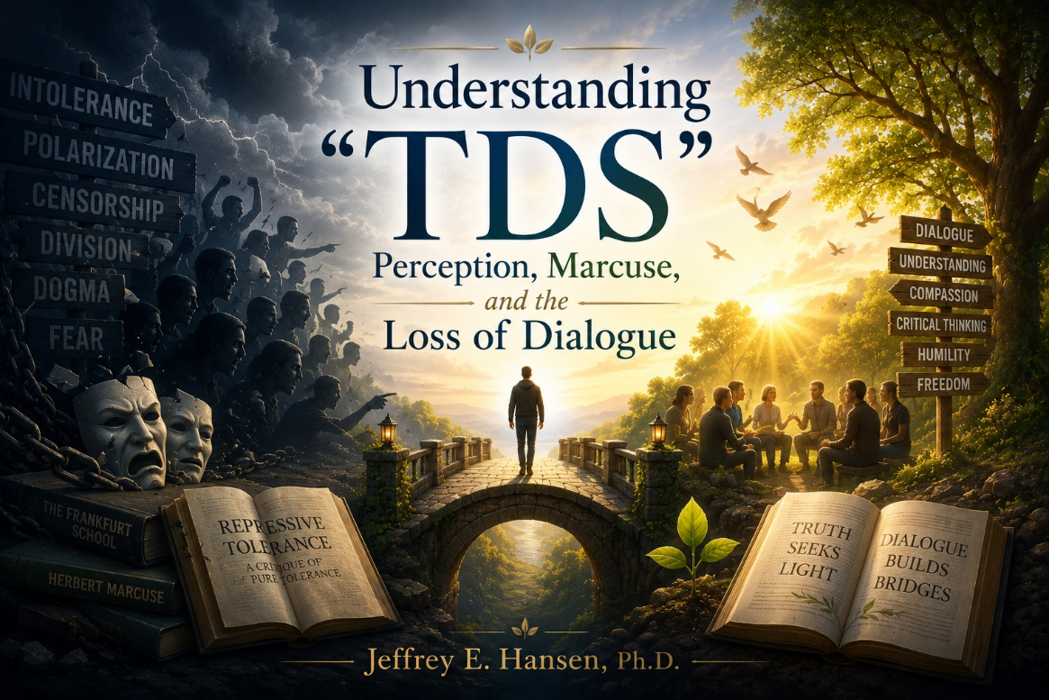
A Posture of Understanding, Not Judgment
I am trying to understand, not to judge. As I contemplate what is happening culturally and politically, I notice something that feels different from the normal tension of ideas that has always existed.
There have always been differences in perspective. The right and the left. The progressive and the conservative. The socialist and the capitalist. These tensions, when held well, create meaningful dialogue. I actually believe those discussions are beautiful.
Yet something shifted several years ago during Donald Trump’s first presidency. Whatever one’s political position, a cultural reaction emerged that did not fade when his presidency ended. It is still alive today.
Trump himself was once admired in many progressive circles as a successful developer and a larger-than-life New York figure. But when he began challenging certain progressive narratives, something ignited that, in my view, has not always been healthy.
The Loss of Dialogue
I am a strong advocate of debate. The left speaking with the right. The conservative listening to the progressive. Socialists and capitalists explaining not only what they believe but why they believe it, including the ideological assumptions and the potential costs of those beliefs.
Healthy disagreement sharpens thought. But dialogue begins to break down when one perspective is permitted while another is dismissed outright.
Herbert Marcuse and the Question of Tolerance
To understand some of the intellectual currents beneath this moment, I find myself drawn back to Herbert Marcuse, one of the central thinkers of the Frankfurt School.
Marcuse’s life story matters if we want to understand his ideas rather than caricature them. Born in Berlin in 1898 into a Jewish family, he lived through the upheaval of World War I, the collapse of the Weimar Republic, and the rise of Nazism. He watched a modern society fracture under propaganda, ideological polarization, and eventually authoritarian rule.
When the Nazis came to power, he emigrated and eventually settled in the United States, where he became a citizen and later worked in intelligence analysis during World War II studying fascist regimes. His concerns about mass persuasion, cultural conditioning, and the fragility of democratic institutions were not theoretical abstractions. They were forged in trauma.
Marcuse’s project was emancipation. He feared that societies could drift into domination while believing they were practicing freedom.
In Repressive Tolerance (1965), published in A Critique of Pure Tolerance, he argued that what appears to be neutral tolerance in liberal democracies may in fact reinforce existing power structures. He proposed what he called “liberating tolerance,” writing that it would mean intolerance toward movements from the Right and toleration of movements from the Left.
Here is where, in my view, he crossed a bridge too far.
Marcuse believed that restoring social balance required asymmetry. He suggested that speech and political movements he considered regressive or reactionary should not receive equal tolerance because equal tolerance, in his framework, only perpetuated structural injustice.
The Left, in his view, represented emancipatory potential. The Right, in many people’s interpretation of his work, represented domination.
The problem is this: once you grant yourself the authority to determine which ideas are liberating and which are oppressive, you also grant yourself the authority to suppress those you deem regressive.
The moral language becomes protective, even redemptive, but the structural outcome is constriction. It is not difficult to see how such a framework, even if born from fear of fascism, can justify narrowing speech and limiting dissent in the name of higher moral aims.
Marcuse was not a cartoon villain advocating chaos. He was attempting to prevent another descent into authoritarianism. But in redefining tolerance as selective rather than universal, he introduced a philosophical rationale for political intolerance that can easily be appropriated by future movements convinced of their own moral superiority.
Projection, Symbolic Containers, and Political Identity
And so, it has been, and so it has been done, I fear.
When intolerance is framed as virtue, disagreement can begin to feel dangerous rather than necessary. Over time, a psychological pattern can emerge in which a single figure becomes the symbolic container for collective fear, anger, and ideological threat.
In my observation, Donald Trump has become such a figure for many people. This does not mean he is beyond criticism. He is hyperbolic. He exaggerates. He is not known for humility, and many critics perceive narcissistic traits in his public persona. Those critiques belong within legitimate political discourse.
But something else seems to have happened beyond critique.
In some circles, the reaction to Trump appears less like political disagreement and more like moral absolutism, where the goal is not merely to oppose him electorally but to delegitimize, silence, or destroy him socially and culturally.
Meanwhile, political leaders on other sides of the aisle have often been treated with greater tolerance even amid public debates about leadership, age, or cognitive capacity. Supporters and critics interpret these dynamics differently, but the asymmetry itself raises psychological questions worth exploring.
At what point does disagreement become dehumanization? At what point does a political stance transform into what many people now call “Trump Derangement Syndrome,” where perception narrows so dramatically that only one narrative remains visible?

A Neuroscience Lens on Cultural Polarization
What concerns me most is the psychological pattern beneath the rhetoric.
When perception narrows, confirmation bias intensifies. Evidence that contradicts one’s viewpoint is filtered out. Nuance disappears. This is not limited to one political side. Hypocrisy and emotional reactivity exist across the spectrum. But the emotional intensity surrounding Trump has, in many cases, taken on the qualities of a cognitive rigidity that resembles a syndrome.
From a neuroscience perspective, this raises important questions. Human beings possess a beautifully developed prefrontal cortex, the executive functioning region that allows us to reflect, inhibit impulses, and integrate complex information. Emotions absolutely belong in politics. Passion matters. Conviction matters. But when emotional reactivity overwhelms executive functioning, reasoning becomes impaired.
In clinical language, we sometimes refer to this as hypofrontality, a state in which the prefrontal cortex does not sufficiently regulate more primitive emotional responses. When that happens, perception becomes binary. The world divides into heroes and villains. Dialogue gives way to outrage.
And again, this can occur on both sides of the political spectrum.
A Call Toward Compassionate Balance
My aim in writing this is not to excuse Trump’s flaws or elevate one ideology over another. Rather, I want to ask deeper questions.
Why has one political figure become such a powerful psychological trigger? What does it reveal about fear, identity, and ideological capture? And how do we return to a culture where strong disagreement does not require the destruction of another person’s humanity?
Perhaps Marcuse himself, if read carefully, offers a paradoxical lesson. A philosophy born from fear of authoritarianism can, when stripped of context and applied rigidly, unintentionally encourage its own form of intolerance.
That does not mean Marcuse was wrong in his concerns. It simply means that ideas carry psychological consequences when they move from theory into lived political identity. The deeper question is not whether someone supports or opposes Trump. The deeper question is whether we are still capable of thinking broadly, listening carefully, and allowing the prefrontal cortex to guide us toward thoughtful engagement rather than reflexive hostility.
If we lose that capacity, the issue is no longer politics. It becomes a matter of perception, cognition, and the health of our shared cultural mind. And perhaps the real work ahead is not defeating one another, but rediscovering how to think, speak, and disagree without surrendering our humanity in the process.

Jeffrey E. Hansen, Ph.D.
A Tragedy That Should Make Us Pause
The recent tragedy in Canada has weighed heavily on me. Whenever children lose their lives in acts of violence, something in all of us should pause. As clinicians, as parents, as citizens, we owe it to the victims and their families not only to grieve, but to examine honestly the conditions that surround such events. Silence may feel safer. But careful inquiry is the deeper form of respect.
I write this not as a partisan, not as an activist, and not as someone looking to score points in a cultural argument. I write this as a psychologist who has spent decades sitting across from suffering human beings, including adolescents presenting with gender dysphoria and their families, and who believes that good medicine must never be afraid of honest questions.

The Spirit in Which This Is Written
Before going further, I want to acknowledge clinicians I respect deeply, including Dr. Josef Witt-Doering and other endocrinologists and psychiatrists who have dedicated their lives to alleviating suffering. These are not reckless individuals. They are thoughtful physicians who entered medicine to help vulnerable patients.
Dr. Witt-Doering has raised concerns about insufficient informed consent and about serious adverse outcomes that, in his view, are not always fully acknowledged. He is not anti-medication. He prescribes when appropriate. But he advocates slowing down, fully informing patients of risks and unknowns, and carefully tapering when medications destabilize.
This essay is written in that same spirit: not to condemn, not to inflame, but to invite reflection where certainty has become culturally accelerated.
The Complexity We Cannot Ignore
This is not an attack on transgender-identified individuals. It is not a dismissal of the profound distress many young people experience as they struggle with identity, belonging, and coherence.
In my experience, adolescents presenting with gender dysphoria frequently carry layered burdens that predate and exceed questions of gender alone: trauma histories, sexual abuse, attachment disruptions, autism spectrum traits, depression, anxiety, loneliness, immersion in social media ecosystems, exposure to pornography, and fragile or diffuse identity formation.
In clinical reality, these underlying psychiatric and developmental vulnerabilities are far more prevalent and far more predictive of long-term instability than medication side effects alone. That weighting matters.
When young people present with that degree of vulnerability, depth should precede decisiveness. Time should precede irreversibility. Curiosity should precede certainty.
Yet many families increasingly hear that the science is settled. Careful reading of the literature, however, reveals small samples, short follow-up periods, high attrition rates, limited controls, and heavy reliance on self-report measures. Rare adverse outcomes are difficult to detect in small cohorts. Short-term improvements do not automatically translate into long-term stability.
These are methodological realities, not ideological accusations.
The Questions Raised by Emerging Data
There is also a broader societal pattern that deserves sober examination. Dr. Witt-Doering recently compiled a dataset of 16 qualifying U.S. K–12 school shootings over a defined period, identifying four perpetrators described in media accounts as transgender-identified or nonbinary.
Four cases do not establish causation. Small numbers demand caution. But when a demographic estimated to represent a small percentage of the youth population appears in a quarter of a defined dataset, further study is not unreasonable.
If there is no disproportionality, rigorous analysis will clarify that. If complexity emerges, we must examine it without scapegoating and without denial.
Asking the question is not accusation. It is inquiry.

Medication, Vulnerability, and Vigilance
Adolescents presenting with gender dysphoria experience elevated rates of depression, suicidality, and comorbid psychiatric diagnoses. Many are prescribed psychotropic medications during adolescence, a period of significant neurological development.
Antidepressants carry FDA black-box warnings regarding increased suicidal ideation in a subset of youth. That alone warrants sober informed consent. At the same time, it must be stated clearly: the overwhelming majority of young people who take antidepressants do not become violent. Underlying psychopathology — trauma, mood disorders, neurodevelopmental conditions — is far more prevalent than rare medication-induced behavioral activation.
Still, respected clinicians including Dr. Josef Witt-Doering and others have raised concerns that, in uncommon but serious cases, certain psychotropic medications may contribute to behavioral activation, akathisia, severe agitation, or impaired impulse regulation. These concerns remain debated. They are not established as population-wide causation. But controversy is not irrelevance.
When layered vulnerabilities are present, vigilance is not alarmism. It is responsibility.
Hormonal Interventions and Developmental Unknowns
Hormonal interventions likewise alter endocrine systems that directly interact with mood regulation, stress physiology, impulse control, and long-term reproductive development.
Particularly in adolescents, supraphysiologic cross-sex hormone exposure may introduce neuroendocrine instability. Emerging concerns include mood volatility, irritability, altered libido, emotional lability, fertility implications, bone density changes, and long-term metabolic consequences. In youth with preexisting trauma histories or neurodevelopmental vulnerabilities, these effects may compound existing instability.
Again, this is not an argument for prohibition. It is an argument for longitudinal humility.
What we do not yet possess are robust, multi-decade studies examining how early hormonal intervention, psychiatric comorbidity, trauma exposure, medication interaction, and identity development unfold across time.
Could early biological intervention destabilize certain vulnerable adolescents?
Could medication activation exacerbate dysregulation in rare cases?
Could layered vulnerabilities, under specific circumstances, compound risk?
We do not know.
And not knowing requires study — not silence.
A Plea to My Colleagues and to My Readers
My fellow clinician.
My fellow parent.
My fellow citizen.
Looking away may feel easier. It spares us conflict. It spares us discomfort. It spares us criticism. But when children die, when young people suffer, when developmental vulnerability meets powerful biological intervention, looking away carries its own burden.
Compassion and scrutiny are not enemies. They are partners. One without the other becomes either cruelty or carelessness.
To protect transgender-identified individuals from cruelty is right.
To protect vulnerable adolescents from premature certainty is also right.
To expand informed consent rather than narrow debate is not aggression; it is integrity.
If we refuse to reflect because reflection is uncomfortable, we drift away from the humility medicine requires.
So let us not look away.
Let us grieve deeply.
Let us study carefully.
Let us speak honestly.
Let us love fiercely.
And let us be brave enough to look, not with accusation, not with ideology, but with compassion, discipline, and the quiet courage that good science and good conscience require.

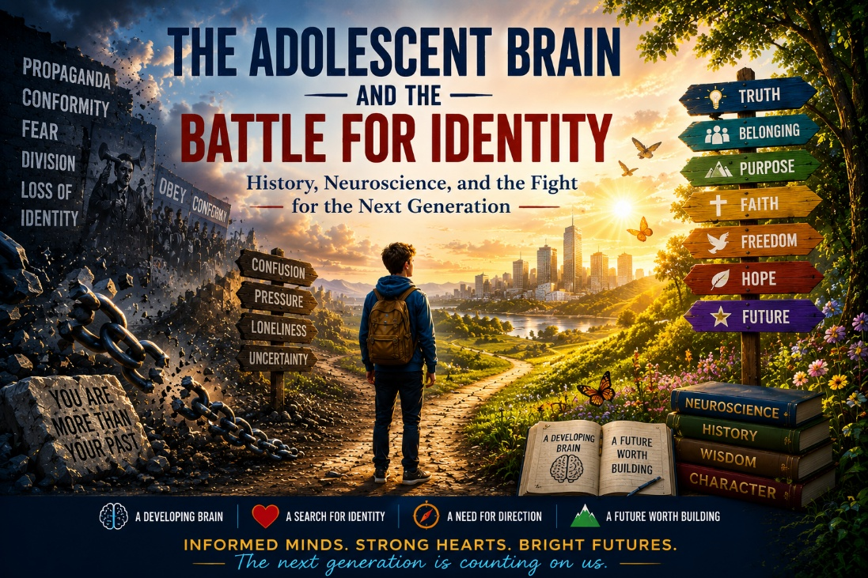
A Witness and a Question
I began listening to Xi Van Fleet not as a political exercise but as a human one. She is not speaking as an analyst. She is speaking as someone whose adolescence was formed inside one of the most radical social experiments of the twentieth century.
Born in 1950, she grew up in a China where tradition had already been declared dangerous, where religion had been pushed aside, and where the primary source of identity had shifted from family and heritage to ideological alignment. School was not first about the pursuit of truth. It was about formation. Children memorized the sayings of Mao. They sang revolutionary songs. They learned that belonging came from standing on the correct side of history.
Then, when she entered the most neurologically and psychologically powerful season of her life, the Cultural Revolution began. Young students were told that they were the pure ones, the future, the moral authority. They were given red armbands and a name, the Red Guards. They gathered by the millions and were personally affirmed by Mao himself.
Their teachers were no longer their guides. Their parents were no longer their primary source of wisdom. Tradition was no longer a gift. It was an obstacle that had to be destroyed.
For an adolescent brain, this was intoxicating. The longing for belonging was met. The hunger for purpose was satisfied. The desire to matter was fulfilled. Their individuation was not a gradual differentiation within relationship. It was a call to sever the past in order to become the future.
And then, when the chaos they helped unleash threatened the stability of the nation, they were no longer needed. The army restored order. The Red Guards were dissolved. Millions of those who had been told that they were the future were sent away to remote rural areas. They lost their education. They lost their opportunities. They lost the identity that had been given to them.
History calls them the lost generation. The movement that gave them identity took away their future.
What Mao Understood and What We Now Know

Mao did not know the language of neuroscience. He did not know about synaptic pruning, dopaminergic reward systems, or prefrontal cortical maturation. But instinctively he understood the most powerful force in any society. He understood the adolescent brain.
He understood that there is a season in human development in which belonging carries more weight than safety, in which moral clarity is more compelling than complexity, and in which a young person is ready to give their entire life to a cause that promises meaning.
We now understand this scientifically. Between the ages of roughly thirteen and twenty-five, the brain undergoes massive reconstruction. It produces an overabundance of synaptic connections and then begins to prune them, strengthening the pathways that are used and eliminating those that are not. Experience becomes structure. The environment wires the brain.
At the same time the limbic system is highly activated. Reward sensitivity is elevated. Peer approval carries extraordinary neurological power. The prefrontal cortex, the region responsible for long-term planning, reflection, and impulse regulation, is still being myelinated and gradually brought online.
This is the design that allows a young person to give themselves to faith, to love, to sacrifice, to a vocation, to a cause larger than the self. But it also means that whatever captures their allegiance in this window becomes biologically embedded.
The adolescent brain is not just learning what to think. It is becoming someone.
The Crisis of the Anxious Generation
Now we place that developmental reality beside the data from our own culture. Since the early 2010s rates of anxiety and major depression among teenagers have roughly doubled. Self-harm severe enough to require emergency medical care has nearly tripled among young adolescent girls. Suicide among children as young as ten to fourteen has risen at a rate that should stop any society in its tracks.
Sleep has declined. Face-to-face interaction has diminished. Sustained attention has been fractured. This is not a small shift.
It is a developmental earthquake.
Our young are not weak. They are being formed in an environment that is not producing resilience. A brain that requires embodied belonging is being raised in a disembodied world.
When Formation Moves Away from the Family
And into that environment come comprehensive systems of meaning. In many educational and social settings today, young people are not only being taught academic content. They are being given interpretive frameworks that tell them who they are, how to understand their bodies, how to interpret their history, and where their moral standing lies.
These frameworks are not experienced as abstract theories. They are experienced as belonging. When moral worth is tied to one’s location in a hierarchy of power, a young person is not simply learning sociology. They are learning their identity.
When biological reality is presented as secondary to internally declared identity, the adolescent is not merely encountering a philosophical claim. They are being asked to ground their sense of self in a framework while the neurological systems required for long-term integration are still under construction.
When inherited faith is presented primarily as a source of harm rather than as a living tradition to be explored, the young person experiences not an intellectual critique but a distancing from the deepest sources of meaning in their family.
There is also a growing dissonance between developmental readiness and the content many children are being exposed to. When the world of adult sexuality enters the consciousness of a child before the brain and body are ready to integrate it, the result is not liberation but confusion.
The developmental sequence that once allowed for the gradual integration of body, relationship, and meaning is disrupted.
In my clinical work I sit with parents and children who love one another and yet find themselves unable to speak across an identity boundary that feels absolute. Not because of abuse, but because belonging has been relocated. Disagreement is experienced as annihilation. Individuation has become severance.
This is not simply a political conflict. It is an attachment crisis.
Why Distress Makes Capture Easier
A generation that is anxious, depressed, sleep-deprived, and socially fragmented does not stop searching for identity. It searches more urgently. Pain intensifies the need for belonging. Isolation intensifies the need for recognition. Confusion intensifies the appeal of moral certainty.
The adolescent brain will give itself to something. And systems that offer immediate affirmation, clear categories, and a sense of purpose become neurologically and psychologically irresistible.
A Call to Formation, Not Fear
And this is where I refuse despair. Because the adolescent brain is not broken. It is the most powerful engine for renewal in any civilization. It is designed for transcendence.
Now that we understand the neuroscience, the developmental psychology, and the cultural moment, we are not helpless observers. We are responsible stewards.
The answer is not to capture our young for a competing ideology. The answer is to form them in environments so rooted in truth, so embodied in love, and so enduring in relationship that they do not have to choose between identity and belonging.
We must rebuild families, faith communities, and educational environments in which a young person can explore difficult questions without severing relationship, can examine history without despising their origins, and can inhabit their body as a gift rather than as a problem to be solved.
Because the adolescent brain will give itself to something. Our task is to ensure that what it gives itself to is worthy of the majesty of its design.
What Xi Van Fleet offers us is not a political argument but a generational memory. She stands as a witness to what happens when the deepest developmental longings of the young are captured and redirected away from family, history, and embodied belonging.
Her story is not ours, and our children are not being sent into rural exile. But we would be naïve not to recognize that there are forms of exile that are not geographic. There is an exile of disconnection, an exile of confusion, an exile in which a young person becomes a stranger to their own body, their own history, and sometimes even to their own family.
History does not ask us to repeat itself. It asks us to pay attention.
And because we can see, because we can understand, and because we can love, we are not bound to the same outcome. We listen, we learn, and we will choose differently.
The Future
The future of our culture will not be determined first by elections or institutions. It will be determined by whatever captures the allegiance of the adolescent heart.
And that means the most important work before us is not control.
It is formation.

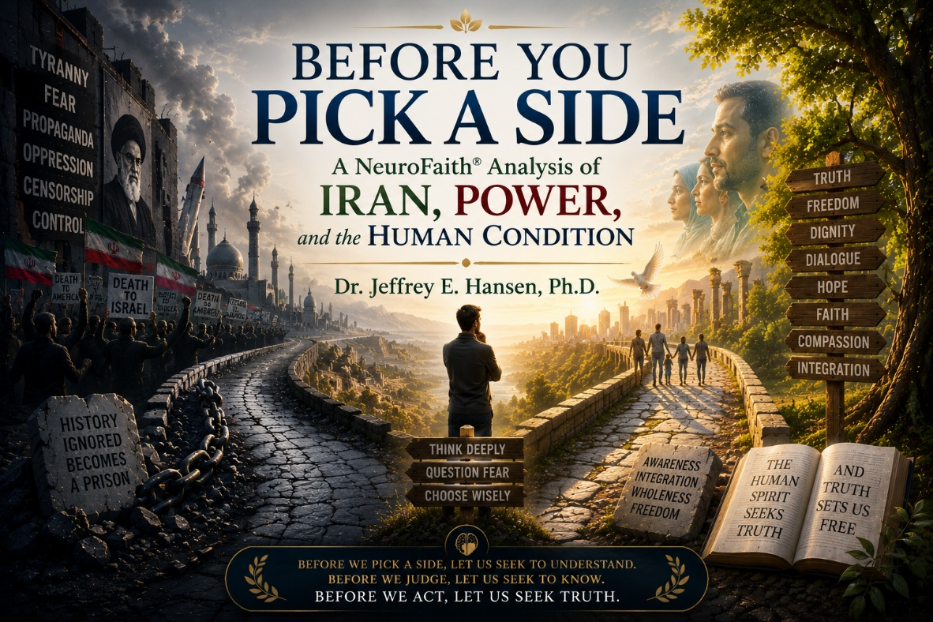
Preamble: Before We Pick a Side
As a psychologist, I would like to think that I am a critical thinker. That is, after all, what a PhD is meant to cultivate. We are trained to analyze situations, to examine data, to hold competing ideas in tension, and to resist the very human urge to rush toward certainty. At our best, we learn to slow down, to observe carefully, and to remain open to being wrong.
I am not claiming expertise as a historian, and I am certainly not suggesting that my interpretation is flawless. What I am offering here is my read, my attempt to understand a complex and often emotionally charged story. I invite you, my friend and reader, to think alongside me. If I have something wrong, I genuinely want to know. This is offered in humility, not certainty.
Before we pick a side, it is worth asking whether we have truly understood what we are choosing between. There are moments in history when taking a stand becomes necessary, when the future of our children and the dignity of human life require clarity and courage. But too often, many of us, myself included at times, have aligned ourselves with a position without doing the deeper work of reflection. We may feel strongly, even passionately, but without understanding the history, the psychological forces at play, or the systems of power that shape outcomes, our convictions can become reactions rather than reasoned positions.
What I am attempting here is something different. I want to slow the process down. I want to look at history not simply as a sequence of events, but as an expression of the human condition. I want to consider the psychological dynamics, the lived experience of people within these systems, and the ways in which power shapes perception, behavior, and belief over time.
In that spirit, it is worth briefly acknowledging the work of Andrzej Łobaczewski in Political Ponerology, where he explored how pathology can emerge within systems of power. His work suggests that under certain conditions, individuals with distorted patterns of thinking and diminished empathy can rise to positions of influence and begin shaping institutions in ways that normalize distortion and suppress dissent. While his focus was primarily political, other contemporary thinkers, such as Michael Rectenwald in The Great Reset and the Struggle for Liberty, have expanded the conversation by examining how similar dynamics can appear across broader social and institutional structures.
These ideas are not easy to sit with. They ask something of us. They ask us to look more carefully, to think more deeply, and at times, to acknowledge that there may be aspects of human systems that are not simply misguided, but at times can become distorted in ways that are difficult, even unsettling, to name. Not so that we become cynical or fearful, but so that we do not look away. Because if we are unwilling to see clearly, we risk participating in patterns we do not fully understand.
And I want to do all of this through the lens of NeuroFaith®, which calls us to remain honest about what is happening within us at every level, mind, body, and soul. There is a spiritual dimension to all of this that cannot be ignored. Human history is not merely political or economic. It is moral. It is existential. It is deeply spiritual.
The Shadow Within Systems
When we look at nations, we are often looking at amplified versions of the same conflicts that exist within the human heart. The same pull toward truth and distortion. The same tension between fear and freedom. The same struggle between the shadow and the deeper, more integrated self.
What we are describing here is what Carl Jung referred to as the shadow, those aspects of ourselves that we do not want to see, that we push out of awareness, deny, or project onto others. The shadow is not simply evil in a simplistic sense. It often contains fear, insecurity, woundedness, and unintegrated parts of the self that, when left unexamined, can express themselves in distorted ways. Individually, this can lead to defensiveness, projection, and reactivity. Collectively, it can shape cultures, movements, and even nations.
When the shadow is not acknowledged, it does not disappear. It organizes. It influences behavior from beneath the surface. It seeks expression, often in ways that distort perception and justify actions that, in a more integrated state, would be recognized as harmful or misaligned with truth.
But Jung was equally clear about something else. The goal is not to eliminate the shadow, but to become aware of it, to integrate it, and to bring it into conscious relationship with the rest of the self. Because it is only through awareness and integration that we move toward wholeness.
And this, in many ways, is the deeper task, not only for individuals, but for systems, and perhaps even for nations.
The Rise of Power and the Possibility of Integration
To understand the modern tensions surrounding Iran and the broader Middle East, we have to go back thousands of years. What we now call Iraq and Iran did not exist as nations in the modern sense, but geographically Babylon was located in what is now Iraq, and the Medes and Persians emerged from what is now Iran. These two regions, separated in part by the Zagros Mountains, developed differently, and those differences matter.
In the lands of Mesopotamia, corresponding roughly to modern Iraq, some of the earliest city-states and empires emerged. Among the most dominant of these was the Assyrian Empire, which rose to power through extraordinary military strength and an unambiguous willingness to use fear as a tool of control.
Their methods were not subtle. They ruled through intimidation, public displays of brutality, and the systematic crushing of opposition. From a psychological perspective, this reflects an unregulated expression of power, where control is maintained through the chronic activation of threat.
Eventually, even such systems fracture. Around 612 BC, an alliance between the Medes, located in the region of modern Iran, and the Babylonians, located in what is now Iraq, brought the Assyrian Empire to an end. This reflects a recurring pattern in human systems. When domination becomes extreme, it generates resistance, and that resistance often takes the form of coalition.
What followed was not harmony, but division. Babylon rose as the dominant power in the west, while the Medes controlled much of the Iranian plateau to the east. These were distinct systems shaped by geography and culture. Babylon represented structure, organization, and centralized authority, while the Medes and later the Persians reflected a more adaptive and expanding identity.
It is into this divided world that Cyrus the Great enters. Around 550 BC, he defeats the Medes and unites the Medes and Persians. What distinguishes Cyrus is not simply conquest, but integration. He does not erase what he conquers. He incorporates it.
In 539 BC, he conquers Babylon. Yet rather than destroying it, he allows its culture, religion, and institutions to remain intact. From a NeuroFaith® perspective, this represents a meaningful shift toward regulation. Power is still present, but it is no longer expressed purely through fear. It becomes more integrated, more stable, and more coherent.
This does not eliminate the shadow. Cyrus is still an empire builder. But something changes. Power begins to move, however imperfectly, from domination toward integration. That movement toward integration, however, would not remain stable across time.
From Empire to Revolution
Over time, the Persian Empire expanded and eventually fell. In 651 AD, following the fall of the Sasanian Empire, Islamic conquest reshaped the region of modern Iran, transforming its cultural and religious identity. This was not merely a political transition, but a profound shift in worldview, embedding new religious and philosophical frameworks into the fabric of society.
Centuries later, the Safavid Dynasty established Shia Islam as the state religion, intertwining belief and governance in a way that would shape identity for generations. Power and faith became tightly interwoven, creating both cohesion and constraint within the system.
In the modern era, the Pahlavi rulers attempted rapid modernization. Under Mohammad Reza Shah, Iran became increasingly aligned with the West. Infrastructure improved, education expanded, and society modernized at a rapid pace. Yet alongside this progress, political repression intensified. Dissent was constrained, opposition was suppressed, and the system became increasingly centralized and top down.
As we see repeatedly across history, when control tightens too far, pressure builds beneath the surface. What may appear stable externally often carries accumulating tension internally, both within individuals and within societies.
By the late twentieth century, that pressure reached a breaking point. The accumulated strain, political, cultural, and psychological, could no longer be contained. In 1979, it erupted.
Where We Find Ourselves Now
The Iranian Revolution overthrew the monarchy and established a new system rooted in religious authority. What began as a movement against authoritarian control became another form of centralized power, now fused with a rigid ideological structure. Over time, that structure has created a level of tension that is not merely political, but deeply human, lived out in the bodies, minds, and daily experiences of the people themselves.
This is where clarity matters. The Iranian people are not the regime. They are a deeply historic and intelligent people, carrying within them a rich legacy of culture, philosophy, poetry, and resilience. There is something enduring within them that has survived empire after empire, a depth that cannot be reduced to any single political system.
From an Internal Family Systems perspective, we might describe a core Self within a people, marked by calm, curiosity, clarity, compassion, confidence, courage, creativity, and connectedness. In spiritual language, we might recognize the fruits of the Spirit, love, joy, peace, patience, kindness, goodness, faithfulness, gentleness, and self-control. This reflects the higher expression of human nature, and it does not disappear, even under pressure.
At the same time, we must be honest about the shadow. From a NeuroFaith® perspective, when systems become organized around fear, control, and rigidity, belief can harden into dogma. When dogma is enforced through power, it suppresses curiosity, punishes dissent, and constrains the human spirit.
This is not a rejection of faith itself, but a recognition of what happens when faith becomes fused with control and loses its capacity for humility, flexibility, and truth.
The Nervous System of a Nation
If we bring in neuroscience, the picture becomes even more compelling. When the human nervous system is regulated, there is coherence between the heart, brain, and body. There is flexibility, clarity, and the capacity to respond rather than react.
But when a system is dominated by chronic threat, it shifts into survival states. It becomes rigid, reactive, or shut down. Heart rate variability constricts. The system loses its rhythm and its capacity for integration.
Now imagine living within that, not as a theory, but as a daily reality. A system in which expression is constrained, where vigilance is required, and where the cost of speaking freely can be high. That level of sustained tension is not just political pressure. It is physiological. It is carried in the nervous system and felt in the body as tightness, anxiety, guardedness, and a constant calibration of what is safe and what is not.
Over time, that kind of environment shapes how people think, how they relate, and how they experience themselves.
And yet, this is the part we must not miss. The nervous system is not designed to remain in a state of chronic dysregulation. The body moves toward healing. A wound begins to close. A broken bone reorganizes. Even a disrupted heart rhythm seeks to return to coherence. The human system is oriented toward restoration, toward integration, toward wholeness.
What is true biologically is often true collectively. A nation, like a body, carries within it that same movement toward healing. What we are witnessing, even in the anguish and the tension, is not only dysregulation, but also the expression of that deeper drive toward dignity, toward freedom, and toward a more integrated way of being.
Bringing It Home
If that is true, then the question before us is not simply what is happening there, but how we choose to see and respond to it.
This leaves us with a choice, not merely a political one, but a deeply human one. We must decide whether we want truth or illusion, honesty or self-deception, coherence or fragmentation, authenticity or performance. The unexamined life is not worth living, and the same is true of unexamined beliefs, allegiances, and narratives. If we are not willing to examine what we believe, we will inevitably be shaped by forces we do not fully understand.
Psychology teaches us that negative core beliefs distort perception. Trauma, fear, and unresolved pain shape how we interpret reality, often without our awareness. What is true for the individual can also become true for families, communities, and nations. Systems can begin to organize around distortion, losing coherence and connection to reality, not because people are inherently evil, but because fear and control begin to replace truth and integration.
From a NeuroFaith® perspective, this is where the language of regulation and coherence becomes essential. When the human nervous system is regulated, there is alignment between heart, brain, and body. There is clarity, flexibility, and the capacity to respond rather than react. But when a system is dominated by chronic threat, it narrows, rigidifies, and moves toward control or collapse. And what is true biologically can become true collectively.
This is why truth matters. Not simply as a moral ideal, but as the foundation of integration itself. Honesty allows alignment. Without it, the system fractures. Without it, perception becomes distorted, and decisions are made from fear rather than clarity.
And yet, even here, there is reason for hope. There appears to be a core within the Iranian people, as within all people, that longs for freedom, dignity, and authentic expression. In the language of Internal Family Systems, this reflects the Self. In spiritual language, the fruits of the Spirit. This is the part that seeks life, truth, and relationship.
The task, then, is not to choose denial or despair, but to see clearly. To hold both realities at once. To recognize the dignity within a people and the distortion within systems, and to resist the pull toward simplistic narratives that divide the world into easy categories.
So study your history. Think carefully. Examine deeply. Pay attention not only to what you are told, but to how it resonates within you, in your body, in your mind, and in your conscience. Stay grounded. Stay curious. Stay honest.
Choose wisely, my friend. Choose with humility. Choose with courage. And pray that we all choose wisely, because the future will always be shaped, in part, by what we are willing to see clearly and live out truthfully.
And even in the tension, there is reason for hope. Because wherever truth is pursued, wherever honesty is embraced, wherever coherence is restored, and wherever human dignity is defended, the possibility of restoration remains, not just for nations, but for each of us.


Understanding the Tension
I have found myself thinking a lot lately about Iran. And when I start thinking deeply, it can be a little dangerous, because I do not want to oversimplify something that is profoundly complex. But I do want to understand. I want to understand my Iranian brothers and sisters. I want to understand the immense tension they are living in, not just politically, but psychologically and spiritually.
I will be the first to admit that I am not a scholar of ancient religions, and I am not a historian. I am a clinical psychologist. I try to understand people, how they think, how they struggle, and how they heal. I see the world through the lens of psychology and neuroscience, through years of clinical work, and through my Christian faith. What I offer here is not a definitive account of history or theology, but an attempt to understand something deeply human from the lane I know best.
That curiosity led me backward in time into the ancient roots of Persian civilization, and into a tradition many in the West rarely think about anymore: Zoroastrianism.
Founded by the prophet Zoroaster thousands of years ago, Zoroastrianism was one of the earliest traditions to frame human life in deeply moral terms. Truth versus falsehood. Good versus evil. A life of integrity defined by what one thinks, says, and does. And perhaps most striking, the idea that human beings are not passive observers in the world, but active participants in a moral reality where their choices carry real weight.
For those of us in the Jewish and Christian traditions, it is worth pausing to recognize that some of these themes did not develop in isolation. During periods of Persian influence, elements of moral accountability, the afterlife, and the ultimate triumph of good over evil became more clearly articulated. In that sense, this ancient Persian worldview has quietly influenced far more of the modern world than most people realize.
Now I am not suggesting that modern Iranians are Zoroastrian. Far from it. The number of practicing Zoroastrians today is relatively small worldwide. But cultural and historical influences do not simply disappear. They echo. They leave impressions. They shape how a people understands truth, authority, and moral responsibility, even across centuries.
Historical Irony and Present Reality
It is also difficult to ignore the historical irony that sits quietly in the background of all of this. Nearly twenty-five hundred years ago, Cyrus the Great ruled over the Persian Empire and became known, in part, for a style of leadership that allowed diverse peoples to maintain their traditions and beliefs. The Cyrus Cylinder is often pointed to as an early expression of this approach, describing policies that permitted displaced communities, including the Jewish people, to return to their homeland and practice their faith.
It is also worth noting, especially for those of us in the Christian tradition, that Cyrus the Great is not an obscure historical figure. He is someone we are already familiar with from Scripture. He is the king who allowed the Jewish people to return to their homeland after their captivity in Babylon, restoring their ability to rebuild and practice their faith.
That moment stands as a powerful example of leadership that did not require uniformity of belief but instead made space for it.
While it would be an overreach to impose modern categories of religious freedom onto the ancient world, there remains something striking about that legacy. It reflects a form of governance that, at least in part, recognized the importance of allowing individuals and communities to live in accordance with their beliefs rather than forcing uniformity.
History continued to unfold, and in the seventh century, Islam entered Persia and, over time, became deeply woven into Iranian identity. That story is not merely one of replacement, but of integration, development, and complexity. Islam itself carries profound ethical, philosophical, and spiritual traditions, and for many Iranians, it is lived as a deeply personal and meaningful faith.
And yet, when we turn to the present, we are confronted with a very different reality. In recent years, there have been documented crackdowns, imprisonments, and the killing of thousands of Iranian citizens in response to dissent. This is not theoretical. This is not abstract. These are real lives, real families, real people navigating immense pressure and, at times, profound danger.
Naming that reality matters. Not to inflame, not to generalize, but to acknowledge that the tension we are discussing is not simply philosophical. For some, it carries real-world consequences that are difficult for most of us to fully grasp.
NeuroFaith® Perspective
And yet, when religion becomes fused with political power and enforced from the outside, something begins to change, not only socially, but neurologically.
From a NeuroFaith® perspective, the human nervous system is exquisitely sensitive to the difference between safety and threat. When a person experiences coercion, pressure, or fear, the system shifts out of relational safety and into protection. The body mobilizes or shuts down. The mind narrows. What could have been meaningful becomes something to survive rather than something to integrate.
In those states, truth does not take root in a deep or lasting way. The individual may comply outwardly, or resist internally, or move back and forth between the two, but the system itself is not organized for transformation. It is organized for survival.
By contrast, when a person encounters truth in a context of safety, something very different becomes possible. The nervous system settles. There is space for reflection rather than reaction. The individual becomes capable of engaging, questioning, and ultimately internalizing what is being experienced. In the language of neurocardiology, this movement toward internal alignment can be understood as a shift toward coherence, where the heart, the brain, and the lived experience of the person begin to come into synchrony.
What emerges from that state is not compliance, but integrity. Not as a rule imposed from the outside, but as a congruence that arises from within, where what a person believes, feels, and lives are no longer in conflict.
This is why authentic faith cannot be sustained through force. Real transformation requires engagement, freedom, and the space for truth to be encountered and owned at a deeply personal level.
Final Reflection
When I look at what is unfolding in Iran, I do not see a simple conflict between one belief system and another. I see what happens when external systems begin to override internal agency.
What becomes clear is that this is not uniquely an Iranian story. It reflects something far more universal about the human condition. The longing for truth, for dignity, for freedom, and for a life that feels internally aligned is deeply human.
And perhaps this is where we all need to slow down a bit. It is easy to make quick judgments about other people, other cultures, and other belief systems. But if we are honest, things are rarely that simple.
Human beings are complex. Cultures are layered. And when we take the time to understand rather than judge, something important begins to shift in us as well.
And perhaps, in the end, the deeper question is whether there is true rest in one’s roots, in those ancient Zoroastrian themes of truth, integrity, and personal moral responsibility, where what one believes, what one speaks, and how one lives are meant to align, or whether, in certain environments, safety is found in remaining within the dominant structure, even when that structure feels misaligned internally, because stepping outside of it can carry very real risk.
In those moments, the tension between safety and integrity is no longer theoretical. It becomes deeply personal, lived out in the nervous system, where the pull toward protection can override the movement toward alignment, not because the person has lost sight of what is true, but because the cost of living it out may simply be too high.
And perhaps that is where humility is most needed, because for many of us, the distance between what we believe and what it costs to live it is not nearly as great. But for others, that distance can be measured in relationships, in livelihood, and at times, even in life itself.
So, before we rush to judgment, before we reduce complex realities into simple narratives, perhaps we are invited to slow down, to listen more carefully, and to recognize that what we are witnessing is not simply a conflict of ideas, but a human struggle to reconcile truth, safety, and identity in a world that does not always make space for all three.
And in that recognition, there is an opportunity, not only to better understand others, but to examine our own lives with greater honesty, asking where we are aligned, where we are divided, and where we may still be learning what it means to live with integrity in the presence of real-world pressures.
Because in the end, things are rarely simple, but they are often more

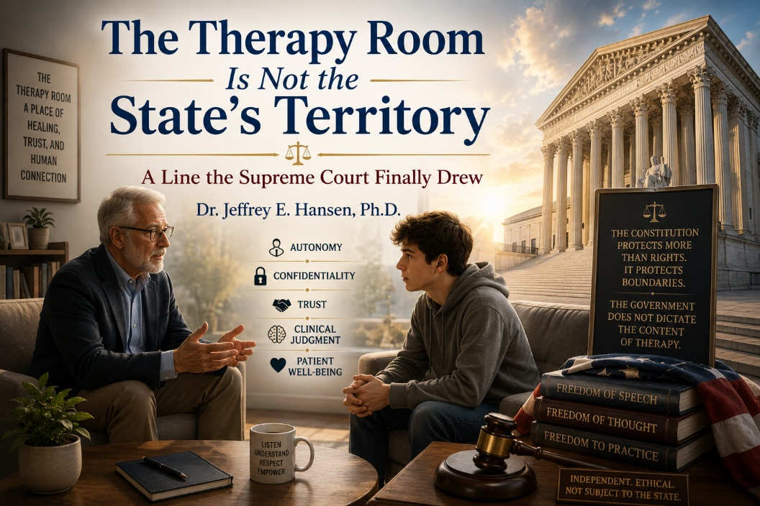
For years now, there has been a slow and unmistakable encroachment into one of the most protected and sacred spaces in our culture, the therapy room. It did not happen all at once, and that is precisely why it was so easy to miss at first. It came gradually, almost quietly, advancing inch by inch. First as guidance. Then as regulation. And eventually as something far more concerning, far more intrusive, the attempt to control what therapists are allowed to say, what questions they are permitted to ask, and which directions of inquiry are deemed acceptable or unacceptable by forces outside the room.
And that is where the line was crossed.
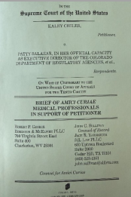
On March 31, 2026, in Chiles v. Salazar, the Supreme Court of the United States stepped in and drew a line that should never have been crossed in the first place. In an 8 to 1 decision, the Court made it unmistakably clear that the government does not have the authority to dictate the content of therapy based on preferred viewpoints. That is not regulation. That is not benign oversight. That is overreach, and it is precisely the kind of overreach the Constitution exists to restrain. This ruling did not merely resolve a legal question. It restored something that had been under increasing pressure, something foundational, something that cannot be compromised without doing harm to the very people therapy is meant to serve. It restored the integrity of the therapeutic relationship.
How We Got Here
To understand the weight of that decision, you have to understand what was happening in Colorado. Under the stated goal of protecting minors, the state enacted a law that reached directly into the therapy room and began defining what licensed clinicians could and could not explore in conversations related to identity, particularly gender identity. On its surface, it sounded protective, even compassionate. It was framed in the language of care. But in practice, it functioned as a constraint on clinical judgment. It replaced the nuance of individualized care with a predetermined boundary around what was considered acceptable exploration. It substituted the lived, relational, moment to moment discernment of a trained clinician with a rigid, externally imposed framework.
It did not trust the therapist.
It did not trust the patient.
It trusted the state.
The named respondent, Patty Salazar, served as the Executive Director of the Colorado Department of Regulatory Agencies, an administrative position responsible for oversight across a wide range of professions. It is a role rooted in policy, compliance, and enforcement. It is not a role grounded in psychotherapy. It is not shaped by years of sitting with patients, working through trauma, identity confusion, developmental struggles, attachment wounds, and the deeply human process of meaning making. And yet, through that office, the state assumed the authority to define what constitutes appropriate therapeutic conversation.
That should give every clinician, every parent, and every citizen pause.

Because if that authority stands, the therapy room ceases to be a place of exploration and becomes a place of compliance.
When Regulation Becomes Control
Because the question in this case was never simply about protecting patients. Ethical clinicians are already bound, rigorously and rightly, to protect those they serve. We are accountable to ethical codes, licensing boards, professional standards, and most importantly, to the well-being of the human being sitting across from us. The real question was whether the state could go further, whether it could begin to prescribe how therapy must unfold, what must be affirmed, what may not be questioned, and which avenues of exploration are effectively closed off, regardless of the patient’s own stated goals, experiences, and internal conflicts.
When that occurs, something essential begins to erode. The therapeutic space narrows, not because of clinical judgment, but because of externally imposed limits on what may be explored and understood. At that point, therapy no longer functions as a process of discovery grounded in the patient’s experience. It becomes, in effect, a state directed dialogue, shaped less by the needs of the individual and more by predetermined boundaries of acceptable thought.
That is a profound shift, and a dangerous one.
Why We Stepped Forward
This case drew national attention because many of us recognized what was at stake and chose not to remain silent. I had the privilege, and I would say the responsibility, of contributing to an amicus curiae brief, titled Amicus Curiae Brief of Medical Professionals in Support of Petitioner, alongside colleagues who are not abstract voices, but seasoned professionals with deep expertise across medicine, endocrinology, pediatrics, and clinical care. Among those who stood together in this brief were the distinguished and widely respected Michelle A. Cretella, M.D., Executive Director of the American College of Pediatricians; Michael K. Laidlaw, M.D., an endocrinologist and expert in hormone physiology; Quentin L. Van Meter, M.D., a pediatric endocrinologist and former president of the American College of Pediatricians; André Van Mol, M.D., a board-certified family physician and co-chair of the American College of Pediatricians’ Committee on Adolescent Sexuality; and Maria Keffler, an author and public speaker focused on parental rights and child advocacy. Alongside them, I contributed as a clinical psychologist, grounded in decades of work with adolescents, trauma, identity formation, and the layered psychological realities that unfold in the therapy room. These are not theoretical voices. These are clinicians, physicians, and professionals who have spent their lives working with real patients, real families, and real suffering. These are individuals who carry responsibility, not just opinion. And we stepped forward together, not because it was easy, but because it was necessary.
Because there are moments when silence becomes complicity.
And this was one of those moments.
The Critical Distortion
At the heart of our concern was a growing and deeply problematic conflation, one that has been repeated often enough that it has begun to take on the appearance of truth. Historically, what has been called conversion therapy referred to coercive attempts to change sexual orientation. These practices were often ethically indefensible and, in many cases, harmful. They have been widely rejected, and rightly so.
There is little disagreement on that point within the profession. In recent years, however, the meaning of that term has expanded in ways that collapse fundamentally different forms of therapy into a single category.
Exploratory therapy, which is careful, patient directed, and grounded in ethical clinical practice, has increasingly been drawn into that same label. In doing so, an important distinction has been lost. This concern has been articulated clearly by Debra Soh, Ph.D., a sexologist and former academic researcher whose work has been published in peer reviewed scientific journals, including research conducted at institutions such as York University. Though generally regarded as politically liberal leaning, she has been notably willing to challenge ideological overreach from within her own side. In her book The End of Gender, she describes how the term conversion therapy has been inflated through conflation, expanding beyond its original meaning in ways that erase critical distinctions. What follows is not simply imprecision, but a critical distortion of meaning that reshapes the conversation, misrepresents the nature of therapeutic work, and obscures the ethical boundaries that actually matter.
This is not a minor semantic issue. It is a meaningful mischaracterization that carries real consequences for both clinicians and patients. When a patient says, “I do not want to move in a certain direction, but I need to understand why I feel this way,” the ethical response is not to shut that down. It is not to redirect them toward a predetermined outcome or to foreclose exploration before it has even begun.
The ethical response is to engage the question fully and thoughtfully. It is to explore developmental history, trauma, relational patterns, identity formation, and the broader psychological landscape in which that experience has emerged. It is to remain grounded in the patient’s stated goals while bringing clinical skill, curiosity, and care to the process.
That is not coercion. It is appropriate and responsible clinical care.
That is therapy.
What the Court Restored
The Court recognized this issue for what it truly is. It affirmed that therapy is, at its core, speech, deeply personal, exploratory, and meaning-making speech that unfolds in the context of trust and professional responsibility. To regulate that kind of speech based on viewpoint is not simply a matter of policy or preference; it crosses into unconstitutional territory by restricting the very process through which individuals come to understand themselves. In doing so, the Court drew an important line, one that protects not only clinicians, but the integrity of the therapeutic relationship itself.
For those of us who have spent our lives engaged in this work, the implications are both immediate and profound. Therapy is not a scripted exchange or a predetermined outcome. It is a process of discovery, often nonlinear and at times uncomfortable, where patients are given the space to examine their thoughts, emotions, beliefs, and experiences without coercion or constraint.
When a patient sits down and says, “Help me understand myself,” they are not asking for direction imposed from the outside. They are asking for guidance in making sense of their own internal world, and that requires freedom, freedom to explore, to question, and to arrive at meaning in a way that is authentic to them. This ruling restores and reinforces that freedom. It allows clinicians to practice ethically and responsibly, grounded in their training and professional judgment, without the fear that certain lines of inquiry are off-limits simply because they challenge prevailing viewpoints. It safeguards the therapeutic space as one where truth can be pursued, not prescribed, and where the goal is not ideological conformity, but genuine understanding and healing.
A Final Word
There is one final point that must be said, and it needs to be said without hesitation. What has unfolded in recent years is not merely a shift in clinical thinking. It reflects a bending of language, a collapsing of essential distinctions, and a movement away from the disciplined clarity that our profession depends on. When that clarity is lost, the consequences are not abstract. They are borne by patients.
We cannot afford that.
Words must mean what they mean if our work is to remain grounded and ethical. A practice rooted in coercion cannot be equated with a process rooted in exploration, and a framework built on predetermined outcomes cannot be confused with one grounded in patient autonomy.
When a patient enters the room seeking to understand their own internal experience, the ethical obligation is not to narrow that path, but to walk it with them carefully and thoughtfully, without imposing conclusions that are not their own. That is not coercion.
That is therapy.
Therapy is not a tool of the state, nor is it a vehicle for ideology. It is a disciplined, relational, deeply human process that requires humility, restraint, and the courage to sit with complexity. It calls the clinician to respond to the individual in front of them, not to an abstract framework, not to a cultural mandate, and not to pressures that originate outside the room. When that freedom is constrained, even subtly, the work itself is compromised.

This moment also calls for reflection among the institutions that shape the field. The American Psychological Association, the American Academy of Pediatrics, the Endocrine Society, and others hold immense influence, and with that influence comes responsibility, to precision, to science, and to truth. When those anchors drift, the consequences do not remain theoretical. They show up in the therapy room, and they show up in the lives of patients.
To my colleagues, both those who have stepped forward and those who are watching carefully, this is a moment that requires clarity and courage. There is risk in being visible, and there is risk in attaching your name to positions that will be challenged, scrutinized, and at times opposed. But there is also responsibility, responsibility to the profession, responsibility to the science, and above all, responsibility to our patients. Some things are worth that risk. We do not step forward because it is comfortable. We step forward because it is necessary, because truth requires it, because our profession depends on it, and because our patients deserve it.
And we must be willing to say plainly what is true. A rock is a rock. A tree is a tree. Exploratory therapy is not coercion. Inquiry is not harm. Listening is not abuse. The therapy room belongs where it has always belonged, in the space between clinician and patient, grounded in trust, guided by ethics, and oriented toward truth, not the state, not ideology.
Truth.
And that is not something we will surrender.

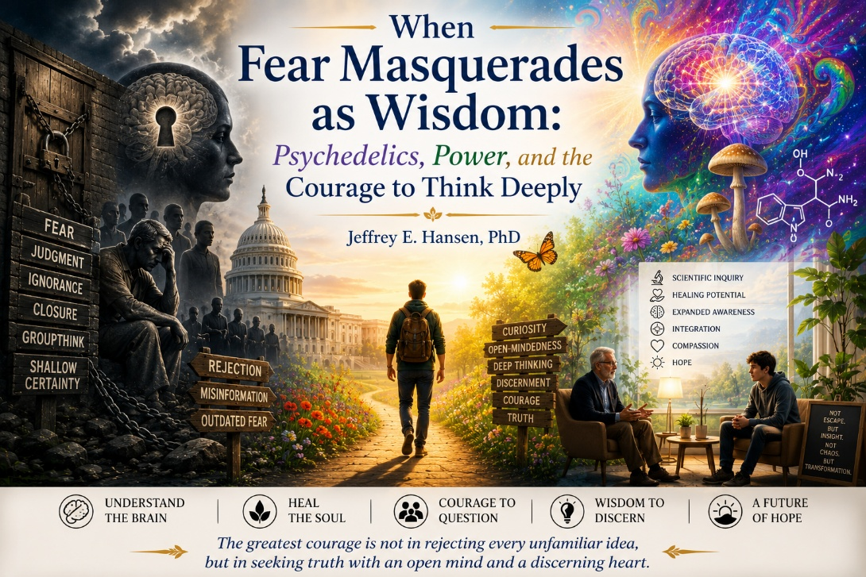
There is something in us, especially within certain cultural and religious communities, that reflexively shuts the door on unfamiliar ideas. We do not always examine them carefully. We do not sit with them long enough to understand them. Instead, we label them, often quickly, sometimes confidently, and then we move on, reassured by our own certainty. At times, that instinct protects us. But at other times, it is not wisdom at all. It is fear, dressed up in moral language, quietly masquerading as discernment.
A moment worth pausing for.
The current conversation surrounding psychedelics has once again forced its way into the public square, and not from the margins this time, but from the center of power. With President Donald Trump’s recent executive order aimed at accelerating research into psychedelic-assisted therapies for depression, PTSD, anxiety, and other severe psychiatric conditions, what was once dismissed as fringe has now been formally invited back into the realm of legitimate medical inquiry.
The order seeks to fast-track clinical trials, reduce regulatory barriers, and allocate meaningful federal resources toward understanding compounds such as psilocybin, MDMA, LSD, and ibogaine, particularly in populations like veterans who have not responded to conventional treatments.
That alone should give us pause, not because it proves anything, but because it demands that we think more carefully than we have in the past.
We have to think more deeply.
If we are going to think carefully, we have to move beyond caricatures and into mechanisms, and even a bit of history.
A Swiss chemist, Albert Hofmann, riding his bicycle through Basel after synthesizing LSD-25, inadvertently opened a door into human consciousness that we still do not fully understand. It was not rebellion. It was discovery. What followed, however, was not simply science. It was cultural explosion, misuse, and eventually backlash.
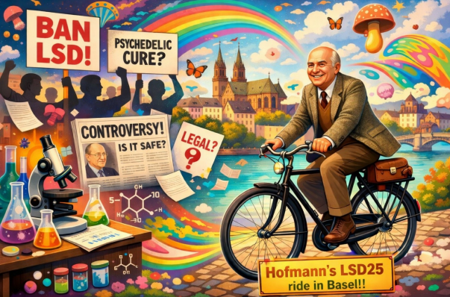
Timothy Leary, a psychologist from my own profession, famously took what might have been a promising scientific frontier and drove it into the ground with reckless cultural advocacy, essentially inviting indiscriminate use. The image of Leary in a tie-dye shirt urging people to “turn on and tune in” is not just a cultural artifact. It is a cautionary tale.
And yet, rejecting that era does not justify rejecting the entire domain.
So what is actually happening?
If we are going to be intellectually honest, we have to ask what these substances actually do in the brain.
At the center of that discussion is the brain’s default mode network, a system that helps organize our sense of self, maintain continuity, and run the countless subroutines that make life predictable. It allows us to move through the world efficiently, to rely on learned patterns, to anticipate outcomes, and to function without having to consciously process every detail of every moment. It is, in many ways, a gift.
But what serves us well can also imprison us.
In conditions like depression, obsessive compulsive disorder, and trauma, the default mode network can become rigid and overactive. It reinforces negative core beliefs about the self. It rehearses shame-based narratives. It traps individuals in loops of rumination that feel inescapable. The brain becomes predictable in the worst possible way, locked into patterns that no longer serve life but instead constrict it.
And this is where something shifts.
Psychedelics appear to temporarily loosen that grip.
Through strong serotonergic activation, particularly at the 5-HT2A receptor sites, these compounds disrupt the usual top-down control of the brain. The hierarchy of the brain’s organization softens. Regions that do not typically communicate begin to do so. Functional connectivity increases in ways that are rarely seen under ordinary conditions. The brain becomes less constrained by its habitual pathways and more globally integrated.
This is not simply about altered visuals or sensory distortions. The deeper phenomenon is that the brain, for a period of time, becomes more flexible. Cortical networks light up in novel configurations. Emotional material that has been locked within rigid interpretive frameworks can emerge into awareness with a different quality, one less fused with shame and more open to observation and insight. Patterns that have been rehearsed for years can, even briefly, loosen their hold.
For someone trapped in severe depression, that can mean experiencing a different relationship to the self for the first time in years. For someone with obsessive compulsive disorder, it can interrupt the relentless loop of intrusive thoughts and compulsions. For someone facing overwhelming fear of death, it can allow that fear to be encountered from a vantage point that is less constricted and more expansive.
None of this should be romanticized.
The same mechanisms that allow for insight can also produce anxiety, disorientation, or psychological destabilization, particularly in individuals who are not properly screened or supported. Certain compounds carry physiological risks as well. These are not benign substances. They are powerful tools, and like any powerful tool, they require careful handling.
This is not the same conversation.
Which brings us back to why the current moment matters.
What is being proposed is not a cultural free-for-all. It is not Timothy Leary in a tie-dye shirt inviting chaos. It is medically supervised, carefully screened, protocol-driven application within a clinical framework. Preparation. Administration. Integration. Thoughtful discernment about who is and is not an appropriate candidate.
That is an entirely different conversation.
And yet, even in the face of that distinction, resistance emerges quickly.
Connection still sits underneath all of this.
At this point, it is worth bringing in Johann Hari, whose work in Chasing the Scream reframed the conversation around addiction in a way that is deeply relevant here. His argument that the opposite of addiction is not simply sobriety, but connection speaks to something far deeper than substance use. It speaks to the human need for meaning, relationship, and integration.
Psychedelic research, at its best, appears to touch that same domain, not by manufacturing connection, but by disrupting the rigid patterns that prevent people from experiencing it.
Faith has to wrestle honestly.
Christians, in particular, need to wrestle with this honestly. There is a long-standing tendency to equate altered states of consciousness with moral danger. Some of that caution is warranted. There has been misuse. There has been confusion between altered experience and genuine transformation. But there has also been a tendency to shut down inquiry prematurely.
History reminds us that this reflex is not always aligned with truth. Galileo challenged the prevailing understanding of the cosmos and found himself under house arrest for it. The idea that the earth was not the center of everything was once considered dangerous. It turned out to be correct.
Now, no, psychedelics are not heliocentrism. Let us not be ridiculous. But the pattern is worth noticing.
The current system is not perfect either.
At the same time, we must not pretend that the current system is without its own limitations. The modern psychotropic landscape is deeply flawed. Medications are often used long-term, sometimes indefinitely, and while they can provide meaningful stabilization, they do not always produce deep transformation. In some cases, they create a kind of maintenance loop rather than a pathway to healing.
This is where a deeper lens becomes relevant.
The psychologist Andrzej Łobaczewski described what he called political ponerology, the study of how distortion and even evil can operate within systems when power, incentives, and human fallibility begin to shift institutions away from their original purpose. Later thinkers, such as Professor Michael Rectenwald, have extended this framework beyond political systems into corporate, economic, and organizational life, examining how power consolidates, how incentives shape behavior, and how systems can drift from serving people to sustaining themselves.
That matters here because both sides of this conversation are vulnerable.
Psychedelics, if rushed or irresponsibly advanced, carry the real risk of becoming yet another domain shaped by profit, ideology, or premature certainty. History has shown that when powerful interventions outpace careful wisdom, the consequences can be significant, particularly for those already vulnerable.
At the same time, it would be equally naïve to ignore the realities of the existing psychopharmacological landscape. Many current treatment models are embedded within systems of financial incentive and institutional momentum that, often unintentionally, favor long-term management over genuine transformation. In some cases, this can lead to patterns that sustain dependence rather than resolve underlying suffering.
This creates a paradox. Psychedelics may offer the possibility of profound, time-limited interventions, experiences that, when used appropriately, do not lend themselves to ongoing consumption models. And precisely because of that, they may encounter resistance within systems that are not structurally aligned with one-time or infrequent treatments.
Neither of these realities should be dismissed. One warns of reckless acceleration driven by greed or cultural enthusiasm. The other points to the quiet inertia of established systems that may resist disruption, even when change is warranted.
Wisdom requires that we hold both tensions at once.
So we walk a narrow path.
Between them lies a narrow path.
A path of rigorous research. A path of careful screening. A path of humility in both innovation and restraint.
The question is not whether psychedelics are good or bad in some simplistic sense. The question is whether we have the courage to approach them with both caution and curiosity, to study them deeply, to regulate them wisely, and to apply them carefully in cases where suffering has not yielded to other interventions.
Because for those whose lives are being dismantled by severe, intractable depression, by obsessive compulsive disorder, or by overwhelming existential fear, this is not an abstract debate.
It is a call.
What emerges from all of this is not a simplistic endorsement or rejection, but a call to think more deeply, to resist both fear and recklessness, and to pursue truth wherever it leads with humility and courage. The question is not simply whether psychedelics are dangerous or promising, but whether we are willing to engage complex realities with discernment rather than reflex.
For those grounded in faith, this is not a retreat from conviction, but an expression of it. Discernment is not rooted in fear of the unknown, but in alignment with Truth itself. Christ did not call us into avoidance, but into clarity, courage, and love of what is real. If something is false, it should be exposed. If something is dangerous, it should be named. But if something holds genuine potential to relieve suffering, it should not be dismissed simply because it challenges what is familiar.
Real healing rarely comes through stagnation. It requires thoughtful, prayerful engagement with the unknown—not careless risk, but courageous willingness to wrestle honestly with what we do not yet fully understand. Anything less may appear wise, but in reality, it is often avoidance.
“Test everything; hold fast what is good.” 1 Thessalonians 5:21


As I step back and look across the sandbox, I realize something important. Not everything we encounter there is pleasant. Sometimes the sandbox is a place of laughter, imagination, curiosity, and joy. Sometimes it is a place where children build castles and dream impossible dreams. Sometimes it is nothing more than sunlight, friendship, and sand slipping peacefully through their fingers.
Children often enter the sandbox simply for the pure joy of playing. There is something beautiful about that. That spirit, in many ways, captures the heart of my first book in this three-book series, An Old Psychologist in the Sandbox. That volume leaned more heavily into hope, inspiration, meaning, faith, healing, and the beauty of the human spirit. It reflected many of the things I love most about psychology, humanity, and life itself. It was, in many ways, the softer sunlight side of the sandbox.
But children do not only enter the sandbox for joy. Sometimes they enter it carrying conflict, frustration, fear, and pain. They struggle there. They wrestle there. They work things out there. Sometimes awkwardly. Sometimes poorly. And sometimes with remarkable creativity and even surprising wisdom. The sandbox becomes a place not merely of play, but of growth, negotiation, testing boundaries, learning relationships, and trying to make sense of difficult emotions and experiences.
This second volume has reflected more of that harder side of the sandbox. Here, I found myself wrestling more openly with difficult issues: ideology, conformity, power, suffering, fear, psychiatry, truth, freedom, identity, cultural pressures, and the ways human beings and systems sometimes lose their way. These essays often walked into more difficult terrain, not because I enjoy negativity or conflict, but because authenticity requires us to examine not only what is lovely and inspiring, but also what is painful, distorted, and unresolved.
Carl Jung spoke of the shadow side, those dimensions of ourselves and humanity that we would often rather avoid. Yet if we refuse to look honestly at the shadow, we risk becoming controlled by it unconsciously. To be authentic, not only as a psychologist but as a human being, requires the courage to sit with both realities: the light and the darkness, the beauty and the brokenness, the inspirational and the unsettling.
This book has not been about certainty. It has not been about pretending that I somehow possess all the answers. Rather, it has simply been my attempt to think deeply, to contemplate honestly, and to sit in the sandbox wrestling with difficult questions instead of pretending they do not exist.
We live in a culture increasingly tempted by simplistic answers, instant outrage, tribal thinking, and performative certainty. Yet real contemplation is slower than that. Real wisdom often emerges through humility, tension, questioning, reflection, and sometimes even discomfort.
Maybe that is what I have been doing all along. Simply sitting in the sandbox and thinking. Not as an expert proclaiming final truths from a mountaintop, but as an aging psychologist still trying to understand people, systems, suffering, healing, faith, meaning, and the extraordinary complexity of being human.
Some readers will agree with parts of these reflections. Others will strongly disagree. That is okay. In fact, perhaps that tension itself is part of the point. Healthy contemplation requires space for disagreement, nuance, humility, and continued dialogue.
What matters to me is not that you think exactly as I do. What matters is that you think deeply, remain curious, resist surrendering your humanity to ideology or fear, and stay willing to examine both the beauty and the brokenness of the world, and perhaps most importantly, within yourself.
And as for me, I suspect I am not done wandering through the sandbox just yet. There are still questions worth asking, mysteries worth contemplating, beauty worth noticing, and shadows worth understanding.
And somewhere along the way, after spending all this time in the sandbox, I suppose I have gotten a little sand in my shoes.
Honestly, I think I am okay with that.
I’ll be back.

About the Author


Jeffrey E. Hansen, Ph.D. is a clinical psychologist specializing in addiction and trauma, with degrees from the University of California, Berkeley and the University of Arkansas. He brings over four decades of clinical experience, including service as an active-duty psychologist in the U.S. Army and later with the Defense Health Agency. He previously served as Clinical Director of Holdfast Recovery and AnchorPoint, faith-centered treatment programs for addiction and trauma recovery.

Dr. Hansen is the founder of NeuroFaith®, an integrative model combining neuroscience, trauma-informed care, and Christian spirituality. He now focuses on writing, training, and consulting with organizations and providers nationwide to advance the NeuroFaith® approach. He is the author of nine books and is active in national conversations on protecting children and adolescents from overly reductive and prematurely medicalized approaches to care.

He lives in Arizona with his wife, their three dogs, stays closely connected with his children and granddaughter, and enjoys time on the open road riding his BMW R1250RS.

