Sermon I -The NeuroFaith® Model – The Four Pillars of Healing
A Call to Wholeness
Jeffrey E. Hansen, Ph.D. and Pastor Earl Heverly
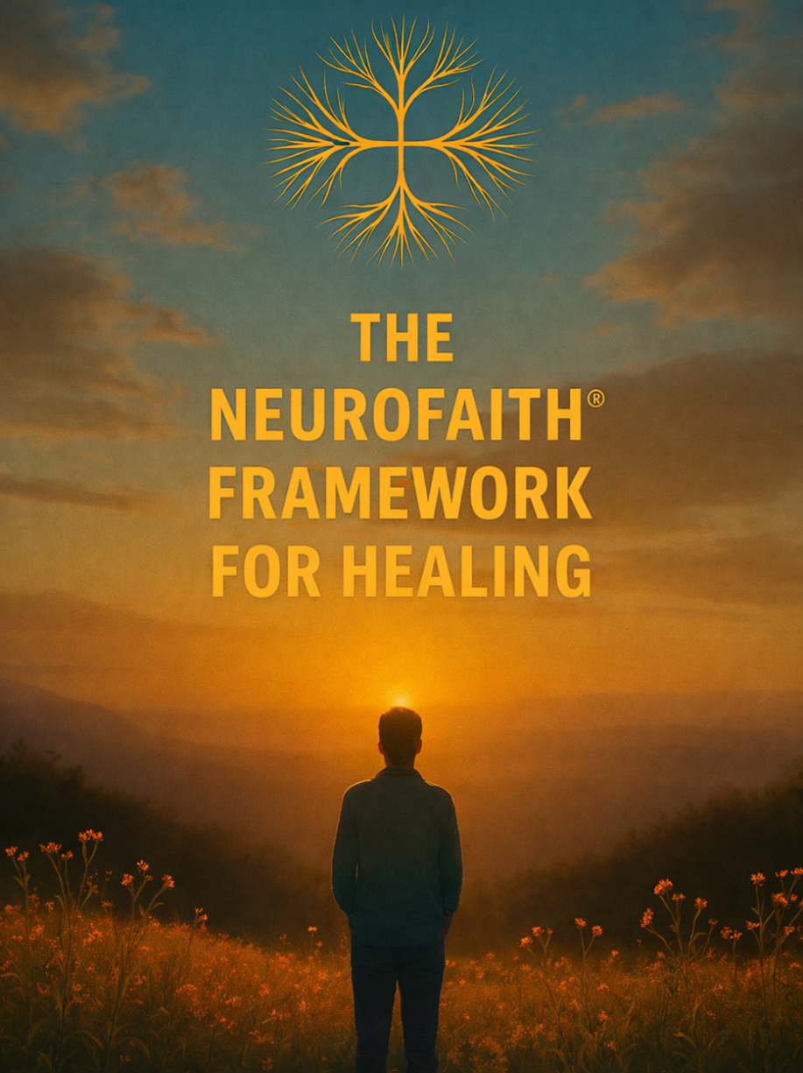

Psalm 103:2–3
“Let all that I am praise the Lord; may I never forget the good things He does for me. He forgives all my sins and heals all my diseases.”

There is a kind of suffering that does not sit politely in the mind and wait to be corrected. There is a kind of depression that settles into the body, a kind of anxiety that lives in the nervous system, a kind of trauma that rewrites the story a person tells about themselves while they are still lifting their hands in worship. You can love God and still feel unsafe. You can know the Word and still feel ashamed. You can be surrounded by people and still feel alone — because these struggles are not merely mental; they are whole-person afflictions, touching brain and body, heart and relationships, identity and soul.
And yet the Psalmist stands up and declares a promise that refuses to let us stay in despair: “Bless the Lord, O my soul… who forgives all your sins and heals all your diseases.” Not some. Not only the spiritual ones. Not only the physical ones. All. Which means the God we serve is not intimidated by trauma in the nervous system, by wounds in the heart, by fragmented places in the mind, or by years of accumulated sorrow. He is a whole-person healer because He created the whole person.
So today we begin a journey — not just into a teaching, but into a testimony of restoration.

Point One – You Are Not Broken; You Are Wounded in Places That Haven’t Been Reached Yet
For many people, the frustration is not that they have never tried to get better — it is that they have tried and still feel stuck. They have prayed, they have read Scripture, they have gone to counseling, they have learned coping skills, and those things matter because coping can keep you alive in the midnight hour. But coping is not the same as transformation.
You can manage your thoughts and still feel unsafe in your body.
You can control your behavior and still feel shame in your story.
You can function in your life and still feel disconnected in your soul.
That is not weakness — that is depth. That means the wound lives in a deeper system, in what neuroscience calls the inner narrative network of the brain, the place where the message keeps looping: “I am broken… I am alone… I am not enough.” And if the wound reached that deep, then healing has to reach that deep too.

Point Two – God’s Healing Is Transformational, Not Just Incremental
We thank God for every tool that stabilizes us, but survival is not the same as wholeness. Incremental change helps you cope; transformational healing restores you.
Transformation is when the nervous system learns safety again.
Transformation is when the heart comes back into peace and coherence.
Transformation is when the fragmented inner world is gathered into integration.
Transformation is when grace becomes louder than shame.
This is not about becoming someone else — this is about returning to who God created you to be before the trauma ever told you a lie about your identity.

Point Three – The Pathway to Wholeness: The Four Pillars of Healing
if healing is going to reach the whole person, then we need a pathway that touches every dimension of how God designed us.
The first pillar is Autonomic Safety — the restoration of the nervous system.
We are going to learn what it means for your body to experience peace, not just your thoughts. We are going to discover that safety is not a weakness — it is a holy ground where connection with God and others becomes possible. Because when the nervous system comes out of survival mode, you can finally rest in the presence of the Lord instead of bracing for the next threat.
The second pillar is the Heart — HeartMath and neurocardiology.
We are going to talk about the heart not just as a symbol, but as an intelligence God designed, a place of coherence, a place where emotion, physiology, and relationship come into alignment. Scripture says, “Guard your heart, for everything you do flows from it.” We are going to discover that when the heart comes into order, it becomes a living doorway for God’s peace.
The third pillar is the healing of the inner world — what we call Internal Family Systems.
We are going to step into the landscape of the soul and understand the parts of us that learned to protect us, the defenses that carried our pain, the places that still feel young, afraid, or ashamed — and we are going to watch what happens when those parts are no longer led by fear but by the compassionate Self that God placed within you.
And the fourth pillar — woven through them all — is our living connection with God.
Because in the end, it is grace that dismantles shame.
It is the presence of Christ that restores identity.
It is the Spirit that brings the fragmented places back into unity.
Each of these pillars is a pathway — but together they form a house of healing.

Close
Please hear me today:
You are not too damaged.
You are not too late.
You are not beyond restoration.
The God who forgives all your sins
still heals all your diseases —
in your body,
in your brain,
in your heart,
in your story,
and in your soul.
We are going to walk that road together — from survival to safety, from fragmentation to integration, from shame to grace, from coping to wholeness.
If you are ready for that journey,
if you are hungry for that kind of healing,
if you believe God is not finished with you yet —
Then stand with me…let’s pray!

