Where Science Meets the Soul: Five Sermons on the Healing Vision of NeuroFaith®
Jeffrey E. Hansen, Ph.D. and Pastor Earl Heverly
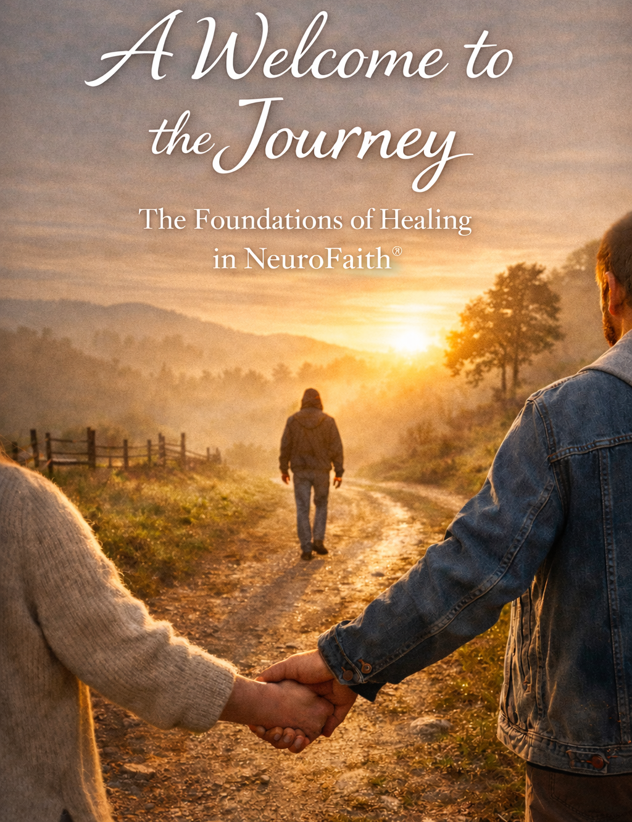
Sermon I -The NeuroFaith® Model – The Four Pillars of Healing
A Call to Wholeness
Jeffrey E. Hansen, Ph.D. and Pastor Earl Heverly
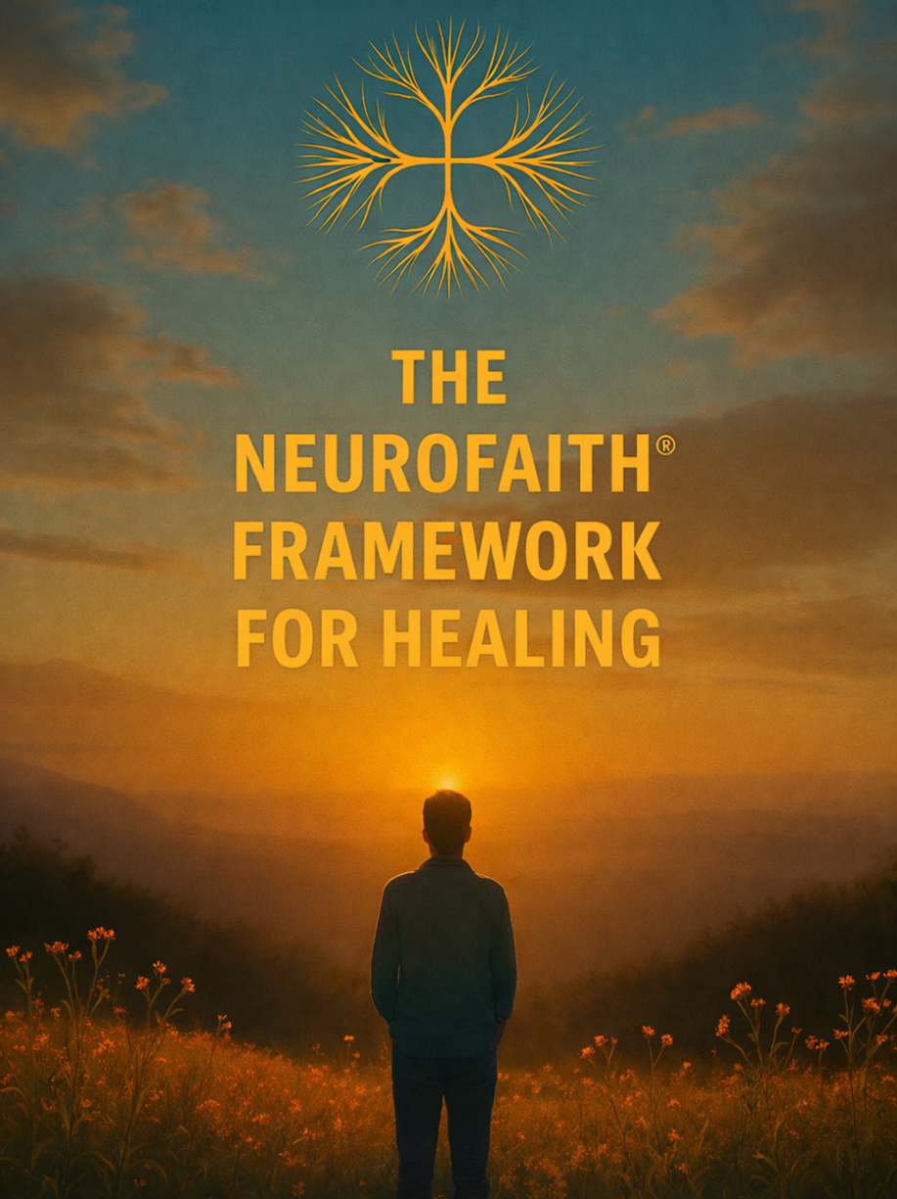

Psalm 103:2–3
“Let all that I am praise the Lord; may I never forget the good things He does for me. He forgives all my sins and heals all my diseases.”

There is a kind of suffering that does not sit politely in the mind and wait to be corrected. There is a kind of depression that settles into the body, a kind of anxiety that lives in the nervous system, a kind of trauma that rewrites the story a person tells about themselves while they are still lifting their hands in worship. You can love God and still feel unsafe. You can know the Word and still feel ashamed. You can be surrounded by people and still feel alone — because these struggles are not merely mental; they are whole-person afflictions, touching brain and body, heart and relationships, identity and soul.
And yet the Psalmist stands up and declares a promise that refuses to let us stay in despair: “Bless the Lord, O my soul… who forgives all your sins and heals all your diseases.” Not some. Not only the spiritual ones. Not only the physical ones. All. Which means the God we serve is not intimidated by trauma in the nervous system, by wounds in the heart, by fragmented places in the mind, or by years of accumulated sorrow. He is a whole-person healer because He created the whole person.
So today we begin a journey — not just into a teaching, but into a testimony of restoration.

Point One – You Are Not Broken; You Are Wounded in Places That Haven’t Been Reached Yet
For many people, the frustration is not that they have never tried to get better — it is that they have tried and still feel stuck. They have prayed, they have read Scripture, they have gone to counseling, they have learned coping skills, and those things matter because coping can keep you alive in the midnight hour. But coping is not the same as transformation.
You can manage your thoughts and still feel unsafe in your body.
You can control your behavior and still feel shame in your story.
You can function in your life and still feel disconnected in your soul.
That is not weakness — that is depth. That means the wound lives in a deeper system, in what neuroscience calls the inner narrative network of the brain, the place where the message keeps looping: “I am broken… I am alone… I am not enough.” And if the wound reached that deep, then healing has to reach that deep too.

Point Two – God’s Healing Is Transformational, Not Just Incremental
We thank God for every tool that stabilizes us, but survival is not the same as wholeness. Incremental change helps you cope; transformational healing restores you.
Transformation is when the nervous system learns safety again.
Transformation is when the heart comes back into peace and coherence.
Transformation is when the fragmented inner world is gathered into integration.
Transformation is when grace becomes louder than shame.
This is not about becoming someone else — this is about returning to who God created you to be before the trauma ever told you a lie about your identity.

Point Three – The Pathway to Wholeness: The Four Pillars of Healing
if healing is going to reach the whole person, then we need a pathway that touches every dimension of how God designed us.
The first pillar is Autonomic Safety — the restoration of the nervous system.
We are going to learn what it means for your body to experience peace, not just your thoughts. We are going to discover that safety is not a weakness — it is a holy ground where connection with God and others becomes possible. Because when the nervous system comes out of survival mode, you can finally rest in the presence of the Lord instead of bracing for the next threat.
The second pillar is the Heart — HeartMath and neurocardiology.
We are going to talk about the heart not just as a symbol, but as an intelligence God designed, a place of coherence, a place where emotion, physiology, and relationship come into alignment. Scripture says, “Guard your heart, for everything you do flows from it.” We are going to discover that when the heart comes into order, it becomes a living doorway for God’s peace.
The third pillar is the healing of the inner world — what we call Internal Family Systems.
We are going to step into the landscape of the soul and understand the parts of us that learned to protect us, the defenses that carried our pain, the places that still feel young, afraid, or ashamed — and we are going to watch what happens when those parts are no longer led by fear but by the compassionate Self that God placed within you.
And the fourth pillar — woven through them all — is our living connection with God.
Because in the end, it is grace that dismantles shame.
It is the presence of Christ that restores identity.
It is the Spirit that brings the fragmented places back into unity.
Each of these pillars is a pathway — but together they form a house of healing.

Close
Please hear me today:
You are not too damaged.
You are not too late.
You are not beyond restoration.
The God who forgives all your sins
still heals all your diseases —
in your body,
in your brain,
in your heart,
in your story,
and in your soul.
We are going to walk that road together — from survival to safety, from fragmentation to integration, from shame to grace, from coping to wholeness.
If you are ready for that journey,
if you are hungry for that kind of healing,
if you believe God is not finished with you yet —
Then stand with me…let’s pray!

Sermon II – Pillar One: Autonomic Safety
From Survival Mode to Sacred Rest
-Pastor Earl Heverly and Jeffrey E. Hansen, Ph.D.
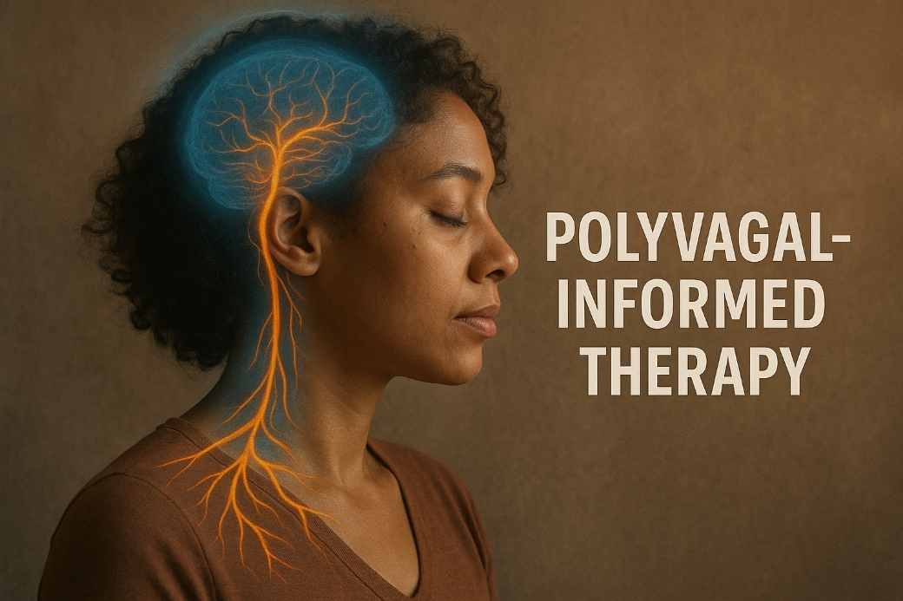
Matthew 11:28
“Come to me, all you who are weary and burdened, and I will give you rest.”

There are many faithful men and women who walk into the presence of God every week with sincere love in their hearts and bodies that are still living as though the danger has not passed. They sing the songs and confess the promises, they pray and serve and show up for life, and yet something inside remains braced. Their sleep is light, their breathing is shallow, their shoulders carry a vigilance they cannot fully explain. For years they have wondered why peace feels so distant, why rest feels unnatural, why trust feels like effort instead of home. Too often they have interpreted this as a spiritual problem, a failure to let go, a lack of faith, when in truth it is the story of a nervous system that learned — through real life adversity — how to survive.
Because trauma is not only what happened to you; trauma is what your body had to learn to deal with in order for you to live through what happened to you.
Long before you had language for your story, your nervous system was listening. It was reading faces, tracking the tone of voices, sensing unpredictability in others, learning whether connection was safe or could disappear without warning. Early attachment wounds, chronic stress, seasons of loss, environments where you had to carry more than you were designed to carry — all of these experiences became teachers. And in the face of those realities your body did something remarkable: it protected you.

The Nervous System Was Created for Protection, Not for Permanent Survival
When our bodily systems sense danger, they mobilize. The heart begins to race, breathing quickens, muscles prepare for action, and cortisol and adrenaline move through the bloodstream. What we often call anxiety is, in reality, the HPA axis, the hypothalamic-pituitary-adrenal axis, is a system in the body that helps regulate stress responses. It involves interactions between the hypothalamus, pituitary gland, and adrenal glands, which work together to release hormones like cortisol in response to stress. doing exactly what it was created by God to do — preparing you to fight or to flee so that you can live.
When the stress is overwhelming, when escape is not possible, when the child cannot leave and the adult cannot change the situation, the body shifts in the opposite direction. Energy drops. Numbness comes. Disconnection settles in. This is the dorsal vagal response — not laziness, not apathy, not spiritual failure, but the ancient endurance system that allows a human being to survive what cannot be escaped. The dorsal vagal response is a physiological reaction that occurs when the body perceives overwhelming stress or danger, leading to a state of shutdown or immobilization. This response is part of the autonomic nervous system and can manifest as feelings of numbness, low energy, or emotional detachment.
And many people have spent years moving between those two states — activation and collapse, anxiety and exhaustion, over-functioning and shutdown — not because they are broken, but because their bodies adapted with extraordinary intelligence.
When the danger passed. Too often the body never received the message.
So you can be living in a season that is objectively safer, and your nervous system is still scanning the present through the lens of the past. You want to connect, but something in you braces. You want to rest, but something in you remains alert. You want to experience the nearness of God, but your physiology does not yet know how to be still.
And into that reality Jesus speaks…not a command, but an invitation:
“Come to Me… and I will give you rest.”

Trauma Trains the Body to Live in Yesterday
This is the heartbreak of developmental trauma and repeated life adversity: the nervous system learns through experience, and what it learns early and often becomes its default setting.
Trauma is not stored as a thought.
It is stored in breath and posture, in muscle tone and heart rhythm, in the constant conversation between body and brain. The body continues to send signals of danger even when the environment has changed, and the brain believes the body.
This is why so much of anxiety, depression, addiction, and relational struggles are rooted in dysregulation. The system is still organized around protection.
Not sin.
Not weakness.
Protection.
And when that truth is understood, shame begins to give way to compassion.

Safety Is the Foundation for Love, Calling, and Spiritual Transformation
Abraham Maslow observed what the Scriptures have declared all along — that once the basic needs of the body are met, the next great human need to be addressed is safety. Without safety, love cannot be fully received. Without safety, belonging remains fragile. Without safety, a person cannot step into the fullness of who God created them to be.
This is why Jesus begins not with instruction, but with invitation.
“Come to Me… and I will give you rest.”
Because rest is not only a spiritual concept — it is the biological experience of safety.
And when the body begins, even in small ways, to experience that it is safe, everything else becomes accessible. The mind becomes more spacious. The heart becomes more open. The inner world becomes less hostile. Spiritual truth becomes nourishment instead of demand.
This is the ground in which transformation takes root.

Christ Meets Us in the Regulated Place of Connection
There is a state — that neuroscience calls ventral vagal regulation and the Scriptures name as peace — in which the human person becomes available for relationship again. The face softens, the voice becomes steady, the heart opens, and the body is no longer preparing for what is not happening.
It is in this place that the words of Jesus take on their full meaning:
“Peace I leave with you; My peace I give to you… Do not let your hearts be troubled, and do not be afraid” (John 14:27).
He is not offering a concept; He is offering a condition in which the troubled system can settle and rest.
This is why autonomic safety is the first pillar of the NeuroFaith® model. Because when the body begins to know that it is safe, the heart can open, the inner world can heal, and the story can be rewritten.
The same Christ who stood in the storm and spoke until the sea grew still speaks into the surges of sympathetic activation that have kept a life on edge for years. The same Christ who called Lazarus out of the tomb reaches into the places that learned to shut down in order to survive. The same Christ who breathed the Spirit into the disciples, is the Christ who restores the rhythm of breath and the steadiness of heart in you.
And when that begins to happen — often slowly, often gently — the promise of the Psalmist becomes lived experience:
“The Lord is my shepherd, I lack nothing.
He makes me lie down in green pastures,
He leads me beside still waters,
He restores my soul” (Psalm 23:1–3).
He does not drive us into rest.
He leads us into it.

Close — From Survival to Sacred Rest
If you have lived for a long time moving between urgency and exhaustion, between over-activation and collapse, between longing for God and not knowing how to rest in His presence, hear this with the tenderness of heaven:
Your body has been telling you the truth about what it has lived through.
Your adaptations were not your failure.
And your story is not over.
The Christ who calls you to Himself is not asking you to force yourself into peace; He is teaching your nervous system that it is finally safe.
And the promise that gathers all of this together is the one the apostle Paul speaks over the anxious and the weary:
“The peace of God, which surpasses all understanding, will guard your hearts and your minds in Christ Jesus” (Philippians 4:7).
Peace that guards the heart.
Peace that settles the mind.
Peace that holds the whole person.
This is the journey from survival into sacred rest.
And if that is the journey your heart has been longing for, then the invitation of Jesus is not far away.
It is as near as your next breath:
“Come to Me… and I will give you rest.”

Sermon III – Pillar Two: The Heart
Living From the Place Where God Speaks
Jeffrey E. Hansen, Ph.D. and Pastor Earl Heverly
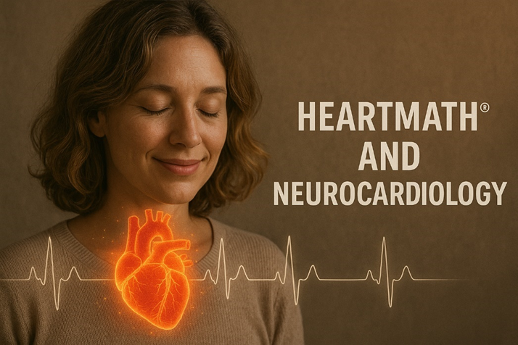
“And I will give you a new heart, and I will put a new spirit in you. I will take out your stony, stubborn heart and give you a tender, responsive heart.” – Ezekiel 36:26
The promise of healing in Scripture has always been a promise about the heart. Long before we had language for trauma or neuroscience, God spoke of transformation in these words. He did not promise merely new behaviors or clearer thoughts, but a new heart—alive, responsive, capable of communion. And then we are entrusted with the sacred calling to guard that heart, because everything in our lives flows from this hidden center. What modern science is only now beginning to describe, Scripture has been declaring for centuries: the heart is the wellspring of the human person and the meeting place between God and His people.
If the first movement of healing is learning that the body can become safe, the second is rediscovering that the heart was never meant to be silent. For generations we were taught to think of the heart as little more than a mechanical pump, faithfully moving blood through the body while the brain did the real work of thinking and deciding. Yet long before modern science began to look more closely, Scripture had already given the heart a place of breathtaking importance. The heart is where we believe. The heart is where we grieve. The heart is where courage rises and where wisdom is formed. It is the place from which we love God and the place where God speaks to us.
More than eight hundred times the Bible turns our attention to the heart, and every time it does it is reminding us that life does not flow first from the head but from this deeper center of the person. “Blessed are the pure in heart, for they shall see God.” “Do not let your hearts be troubled.” “Love the Lord your God with all your heart.” Again and again we are brought back to the same revelation. Transformation is not merely a change of thought. It is a renewal of the heart.

The Heart Is a God Designed Center of Wisdom and Connection
What Scripture has declared for centuries, science is now beginning to describe with remarkable clarity. The heart is not a passive organ. It is an intelligent, communicative, regulatory center that is in constant conversation with the brain and the rest of the body. Within the heart are tens of thousands of sensory neurites, cells that function in ways strikingly similar to neurons. They form networks that process information, influence emotional experience, and participate in memory and learning.
In other words, the heart is not only responding to your life. It is helping shape how you experience your life.
This begins to explain why we have always spoken of knowing something in our hearts before we can explain it in our minds. It explains why a person can think their way through a decision and still feel unsettled until the heart becomes quiet. It explains why trauma drives people upward into their heads, into rumination and analysis, while healing always involves a return to a deeper, more grounded place.
God did not design you to live from your head alone.
He designed you to live from the heart.
And when the heart is engaged, the whole person begins to come into alignment.

Coherence Is the Physiology of Peace
One of the most hopeful discoveries in this field is the reality of heart rate variability and what researchers call coherence. A healthy heart is not rigid and mechanical. It is responsive and rhythmic, constantly adjusting to the needs of the moment. When the heart is in a coherent state, its rhythms become smooth and ordered, and this pattern sends signals to the brain that quiet fear, strengthen clarity, and support wise decision making.
When the heart is chaotic, the brain becomes reactive.
When the heart is coherent, the brain becomes receptive.
And what brings the heart into coherence is not positive thinking alone. It is the combination of steady breathing and regenerative emotion. Gratitude. Compassion. Love. Reverence.
These are not merely spiritual virtues.
They are regulatory forces.
This is why Scripture calls us again and again into thanksgiving and love. Not because God needs our praise, but because our hearts need to enter a rhythm that restores the entire person.
“Let the peace of Christ rule in your hearts.”
Not only in your theology.
In your hearts.

The Breath, the Heart, and the Presence of God
Breathing becomes one of the most sacred bridges between the body and the heart. Slow, steady breathing, especially with a gentle and extended exhale, activates the vagus nerve and begins to settle the entire system. When that breath is joined with attention to the heart and with emotions such as gratitude and love, coherence begins to emerge.
It is not difficult to hear the echo of Scripture in this.
God breathed into Adam and he became a living being.
Jesus breathed on the disciples and said, “Receive the Holy Spirit.”
Breath and heart together become a place of encounter.
As we inhale, we receive.
As we exhale, we release.
As the rhythm steadies, the heart becomes quiet.
And in that quietness we discover that God has been nearer than we imagined.

A Coherent Heart Becomes a Gift to Others
One of the most beautiful implications of this research is the reality that the heart does not regulate in isolation. The heart generates an electromagnetic field that extends beyond the body, and our physiological states begin to influence one another. Calm invites calm. Peace invites peace. Dysregulation spreads anxiety, but coherence spreads stability.
This is what Scripture has always meant when it speaks of the ministry of presence.
“Encourage one another and build each other up.”
“Comfort with the comfort you have received.”
A regulated heart becomes a refuge for others.
This changes how we understand leadership, parenting, marriage, friendship, and ministry. The most powerful thing we bring into a room is not our words but the state of our heart.

The Heart as the Bridge to Deeper Healing
Within the NeuroFaith® model, the heart becomes the bridge between safety and transformation. When the heart comes into coherence, the nervous system feels safer. When the nervous system feels safer, the inner world becomes accessible. And when the inner world opens, God’s grace can reach places that were once guarded by fear and shame.
This is why the promise of Jesus is so profoundly heart centered.
“Peace I leave with you. My peace I give you.”
And this is why the prayer of Paul becomes our prayer:
“That Christ may dwell in your hearts through faith.”
Not merely in your thoughts, but in the very center of your being—because when the heart is awakened, we do not only think differently; we live differently. We love differently. We see God more clearly. The guarded places become places of encounter. The rhythms that once carried fear begin to learn the cadence of peace. What was once closed becomes capable of communion.
So this pillar is not an invitation to sentimentality, but a return to the place God designed as the wellspring of life. The heart you have protected for so long is not only the place where you were wounded; it is the place where you will meet Him, the place where His promise continues to unfold. He does not demand that you manufacture a new heart by effort. He gives one. And as that gift is received, guarded, and brought into the gentle rhythm of His presence, everything that flows from your life begins to change—quietly, steadily, organically—until the prayer of the psalmist becomes your own lived reality:
“Create in me a pure heart, O God, and renew a steadfast spirit within me.”
And in that renewed heart, coherence is no longer merely a physiological state. It becomes communion. It becomes the life of Christ within you, the peace of Christ ruling within you, the love of Christ flowing from you—because when the heart comes alive in Him, everything begins to flow again.

If the first movement of healing is learning that the body can become safe, the second is rediscovering that the heart was never meant to be silent. For generations we were taught to think of the heart as little more than a mechanical pump, faithfully moving blood through the body while the brain did the real work of thinking and deciding. Yet long before modern science began to look more closely, Scripture had already given the heart a place of breathtaking importance. The heart is where we believe. The heart is where we grieve. The heart is where courage rises and where wisdom is formed. It is the place from which we love God and the place where God speaks to us.
More than eight hundred times the Bible turns our attention to the heart, and every time it does it is reminding us that life does not flow first from the head but from this deeper center of the person. “Blessed are the pure in heart, for they shall see God.” “Do not let your hearts be troubled.” “Love the Lord your God with all your heart.” Again and again we are brought back to the same revelation. Transformation is not merely a change of thought. It is a renewal of the heart.

The Heart Is a God Designed Center of Wisdom and Connection
What Scripture has declared for centuries, science is now beginning to describe with remarkable clarity. The heart is not a passive organ. It is an intelligent, communicative, regulatory center that is in constant conversation with the brain and the rest of the body. Within the heart are tens of thousands of sensory neurites, cells that function in ways strikingly similar to neurons. They form networks that process information, influence emotional experience, and participate in memory and learning.
In other words, the heart is not only responding to your life. It is helping shape how you experience your life.
This begins to explain why we have always spoken of knowing something in our hearts before we can explain it in our minds. It explains why a person can think their way through a decision and still feel unsettled until the heart becomes quiet. It explains why trauma drives people upward into their heads, into rumination and analysis, while healing always involves a return to a deeper, more grounded place.
God did not design you to live from your head alone.
He designed you to live from the heart.
And when the heart is engaged, the whole person begins to come into alignment.

Coherence Is the Physiology of Peace
One of the most hopeful discoveries in this field is the reality of heart rate variability and what researchers call coherence. A healthy heart is not rigid and mechanical. It is responsive and rhythmic, constantly adjusting to the needs of the moment. When the heart is in a coherent state, its rhythms become smooth and ordered, and this pattern sends signals to the brain that quiet fear, strengthen clarity, and support wise decision making.
When the heart is chaotic, the brain becomes reactive.
When the heart is coherent, the brain becomes receptive.
And what brings the heart into coherence is not positive thinking alone. It is the combination of steady breathing and regenerative emotion. Gratitude. Compassion. Love. Reverence.
These are not merely spiritual virtues.
They are regulatory forces.
This is why Scripture calls us again and again into thanksgiving and love. Not because God needs our praise, but because our hearts need to enter a rhythm that restores the entire person.
“Let the peace of Christ rule in your hearts.”
Not only in your theology.
In your hearts.

The Breath, the Heart, and the Presence of God
Breathing becomes one of the most sacred bridges between the body and the heart. Slow, steady breathing, especially with a gentle and extended exhale, activates the vagus nerve and begins to settle the entire system. When that breath is joined with attention to the heart and with emotions such as gratitude and love, coherence begins to emerge.
It is not difficult to hear the echo of Scripture in this.
God breathed into Adam and he became a living being.
Jesus breathed on the disciples and said, “Receive the Holy Spirit.”
Breath and heart together become a place of encounter.
As we inhale, we receive.
As we exhale, we release.
As the rhythm steadies, the heart becomes quiet.
And in that quietness we discover that God has been nearer than we imagined.

A Coherent Heart Becomes a Gift to Others
One of the most beautiful implications of this research is the reality that the heart does not regulate in isolation. The heart generates an electromagnetic field that extends beyond the body, and our physiological states begin to influence one another. Calm invites calm. Peace invites peace. Dysregulation spreads anxiety, but coherence spreads stability.
This is what Scripture has always meant when it speaks of the ministry of presence.
“Encourage one another and build each other up.”
“Comfort with the comfort you have received.”
A regulated heart becomes a refuge for others.
This changes how we understand leadership, parenting, marriage, friendship, and ministry. The most powerful thing we bring into a room is not our words but the state of our heart.

The Heart as the Bridge to Deeper Healing
Within the NeuroFaith® model, the heart becomes the bridge between safety and transformation. When the heart comes into coherence, the nervous system feels safer. When the nervous system feels safer, the inner world becomes accessible. And when the inner world opens, God’s grace can reach places that were once guarded by fear and shame.
This is why the promise of Jesus is so profoundly heart centered.
“Peace I leave with you. My peace I give you.”
And this is why the prayer of Paul becomes our prayer.
“That Christ may dwell in your hearts through faith.”
Not merely in your thoughts.
In your heart.
Because when the heart is awakened, we do not only think differently.
We live differently.
We love differently.
We see God more clearly.
“Blessed are the pure in heart, for they shall see God.”

Closing
So, this second pillar is not about sentimentality. It is about returning to the place God designed as the center of your life. It is about learning that the heart you have guarded for so long is not only the place where you were wounded. It is the place where you will meet Him.
The heart that once carried fear can learn a new rhythm.
The heart that once lived in chaos can enter coherence.
The heart that once felt closed can become alive again.
And as that happens, the promise becomes real.
“Create in me a pure heart, O God, and renew a steadfast spirit within me.”
This is the journey.
From the head to the heart.
From striving to receiving.
From fragmentation to coherence.
From distance to communion.
And if your heart has been longing to live in that place, then hear the invitation of the Lord who has always spoken to the heart of His people.
“Above all else, guard your heart, for everything you do flows from it.”
Because when the heart comes alive in Him,
everything begins to flow again.

Sermon IV – Pillar Three: Internal Family Systems (IFS)
From Inner Fragmentation to Christ-Centered Wholeness
Jeffrey E Hansen, Ph.D. and Pastor Earl Heverly
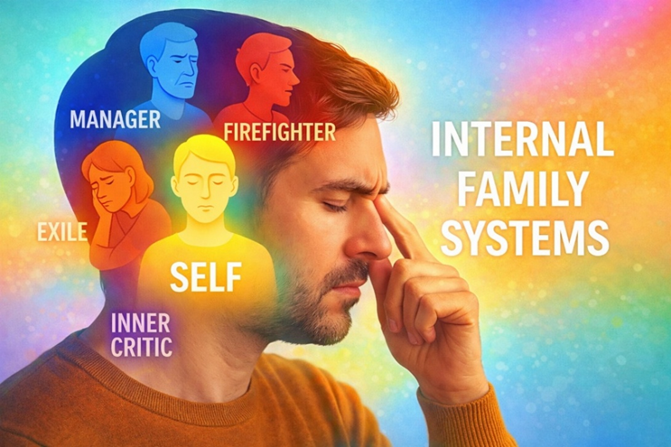
Psalm 103:2–3
Let all that is within me praise the Lord; may I never forget the good things He does for me. He forgives all my sins and heals all my diseases.

From Bottom-Up Healing to the Renewal of the Inner World
In the first two movements of this journey we began where healing so often must begin, beneath the level of conscious thought, in the body where trauma first takes root and where survival patterns are formed long before we have language for them. We learned that anxiety, depression, addiction, and so much of what we struggle with is not simply a failure of thinking but the expression of a nervous system that adapted to real experiences. Through the lens of Polyvagal-informed therapy we discovered that the body carries the story and that healing begins as the body learns safety, as chronic activation and collapse give way to regulation and connection.
Then we turned to the heart and saw the brilliance of God’s design. What the world called a pump, Scripture had already revealed as the center from which life flows. As the heart moves into coherence, the brain quiets its threat circuitry, the mind becomes clearer, and the entire person becomes more available for relationship with God and with others. The heart becomes a meeting place where physiology and spirituality embrace, where peace is no longer an abstract promise but a lived experience.
The body finds safety and the heart finds rhythm, and as that happens something else becomes possible. The inner world, which for so long had been locked behind layers of protection, begins to open. We are no longer trying to force change through willpower alone. We are now able to bring awareness, compassion, truth, and the leadership of Christ into the psychological system that formed around our wounds. This is the movement from bottom-up healing into the renewal of the mind and the integration of the soul, and it is here that Internal Family Systems becomes such a profound gift.

The Gospel Is the Gathering Together of What Has Been Scattered
For many believers the inner life has felt like a contradiction. We love God and yet feel divided within ourselves. There are moments when faith feels strong and other moments when fear or shame seems to speak louder. There are seasons when obedience flows naturally and others when the very behaviors we long to leave behind reappear with discouraging persistence. Too often we have interpreted this as spiritual failure, when in reality we are living in the tension between two deep realities.
On the one hand there is the fracture that came through original sin, the breaking of communion with God that left the human heart disoriented and searching for life in places that could never give it. On the other hand there are the personal wounds of our own stories, the experiences that shaped our nervous systems, our emotions, and our expectations of relationship. Sin disrupted our union with God, and trauma multiplied that fragmentation within us, pushing vulnerable parts of the soul into hiding and building layers of protection around them.
The Gospel speaks into both realities at once. It does not merely offer forgiveness for what we have done; it restores communion with the One for whom we were created and begins the patient work of gathering together everything inside us that has lived in separation. When the Psalmist cries, “Let all that is within me praise the Lord,” he is not describing a life in which every part already agrees. He is proclaiming the hope that every part can be brought into the light of God’s presence and gradually learn to live in harmony under His care.

The Exiles – The Wounded Places That Still Carry the Pain
At the center of this inner landscape are the Exiles, the parts of us that still carry the emotional weight of what was too overwhelming when it first occurred. These are the regions of the soul where shame, grief, fear, and loneliness were stored because there was no safe place for them to be expressed. They often hold the perspective of the age at which the wound took place, which is why certain moments in the present can suddenly feel as though we have been transported into an earlier season of our lives.
These exiled places are not signs of weakness. They are signs that we endured more than we were meant to endure alone. And because their pain felt so intense, other parts of us learned to keep them out of awareness. Yet the longing of the Gospel is always toward these very places. The Christ who said that He came to bind up the brokenhearted is moving toward the exiles, not away from them, and when His presence reaches them the shame they carry begins to loosen and their isolation begins to give way to connection.

The Managers – The Protectors That Learned to Stay in Control
Surrounding those vulnerable places are the Managers, the parts of us that organized life around the prevention of further pain. They are the planners, the achievers, the perfectionists, the people pleasers, the hyper-responsible ones, and even the spiritual performers. They learned early that control created a sense of safety, and so they gave themselves to the work of keeping everything in order.
Over time we came to think of these parts as simply who we are. Yet when we look with compassion we see how tirelessly they have labored and how little rest they have known. They are not enemies of healing; they are guardians that have been standing watch for years, trying to keep us from ever having to feel what once overwhelmed us.

The Firefighters – The Emergency Responders of the Soul
And when the pain of the exiles begins to break through despite the managers’ efforts, the Firefighters move into action. They are concerned not with long-term outcomes but with immediate relief. Their assignment is to extinguish emotional fire as quickly as possible, and they will use whatever strategy seems most effective in the moment. What we have called addiction, compulsion, rage, numbing, withdrawal, or dissociation often began as an attempt to survive an internal flood.
When we begin to see this clearly, the harsh self-hatred that once accompanied these behaviors starts to soften. Even here we recognize an effort to live.

The Inner Critic – Conviction and Condemnation
Within the system of the managers there is often a powerful voice we have long mistaken for the voice of God. It is the Inner Critic, and in its healthy form it can call us toward growth and responsibility. But when it becomes distorted by shame it becomes condemning and relentless.
The Holy Spirit convicts in order to restore relationship.
The accuser condemns in order to sever it.
The Spirit speaks with clarity and hope.
The condemning voice attacks identity and leaves us in despair.
There is now no condemnation for those who are in Christ Jesus.

The Self – Restored Through Union With Christ
Classical IFS speaks of a centered Self that leads the system with calm, compassion, and clarity. The NeuroFaith® vision carries that insight into the full light of the Gospel, because the true center of the human person is not discovered through insight alone but restored through union with Christ. We are not simply wounded people trying to become integrated. We are new creations in whom the life of Jesus is being formed, and as His life becomes the organizing presence within us, the entire inner world begins to take on a different atmosphere.
When the Self is leading, eight qualities emerge with remarkable consistency: calm, curiosity, clarity, compassion, confidence, courage, creativity, and connectedness. They describe a soul that is no longer driven by fear but guided by presence. Scripture describes that same transformation in different language, calling it the fruit of the Spirit: love, joy, peace, patience, kindness, goodness, faithfulness, gentleness, and self-control. These are not behaviors we manufacture. They are the life of Christ being formed within us.
As that life takes its rightful place at the center, the managers are finally able to rest, the firefighters are no longer forced into emergency action, and the exiles are no longer alone. The inner world begins to experience what it was created for — not conflict, but communion.
A House Fully Alive With the Presence of God
As this work of Christ unfolds within us, the prayer of the Psalmist begins to move from poetry into lived experience. “Let all that is within me praise the Lord.” What was once divided slowly learns to live in harmony. The parts of us that carried fear are no longer forced to hide, the parts that labored to protect are finally able to rest, and the places that held shame are brought into the light of mercy. The inner world that once felt like a battlefield becomes, over time, a dwelling place.
This is the miracle of redemption, that God does not merely forgive us from a distance but makes His home within us. The body that once lived in survival begins to discover what it means to be still. The heart that once moved in chaos finds a new rhythm of peace. The mind that once raced with accusation becomes quiet enough to hear the gentle voice of the Spirit. And the soul that felt scattered across years of pain and performance is gathered into a living communion under the lordship of Christ.
Scripture tells us, “Don’t you know that you yourselves are God’s temple and that God’s Spirit dwells in your midst?” (1 Corinthians 3:16). This is not a metaphor meant only for theology; it is the lived reality of healing. Every exile welcomed, every protector relieved of its burden, every condemning voice silenced by grace becomes another room in that temple filled with light.
So the invitation tonight is not to strive for wholeness through effort, but to yield to the One who is already moving through every layer of your being. Christ does not stand at the surface waiting for you to fix yourself. He walks into the deepest rooms of the soul, into the memories that still ache, into the defenses that never learned to rest, into the places where you learned to live without hope, and He speaks peace there.
And as His presence settles, something holy begins to happen. What once reacted now responds. What once hid now comes forward. What once lived in isolation begins to sing.
Until, slowly and truthfully, all that is within you blesses His name.
Not because every struggle has vanished, but because every part has found its center in Him.
This is the house fully alive with the presence of God.
This is the soul becoming a sanctuary.
This is what it means to be healed.
“Christ in you, the hope of glory.” (Colossians 1:27)
Amen.

Sermon V – Pillar Four: Spirituality and Faith
The Living Center That Holds All Things Together
Pastor Earl Heverly and Jeffrey E. Hansen, Ph.D.
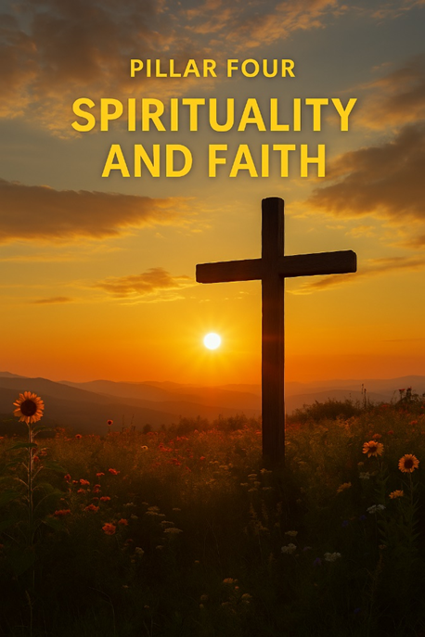
“He is before all things, and in Him all things hold together.” (Colossians 1:17)

The Pillar That Gives Life to the Others
As we come to the final movement in this series, we are not simply adding one more component to the model. We are stepping into the dimension that gives meaning and coherence to everything we have already explored. We have learned how trauma shapes the nervous system and how the body must rediscover safety. We have seen how the heart, in its God-designed intelligence, becomes a place of physiological and relational alignment. We have entered the inner psychological world and watched the fragmented parts of the self begin to live under compassionate, Christ-centered leadership. Yet beneath all of these movements there has always been a deeper question, not merely how we function, but who we are, why we suffer, and whether our lives can be redeemed.
These are spiritual questions, and for that reason spirituality is not an additional tool in the process of healing. It is the deep structure that allows healing to become transformation rather than symptom management. If the other pillars describe how restoration unfolds in the body, the heart, and the mind, this pillar reveals the source from which restoration flows. Without it the others can still operate, but they cannot reach their intended purpose. With it, everything comes alive with meaning.

The Research That Confirms What Scripture Has Always Declared
For generations the language of faith spoke of the soul in ways that modern science did not know how to measure. Now, in what can only be described as a providential convergence, research is beginning to observe the measurable effects of a living, relational spirituality.
Longitudinal studies have demonstrated that individuals who grow up in spiritually engaged environments show dramatically lower rates of major depression, substance dependence, and suicidality. Neuroimaging research has revealed structural and functional differences in brain regions associated with reflection, emotional regulation, and meaning-making in those who maintain an active life of faith. These are not marginal changes. They represent a profound increase in resilience under stress and a greater capacity to recover from adversity.
When a person engages regularly in practices such as prayer, worship, gratitude, and relational communion with God, the Default Mode Network, the system that carries the narrative of identity, begins to shift. Shame-based core beliefs lose their dominance. A different internal story begins to take root, one marked by belonging, purpose, and relational security. This is accompanied by measurable changes in emotional regulation, decreased stress reactivity, improved immune functioning, and lower overall mortality rates even when controlling for health behaviors and socioeconomic factors.
What Scripture has always proclaimed, that human beings were created to live in relationship with God, is now being observed at the level of neurobiology and public health.
“Above all else, guard your heart, for everything you do flows from it.” (Proverbs 4:23)
Spirituality is not simply comforting. It is structurally healing.

Healing the Story Where Trauma Wrote Its Lies
Trauma does more than wound the body and disturb the emotions. It writes a story, and that story becomes the lens through which every experience is interpreted. A person can achieve sobriety and still feel unworthy. They can learn coping skills and still feel alone. They can function successfully and still believe that something at the core of their identity is broken.
This is why healing must reach the level of narrative.
The Gospel does not merely offer new behaviors. It offers a new name.
“If anyone is in Christ, the new creation has come: the old has gone, the new is here.” (2 Corinthians 5:17)
This is the rewriting of the deepest operating system of the soul. The old conclusions are gradually replaced by a truth that is not self-generated but received in relationship.
I am loved.
I am forgiven.
I belong.
I am not alone.
And as that new narrative takes root, the nervous system settles more easily, the heart moves toward coherence, and the inner world becomes more open to connection. Identity-level transformation produces system-wide regulation.
“Do not conform to the pattern of this world, but be transformed by the renewing of your mind.” (Romans 12:2)

Grace as the Only Cure for Shame
At the center of trauma and addiction we consistently find shame, not the awareness of wrongdoing but the belief that one’s very existence is a mistake. This is the point at which psychology reaches its limit, because shame is not only an emotional state, it is a spiritual rupture. It is the experience of being cut off from love.
The cross answers that rupture in a way nothing else can. In Christ, shame is not negotiated or minimized. It is carried, absorbed, and removed. The most feared moment, being fully seen, becomes the moment of full acceptance.
“There is now no condemnation for those who are in Christ Jesus.” (Romans 8:1)
Grace does not merely change how we feel. It changes who we understand ourselves to be. It restores identity at its source.

The Integration of the Whole Person
When this spiritual dimension becomes living and active, the other pillars find their full purpose. Regulation of the nervous system becomes the body learning to rest in the presence of God. Heart coherence becomes the physiological expression of peace with Him. Self-leadership becomes the life of Christ ordering the inner world from the center outward.
What once were separate processes become one movement of communion.
This is the renewal of the mind that Scripture speaks of, not an incremental adjustment, but a metamorphosis in which the person is gradually brought into alignment with the truth of who they are in Christ.
“He who began a good work in you will carry it on to completion until the day of Christ Jesus.” (Philippians 1:6)

The Soul Becoming a Dwelling Place
So we arrive at the end of this journey not with a technique but with a homecoming. The goal was never merely to calm the body, organize the mind, or understand the past. The goal has always been communion, the restoration of the human person as a dwelling place for God.
As His presence fills the story, the old narratives lose their authority. As His love becomes the atmosphere of the inner world, every part of the self begins to move toward life. What was once defined by survival becomes defined by relationship. What was once held together by control becomes held together by grace.
“Don’t you know that you yourselves are God’s temple and that God’s Spirit dwells in your midst?” (1 Corinthians 3:16)
The prayer of the Psalmist is no longer an aspiration but a lived reality.
“Let all that is within me bless His holy name.” (Psalm 103:1)
The body participates. The heart participates. The mind participates. The soul participates. Everything that once lived in fragmentation is gathered into a single movement of worship.
This is why this pillar stands at the center. Because it is here that healing becomes more than recovery. It becomes redemption.
“Christ in you, the hope of glory.” (Colossians 1:27)
Amen.

