Transgender Confusion amidst the Search for Identity


Jeffrey E. Hansen, Ph.D.
Pediatric and Adolescent Clinical Psychologist
Clinical Director, Holdfast Recovery
Founder and Director, Center for Connected Living, LLC
Endorsements for Transgender Confusion amidst the Search for Identity



Dr. Hansen delivers an outstanding look at the transgender phenomenon and how it is affecting our youth in a book which is broad in scope, yet concise. He starts with definitions and statistics and then moves to the root causes of the development of dysphoria in children such as trauma and social media use. He then takes a deep dive into the problems of hormonal manipulations and surgeries followed by the abrupt change of course of several European nations in using these interventions. And all of this backed with useful quotes and references and enhanced by engaging illustrations.
As an endocrinologist, I clearly recognize that if anything, endocrinology is about balance. The hormones of the body need to be finely tuned in order to bring about both physical and mental health. The inevitable harms that result from driving these hormones far out of their normal ranges by "gender affirmative care" are clearly expressed in Dr. Hansen's explanations (and I am both proud and grateful that he has used some of my graphics for illustration). But as Dr. Hansen rightly points out, a mind that is unbalanced is no less dangerous than a body unbalanced and in fact the two need to be viewed as an integrated whole. It is this desire to bring about such healthy wholeness to youth that has guided his years of clinical experience with children and, in my opinion, provides him with the best vantage point to see how those suffering with gender dysphoria may be healed. This book is a most excellent and strong step forward in that direction.
Michael K. Laidlaw, MD
Board Certified Endocrinologist
Rocklin, CA, USA

Child and adolescent psychologist Dr. Jeffrey Hansen brings his decades of experience working with gender dysphoric youth and young adults to bear in this thorough yet condensed and highly readable volume. Dr. Hansen’s very practical insights and guidance are greatly needed to both protect gender dysphoric youth and assist their families in seeing them through the problem. There is a more honest path for dealing with gender dysphoria than chemical sterilization and surgical mutilation of otherwise healthy young bodies.
Andre Van Mol, MD
Board-certified Family Physician
Co-chair, Committee on Adolescent Sexuality, American College of Pediatricians
Co-chair, Sexual and Gender Identity Task Force, Christian Medical & Dental Association

Dr. Hansen provides an extensive, readable guide to the patients experiencing gender dysphoria and their families. This carefully crafted publication is also a wonderful resource for physicians and advanced-practice health care providers as they delve into the stormy waters surrounding the transgender care world. His references are comprehensive and balanced. This book should be on the shelf of everyone who is in the midst of a gender crisis or who is trying to manage the crisis as a professional.
Quentin L. Van Meter, M.D.
Pediatric Endocrinologist
Immediate Past President of the American College of Pediatricians

Dr. Jeff Hansen's work as an author, clinician, and therapist combines the best in therapeutic insight with an unwavering foundational commitment to empirical judgement and ethical integrity. The conclusions of Dr Hansen's work defeat all those who challenge the outcomes of his process. For those who deny the science behind his work knowingly jeopardize the future lives of others, and the “innocents."
Fr. John E. Anderson, D.Min., M.S., M.Th., M.Div, LMHC
Orthodox Priest
Former National Agency Director EAP, United States Marshal Service
Retired, U.S. Army

Dr. Hansen’s book "Transgender Dilemma in the Young" epitomizes the pledge of primum non nocere, “First, do no harm.” The information within seeks first and foremost to protect and help those struggling with transgenderism. By presenting the facts Dr. Hansen avoids division and presents the tools needed to navigate through the subject as presented in today’s society. This text should be required reading for parents, teachers, and healthcare providers. If one truly wishes to support and advocate for the individual then the information with this book is fundamental. Dr. Hansen presents with clarity and empathy earned through years of devotion to his patients It is an honor to give my support to Dr Hansen and my recommendation of this important book.
Devin Spera M.D. Emergency Physician
American Board of Emergency Medicine

With special gratitude to endocrinologist, Dr. Michael Laidlaw, for his generosity in the sharing of his vast knowledge and PowerPoint slides. I have much respect for his professional integrity, moral courage, and commitment to making a difference.

Contents

Part 1: Introduction……………………………………………………….…….……..….8
Part 2. How Did We Get here?..........................................................11
Part 2: Some Definitions Please……………………………….…………..…….…24
Part 3: Prevalence……………………..……………………….………………..……….29
Part 4: Etiology………………………….…………………..…...………………………..34
Part 5: Current Guidelines of Practice Protocol…….…..…….……..……..53
Part 6: Problems in Normal Sexual Development ………….………………60
Part 7: Outcome Research………………………………………………………..……64
Part 8: Legislation and Pushback..………………..…………..……..………...…88
Part 9 Clinical Guidelines for Intervention……………………………………108
Part 10 Resources………………………………………………….……………..……..113
Part 11: Closing Thoughts…………………….…………..…………..…...…....…117
Part 12: References…………………………………………….….……….…….…….122

Gender Confusion amidst the Search for Identity
By Jeffrey E. Hansen, Ph.D.

“The views expressed are those of the author and do not reflect the official policy of the Defense Health Agency, the Department of the Army, the Department of Defense, or the U.S. Government.”

NO MEDICAL ADVICE IS GIVEN NOR IS PROVIDED IN THIS BOOK. SUCH INFROMATION WHICH MAY BE MEDICAL IN NATURE IS INFORMATION ONLY FOR THE USED OF LICENSED AND EXPERIENCED MEDICAL PRATICTIONERS. A READER INTERESTED IN MEDICAL ADVICE OR MEDICAL TREATMENT SHOULD CONSULT A MEDICAL PRATICTIONER WITH APPROPRIATE SPECIALTY WHO IS PROPERLY LICENSED IN THE READER’S JURISDICTION.

Copyright © Jeffrey E. Hansen, Ph.D.

Published by the Center for Connected Learning, LLC
1579 W Gurley St
Prescott Valley, AZ 86305

2023 Jeffrey E. Hansen

Introduction

“If you are distressed by anything external, the pain is not due to the thing itself, but to your estimate of it; and this you have the power to revoke at any moment.”
― Marcus Aurelius

I am writing this paper for you, young person, teen, adult, and parent who have been touched in some way by the issue of gender dysphoria. This paper is in no way against those who are considering seeking gender reassignment. Rather, it is an attempt to provide you with some of the literature on gender dysphoria in the young. The best decisions by and for our children and adolescents are made in full knowledge of the truth, based on a sound awareness of what we do know and what we don’t really know as supported by the research literature in the pediatric and adolescent populations.
Gender dysphoria is deeply painful as Andrea Long Chu (2018) openly posted her personal story in the New York Times a few years ago. As such, for those who might be identifying as gender dysphoric and for those whom we might know who are dealing with it, we and they must be treated with the upmost compassion, respect, and care. In the words of Andrea:
Next Thursday, I will get a vagina. The procedure will last around six hours, and I will be in recovery for at least three months. Until the day I die, my body will regard the vagina as a wound; as a result, it will require regular, painful attention to maintain. This is what I want, but there is no guarantee it will make me happier. In fact, I don’t expect it to. That shouldn’t disqualify me from getting it.
I like to say that being trans is the second-worst thing that ever happened to me. (The worst was being born a boy.) Dysphoria is notoriously difficult to describe to those who haven’t experienced it, like a flavor. Its official definition — the distress some transgender people feel at the incongruence between the gender they express and the gender they’ve been socially assigned — does little justice to the feeling. I feel demonstrably worse since I started on hormones. One reason is that, absent the levees of the closet, years of repressed longing for the girlhood I never had have flooded my consciousness. I am a marshland of regret. Another reason is that I take estrogen — effectively, delayed-release sadness, a little aquamarine pill that more or less guarantees a good weep within six to eight hours.
Like many of my trans friends, I’ve watched my dysphoria balloon since I began transition. I now feel very strongly about the length of my index fingers — enough that I will sometimes shyly unthread my hand from my girlfriend’s as we walk down the street. When she tells me I’m beautiful, I resent it. I’ve been outside. I know what beautiful looks like. Don’t patronize me.

I was not suicidal before hormones. Now I often am.
I won’t go through with it, probably. Killing is icky. I tell you this not because I’m cruising for sympathy but to prepare you for what I’m telling you now: I still want this, all of it. I want the tears; I want the pain. Transition doesn’t have to make me happy for me to want it. Left to their own devices, people will rarely pursue what makes them feel good in the long term. Desire and happiness are independent agents (Andrea Long Chu, 2018).
As Thomas à Kempis wrote in the fifteenth century, “Not every affection which seems good is to be immediately followed. Neither is every opposite affection to be immediately avoided. Sometimes it is expedient to use restraint even in good desires and wishes, lest through importunity you fall into distraction of mind, lest through want of discipline you become a stumbling block to others.”

How Did We Get Here?
“The truth knocks on the door, and you say, ‘Go away, I’m looking for the truth,′ and so it goes away. Puzzling.”
― Robert M. Pirsig


Carl Marx and Classical Marxism:
Melvin Tinker (2020), former Vicar of St. John Newland Hull England and prolific author who passed away from cancer in 2021, wrote in his excellent book, That Hideous Strength: A Deeper Look at How the West Was Lost, that one of the main ideologies of our day is a variant of naturalistic materialism, or neo-Marxism which is now often called cultural Marxism or libertarian Marxism.
In order to understand more fully what is “new” or “neo” about this brand of Marxism, Tinker (2020) explains that it is important to provide a basic sketch of classical Marxism from which it derived. He adds that Marx who, along with his partner Frederick Engels, wrote their famous or dare I say, infamous, The Communist Manifesto in 1948. Marx disagreed with the great German idealist philosopher, G.W.F. Hegel (1770 – 1831) who asserted that all reality was the outworking of the Absolute Spirit though nature, history, or human mins and, for Hegel, religion itself was the ‘self-consciousness’ of God. In other words, all that we experience is part of the process of a divine evolution which is in essence inexorable and progressive. Marx agreed that our identity as human beings was construed in terms of our human relationships; however, Marx did not believe that those relationships were determined by ‘Spirit’ but rather by the ‘material’, and more specifically, our place in an economy.

For Marx, the fundamental human problem was comprised of two things: oppression and alienation (Tinker, 2020) and oppression resulted from living in a capitalist society which was exploitative and unjust as the bourgeoisie (or ruling class) owned the means of production which in turn used and abused the proletariat (working class) to line its own coffers. This resulted in the working class experiencing a fourfold alienation:
- From the act of production
- From the product made
- From other workers
- From his identity.
Marx revealed his untoward intention to turn society on its heals in the Communist Manifesto in writing, “There is only one way in which the murderous death agonies of the old society and the bloody birth throes of the new society can be shortened, simplified, and concentrated, and that way is revolutionary terror (Smith, 2020). Smith elaborated that Marx believed this would eventually end in a classless Utopia after the bourgeois were violently overthrown. Marx surmised that communist revolutions would first take place in Europe led by awakened industrial workers. Of course, as we know, this did not happen. In Russia and China, the Communist revolution was led by intellectuals and supported mostly by peasants (Smith, 2020).
Marxist devotees attempted to make sense as to why the industrial workers failed in bringing revolution in Europe and America, and why only a small minority were truly radicalized. Some of the answers were provided by the Italian Communist Antonio Gramsci (1891-1937) who died young but left an extremely influential set of writings known as thee “Prison Notebooks” as these were written while he was in one of Mussolini’s prisons. Reflecting on his Catholic youth, Gramsci concluded that the issue that prevented workers from becoming communist as Marx had predicted was that the culture was for the most part Christian and held onto its Judeo-Christian values and ethics. This would always impede and stop the spread of communism. His solution was not a frontal attack on the church, as was happening in Russia, but rather a slow takeover of church institutions and government agencies.

Antonion Gramsci Wikapedia Public Domain

Tinker (2020) notes that in contrast to Marx, Gramsci believed that it was ideas that shaped economies rather than the converse. In addition, he did not suggest a violent overthrow as did Marx, but supported change through capturing it through infiltration of culture by overtaking key culture-making institutions such as churches, schools, media, police, the judicial system, and civil services, etc. He coined the term, Hegemony (from Greed Hegemon which means ruler) which refers to the dominant class exertion of control and influence over the people by oppressive cultural ideas and norms and advocated for the abolition of those norms. This is essentially what the German student, Rudi Dutschke, of the 1960’s, AKA “Red Rudi” referred to as “The Long Walk through the Institutions.”
As Samuel Kronen (2006) wrote, “A low resolution interpretation of Marx, packaged in a very particular ideological framework that is applied to all social problems. It is taking this discovery of the conflict between social classes that comes up in the development of advanced civilizations and assigning the same conflict narrative to all categories of people, whether it be gender, race, class, ethnicity, sexuality, and so on (Kronen, cited by Tinker, 2020).
The Frankfurt School:


The Frankfurt School in Germany - Facsimile

The Frankfurt School also emerged in the early 20th century and was a group of scholars associated with the Institute for Social Research at the Goethe University Frankfurt. They were known for developing and contributing to critical theory. The primary goal of the Frankfurt School was to develop a comprehensive theory that could explain and critique the social structures of capitalist societies. This theory sought to identify the underlying social, economic, and political dynamics that shape societies. Some of the most prominent figures of the first generation of Critical Theorists were Max Horkheimer (1895-1973), Theodor Adorno (1903-1969), Herbert Marcuse (1898-1979), Walter Benjamin (1892-1940), Friedrich Pollock (1894-1970), Leo Lowenthal (1900-1993), and Eric Fromm (1900-1980).

One of the key members of the Frankfurt School clan, Herbert Marcuse wrote, “But society cannot be indiscriminate where the pacification of existence, where freedom and happiness themselves are at stake: here, certain things cannot be said, certain ideas cannot be expressed, certain policies cannot be proposed, certain behavior cannot be permitted without making tolerance an instrument for the continuation of servitude (Marcuse, 1965). This clearly paved a path toward suppression of any opposing view and should be, in itself, totally terrifying, and clearly, we find ourselves today in just such a fix.

Michael Walsh writes in his book on the Frankfurt School, The Devil’s Pleasure Palace: The Cult of Critical Theory and the Subversion of the West, that Marcuse was very popular among student radicals in the 1960s and provided intellectual support for the Left’s counter-cultural movement of that era. Blending Marxist theory with Freudian psychoanalysis, Walsh notes that Marcuse argued that Judeo-Christian culture repressed perfectly natural sexual urges and that true liberation required freeing society from those restraints. Those ideas helped to fuel the notions that “if it feels good, do it” and “make love, not war” that became popular slogans of campus leftists. This thinking left a very negative mark on our youth back then and is alive and well now (Walsh, 2017).

Herbert Marcuse 1955 – Public Domain Wikipedia
GNU Free Documentation License.

Walsh adds that Marcuse also helped to lay the intellectual groundwork for the Left’s repression of opposing speech in his classic 1965 treatise, Repressive Tolerance. The essential argument according to Marcuse is that, because the existing system is intolerant by the Left’s standards, true tolerance requires suppression of ideas and movements on the Right and acceptance only of those on the Left. (Walsh, 2017). Sadly, it is my belief and that of many others that this perspective has permeated the medical world specifically and research that promotes a more conservative and cautions approach to transitioning children too early is suppressed and authors are often even punished by having their reputations smeared if not completely destroyed.

Eric Fromm
Wikipedia Public Domain

Erich Fromm was another key figure in the Frankfurt School and was known for his synthesis of Marx and Freud, and his development of Marxian social psychology. His affiliation with the Institute for Social Research, which was the hub of the Frankfurt School, spanned from 1928 to 1938. Fromm's work combined Freudian psychology with Marxian social theory. Fromm argued that sexual orientation was merely a social construct and asserted that there are not innate differences between men and women, and sexuality and gender roles are socially determined. William Reich similarly synthesized Marx with Freud and went on to coin the term, “the sexual revolution” which became the title of his 1945 book. (Reich, 1945). He specifically contended that innate sexual impulse should be liberated from man-made moral restriction (Tinker, 2020). One can again easily see how this removal of social/cultural mores help pave the way to promote ideas that children should be allowed go whatever path they choose in pursuit of whatever “feels right.”
Queer Theory:

As noted in an article posted in Libraries: Indiana University Bloomington (2023) , Queer Theory is an interdisciplinary field that suggests that we look at the world through new avenues. It is a way of thinking that completely dismantles traditional assumptions about gender and sexual identities, challenges traditional academic approaches, and fights against social inequality.

Informal use of the term “queer theory” began in the 1990s with scholars, such as Michel Foucault's 1976 who wrote The History of Sexuality which proposed that identity is not innate and that sexuality is a only a social construct. In 1984, Gayle Rubin later published the influential essay Thinking Sex: Notes for a Radical Theory of the Politics of Sexuality which criticized the value system that societies attribute to sexuality and sexual practices. In 1990. Judith Butler published Gender Trouble, developing the theory of gender performance.

Michel Foucault
Wikipedia, Public Domain

Although once might make an argument that challenging some of the traditional values of sexuality, Queer Theory advocates took a bridge too far. Dr. Em (pseudonym) in her series of essays, The Trojan Unicorn: Queer Theory and Paedophilia, bravely wrote a critique of Queer Theory and its most ardent supporters, citing their original writing, and exposed just how radical this theory really is and how dangerous this is to the safety of our children.
Dr. Em (2019) notes that Queer Theory was built on the philosophical traditions known as poststructuralism and postmodernism. Foucault advanced the position that power is relational and ubiquitous and rather than being dictated from above and unilateral, he claimed that power and prohibition were movable and pervasive. Foucault adds that this means that the harm of rape, for example, is how we discursively construct a victim and an offender rather than the physical act itself. Moreover, transgression of norms, and in particular sexual norms becomes the only response to punishment and classification, which would in Foucauldian thinking, challenge oppression and power. Some welcomed Foucault’s challenge to heteronormative dominance. However, the extension of his idea that all norms are bad and freeing repressed deviant sexualities is a good thing is a bridge too far for many, to include me. Shockingly, Foucault went on to advocate for and sign a petition to the French Parliament in 1977 arguing for the abolition of all legislation regarding the age of consent, or the effective legalization of pedophilia. One year later in 1978 Foucault participated in a radio broadcast which once again argued that age of consent legislation should be abolished and that children’s sexuality and suppressed desire for sex with adults should be acknowledged. Moreover, Foucault purported in an interview, “The child with his own sexuality , may have desired that adult (making sexual advances) he may even have consented, he may even have made the first moves. We may even agree that he may have even made the first moves. We may even agree that it was he who seduced the adult” (Em, 2019a).

Judith Butler Facsimile

Dr. Em further exposed Judith Butler an American philosopher and gender theorist, born in 1956, best known for her influential work in gender studies and critical theory. Her seminal book "Gender Trouble," published in 1990, introduced the idea that gender is performative, meaning it is constructed through repeated actions rather than being innate. Butler's theories have significantly impacted queer theory, feminist theory, and cultural studies (Duignan, 2023). Dr. Em aptly refers to Butler as the “high Priestess of queer theory gibberish.” Em explains, “In her magnum opus of flimflam, Gender Trouble, Butler postulated that the incest taboo is the juridical law that is aid both to prohibit incestuous desires and to construct certain gendered subjectivities through the mechanism of compulsory identification.” Butler promoted “the legitimacy and legality of public zones of sexual exchange, intergenerational sex, adoption outside of marriage, increased research and testing for AIDS and gender policies. As well as opposing the legal restrictions against intrafamilial child sexual abuse, Butler claimed that the law against incest actually produces incest and the desire to sexually abuse children (Em, 2019b).
It can be argued that untethering all forms of protection of sexuality toward children and giving attributing to them at young ages that they know what is healthy, might help to pave the way for children to make decisions about their sexual identity far to early when they do not appreciate the consequences of such decision. As we can see, Queer Theory involves a critique of all that used to be labelled ‘normal’ when it comes to sexuality and gender, and it has crowned the transsexual community as the heroes of our time (Edsinger, 2023).
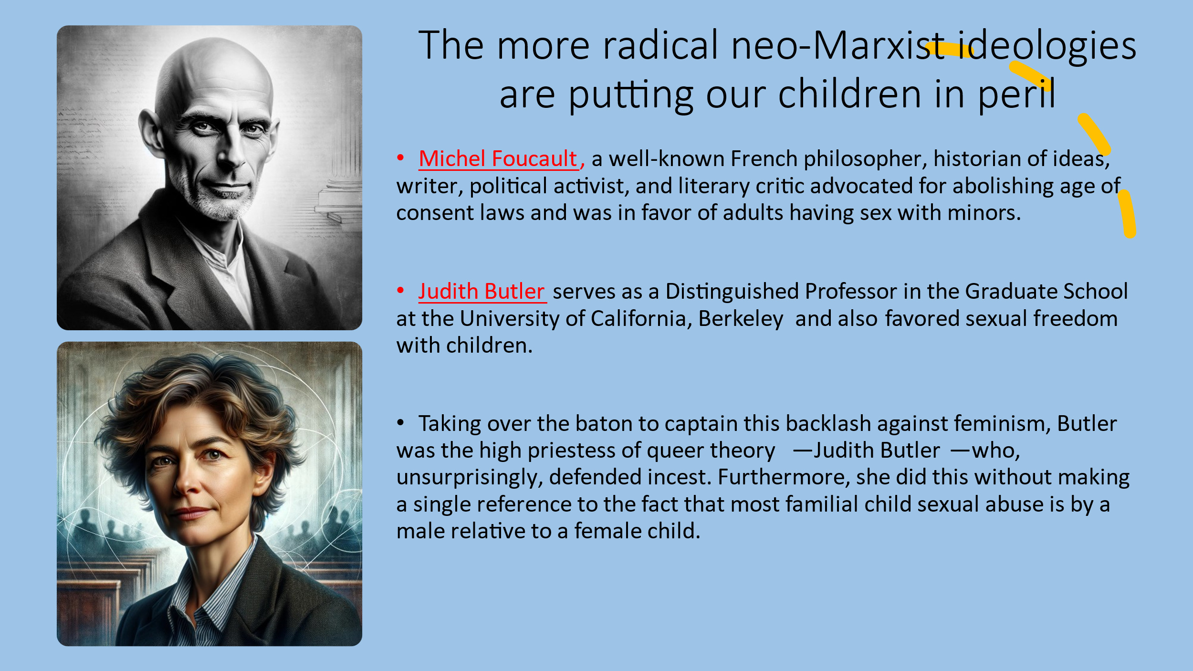
So, the pathway to confusing our children in their identity becomes clearer:
- Create a new ideology that under the cloak of making us all equal, forces us to accept that ideology as defined by the man defining that ideology, and if you refuse that it, you are destroyed, even killed. That is Classical Marxism.
- Appreciate that this new way of thinking, in order to more fully to take root, must change every aspect of existing culture. That is Antonio Gramsci.
- Disrespect and criticize every foundational cultural tradition or mores. That is The Frankfurt School.
- Turn upside down common sense sexual behavior and legitimize the perverse. That is Queer Theory.

Some Definitions Please



“We demand rigidly defined areas of doubt and uncertainty!”

― Douglas Adams

Autogynephilia: Autogynephilia refers to gender dysphoric males who sexually aroused by the thought or image of themselves as a woman.

Biological sex: As defined by Dr. Deborah Soh, a neuroscientist who specializes in gender research, biological sex is either male or female. It is not, as many believe, defined by chromosomes or our genitals or hormonal profiles, but by our gametes: small ones called sperm produced by males or large ones called eggs produced by females. Soh notes that there are no intermediate types of gametes between sperm and egg cells, hence sex is binary and not a spectrum as some have postulated (Soh, 2020a).

Cisgender: Cisgender, coined in the 1990s to mean the opposite of “transgender” (sometimes cissexual, often abbreviated to simply cis, the Latin prefix for being on the side of) refers to people whose gender identity matches their sex. For example, someone who identifies as a woman whose sex is female is a cisgender woman. The term cisgender is the opposite of the word transgender (Wikipedia 2020b).

Cross-sex hormones: Cross-sex hormones (also known as gender-affirming hormones): physiological doses of testosterone in transboys and estrogen in transgirls are used to induce secondary sex changes associated with the gender of identification (Cohen et al., 2018).

Gender dysphoria: Gender dysphoria is the distress a person feels due to a mismatch between their gender identity and their sex assigned at birth (Wikipedia 2020a). As a general descriptive term, gender dysphoria refers to an individual’s discontent with their “assigned” gender and their identification with a gender other than that associated with their birth sex based on physical sex characteristics (Butler et al., 2018).

‘Dysphoria’ relates to the distress and unease experienced. The term is more specifically defined when used as a diagnosis (Diagnostic and Statistical Manual of Mental Disorders, Fifth Edition).

As defined by the DSM-5 (the diagnostic Bible for mental health disorders), gender dysphoria is a marked incongruence between one’s experienced/expressed gender and assigned gender, of at least six months’ duration, as manifested by at least two or more of the following:

As defined by the DSM-5 (the diagnostic Bible for mental health disorders), gender dysphoria is a marked incongruence between one’s experienced/expressed gender and assigned gender, of at least six months’ duration, as manifested by at least two or more of the following:
- A marked incongruence between one’s experienced/expressed gender and primary and/or secondary sex characteristics (or in young adolescents, the anticipated secondary sex characteristics)
- A strong desire to be rid of one’s primary and/or secondary sex characteristics because of a marked incongruence with one’s experienced/expressed gender (or in young adolescents, a desire to prevent the development of the anticipated secondary sex characteristics)
- A strong desire for the primary and/or secondary sex characteristics of the other gender
- A strong desire to be of the other gender (or some alternative gender different from one’s assigned gender)
- A strong desire to be treated as the other gender (or some alternative gender different from one’s assigned gender)
- A strong conviction that one has the typical feelings and reactions of the other gender (or some alternative gender different from one’s assigned gender)
The condition is associated with clinically significant distress or impairment in social, occupational, or other important areas of functioning (American Psychiatric Association, 2013).

Gender expression: Gender expression refers to the “external manifestation” of our gender identity and how we express our gender identity through our appearance such as clothing, hairstyle choices, and mannerisms (Soh, 2020a).
Gender identity: Gender identity is how we “feel” in relation to our sex regarding whether we “feel” masculine or feminine (Soh, 2020a). To elaborate, it has been defined as a person’s deeply felt, inherent sense of being a girl, woman, or female; a boy, a man, or male; a blend of male or female; or an alternative gender (Bethea & McCollum, 2013; Institute of Medicine [IOM], 2011).
GnRH analogue: GnRH analogue known colloquially as ‘the blocker’. A longer acting version of the naturally occurring gonadotropin-releasing hormones (GnRH) such as triptorelin (Gonapeptyl Depot or Decapeptyl SR) used to prevent pituitary gonadotropin (follicle stimulating hormone FSH and luteinizing hormone LH) secretion by competitive inhibition of the GnRH receptor (Cohen et al., 2018).
Gender nonconforming: Describes an individual whose gender identity or gender expression differs from the gender norms associated with the sex they were assigned at birth (American Psychological Association, 2018).
Gender variance and gender diversity: Gender variance and gender diversity are umbrella terms used to describe the wide range of gender identifications outside conventional gender categories (Cohen et al., 2018).
Genderqueer: Describes an individual whose gender identity doesn't align with a binary understanding of gender, including those who think of themselves as both male and female, neither, moving between genders, or a third gender or outside of gender altogether (American Psychological Association, 2018).
Intersex: Intersex is a general term used for a variety of situations in which a person is born with reproductive or sexual anatomy that doesn’t fit the box of “female” or “male.” Sometimes doctors do surgeries on intersex babies and children to make their bodies fit binary ideas of “male” or “female”. (Planned Parenthood, 2021). For more than 9 percent of the population, our gender is our biological sex. For the remaining 1 percent of individuals for whom gender identity is not in alignment with their biological sex, they may identify as transgender or have a medical condition known as intersex (Soh, 2020a). The latest statistics on this indicate that 6 in 1,000 American adults currently identify as transgender and 1 in 10 individuals are intersex (Arboleda et al., 2014).
Non-binary: Non-binary is a lack of identification with conventional maleness or femaleness. Non-binary people may express attributes of both genders or neither (Cohen et al., 2018).
Trans-affirmative: Being aware of, respectful, and supportive of the needs of transgender and gender-nonconforming individuals (American Psychological Association, 2018).
Transgender: Transgender encompasses the Latin prefix, which means “on the other side of.” By definition, a transgender person “feels” that their gender identity is more aligned with the opposite sex than their birth sex (Soh, 2020a). According to Butler et al. (2018), it refers to the broad spectrum of individuals who identify with a gender other than that associated with their birth sex.
Transman/transboy: A person born phenotypically female (natal female), registered (assigned) female at birth, who identifies as male. Also known as female to male (Cohen et al., 2018).
Transwoman/transgirl: A person born phenotypically male (natal male), registered (assigned) male at birth, who identifies as female. Also known as male to female (Cohen et al., 2018).

Prevalence

A sure sign of a crisis is the prevalence of cranks.
It is characteristic of a crisis in theory
that cranks get a hearing from the public
which orthodoxy is failing to satisfy.

- Joan Robinson

Megan Hull (2020) writes that various studies have been conducted around the world in an effort to determine the prevalence of gender dysphoria.
A Dutch study conducted by Bouman et al. (2016) found that 4.6% of 8,064 study participants who were born male and 3.2% who were born female-identified themselves as having significant ambivalence about their specific birth gender and were equally able to identify as male or female according to their apparent internal perception of self.
The number of people with gender dysphoria and gender incongruence who seek assessment, support, and treatment at gender identity clinic services has grown significantly over recent years in both Europe and North America (Aitken et al., 2015; de Vries et al., 2015). More specifically, Aitken et al. (2015) noted that the number of adolescents referred to specialized gender identity clinics for gender dysphoria appears to be increasing and there also appears to be a corresponding shift in the sex ratio, from one favoring natal males to one favoring natal females. They conducted two quantitative studies to ascertain whether there has been a recent inversion of the sex ratio of adolescents referred for gender dysphoria. They found that across both clinics, the total sample size was 748. In both clinics, there was a significant change in the sex ratio of referred adolescents between the two cohort periods: between 2006 and 2013, the sex ratio favored natal females, but in the prior years, the sex ratio favored natal males. In Study 1 from Toronto, there was no corresponding change in the sex ratio of 6,592 adolescents referred for other clinical problems.
In addition, there has been a significant increase in people who self-diagnose as having gender dysphoria and/or gender incongruence. Kuyper & Wijsen (2014) investigated self-reported gender identity and dysphoria in a Dutch population sample (N = 8,064, aged 15–70 years old). They found that 4.6% of people assigned male at birth and 3.2% of people assigned female at birth reported an “ambivalent gender identity,” which they defined as equal identification with other sex as with sex assigned at birth. 1.1% of people assigned male at birth and 0.8% of people assigned female at birth reported an “incongruent gender identity, ” which they defined as stronger identification with other sex as with sex assigned at birth.
Consistent with their results, Van Caenegem et al. (2015) reported results on two population-based surveys, one of 1,832 Flemish persons and the other of 2,472 sexual minority individuals in Flanders. This study aimed to examine the prevalence of gender incongruence (identifying stronger with the other ex than with the sex assigned at birth) and gender ambivalence (identifying equally with the other sex as with the sex assigned at birth) based on two population-based surveys, one of 1,832 Flemish individuals and one of 2,472 sexual minority individuals in Flanders. In the general population, gender ambivalence was present in 2.2 % of male and 1.9 % of female participants, whereas gender incongruence was found in 0.7 % of men and 0.6 % of women. In sexual minority individuals, the prevalence of gender ambivalence and gender incongruence was 1.8 and 0.9 % in men and 4.1 and 2.1 % in women, respectively. With a current Flemish population of about 6 million, the results indicate a total of number between 17,150 and 17,665 gender incongruent men and between 14,473 and 15,221 gender incongruent women in Flanders.
The Centers for Disease Control and Prevention surveyed ten states (Colorado, Delaware, Hawaii, Massachusetts, Maryland, Maine, Michigan, Rhode Island, Vermont, Wisconsin) and nine large urban school districts (Boston, Cleveland, District of Columbia, Detroit, Broward County, Los Angeles, New York City, San Diego, San Francisco). The survey data indicated that an average of 1.8% of high school students identify as transgender. They noted that transgender students are more likely than cisgender students to report violence victimization, substance use, and suicide risk (Center for Disease Control and Prevention, 2019).

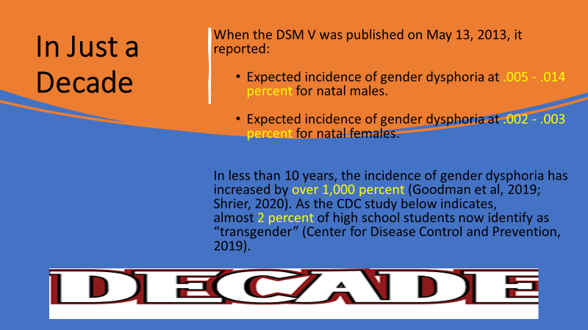

The Gender Identity Development Service in the United Kingdom, which treats only children under the age of 18, reported that it received 94 referrals of children in 2009/2010 and 1,986 referrals of children in 2016/2017 — a relative and staggering increase of 2,000% (GIDS referrals figures for 2016/17).

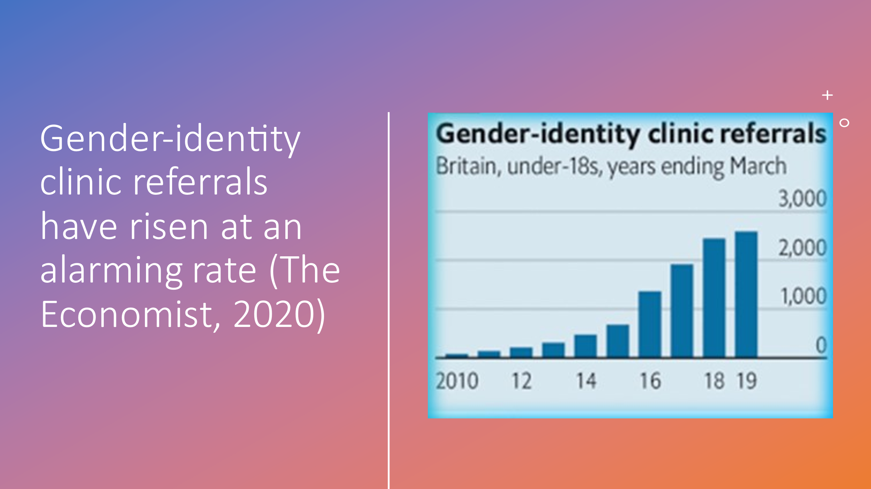

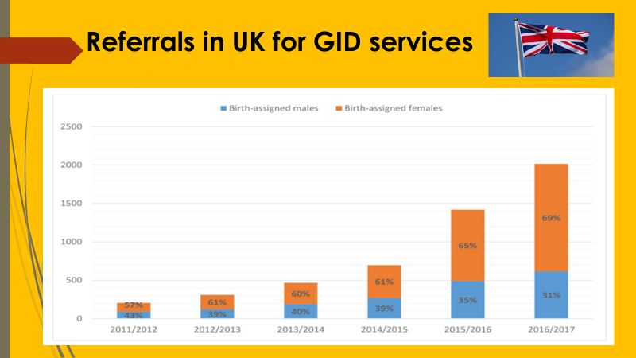Reference: Referrals to UK GID services: Assessment and support of children and adolescents with gender dysphoria. Arch Dis Child 2018; 103:631–6. doi:10.1136/archdischild-2018-314992 (Butler et al., 2018).

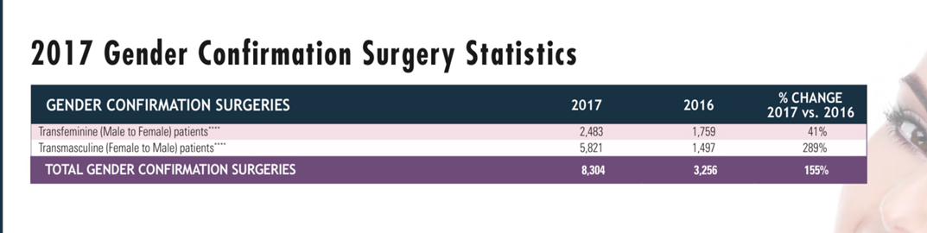
Plastic Surgery Report (2017)

Between 2016 and 2017 the number of gender surgeries for natal females has quadrupled in the United States (Plastic Surgery Report, 2017; Shrier, 2020).

Etiology


Natural science is either the description of forms (morphology)
or the explanation of changes (etiology). Neither can afford us
the information we chiefly desire.
— Arthur Schopenhauer

Dr. William Malone, board certified endocrinologist, holding a BA from Stanford University and an MD from New York University and currently serving as the medical director at an endocrinology and diabetes center in Idaho notes that gender dysphoria typically has an underlying cause.
Autogynephilia: Dr. Anne Lawrence at the Department of Psychology, University of Lethbridge in Canada notes that autogynephilia is defined as a male's propensity to be sexually aroused by the thought of himself as a female. It is the paraphilia that is theorized to underlie transvestism and some forms of male-to-female (MtF) transsexualism (Lawrence, 2011). The term autogynephilia was coined by researcher/psychologist Dr. Ray Blanchard. The term “autogynephilia” denotes being sexually aroused by the idea of being or becoming a woman. (Auto=self; gyn=female; philia=love of) (Dreger, 2015).

Autogynephilia encompasses sexual arousal with cross-dressing and cross-gender expression that does not necessarily involve women's clothing. The concept of autogynephilia defines a typology of MtF transsexualism and offers a theory of motivation for one type of MtF transsexualism. Autogynephilia resembles a sexual orientation in that it involves elements of idealization and attachment as well as erotic desire. Nearly 3% of men in Western countries may experience autogynephilia. Its most severe manifestation, MtF transsexualism, is rare but has been increasing in prevalence. Lawrence notes that some theorists and clinicians reject the transsexual typology and theory of motivation derived from autogynephilia and she believes that their objections suggest a need for additional research. Autogynephilia exemplifies an unusual paraphilic category called 'erotic target identity inversions' in which men desire to impersonate or turn their bodies into facsimiles of the persons or things to which they are sexually attracted (Lawrence, 2011). Clinically, Dr. Blanchard has observed autogynephilic natal male individuals who were aroused, for example, at the ideas of using a tampon for menses or knitting as a woman with other women (Dreger, 2015).
Homophobia: Dr. Soh (2020a) writes that despite the many strides forward that have been made by the gay rights movement, some children are actually being encouraged to transition as a solution to homophobia. Effeminate sons tend to evoke a stronger negative response than tomboy daughters. She adds that with greater public awareness about gender dysphoric children and the difficulties and stigma that they would face, parents receive more attention and admiration when raising a transgender daughter than a gay child. Moreover, for those who are troubled at the thought of having a son who is effeminate, transitioning offers an elegant solution – by allowing a feminine boy to transition.

The consequences of concrete thinking processes that characterize autism spectrum conditions (“I don’t like dresses therefore I must be a boy”): Dr. Glidden and his colleagues conducted a review of over 58 studies and concluded that there is a considerably higher rate of autism spectrum disorder (ASD) in children and adolescents with gender dysphoria than in the general population (Glidden et al., 2016). In an effort to show how ASD and gender dysphoria might he linked, Dr. Kenneth Zucker and his colleagues noted that “children with Gender Identity Disorder (GID) generally show intense, if not obsessional, interests in cross-gender activities. Both GID and ASD involve a “predisposition for obsessional or focused interests and extreme rigidity in thinking,” accompanied by “intense anxiety” in response to any interference with the obsession. Gender can be a focus of obsessional thinking and this obsession could be a “magnification” of interests that a typical child would have at a similar state of development (Zucker et al., 2012; Anderson, 2019).
A protective mechanism to avoid repeat sexual trauma. Walt Heyer, a former Honda executive, had gender reassignment surgery in 1983 and found that surgery couldn’t solve the underlying issues driving his gender dysphoria and resultantly detransitioned more than 25 years ago. He was sexually molested as a child and asserts that this was a factor in his gender dysphoria. Moreover, in his work involving sex change regret, he has found that over 50 percent of these individuals were sexually abused as children (Heyer, 2018).
Statistics documenting transgender people's experience of sexual violence indicate shockingly high levels of sexual abuse and assault. One in two transgender individuals are sexually abused or assaulted at some point in their lives. Some reports estimate that transgender survivors may experience rates of sexual assault up to 66 percent, often coupled with physical assaults or abuse. This indicates that the majority of transgender individuals are living with the aftermath of trauma and the fear of possible repeat victimization (Office for Victims of Crime, 2014).
The influence of role models: According to Bouman et al. (2016), the increase in prevalence of gender dysphoria and gender incongruence in the last decade is most likely due to a number of interactively linked factors one of which is the increased visibility of accepted trans people on television and in films, such as Caitlyn Jenner, Transparent, and The Danish Girl. These individuals and films enter societal conscience as an increasingly mainstream phenomenon and contribute to at least a partial de-stigmatization of being trans.



In addition, Bouman et al. (2016) posit that the wide availability of information on the Internet and other communication channels about gender dysphoria and gender incongruence also are likely to contribute to the de-stigmatization and the increased awareness of the availability of biomedical treatment.
Childhood Trauma: Trauma exposure, particularly child maltreatment (e.g., neglect, emotional, physical and sexual abuse), has been established as one of the main determinants of emotional dysregulation and is also a known risk factor for psychiatric disorders, especially depression and PTSD (McLaughlin et al., 2012; McLaughlin et al., 2013). Moreover, several prior studies have shown that trauma exposure is clearly associated with profound deficits in emotional regulation across the entire lifespan, including during preschool (Langevin, Hebert, Allard-Dansereau & Bernard-Bonnin, 2016), adolescence (Shields & Cicchetti, 1997; Vettese, Dyer, Li, & Wekerle, 2011) and even adulthood (Briere & Rickards, 2007; Thompson, Hannan, & Miron, 2014; Dunn et al., 2018).

As trauma expert Dr. Peter Levine notes in his book, Healing Trauma, “Trauma is much about loss of connection – to ourselves, to our bodies, to our families, to others, and to the world around us. This loss of connection is often hard to recognize because it doesn’t happen all at once. It can happen slowly over time, and we adapt to these subtle changes sometimes without even noticing them. These are the hidden effects of trauma, the ones most of us keep to ourselves … our choices become limited as we avoid certain, feelings, people, and situations. The result of a gradual constriction of freedom is the loss of vitality and potential for the fulfilment of our dreams” (Levine, 2008, p. 9).


Most important to normal development is “social engagement” which is the ability to know, understand, regulate, and express emotions in the present moment. Even though everyone is born with a social engagement system (i.e., a neurological system that promotes human connection), we know that early trauma can disrupt its normal development. Anda et al. (2018) note, “Early adverse experiences may disrupt the ability to form long-term attachments in adulthood. Developmental traumal has a tremendous impact on how children view themselves, their relationships, and their place in the world. As a result of adverse developmental trauma, the ensuing loss of connection with our inner self, our bodies, others, and the world around us, we can become so desperate to connect to anyone and the trans community, not unlike many unique communities, welcomes anyone who might come their way and offers comfort, “I can finally belong.”
On a neuropsychological level, trauma occurs when we are faced with an experience that overwhelms our ability to process incoming information both at the time of that experience and in future situations (Barta, 2018). Dr. Michael Barta suffered from trauma himself as a child which led him to addictions that ultimately landed him in jail and almost destroyed his life. In his book, TINSA, he wrote that trauma occurs when our natural defenses are unable to keep us safe from physical, emotional, or mental threats or harm (Barta, 2018).
Moreover, the long-term consequences of these traumas are tremendous and often lead to a total inability or impaired ability to access appropriate responses to threatening events and can lead to chronic hyperarousal, intense anxiety, panic, mood instability, poor emotional/behavioral regulation, feelings of powerlessness, helplessness, shame, and even immobility (Hansen, 2020). Some individuals, in a desperate attempt to find an explanation to the overwhelming emotional and even physical pain they feel, will conclude that is it is gender dysphoria that is at the root of the pain and are deeply comforted by this knowledge, namely, “My problems can be explained by gender dysphoria and if I solve this, I will bring an end to my pain.”
Transgender OCD (TOCD): Clinical social worker Josh Kaplan who specializes in, among other things, OCD, and working out of Denver, Colorado, notes that individuals with TOCD are focused on trying to know for sure whether their thoughts are a sign of an underlying, unrecognized desire to transition their gender presentation. Like other forms of OCD, he writes that TOCD is the inability to tolerate uncertainty — not simply the idea that a person might be transgender — that creates anxiety and drives the disorder.
According to Kaplan, as the idea of transitioning away from your gender assigned at birth has entered mainstream public discourse, there has also been a rise in reports of TOCD. As one hears about transgender people in the media or at school, this may cause someone to question their own gender identity, which is perfectly healthy and for some may lead to a fulfilling and appropriate gender transition. For many people, it’s a fleeting thought that disappears. However, for those with TOCD (also referred to as GOCD), that momentary doubt can spiral into an ever-deepening cycle of obsessions and compulsions, as the person gets caught up in a circle of doubt and wondering which, in reality, has little to do with their true gender identity. In this subtype of OCD in which a person obsesses over their gender identity, these intrusive thoughts cause the person significant amounts of anxiety and uncertainty, which they desperately try to relieve with compulsive behaviors such as emotional checking, memory review, reassurance-seeking, and researching. It is important to note that TOCD is not the same thing as gender dysphoria, which transgender people often experience (Kaplan, 2020).
As one TOCD sufferer wrote: “I recently developed TOCD again and it’s relentless. With my obsessions about sexuality and schizophrenia, it was kind of easy to tell it was OCD, especially with hindsight, but this one feels so f-ing real. I don’t think I’m trans because thinking about me being a girl makes me pretty sad and I feel anxious with these thoughts. But then again, I feel like I’m just in denial. I’ve lost attraction and desire for females and every time I try and get aroused to females, I just end up panicking. I also feeI like my body is feminizing, especially my chest area and I hate it. I can’t even socialize I just feel like i’ve hit rock bottom. To make it even worse, with this pandemic, I can’t even get help. Anyone else in this boat?” (r/tocd, 2016).
Rapid-Onset Gender Disorder: Soh (2020a) writes that until recently, adolescent-onset gender dysphoria had typically appeared in adolescent males (in the form of autogynephilia). On the other hand, rapid-onset gender dysphoria (ROGD) is typically seen in teenage girls and is characterized by a sudden and often “out-of-the-blue” onset, with no apparent previous history of gender dysphoria (Soh, 2020a).


Dr. Lisa Littman, an OB-GYN physician and assistant professor at Brown University, published one of the first studies on ROGD. This study surveyed 256 parents who completed a ninety-question survey and the results suggested that for at least some of these girls, their transgender drive was a function of social contagion. In the study more than 25 percent had come out as gay and one third had come out as bisexual prior to identifying as transgender. Approximately 60 percent had comorbid disorders such as anxiety and borderline personality disorder. She concluded that regarding the social contagion factor, there was an association between suddenly coming out as trans and having a friend or many friends who also identified as transgender. She added that for approximately 40 percent of these adolescent girls, more than half of their friend groups had likewise identified as transgender.
As nicely summarized by Abigail Shrier (2020) the Littman study showed:

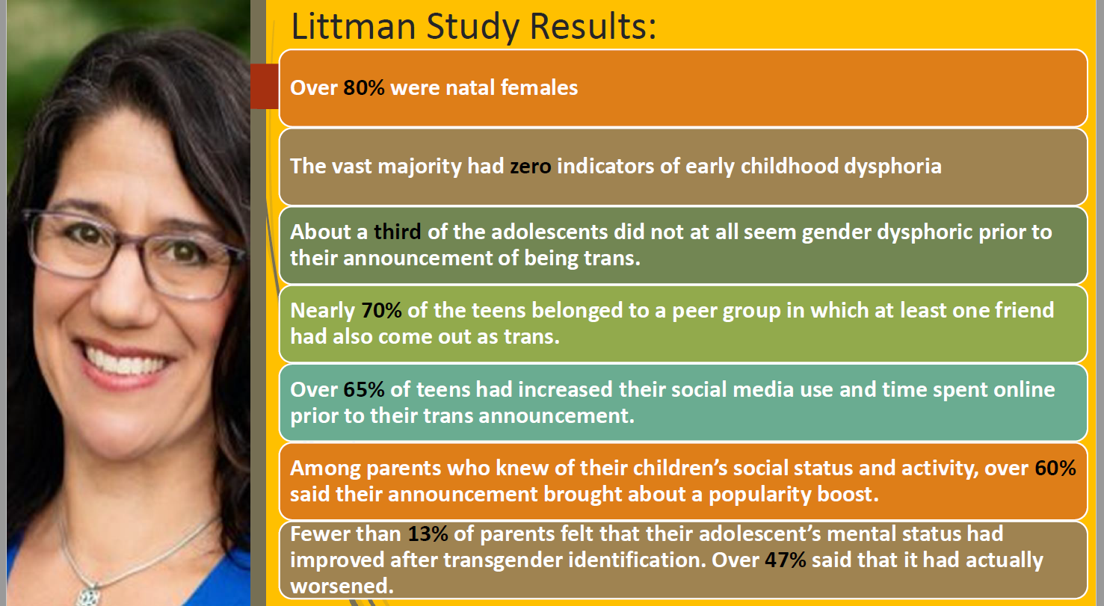

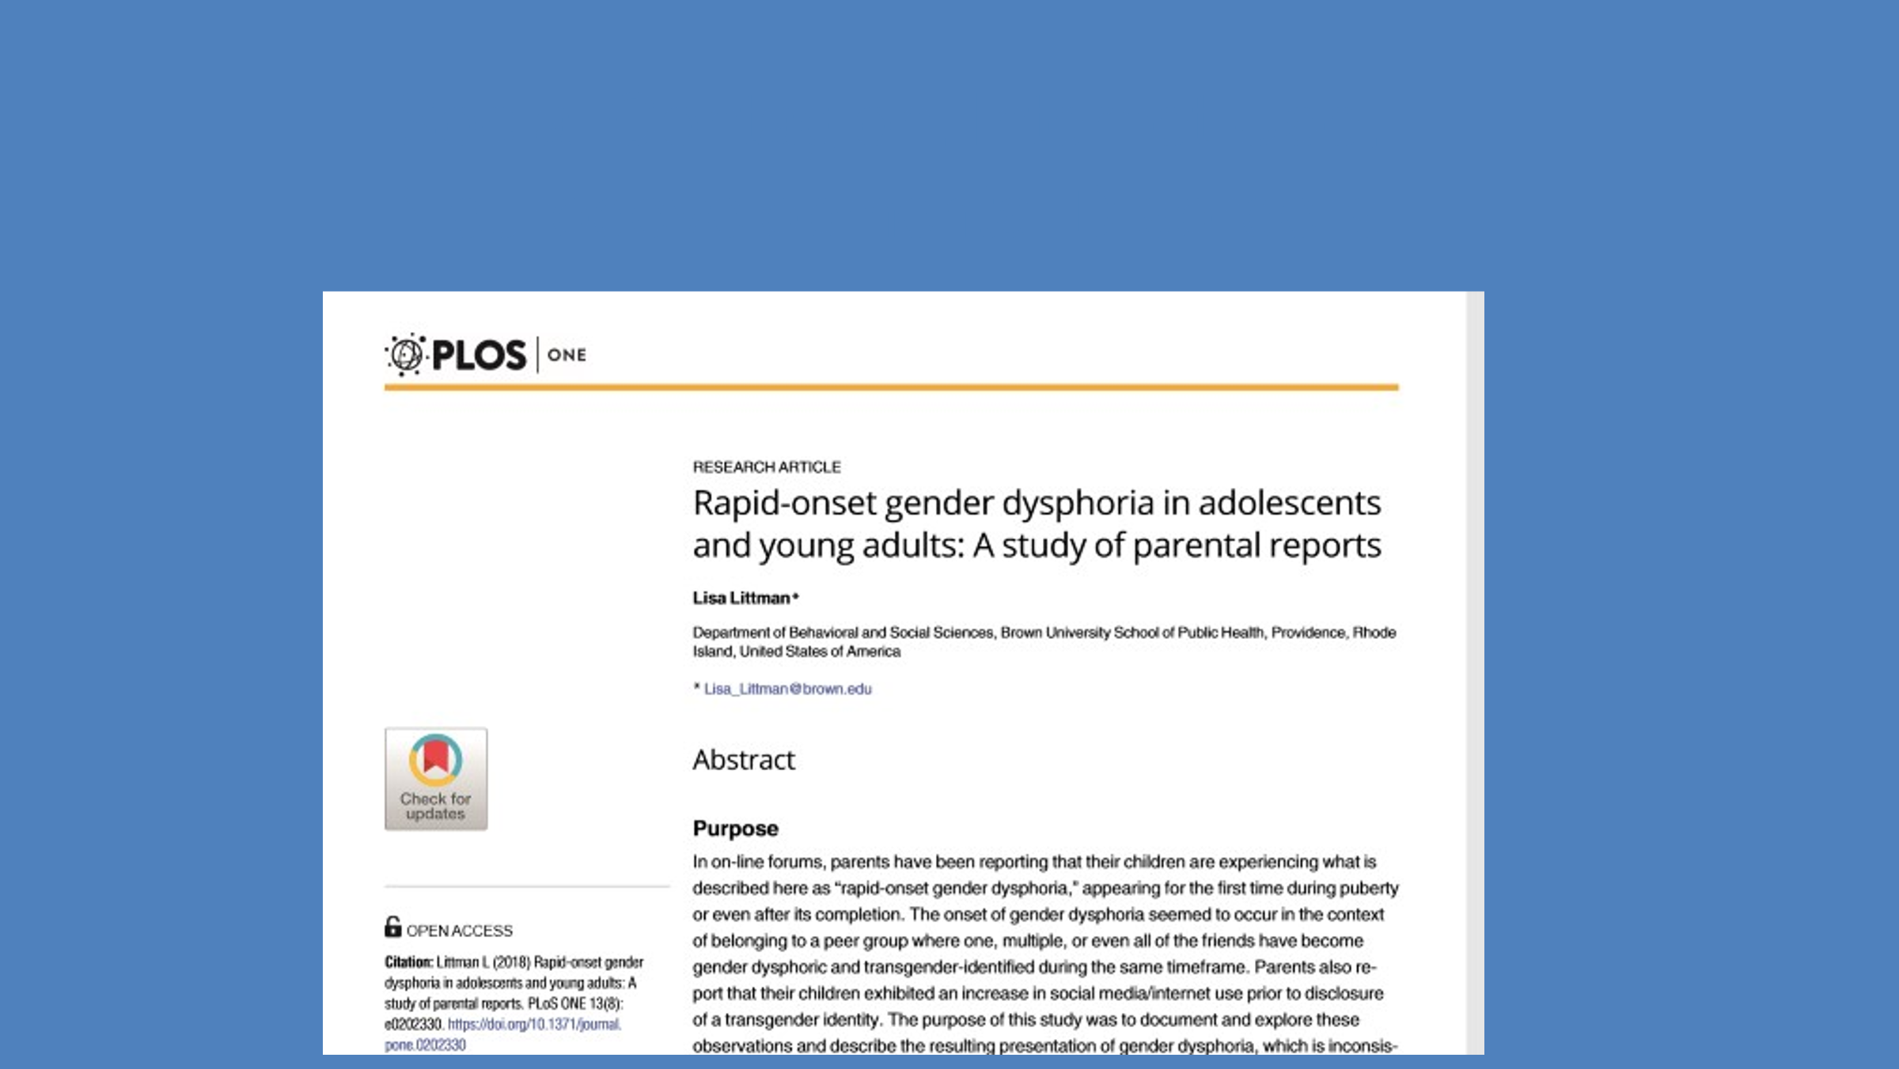
Used with permission from Dr. Michael Laidlaw (2019). “Medical Harms from the Treatment of Child and Adolescent Gender Dysphoria” Endocrinologist and Specialist on Childhood Gender Dysphoria YouTube Presentation https://www.youtube.com/watch?v=2iJHf1BKPJY&feature=youtu.be

This statistic is more than seventy times the prevalence rate of trans adults in the general population (Soh, 2020a). The results of Littman’s study were so shocking that it resulted in a strong, if not militant, response from activists who announced the study as “transphobic.” Soh noted that some left-leaning media publications called it “junk science” and “anti-trans” and alleged that the parents who participated in the study were recruited from “right-wing hate groups.” This is surprising as 86 percent of these parents endorsed marriage equality and 88 percent actually supported transgender rights. Moreover, Dr. Littman describes herself as a liberal Democrat. As a result of the backlash, Brown University pulled the press release of the Littman study and the journal that published it made the announcement that it would conduct a post-publication review of its methodology and analysis.

The notice of republication from PLOS ONE states: “After publication of this article... questions were raised that prompted the journal to conduct a post-publication reassessment... involving senior members of the journal’s editorial team, two Academic Editors, a statistics reviewer, and an external expert reviewer. The post-publication review identified issues that needed to be addressed to ensure the article meets PLOS ONE’s publication criteria. Given the nature of the issues in this case, the PLOS ONE Editors decided to republish the article, replacing the original version of record with a revised version” Brown University, 2019).

This is troubling as reconsidering the methodology of a peer-reviewed research after has been published is essentially unprecedented. Soh (2020a) notes that given the aforementioned demographics of the subjects, many of the proponents had not even read the research as they criticized the subjects as being transphobic but, in reality, they were not. Fortunately, the post-publication review largely supported the Littman study and only resulted in minor cosmetic changes, but not without the activists filing complaints against her which resulted in the loss of a consultation position (Littman, 2020).
Suzanna Dias (yes a pseudonym as she appropriately fears being attacked and vilified by extreme activists who might oppose her work) and Dr. Michael Bailey, psychologist, behavioral geneticist, and professor at Northwestern University, replicated Littman’s ROGD and with a much larger sample size . The sample size of 1655 was much larger and focused on children whose gender dysphoria reportedly began between ages 11 and 21 years, inclusive. These youths were disproportionately (75%) natal female. It was found that natal males had later onset (by 1.9 years) than females, and they were significantly less likely to have taken any decisive steps toward social gender transition (65.7% for females versus 28.6% for males). Similar to the Littman study, pre-existing mental health issues were common, and perhaps not so surprisingly youths with these issues were more likely than those without them to have socially and medically transitioned which suggested that young people who transition are perhaps at least in part fueled by mental health issues. Sadly, parents reported that they had often felt pressured by clinicians to affirm their child's new gender and support their transition and their children's mental health deteriorated considerably after social transition.

Research Review Boards in service of activist
ideology is no longer unbiased

Perhaps not so surprisingly, activists attacked this study as they did with the 2018 Littman study and were successful in getting it redacted on the grounds that the researchers failed to obtain informed consent. To clarify,informed consent refers to potential participants being informed about the study before actually participating in it. Evolutionary biologist and fellow at the Manhattan Institute Dr. Colin Wright asserts and agree that this is a play right out of the activist playbook: to get the Diaz and Bailey paper retracted over a technicality, then spin the retraction as an invalidation of the study’s main findings. Such a tactic was successfully used on Littman’s 2018 ROGD paper as noted earlier. He adds, “Under pressure, a journal once notable for its courage retracts a major paper on the social roots of gender-related distress—all over a minor, inconsistently applied technicality” (Wright, 2023).

Mental Health Crisis in Today’s Youth: Abigail Shrier, a writer for the Wall Street Journal, author of Irreversible Damage, and with a law degree from Yale Law School, cites the work of academic psychologist, Jonathan Haidt, who reports that teens are in a mental health crisis – evincing record levels of anxiety and depression, in part driven by social media (Shrier, 2020; Haidt, 2019).
A 2018 study conducted by Blue Cross and Blue Shield revealed that the highest rate of growth in depression has occurred in the youngest and the most digitally connected age bracket (see chart below). The most dramatic rise in major depression diagnoses (MDD) is among those under 35 years of age. Between 2013 and 2016 diagnoses of MDD increased 63 percent among adolescents and 47 percent among millennials. Gender differences among millennials were similar but among adolescents there was a 65 percent increase for girls compared to a 47 percent rise for boys (Blue Cross and Blue Shield, 2018).
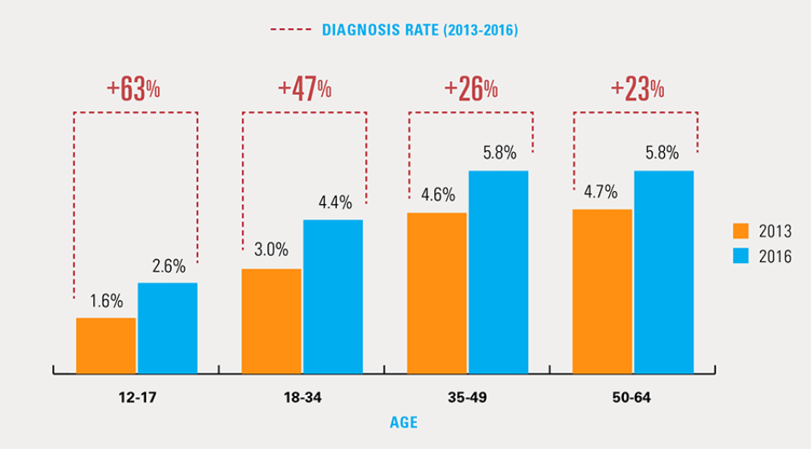
(Blue Cross and Blue Shield, 2018).

The CDC recently reported that the suicide rate among the “Most Digitally Connected Generation” has increased at an alarming rate in the last 10 years after being flat for nine years. This 30% increase in suicide correlates with the advent of the smart phone (see graph below).

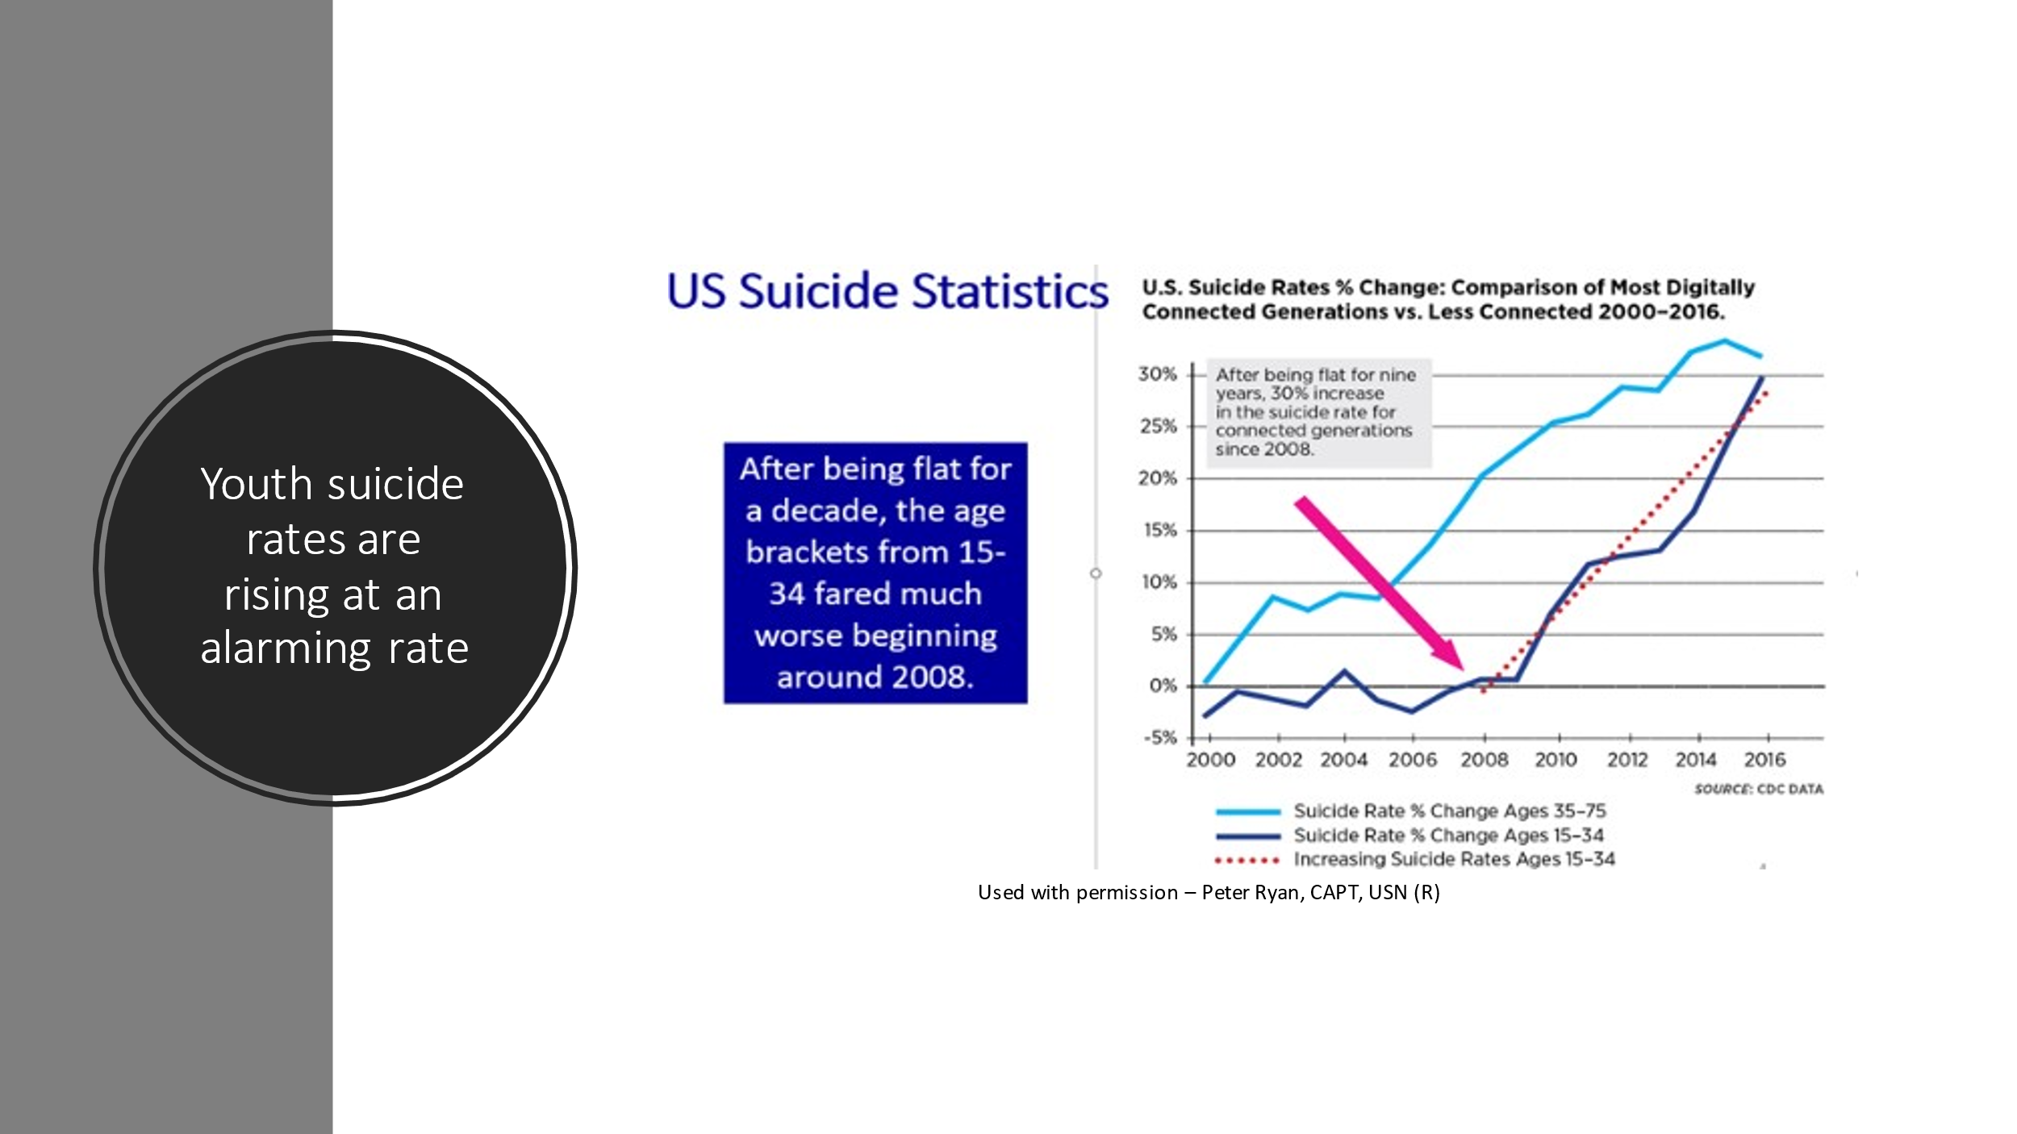
Used with permission – Peter Ryan, CAPT, USN (R)

Girls are reporting more depression than boys and Haidt points out that the average rates of self-harm reflect that same spike. Self-injury in girls has increased 62% since 2009. Among teenage girls aged 10 to 14, rates of self-injury have increased an alarming 189% since 2010, nearly triple what it was six years before (Haidt, 2019). There is an increasing consensus that social media is to a large degree driving this crisis. Jean M. Twenge, Professor of Psychology at San Diego State University, the author of more than 130 scientific publications and 6 books, including iGen: Why Today’s Super-Connected Kids Are Growing Up Less Rebellious, More Tolerant, Less Happy–and Completely Unprepared for Adulthood, writing for “The Atlantic, “It’s not an exaggeration to describe iGen as being on the brink of the worst mental health crisis in decades. Much of that deterioration can be traced to their phones” (Twenge, 2017). The iPhone was released in 2007 and by 2018, only a decade later, 95% of teens had access to a smartphone and 45% report being online “almost constantly” (Schlosser, 2018).

Shrier (2020) writes, “Tumblr, Instagram, TikTok, and YouTube – all very popular with teens- host a wide array of visual tutorials and pictorial inspiration to self-harm via anorexia (“thinspiration” or “thinspo”), cutting, and suicide. Posting one’s experiences with any of these afflictions offers the chance to win hundreds – even thousands – of followers” Shrier, 2020; Helena, 2019). Helena (2019) notes that anorexia, cutting, and suicide have all spiked frighteningly since the advent of the smartphone.

Shrier writes that girlhood in America is piratically synonymous with the worry that one’s body does not measure up and that girls “flee womanhood like a house one fire, their minds fixed on escape, not on any particular destination” (Shrier, 2020 p.7). She cites, Sasha Ayad, an internationally renowned therapist specializing in gender dysphoria, “A common response that I get from female clients is something along the lines: ‘I don’t know exactly that I want to be a guy. I just know I don’t want to be a girl’”

The Impact of Pornography: Dr. Soh (2020b) notes that the increase of gender dysphoria in women is also possibly due to the effect of pornography as many girls or young teens view the abhorrent mistreatment of women in porn and seek to avoid being in a submissive role where they, too, can be mistreated. Pornography has far-reaching impact on normal sexual development and many teens are using it to develop their sense of sexuality and who they are to a large extent (Hansen, 2019).



Gary Wilson (2017) writes that once upon a time, men could trust their penises to tell them everything they needed to know about their sexual preferences and orientation. However, our brains are very plastic (or able to change with experience). As such, our brains change with experience with or without our conscious participation. Wilson notes, that as a function of porn involvement, porn users often move from one genre to another and will often arrive in places that they find very disturbing and/or confusing. As a result, a previously defined heterosexual boy might ultimately find himself enjoying homosexual pornography and then begin to question his sexuality. Additionally, many men end up viewing child pornography as they have habituated to everything else. As has been said, “I did it all and then got bored (habituated) with it all and thus (child porn) was the final taboo that excited me.”

Another young man cited in Wilson (2017), stated, “I wasn’t interested in any weird stuff before I started to watch porn. Just real girls of my age. Now, I like BBB, BBW, MILF, Tranny, Crossdresser, Fat, Skinny, and Teen.”

Downing et al. (2016) conducted a study that found that it is now quite common to find men who view porn that is inconsistent with their sexuality. Specifically, they reported that heterosexual-identified men in the study reported viewing porn containing male same-sex behavior (20.7%) and gay-identified men reported viewing heterosexual behavior in porn (55%). Wilson (2017) notes that it is very sad that porn users are ignorant of how common it is to escalate often leaving porn users in the end, feeling very anxious, demoralized, and hopeless. He adds that it can be especially distressing to escalate through porn fetishes that ultimately cast doubt on one’s sexual orientation.
Current Guidelines of Practice Protocol
You cannot construct your house in the jungle without good relations
with the wolf, the tiger, the lion.”
― Avijeet Das

Back in 2001 The World Professional Association for Transgender Health (WPATH) published guidelines (note that I have substituted “guidelines” for “standards” as these are not empirically supported) on the clinical care of transgender children, set out three stages of gender-affirming interventions with progressive levels of irreversibility:
Stage 1, puberty suppression

Stage 2, gender-affirming hormones

Stage 3, gender-affirming surgery

Dr. Anderson (2018) nicely summarized the current four stage treatment plan (not three) for treatment of gender dysphoria according to activists which have come to be accepted as “standards of practice.”

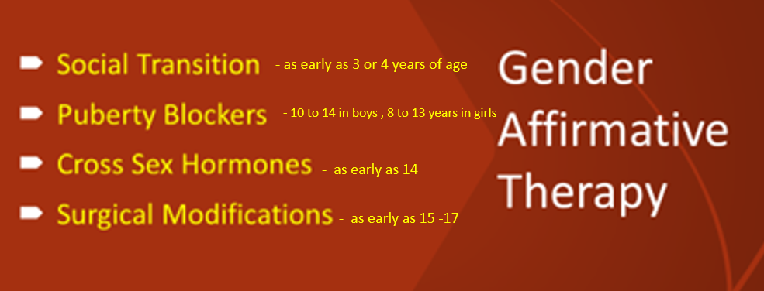

Stage 1 – Social Transition:
According to the guidelines of practice protocol, when a child identifies as the opposite sex in a manner that is “consistent, persistent, and insistent,” the appropriate response is to support that identification. This would constitute a “social transition” which might involve giving the child a new name, a new wardrobe, new pronouns or essentially treating the child as if (s)he were the opposite sex. This could start as early as 3 or 4 years of age (Anderson, 2018). Social transitioning means that everyone who knows the child will refer to them as the opposite sex and will endorse the belief that they are not the sex that they were born with (Soh, 2020a). Dr. Soh argues on the other hand, there is no reason why adults can’t support the young child’s preferences, while at the same time maintaining that they are the sex that they were born as. She noted that, based on the research literature on desistance, at puberty to reconsider this if the gender dysphoria persists.
Stage 2 – Puberty Blockers:
As the child approaches puberty, Dr. Anderson (2020) notes that they will be placed on puberty blockers to prevent the normal process of development and maturation. This to say that there will be no progression of the pubertal stage and the regression of sex characteristics that have already taken place will ensue. In boys, testicular volume will decrease and in girls breast tissue will weaken and possibly disappear altogether (Hurz et al., 2017; Anderson, 2018). According to the Endocrine Society, puberty blockers are recommended at the start of puberty (between the ages of 10 to 14 in boys and 8 to 13 years in girls) until the age of 16 (Hembree, 2017).
Guidelines require puberty to have begun (Tanner stage 2, when pubic hair and breast buds appear) before any intervention is agreed. This is because gender dysphoria may resolve once puberty begins. In 2008, the Endocrine Society approved puberty blockers for transgender adolescents as young as 12 years old (ages have since decreased) (The World Professional Association for Transgender Health (WPATH, 2001).
Stage 3 – Cross-Sex Hormones:

In this stage cross-sex hormones will be administered. Boys will be given feminizing hormones such as estrogen and girls will be given masculinizing hormones such as androgens, i.e., testosterone. The goal here is to mimic the process of puberty that would have occurred in the opposite sex. For girls, testosterone will lead to a low voice, body and facial hair, and a more masculine body shape and for boys, estrogen and androgen blockers such as spironolactone will lead to the development of breasts and a body shape with a female phenotype. These individuals will need to remain on cross-sex hormones for the rest of their lives (Anderson, 2018). Gonadotropin-releasing hormone agonists are said by some but not all to be reversible and do not require fertility preservation; however, changes that occur with cross-sex hormones may make it more difficult to produce eggs in the future (Mayer et al., 2016; Anderson, 2018).
Stage 4 – Reassignment Surgery:

Finally, by age 18, and in increasing cases, earlier, reassignment surgery is begun. This can include amputation of primary and secondary sex characteristics and plastic surgery to create new sex characteristics. Male-to-female surgery involves removing the testes and constructing genitalia that resemble female anatomy. This might also include breast enlargement if estrogen therapy has not resulted in satisfactory breast growth. Female-to-male surgery typically involves a double mastectomy, and the uterus and ovaries are often removed as well. Finally, some individuals will choose to a have phalloplasty procedure which involves the surgical construction of a penis. This later intervention is often not done as quality and functionality are not always satisfactory (Hurz et al., 2017).

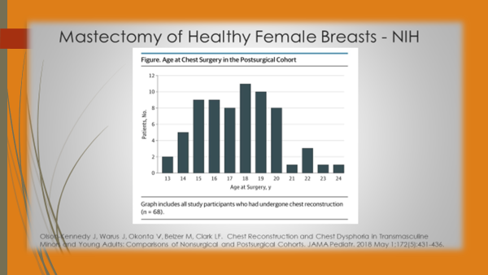
Used with permission from Dr. Michael Laidlaw (2019). “Medical Harms from the Treatment of Child and Adolescent Gender Dysphoria” Endocrinologist and Specialist on Childhood Gender Dysphoria YouTube Presentation https://www.youtube.com/watch?v=2iJHf1BKPJY&feature=youtu.be

Activists have created child-friendly graphics in an effort to teach young children about sex and gender. The first generation of such graphics was the Gingerbread Person developed by Sam Kellerman (Kellerman, 2015). As can be seen, this graphic lists four potential aspects of gender identity based on how you align or don’t align with your perception of the options of gender based on identity, expression, anatomical sex, and attraction (romantic or sexual). The graphic goes on to say that each category does not necessarily align with the other. As such, there are a plethora of possibilities. The Gingerbread Person localizes gender identity in the brain, sexual and romantic attraction in the heart, biological sex in the pelvis, and gender expression everywhere. This graphic has been criticized by activists as looking overly male. An earlier version was criticized for using the term biological sex and this more recent version changed that to anatomical sex.

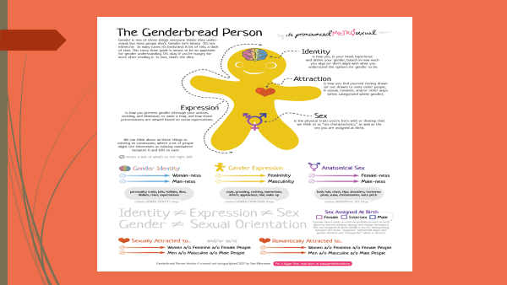
Kellerman (2017) Uncopywrighted https://www.genderbread.org/resource/genderbread-person-v4-0-poster

A more accepted version which is often used in the classroom is the Gender Unicorn below which was created by Trans Educational Resources (TESR). This body shape was carefully designed to not appear male or female and in lieu of biological or anatomical sex, uses “sex assigned at birth” (Trans Educational Resources, 2015). It is used around the world and has been translated into at least 13 languages. According to this model, biological sex is ambiguous and has no scale or meaning, to quote: “The assignment and classification of people as male, female, intersex, or another sex based on a combination of anatomy, hormones, and chromosomes. It is important we don’t simply use “sex” because of the vagueness of the definition of sex and its place in transphobia. Chromosomes are frequently used to determine sex from prenatal karyotyping (although not as often as genitalia). Chromosomes do not always determine genitalia, sex, or gender.”
Anderson (2018) notes that the Gender Unicorn is the graphic that our children are most likely to see in school. As such, their views of sexuality are being molded in ways that are not necessarily science-based nor in ways that fit into the perspectives of many parents.

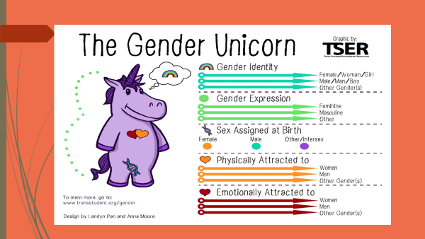The Gender Unicorn uses a Creative Commons License. This means you can share the infographic with credit, even for commercial purposes. You do not have to request permission to use it. (Trans Educational Resources, 2015).

Problems in Normal Sexual Development
There is no sexuality that is greater or lesser than another.
-Jasmine Guy



Dr. Soh notes that for more than 99 percent of the population, our gender is our biological sex and that the 1 percent of individuals for whom gender and biological sex do not align, they identify as transgender or have a medical condition called intersex (Soh, 2020a). The research indicates that approximately 1 in a 100 or 1 percent of people are intersex (Arboleda et al., 2014). Soh (2020a) notes that intersex is also known as having a difference in sexual development and this was previously known as hermaphrodism, which is today felt to be an insensitive and stigmatizing label. Intersex people possess reproductive or sexual anatomy that would be considered atypical because is it does not match the standard definition of male or female. There are as many as 30 variations (Jones et al., 2019). Some of these variations can be due to chromosomes, hormones, or anatomy.
Jones et al. (2019) note that intersex variations include naturally occurring chromosomal, hormonal and/or anatomical traits that do not entirely conform to a binary model of sex or to binary categories of female or male. Some people with intersex variations do not develop primary and secondary sex characteristics indicative of one sex or the other and some combine features of both sexes. Some intersex variations are detectable prenatally, at birth, or during infancy. Some become apparent around puberty, particularly those that involve differences in reproductive functions. Other intersex variations may go undetected during a person’s lifetime. Four categories of intersex include:
Chromosomes: “A binary model assumes two sex-specific chromosomal patterns: 46XX for females and 46XY for males. People with intersex variations may have atypical chromosomal patterns and combinations including a fewer or greater number of chromosomes (such as 47XXY, 47XYY, 45XO, 47XXX, 48XXXX and 49XXXXX) or chromosomal mosaics – cellular combinations of two different chromosomal patterns (such as 46XY/45XO or 46XY/47XXY). Some intersex people may have been assigned to one sex but have the chromosomal pattern of the opposite sex (male presentation and 46XX chromosomes or female presentation and 46XY chromosomes), while others may combine characteristics of both sexes. These natural variations mean that sex chromosomes alone are an unreliable determinant of sex and gender” (Jones et al., 2019). For example, in Klinefelter Syndrome (XXY), a man will inherit an extra X chromosome from either his mother or his father (Soh, 2020a). Males born with Klinefelter syndrome may have low testosterone and reduced muscle mass, facial hair, and body hair. Most males with this condition produce little or no sperm (Mayo Clinic, 2021a).
In Turner Syndrome Turner (XO), a condition which affects only females and was named after Dr. Henry Turner, who first described it in 1938. In this condition one of the X chromosomes (sex chromosomes) is missing or partially missing. Turner Syndrome can cause a variety of medical and developmental problems, including short height, failure of the ovaries to develop, and heart defects (Mayo Clinic, 2021b; Birth Defect Research for Children, 2021).
Hypogonadotropic hypogonadism (HH): HH is a form of hypogonadism that is due to a problem with the pituitary gland or hypothalamus. It is caused by a lack of hormones that normally stimulate the ovaries or testes. These hormones include gonadotropin-releasing hormone (GnRH), follicle stimulating hormone (FSH) and luteinizing hormone (LH). These hormones tell the female ovaries or the male testes to release hormones that lead to normal sexual development in puberty, normal menstrual cycles, estrogen levels and fertility in adult women, and normal testosterone production and sperm production in adult men. Any change in this hormone release chain causes a lack of sex hormones. This prevents normal sexual maturity in children and normal function of the testicles or ovaries in adults (Medline Plus, 2021).

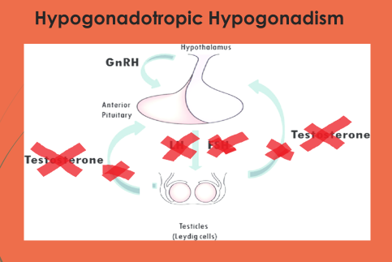
Used with permission. Dr. Michael Laidlaw (2019). “Medical Harms from the Treatment of Child and Adolescent Gender Dysphoria” Endocrinologist and Specialist on Childhood Gender Dysphoria. YouTube Presentation https://www.youtube.com/watch?v=2iJHf1BKPJY&feature=youtu.be

Anatomy: “A binary model assumes development of clearly differentiated primary sex characteristics (ovaries, a clitoris and vagina for XX females, and testes and a penis for XY males), as well as secondary sex characteristics such as height, vocal cord length and/or tenor, facial and bodily hair distributions and thickness, breast development, jawline prominence, muscle mass, and other features. People with intersex variations may experience atypical primary sex characteristics relating to differences in the development, size, appearance and/or absence of internal and external genitalia. The development of secondary sex characteristics may also differ as a result of an intersex variation” (Jones et al., 2019).
Outcome Research
You’re not supposed to pick favorites among the amendments,
Because it’s silly, but I have one, and it’s the First.
- Abigail Shrier

Puberty Blockers:

Jane Robbins, an attorney, and a retired senior fellow with the American Principles Project in Washington DC, who graduated from Clemson University and the Harvard Law School, offers an excellent overview of gender blocking therapy (Robins, 2018). She makes several cautionary remarks about pursuing this course in young children.

Stopping puberty, advocates argue, provides psychological relief to a transgender child. They assert that any hormonal changes are completely reversible — once the medication is stopped, puberty progresses as usual — so, they reason, the medication simply provides an adolescent more time to explore their identity as well as the possibility for gender reassignment. Moreover, treatment with GnRH analogues reportedly makes certain forms of transsexual surgery either redundant or less invasive because many of the irreversible features (such as height) or surgically reversible features (such as breast and genital development) would not have yet formed. After going through adolescence, a trans person may then decide to change their sex and can commence cross-sex hormones and later, as transgender adults, they will reportedly have fewer problems in passing in the new gender than untreated adolescents would have. Hence, it is for these reasons that the Endocrinology Society recommends "that adolescents who fulfill eligibility and readiness criteria for gender reassignment initially undergo treatment to suppress pubertal development." (Scutti, 2013).
Lupron was originally approved by the Food and Drug Administration to treat prostate cancer; however, it is now routinely prescribed for other conditions such as endometriosis and “precocious puberty” — i.e., puberty that begins too early (generally considered under age eight for girls, under age nine for boys); it is now widely being used to block puberty (Robbins (2018).
Lupron is a gonadotropin-releasing hormone analog. The primary pharmacological effect of Lupron administration is a decrease in the concentrations of testosterone and estrogen throughout the body. How does it achieve this decrease? It does so by tinkering with a hormonal feedback loop between the hypothalamus and the pituitary gland and interferes in the release of gonadotropins (“Gn”), which is a catch-all term for two separate hormones, luteinizing hormone (LH) and follicle-stimulating hormone (FSH). Gn acts as the primary means by which the body controls the release of testosterone and estradiol (4th Wave Now, 2017).

Robbins writes that many people who have taken Lupron have experienced extreme side effects that shatter their health and their lives, including severe joint pain, osteoporosis, compromised immune systems, and mental health issues such as severe depression and even suicidal ideation (Robbins, 2018).
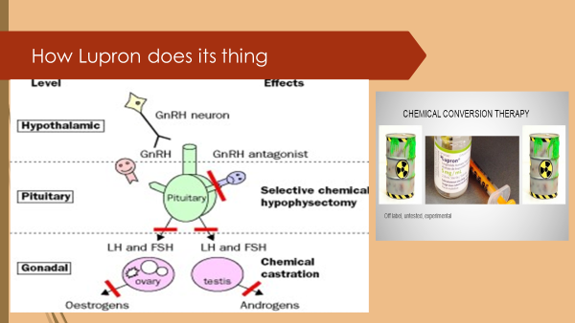
Used with permission. Dr. Michael Laidlaw (2019). "Medical Harms from the Treatment of Child and Adolescent Gender Dysphoria" Endocrinologist and Specialist on Childhood Gender Dysphoria YouTube Presentationhttps://www.youtube.com/watch?v=2iJHf1BKPJY&feature=youtu.be

Lupron users have filed nearly 24,000 reports of adverse reactions with the FDA; 60 percent of those were filed by women. The FDA deemed more than half of them serious cases. The FDA has also received 24,000 reports of adverse reactions, about half of which the agency has deemed serious (Robbins, 2018).
Lupron manufacturer AbbVie has been fighting lawsuits over the drug for years and Lupron users have filed nearly 24,000 reports of adverse reactions with the FDA; 60 percent of those were filed by women. The FDA deemed more than half of them serious cases (Strickland et al., 2018).

In one lawsuit Terry Paulsen alleges negligence and product liability. Paulsen who lives in Lexington, GA. She is not yet 60 but looks closer to 80, according to the author of this article. “My body is on fire,” Paulsen told the reporter. “My joints have arthritis everywhere.” In another life, Paulsen was a neonatal emergency nurse and avid equestrian. She has endured multiple surgeries, mysterious rashes and constant pain over a 14-year period (Strickland et al., 2018).
“It feels like I have 80-year-old bones,” said 22-year-old Brooklyn Harbin. She’s one of the people who filed an adverse reaction report. She had been an active and athletic 10-year-old. But she began her period too early and her doctor prescribed Lupron for Harbin to halt early puberty. “The back pain became very, very severe. It got very, very depressing having to be in a wheelchair in the fifth grade,” said Harbin (Strickland et al., 2018).
Gynecologist Dr. David Redwine testified as an expert witness about the adverse effects of Lupron, which he has observed over 31 years of medical practice. Due to Lupron’s suppression of the pituitary-gonadal system, a body’s immune response can be suppressed. Dr. Redwine concluded that the plaintiff, Karen Klein, suffered extreme bone density loss and other symptoms as a result of being administered Lupron beginning at the age of 17 (Klein, 2013).
Gynecologist Dr. Ken Sinervo, who specializes in endometriosis surgery, reported that he has seen many women on Lupron suffering memory loss and joint pain. He was quoted as warning that “Lupron or any of the similar types of medications should never be used in someone under the age of 21.” (Strickland et al., 2018).
Soh (2020a) notes that according to data from the Tavistock Centre, between the years 2012 and 2018, 267 children 15 and younger began using puberty blockers. Cohen et al. (2018) recently reported a study on this clinic that indicated that after a year of being on puberty blockers, some children reported an increase in suicidal ideation and self-harm (it is important to note that causality cannot be determined in this study as there was no control group of gender dysphoric children not taking puberty blockers (Soh, 2020a). The study's full findings have not been published, but early data showed some individuals taking the drugs reported an increase in thoughts of suicide and self-harm.
Robbins (2018) notes that all gender dysphoric patients who might be placed on Lupron to delay puberty are years younger than 21 and that there is a serious added danger in using Lupron merely to stop normal puberty in a gender dysphoric child. Moreover, this treatment is “off-label,” meaning that the FDA hasn’t approved the drug for this purpose, nor is there reliable research showing the safety of such use in children.
According to studies and articles reviewed by Robbins (2018), in addition to preventing the development of secondary sex characteristics, GnRH agonists can arrest bone growth, decrease bone accretion, prevent the sex-steroid dependent organization and maturation of the adolescent brain, and inhibit fertility by preventing the development of gonadal tissue and mature gametes for the duration of treatment.
Professor Michael Biggs of Oxford. Criticized the UK’s NHS’s Gender Identity Development Service’s (world’s largest pediatric gender clinic) single study produced from their trial of puberty blockers, saying It showed no statistically significant difference in psychosocial functioning between the group given blockers and the group given only psychological support. Furthermore, unpublished evidence showed puberty blockers worsened gender dysphoria (Biggs, 2019)
World expert on the perils of early affirmative care, Dr. Andre Van Mol, noted that the UK’s N.I.C.E. reviews (The National Institute for Health and Care Excellence) which looked at the evidence for children and adolescents with gender dysphoria being treated with puberty blockers failed to support puberty blockers in early affirmative care (Van Mol, 2022).
“The results of the studies that reported impact on the critical outcomes of gender dysphoria and mental health (depression, anger, and anxiety), and the important outcomes of body image and psychosocial impact (global and psychosocial functioning), in children and adolescents with gender dysphoria are of very low certainty using modified GRADE (Grading of Recommendation, Assessment, Development and Evaluation which is a modern framework for rating the certainty in evidence). They suggest little change with GnRH analogues (puberty blockers) from baseline to follow-up” (NICE, 2020).

The Royal College of General Practitioners published a position paper in which they highlighted a lack of evidence for puberty blockers as well as cross-sex hormones with an endorsement for the need of more research needing to be done regarding other treatment approaches such as “wait and see.”
To quote: “Whilst in the past, many transgender patients sought a gender transition treatment, increasingly many people identify with a range of gender types (such as trans, fluid, non-binary and genderqueer). Not all these people seek interventions for their gender dysphoria. Gender identity services are also needed for people who are uncomfortable or distressed by their biological sex or gender roles and behaviours assigned to them by society, but do not wish to alter their sexual characteristics. The significant lack of evidence for treatments and interventions which may be offered to people with dysphoria is a major issue facing this area of healthcare. There are also differences in the types and stages of treatment for patients with gender dysphoria depending on their age or stage of life. Gonadorelin (GnRH) analogues are one of the main types of treatment for young people with gender dysphoria. These have long been used to treat young children who start puberty too early, however, less is known about their long-term safety in transgender adolescents. Children who have been on GnRH for a certain period of time and are roughly 16 years of age can be offered cross-sex hormones by the NHS, the effects of which can be irreversible. There is a significant lack of robust, comprehensive evidence around the outcomes, side effects and unintended consequences of such treatments for people with gender dysphoria, particularly children and young people, which prevents general practitioners from helping patients and their families in making an informed decision (Royal Academy of General Practitioners, 2019 p. 5).

A longitudinal study of 300 children is now underway by Canadian researchers, Dr .Greta Bauer, Principal Investigator, and Dr Margaret Lawson, Pediatric Endocrinologist and Co-Co-principal Investigator, to look at the impact of puberty blockers in children. In their review of the literature so far, they recommend, “It is unconscionable to continue funneling more and more children into treatment with puberty suppression and cross-sex hormones unless there is a solid evidence base to prove the long-term health outcomes of this high-risk approach are significantly better than other treatment options. In addition, until such time that puberty suppressing pharmacological treatments have been approved for the treatment of youth who wish to align their physical characteristics with their gender identity, we demand that the Canadian government require accurate information that clearly identifies this treatment is experimental as it requires the off-label usage of drugs that will result in infertility and other compromising physiological effects when used over an unknown period of time. The type of information that is currently being promoted to the public is a serious misrepresentation of the experimental nature of puberty blockers and cross-sex hormone treatments targeted at a youth population” (Canadian Gender Report, 2019).

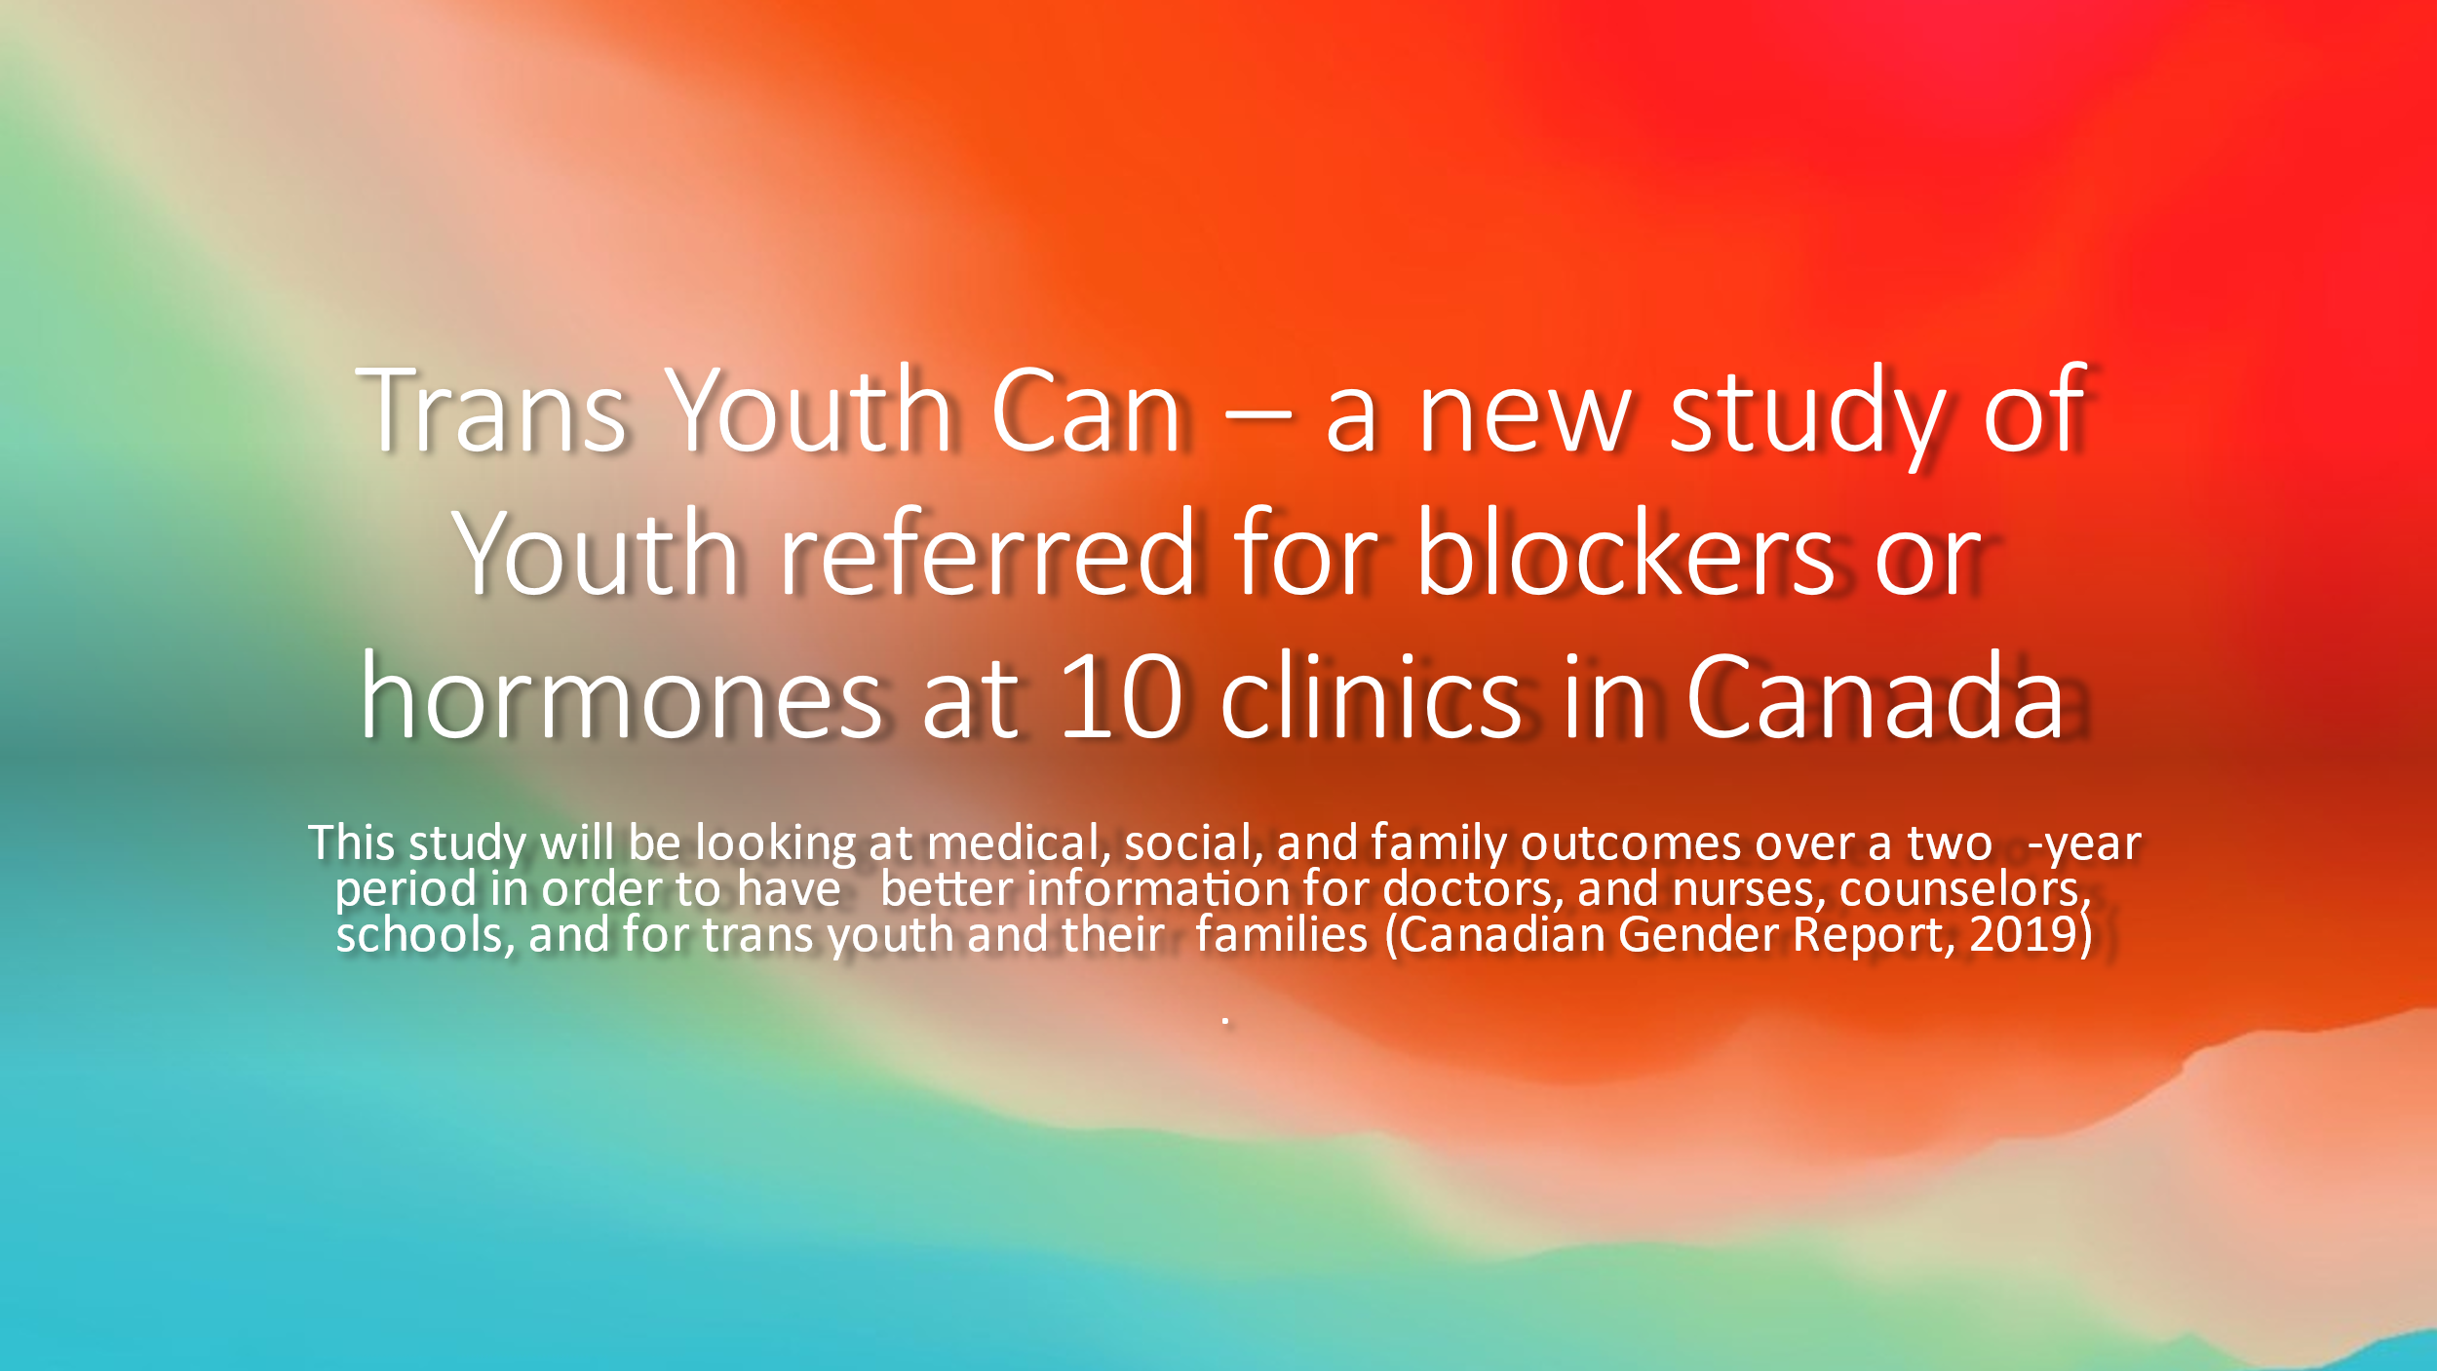

The following slides were generously shared with permission of widely respected and very accomplished endocrinologist, Dr. Michael Laidlaw. They succinctly summarize the impact of puberty blockers and cross hormone therapies in children.


Dr. Michael Laidlaw

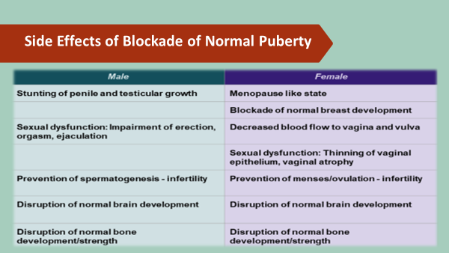
Used with permission. Dr. Michael Laidlaw (2019). "Medical Harms from the Treatment of Child and Adolescent Gender Dysphoria" Endocrinologist and Specialist on Childhood Gender Dysphoria YouTube Presentation https://www.youtube.com/watch?v=2iJHf1BKPJY&feature=youtu.be
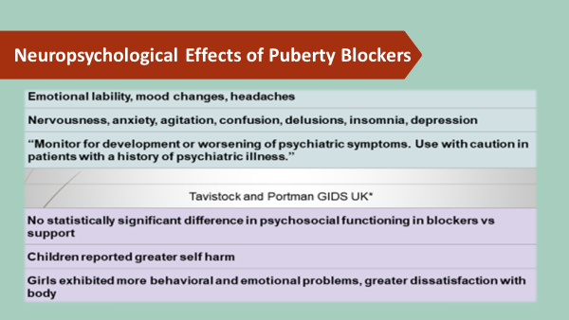
Used with permission. Dr. Michael Laidlaw (2019). "Medical Harms from the Treatment of Child and Adolescent Gender Dysphoria" Endocrinologist and Specialist on Childhood Gender Dysphoria YouTube Presentation https://www.youtube.com/watch?v=2iJHf1BKPJY&feature=youtu.be

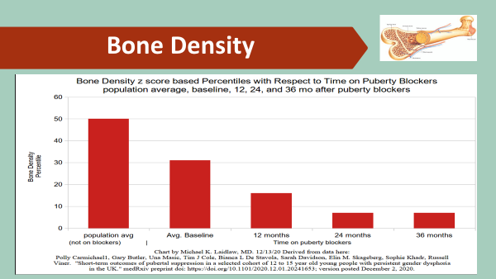
Used with permission. Dr. Michael Laidlaw (2019). "Medical Harms from the Treatment of Child and Adolescent Gender Dysphoria" Endocrinologist and Specialist on Childhood Gender Dysphoria YouTube Presentation https://www.youtube.com/watch?v=2iJHf1BKPJY&feature=youtu.be

Cross Sex Hormone Therapy:
According to Dr. William J. Malone, MD, board certified endocrinologist who has a BA from Stanford University and an MD from New York University and currently serving as the medical director at an endocrinology and diabetes center in Idaho addresses the concept of desistence. Noting that the 0.5% of children who experience gender dysphoria, Malone cites that approximately 80% of childhood-onset gender dysphoria resolves by age 20. A majority of the children who have gender dysphoria will be same-sex attracted or bisexual. Dr. Malone notes that it is impossible to determine whose GD will resolve and whose will persist without allowing for pubertal development. Some practitioners claim that they can tell clinically in early puberty who will persist in their gender dysphoria, but there are no validated protocols that are predictive of persistence (Malone, 2019).


”Due to the general lack of evidence that cross sex hormones and sex reassignment surgery improve the long term psychological functioning of gender dysphoric people, and due to evidence that suicide rates actually increase long term post-surgery (see below), in approximately 2010, puberty blockers were introduced into the treatment protocols for gender dysphoric children and adolescents, with the thinking being that by preventing the development of secondary sexual characteristics, that person would be more likely to look like the opposite sex long term, reducing dysphoria and improving long term psychological functioning. The first problem with this approach is that it’s completely unproven, and the second is that no one can tell who will persist in their gender dysphoria. This means treating all adolescents with gender dysphoria, in an effort to help the 10% who have persistent gender dysphoria, harms 90% of those treated” (Malone, 2019).
An excellent literature review posted in the British Medical Journal (BMJ) Spotlight in 2019 included 16 studies with 1,132 participants (transgender males (54%); transgender females (37%) and (7.6%) control subjects, and some of the studies posted and reviewed here were from that review (BMJ Spotlight, 2019).
Cognitive and brain-related effects:
Neuroimaging studies suggest cross sex hormones affect brain structure and circuitries, ventricular volume and thickness, hypothalamic neuroplasticity, and functional connectivity (BMJ Spotlight, 2019).
Burke et al. (2016) in a study of 21 girls with GD, 20 male controls and 21 female controls found in the absence of any group differences in performance, control girls showed significantly increased activation in frontal brain areas compared with control boys. Girls with GD before testosterone treatment differed significantly in frontal brain activation from the control girls, suggesting a masculinization of brain structures associated with visuospatial cognitive functions. After 10 months of testosterone treatment, girls with GD, similar to the control boys, showed increases in brain activation in areas implicated in mental rotation.
Bone development:
Klink and associates found that lumbar spine bone mineral density scores fell during puberty suppression with GnRHa for transgender adolescent females but did not increase following estrogen treatment. Specifically, between the start of GnRHa and age 22 years the lumbar areal BMD z score (for natal sex) in transwomen decreased significantly from -0.8 to -1.4, and in transmen there was a trend for decrease from 0.2 to -0.3. (Klink et al., 2015).
Hematological variables:
Jarin et al. (2017) found that testosterone use was associated with increased hemoglobin and hematocrit, increased BMI, and lowered high-density lipoprotein levels; estrogen was associated with lower testosterone and alanine aminotransferase levels Specifically, of the 72 subjects taking testosterone, a significant increase in hemoglobin/hematocrit levels and BMI, as well as a decrease in high-density lipoprotein level, was recorded at each visit.
Tack et al. (2016), in a retrospective analysis of clinical and biochemical data obtained during at least 6 months of hormonal treatment in female to male adolescents followed at their adolescent gender clinic since 2010 (n = 45) over the course of treatment, found an increase in musculature, hemoglobin, hematocrit, creatinine, and liver enzymes, progressively sliding into male reference ranges. Lipid metabolism shifted to an unfavorable high-density lipoprotein (HDL)/low-density lipoprotein (LDL) ratio; glucose metabolism was not affected. Sex hormone-binding globulin (SHBG), total testosterone, and estradiol levels decreased, and free testosterone slightly increased during monotherapy; total and free testosterone increased significantly during combination therapy.
Cardiovascular Health:
Olson-Kennedy (2018) report significant increases in triglyceride concentrations and HDL after two years of estrogen treatment. None of the studies showed significant changes in mean total cholesterol concentrations. Olson-Kennedy (2018) report elevations in systolic and diastolic blood pressure with testosterone treatment after two years (BMJ Spotlight, 2019).
Conclusions of the BMJ (2019):
“There are significant problems with how the evidence for gender-affirming cross-sex hormone treatment has been collected and analyzed that prevents definitive conclusions to be drawn. Similar to puberty blockers, the evidence is limited by small sample sizes, retrospective methods, and loss of considerable numbers of patients in the follow-up period. The majority of studies also lack a control group (only two studies used controls). Interventions have heterogeneous treatment regimens complicating comparisons between studies. Also, adherence to the interventions is either not reported or inconsistent. Subjective outcomes, which are highly prevalent in the studies, are also prone to bias due to lack of blinding.
In an Archive of Diseases in Childhood letter referred to GnRHa treatment as a momentous step in the dark (Richards et al., 2019) It set out three main concerns: 1) young people are left in a state of ‘developmental limbo’ without secondary sexual characteristics that might consolidate gender identity; 2) use is likely to threaten the maturation of the adolescent mind, and 3) puberty blockers are being used in the context of profound scientific ignorance.
The development of these interventions should, therefore, occur in the context of research, and treatments for under 18 gender dysphoric children and adolescents remain largely experimental. There are a large number of unanswered questions that include the age at start, reversibility; adverse events, long term effects on mental health, quality of life, bone mineral density, osteoporosis in later life and cognition. We wonder whether off label use is appropriate and justified for drugs such as spironolactone which can cause substantial harms and even death. We are also ignorant of the long-term safety profiles of the different GAH regimens. The current evidence base does not support informed decision-making safe practice in children.” (BMJ, 2019).
Conclusions of the UK National Institute for Health and Care Excellence (NICE):
In 2020, the UK National Institute for Health and Care Excellence (NICE) undertook a study to review cross sex hormone They identified shortcomings in the quality of the evidence for cross sex hormones. The reviewers reported and to quote, “a fundamental limitation of all the uncontrolled studies in this review is that any changes in scores from baseline to follow-up could be attributed to a regression-to-the-mean,” rather than the beneficial effects of hormone treatment itself. They reported that no study detailed concomitant treatments in detail, meaning that it is not possible to determine if positive changes were due to hormones or the other treatments participants may have received. The reviewers went on to note that hormones may improve symptoms of gender dysphoria, mental health, and psychosocial functioning, but cautioned that potential benefits are of very low certainty and “must be weighed against the largely unknown long-term safety profile of these treatments.” (National Institute for Health and Care Excellence, 2020).
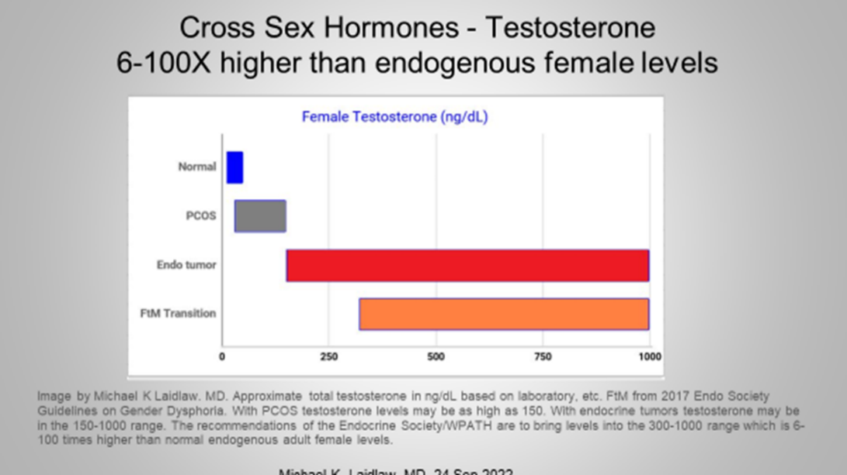
Used with permission. Dr. Michael Laidlaw (2019). “Medical Harms from the Treatment of Child and Adolescent Gender Dysphoria” Endocrinologist and Specialist on Childhood Gender Dysphoria YouTube Presentation https://www.youtube.com/watch?v=2iJHf1BKPJY&feature=youtu.be

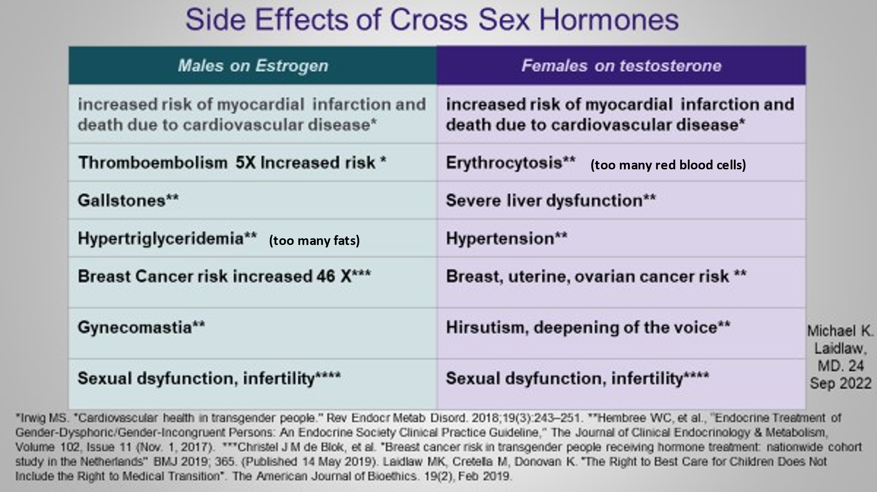
Used with permission. Dr. Michael Laidlaw (2019). “Medical Harms from the Treatment of Child and Adolescent Gender Dysphoria” Endocrinologist and Specialist on Childhood Gender Dysphoria YouTube Presentation https://www.youtube.com/watch?v=2iJHf1BKPJY&feature=youtu.be

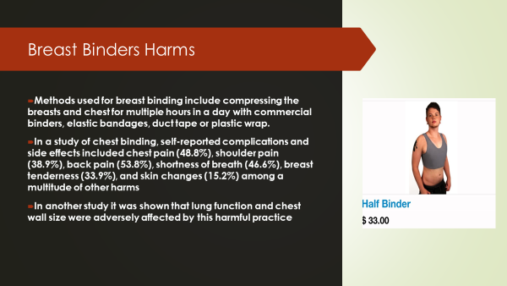
Used with permission. Dr. Michael Laidlaw (2019). “Medical Harms from the Treatment of Child and Adolescent Gender Dysphoria” Endocrinologist and Specialist on Childhood Gender Dysphoria YouTube Presentation https://www.youtube.com/watch?v=2iJHf1BKPJY&feature=youtu.be

Reassignment Surgery:
Dr. Paul McHugh, a graduate of Harvard University and Medical School and later chair of psychiatry at Johns Hopkins and psychiatrist-in-chief at Johns Hopkins Hospital, put a stop to sex reassignment surgery at that facility in 1979 after he concluded that there was a lack of empirical evidence in support of this practice. As a result of this distinguished man’s lead, many other centers at that time followed suit and closed their programs. However, there has since been a resurgence of these procedures. In 2007, Boston Children’s Hospital became the first major program in the United States to open it doors to focus on transgender in children and adolescents and since that time, more than 45 pediatric gender clinics have spawned.


The study which helped Dr. McHugh reach the conclusion to stop surgical reassignment was conducted by Meyer and Reter (1979). This study included 100 patients seeking sex reassignment surgery (SRS), sixty-six of whom had surgery and 34 of whom did not. The operated-upon groups were followed from the time of surgery and the unoperated-upon group from the time of initial interview at the Gender Identity Clinic at Johns Hopkins. Of those operated on, 21 had a trial period (taking hormones and working in the opposite-gender role) while the other thirteen had been well-established in the cross-gender role at the time of surgery but did not have a formal trial period. Follow-up was successful in fifty-two patients, of whom fifty consented to have their data published. Follow-up interviews covered three main areas: (1) adaptation; (2) family relationships and adaptational patterns at major life intervals; and (3) fantasy, dreams, and sexual activity. 73–80 percent of the patients were male. Average follow-up for operated-upon patients was sixty-two months and twenty-five months for the unoperated-upon group. Residential instability was similar in the groups (average of twenty months between moves in the operated-upon group pre-surgery, eighteen months post-surgery, and twelve months pre-contact and ten months post-contact in the unoperated-upon group). Job levels indicated a slight upward trend in both groups. Changes in psychiatric contacts were also similar in the two groups.
A third group was found that went elsewhere for surgery when this was not performed at Hopkins. Adjustment scores were improved in the surgery and unoperated-upon group to a similar extent, with no significant difference between the groups, but the group that sought surgery elsewhere did less well (although there was no statistical significance to the difference).
As stated by the authors, “At the simplest level, these data suggest that significant change in adjustment scores may be achieved either through surgery or through the passage of time in association with some contact and acceptance into an organized evaluation program” (Meyer & Reter, 1979). The conclusion was that sex reassignment surgery was not successful in treating this condition and led to the discontinuation of SRS at Johns Hopkins.
In spite of these early findings, and lack of contravening evidence that SRS conveyed any benefits compared with any unoperated-upon control groups, the practice of SRS has continued and has been extended into younger age groups. In a 2015 Boston study of 180 transsexual youth who had undergone sex reassignment surgery (106 female-to-male; 74 male-to-female), these youth had a twofold to threefold increased risk of psychiatric disorders, including depression, anxiety disorder, suicidal ideation, suicide attempt, self-harm without lethal intent, in both inpatient and outpatient mental health treatment compared to a control group of youth (Reisner et al., 2015; Fitzgibbons, 2015).

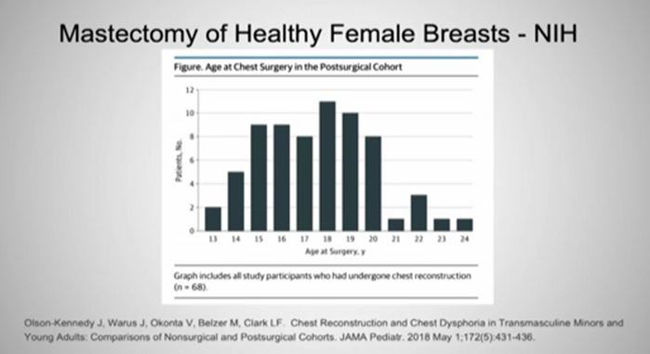
Used with permission. Dr. Michael Laidlaw (2019). “Medical Harms from the Treatment of Child and Adolescent Gender Dysphoria” Endocrinologist and Specialist on Childhood Gender Dysphoria. YouTube Presentation https://www.youtube.com/watch?v=2iJHf1BKPJY&feature=youtu.be

In an exhaustive and complex review of the literature Jensen et al. (2016) concluded that for the Medicare population:
“Based on an extensive assessment of the clinical evidence as described above, there is not enough high-quality evidence to determine whether gender reassignment surgery improves health outcomes for Medicare beneficiaries with gender dysphoria and whether patients most likely to benefit from these types of surgical intervention can be identified prospectively.
The knowledge on gender reassignment surgery for individuals with gender dysphoria is evolving. Much of the available research has been conducted in highly vetted patients at select care programs integrating psychotherapy, endocrinology, and various surgical disciplines. Additional research of contemporary practice is needed. To assess long-term quality of life and other psychometric outcomes, it will be necessary to develop and validate standardized psychometric tools in patients with gender dysphoria. Further, patient preference is an important aspect of any treatment. As study designs are completed, it is important to include patient-centered outcomes” (Jensen et al., 2016).
The most often cited and best long-term study (30 years, 1973 – 2003), yet very worrisome study on gender reassignment surgery in Sweden was conducted by Dr. Cecilia Dhejne et al. and published in 2011, which indicated that persons who undergo sex reassignment surgery are 19 more times to complete suicide at 10 years out from the surgery. This is not to say that the surgery itself results in an increased risk for suicide; rather, a safer interpretation is that whatever comorbidities that are present in this population are not sufficiently resolved by surgical intervention and thus completed suicide is dramatically and tragically higher.

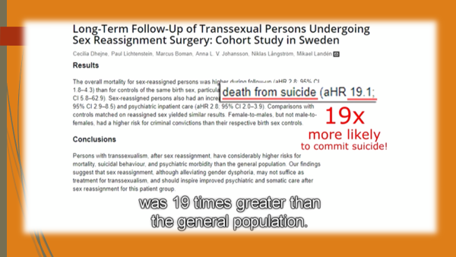
“All 324 sex-reassigned persons (191 male-to-females, 133 female-to-males) in Sweden, 1973-2003. Random population controls (10:1) were matched by birth year and birth sex or reassigned (final) sex, respectively. Hazard ratios (HR) with 95% confidence intervals (CI) for mortality and psychiatric morbidity were obtained with Cox regression models, which were adjusted for immigrant status and psychiatric morbidity prior to sex reassignment (adjusted HR [aHR]).
The overall mortality for sex-reassigned persons was higher during follow-up (aHR 2.8; 95% CI 1.8-4.3) than for controls of the same birth sex, particularly death from suicide (aHR 19.1; 95% CI 5.8-62.9). Sex-reassigned persons also had an increased risk for suicide attempts (aHR 4.9; 95% CI 2.9-8.5) and psychiatric inpatient care (aHR 2.8; 95% CI 2.0-3.9). Comparisons with controls matched on reassigned sex yielded similar results. Female-to-males, but not male-to-females, had a higher risk for criminal convictions than their respective birth sex controls.
Persons with transsexualism, after sex reassignment, have considerably higher risks for mortality, suicidal behaviour, and psychiatric morbidity than the general population. Our findings suggest that sex reassignment, although alleviating gender dysphoria, may not suffice as treatment for transsexualism, and should inspire improved psychiatric and somatic care after sex reassignment for this patient group” (Dhejne et al., 2011).
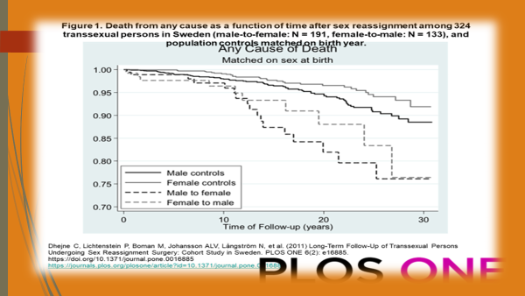

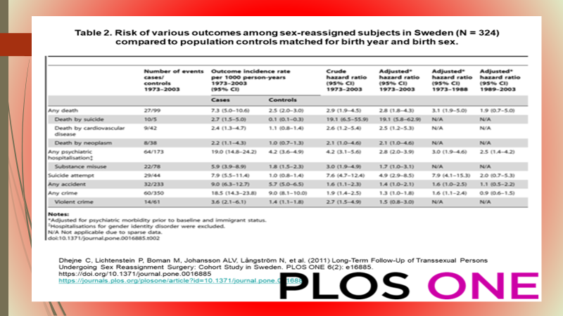

Family Watch International (2020) made a compelling YouTube video largely narrated by Dr. Michelle Cretella, M.D., the executive director of the American College of Pediatricians, a national organization of pediatricians and other health care professionals dedicated to the health and well-being of children. This video (see link below) details negative outcomes of transgender surgery (Family Watch International, 2020).
Family Watch International (2020). Gender Agenda Full Documentary.
https://www.youtube.com/watch?v=Djw-QkYt0Fo


Dr. Michelle Cretella, M.D.
A recent study conducted by Toomey et al. (2018) entitled “Transgender Adolescent Suicide Behavior,” made national headlines upon its release in 2018 in the Journal of Pediatrics. It revealed that among adolescents who identify as transgender, female-to-male youth have the highest suicide risk.
The researchers examined data collected between 2012 and 2015 from the “Profiles of Student Life: Attitudes and Behaviors” survey. The survey was administered to 120,617 adolescents across the nation between the ages of 11 and 19 years old and focused on 40 developmental strengths known to predict healthy development, as well as risk behaviors, such as depression and suicide.
The survey also asked students to indicate which of the following best described them: female; male; transgender, female to male; transgender, male to female; transgender, nonbinary (neither male nor female); or questioning. It also asked them whether they had ever attempted suicide.
The team found that adolescent girls who identified as male had the highest rate of ever having attempted suicide: 50.8 percent. Adolescents who identified as nonbinary were next at 41.8 percent. Among male adolescents who identified as female, 29.9 percent had attempted suicide at least once. Those who were questioning their gender identity were next with a rate of 27.9 percent.
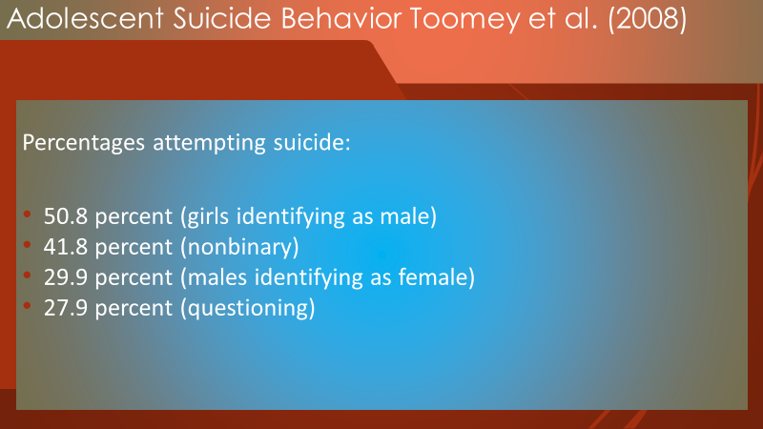
These stand in stark contrast to significantly lower rates of attempted suicide among the girls in the sample without gender dysphoria (17.6 percent) and the boys without gender dysphoria (9.8 percent).
The authors state that further research into this risk differentiation may help to develop strategies for preventing suicide among trans-identifying adolescents. Ideally, this would include an analysis of suicide attempts based upon adolescents’ biological sex, not just their gender identity.
This is important because overall, biological girls are more likely than biological boys to attempt suicide—a fact demonstrated by data from the Centers for Disease Control and Prevention. Given the current data, my hypothesis is that such a survey would reveal that the majority of nonbinary and questioning teens are in fact biological girls. In other words, it is possible that the much higher rate of attempted suicide among female-to-male, nonbinary, and questioning transgender youth has more to do with factors relating to their biological sex (i.e., being a girl) than it does with anything related to gender identity. If confirmed, this may help explain the causes, since it is possible that common underlying psychological and environmental factors may be at play triggering both gender dysphoria and suicidal tendencies in a subset of these adolescents (Toomey, 2018).

Legislation and Pushback
“we ask for too much salvation by legislation. All we need to do is empower individuals with the right philosophy and the right information to opt out en masse. (quoting Joel Salatin)”
― Michael Pollan

Education Legislation: In my former home State of Washington, school children as young as five years old are now already learning about gender fluidity and the differences between gender and sexual identity. This new curriculum which was initially proposed in 2016 was finally passed into law in late 2020.

As initially reported by The Daily Caller, and nicely summarized by John Backholm back in 2016 writing for the Family Policy Institute of Washington, who commented that the then proposed standards now require students to learn about gender identity and expression beginning in kindergarten.
- Beginning in Kindergarten, students will be taught about the many ways to express gender. Gender expression education will include information about the manifestations of traits that are typically associated with one gender. Cross-dressing is one form of gender expression.
- Third graders will be introduced to the concept of gender identity. These children will be taught that they can choose their own gender.
- Fourth graders will be expected to “define sexual orientation,” which refers to whether a person identifies as heterosexual, homosexual, or bisexual; they’ll also be taught about HIV prevention. Children in fourth grade will be told that they can choose their sexual orientation.
- Fourth and fifth graders will learn about the relativity of gender roles and why such roles are social constructs that are not inherent to who we are as male or female human beings.
- Seventh graders will be expected to “distinguish between biological sex, gender identity, gender expression, and sexual orientation.”
- High school students will critically “evaluate how culture, media, society, and other people influence our perceptions of gender roles, sexuality, relationships, and sexual orientation.”

Perhaps the most concerning element about the new standards, however, is that the Office of the Superintendent of School Instruction OSPI has no plans to notify parents of these controversial changes. In a phone call with FPIW, OSPI communications manager Nathan Olsen confirmed the changes and said that the state does not plan to issue a press release or otherwise inform parents of the changes.
When asked by The Daily Caller “whether a student who rejects the idea that ‘gender identity’ is distinct from ‘biological sex’ could end up failing a course on account of their beliefs, Olson replied that it “would be handled at the district/school level.’”
As specifically stated in a newly signed law, RCW 28A.300.475, sexual health education begins in kindergarten, but the content is not specifically defined which leads a lot of leeway to teachers.
“(c) Comprehensive sexual health education must be consistent with the Washington state health and physical education K-12 learning standards and the January 2005 guidelines for sexual health information and disease prevention developed by the department of health and the office of the superintendent of public instruction.
(2)(a) Beginning in the 2021-22 school year, comprehensive sexual health education must be provided to all public school students in grades six through twelve.
(b) Beginning in the 2022-23 school year, comprehensive sexual health education must be provided to all public school students.
(c) The provision of comprehensive sexual health education to public school students as required by (a) and (b) of this subsection (2) must be provided no less than:
(i) Once to students in kindergarten through grade three;
(ii) Once to students in grades four through five;
(iii) Twice to students in grades six through eight; and,
(iv) Twice to students in grades nine through twelve.”

Rantz (2020) writes that the “comprehensive sexual health education” (CSHE) inexplicably includes kindergartners, despite public input rejecting the requirement. He noted that House Bill 2184 was born out of an equity issue to ensure that all students have access to the information, which includes lessons about affirmative consent, but to also address the needs of “LGBTQ+ students.”
Rantz (2020) conjectures that according to a document submitted by the comprehensive sexual health education CSHE, planners in Washington State, they justify starting at such a young age because the “social emotional needs of our youngest students must be addressed for prevention of future issues. Rantz (2020) writes, “While it’s certainly true that most of the curriculum isn’t particularly controversial, they do delve into language you may not want your kindergartner learning about. One section of the curriculum for teachers to use as a guide, suggests talking to students about the penis as not having “any bones in it, but when people talk about an erection as a ‘boner,’ they’re mistaken.” Girls are taught about a “very sensitive little area at the top called the clitoris.”
The sex ed curriculum includes many of the controversial topics and according to Rantz who believes, that along with a certain following, it is less about meeting the sexual needs of young kids (as he feels that these needs don’t exist), than it is about pushing a very specific social justice agenda on gender identity for all classrooms. While the document wasn’t provided in the Bill summary, you can review a proposed sexual education agenda by clicking here.
Rantz (2020) editorializes, “The curriculum is aimed at being inclusive, thus it treats biology as second to identity. For kindergarten teachers, the curriculum starts to slow-walk concepts on transgenderism, warning teachers (on page 8), “This lesson does, however, acknowledge that ‘there are some body parts that mostly just girls have and some parts that mostly just boys have. Being a boy or a girl doesn’t have to mean you have those parts, but for most people this is how their bodies are.’”
For Grade 1, teachers should have their students read “My Princess Boy” before teaching the six and seven-year-olds about reproduction. For Grade 6 curriculum on Gender Roles (page 191), teachers are cautioned:
You may notice language throughout the curriculum that seems less familiar – using the pronoun ‘they’ instead of ‘her’ or ‘him,’ using gender neutral names in scenarios and role-plays and referring to ‘someone with a vulva’ vs. a girl or woman.’ This is intended to make the curriculum inclusive of all genders and gender identities.
The curriculum gets more advanced — and woke — for older students, including the lesson that biological males are simply “assigned” a gender at birth.
There’s no doubt that depending on your worldview (political, religious or otherwise), you will see the content differently. There are parts that are objectively controversy-free, but some are clearly problematic by any reasonable view. And it’s not the same curriculum that would be taught statewide.
The question then becomes whether or not you trust your kid’s teachers to present the lesson plan fairly, or with a specific agenda in mind — to teach a worldview. Even if you agree with the worldview, shouldn’t parents be the one to introduce it to young children?” (Rantz, 2020; Advocates for Youth, 2020).
Conversion Therapy History and Legislation: Erin Blakemore intelligently reviewed the origins for conversion therapy. She writes, “In 1899, a German psychiatrist electrified the audience at a conference on hypnosis with a bold claim: He had turned a gay man straight. Albert von Schrenck-Notzing bragged that all it took was 45 hypnosis sessions and a few trips to a brothel. Through hypnosis, he claimed, he had manipulated the man’s sexual impulses, diverting them from his interest in men to a lasting desire for women. He didn’t know it, but he had just kicked off a phenomenon that would later be known as “conversion therapy”—a set of pseudoscientific techniques designed to quash LGBTQ people’s sexuality and make them conform to society’s expectations of how they should behave. Though it’s dismissed by the medical establishment today, conversion therapy was widely practiced throughout the 20th century, leaving shame, pain and self-hatred in its wake. Some LGBTQ people were given electroconvulsive therapy, but others were subjected to even more extreme techniques like lobotomies. Other “treatments” included shocks administered through electrodes that were implanted directly into the brain. Robert Galbraith Heath, a psychiatrist in New Orleans who pioneered the technique, used this form of brain stimulation, along with hired prostitutes and heterosexual pornography, to “change” the sexual orientation of gay men. But though Heath contended he was able to actually turn gay men straight, his work has since been challenged and criticized for its methodology.
An offshoot of these techniques was “aversion therapy,” which was founded on the premise that if LGBTQ people became disgusted by homosexuality, they would no longer experience same-sex desire. Under medical supervision, people were given chemicals that made them vomit when they, for example, looked at photos of their lovers. Others were given electrical shocks—sometimes to their genitals—while they looked at gay pornography or cross-dressed” (Blakemore 2019)
According to RCW 18.130.020 “Conversion therapy" means a regime that seeks to change an individual's sexual orientation or gender identity. The term includes efforts to change behaviors or gender expressions, or to eliminate or reduce sexual or romantic attractions or feelings toward individuals of the same sex. The term includes, but is not limited to, practices commonly referred to as "reparative therapy."
(b) "Conversion therapy" does not include counseling or psychotherapies that provide acceptance, support, and understanding of clients or the facilitation of clients' coping, social support, and identity exploration and development that do not seek to change sexual orientation or gender identity.”
The consequences per RCW 18.130.160 of practicing any form of conversion therapy in the State of Washington can include:
(1) Revocation of the license;
(2) Suspension of the license for a fixed or indefinite term;
(3) Restriction or limitation of the practice;
(4) Requiring the satisfactory completion of a specific program of
remedial education or treatment;
(5) The monitoring of the practice by a supervisor approved by
the disciplining authority;
(6) Censure or reprimand;
(7) Compliance with conditions of probation for a designated
period of time;
(8) Payment of a fine for each violation of this chapter, not to
exceed five thousand per violation. Funds received shall be
placed in the health professions account; dollars
(9) Denial of the license request;
(10) Corrective action;
(11) Refund of fees billed to and collected from the consumer; and;
(12) A surrender of the practitioner's license in lieu of other
sanctions, which must be reported to the federal data bank.

Pushback against Activist Agenda and Legislation: More recently there has been pushback to the affirmation approach and legislation in support thereof due to a lack of supporting research. Dr. Soh is of the opinion that the watchful waiting and developmental approach as noted earlier in this paper can be a very appropriate choice for children who are questioning their gender identity. Unfortunately, she adds, this has been “denounced” by the so-called experts, medical organizations, and academic researchers as transphobic, “conversion therapy,” and abusive. Dr. Soh is careful to add that conversion therapy that aims to change sexual orientation is quite harmful for those dealing with sexual orientation issues, as sexual orientation is fixed and therefore cannot be changed. She agrees that for these individuals, conversion therapy is inappropriate and unethical. On the other hand, she states that gender identity is fluid or flexible in children, it is not appropriate to conflate or combine therapies which help children grow comfortable in their bodies with those that effectively seek to change sexual orientation. This is to say that any kind of questioning of gender identity can be construed as conversion therapy, and we now have a situation whereby doctors and therapists are simply afraid to do so as it could cause them their licenses, their livelihoods, and/or their reputation. Moreover, if an expert in the field defends research suggesting that other therapeutic approaches are possibly more effective, they will be seen as unethical and operating outside of what is seen as acceptable in the field (Soh, 2020a).
In September 2019, JAMA Psychiatry published an article, written by Turban et al. (2019) entitled Association Between Recalled Exposure to Gender Identity Conversion Efforts and Psychological Distress and Suicide Attempts Among Transgender Adults. This article concluded that therapies that did not "affirm" an individual's transgender identity (which the article refers to as "gender-identity conversion efforts / "GICE") lead to severe distress and even possibly suicide attempts. These findings have been used to argue for legislative bans on non-affirmative therapies worldwide.
I agree, along with Dr. Soh and The Society for Evidenced Based Gender Medicine (SEGM), that attempts to force a change in one’s gender identity have no place in the field of mental health. SEGM states, “We are increasingly concerned with the conflation of ethical psychotherapy for gender dysphoria with conversion therapy. The study authors erased the critical lines that separate coercive and unethical attempts of conversion from ethical psychotherapy. Our analysis also revealed a number of serious methodological flaws and misinterpretations of the data that invalidate the study conclusions. In fact, the study provides no credible evidence that either psychological distress or suicide attempts (which are present at elevated rates in gender dysphoric individuals), are a result of ethical psychotherapy.”
SEGM (2020) and DeAngelo (2020) criticize that the authors also failed to reflect on their own key finding—the high prevalence of serious uncontrolled mental illness in the study subjects. The fact that gender dysphoric people continue to struggle with a significant burden of mental illness, both pre- and post-transition, has been documented consistently across a range of studies, and this finding in itself calls for more emphasis on the provision of quality mental health.
As reported in Davis (2024) S News, several states as of January 2024 have banned early affirmative care

Arkansas
Florida
Georgia
Idaho
Indiana
Iowa
Kentucky
Louisiana
Mississippi
Missouri
Montana
Nebraska
North Carolina
North Dakota
Ohio
Oklahoma
South Dakota
Tennessee
Texas
Utah
West Virginia

Davis appropriately refers the reader to a report by Reuters that sheds concern. To quote Terhune et al (2022), in Reuters article,

“Puberty blockers and sex hormones do not have U.S. Food and Drug Administration (FDA) approval for children’s gender care. No clinical trials have established their safety for such off-label use. The drugs’ long-term effects on fertility and sexual function remain unclear. And in 2016, the FDA ordered makers of puberty blockers to add a warning about psychiatric problems to the drugs’ label after the agency received several reports of suicidal thoughts in children who were taking them.
More broadly, no large-scale studies have tracked people who received gender-related medical care as children to determine how many remained satisfied with their treatment as they aged and how many eventually regretted transitioning. The same lack of clarity holds true for the contentious issue of detransitioning, when a patient stops or reverses the transition process” “Terhune et al., 2022).
And more recently, some European countries are leading the way against the medical scandal of early transitioning of children to include England, Finland, and Sweden.

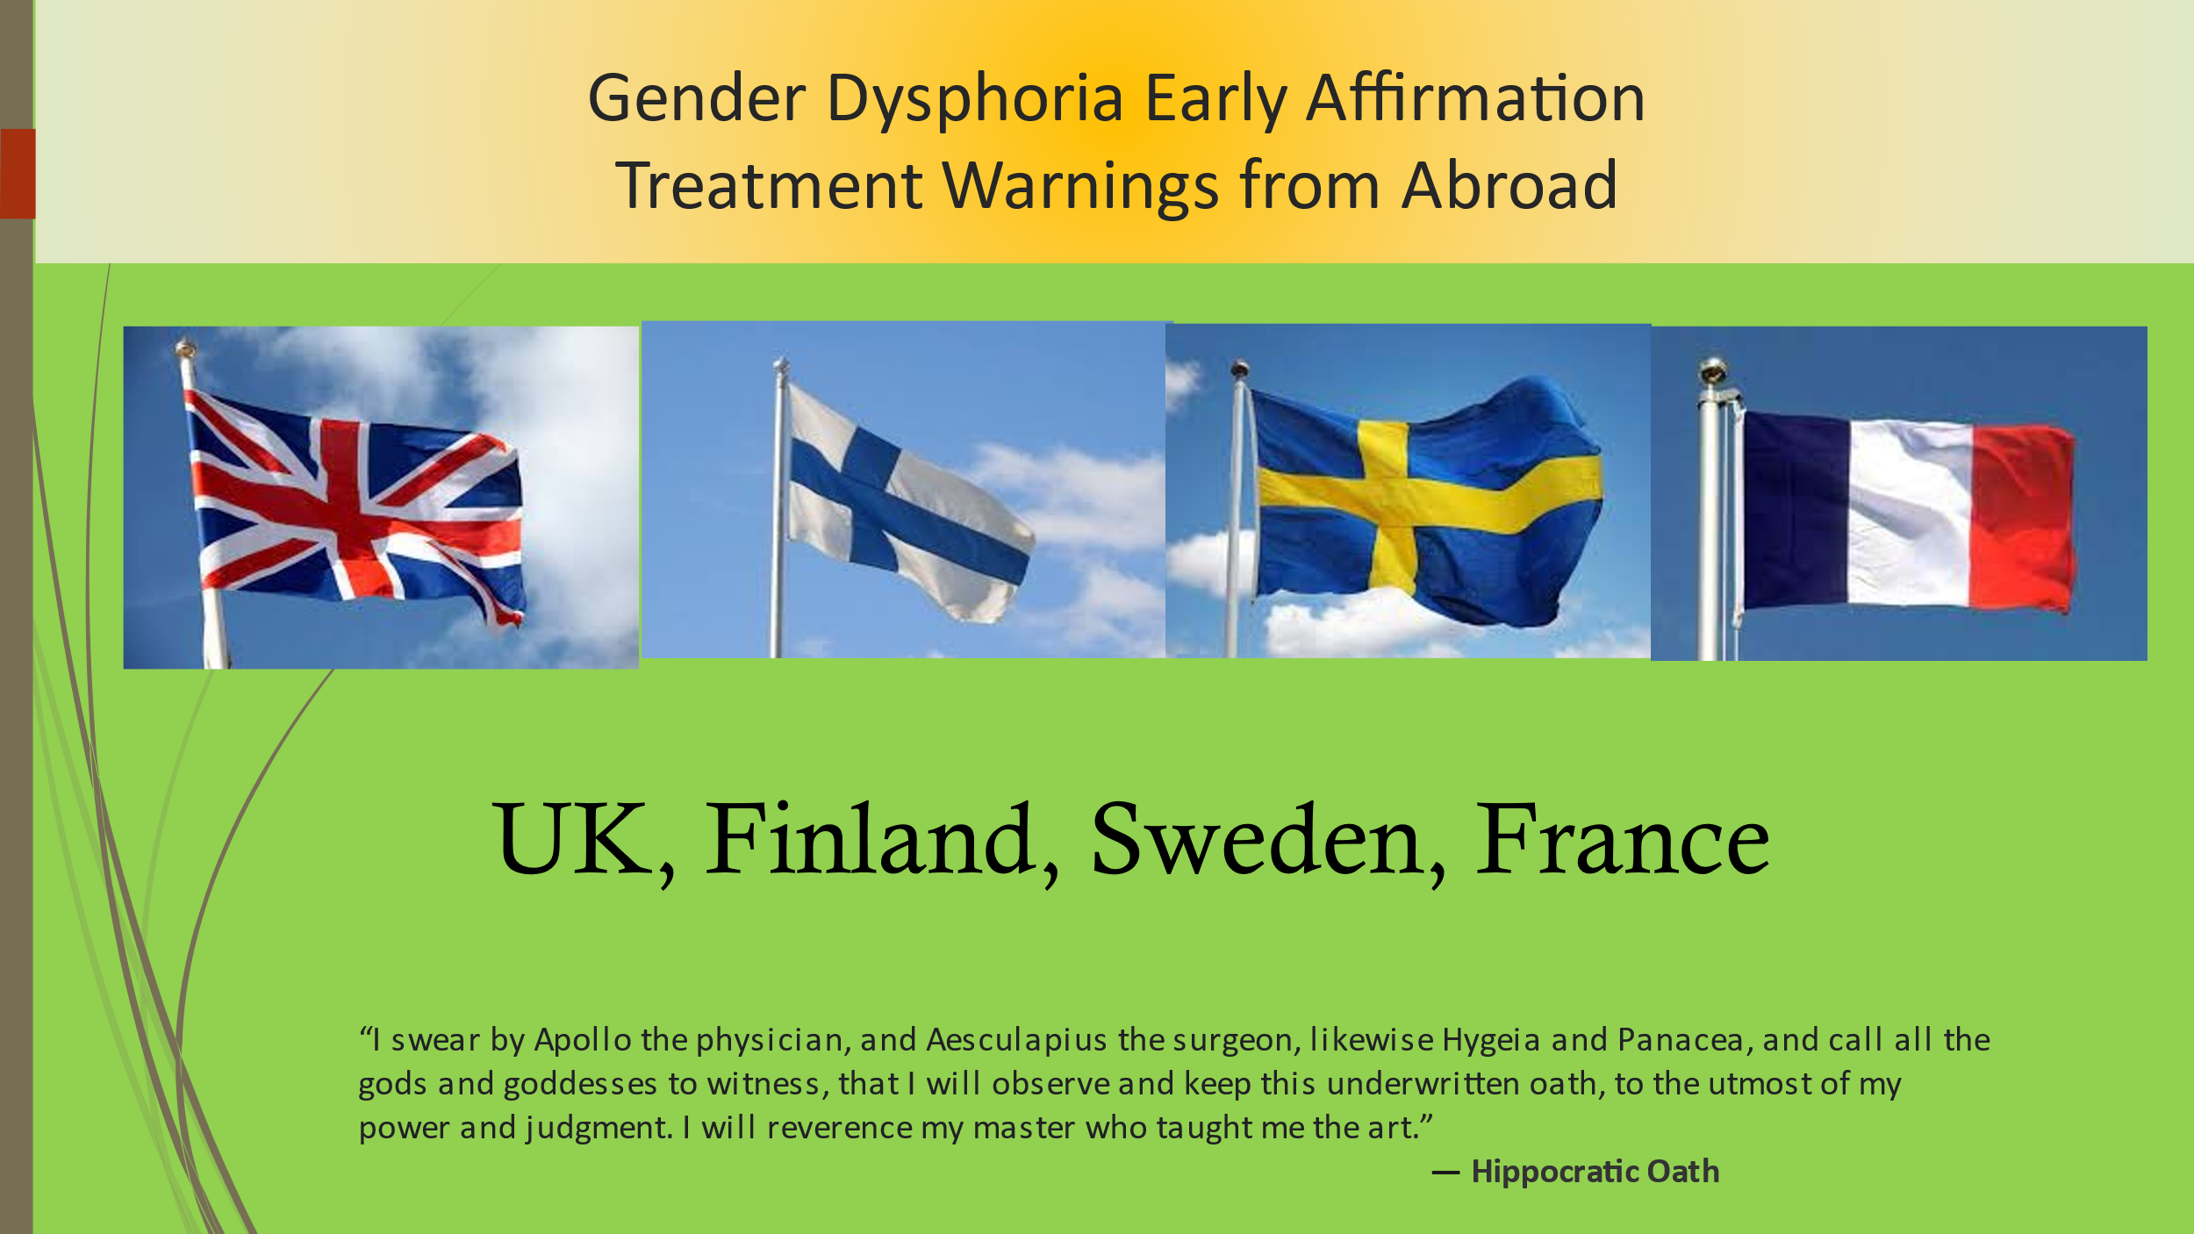Click low for fulhttps://www.bbc.com/news/uk-623356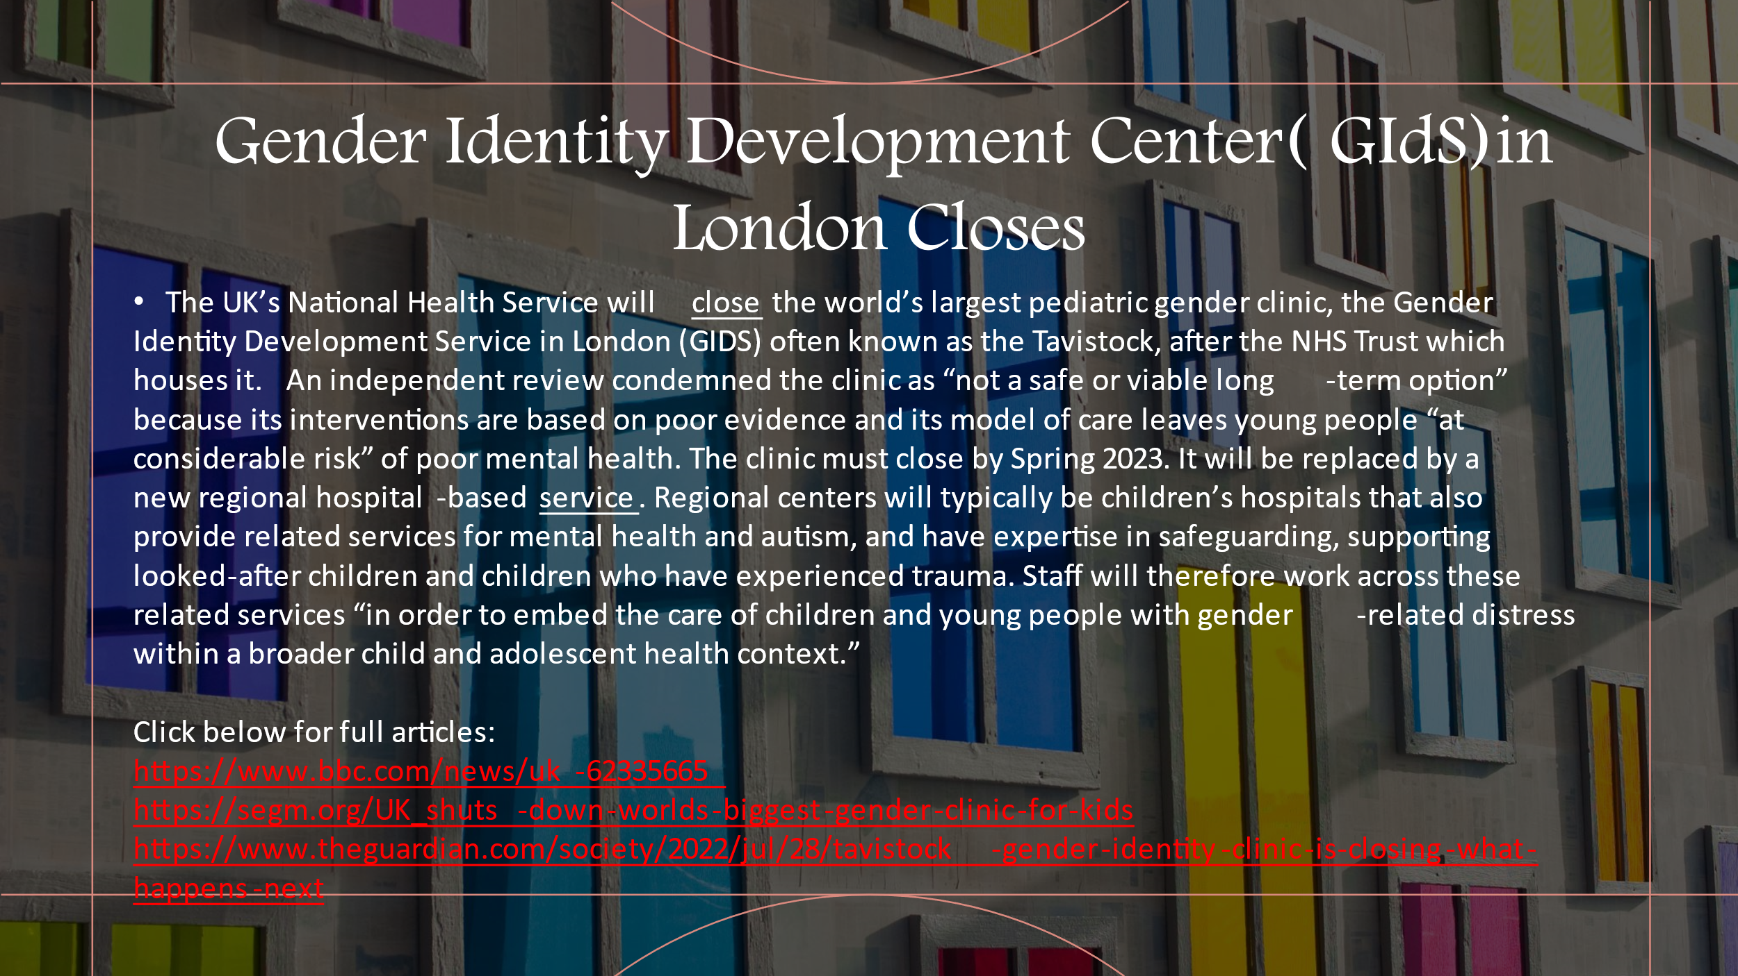65
Legislation against radical affirmation in children and teens is surfacing in the UK. As stated by SEGM, “The UK High Court determined that the provision of puberty blocking medications (GnRHa) to stop normally-timed puberty in gender dysphoric young people is experimental. The judges recognized puberty blockers as the first step in a trajectory that almost invariably leads to later prescription of cross-sex hormones with irreversible consequences. Because of this, the Court ruled that persons under age 16 are unlikely to be able to provide valid informed consent, as they lack the capacity to properly comprehend and evaluate the profound and life-long impacts of these interventions. Additionally, the Court issued caution for those between the ages of 16-17, as young people have a limited ability to comprehend the profound life-long implications for sexual and reproductive function and other health risks. With this ruling, the High Court has set up an expectation of accountability of the health professionals engaged in the provision of pediatric medical transition.
The UK High Court’s conclusions reflect growing concern among a significant number of researchers and clinicians about the poorly understood rapid rise in the number of adolescents with gender dysphoria, and the marked lack of evidence that hormones and surgery improve long-term health outcomes” (Bell-v-Tavistock Judgement, 2020; SEGM, 2020).
More recently, Jasmine Andersson and Andre Rhoden-Paul (2022) reported in the BBC that Tavistock and Portman NHS Foundation Trust has been told to shut the clinic by spring after it was criticized in an independent review. Instead, new regional centers will be set up to "ensure the holistic needs" of patients are fully met, the NHS said. “The trust said it supported plans for a new model due to a rise in referrals. The changes will take place after an independent review, led by Dr Hilary Cass, said the Tavistock clinic needed to be transformed.” (Anderson, J., & Rhoden-Paul, 2022).
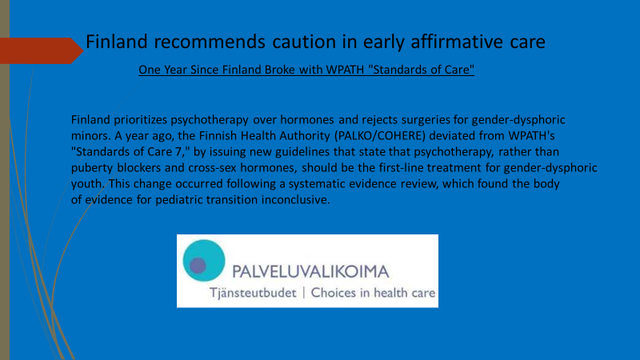

Click below for the full article:
https://segm.org/Finland_deviates_from_WPATH_prioritizing_psychotherapy_no_surgery_for_minors

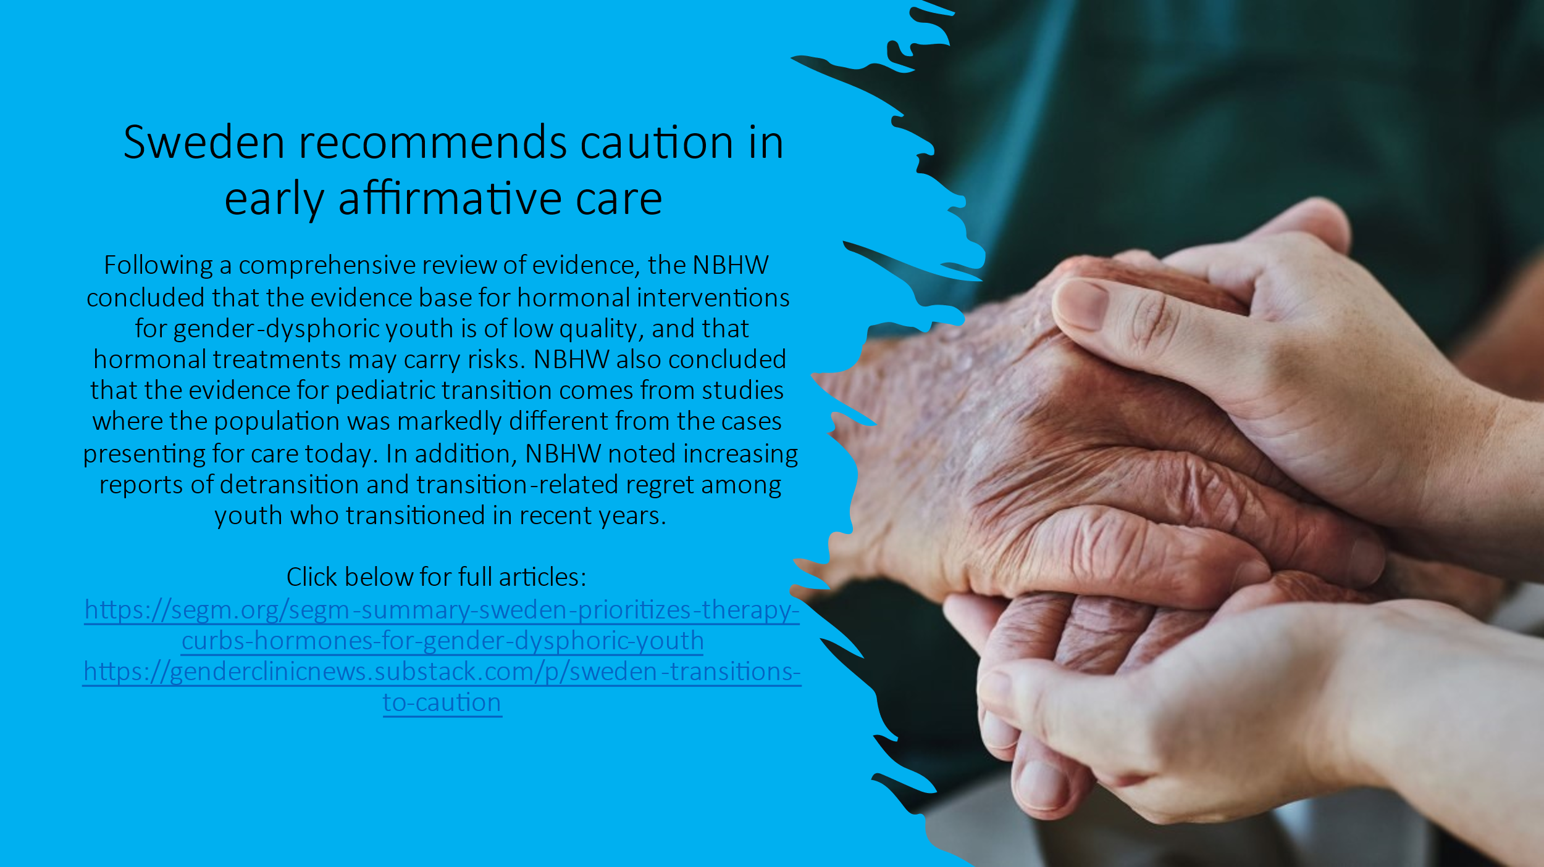

Click below for full articles:
https://segm.org/segm-summary-sweden-prioritizes-therapy-curbs-hormones-for-gender-dysphoric-youth
https://genderclinicnews.substack.com/p/sweden-transitions-to-caution

In Norway, the country’s Healthcare Investigation Board (NHIB or UKOM in Norwegian) recommended in part that gender-affirming care treatments such as puberty blockers be defined as experimental and specifically to quote, “UKOM recommends that puberty blockers and hormonal and surgical gender-affirming treatment for children and adolescents be defined as experimental treatment. This is especially important for teens with gender dysphoria” (UKOM, 2023).

And yes, even the French are recommending great caution as noted in this recent press release in March 2022 and translated from French to English by SEGM.

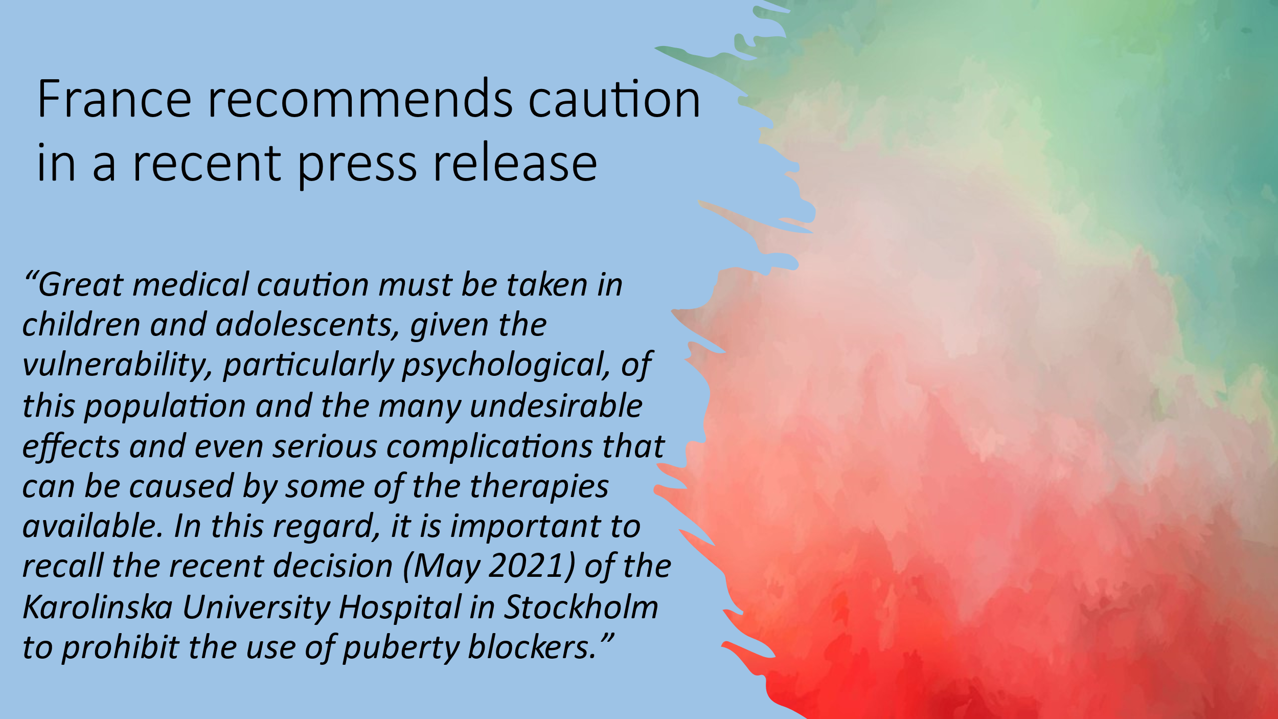

National Academy of Medicine, France
Press Release

Medical Care of Children and Adolescents with Transgender Identity
This press release was adopted by the National Academy of Medicine, France, on February 25, 2022, with 59 votes in favor, 20 votes against, and 13 abstaining. It was approved in its revised version by the Administrative Council on February 28, 2022.
“Transgender identity is a feeling of identifying as a gender different from that assigned at birth, which is persistent and lasts more than 6 months. This experience can cause significant and prolonged distress, which can contribute to an increased risk of suicide [a]. No genetic predisposition has been found.
While this condition has been long recognized, a sharp increase in demand for medical interventions has been observed (1,2) first in North America, then in Northern Europe, and, more recently, in France, particularly among children and adolescents. A recent study of a number of high schools in Pittsburgh revealed a prevalence that is clearly higher than previously estimated in the United States (3): 10% of students declared themselves to be transgender or non-binary or were unsure of their gender [b]. In 2003, the Royal Children's Hospital in Melbourne diagnosed only one child with gender dysphoria, whereas today it treats nearly 200.
Whatever the mechanisms involved in adolescents - excessive engagement with social media, greater social acceptability, or influence by those in one’s social circle - this epidemic-like phenomenon manifests itself in the emergence of cases or even clusters of cases in the adolescents’ immediate surroundings (4). This primarily social problem is due, in part, to the questioning of an overly dichotomous view of gender identity by some young people.
The demand for medical interventions, due to the distress that this condition (which is not a mental illness per se) causes, leads to a growing supply of care in the form of consultations or care in specialized clinics. This involves many pediatric subspecialties. The psychiatric consultations are utilized first, and if the identity is authentic and the discomfort persists, endocrinology, gynecology and, ultimately, surgery become involved.
However, great medical caution must be taken in children and adolescents, given the vulnerability, particularly psychological, of this population and the many undesirable effects and even serious complications that can be caused by some of the therapies available. In this regard, it is important to recall the recent decision (May 2021) of the Karolinska University Hospital in Stockholm to prohibit the use of puberty blockers.
If France allows the use of puberty blockers or cross-sex hormones with parental authorization and no age limitations, the greatest caution is needed in their use, taking into account the side-effects such as the impact on growth, bone weakening, risk of sterility, emotional and intellectual consequences and, for girls, menopause-like symptoms.
As for surgical treatments, specifically mastectomy, which is allowed in France at the age of 14, and surgeries relating to the external genitalia (vulva, penis), it must be emphasized that these procedures are irreversible.
When medical care is provided for this reason, it is essential to ensure medical and psychological support, first for the affected children and adolescents, but also for their parents, especially since there is no test to distinguish between persisting gender dysphoria and transient adolescent dysphoria. Moreover, the risk of over-diagnosis is real, as evidenced by the growing number of young adults wishing to detransition [c]. It is, therefore, appropriate to extend the phase of psychological care as much as possible.
The National Academy of Medicine draws the medical community’s attention to the growing demand for care in the context of transgender identity in children and adolescents, and recommends the following:
Children and adolescents expressing a desire to transition, as well
as their families, should receive extended psychological support.
Should the desire to transition persist, the decision to treat with puberty blockers or cross sex-hormones must be considered carefully and within the framework of multidisciplinary consultations.
Medical studies should include clinical information specifically adapted for informing and guiding young people and their families.
Continued research into both, clinical and biological, as well as ethical aspects of this matter, still lacking in France, is needed.
Parents addressing their children’s questions about transgender identity or associated distress should remain vigilant regarding the addictive role of excessive engagement with social media, which is both harmful to the psychological development of young people and is responsible for a very significant part of the growing sense of gender incongruence” (SEGM, 2022).
And now the lawsuits are coming to America and to my medical and mental health colleagues, please examine what you are doing and if you are not following the real science, ensure that your malpractice premiums are paid up.
Note that not only was Kaiser Permanente in Oakland, CA named in the suit but the medical professionals (I am using the word professional loosely) were specifically listed to include one provider from my profession, clinical psychologist Susanne E. Watson, Ph.D.

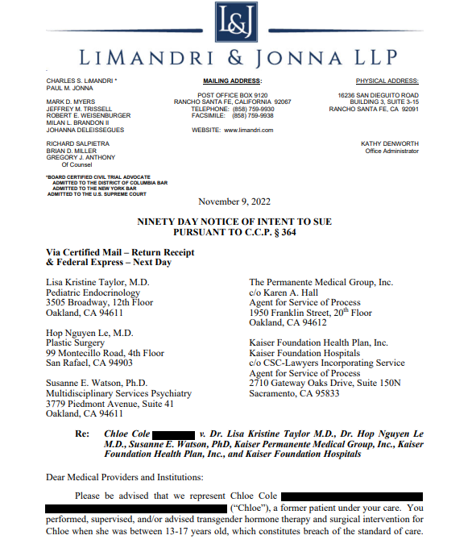

“Chloe Cole, a detransitioned 18-year-old woman, announced her intent on Thursday to sue the hospital and affiliated medical group that facilitated her medical transition as a minor.

According to the press release, Cole, represented by the Dhillon Law Group and LiMandri & Jonna LLP, in conjunction with the Center for American Liberty, sent a letter of intent to sue the Permanente Medical Group, Kaiser Foundation Health Plan, and Kaiser Foundation Hospitals who “performed, supervised, and/or advised transgender hormone therapy and surgical intervention for Chloe Cole when she was between 13-17 years old.” They will also be seeking “punitive damages based on the evidence of malice, oppression and fraud.”
“My teenage life has been the culmination of excruciating pain, regret, and most importantly injustice,” Cole said. “I have been emotionally and physically damaged and stunted by so-called medical professionals in my most important developmental period. I was butchered by an institution that we trust more than anything else in our lives.”
The letter of intent to sue outlines the “experimental nature” and “off-label use” of the puberty blockers, cross-sex hormones, and double mastectomy surgery offered to Cole, which lack long-term studies to support their use in gender medicine and alleges that the treatments amount to “medical experimentation.”
The letter finds that Kaiser “coerced” Cole and her parents into medical transition by “falsely informing” them that her gender dysphoria would not resolve on its own, despite considerable evidence that contradicts this claim, which was withheld from Cole and her family.
Chloe and her parents were never informed of the high rate of desistance for children diagnosed with gender dysphoria,” the letter stated. “Also, they were never informed of the high probability that Chloe’s gender dysphoria would resolve as an adult without hormone or surgical treatment.”
Indeed, current evidence indicates that roughly 60–90% of children who identify as transgender but do not socially or medically transition will no longer identify as transgender in adulthood. The letter states that Cole’s doctors informed her parents that their daughter was at a high risk for suicide if they did not proceed with social and medical transition, despite the fact that Cole had “no significant indications of suicide or severe depression.
Cole was never offered an alternative to medical transition, the letter delineated. In fact, the much more appropriate option of psychiatric treatment, including a “watchful waiting” approach, or an attempt to treat underlying psychological conditions, was never recommended to Cole or her family.
The letter continues by alleging that the “informed consent” doctors obtained from Cole for both hormones and surgery failed to exhaustively list the risks and side effects associated with the treatments, and questions whether “it is even possible to give such consent as a minor and at such a critical time in her life and development?”
“This radical, off-label, and inadequately studied course of chemical and surgical ‘treatment’ for Chloe’s mental condition amounted to medical experimentation on Chloe,” the letter charges. “These experimental procedures are very dangerous, especially to young patients, but also very lucrative to the Defendants.”

Clinical Guidelines for Intervention
“Give sorrow words. The grief that does not speak whispers the o’re-fraught heart, and bids it break...”
— William Shakespeare, Macbeth

We needn’t rush children into transition and there is an emerging literature to support this.
Soh (2020a) writes that an alternative approach to rushing to transition, called watchful waiting or wait and see enables the child to discover the course that they take. They may or may not eventually decide to go forward with transitioning.
Soh (2020a) adds that an approach called the therapeutic approach, or the developmental model approach allows for the child in question to explore the parameters of their gender while being open to the possibility that he or she might eventually grow comfortable in their natal sex. Their therapist would endeavor to understand possible relevant factors of their development to include adverse childhood experiences, trauma, and other psychopathology, or whatever else might be transpiring in the child that might be moving the child to feel this way.
The developmental approach has received empirical support. For example, in case studies, Churcher et al. (2019) found that extended counseling can be effective in resolving adolescents’ gender dysphoria. To quote: “In conclusion, the adolescents included in this review met criteria for GD and initially requested medical interventions to resolve their difficulties. Over the course of the psychosocial assessment, they came to understand their distress and its alleviation (at that particular point in time) differently and eventually chose not to take a medical (hormonal) pathway and/or identified their gender identity as broadly aligned with their biological sex. Of course, this is not the case for many other young people presenting to the service and it is important to hold onto the multiplicity of possible outcomes” Churcher et al., 2019).
World renowned gender experts Sasha Ayad, Roberto D’Angelo, Dianna Kenny, Stephen Leving, Lisa Marchiano, and Stella O’Mally recently the best and most scholarly work for how to work with these children, A clinical Guide for Therapists Working with Gender-Questioning Youth. This 120 page manual provides a superb overview of gender dysphoria, the research, and therapeutic approaches and was supported by the Society for Evidence-Based Medicine (Ayad et al., 2022).
Ahad and her colleagues note that the exploratory approach stands in stark contrast to the gender-affirmative approach (which I sometimes call the rush to transition) and that it has gained popularity over recent years.
They elaborate that exploratory therapy consists of nine principles:
- It is open to a range of outcomes.
- It understands that gender dysphoria emerges in a context.
- It is developmentally informed.
- It considers and addresses comorbid conditions such as ASD, ADHD, social anxiety, depression, suicidality, and eating disorders which are common in youth with gender dysphoria. .
- It acknowledges the complex interplay of sexual development and gender identity.
- It is a process that occurs over and extended length of time.
- It maintains an evidence-based approach to suicidality.
- It promotes true informed consent (Ayad et al., 2022).
Ayad and her colleagues elaborate what exploratory therapy is not:
- It is NOT conversion therapy. Gender-exploratory therapy does not aim for any fixed outcome regarding how one comes to experience or express their gender and a cis-gender identification is not its goal. Rather, it aims to understand and ameliorate gender-related distress in a noninvasive manner and at the same time respect and appreciate the youth’s freedom to express oneself authentically and freely.
- It does not assume that trans-identification is universally adaptive.
- It does not assume that gender-affirming interventions are universally helpful.
- It does not encourage the obfuscation of biological facts – or otherwise lie to vulnerable children.
Child psychiatrist Dr. Miriam Grossman wrote in my mind the best book summarizing the broad issues of gender dysphoria and provides numerous helpful guidelines. Her book, Lost in Trans Nation: A Child Psychiatrist’s Guide Out of the Madness is a groundbreaking book in the context of growing discussions about gender identity and expression, particularly regarding transgender and gender-nonconforming children. Dr. Grossman provides insights, guidance, and evidence-based strategies for professionals and families dealing with child and adolescent gender dysphoria specifically advocates for parents to trust their instincts in the face of ideologically driven misinformation and to question the advice of gender experts and politicians. The book critically examines medical and societal approaches to gender identity in children, highlighting concerns about the irreversible nature of some medical interventions and the need for more cautious, evidence-based approaches​​. I particularly appreciate Dr. Grossman provides invaluable Appendices on how to deal with WOKE school, how to handle Child Protective Servies when they get out of hand, how to find an appropriate therapist (as an undereducated, activist-biased, knowledge-deprived therapist can wreak alarming damage in a very short time.)
In short, Dr. Grossman’s book is magnificent and deserves my highest recommendation. It can be found on Amazon:
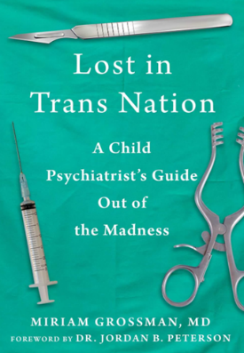
https://www.amazon.com/Lost-Trans-Nation-Psychiatrists-Madness/dp/1510777741/ref=sr_1_1?crid=25VNG1JEFV78X&keywords=dr.+Miriam+grossman&qid=1704130091&sprefix=dr.+miriam+grossman%2Caps%2C164&sr=8-1
Susan and Marcus Evans, formerly involved with the now infamous Tavistock GIDS after disassociating themselves from it wrote Gender Dysphoria: A Therapeutic Model for Working with Children, Adolescents and Young Adults, which explores gender dysphoria, primarily aimed at clinicians. The book provides a model for understanding, assessing, and treating individuals who identify as transgender. It addresses the recent surge in self-diagnosed gender dysphoric children and young people, highlighting the need for careful assessment before proceeding with life-altering treatments. Although an excellent and brave book, my primary concerns is that it employs a psychoanalytic framework to understand disturbed states of mind and offers insight into the internal worlds, thoughts, and interpersonal relationships of transgender children, adolescents, and young people which my not prove very helpful with those (to include me) who hold a different theoretical perspective. Nonetheless it is a useful and important book, particularly because it was written by defectors from the trans-crazy narrative who agreed to follow the science even at great personal cost.
There book can be found on Amazon:
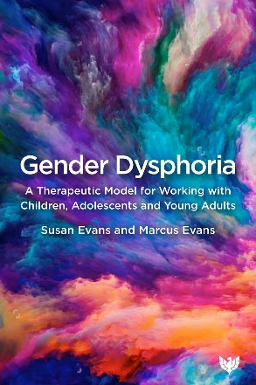
https://www.amazon.com/Gender-Dysphoria-Therapeutic-Children-Adolescents/dp/1912691787/ref=asc_df_1912691787/?tag=hyprod-20&linkCode=df0&hvadid=509159807707&hvpos=&hvnetw=g&hvrand=6008617586878050239&hvpone=&hvptwo=&hvqmt=&hvdev=c&hvdvcmdl=&hvlocint=&hvlocphy=1013466&hvtargid=pla-1262896324724&psc=1&mcid=b4cdcfba0f79395a901f09d7cb03b98c&gclid=CjwKCAiA4smsBhAEEiwAO6DEjUr7YZktdHtKqiXMHk_jyNNOm6B6bGRFw5Ly-7978C279kluisgkABoCzjMQAvD_BwE

Resources
Christian Medical and Dental Associations: This website offers several scholarly reviews on the facts and outcome research on transgender medicine in the pediatric and adolescent populations.
Website:
https://cmda.org/

Society for Evidenced-Based Gender Medicine (SEGM): SEGM’s stated mission is “to promote safe, compassionate, ethical and evidence-informed healthcare for children, adolescents, and young adults with gender dysphoria.”
Website:
https://segm.org/

The Center for Bioethics and Culture Network (CBC): CBC features many excellent videos on the topic of the perils of early transitioning from experts such as family practice physician Dr. Andre Van Mol and pediatric endocrinologist Dr. Quentin Van Meter as well as from victims of this practice as well.
Website:
https://www.youtube.com/@Cbc-networkOrg

Transmission: What's the Rush to Reassign Gender?: is a superlative documentary film featuring experts such as Dr. Andre Van Mol, Dr. Hrusta, and Dr. Quentin Van Meter, activists, parents, and educators discussing the medical and surgical transitioning of children. With a runtime of approx. 52 minutes, this is by far the best documentary out there.
Link: https://www.youtube.com/watch?v=rUeqEoARKOA&t=954s&ab_channel=TheCenterforBioethicsandCultureNetwork
Questioning the Science of Gender Industry: Moderated by Jennifer Lahl, President of the Center for Bioethics and Culture. This excellent video features detransitioner Helena Kerschner, endocrinologist Dr. Michael Laidlaw, and Colin Wright, an evolutionary biologist and Senior Editor at the Foundation Against Intolerance & Racism (FAIR).
Link: https://www.youtube.com/watch?v=p2pb3FZ69Ag&ab_channel=TheCenterforBioethicsandCultureNetwork

Inspired Teen Therapy: Founded by perhaps the top gender dysphoria therapist in the nation, Sasha Ayad, a Licensed Professional Counselor who works in private practice and has treated adolescents for over 13 years. Her work focuses on teens and young adults struggling with issues of gender dysphoria and gender identity. She became interested in the sharp rise in teenagers who declare a trans identity for the first time during adolescence. She also discovered, through working with hundreds of families, that teens were developing gender dysphoria only after adopting a transgender identity. She questions the practice of medical transition for children and teenagers, and her clinical work focuses on developmentally appropriate, least-invasive-first talk therapy.
She is also the co-host of Gender: A Wider Lens Podcast and a founding board member of the Society for Evidence-based Gender Medicine, The Gender Exploratory Therapy Association, Genspect, and The Institute for Comprehensive Gender Dysphoria Research.
Website:
https://inspiredteentherapy.com/
Dr. Miriam Grossman: Miriam Grossman MD is board certified in psychiatry and in the sub-specialty of child and adolescent psychiatry. Before gender ideology was on anyone’s radar, she warned parents about its falsehoods and dangers in her 2009 book about sexuality education, "You’re Teaching My Child WHAT?"
Dr. Grossman’s practice currently focuses on gender-distressed young people and their parents. She believes that every child is born in the right body. Dr Grossman has been vocal about the capture of her profession by ideologues, leading to dangerous and experimental treatments on children and betrayal of parents.
The author of five books, Dr. Grossman's work has been translated into eleven languages. She has testified in Congress and lectured at the British House of Lords and the United Nations.
Website:
https://www.miriamgrossmanmd.com/

Ethics and Public Policy Center (EPPC): Founded in 1976, the Ethics and Public Policy Center is Washington, D.C.’s premier institute working to apply the riches of the Judeo-Christian tradition to contemporary questions of law, culture, and politics, in pursuit of America’s continued civic and cultural renewal. EPPC’s president, Dr. Ryan T. Anderson, received his doctoral degree in political philosophy from the University of Notre Dame and wrote the book, When Harry Became Sally: Responding to the Transgender Moment. This website offers may scholarly articles and videos on the perils of early affirmation therapy in children.

Website:
https://eppc.org/?auth=&flexdatalist-auth=&s=gender+dysphoria&ptype=&ctype=

Family Watch International (2020): “The Gender Agenda” is a documentary that has been produced by Family Watch International. It has key messages from individuals who have lived as transgender who were able to resolve their gender dysphoria and embrace their biological sex. It also includes testimony from doctors and psychologists who share the science and medical facts related to gender identity issues, including the physical harms that emanate from failed attempts to “transition” to the opposite sex. They show that this is medically impossible. This video features Dr. Michelle Cretella, M.D. and dedtransitioners, Erin Brewer and Walt Heyer, among others.

Link: https://www.youtube.com/watch?v=Djw-QkYt0Fo

Sex Change Regret: Sex Change Regret was founded by Walt Heyer and offers encouragement and hope for others who want to detransition back to their innate birth gender. Walt who identified as a transgender woman for 8 years now has a passion to help others who regret gender change. Walt has appeared on numerous radio and television shows in the U.S. and Canada. Walt’s articles have been published online and his many books are a welcome resource in understanding the issue.
Website: https://sexchangeregret.com/

Closing Thoughts
Let my skin and sinews and bones dry up, together with all the flesh and blood of my body! I welcome it! But I will not move from this spot until I have attained the supreme and final wisdom.
- Buddha

In the words of Ryan T. Anderson, “First and foremost, as we advocate for the truth, we must be careful not to stigmatize those who are suffering. Many people who have detransitioned say that they felt pressured to transition and are now being attacked from the political left for detransitioning. But many also say that people on the political right made them feel like misfits in society, and that’s part of what led their desire to transition in the first place” (Anderson, 2019). We must always treat them with dignity and respect!
That said, our children are in a crisis and extreme activists are redefining reality. This activist ideology is replacing parents’ rights to raise a child within their own value system. They have invaded our families and the minds of our children. They are giving them a false narrative that is founded neither on science nor on common sense. They confuse our children with a warped definition of sexuality and gender with the promise that transitioning will be the answer to their pain and struggle. Science is no longer the gold standard, but the activist agenda is. Good researchers, doctors, therapists, and educators are marginalized, censored, cancelled, and even punished for speaking the truth as they know it. They must align with the activist’s voice. Critical thinking is now criticized.
I do not stand in opposition to our transgender community or anyone struggling with gender dysphoria. We are all one and trans people deserve to be loved, respected, and treated equally. I am in no way stating that people should be dissuaded from transitioning. What I am saying, however, is that there is ample reason to reconsider the current “standards of practice” for children and teens, as these standards in far too many cases when rushed are leading to horrific outcomes.
I propose reflection on the following:
- Demand that parents, children, and teens be told the whole truth about the impact of early affirmation, puberty blockers, cross-sex hormone therapy, and gender reassignment surgery; and not only short-term outcomes, but long-term outcomes as well, so they can make the best decisions for themselves and/or for their children.

- Consider that children may be unable to appreciate the full magnitude of too-early gender identification and the ramifications of the potential medical and surgical transitioning that follow.

- Restore real and honest science, not activist-biased ideology, to medicine and psychology. Demand, similar to all other areas of medicine, that treatments are founded on the latest research. The holy grail of all providers is that we do no harm, and harm that results from a provider’s lack of being current in the research and treatment outcomes cannot exclude that provider from accountability. Moreover, treatments that are experimental and/or unproven should be clearly labeled/identified as such to allow for open and visible informed consent. Moreover, Dr. Melissa Moschella, assistant professor of ethics, Department of Medicine at Columbia University writes, “People with gender dysphoria are not uncommonly given treatments that involved grave health hazards and few (if any) lasting benefits” (Moschella, cited in Anderson, 2019).

- Demand that universities be strong proponents of the First Amendment and not allow them to stifle free speech and open discussion of all ideas and all good research studies. Do not allow them to capitulate to the demands of those who have little to no respect for the academic process or intellectual discourse (Soh, 2020a). Vet the college that you or your child might attend and ensure that intellectual integrity and pure sciences are at the foundation. If not, strike that one from the list.

- Should your child or teen need therapy, ensure that the provider is up-to-date on the research, not on mere ideology alone. A misguided therapist can destroy your child faster than most anything.

- Become fully informed of your child’s school’s sex education program and opt your child out if it violates your family values and/or real science.

- Monitor your child’s access to the Internet and social media. Sasha Ayad, a therapist who has worked with scores of trans-identified adolescents’ comments, “The most fundamental thing I want parents to understand is that this isn’t necessarily about gender at all. When these kids go online, they’re essentially being steeped in what could be seen as propaganda” (Shrier, 2020).

- Consider pulling your child’s smartphone. It is becoming increasingly clear that nearly all novel problems that teens face can be linked to the introduction of Mr. Steve Job’s iPhone in 2007 (many tech-industry parents to include Jobs did and do not allow their own children access to these devices). Since that time there has been an explosion of bullying, self-injury, suicidality, depression, anorexia, and more recently sudden transgender identification, which many believe are owed to the self-harm instruction, manipulation, abuse, and relentless harassment supplied by a single smartphone (Shrier, 2020).

- Sasha Aad suggests that parents consider refraining from early affirmation of a child/adolescent gender identity, but instead support their child’s identity exploration without necessarily taking on the identity literally (Ayad cited in Shrier, 2020). Find a Counselor or psychologist/psychiatrist who does not follow the gender affirmative paradigm as the sole treatment option.

- For the child/adolescent: Before active transitioning is pursued, explore, identify, and fully address all underlying psychological and social issues. Has there been trauma to include, for example, sexual abuse, physical abuse, neglect, bullying, a divorce or separation, or sibling conflict? Are there signs of anxiety, depression, obsessive compulsive disorder, autism, psychosis? These must be identified and treated first (Laidlaw, 2019).

- Never give up your authority as a parent on the issue of early gender transformation. You are a parent because children need parents for guidance and structure even though activists attempt to exclude you from the parenting of your child in the gender arena, asserting that they know better than you. Just as you would not allow your child to get liposuction surgery for anorexia, do not allow your child to seek treatments for gender dysphoria that might result in irreversible harm or worse.

We can get this right and in so doing help our youth grow into successful and happy adults if we come together in open honesty.

References

Advocates for Youth (2020). A Lesson Plan from Rights, Respect, Responsibility: A K-12 Curriculum Fostering respect and responsibility through age-appropriate sexuality education.
https://mynorthwest.com/wp-content/uploads/2020/01/Sexual-Education-proposal-Washington-state.pdf
(accessed December 27, 2020).

American Psychological Association (2018). A glossary: Defining transgender terms. September 2018, Vol 49, No. 8.
https://www.apa.org/monitor/2018/09/ce-corner-glossary
(accessed January 18. 2021).

Aitken, M., Steensma, T.D., Blanchard, R., VanderLaan, D.P., Wood, H., Fuentes, A., & Zucker, K.J. (2015). Evidence for an altered sex ratio in clinic-referred adolescents with gender dysphoria. Journal of Sexual Medicine, 12, 756–763.
https://www.tandfonline.com/doi/full/10.3109/09540261.2016.1125740
(accessed November 28, 2020).

American Psychiatric Association. (2013). Diagnostic and Statistical Manual of Mental Disorders (5th ed.). Arlington, VA: American Psychiatric Publishing.

Anderson, R. T. (2019). When Harry Became Sally: Responding to the Transgender Movement. New York, NW: Encounter Books

Arboleda, V.A., Sandberg, D.E., & Vilain, E. (2014). DSDs: genetics, underlying pathologies and psychosexual differentiation. Nat Rev Endocrinol. 10, 602-615.
https://www.ncbi.nlm.nih.gov/pmc/articles/PMC4441533/
(accessed December 1, 2020).

Ayad, S., et al. (2022). Clinical guide for therapists working with gender-questioning youth. Ayad, S., et al.
GETA_ClinicalGuide_2022.pdf (therapyfirst.org) (accessed 1 January 2024).

Ayad, Sasha (2021). Inspired Teen Therapy website.
https://inspiredteentherapy.com/about/
(accessed January 2, 2021).

Backholm, J. (2016). Washington Schools to Teach Gender Identity Curriculum in Kindergarten. Family Policy Institute of Washington. June 2016.
https://doi.org/10.1038/nrendo.2014.130
https://www.fpiw.org/blog/2016/06/02/washington-schools-to-teach-gender-identity-curriculum-in-kindergarten/
(accessed December 27, 2020).

Bailey, M., & Blanchard, R. (2017). Gender dysphoria is not one thing, 4thWaveNow. Posted https://4thwavenow.com/2017/12/07/gender-dysphoria-is-not-one-thing/
(accessed 17 January 2021).

Barta, M. (2018). TINSA: Trauma Induced Sexual Addiction. North Charleston, SC: CreateSpace Independent Publishing Platform.

Bell-v-Tavistock Judgement (2020). Published online December 1, 2020. Accessed December 2, 2020.
https://www.judiciary.uk/wp-content/uploads/2020/12/Bell-v-Tavistock-Judgment.pdf
(accessed January 16, 2021).

Bethea, M. S., & McCollum, E. E. (2013). The disclosure experiences of male-to-female transgender individuals: A Systems Theory perspective. Journal of Couple & Relationship Therapy, 12, 89 –112. http://dx.doi .org/10.1080/15332691.2013.779094
(accessed December 12, 2020.

Biggs, M. “The Tavistock’s Experiment with Puberty Blockers,” 29 July 2019, http://users.ox.ac.uk/~sfos0060/Biggs_ExperimentPubertyBlockers.pdf
(accessed November 34, 200)

Birth Defect Research for Children (2021). Turner Syndrome.
https://birthdefects.org/turners-syndrome/?gclid=EAIaIQobChMI0dLz9o617gIV5MiUCR18ng2SEAAYAiAAEgK2dPD_BwE
(accessed January 24, 2021.

Blakemore, E. (2019). Gay Conversion Therapy's Disturbing 19th-Century Origins. History Stories.
https://www.history.com/news/gay-conversion-therapy-origins-19th-century
(accessed January 16, 2021)

Blue Cross and Blue Shield Study (2018). Major Depression: The Impact on Mental Health.
https://www.bcbs.com/the-health-of-america/reports/major-depression-the-impact-overall-health
(accessed January 17, 2021).

BMJ (2019). Gender-affirming hormone in children and adolescents. BMJ EBM Spotlight.
https://blogs.bmj.com/bmjebmspotlight/2019/02/25/gender-affirming-hormone-in-children-and-adolescents-evidence-review/
(accessed January 9, 2021).

Briere J, Rickards S. (2007). Self-awareness, affect regulation, and relatedness: differential sequels of childhood versus adult victimization experiences. J Nerv Ment Dis. 195(6):497–503. doi: 10.1097/NMD.0b013e31803044e2. [PubMed] [CrossRef] [Google Scholar]
Self-Awareness, Affect Regulation, and Relatedness: Differen... : The Journal of Nervous and Mental Disease (lww.com)
(accessed February 15, 2021).

Bouman, W.P. Annelou LC de Vries, A &Guy T’Sjoen, G. (2016). Gender Dysphoria and Gender Incongruence. Volume 28, 2016 - Issue 1
https://www.tandfonline.com/doi/full/10.3109/09540261.2016.1125740
(accessed November 28, 2020).

Brown University (2019). Updated: Brown statements on gender dysphoria study.
https://www.brown.edu/news/2019-03-19/gender
(assessed December 6, 2020).

Butler, G. De Graaf, N., Wren, B., & Carmichael, P. (2018).
Assessment and support of children and adolescents with gender dysphoria. Arch Dis Child July 2018 Vol 103 No 7.
Assessment and support of children and adolescents with gender dysphoria | Archives of Disease in Childhood (bmj.com)
(accessed January 21, 2021).

Buttons, C (2022). Detransitioner Chloe Cole Announces Intent To Sue Kaiser Permanente For ‘Experimental’ Hormones And Surgery. Daily Wire.
https://www.dailywire.com/news/detransitioner-chloe-cole-announces-intent-to-sue-kaiser-permanente-for-experimental-hormones-and-surgery
(accessed November 12, 2022).

California Department of Education (2016).
Comprehensive Sexual Health & HIV/AIDS Instruction - Health (CA Dept of Education)
(accessed December 20, 2020).

Canadian Gender Report (2010). The Canadian experiment with puberty blockers: what we know so far
https://genderreport.ca/trans-youth-can-study-puberty-blockers/
(accessed January 31, 2021).

Centers for Disease Control and Prevention (2019). Health Considerations for LGBTQ Youth
https://www.cdc.gov/healthyyouth/disparities/health-considerations-lgbtq-youth.htm
(accessed December 5, 2019).

Chu, A. L. (2018). My New Vagina Won’t Make Me Happy. Opinion. New York Times. November 24, 2018.
https://www.nytimes.com/2018/11/24/opinion/sunday/vaginoplasty-transgender-medicine.html
(accessed December 6, 2020).

Churcher Clarke, A. & Spiliadis, A. (2019). ‘Taking the lid off the box’: The value of extended clinical assessment for adolescents presenting with gender identity difficulties. Clinical Child Psychology and Psychiatry. 24, 338-353.
https://journals.sagepub.com/doi/full/10.1177/1359104518825288
(accessed December 28, 2020).

Cohen, D., & Barnes, H. (2019). Transgender treatment: Puberty blockers study under investigation. BBC Newsnight. July 22, 2019.
https://www.bbc.com/news/health-49036145
(accessed December 2020).

D’Angelo, R., Syrulnik, E., Ayad, S. et al (2020). One Size Does Not Fit All: In Support of Psychotherapy for Gender Dysphoria. Arch Sex Behav (2020).
https://doi.org/10.1007/s10508-020-01844-2
(accessed January 16, 2021).

De Vries, A.L.C., Kreukels, B.P.C., T’Sjoen, G., Ålgars, M., & Mattila, A. (2015). Increase of referrals to gender identity clinics: A European trend? In Transgender Healthcare in Europe. Book of Abstract (p. 10). Ghent, Belgium: European Professional Association of Transgender Health (EPATH).
http://epath.eu/wp-content/uploads/2014/07/EPATH-2015-Book-of-Abstracts.pdf
(accessed November 28, 2020).

Dhejne, C. et al. (2011). Long-Term Follow-Up of Transsexual Persons Undergoing Sex Reassignment Surgery: Cohort Study in Sweden. PLOS ONE 6. e16885. 10.1371/journal.pone.0016885.
https://journals.plos.org/plosone/article?id=10.1371/journal.pone.0016885
(accessed February 15, 2021).

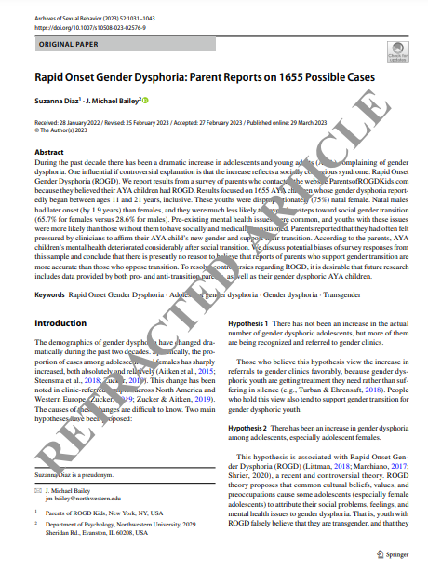
Diaz, S., & Bailey, M. (2023). Rapid Onset Gender Dysphoria: Parent Reports on 1655 Possible Cases. Arch Sex Behav. 2023 Apr;52(3):1031-1043. doi: 10.1007/s10508-023-02576-9. Epub 2023 Mar 29. Retraction in: Arch Sex Behav. 2023 Nov;52(8):3577. PMID: 36991212; PMCID: PMC10102036.
https://pubmed.ncbi.nlm.nih.gov/36991212/
(accessed January 12, 2024).

Downing, M. J. et al. (2016). Sexually Explicit Medial Use by Sexual Identity: A Comparative Analysis of Gay, Bisexual, and Heterosexual Men in the United States. Archives of Sexual Behavior.
DOI:10.1007/s10508.-016=0837-9
https://link.springer.com/article/10.1007/s10508-016-0837-9
(accessed February 15, 2021).

Dreger, A. (2015). Answers to Some Questions about Autogynephilia. Blog of Alice Domurat Dreger.
http://alicedreger.com/autogyn
(accessed January 18, 2021).

Duignan, Brian. "Judith Butler". Encyclopedia Britannica, 7 Dec. 2023, https://www.britannica.com/biography/Judith-Butler
(accessed 30 December 2023).

Dunn E., Nishimi K, Gomez S., Powers A., & Bradley B. (2018). Developmental timing of trauma exposure and emotion dysregulation in adulthood: Are there sensitive periods when trauma is most harmful? J Affect Disord. Feb;227:869-877. doi: 10.1016/j.jad.2017.10.045. Epub 2017 Oct 28.
https://www.sciencedirect.com/science/article/abs/pii/S0165032717311205?via%3Dihub
(accessed February 15, 2021).

Edsinger, O. Queer Theory on the Rise: An Attack on the Concept of Fixed Sexual Identity.
https://lausanne.org/content/lga/2019-01/queer-theory-on-the-rise (accessed December, 30 2023).

Davis, E. (2024). States That Have Restricted Gender-Affirming Care for Trans Youth. US News.
https://www.usnews.com/news/best-states/articles/2023-03-30/what-is-gender-affirming-care-and-which-states-have-restricted-it-in-2023
(accessed January 12, 2024).

Em (2019a). The Trojan Unicorn: QT and Paedophilia, Part I | Dr Em
https://www.youtube.com/watch?v=qAP4czG3DjE&ab_channel=ThoughtsonThingsandStuff (accessed December, 28 2023).

Em (2019b). The Trojan Unicorn: QT and Paedophilia, Part IV. | Dr Em
https://uncommongroundmedia.com/the-trojan-unicorn-qt-and-paedophilia-part-iv-dr-em/ (accessed December 30, 2023).

Evans, S., & Evans, M. (2021). Gender Dysphoria: A Therapeutic Model for Working with Children, Adolescents and Young Adults. Phoenix Publishing House, Ltd. Oxfordshire, OX
Family Watch International (2020). Gender Agenda Full Documentary.
https://www.youtube.com/watch?v=Djw-QkYt0Fo
(accessed January 10, 2021).

Farrow, D., & Mink, C. (2019). “Vile,’ ‘horrible’ reactions to Gender Unicorn take Denair school leaders on wild ride. The Modesto Bee. August 15, 2010. Updated August 19, 2019.
https://www.modbee.com/news/local/education/article233993447.html
(accessed December 20, 2020).

Fitzgibbons, R. P. (2015). Transsexual attractions and sexual reassignment surgery: Risks and potential risks. The Linacre Quarterly. November 2015; 82(4): 337–350.
https://www.ncbi.nlm.nih.gov/pmc/articles/PMC4771004/#:~:text=They%20include%20the%20risk%20of,informed%20of%20other%20treatment%20options.
(accessed January 10, 2021).
Richard P. Fitzgibbons

4th Wave Now (2017). Lupron: What’s the harm?
Lupron: What’s the harm? | 4thWaveNow
(accessed January 2, 2021).

Glidden, D. (2016). Gender Dysphoria and Autism Spectrum Disorder: A Systematic Review of the Literature. Sexual Medicine Review.
https://www.smr.jsexmed.org/article/S2050-0521(15)00004-9/pdf
(accepted January 18, 2021).

GIDS referrals figures for 2016/17. Gender Identity Development Service, GIDS.NHS.uk (undated), http://gids.nhs.uk/sites/default/files/content_uploads/referral-figures-2016-17.pdf.

Goodman M, Nash R. Examining Health Outcomes for People Who Are Transgender. Washington, DC: Patient-Centered Outcomes Research Institute (PCORI).
https://doi.org/10.25302/2.2019.AD.12114532
(accessed January 23, 2021).

Grossman, M (2023). Lost in Trans Nation: A Child Psychiatrist's Guide Out of the Madness. Skyhorse and Skyhorse Publishing. New York, NY.

Haidt, J (2019). JRE Clips – Social Media is Giving Kids Anxiety. Joe Rogan and Jonathan Haidt.
Joe Rogan & Jonathan Haidt - Social Media is Giving Kids Anxiety - Bing video
(accessed January 17, 2021).

Hansen, J (2019). Pornography Addiction – and the Demise of Mind, Body, and Soul. Unpublished paper posted on my personal website.
https://www.jeffreyhansenphd.com/
(accessed February 14, 2021).

Hansen, J. (2020). Our Internal Tempest and the Pathway to Peace. Unpublished paper posted on my personal website.
https://www.jeffreyhansenphd.com/
(accessed February 14, 2021).

Hasson, Peter (2016). Washington State to Teach Transgenderism to Kindergartners. The Daily Caller. June 2016.
https://dailycaller.com/2016/06/01/washington-state-to-teach-transgenderism-to-kindergartners/
(accessed December 27, 2020).

Helena (2019). How Mental Illness Becomes Identity: Tumblr, a Callout Post, Part 2. 4thWaveNow.
How Mental Illness Becomes Identity: Tumblr, a Callout Post, Part 2 | 4thWaveNow
(accessed January 17, 2021)

Hembree, W.C. et al. (2017). Endocrine Treatment of Gender-Dysphoric/Gender-Incongruent Persons: An Endocrine Society Clinical Practice Guideline. J Clin Endocrinol Metab. 2017 Nov 1;102(11):3869-3903.
https://pubmed.ncbi.nlm.nih.gov/28945902/ (accessed December 13, 2020).

Hull, M. (2020). The Recovery Village.
https://www.therecoveryvillage.com/mental-health/gender-dysphoria/related/gender-dysphoria-statistics/
(accessed November 28, 2020).

Heyer, W. (2018). Trans Life Survivors. Self-published.

Hurz, P.W., Mayer, L.W., & McHugh, P.R., (2017). Growing Pains: Problems with puberty suppression in treating gender dysphoria. The Atlantis 52. (Spring 2017): cited from the European Journal of Endocrinology..
https://www.thenewatlantis.com/publications/growing-pains
(accessed December 13, 2020).

Institute of Medicine. (2011). The health of lesbian, gay, bisexual, and transgender people: Building a foundation for better understanding. Washington, DC: National Academy of Sciences.
https://www.nap.edu/catalog/13128
(accessed January 9, 2021).

Jarin, J, Pine-Twaddell, E., Trotman, G, Stevens, J, Conard, L, Tefera, E, & Lobo, V. (2017)
Cross-Sex Hormones and Metabolic Parameters in Adolescents with Gender Dysphoria.
Pediatrics. 139(5).
Cross-Sex Hormones and Metabolic Parameters in Adolescents With Gender Dysphoria - PubMed (nih.gov)
(accessed January 9, 2021).
Jasmine Andersson. J & Rhoden-Paul, A. (2022). NHS to close Tavistock child gender identity clinic. BBC.
https://www.bbc.com/news/uk-62335665
(accessed November 11, 2022).

Jensen, T.S., et al. (2016). Decision Memo for Gender Dysphoria and Gender Reassignment Surgery (CAG-00446N). Centers for Medicare & Medicaid Services. August 30, 2016.
https://www.cms.gov/medicare-coverage-database/details/nca-decision-memo.aspx?NCAId=282
(accessed January 10, 2021).

Jones, T., & Leonard, W. (2019). Health and wellbeing of people with intersex variations: Information and resource paper. (Intersex Advisory Group).
https://www2.health.vic.gov.au/Api/downloadmedia/%7BB6F44633-5E80-40EB-89DD-F4B348054E8A%7D
(accessed January 24, 2021).

Kaplan, J. (2020). Transgender OCD: Symptoms and Treatment. nocd.
https://www.treatmyocd.com/blog/transgender-ocd-symptoms-and-treatment
(accessed January 30, 2021).
Kellerman, S. (2015) It’s Pronounced Metrosexual. March 16, 2015.
https://www.itspronouncedmetrosexual.com/2015/03/the-genderbread-person-v3/
(accessed December 16, 2020).

Kellerman, S. (2017). The Gingerbread Person.
https://www.genderbread.org/explainers
(accessed December 16, 2020).

Kellner, D. (n.d.). Erich Fromm, Judaism, and the Frankfurt School.
Frankfurt School and Critical Theory | Internet Encyclopedia of Philosophy (utm.edu) (accessed 30 December 2023).

Kidd K.M., Sequeira G.M., Douglas C. et al. (2021), Prevalence of gender diverse youth in an urban school district, Pediatrics, 2021, vol 147, issue 6

Klein, K. (2013). MOTION OF LUPRON VICTIMS HUB FOR LEAVE TO FILE AN AMICUS CURIAE BRIEF AND AMICUS CURIAE BRIEF IN SUPPORT OF PETITIONER KARIN KLEIN AND OTHERS SIMILARLY SITUATED. In The Supreme Court of the United States.
Klein_Amicus_Published.pdf (lupronvictimshub.com)
(accessed January 2, 2021).

Klink, D., Caris, M., Heijboer, A., van Trotsenburg, M., & Rotteveel, J. (2015). Bone mass in young adulthood following gonadotropin-releasing hormone analog treatment and cross-sex hormone treatment in adolescents with gender dysphoria. J Clin Endocrinol Metab Feb;100(2):E270-5.
Bone mass in young adulthood following gonadotropin-releasing hormone analog treatment and cross-sex hormone treatment in adolescents with gender dysphoria - PubMed (nih.gov)
(accessed January 3, 2021).

Kuyper L, & Wijsen C. (2014). Gender identities and gender dysphoria in the Netherlands. Archives of Sexual Behavior, 43, 377–385.
https://link.springer.com/article/10.1007%2Fs10508-013-0140-y
(accessed November 28, 2020).

Laidlaw, Michael (2019) "Medical Harms from the Treatment of Child and Adolescent Gender Dysphoria" Endocrinologist and Specialist on Childhood Gender Dysphoria YouTube Presentation
https://www.youtube.com/watch?v=2iJHf1BKPJY&feature=youtu.be
(accessed January 4, 2021).

Langevin R, Hebert M, Allard-Dansereau C, & Bernard-Bonnin AC (2016). Emotion Regulation in Sexually Abused Preschoolers: The Contribution of Parental Factors. J Trauma Stress. 29(2):180–184. doi: 10.1002/jts.22082. [PubMed] [CrossRef] [Google Scholar]

Lawrence, A. A. (2011). Autogynephilia: an underappreciated paraphilia. Adv Psychosom Med. 2011;31:135-48.
https://pubmed.ncbi.nlm.nih.gov/22005209/#affiliation-1
(accessed January 18, 2021).

Levine, P. (2008). Healing Trauma. Boulder, CO: Sounds True, Inc.

Libraries: Indiana University Bloomington (2023). Introduction to Queer Theory.
https://guides.libraries.indiana.edu/c.php?g=995240&p=8361766#:~:text=Queer%20Theory%20is%20an%20interdisciplinary,and%20fights%20against%20social%20inequality. (accessed 28 December2023).

Littman, L. (2020). Rapid Onset Gender Dysphoria: A Primer | with Lisa Littman and Sasha Ayad
https://www.youtube.com/watch?v=U7FI6_OKrzc
(assessed February 14, 2021).

Littman, L. (2019). Parent reports of adolescents and young adults perceived to show signs of a rapid onset of gender dysphoria. PLoS ONE, 2018, 13(8), e0202330.
https://doi.org/10.1371/journal.pone.0202330
(accessed attempted November, 2022 - unsuccessful)
Correction: PLoS ONE 2019; 14(3): e0214157. Published online 2019 Mar 19. https://journals.plos.org/plosone/article?id=10.1371/journal.pone.0214157
(accessed November 12, 2022).

McLaughlin KA, Koenen KC, Hill ED, Petukhova M, Sampson NA, Zaslavsky AM, Kessler RC (2013). Trauma exposure and posttraumatic stress disorder in a national sample of adolescents. J Am Acad Child Adolesc Psychiatry. 2013;52(8):815–830 e814. doi: 10.1016/j.jaac.2013.05.011.
Trauma Exposure and Posttraumatic Stress Disorder in a National Sample of Adolescents (nih.gov)
(accessed February 15, 2021).

McLaughlin KA, Kubzansky LD, Dunn EC, Waldinger R, Vaillant G, Koenen KC (2010). Childhood social environment, emotional reactivity to stress, and mood and anxiety disorders across the life course. Depression and Anxiety. 2010;27(12):1087–1094.
Childhood Social Environment, Emotional Reactivity to Stress, and Mood and Anxiety Disorders across the Life Course (nih.gov)
(accessed February 15, 2021).

Malone, W.J. (2019). Gdworkinggroup.org (blog).
http://gdworkinggroup.org/2019/08/02/gender-dysphoria-resource-for-providers/
(accessed December 14, 2020).

Malone, W. J. (2019). Gender Dysphoria Resource for Providers, GDworkinggroup.org. August 2, 2019.
http://gdworkinggroup.org/2019/08/02/gender-dysphoria-resource-for-providers/
(accessed January 17, 2021).

Malone, W.J. (2020). Cited by personal interview by Dr. Soh in her book, The Gender Trap. New York, NW: Threshold Editions.

Marcuse, Herbert. (1965) Repressive Tolerance. In A Critique of Pure Tolerance, Robert Paul Wolff, Barrington Moore Jr., and Herbert Marcuse. Boston: Beacon Press.

Martinerie L., Condat A., Bargiacchi A., et al. (2018). Management of endocrine disease. Approach to the management of children and adolescents with gender dysphoria, European Journal of Endocrinology, 179, p. 1219-1237
https://pubmed.ncbi.nlm.nih.gov/30049812/
(accessed November 12, 2022).

Marx, K., & Engels, F. (1848). The Communist Manifesto.
Mayer, L. S., & McHugh, P.R. (2016). The Atlantis.
https://www.thenewatlantis.com/publications/part-one-sexual-orientation-sexuality-and-gender
(accessed December 13, 2020).

Mayo Clinic (2021a). Klinefelter Syndrome.
https://www.mayoclinic.org/diseases-conditions/klinefelter-syndrome/symptoms-causes/syc-20353949?utm_source=Google&utm_medium=abstract&utm_content=Klinefelter-syndrome&utm_campaign=Knowledge-panel
(accessed January 24. 2021).

Mayo Clinic (2021b). Turner Syndrome
https://www.mayoclinic.org/diseases-conditions/turner-syndrome/symptoms-causes/syc-20360782#:~:text=Turner%20syndrome%2C%20a%20condition%20that,to%20develop%20and%20heart%20defects.
(accessed January 24, 2021).

Medline Plus (2021). Hypogonadotropic hypogonadism.
https://medlineplus.gov/ency/article/000390.htm#:~:text=Hypogonadism%20is%20a%20condition%20in,the%20pituitary%20gland%20or%20hypothalamus.
(accessed January 30, 2021).

Meyer J.K., & Reter, D.J. (1079).Sex reassignment. Follow-up. Archives of General Psychiatry. Aug;36(9).
Sex reassignment. Follow-up - PubMed (nih.gov)
(accessed January 10, 2021).

Morrison, J. (2017). What is ‘TOCD’ ? : Why Transgender Themes in Obsessive-Compulsive Disorder are on the Rise.
https://medium.com/@jemima.s/tocd-why-we-re-seeing-transgender-themes-in-cases-of-obsessive-compulsive-disorder-bf4b869a3817
(accessed January 30, 2021).

Newman (2006). Are we all Cultural Marxists Now?
Dr Simon Newman: Are We All Cultural Marxists Now? | Conservative Home (accessed 26 December 2023).

NICE National Institute for Health Care Excellence (2020).
https://arms.nice.org.uk/resources/hub/1070871/attachment
https://arms.nice.org.uk/resources/hub/1070905/attachment
(accessed November 24, 2022).

National Institute for Health and Care Excellence. (2020). Supporting adult carers (NICE guideline NG150).
https://www.nice.org.uk/guidance/ng150/resources/supporting-adult-carers-pdf-66141833564869
https://web.archive.org/web/20220215111922/https://arms.nice.org.uk/resources/hub/1070871/attachment
(accessed 13 January 13, 2024).

NHS, The Tavistock and Portman, Referrals to the Gender Identity Development Services (GIDS) for children and adolescents level off in 2018-19, 28 June 2019
https://tavistockandportman.nhs.uk/about-us/news/stories/referrals-gender-identity-development-service-gids-level-2018-19/
(accessed November 10, 2022).

Office for Victims of Crime (2014). Responding to Transgender Victims of Sexual Assault.
https://ovc.ojp.gov/sites/g/files/xyckuh226/files/pubs/forge/sexual_numbers.html
(accessed January 18, 2021).

Planned Parenthood (2021). What's intersex?
https://www.plannedparenthood.org/learn/gender-identity/sex-gender-identity/whats-intersex
(accessed February 13, 2021).

Plastic Surgery Report (2017). ASPS National Clearinghouse of Plastic Surgery Procedural Statistics.
https://www.plasticsurgery.org/documents/News/Statistics/2017/plastic-surgery-statistics-full-report-2017.pdf
(accessed January 23, 2021).

Rantz, J (2020). Rantz: WA Democrats ignore parents, push mandatory sex ed for kindergartners
770KTTH. January 20, 2020
https://mynorthwest.com/1676789/rantz-mandatory-sex-ed-kindergarten-washington/?
(accessed December 27, 2020).

Reich, William (1945). The Sexual Revolution.
Wilhelm Reich and the Sexual Revolution | libcom.org (accessed 30 December 2023).

Reisner, S., Vetters, R., Leclerc, M., Zaslow, S., Wolfrum, S Shumer, D., Mimiaga, M. (2015).
Mental health of transgender youth in care at an adolescent urban community health center: a matched retrospective cohort study. Journal of Adolescent Health.
https://pubmed.ncbi.nlm.nih.gov/25577670/
(accessed January 10 2021).

Richards, C., Maxwell, J, & McCune (2019). Use of puberty blockers for gender dysphoria: a momentous step in the dark. Archives of Diseased in Childhood. 105(6).
Use of puberty blockers for gender dysphoria: a momentous step in the dark | Archives of Disease in Childhood (bmj.com)
(accessed January 9, 2021).

Robbins, J. (2018a). Why Puberty Blockers Are a Clear Danger to Children’s Health. The Federalist.
https://thefederalist.com/2018/12/14/puberty-blockers-clear-danger-childrens-health/
(accessed December 29, 2020).

Robbins, J. (2018b). U.S. Doctors Are Performing Double Mastectomies On Healthy 13-Year-Old Girls. The Federalist.
U.S. Doctors Are Performing Mastectomies on Healthy 13-Year-Old Girls (thefederalist.com)
(accessed January 2, 2021)

Royal Academy of General Practitioners (2019). The role of the GP in caring for gender-questioning and transgender patients RCGP Position Statement. June, 2019.
https://www.rcgp.org.uk/-/media/Files/Policy/A-Z-policy/2019/RCGP-position-statement-providing-care-for-gender-transgender-patients-june-2019.ashx?la=en
(accessed December 28, 2019).

r/tocd (2016). Reddit Blog.
https://www.reddit.com/r/tOCD/comments/fvm3zm/completely_freaked_out/
(accessed January 30,2021).

Shields A, & Cicchetti D. (1997). Emotion regulation among school-age children: The development and validation of a new criterion Q-sort scale. Developmental Psychology. 1997;33(6):906–916. doi: 10.1037/0012-1649.33.6.906. [PubMed] [CrossRef] [Google Scholar]
https://journals.plos.org/plosone/article?id=10.1371/journal.pone.0016885
(accessed February 15, 2021).

Shrier A. (2020). Irreversible Damage: The Transgender Craze Seducing out Daughters. Washington, DC: Regnery Publishing.

Scutti, S. (2013). Transgender Youth: Are Puberty-Blocking Drugs an Appropriate Medical Intervention? Medical Daily.
Transgender Youth: Are Puberty-Blocking Drugs An Appropriate Medical Intervention? (medicaldaily.com)
(accessed January 2, 2021).

SEGM (2020). Society for Evidenced Based Medicine https://www.segm.org/UK_HighCourt_Rules_PubertyBlockers_Experimental
(accessed January 16, 2021).

Smith, R. (2020). Cultural Marxism: Imaginary Conspiracy or Revolutionary Reality. (p. 439).

Soh, D. (2020a). The End of Gender. New York, NW: Threshold Editions.

Soh, D. (2020b). The Gender Trap | with Dr. Debra Soh & Abigail Shrier
https://youtu.be/DNhn2ufmSVg (accessed December 2, 2020).

Strickland, J, & Schutt, S. ‘My body is on fire’: Ga. woman blames drug for pain, sues maker. AJC.
‘My body is on fire’: Ga. woman blames drug for pain, sues maker (ajc.com)
(accessed January 2, 2021).
Swedish national health Council (2022). Report on the prevalence of persons diagnosed with gender dysphoria since 1998 among registered citizens of Sweden, 2020, www.socialstyrelsen.se.
Terhune, C., Respaut, R., & Conlin, M. (2022). A REUTERS SPECIAL REPORT: As more transgender children seek medical care, families confront many unknowns, Reuters.
https://www.reuters.com/investigates/special-report/usa-transyouth-care/
(accessed January 12, 2024).

The Economist (2020).
https://www.google.com/url?sa=i&url=https%3A%2F%2Fwww.economist.com%2Fleaders%2F2020%2F01%2F30%2Fwhat-to-do-about-puberty-blockers&psig=AOvVaw3SSh19BH7YggLkVZ0cWzKh&ust=1607991777741000&source=images&cd=vfe&ved=2ahUKEwj73f2mmsztAhUHATQIHUrOAxYQr4kDegUIARC8AQ
(accessed December 13, 2020).

Thompson KL, & Hannan SM, Miron LR. (2014). Fight, flight, and freeze: Threat sensitivity and emotion dysregulation in survivors of chronic childhood maltreatment. Personality and Individual Differences. 69:28–32. doi: 10.1016/j.paid.2014.05.005.
https://journals.plos.org/plosone/article?id=10.1371/journal.pone.0016885
(accessed February 15, 2021).

Tinker, M. (2020). That Hideous Strength: How the West Was Lost, Expanded Edition. Evangelical Press.

Toomey, R., Syvertsen, A, & Shramko, M. (2018). Transgender Adolescent Suicide Behavior.
Pediatrics October 2018, 142 (4).
Transgender Adolescent Suicide Behavior | American Academy of Pediatrics (aappublications.org)
(accessed January 10, 2021).

Transgender Student Educational Resources (2015). “The Gender Unicorn.”
https://transstudent.org/gender/
(accessed December 20, 2020).

Turban, J, Beckwith, N, Reisner, S, & Keuroghhlian, A. (2020). Association Between Recalled Exposure to Gender Identity Conversion Efforts and Psychological Distress and Suicide Attempts Among Transgender Adults. JAMA Psychiatry Jan 1;77(1):68-76.
Association Between Recalled Exposure to Gender Identity Conversion Efforts and Psychological Distress and Suicide Attempts Among Transgender Adults - PubMed (nih.gov)
(accessed January 16, 2021).

Twenge, J. (2017). Have Smartphones Destroyed a Generation? The Atlantic. September 2017.
Have Smartphones Destroyed a Generation? - The Atlantic
(accessed January 17, 2021).

UKOM (2023).
https://ukom.no/rapporter/pasientsikkerhet-for-barn-og-unge-med-kjonnsinkongruens/vare-anbefalinger
(accessed January 13, 2024)

Van Mol, A. (2022). MSC CONFERENCE 29 OCT 2022: TRANSING KIDS: A GOOD IDEA? – PART 10
https://msc.support/msc-conference-transingkids2022/
(accessed November 24, 2022).

Van Caenegem, E., Wierckx, K., Elaut, E., Buysse, A., Dewaele, A., Van Nieuwerburgh, F., De Cuypere, G., & T’Sjoen, G. (2015). Prevalence of gender nonconformity in Flanders, Belgium. Archives of Sexual Behavior, 44, 1281–1287.
https://link.springer.com/article/10.1007%2Fs10508-014-0452-6
(accessed November 28, 2020).

Vettese LC, Dyer CE, Li WL, Wekerle C. (2011). Does self-compassion mitigate the association between childhood maltreatment and later emotion regulation difficulties? A preliminary investigation. International Journal of Mental Health and Addiction. 9(5):480–491. doi: 10.1007/s11469-011-9340-7.
https://journals.plos.org/plosone/article?id=10.1371/journal.pone.0016885
(accessed February 15, 2021).

Walsh, M. (2017). The Devil’s Pleasure Palace: The Cult of Critical Theory and the Subversion of the West. Encounter Books.

Washington State Legislature (2020). Comprehensive sexual health education. RCW 28A.300.475
https://app.leg.wa.gov/RCW/default.aspx?cite=28A.300.475
(accessed December 27, 2020).

Washington State Legislature. Definitions. RCW 18.130.020
https://app.leg.wa.gov/rcw/default.aspx?cite=18.130.020
(accessed December 28, 2020).

Washington State Legislature. Finding of unprofessional conduct—Orders—Sanctions—Stay—Costs—Stipulations. RCW 18.130.160
https://app.leg.wa.gov/RCW/default.aspx?cite=18.130.160
(accessed December 28, 2020).

Wikipedia (2020a).
https://en.wikipedia.org/wiki/Gender_dysphoria#Biological_treatments
(accessed December 1, 2020).

Wikipedia (2020b).
https://en.wikipedia.org/wiki/Cisgender
(accessed December 1, 2020).

Wilson, G. (2014). Your Brain on Porn. UK: Commonwealth Publishing.

Wright, C. (2023). Anatomy of a Scientific Scandal. City Journal.
https://www.city-journal.org/article/anatomy-of-a-scientific-scandal#:~:text=Anatomy%20of%20a%20Scientific%20Scandal
(accessed January 12, 2024).

The World Professional Association for Transgender Health (WPATH)
(2001) Standards of Care for the Health of Transsexual, Transgender, and Gender Nonconforming People
https://www.wpath.org/media/cms/Documents/SOC%20v7/SOC%20V7_English.pdf
(accessed January 2, 2021).

Zucker, K. J., Wood, H., Singh, D., & Bradley, S. J. (2012). A Developmental, Biopsychosocial Model for the Treatment of Children with Gender Identity Disorder. Journal of Homosexuality. Volume 59, 2012 - Issue 3: Pages 369-397 | Published online: 28 Mar 2012.
https://www.tandfonline.com/doi/abs/10.1080/00918369.2012.653309
(accessed January 18, 2021).

