Sermon II – Pillar One: Autonomic Safety
From Survival Mode to Sacred Rest
-Pastor Earl Heverly and Jeffrey E. Hansen, Ph.D.
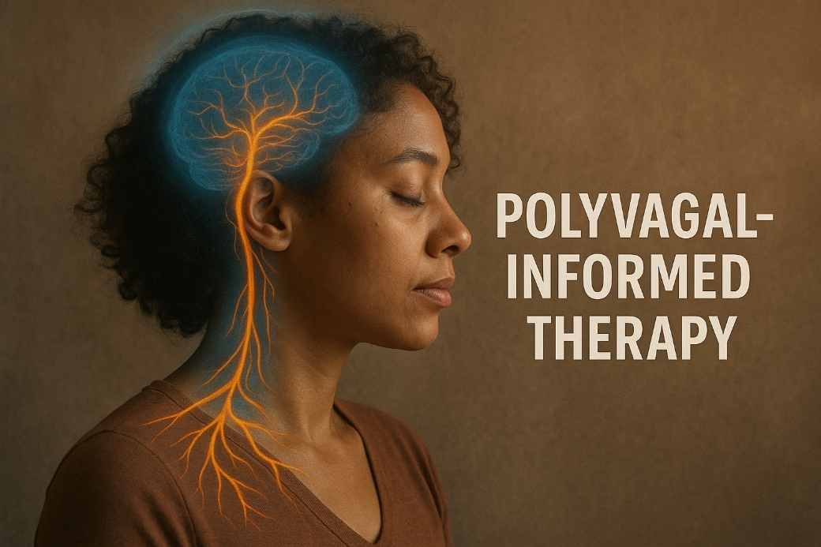
Matthew 11:28
“Come to me, all you who are weary and burdened, and I will give you rest.”

There are many faithful men and women who walk into the presence of God every week with sincere love in their hearts and bodies that are still living as though the danger has not passed. They sing the songs and confess the promises, they pray and serve and show up for life, and yet something inside remains braced. Their sleep is light, their breathing is shallow, their shoulders carry a vigilance they cannot fully explain. For years they have wondered why peace feels so distant, why rest feels unnatural, why trust feels like effort instead of home. Too often they have interpreted this as a spiritual problem, a failure to let go, a lack of faith, when in truth it is the story of a nervous system that learned — through real life adversity — how to survive.
Because trauma is not only what happened to you; trauma is what your body had to learn to deal with in order for you to live through what happened to you.
Long before you had language for your story, your nervous system was listening. It was reading faces, tracking the tone of voices, sensing unpredictability in others, learning whether connection was safe or could disappear without warning. Early attachment wounds, chronic stress, seasons of loss, environments where you had to carry more than you were designed to carry — all of these experiences became teachers. And in the face of those realities your body did something remarkable: it protected you.

The Nervous System Was Created for Protection, Not for Permanent Survival
When our bodily systems sense danger, they mobilize. The heart begins to race, breathing quickens, muscles prepare for action, and cortisol and adrenaline move through the bloodstream. What we often call anxiety is, in reality, the HPA axis, the hypothalamic-pituitary-adrenal axis, is a system in the body that helps regulate stress responses. It involves interactions between the hypothalamus, pituitary gland, and adrenal glands, which work together to release hormones like cortisol in response to stress. doing exactly what it was created by God to do — preparing you to fight or to flee so that you can live.
When the stress is overwhelming, when escape is not possible, when the child cannot leave and the adult cannot change the situation, the body shifts in the opposite direction. Energy drops. Numbness comes. Disconnection settles in. This is the dorsal vagal response — not laziness, not apathy, not spiritual failure, but the ancient endurance system that allows a human being to survive what cannot be escaped. The dorsal vagal response is a physiological reaction that occurs when the body perceives overwhelming stress or danger, leading to a state of shutdown or immobilization. This response is part of the autonomic nervous system and can manifest as feelings of numbness, low energy, or emotional detachment.
And many people have spent years moving between those two states — activation and collapse, anxiety and exhaustion, over-functioning and shutdown — not because they are broken, but because their bodies adapted with extraordinary intelligence.
When the danger passed. Too often the body never received the message.
So you can be living in a season that is objectively safer, and your nervous system is still scanning the present through the lens of the past. You want to connect, but something in you braces. You want to rest, but something in you remains alert. You want to experience the nearness of God, but your physiology does not yet know how to be still.
And into that reality Jesus speaks…not a command, but an invitation:
“Come to Me… and I will give you rest.”

Trauma Trains the Body to Live in Yesterday
This is the heartbreak of developmental trauma and repeated life adversity: the nervous system learns through experience, and what it learns early and often becomes its default setting.
Trauma is not stored as a thought.
It is stored in breath and posture, in muscle tone and heart rhythm, in the constant conversation between body and brain. The body continues to send signals of danger even when the environment has changed, and the brain believes the body.
This is why so much of anxiety, depression, addiction, and relational struggles are rooted in dysregulation. The system is still organized around protection.
Not sin.
Not weakness.
Protection.
And when that truth is understood, shame begins to give way to compassion.

Safety Is the Foundation for Love, Calling, and Spiritual Transformation
Abraham Maslow observed what the Scriptures have declared all along — that once the basic needs of the body are met, the next great human need to be addressed is safety. Without safety, love cannot be fully received. Without safety, belonging remains fragile. Without safety, a person cannot step into the fullness of who God created them to be.
This is why Jesus begins not with instruction, but with invitation.
“Come to Me… and I will give you rest.”
Because rest is not only a spiritual concept — it is the biological experience of safety.
And when the body begins, even in small ways, to experience that it is safe, everything else becomes accessible. The mind becomes more spacious. The heart becomes more open. The inner world becomes less hostile. Spiritual truth becomes nourishment instead of demand.
This is the ground in which transformation takes root.

Christ Meets Us in the Regulated Place of Connection
There is a state — that neuroscience calls ventral vagal regulation and the Scriptures name as peace — in which the human person becomes available for relationship again. The face softens, the voice becomes steady, the heart opens, and the body is no longer preparing for what is not happening.
It is in this place that the words of Jesus take on their full meaning:
“Peace I leave with you; My peace I give to you… Do not let your hearts be troubled, and do not be afraid” (John 14:27).
He is not offering a concept; He is offering a condition in which the troubled system can settle and rest.
This is why autonomic safety is the first pillar of the NeuroFaith® model. Because when the body begins to know that it is safe, the heart can open, the inner world can heal, and the story can be rewritten.
The same Christ who stood in the storm and spoke until the sea grew still speaks into the surges of sympathetic activation that have kept a life on edge for years. The same Christ who called Lazarus out of the tomb reaches into the places that learned to shut down in order to survive. The same Christ who breathed the Spirit into the disciples, is the Christ who restores the rhythm of breath and the steadiness of heart in you.
And when that begins to happen — often slowly, often gently — the promise of the Psalmist becomes lived experience:
“The Lord is my shepherd, I lack nothing.
He makes me lie down in green pastures,
He leads me beside still waters,
He restores my soul” (Psalm 23:1–3).
He does not drive us into rest.
He leads us into it.

Close — From Survival to Sacred Rest
If you have lived for a long time moving between urgency and exhaustion, between over-activation and collapse, between longing for God and not knowing how to rest in His presence, hear this with the tenderness of heaven:
Your body has been telling you the truth about what it has lived through.
Your adaptations were not your failure.
And your story is not over.
The Christ who calls you to Himself is not asking you to force yourself into peace; He is teaching your nervous system that it is finally safe.
And the promise that gathers all of this together is the one the apostle Paul speaks over the anxious and the weary:
“The peace of God, which surpasses all understanding, will guard your hearts and your minds in Christ Jesus” (Philippians 4:7).
Peace that guards the heart.
Peace that settles the mind.
Peace that holds the whole person.
This is the journey from survival into sacred rest.
And if that is the journey your heart has been longing for, then the invitation of Jesus is not far away.
It is as near as your next breath:
“Come to Me… and I will give you rest.”

