

Pages Found in my Special People in the Sandbox
Introduction to My Special People in the Sandbox 6
A Letter to My Schatz 9
Mother: The Beautiful Mountain Girl from Gunnison, Colorado 14
The Sacred Science of Sorrow: Remembering My Twin Brother, Gregg 24
The Space in My Heart Where My Identical Twin Once Lived 32
What’s It Like to Not be a Twin………………………………………………………………………………..……………...41
The Measure of a Man, My Son Gregg 50
Ashley: The Strength That Was always There 59
Does My Dad Have The “Tism” 66
More Than a Soldier: The Hero Who Walked with Me Through War and Life 71
Sanity, Hope, and Healing: A Morning Firestarter with Dr. Frank Nagy 77
Turning the Corner Home 80
Brotherhood Born in Ashes: DJ Joos 85
My Dog Henry and The Theology of the Potato Chip 89
The Quiet Strength of Uncle Ed and Aunt Marguerite 96
Grace in the Turn of US 102
Aunt Eileen: Everyone Needs a Hero 106
Touched by Two Angels in Sedona 111
Mother’s House: Built on Love 117
Rachel: A Faithful Life that Changes Mine 121
Hazel Grace and the Belly Rub 126
Under the Wire: The Escape and the Life of Dr. Frank Nagy 132
Father John: A Friend Who Knows the Cost 141
Driving South from Williamsport: Gratitude, Conviction, and the Courage to Speak 146
The Mystery of Faith and the Depth of Relationship 151
Love Does Not Surrender: Alan, Kitty, Deborah, and Sam 156
The Final Gift from Craig 163
The Debt We Carry and the Life We Avoid: A NeuroFaith® Reflection from the Road 167
The Strength of Ordered Men: My Brother Pat Akana 173
The Men Who Stay: Reflections on Tim Olson 180
The Man of Armor: Reflections on Rage XXX 185
Dr. Dr. Libby: The Ministry of Encouragement 191
Brothers in Purpose, Faith, & Grace: The Friendship of Dr. Andy Doan and Me 196
Pastor Gary: The Man Who Taught Me the Love of Jesus 201
An Old Psychologist Talks to a Machine and the Both Get Smarter 207
Throttle Therapy: The Healing Language of the Open Road 211
Mallory Mikel: Silent Waters Run Deep 217
Too Good to Be Ture: The Remarkable Life of Jered the Longshoreman 221
Every Neighborhood Needs a Leonard 227
The Mission That Never Ended: LTC Colonel Diane Williams and AJ 231
Konomi and Saya: New Beginnings, Second Chances, and Enduring Grace 240
Pastor Earl: Fingerprints on our Family’s Story 247
Salvatore Bitondo: The Boss Who Brought Out My Best 255
Karen Coppock: The Activist Who Surprised Me 261
The Final Gift: A life of Service, A Heart of Love, A Legacy That Lives On – Goodbye Craig 266
Tad and the Fiber Optic Cable to Jesus 270
Dr. Ayer: Brothers in the Valley………………………………………………………………………………………………276
Today My Gratitude Has Names: Ashley and Gregg……………………………………………………………....282
Karen: My Sister Who Shows Up……………………………………………………………………………………………286
The Space in My Heart Where My Identical Twin Once Lived…………………………………………………293
What’s it Like to Not Be a Twin?.................................................................................................302
The Legacy of my Big Brother, Ken…………………………………………………………………………………………310
Final Reflections in the Sandbox 317
About the Author 321

My Special People in the Sandbox
A Psychologist’s Tribute to Family, Friends, and the People Who Shaped The Journey
Jeffrey E. Hansen, Ph.D.

Author’s Note
This book is a collection of reflections on family members, friends, colleagues, mentors, former clients, and others whose lives have left lasting footprints on my heart.
A small number of the individuals featured in these pages are former clients whose lives touched me in meaningful ways. Each person included has given express permission for me to share my reflections and to use their name. I am deeply grateful for their trust, their friendship, and the privilege of having walked alongside them during important seasons of life.
This book was written to honor the people who helped shape my journey. While every story is unique, each reflects the profound impact that relationships can have on our lives.
Limited portions of this manuscript were developed with the assistance of ChatGPT, an artificial intelligence tool that helped refine wording, improve transitions, and assist with research. All reflections, opinions, interpretations, and final editorial decisions remain my own. Several images included in this book were also created with the assistance of AI technology.
Thank you for joining me in the Sandbox.

Copyright © 2026 Jeffrey E. Hansen, Ph.D.
All Rights Reserved
Published by NeuroFaith® LLC
Prescott Valley, Arizona
First Edition


This book marks the third volume in the A Psychologist in the Sandbox series.
The first book, A Psychologist in the Sandbox, was largely reflective. It explored suffering, healing, trauma, resilience, faith, meaning, and the strange beauty that can still emerge from broken places. It was, in many ways, the reflections of an older psychologist quietly sitting in the sandbox of life, trying to make sense of what matters most.
The second volume, Storms in the Sandbox, turned toward conflict and turbulence. It wrestled with grief, cultural fracture, politics, disappointment, loss, addiction, trauma, and the emotional storms that shape every human life. Some chapters were uncomfortable. Some were deeply personal. But storms have a way of revealing what is real, what endures, and who truly stands beside us when life becomes difficult.
But this third book may be my favorite of them all, because this book is about people. Not perfect people. Not idealized people. Simply real human beings who, in one way or another, entered the sandbox beside me and left footprints on my heart.
As I grow older, one reality becomes increasingly clear to me: life is very short, far shorter than we imagine when we are young. Too often, people pass through our lives, or pass from this life entirely, without fully knowing what they meant to us. We carry things quietly in our hearts: gratitude, admiration, love, respect, affection, appreciation, and sometimes even awe. Yet somehow those things remain unspoken. We assume there will be more time. Another conversation. Another lunch. Another phone call. Another Christmas. Another chance.
And then suddenly there isn’t.
The death of my twin brother Gregg profoundly deepened this awareness in me. His passing forced me to confront the painful reality that there are always things we wish we had said more clearly, more often, or perhaps one last time. Since losing him, I have felt an even deeper conviction that I do not want to leave this world with love left unexpressed.
Everybody who truly knows me knows I am big on the heart. Not sentimentality. Not performance. Not flattery. I mean the real stuff. The sacred things we feel about people who have shaped us, carried us, strengthened us, encouraged us, challenged us, forgiven us, laughed with us, cried with us, prayed for us, and reminded us who we are when we were in danger of forgetting.
This book is my attempt to speak those things aloud while I still can.
These chapters are about family members I deeply cherish, friends who stood beside me during difficult seasons, colleagues whose integrity and courage deeply moved me, and quiet souls whose kindness carried more weight than they may ever fully understand. They are about beautiful human beings who brought meaning, laughter, wisdom, faith, healing, loyalty, and life into my journey.
In many ways, this book is simply a collection of living thank-you letters. But if I am honest, there is another reason for writing them as well.
I believe love endures.
As a Christian, I certainly believe in eternity and in life beyond this one. But even beyond theology, I believe love itself leaves a permanent imprint. It moves through generations, through memory, through story, through influence, through sacrifice, and through the lives we touch and the people we shape. Love continues moving long after we ourselves are gone.
So why not express it? Why not let people know they mattered? Why not allow love to become something living and active instead of something merely felt in silence?
One of the greatest joys in my life is telling people that I love them, appreciate them, admire them, and value the difference they have made in my journey. There is something deeply healing, deeply human, and perhaps even deeply holy about honestly blessing the people who have blessed us.
That is what this book is: a celebration of people, a celebration of connection, a celebration of gratitude, and a celebration of the beautiful souls who entered the sandbox beside me for a little while and helped make life far richer, far warmer, and far more meaningful than it otherwise would have been.
And for every one of them, I remain profoundly grateful.

Dear Schatz,
When We First Met
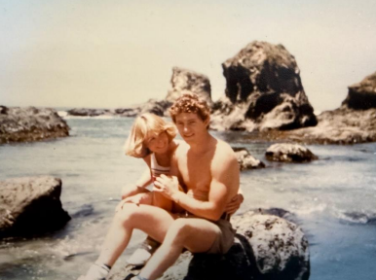
Meeting you was the best thing that ever happened to me. Our friend Rachel tried to play matchmaker, but it didn’t click the first time. I probably should have known then that winning your love would not be easy, it would be worth it, but not easy. I remember cooking for you one night with the guys, proudly serving up artichoke hearts, not realizing you hated them. But you stayed anyway, even though the food missed the mark. I was already taken with you. You were absolutely beautiful. Still are. A ten out of ten. And let’s just say, I knew I wasn’t.
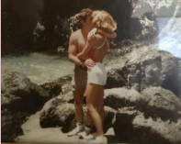
They say a man is lucky when he marries up. But sometimes I wonder if that makes you the one who had to marry down. And yet, you chose me, with all my edges and energy and chaos, you still chose me. You were not an easy pursuit. You held your cards close. You were not going to be won over by smooth talk or showmanship. And for a guy like me, that just raised the stakes. It made me want to rise. I remember that alumni gymnastics meet when all the old gladiators were sitting around getting back rubs in the bleachers. I tried to get one from you, and you turned me down flat. That moment got under my skin, but it also told me everything I needed to know. You were not going to baby me. You were not going to coddle me. And deep down, I knew that was exactly what I needed. You were the one.
Building a Life
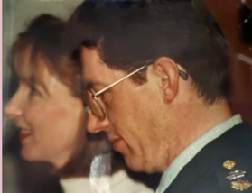
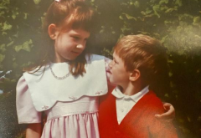
Not long after, you got baptized, and I fumbled my way through a proposal that same day. Somehow, you said yes. We honeymooned in Hawaii, remember that? What a beginning. Then came grad school, military life, and years of adventure and transition. Ten moves in ten years. Six of those years overseas in Europe. Through it all, you anchored our home in every place we landed. And along the way, you gave me two incredible kids, Ashley and Greggory, two of the greatest gifts I have ever received.
Of course, the story has not all been mountaintops. Life came hard for a season. My health took a hit. We crashed financially. I burned out from overwork, and I bottomed out. Trauma from long ago caught up with me. Add to that an injury from medication, and I was flat on my back. That was one of the lowest points of my life. I did not bounce back quickly. But you, you did not walk away. You stood firm. You held me up when I could not stand on my own. You saw through the pain and confusion to the man you married. You reminded me who I was. You told me to get back up. Any reasonable woman might have said, I did not sign up for this. But you stayed. You gave me love, support, grit, and when needed, some tough truth. You did not baby me, you helped save me.
Courage and Simplicity
When my lucrative private practice turned toxic, you encouraged me to walk away. You never once cared about the loss of status or income. You said, “Simplify.” And we tried. Sometimes we nailed it, sometimes not so much, but the heart was there.
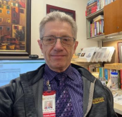
You encouraged me to take a government job with the Department of Defense, where I spent nearly ten years. You were never driven by material things. You cared about peace, health, and purpose. You reminded me again and again that our wealth was not in numbers or square footage. Our wealth was in what we had already built, each other, our family, our faith. You never worried about the bank account. You worried about our souls. And that is one of the reasons I love you most. Even now, as I step into my new roles at Holdfast and AnchorPoint, I carry with me the steadying love and wisdom you have always given me. I am grateful beyond words.
When Life Hit Us Again
Just when we thought we were stepping into calmer waters, life threw us another blow. We were out of the military system, transitioning toward a simpler, more grounded life, and then came the hardest loss I have ever known. Gregg. My twin. My brother. Losing him tore through me in a way I cannot even fully explain.
And while I was still reeling from that, allegations came at me from my former post at Madigan, false and driven by ideological bias, just because I held firm to my conservative values. It was vicious. I had to fight for almost a year to clear my name. The weight of it all could have crushed me. Honestly, some days I thought it might. But because of you, I did not fall apart. You were my shield, my voice of reason, and the one who reminded me who I was when everything else tried to redefine me. You helped me hold my ground with grace, courage, and integrity. I made it through because you were there.
The Wealth That Matters
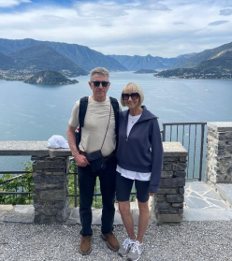
Schatz, you have been with me through it all, through seasons of joy and seasons that nearly broke us. You stayed. You fought for us. You challenged me, believed in me, loved me even when I had nothing left to offer. You kept our family strong. You never stopped seeing the best in me, even when I could not see it myself. Here we are now, easing into this next chapter of life. We have faced so many battles, but we have also known great love. What we have now is deeper, richer, more real. We are not rich in the way the world defines it, but we are rich in all the ways that count. And that is because of you. We have not just survived, we have grown. Through the fire, the loss, the laughter, and the grind, I have found what truly matters. Not accolades. Not titles. Not wealth. What matters is faith, love, grit, and the grace to keep showing up for each other. That is what we have done. We have kept showing up. Again and again. And that kind of love, the enduring, refining, fire-tested kind, is sacred.
Let us not become weary in doing good, for at the proper time we will reap a harvest if we do not give up. (Galatians 6:9, NIV)
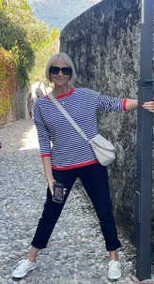
You are the harvest, Schatz. You are the beauty that has come from choosing love again and again. You are the reason I believe that God’s promises are real and that steadfast love truly never fails. Thank you for staying. For loving. For enduring. And thank you for still being the most beautiful woman I have ever known.
With all my love forever,
Jeff

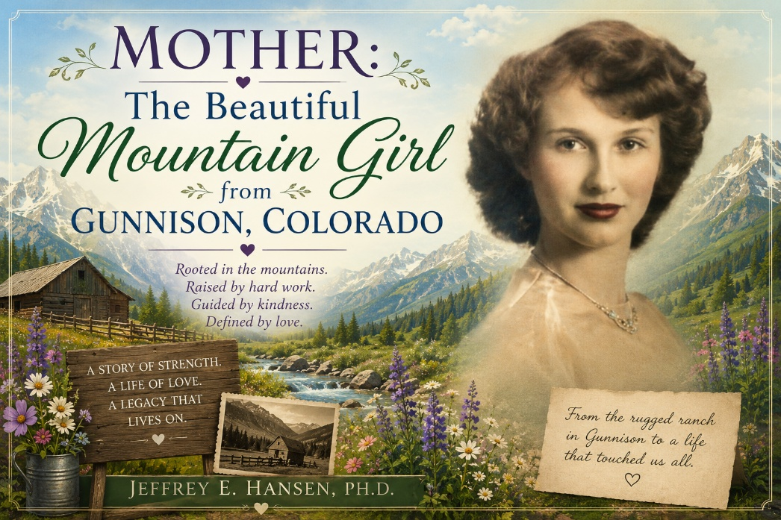
Beginnings in Gunnison
My Mother just turned ninety-three this November and I want to honor her story. She has lived a long and remarkable life, and she is still going strong. Still laughing. Still wise. Still moving through the world with that quiet strength she learned on a very rugged ranch in Gunnison Colorado.
Mother was born in 1932 in Gunnison Colorado and her parents were rugged immigrants from Switzerland. They came to America sometime before the First World War. Grandpa Vouga eventually went back to Switzerland when the war broke out because he was required to serve. Switzerland remained neutral so he did not fight in the trenches, but he still had to serve his country.
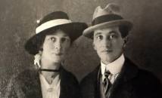
As best as I understand it, he returned to Colorado after the war ended and I do not think the entire family came to Gunnison until that post war period. When they settled in Colorado the conditions were unbelievably rough. The ranch house had dirt floors and a dirt roof and no plumbing. Winters could fall to fifty degrees below zero. Snow would bury the house, and wind would sweep across the high country with a force that chilled you to the bones. My Mother was the youngest of three children. Her sister Marguerite was more than a decade older, and her brother Ernie was somewhere around ten years older.
Growing up on the Ranch
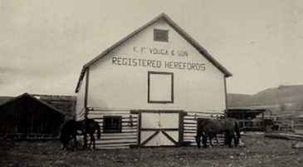
Being so much younger than her siblings, she did not have friends close by. While other children spent their afternoons riding bikes with neighborhood kids or gathering for games after school, her world was shaped by long stretches of solitude. Her closest companions were the animals on the ranch, and she formed bonds with them that were just as real and meaningful to her young heart as any childhood friendship could have been. She dressed up the chickens, and they followed her everywhere, an unexpected little parade that made sense only in the imagination of a child who longed for company. She dressed the dogs too, talked to them, confided in them, and treated them as if they understood every word. And in her mind, they did. They were her friends, the ones who listened without judgment and stayed close without ever leaving her side.
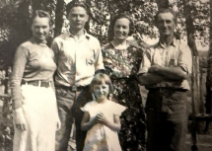
Most children grow up surrounded by peers, learning social rules through recess friendships and schoolyard conversations. Mother grew up instead surrounded by livestock and silence. The wide-open spaces became her playground, and the quiet sounds of ranch life became her constant background. In those years she learned to be content with her own company, to create her own world when the outside world felt far away.
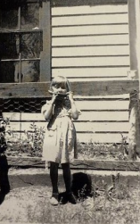
That early solitude shaped her spirit and her character. It taught her resilience, patience, and an inner gentleness that came from observing life rather than rushing through it. She learned to listen more than she spoke, to care deeply for creatures most people overlooked, and to find comfort in the simple presence of another living being.
That unique beginning did not make her withdrawn; it made her compassionate. It formed in her a tender strength that she carried throughout her life, one that allowed her to love people in a way that made them feel seen, valued, and safe.
College and Early Marriage
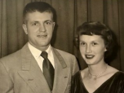
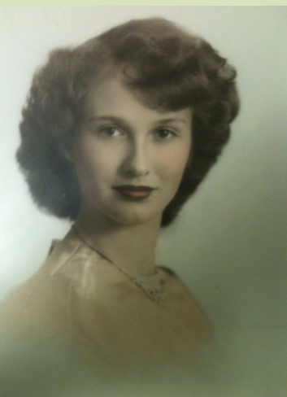
Eventually she went to Gunnison for school which was about an hour from the ranch. She played in the band and later went to Colorado State College where she met my dad. Soon they were married and in no time, they had children.
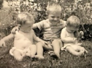
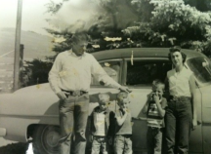
My older brother Ken arrived first and then the twins. In those early years she was raising three children in a Quonset hut which is basically a tin can cut in half. Storms in Fort Collins would blow the roof off that place. Life was hard but she made the best of it. When my twin brother Gregg and I were born the doctor confidently said she was not having twins. But Mother knew better. She had already bought two sets of clothes for the babies and she was right.

Veterinary Practice and Hard Work
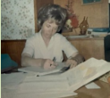
As life moved along and my dad graduated from veterinary school things changed again. He was very driven and graduated at the top of his veterinary class. While he pushed forward in his work Mother was completely committed to running the business side of his veterinary practice.
I remember her sitting at the dining table before computers were common with piles of receipts and billing statements in front of her. She managed everything by hand with diligence and remarkable attention to detail. She worked late into the evenings making sure the practice stayed healthy and organized. My dad was fortunate to have such a gifted partner.
Athletic Spirit and Independence
Mother was also never afraid to work outside the home. She worked in a ski shop for a time and took on other jobs whenever needed. She was an avid skier for many years and in her prime she became a skilled tennis player. She played tennis for a long stretch of her adult life. Always active. Always moving. Always athletic. That was simply part of her nature.
My Parents Go Their Separate Ways
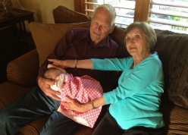
After almost twenty years of marriage my parents eventually went their separate ways. It was a long marriage with a difficult ending. Sometime later Mother met Stu, and they gradually became close. Stu was quiet and stoic, but he had the biggest Texas sized heart imaginable. At first, I did not know what to make of him but over time I grew incredibly fond of him.
Mother chose wisely because he was so good to her. They were married for more than four decades and had a beautiful life together until his passing about six or seven years ago. Losing him was a hard blow but she carried that loss with the same quiet courage she learned early in life.
Lunch stops and covert laundry
During our high school years, the home of Mother and Stu became the regular pit stop before gymnastics. Gregg and I would swing by for one of Mother’s famously delicious lunches and then race up to practice. By the time we were at UC Berkeley and coming home on breaks nothing had changed. We still found our way to that kitchen, and we still found a way to slip our laundry into the wash without Stu noticing. I am not sure he ever approved of two college boys sneaking in dirty socks like a covert special ops mission, but we did it anyway.
Mother also managed to get us hopelessly addicted to her soap operas. We started arranging our college classes to make sure we could land at her table in time to eat lunch and watch the daily drama unfold. I still laugh thinking about how two reasonably intelligent college students planned their academic schedules around soap operas laundry drop offs and Mother’s sandwiches. That little routine has become one of my fondest memories of those years.
Loved by Friends and Family

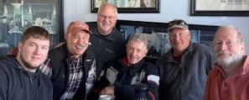
There were some who especially experienced her as a second mother during those early years in California. We always had children in and out of the house, and Mother instinctively gathered them under her wing. Over time, that circle grew into an extended family of sons she never set out to adopt but somehow did by the sheer force of her love. Across the decades, the list of those she embraced includes Chris Wright, Ross Tessein, Jon Patterson, Mark Greene, Nicholas Vargas, and others whose names would lengthen this list further.

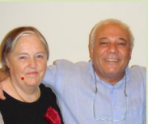

Many of them practically lived with us in those years, and Mother treated them as her own, without ever needing to say it out loud. When we later moved to Switzerland in the late 1960s and early 1970s, Mother’s heart simply widened again. She welcomed new students, expatriates, and lonely souls into our home just as easily as she had welcomed children in the Lovelace house. Among them was Mohamed, who fled the Middle East in 1969 and found himself painfully alone. Mother welcomed him to our table and into our lives. To this day, Mohamed remains my closest friend overseas, my longest-standing friend, and truly my brother.

And back at home, through all the decades, Chris Wright has remained the brother to my own soul on this side of the Atlantic. What began as childhood friendship became a lifelong bond, just as it did with Mohamed abroad. In many ways, those two men embody the deepest fruit of Mother’s love across continents, cultures, and generations.
To name them is already to leave many out, because Mother’s heart never had borders. It simply kept widening through each season of life, welcoming new souls and forming bonds that have endured for decades. Each name represents another life touched, another story of belonging, another chapter in the legacy of love she offered so freely.

Gregg’s Gift
After Stu passed away, she moved into a condo where she could care for herself more easily. It felt like a necessary transition at the time, something that would allow her to maintain her independence while still being surrounded by comfort and familiarity. Yet it also marked a new chapter of life, and everyone wanted that chapter to feel peaceful and secure for her. My twin brother
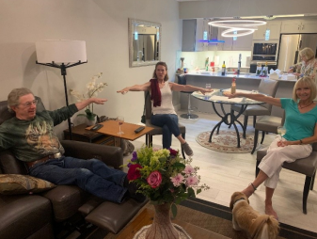
Gregg immediately stepped in with that deep sense of loyalty and protectiveness that was so much a part of him. He wanted her home to be more than comfortable; he wanted it to be beautiful. Using his extraordinary skill as a contractor, he remodeled the entire condo from top to bottom. He selected colors, textures, finishes, and architectural details with a level of intentionality that reflected his heart for her. He poured himself into that project, and in a very real way, he poured his love into every inch of that space. She ended up living in a stunning home with pendant lighting and cabinetry from Italy, and every time she pointed to something special in the house, it always came back to Gregg.
It was his way of honoring her, blessing her, and making sure she felt treasured in this season of life. She often told people that living there felt like being surrounded by a personal gift he crafted just for her. Gregg had his little touches too, those small and thoughtful gestures that were so uniquely him. He kept the pendant lights on at night so that if she happened to get up in the middle of the darkness, she would see their gentle glow and think of him. After Gregg passed away, she continued that ritual. She would keep the pendant lights on just to remind her of him, and in a quiet way it made her feel closer to him, as if the light he left behind still lingered in her home and in her heart.
All those little touches were signatures of who Gregg was, his devotion, his care, his tenderness, and his desire to protect the people he loved. When Gregg passed away two years ago, those lights became something more than décor. They became a reminder of his presence, his workmanship, and his heart. And the memory of that gift, given at such a meaningful time in her life, remains forever etched in her heart.
A New Chapter in Nevada

As Mother now prepares to move away from the state, she has called home for more than half a century, my brother Ken and my stepsister Karen, who I consider fully and completely my sister, have lovingly stepped up to help her transition. Ken has shepherded her with exceptional care and attention, taking on responsibilities quietly and faithfully, and never once making it about himself. He has overseen her new home in Nevada, a place that is not only comfortable but absolutely spectacular, and it is clear that every detail was chosen with her well-being in mind. His devotion in this season has been a profound gift to her and to all of us.
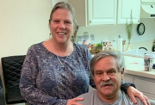
Karen and Chris have likewise been unfailingly supportive, watching over her with such tenderness and care. And even after Chris’ passing Karen helped Mother navigate decisions and manage daily life, not out of obligation but out of a genuine, heartfelt love. She has been a devoted and loving daughter figure to her, one who has stepped into that role with grace and humility. I am deeply grateful for the ways she cares for Mother and for the steady presence she provides.
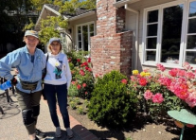
Their compassion has given me comfort as well, knowing she is surrounded by people who adore her. I would also be remiss not to mention my cousin Izer, who lives near Mother in Walnut Creek. The connection they have formed over these past years has been something truly beautiful to watch. They get together, garden side by side, go places, and genuinely enjoy one another in a way that feels nourishing to both of them. Iser has always been so special to me personally, and it brings me great joy to see the friendship and tenderness she and Mother share. In her own way, Izer has been a quiet guardian and a companion for her.
The Heart of it All
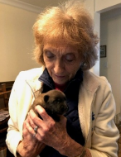
Mother is, in every way, a living picture of strength and kindness woven together. Her life has not been without hardship, yet she has carried each season with a quiet courage that often went unnoticed because she never drew attention to herself. She has met life with a mixture of gentleness and grit, a rare combination that allowed her to endure difficulty without ever becoming hardened by it. She has lived generously and loved deeply. Her heart has always been open, both to her family and to all those who found themselves drawn to her home, her warmth, and her spirit. She has given more than she ever asked in return, and she has done so with a grace that has touched countless lives.
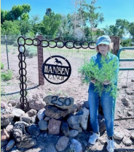
When people speak of kindness, when they speak of steadfastness, when they speak of love that does not falter, they are in many ways describing her. If anyone ever wonders what a life of love truly looks like, they need only look at Mother. Quiet, steady, strong, and always faithful, she has been a gentle force of goodness to everyone who has known her.
Thank you, Mother, for the life you have lived and the grace you have shown. Thank you for the generosity that has marked every season of your life, for putting others before yourself, and for opening your heart so freely to family, friends, and strangers alike. You never sought recognition. You simply loved people because that is who you are.
My life has been forever enriched by your presence. I am deeply grateful, and in many ways, forever indebted to you. The heart that guides my life is, in large measure, a reflection of the heart I first encountered in you. Long before I became a psychologist or developed NeuroFaith®, I was learning the lessons that would shape both my character and my calling by watching you.
You taught them not through words, but through the way you lived. Through the way you welcomed people into your home, noticed the lonely, carried burdens quietly, and offered love without keeping score.
People often ask me why my work focuses so much on the heart, on connection, compassion, presence, and healing. The answer is simple. I learned about the power of the heart from you.
Your heart helped shape my character, my profession, and the way I see every person who walks through my door. If there is any goodness in the work I do, any ability to sit with people in their pain and help them find hope, a meaningful part of that story begins with you.
Thank you, Mother, for ninety-three remarkable years of strength, resilience, kindness, and love. Your greatest legacy is not what you accomplished, but the lives you touched and the hearts you helped form.
Mine most of all.
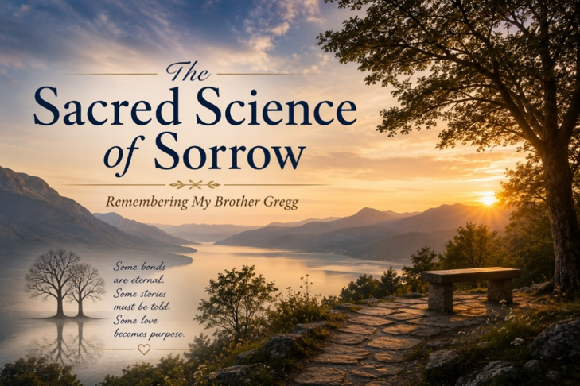
A twin bond forged through adversity
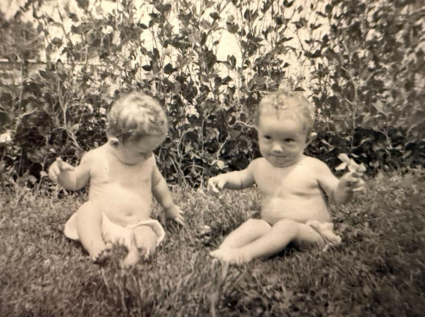
Gregg and I arrived in this world together. We were identical twins, each other’s playmate, confidant and mirror. Our early years unfolded against the backdrop of inter-generational trauma. My father was a fundamentally good man, but he carried the scars of the savage beatings he had received as a child. He worked tirelessly to provide for our family and broke many of the abusive patterns he inherited, yet the pain of his upbringing sometimes spilled over into his own parenting. Gregg and I responded to this adversity by overachieving; we collected trophies, maintained near perfect grades and treated accomplishment as armor. He always seemed to have an extra gear. He was recruited by the U.S. Air Force Academy for his brilliance in gymnastics as an all-around gymnast, pivoted to engineering and secured a patent with Ford Aerospace, then reinvented himself as a high-end builder and later as an accountant. I took another route. Realizing I could not match his pace, I leaned into people and connection. Becoming a psychologist taught me that our relationships, not our résumés, heal trauma.
Our divergent strategies defined our adult lives. Gregg continued to chase milestones, believing that the next achievement would finally make him feel “enough.” I chose to cultivate deep relationships, to lean into faith and community. Ironically, my choice saved me when my life unraveled around age fifty. My wife battled melanoma, my daughter was hospitalized for a suspected lymphoma, and the economy collapsed. Overwork and over acquisition landed me in an emotional breakdown. Therapy, spiritual practice and the love of others pulled me through. Gregg’s story would unfold differently. He cycled through episodes of depression, often comparing himself negatively against the impossible standard he had set. In his sixties he withdrew further, eventually moving to Florida and severing contact. On 11 October he died. Time has not healed the hole he left. Even now, reaching for the phone to call him triggers a wave of grief and a physical ache in my chest.
A promise to finish his story
When I sensed I would lose Gregg, I told my wife Leah two things. First, that I could feel his life slipping away a twin’s intuition reinforced by years of working with trauma. Second, that I would not let his death destroy me. I knew the pain would be profound and enduring, but I decided to lean into the love of family and friends, to ground myself in prayer, and to transform our shared suffering into purpose. When Gregg died, I whispered to him that I would finish the life he could not. I vowed to take the truth of his beautiful, complicated journey, his victories and struggles and use it to help others. This blog and my NeuroFaith® model are part of that promise.
The grieving body: how loss affects the heart
Mary Frances O’Connor’s book The Grieving Brain (which Leah gave me knowing my love of neuroscience) emphasizes that grief is not merely emotional; it is embodied. Research shows that the death of a loved one dramatically increases cardiovascular risk. In a 2012 case crossover study, individuals were more than twenty-one times more likely to suffer an acute myocardial infarction in the first day after learning of a significant person’s death, and the risk remained elevated roughly eightfold across the first week. A separate Harvard Health review noted that the risk begins to decline after the first week but remains above baseline for at least a month. These findings provide a biological basis for the phrase “broken heart.” Intense emotional stress triggers surges of catecholamines (stress hormones) that elevate blood pressure, accelerate the heart and increase clotting tendency. In some cases the stress “stuns” the left ventricle, causing a temporary condition called takotsubo cardiomyopathy or broken heart syndrome the heart balloons and mimics a heart attack.
The heart itself is a marvel. It beats about 100 000 times per day and sends blood through a circulatory system long enough to wrap around the Earth. Its rhythm is partly governed by the vagus nerve Latin for “wanderer.” This cranial nerve originates in the medulla and travels down through the neck and chest, innervating the larynx, lungs, heart, stomach, liver, pancreas and intestines. Parasympathetic fibers of the vagus slow the heartbeat and regulate its rhythm. A healthy heart exhibits heart rate variability (HRV): heart rate rises during inhalation and falls on exhalation, creating a gentle sine wave. High HRV reflects flexible vagal control and is associated with resilience and better cardiovascular health, whereas low HRV signals distress and predicts higher risk of disease. In grief, HRV often becomes jagged and dysregulated, mirroring our emotional turmoil. The heart can thus be thought of as an acoumeter for our thoughts, feelings and motivations.
Attachment and the brain’s protest
Attachment theory further illuminates why losing Gregg felt like losing a part of myself. When we form deep bonds, our nervous systems synchronize; the me and you become “us.” This neural attunement becomes the baseline from which we explore the world. The sudden absence of a central attachment figure triggers a protest response: heart rate and sympathetic arousal rise to fuel the search for the missing person. This response is adaptive in temporary separations, such as a child searching for a caregiver. In bereavement, however, the loss is permanent. Over time our brains slowly learn this new reality; the protest gives way to despair and eventually to adaptation. In the process we must reattach to others and to God and find new ways to regulate our nervous systems. For me, Gregg had always been a source of co-regulation, someone who could calm my nervous system with a look or a joke. Losing him dysregulated me; I felt like half of “us.” Understanding that this reaction arises from well-studied attachment circuitry helped me normalize my grief. Dan Siegel’s interpersonal neurobiology teaches that our brains and bodies are shaped by relationships, and Mary Frances O’Connor emphasizes that grief is the cost of attachment. Without connection, we cannot heal.
Co-regulation, external pacemakers and broken hearts
Interpersonal neurobiology and attachment theory suggest that when we give our heart away when we fall in love or form a secure bond, we become external pacemakers for each other’s cardiovascular systems. Our heart rhythms synchronize, our breathing aligns and our vagal tone responds to the presence of the beloved. Gregg’s heart helped regulate mine, and mine his; together we formed an “us” at both the emotional and physiological levels. The benefits of this co-regulation are profound. Polyvagal theory teaches that co-regulation through social connection dampens sympathetic arousal and enhances parasympathetic safety. Heart math research shows that shared positive emotion can entrain heart rate variability into coherent, sine wave patterns. Bowlby’s attachment theory frames these physiological patterns in terms of security: we feel safe enough to explore the world because another heart beats alongside ours.
Mary Frances O’Connor notes that upon the death of a partner, the surviving person must learn to regulate the cardiovascular system without this external pacemaker. Tragically, some hearts cannot adapt. The loss of co-regulation may lead to rapid heart rate, arrhythmia or stress induced cardiomyopathy (takotsubo), and in some cases people literally die of a broken heart. Longer term bereavement also taxes the immune system by keeping the body in a prolonged state of stress. I experienced the frantic search for Gregg’s regulating presence in my own chest, a racing heart, a sense of being physically unmoored. Recognizing that this reaction is a natural consequence of losing an external pacemaker helped me extend compassion to myself and underscored the importance of cultivating new sources of co-regulation. In the next section I will explore how grief affects immunity and what science suggests we can do to heal.
Facing the truth: the medical examination
As someone who strives to live in the light of truth, I knew I could not hide from the reality of Gregg’s death. My work as a therapist has taught me that healing requires confronting the facts, however painful they may be. Shortly after his passing I arranged to meet with Marty, the medical examiner who evaluated Gregg. She had authored the official report, and she kindly offered to walk me through it. Marty’s empathy and candor were a gift; she understood that I needed to know what had happened and that I could handle the truth. Reading the report was devastating, but I was grateful for her presence.
The report confirmed what I already sensed: Gregg had wasted away in his despair. I will not share the exact figure, but his weight loss was severe. It spoke volumes about how deeply he had given up on living. Marty looked me in the eye and asked if I really wanted to know all the details. I nodded. In those pages I saw a man who had once been vibrant and strong now reduced by depression and isolation. Yet the report also revealed that, alongside the weight loss, his heart showed signs of chronic disease. Among his organs, the heart bore the brunt of the damage.
This finding resonated with everything I had learned about neurocardiology. The heart is more than a pump; it is exquisitely sensitive to emotional states. As discussed earlier, bereavement can precipitate acute heart attacks and stress induced cardiomyopathy. The official report made clear that Gregg’s despair had weakened his heart long before it stopped beating. In a very real sense he died of a broken heart. Knowing this did not lessen my pain, but it did deepen my understanding. It underscored that his death was not simply an act of will; it was the culmination of physiological and psychological stress. Facing this truth allowed me to honor him more fully and to champion the scientific truths that support our stories of loss.
Grief and the immune system
Loss affects not only the heart and nervous system but also the immune system. The emerging field of psychoneuroimmunology explores how our thoughts and emotions influence immune function. From an attachment perspective, the brain encodes a map of the world that includes our loved ones. When a loved one dies, that map must be updated. In grief we are torn between two streams of information: the memory of the death and the attachment belief that our loved one will always be there. This conflict O’Connor calls it the “gone but everlasting” paradox can keep our physiology in a state of high alert. We used to think the brain was immune, privileged, shielded from inflammation in the body. In fact, the central nervous system has its own immune cells. Microglia, the resident macrophages of the brain, represent roughly 5 10 % of all central nervous system cells. These “resident gardeners” prune synapses, remove dead cells and help refine neural circuits during development. Under stress, however, they can produce inflammatory molecules that alter neurotransmission and synaptic pruning.
Inflammatory proteins produced elsewhere in the body also influence the brain. Cytokines, such as interleukin 6 (IL 6), can cross the blood brain barrier in certain regions and can bind to receptors on the vagus nerve. The vagus then transmits electrical signals to the brain, relaying information about peripheral inflammation. In bereaved people, this neuroinflammation can disrupt the production of serotonin and other neuromodulators. Microglia may become overactive, leading to dysregulated pruning over pruning of synapses that weakens neural networks and impairs social cognition. Because microglia comprise a tenth of the cells in our brain, their dysregulation can have far reaching consequences.
Grief and stress also reshape the microbiome. Chronic stress can disrupt the gut flora, increasing intestinal permeability (“leaky gut”). Bacteria and their byproducts may then enter the bloodstream and activate the immune system, fueling systemic and neuroinflammation. The vagus nerve communicates these inflammatory states to the brain, further heightening arousal. The result is a feedback loop: loss triggers stress, stress alters the gut and immune function, and immune activation feeds back into the nervous system.
O’Connor argues that there is no quick pharmacological fix for this cascade. The best medicine is human connection. Four elements, she writes, are essential to healing after loss: people, community, belonging and mattering. Medication may blunt symptoms, but it cannot replace the co-regulation, meaning and security that come from being seen and held by others. In the weeks and months after Gregg’s death, I felt the urge to withdraw. Gregg had lost his sense of belonging and mattering as he isolated, and his heart could not recover. I chose differently. I leaned into my faith, into my family and friends, and into my calling to help others heal. I discovered that the most helpful comforters were often those who simply sat with me in silence, whose calm breathing and coherent heart rhythms reflected in their own heart rate variability helped stabilize mine. God reached me directly through prayer and through the presence of others. As I learned to regulate without Gregg’s external pacemaker, I found that new attachments and a sense of purpose tempered the neuroinflammatory storm.
Meaning making and resilience
In the months after Gregg’s death I read O’Connor’s book slowly, letting her insights settle from my head into my heart. I discovered that integrating neuroscience with faith deepened my resilience. Knowing that grief can disrupt vagal tone and heart rhythms compelled me to practice breathwork and prayer. Recognizing the protest response in my racing heart allowed me to gently tell myself that Gregg was gone and that searching would not bring him back. My wife Leah, my family and my community became new sources of coregulation. I also channeled my energy into this narrative: honoring Gregg by sharing his story and by weaving it into the science of grief. The integration of research and personal narrative is itself healing it transforms pain into purpose.
Conclusion: honoring Gregg through science and story
Gregg’s life was a tapestry of brilliance and struggle. He was a gifted gymnast, engineer and builder; he carried the weight of inter generational trauma and the burden of feeling never good enough. Our twin bond was soul deep, and his absence is a wound that still throbs. Yet grief has also revealed the profound wisdom of our bodies and brains. It has taught me that the heart registers loss in its very beat, that the vagus nerve carries our emotions throughout the body, and that attachment leaves neural imprints that protest when bonds are severed. It has shown me that faith, breath and community can restore coherence to a dysregulated heart. Most of all, it has reaffirmed my vow: to finish the life Gregg could not, to carry his story forward, and to use the neuroscience of grief to help others find meaning in their pain.
A letter to Gregg

Gregg, you gave me so much of yourself. You were there for me through my lowest valleys and you rejoiced with me on the mountaintops. You blessed my life in ways that words fail to capture. I have chosen not to dwell in the negative space of your absence but to celebrate the value you were and still are to me. I will live on the legacy of “us.” I will honor the beauty of our bond and reflect it in all my relationships. I will seek out others who can offer me what you offered, and I will strive to be the blessing to them that you were to me.
I will always love you, Gregg. I will always miss you. I will always ache for you. Yet I will carry your light forward. Your life and our love will inform the way I love others and the way I help those in pain. In celebrating you, I am celebrating the best parts of myself.
And why the red background you might wonder – it was Gregg’s favorite color – every motorcycle he owned was indeed red.


The Wounds We Shared
Gregg and I both suffered from toxic shame as a result of our father's emotional and physical mistreatment. We learned the same core wounds: We were not safe. We were not good enough.
And so we adapted.
Our manager systems went into hyperdrive. We developed rigid, fixed, and unrelenting routines built around performance and achievement. We became overachievers, not simply because we were bright or ambitious, but because achievement became a way to feel safe. It became a way to be seen, a way to earn approval, perhaps even a way to convince ourselves, for a little while, that we were good enough after all.
For both of us, this really took hold in the fourth grade, when our family moved from the small coastal town of Point Reyes, California, back to Fort Collins, Colorado, where our father was pursuing a second doctorate, this time in pathology. The schools in Colorado were far more academically advanced than what we had experienced before, and suddenly our insecurities were exposed. We responded the way we had learned to respond: We worked harder. We achieved more. We demanded more of ourselves.
But the achievement came with tremendous emotional turmoil.
When Achievement Became Survival
By junior high, the compulsivity had intensified. We had to get straight A's. And we did. Nothing but straight A's. Not one B on a report card.
But perfection is a cruel master.
Even when the report card showed all A's, a single assignment that fell short of perfection could set us off into a state of intense anxiety. Our worth had become tied to achievement because achievement was how we were recognized by our father and by others. We had learned, deeply and dangerously, that what we accomplished determined whether we were worthy of being seen.
This continued into high school, where both of us achieved at very high levels. But somewhere along the way, a slight divergence began.
Where Our Paths Began to Diverge
Gregg was always the more naturally gifted of the two of us academically. He received the highest scholastic awards, particularly in mathematics, and he was an exceptional gymnast. He was named Athlete of the Year for our entire district, an extraordinary honor recognizing him not merely among gymnasts but among athletes across all sports.
I was, perhaps, second fiddle to Gregg in some of those areas, though I achieved considerably in my own right. But somewhere along the way, I began choosing relationship a little more often than achievement.
And I now believe that decision was the beginning of what saved me.
Gregg continued to soar. The United States Air Force Academy wanted him so badly that they flew him out for recruitment even without a congressional nomination, drawn not only by his extraordinary academic prowess but also by his excellence in gymnastics. He was exceptional in both worlds: a gifted scholar and a gifted athlete.
Later, he entered medical school. But by then, depression had begun nipping at his heels, and eventually he withdrew.
Still, he kept going. He trained as a mechanical engineer and later became a highly successful high-end builder in California. When the financial crisis struck, he closed that business and reinvented himself yet again, creating a successful career in forensic accounting.
He kept achieving. He kept performing. He kept moving.
But the wounds underneath had never healed.
The Wounds Beneath the Achievement
As Gregg entered midlife and then his later years, depression came and went, even as he continued to achieve. But the toxic shame remained. And by his mid-to-late sixties, those old wounds had grown louder and more merciless.
Erik Erikson described this stage of life as a confrontation between generativity and stagnation, a time when we begin to look back upon what we have done with the life we were given. But when Gregg looked back, his inner critic allowed him to see almost nothing good.
Despite all he had accomplished, it was never enough. Despite his brilliance, it was never enough. Despite the lives he had touched, the businesses he had built, and the obstacles he had overcome, it was never enough.
Because shame does not grade on accomplishment.
The inner critic that had driven him for so many years eventually turned mercilessly against him. Gregg fell into a deep well of despair and lost his will to endure. Later, he stopped eating. He became profoundly anhedonic, losing interest in nearly everything that had once given life meaning or pleasure. He became anorexic. And eventually, my identical twin brother died alone on the other side of the country.
I have had to live with that.
And I always will.
The Space in My Heart Where Gregg Once Lived
But those words hardly begin to capture the agony of what it means to live without Gregg.
He was not simply my brother. He was my identical twin, my best friend, my closest confidant, and my forever encourager. For 68 years, there was a person on this earth who had been there from the very beginning. Before either of us could speak, before memory itself, there was Gregg and there was me. We began this life together.
And then, suddenly, there was only me.
I miss the conversations that never really ended. Gregg and I could begin talking one day, leave a thought unfinished, and pick it up the next as if no time had passed. There were stories that needed no explanation, memories that belonged only to us, jokes that no one else could fully understand and that somehow became funnier simply because the other one was laughing.
Now those conversations remain unfinished.
The jokes we shared are still inside me, but there is no Gregg on the other end to laugh with me. There are memories I still carry, but the only other person who stood inside those memories with me is gone.
And that is one of the loneliest parts of grief that I know.
So much of my life that only Gregg had access to is now mine alone to hold. There were parts of me he knew simply because he had been there. I did not have to explain the childhood. I did not have to explain our father. I did not have to explain Point Reyes or Fort Collins, the straight A's, the fear of not being good enough, the striving, the laughter, the dreams, or all the countless ordinary moments that somehow become sacred only after the person who shared them with you is gone.
He knew.
And now I am the only one left to remember so much of it.
There are still times when something happens and my first instinct is to tell Gregg. A thought crosses my mind, something makes me laugh, something hurts, something wonderful happens, and somewhere inside me there remains that almost automatic movement toward my brother.
And then I remember. He is not there. There is now an empty space in my heart where Gregg once lived, a space no one else can ever occupy.
There is an agony in that which I do not know how to fully put into words. I am a psychologist. I have spent a lifetime studying human suffering, grief, trauma, resilience, and the mysterious ways in which we heal. But there are some losses that cannot be reduced to clinical language. There are some absences that cannot be resolved, only carried.
I carry Gregg. I carry his voice. His laughter. His encouragement. His brilliance. His wounds. His unfinished conversations. I carry the jokes that now have only one person left to remember why they were so funny.
And perhaps most painfully, I carry the part of myself that existed only when I was with him. I will forever mourn my brother. I will forever hear him in my heart. And my heart will always cry for him. But I would rather carry the pain of having loved Gregg than live a life in which I had never known what it was to have him as my brother, my identical twin, my best friend, my closest confidant, and my forever encourager.
He was here.
He mattered.
He was loved.
And he is missed beyond anything these words can ever fully say.
And Then There Was Me
But if I am going to tell you the truth about Gregg, I must also tell you more of the truth about me. My own journey was not simply a story of resilience or an easy turn toward faith. I, too, experienced my own tragedy. Mine came earlier, triggered by so many internal and external events that the resilience I had relied upon for so long was no longer strong enough to carry me. The ways I had learned to survive were failing. My nervous system was overwhelmed.
My values had to be reconsidered because I began to understand that our negative core beliefs are often tightly intertwined with our deepest values, with what we believe gives us worth, identity, and significance.
And I had valued performance. I had valued achievement, external accolades, big houses, beautiful properties, professional recognition, and all the other things I genuinely enjoyed and had worked hard to attain. There was nothing inherently wrong with those things. But somewhere along the way, I had allowed too much of my identity to become attached to them.
Beneath the accomplishments still lived the old core wound:
You are not good enough.
And so, I had to begin again.
Learning to Settle
My first step was not theological or intellectual. It was physiological.
I had to learn how to settle my autonomic nervous system, which had carried so much for so long. For years, I had lived largely in chronic sympathetic and HPA-axis activation, punctuated by occasional periods of dorsal vagal shutdown. I knew surprisingly little, experientially, about what it meant to live from a ventral vagal state of safety, connection, openness, and peace.
I had to learn to settle. I had to learn to listen to my body rather than constantly drive it. I had to understand that the nervous system I had once relied upon to push me toward achievement was also exhausted from years of trying to protect me.
My work with neurobiology helped me understand what was happening inside me, and slowly I began to discover that living was not the same thing as performing.
Life was not meant to be lived from a performative mindset, forever trying to silence a negative core belief by achieving enough to finally become worthy.
Because no achievement can heal the wound that says, I am not enough.
When Neuroscience Met Faith
For me, the deepest healing came when neuroscience and faith began to converge. I came to understand, not merely intellectually but in my heart, that my worth did not come from what I had achieved, what I owned, what degrees followed my name, or how others regarded me.
It came down to something that may sound almost too simple. Jesus loves me. Not because I performed well. Not because I earned it. Not because I achieved enough. Simply because I am His.
I came to understand that I was made for relationship with Jesus. I was made to define myself not by the relentless verdict of my inner critic, but by His love for me. I was adopted into His family. I was loved and valued so profoundly that God sent His Son to die for me.
These were truths I had known intellectually for years. But knowing something in your head is not the same as experiencing it in your heart, your body, and your nervous system.
And slowly, I began to find the peace Scripture had promised: “And the peace of God, which surpasses all understanding, will guard your hearts and your minds in Christ Jesus.” I found that peace. Not perfectly. Not without struggle. Not as a permanent state in which I never again feel anxiety, grief, or pain. But I found it deeply enough to know that it is real.
And why would I not want to share that with others? Why would I not want to share it with you, dear reader?
Because your life can go either way. I do not necessarily mean that you will lose your physical life as my brother did. But shame can steal something else from you. It can steal your joy. It can steal your peace. It can convince you to spend a lifetime performing for a worth that was never meant to be earned in the first place.
It can leave you living a life of defeat, which is precisely where the enemy wants you.
But that is not what God wants for you.
It Is Never Too Late
I know that somewhere along the way, Gregg made a decision to receive Jesus. And I can only trust and pray that this decision mattered eternally. Although he did not find the peace in this life that I so desperately wish he had known, I hold on to the hope that he has found that peace now.
And I look forward to seeing him again.
But there is another part of this story that matters deeply to me. My father, the same father whose own wounds led him to emotionally and physically mistreat his sons, found Christ in the last lap of his life.
And so did my grandfather.
These were two men who had carried wounds of their own and who, for much of their lives, had lived with deep differences between them. But in those final chapters, something beautiful happened. They found Christ, and they beautifully reconciled their differences.
That does not erase what happened. It does not undo the wounds or change the past. Grace does not require us to pretend that harm never occurred. But it reminds me of something I believe with all my heart:
It is never too late.
It is never too late for grace. Never too late for reconciliation. Never too late for a wounded heart to turn toward Christ. God works in His own time, and if we remain open to Him, no life is beyond redemption. No story has to end where it began.
My father and grandfather taught me that.
The father who once caused such pain was himself a wounded man. And his story, too, was still being written. So was my grandfather's. And in the last lap of their lives, grace entered the story in a way that allowed two wounded men to find Christ and find their way back to one another.
What a Reunion That Will Be
And so, yes, I hold on to the hope that one day, in God's time, I will see Gregg again. And I hope Dad and Grandpa will be there too, waiting at the gates of heaven. What a reunion that will be. No more shame. No more fear. No more wounds passed from one generation to the next. No more inner critics whispering that we were never good enough.
Only grace. Only forgiveness. Only love.
And I do not believe that God caused these tragedies. I do not believe that.
I believe God allows tragedy to occur and natural consequences to unfold. But I also believe that God lets no pain go unused, if we allow Him to redeem it. I do not want my pain to have been in vain. I do not want my loss to have been in vain. Nor do I want Gregg's pain, his life, or his loss to go untold.
I share our story not so that you will feel sorry for either one of us. I share it in the hope that perhaps it may touch your heart, help you make a choice a little differently, or invite you to lean more deeply into what I have written from my heart to yours in the pages of this book.
From My Heart to Yours
My prayer is that these pages will somehow write their love upon your soul. That they will point you toward healing of the body, healing of the mind, healing of the heart, and healing of the soul. And ultimately, that they will turn your heart toward Christ.
That is my prayer for you, dear brother or sister who has walked with me through these pages.
And perhaps, in that way, neither Gregg's pain nor mine will have been in vain.


When Gregg Died
When Gregg and I were young, people would often ask us a question that seemed perfectly reasonable to them: "What’s it like to be a twin?"
And I would sometimes answer, not trying to be a smart aleck, "What’s it like not to be a twin?"
I wasn’t being clever. I truly didn’t know. How could I possibly explain what it was like to be an identical twin when I had never known anything else? Gregg was simply there. He had always been there. From before memory, before language, before either of us knew there was a difference between me and we. I had no point of comparison.
Now I do. And I wish I didn’t.
Since Gregg died, I have found myself increasingly aware of something I never fully understood while he was alive. I had known a depth of human connection that relatively few people ever experience. I didn’t earn it or create it. I was born into it. And because I had it from the very beginning, perhaps I never fully realized how much I depended upon it, how much it shaped me, or how extraordinary it actually was.
I suppose I am finally finding out what it’s like not to be a twin. And to be brutally honest, there are parts of it I don’t like very much.
Aristotle and the Friendships We Keep
More than two thousand years ago, Aristotle wrestled deeply with the meaning of friendship. Born in 384 BC in the ancient Greek city of Stagira, Aristotle became one of history’s most influential thinkers. He studied for approximately twenty years at Plato’s Academy, later tutored the young Alexander the Great, and eventually founded his own school, the Lyceum, in Athens. His thinking would profoundly shape Western philosophy, ethics, science, politics, and theology for centuries.
Among the many questions Aristotle explored was one that seems remarkably simple: What makes a true friend?
In the Nicomachean Ethics, Aristotle described three broad forms of friendship: friendships of utility, friendships of pleasure, and friendships of virtue. A friendship of utility is based, at least in part, upon what we can do for one another. You scratch my back, I’ll scratch yours. There is nothing inherently wrong with such relationships. Much of life depends upon mutual exchange and cooperation. But the relationship lasts primarily because it is useful.
A friendship of pleasure exists because we enjoy one another. We laugh together, ride motorcycles together, share meals, stories, coffee, hobbies, adventures, and good times. These friendships can be wonderful and genuinely life-giving.
But Aristotle believed the highest form of friendship was the friendship of virtue. In such a friendship, I want what is good for you because it is good for you. I don’t merely value what you do for me or how you make me feel. I care about your flourishing. I want to lift you when you fall, tell you the truth when the truth is difficult, and stand beside you when standing beside you costs me something. Your well-being matters to me because you matter to me.
That was Gregg and me.
Not perfectly, of course. We were human beings. We irritated one another. We disagreed. We had our own wounds, weaknesses, and blind spots. But beneath all of it was something immovable: I had his back, and he had mine. There was no calculation, no keeping score, no wondering whether I had called too many times or said too much or needed too much. There was no wondering whether this was a convenient time to be a brother.
We simply belonged to one another.
The Friendship I Didn’t Know I Had
I have many friends. Good friends. Dear friends. People I love deeply and who, I believe, love me deeply in return. This is not a criticism of them. I need to say that clearly, because what I am trying to understand is not their failure. It is my loss.
Since Gregg died, however, I have become increasingly aware that even very good friendships often have boundaries. There is a tempered quality to them, a limit, perhaps even a cost. They can go far, sometimes very far, but only so far.
A phone call isn’t returned. A text goes unanswered. Someone says, "I’ll call you," but doesn’t. Someone asks, "How are you doing?" but doesn’t really have the time, or perhaps the emotional room, to hear the answer. Not because they are cruel, not because they don’t care, and not because they are bad friends. They have lives, families, responsibilities, wounds, exhaustion, and needs of their own. I understand all of that.
But I notice these things now in a way I didn’t before, because Gregg is gone. And perhaps the painful truth is that when Gregg was alive, I didn’t need others to reach that deepest place in me. I already had someone there. Now I don’t.
Trying to Find Gregg in Other People
This may be one of the hardest things for me to admit: I think sometimes I am looking for Gregg in other people.
I am looking for the returned phone call, the unexpected text, the person who asks, "How are you really doing?" and then sits quietly enough to hear the real answer. I’m looking for someone who notices when I disappear a little, someone who doesn’t always need me to initiate, someone who says, "I’ve got you. You don’t have to earn my attention today. You don’t have to be interesting or funny or wise or useful. You can just be here."
And that isn’t entirely fair. I know it isn’t. No friend should be asked to replace an identical twin brother. No one should be measured against a bond that began in the womb and lasted for nearly seven decades. I know that intellectually, although my heart apparently hasn’t fully received the memo.
Because I find myself reaching for a depth of connection that I once had without needing to ask for it. And when I don’t find it, I feel the absence all over again.
Lonely Among Friends
Perhaps this is the strangest part of grief. I am not alone. I have a wife I love, a family, many friends, brothers in faith, colleagues, and people who care about me. Their presence in my life is a genuine blessing.
And yet I am tremendously lonely.
Those two truths can exist together. Gratitude does not cancel loneliness, and love does not erase grief. Having many people around you does not necessarily fill the space left by the one person who knew you in a way no one else ever could. Sometimes loneliness isn’t the absence of people. Sometimes it is the absence of one particular person.
But as I have wrestled with this, I have begun to realize that there is something more going on inside me than simply wanting my friends to understand my grief. Yes, I wish they could understand what I lost. But that isn’t the whole of it. Perhaps it isn’t even the most important part.
I wish they could understand what they may be missing.

I Wish You Could Taste the Chocolate
For most of my life, when people asked me what it was like to be an identical twin, I couldn’t explain it because I had nothing to compare it to. Gregg had always been there. Our connection was simply part of the fabric of my existence. I couldn’t step outside of it and describe it any more than I could explain to someone what it was like to be me.
It’s a little like trying to describe chocolate ice cream to someone who has only ever tasted vanilla. You can use all the right words. You can say it is richer, darker, different. But until you’ve tasted chocolate, you cannot really know chocolate.
For nearly seventy years, I had tasted something extraordinary in my relationship with Gregg, although I didn’t fully understand how extraordinary it was because it was all I had ever known. Now, for the first time, I am learning what it’s like to live without it.
And what I wish for my friends is not simply that they could taste the chocolate so they would better understand me. It is much bigger than that. I wish they could taste it because then they might understand what they could have.
I wish they could experience the richness of a relationship in which there was no keeping score, no wondering whether you had called too often, needed too much, or taken too much time. A relationship in which the other person’s well-being mattered to you simply because that person mattered. A relationship where you knew, without asking, that someone had your back, and they knew you had theirs.
Because if they could experience that, even briefly, perhaps they might look differently at their own relationships. Perhaps they might return the phone call they intended to return, send the text they thought about sending, ask, "How are you really doing?" and stay long enough to hear the answer. Perhaps they might risk going a little deeper, giving a little more freely, and letting themselves be known a little more fully.
Not because every friendship can or should become what Gregg and I had. I know better than that. But perhaps many of our relationships could be deeper than they are. Perhaps we have grown so accustomed to guardedness, busyness, convenience, and carefully managed boundaries that we no longer recognize how much richness is available when two human beings truly decide to have one another’s backs.
Perhaps Jesus Understood This Best
And perhaps this is where Jesus understood something about human connection that even Aristotle, brilliant as he was, could only begin to describe.
Aristotle gave us the friendship of virtue, the highest form of friendship in which we seek the good of another not because of what they can do for us or because they bring us pleasure, but simply because we love them and desire their flourishing. I experienced something very close to that with Gregg. I had his back, and he had mine. There was no keeping score, no wondering whether I had called too often or needed too much, no calculating whether the relationship was worth the effort.
But I think there is something even deeper here.
The more I think about it, the more I wonder whether the bond I shared with my identical twin brother might be, in some small and imperfect human way, a metaphor for the kind of relationship Christ wants to have with us. Gregg knew me at a depth few people ever could. He knew my history because so much of it was also his history. He knew where I came from because we came from the same place. He knew my strengths and my failures, my wounds and my foolishness, and I knew his. There was very little explaining required between us. There was simply a knowing.
Isn't that something like what Christ offers us, only infinitely deeper? To be fully known and still fully loved. To have someone who does not merely tolerate our wounds but enters them with us. Someone who does not say, "Call me when you've cleaned yourself up," but instead says, "I'm already here." Someone who knows the parts of us we hide from everyone else and does not turn away.
Jesus will go that deep. In fact, Jesus wants to go deeper. And perhaps he wants us to go deeper with one another too, yes, even among us non-twinners.
I don't mean that every friendship can become the equivalent of an identical-twin relationship. Of course it can't. Gregg and I shared something biologically, developmentally, historically, and emotionally unique. We began together before either of us had taken a breath, and no friendship can simply manufacture that.
But I do wonder whether those of us who are not twins sometimes accept a level of distance in human relationships that Christ never intended to be the best we could do. We guard ourselves. We ration our time. We measure our vulnerability. We say we'll call and then don't. We ask how someone is doing but sometimes don't leave enough room for the real answer. We love, certainly, but often with carefully negotiated limits.
And I wonder whether Jesus invites us to something richer.
My wish for my friends is not simply that they could understand my grief or comprehend what I lost when Gregg died. I wish they could somehow taste what I tasted, because then they might understand what they could have. Perhaps they would risk going deeper in their own friendships. Perhaps they would return the call, send the text, stay a little longer, listen a little more carefully, and risk being more fully known themselves. Not for me, but for them and for one another.
Because perhaps the deepest lesson of having been an identical twin is not simply that I lost something irreplaceable when Gregg died. Perhaps it is that, for nearly seventy years, I was given a glimpse of the richness of being deeply known, deeply connected, and profoundly loved.
And perhaps that is not so far from what Jesus has been trying to offer us all along.
And perhaps that is not so far from what Jesus has been trying to offer us all along.
The Space in My Heart
And then one day, he was gone.
Yesterday, I wrote about the space in my heart left by my identical twin brother. Perhaps I am only now beginning to understand the true dimensions of that space.
For most of my life, when people asked me what it was like to be a twin, I couldn't answer them. Now, after losing Gregg, I finally understand what it is like not to be one. It is to discover that there had always been another human being in the world who carried part of my history, part of my identity, part of my memory, and somehow, mysteriously, part of me.
And then one day, he was gone.
I am still here, and I have good people around me. I am grateful for them, and I love them. But I am learning to live with a loneliness I never knew before, because I once had a brother who occupied a place in my life that I didn't even know could become empty.
Yet perhaps the space Gregg left is teaching me something too. Maybe the gift of having known that depth of connection is not merely that I can mourn what I lost. Maybe it is that I can bear witness to what is possible.
Gregg and I didn't create what we had. We didn't earn it. We simply opened our eyes to the world and discovered that the other was already there. And perhaps Christ says something similar to each of us: "I am already here."
I cannot have Gregg back. No friend can fill his place, nor should I ask anyone to try. But I can carry forward what loving him and being loved by him taught me. There is more depth available to us. More intimacy. More presence. More courage to know and be known. More willingness to stay when leaving would be easier. More room to ask the question and actually wait for the answer.
Perhaps Gregg's final gift to me is that now, through his absence, I can finally see the extraordinary richness of what was always there.
And I wish more people knew what chocolate tastes like.

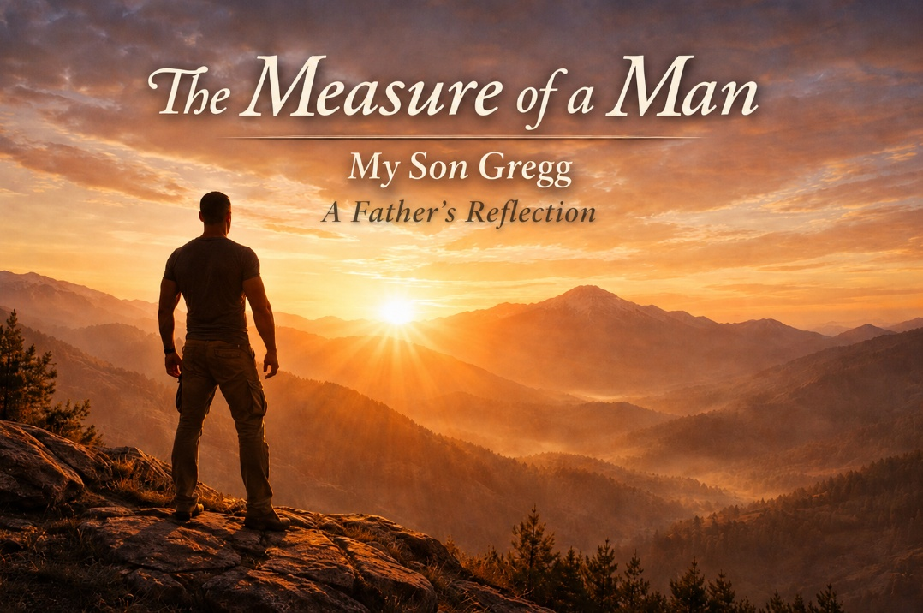
Early Years in Germany
There are sons, and then there are sons, if you know what I mean. I have been blessed with a son who, from the earliest days of his life, carried within him the qualities that define what it means to be a man. Not loud qualities, not boastful ones, but the deeper things that reveal themselves over time. Honor that guides a man’s decisions. Courage that steadies him when life demands more than he thought he could give. Commitment that holds fast when the easier path would be to walk away. If you know the Marine Corps motto, Honor, Courage, Commitment, then you understand the measure of the man I am speaking of. Gregg has lived those words in a way that few people ever truly do.
You were born in Germany at Landstuhl Army Medical Center, although your arrival into the world had a bit of a story even before you were delivered. The hospital nursery was full at the time, and the plan was to have you delivered and admitted to a German hospital instead. That would have meant your mother and I would have had to wait about ten days before bringing you home.
Fortunately, because I had staff privileges at Landstuhl, Mom’s doctor stepped in and made sure that did not happen. So, you were born right there at Landstuhl, arriving at about forty-two weeks, taking your time as if you were already contemplating the world before joining it. From the very beginning you had a presence. You were a big baby and utterly adorable in the nursery crib. You also had what we came to call a very robust cry. When you cried, everyone in the ward knew it was you. But even as a baby you had a charm about you. In some ways you were a child of few words, but when you did speak, people were drawn to you. You had a natural warmth that made people smile. Not long after we returned to the United States for about a year and a half while I completed my postdoctoral training, we were suddenly on our way back to Germany again. By then you were about two, maybe pushing three. On that flight you had a pair of socks with little airplanes on them, and you proudly called them your airplane socks. You spent much of the flight walking up and down the aisle telling passengers about your airplane socks, charming people one by one and enjoying the adventure of the moment.
Friendship and Loyalty
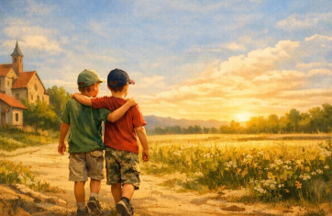
It was during that second tour in Germany that you met your best friend, Skye, a blond haired South African boy. And yes Gregg, you had blond hair back then too. Blue eyes. The Germans loved that look, and people seemed to fall in love with you almost instantly. You and Skye quickly became partners in crime in the innocent and mischievous ways that young boys often are. One day the two of you snuck into his basement and helped yourselves to all the ice cream you could find.
On another occasion you were playing near a German neighbor’s yard and managed to pull a stake from his fence. The gentleman came hobbling after you with a broken foot while the two of you ran away laughing, confident he could never catch you. What made the story even better was that he was not angry at all. In fact, he later told us about it with great amusement. It was hard for anyone to stay upset with you for long. But what I remember even more clearly came on our final day in Germany. We spent much of that day with Skye, knowing that the time had come for us to leave and return to the United States. I had assumed, perhaps too casually, that it would be another move in a life that already had several moves in it.
But that day I saw something in you that stayed with me. You were utterly heartbroken at the thought of leaving your friend. The sadness was deep and very real. It lingered with you long after we had returned to the States. Looking back now, I realize that moment revealed something about you that would define the man you would become. Even as a young boy, your friendships mattered deeply to you. When you gave your loyalty to someone, you gave it completely. That fierce loyalty, that sense of commitment and honor in your friendships, became one of the defining traits of your life and remains so to this day.
School Years and Character
Like many children who spend their early years moving from place to place, you had a few challenges when you first began school. You struggled somewhat with reading, in part because you had suffered so many ear infections as a young child. Those repeated bouts of otitis-media delayed your speech development for a time, and you needed some extra help in the early grades. You accepted that help willingly. But what I remember most clearly is what happened a few years later.
Somewhere around the fifth grade you simply stood up one day from the desk where you had been receiving that extra help, walked back to your regular seat, and from that point forward you were on your own. You had used the help you needed, and then you moved forward. And your teacher had the wisdom to accept your decision without hesitation. That was you even then. If help was needed, you accepted it. But you never leaned on it longer than necessary.
By middle school you had discovered girls, as most boys do, but early in high school you came to Mom after experiencing some teenage drama and made a declaration I have never forgotten. You told Mom you had decided you were not going to date any girls until after you graduated from high school because, in your words, there was simply too much drama. To be honest, I did not think you would stick to that decision. But you did. Instead, you poured your energy into music. You were a trumpet player, and when you played there was something in the tone that reflected the depth of your own spirit. Your trumpet carried a soulful melody that could move people. I remember more than one occasion when hearing you play brought tears to my eyes and I suspect to many others. Your band instructor begged you to pursue music in college, but you had other plans, a larger mission. You also developed a love for tennis and eventually earned a varsity letter. You were a strong player, disciplined and competitive yet composed and respectful in all the right ways.
Choosing the Marine Corps
Then at eighteen you graduated from high school. At the time you were not entirely sure whether you wanted to go straight to college. We talked about it, and Mom and I told you something simple. Staying home and doing nothing was not an option. You would move forward in some meaningful yet undetermined direction, and that was soon to be understood. The early part of that summer was a time of deep reflection for you. I could see that you were thinking seriously about the kind of man you wanted to become and about the path you were going to take.
Then sometime around the middle of that summer you came home with your Marine recruiter, a striking and handsome gunnery sergeant dressed in the unmistakable Marine Corps dress blues. It is one of the most striking uniforms worn by any branch of the military, and there you were standing beside him, listening carefully, taking it all in. And then you made your decision. With a seriousness that was unmistakable, you committed yourself to the United States Marine Corps.
You signed the papers in front of us, so respectful and dignified – and yet in another way, deeply solemn. Even in that moment, I could sense the weight of what you were choosing. As your father, I also felt it. The thoughts that no father wants to contemplate began to move quietly through my mind. The seriousness of that commitment and what it could possibly mean. The good that would come from it, but also the potential cost that Marines so often carry with dignity. And yet I could see in you the resolve of a young man who understood that some callings require exactly that kind of courage.
Forged in Boot Camp
Boot camp transformed you. Those thirteen weeks were a crucible that thousands of Marines before you have endured. Trial, exhaustion, pain, and moments of doubt that any reasonable man would feel under the sheer physical and mental demands of that training. But through that crucible you were forged. You went in a young man. You came out something remarkably different. I remember looking at you at graduation with tears in my eyes. You were no longer just my son who had left home a few months earlier. You stood before me a United States Marine. There was a bearing in you that had changed. Something deeper. Something steady. You had become a warrior. Noble, fierce, proud, unmovable, unbendable, unbreakable. I have had many proud moments in my life, but all were eclipsed by that moment.
After graduation we had a wonderful time together as a family. Your grandfather was there that day, the last time you would see him before his life was tragically taken in a terrible accident not long afterward. Before you left for Marine Combat Training he wrote you a letter. I remember the words very clearly. “Wear your responsibility well.” Grandpa was so proud of you, as were the rest of the family. And you did just that in no small measure.
War and Moral Courage
You went on to Marine Combat Training and then on to artillery school. When we picked you up after Marine Combat Training, I remember noticing something immediately. You could barely carry your sea bags. One of your buddies carried them out for you, and as you walked toward the car, Mom and I could see that you had a slight limp. It was subtle, but it was there. When you finally climbed into the car and sat down, we asked what had happened. You looked at me calmly and simply said, “Don’t ask.” But mothers know things. Your mother certainly did. It didn’t take long before we learned what had really happened. Somewhere during Marine Combat Training, you broke your foot. Most people would have reported it immediately, because a broken foot would have meant medical attention and recovery time. But you knew something else too. You knew that if you reported it they would recycle you through the training and you would have to start the entire process over again. That was not something you were willing to do. So instead, you did what Marines sometimes do. You kept going. You pushed through the pain, finished Marine Combat Training, and completed it with a broken foot. God knows how you managed to do that.
During the short break before artillery school, you spent your time hopping around in a cast, helping out with the recruiting while you recovered as best you could. Eventually you reported to artillery school at Fort Sill. As Marines often do, the instructors noticed immediately that you were still dealing with a broken foot. They did not baby you. If anything, they were harder on you, almost as if a Marine had no permission to be injured. You didn’t particularly like that treatment, but you accepted it the same way you had accepted everything else. You pushed through it.

And then came the orders that would change everything. Fallujah, Iraq. A full combat deployment. Some of your buddies did not make it home. You told me stories about those months later on, usually in pieces, never all at once. Combat has a way of doing that to men. The stories tend to surface slowly, often years later, sometimes in the quiet moments when we were riding our motorcycles together as we often did or sitting somewhere without distractions. You spoke about daily patrols outside the wire, about the constant danger that surrounded you, and about the reality that too many Marines were struck by land mines and improvised explosive devices. It was the kind of environment where every day carried a level of risk that most people can scarcely imagine.
There was one story you told me that I have never forgotten. You had been scheduled to give a briefing one day, but you were suddenly called out on a mission and could not do it. Another young Marine stepped in and gave the briefing in your place. Later that same day, that Marine was killed by a suicide bomber. You didn’t talk about it much. In fact, you rarely spoke about moments like that at all. But on one of our motorcycle rides years later, you finally shared a small piece of what those experiences had been like. We were riding together, the road stretching out ahead of us, when you spoke quietly and said, “Dad, the smell of death is bad.” That was all you said. There was nothing dramatic about the way you said it. No long explanation. Just those few words, spoken with the calm honesty that has always been part of who you are. Yet those words carried a weight that only someone who has stood in those places could fully understand.
On another ride I asked you how you managed to get through those deployments without falling apart. Your answer was simple, but it revealed something important about the way your mind works. You told me that at some point you had accepted the likelihood that you would die there. Once you came to terms with accepting your possible death, the anxiety that had been pressing in on you began to lose its grip. When you stopped fighting that possibility and simply acknowledged it, something shifted inside you. From that point forward you were able to focus on the job in front of you and keep moving forward. But even in the middle of war, you carried something else with you besides courage.
You carried wisdom. You once told me about traveling in a Humvee along a convoy road when you spotted an Iraqi man pulled over nearby. Under your rules of engagement, you could have taken him out. In a combat zone those decisions often have to be made quickly, and hesitation can be dangerous. You raised your weapon and prepared to pull the trigger. And then something in you paused. You studied him for a moment. You read the cues. Your instincts were telling you something important about the situation unfolding in front of you. In the last moment before you acted, you lowered your weapon. Later I asked you why you had made that decision. Your answer was simple. “I read the cues, Dad. He was terrified. I could see he wasn’t evil.”
Thank God you trusted that instinct. War places young men in situations that no human being should ever have to face. Decisions must sometimes be made in seconds, and those decisions can carry consequences that last for the rest of a lifetime. Some of those moments demand action. Others demand restraint. What has always stayed with me is the quiet wisdom you showed in that moment. You understood that your responsibility was not simply to pull a trigger whenever the opportunity presented itself. Your responsibility was to do what was right in a complicated and dangerous world, even when the pressure of war made those decisions unimaginably difficult.
Life After War
When you returned from Iraq and eventually left the Marine Corps, you entered another difficult chapter of life. You were also carrying the pain of a relationship that had ended in betrayal. You cared deeply for that young woman and remained loyal far longer than most people would have. Even when the relationship collapsed, you did not lash out or try to diminish her. You simply mourned the loss quietly. I remember flying down to San Diego during that time. At one point I looked at you and said, “Son, I think we need to get you the hell out of here.”
And so that is what we did. You stepped away from that chapter with dignity and began building the next one. Not long after that you met Clare. She became the love of your life. Clare is a remarkable woman, beautiful in every sense of the word but even more remarkable for the depth of her character and inner beauty with a depth of soul that matches yours. She carries so many of the qualities I have come to admire in Filipino culture. Generosity, kindness, warmth, and a deep devotion to family.
Together the two of you built something real. You bravely moved to Arizona and began pursuing aviation, earning your private pilot and instrument licenses even though the helicopter path you hoped for did not work out because of bureaucratic complications in the VA. You continued pressing forward anyway. You earned your CDL. You obtained your drone pilot certification. Through it all you worked hard while Clare pursued her education in radiology.

None of it was easy, but the two of you kept moving forward together. Now you are in your first home together, building a life rooted in stability, love, and shared purpose. What stands out most to me is the devotion you show to Clare. Over the years I have never heard you speak a single unkind or disrespectful word about her. Only respect, loyalty, and admiration. Those same qualities that defined you as a young boy and were forged in the Marine Corps continue to define the man you are today. And as your father, I could not be prouder. It has been an extraordinary privilege to watch your life unfold. I look forward to the chapters that still lie ahead. Thank you, my son, for the pride you have brought to my life. Not only through what you have accomplished, but through the heart you carry and the man you have chosen to be. A man grounded in faith, devoted to family, loyal to country, and guided by a deep sense of soul.

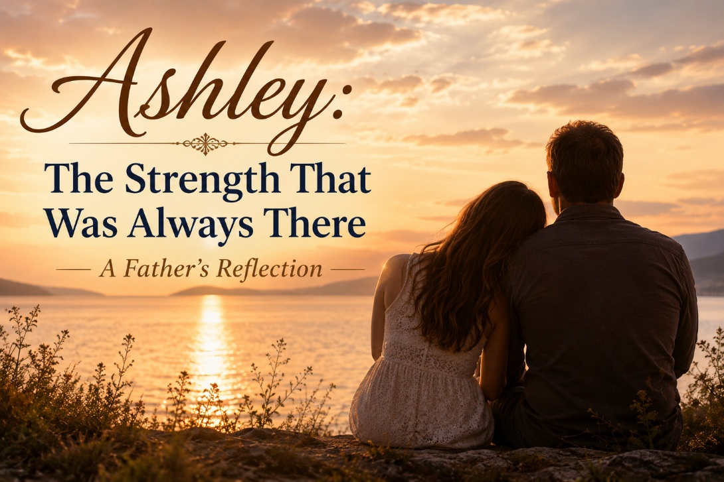
Beginnings
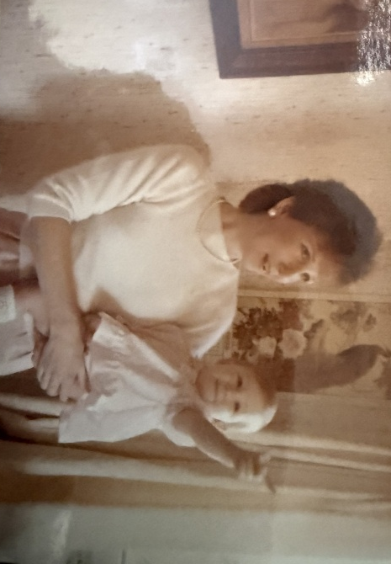
Ashley, it’s hard for me to believe sometimes how much time has passed. You were born on October 20, 1984, at the hospital in Fort Ord. I can still picture that moment clearly. When they placed you in my arms, I immediately fell in love with my daughter. You were one of the most beautiful babies I had ever seen. Your birth was not without complications. It was a difficult delivery, and there were moments of real concern. But you came through it beautifully.
Looking back now, it seems almost symbolic. You entered this world the same way you have approached so many things in life— with determination.
From the very beginning you had a spark. You were bright, talkative, quick, and funny. You laughed easily and you paid attention to everything around you. But more than anything, you were independent-minded from the start.
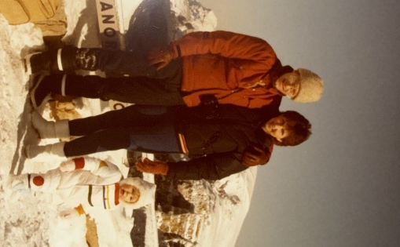
Only a few weeks after you were born, we moved to Germany. That’s a big adjustment for any family with a newborn, yet you thrived there. People adored you. Even as a very young child you had a way of drawing people in.
One of my favorite memories from those early years is when you were about three. In the mornings, when I would come home from the night shift at the hospital and I was making coffee in the kitchen, you would climb up on a chair next to the counter. I would be scooping coffee grounds into the filter, and you would grab the spoon, push my hand away, and insist, “‘Ashee’ do it.” That small moment captures something essential about you. You wanted to do things yourself. You wanted to learn, try, and participate. That spirit has stayed with you throughout your life.
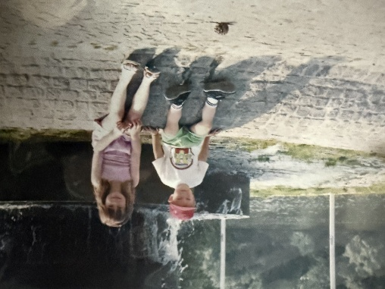
After three years in Germany, we returned to the United States for a time while I completed my postdoctoral work, and eventually we moved back to Germany again. You attended German kindergarten there. At first you were a little shy, but before long, you were speaking German remarkably well for such a young child. You adapted quickly, something that would become a recurring theme in your life.
Later came the transition back to the United States, middle school, and eventually high school. Those were years that made me very proud as a father. I remember watching you perform on drill team and later cheering, carrying yourself with confidence and energy. At the same time, you were doing well academically and growing into a thoughtful young woman.
Even during those teenage years there was something about you that stood out. You had a natural instinct to reach out to people who were often overlooked. I remember how you connected with the autistic and developmentally disabled students at school. You treated them with kindness and dignity. You didn’t talk down to them. You simply accepted them as people.
That kind of empathy is rare, and it was already clearly part of who you were.
Finding Your Way
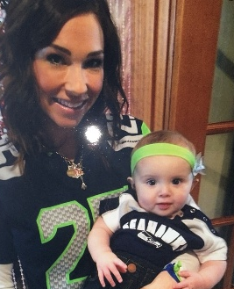
Adulthood brought new chapters. You met Bob, and together you welcomed Hallie into the world. Hallie is a beautiful child and an extraordinary gift. Watching you become a mother and seeing the love you have for her has always meant a great deal to me. She carries so many of your qualities—your independence, your curiosity, and your willingness to think differently rather than simply follow the crowd.
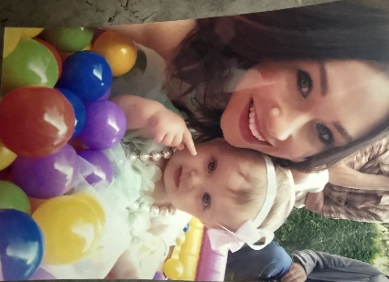
Life, of course, rarely unfolds in a straight line. After your relationship with Bob ended, you went through a season of trying to find your footing again. During that time, you became involved in a difficult relationship. That period created real strain and real rifts. It was painful and complicated for many people involved. Yet what stands out most to me looking back is the way you eventually fought your way out of that situation. It took clarity, courage, and real determination to extricate yourself from something that had become destructive.
That kind of tenacity says a great deal about who you are.
Through all of those seasons you never lost sight of Hallie. She remained your priority, and that speaks volumes about your heart as a mother.
A Harder Road Than Most
In more recent years you have also been navigating a set of medical challenges that are anything but simple. Coming to terms with Ehlers-Danlos Syndrome and POTS is not easy. I have some familiarity with Ehlers because I worked with a family for nearly twenty years where the mother and three sons lived with it. Even so, as I have read the information you shared and looked more closely at what you are facing, it is clear how complex these conditions can be.
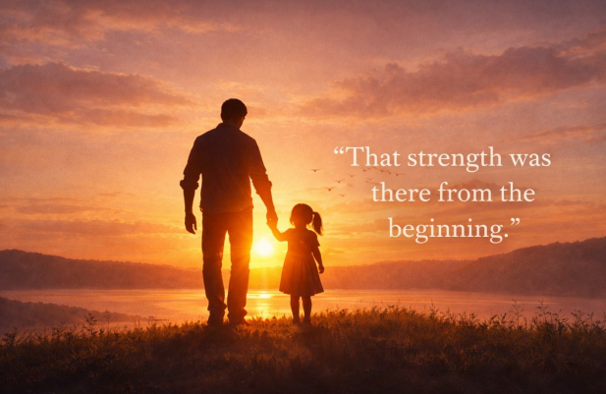
What impresses me most is how you approached it. You sensed for a long time that something wasn’t quite right. You researched. You asked questions. You advocated for yourself until you finally received answers. That kind of persistence takes grit.
At the same time, you have continued to maintain an extraordinary level of physical fitness. Given what your body has been dealing with, that is remarkable. Mom shared some of the reviews people have written about you at the high-end fitness center you instruct at, and they were impressive to read. But when I thought about it more carefully, they also made sense. The same qualities that made you reach out to people who felt invisible years ago are still part of who you are today.
Looking back now, I also realize that some of the emotional struggles you experienced over the past twenty years may have been connected to physical realities that no one understood at the time. To live with that uncertainty—to know something was wrong but not have it recognized— must have been incredibly difficult. In some ways, understanding that now gives me a deeper appreciation for the complexity of your journey.
Life is rarely simple and almost never linear.
A Depth of Spirit
There is another dimension of who you are that I have always admired, and that is your depth of spirit.
You have never been someone who simply accepts the status quo. Like your old man, you tend to ask questions. You think deeply about things. You are willing to challenge ideas rather than simply inherit them. That kind of intellectual and spiritual independence is something I have always respected in you.
We do not always see every issue in exactly the same way. That is natural. But what has always stood out to me is the depth from which you approach life. There is a seriousness and curiosity about the deeper dimensions of being human that has always been part of you.

Over the years we have had many conversations about these things, and in some ways you have even challenged me to think outside of my own paradigms. I appreciate that more than you probably realize. Real growth often happens when people who respect each other are willing to explore ideas together rather than simply agree.
That same depth shows up in the way you approach your work. I think part of the reason people respond so strongly to you as a fitness instructor is that you relate to them as whole human beings. You understand that health and strength are not only physical matters. They involve the body, the mind, and something deeper that connects us at a more fundamental level.
One of the things you appreciate, and something we have talked about together many times, is the power of sound and resonance. In your own way you have recognized that certain kinds of sound, rhythm, and energy can affect the human body and nervous system in profound ways. Interestingly, that intuition overlaps with things I have written about in NeuroFaith®. In neurocardiology and the study of the autonomic nervous system, we see how resonance and coherence within the body can actually shift physiology toward healing.
You discovered that insight through your own path, through fitness and the embodied experience of energy and sound. I came at it through psychology, trauma work, and neuroscience. Yet somehow the two paths meet in the same place.
In fact, we even started writing a book together exploring that very idea, where sound meets faith and healing. I still believe deeply in that project, and I hope someday we finish it together. Your perspective and mine come from different directions, but they resonate with one another in ways that are both fascinating and meaningful.
You bring intelligence, creativity, and a deeply thoughtful spirit to the work you do. And as your father, that is something I admire tremendously.
The Strength That Was Always There
I think about my own turning point around age fifty, when I had to confront some things in my own life that had been buried for a long time. I also think about my brother, Gregg, and the larger story of our family. I dislike the word trauma because it has become so overused, but the reality is that Grandpa endured very difficult experiences earlier in his life that left deep marks on him. At his core he was a good man, but he carried wounds that never fully settled. My brothers and I felt the effects of that growing up. Later in his life he found faith, which helped him tremendously and brought him peace that he had not known before.
Gregg’s life eventually ended in tragedy and losing him left a mark that will always remain with me.
What experiences like that teach you over time is that every family carries both wounds and strengths forward from one generation to the next. Some things we inherit without choosing them. But we also have the opportunity to shape what happens next. When I look at your life, Ashley, I do not simply see struggle. I see someone who has taken the complicated inheritance of family, circumstance, and personal hardship and continued to move forward with courage. That matters more than you probably realize.
Over the years I have also come to see experiences like these through a deeper lens of faith. Not the kind of faith that pretends suffering makes sense or offers simple explanations, but the quieter kind that trusts there is a larger story unfolding even when we cannot see it clearly in the moment. Life leaves its marks on us. It leaves them in memory, in the body, and even in the nervous system, something I have spent much of my career trying to understand. Yet love leaves its imprint as well. The connections we form with one another shape who we become, and in ways that continue long after particular chapters of life have ended.
All of these things are part of the larger story we come from. None of us move through life untouched by struggle or complexity. Yet when I look at you, what I see most clearly is resilience.
Resilience does not mean life has been easy. It means that even when life becomes complicated, painful, or uncertain, something inside a person continues to move forward.
I have watched that quality in you for many years now. Through changes in relationships, through the challenges of raising your daughter, and through the confusing and often frustrating journey of trying to understand your own health, you have kept going. You have kept asking questions. You have kept searching for clarity. And you have continued to build a life that reflects both strength and independence.
What stands out most to me is not simply that you have endured difficult seasons. Many people endure hardship. What stands out is the way you continue to grow through it. You continue to pursue health, to care deeply for your daughter, and to build a life that reflects your own convictions rather than simply following the expectations of others.
That takes courage.
It takes character.
And it takes a kind of inner strength that has been part of you since the very beginning. It takes character. And it takes a kind of inner strength that has been part of you since the very beginning.

When I think back to that little girl standing on a chair in the kitchen insisting that she could scoop the coffee herself, I realize now that the determination I saw even then was not a passing childhood trait. It was a glimpse of the woman you would eventually become.
Ashley, I want you to know how deeply proud I am of you. I see your strength. I see your heart. And I see the remarkable woman you have become. And I love you just as deeply today as I did the first moment I held you in that military hospital so many years ago.

The Arizona Broil Tour
We were deep into Day 3 of what I like to call The Arizona Broil Tour, just me and my son Gregg blasting through the desert like two red-blooded, oil burning patriots fleeing from a world gone soft. The desert heat was biblical. The kind of heat that cooks your boots at stoplights and makes you question every life decision that brought you to a motorcycle seat in triple digit weather.
Gregg’s not much of a talker. He is a Marine, and not the kind that simply survived boot camp and bought a bumper sticker for the back of his truck. Gregg is a Fallujah veteran. Boots on the ground. Real combat. Real loss. Real loyalty. Real trauma. The kind of experiences that permanently alter a man’s nervous system and leave him seeing the world differently for the rest of his life.
So, when Gregg speaks, you listen.
By that point in the ride, we had already downed enough water to float a canoe and sweat out every electrolyte God ever designed into the human body. Meanwhile, my brain was doing what it always does. Roaring. Processing. Connecting dots. Writing essays in real time while barreling down Interstate 10 at ninety miles an hour.
A Marine Observation
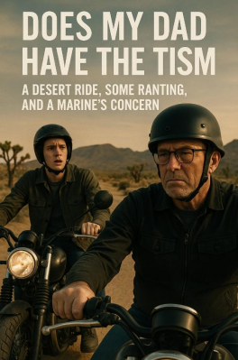
Somewhere past Tucson, around temperature marker Inferno, we pulled into a gas station to regroup. I was peeling my gloves off like I was molting skin while Gregg stood there in silence, sunglasses on, desert dust across his face, studying me with that strange mixture of affection and tactical assessment Marines seem to perfect.
Then he said it.
“Hey Dad… you got the tism?”
I blinked at him.
“The what?”
“The tism,” he repeated. “You’re locked in, man. Hyper focused. One topic. No filter. Writing manifestos in your head while riding through hell’s convection oven. I’m just saying… maybe you got a little tism.”
And I started laughing.
Not because it offended me, but because I knew exactly what he meant.
What Marines Mean by 'The Tism'
Now for the civilian audience, let me explain something important here.
The tism is Marine shorthand. It is not a clinical diagnosis. It is not a DSM category. It is cultural language for somebody who gets intensely locked onto something and refuses to let go. Maybe a little obsessive. Maybe rigid. Maybe wildly over focused. Maybe incapable of superficial small talk because the stakes feel too high.
In Marine humor, it becomes a strange compliment. A recognition that somebody is driven by conviction strongly enough to become socially inconvenient.
Gregg was basically telling me that once my brain locks onto an issue, I do not disengage. I study it, dissect it, connect it to larger systems, and keep pushing long after polite society wants the conversation to stop.
And honestly, he was not wrong.
The Burden of Seeing Too Much
There I was, a seventy-year-old psychologist roaring across the Arizona desert mentally ranting about gender clinics, the medicalization of childhood, the overprescription of psychiatric medications, and the growing inability of our culture to tolerate honest disagreement.
I have spent decades sitting across from wounded people. I have listened to addicts, trauma survivors, veterans, abused children, shattered marriages, and deeply depressed adolescents. I have watched what happens when institutions confuse ideology for compassion and when medicine forgets humility.
That leaves a mark on a person.
At some point you stop being able to pretend that every cultural trend is healthy simply because it is fashionable. You begin to notice the fractures. You begin asking harder questions. And eventually, people start accusing you of being too intense simply because you refuse to stop noticing what everybody else has normalized.
So maybe Gregg was right.
Maybe I do have the tism.
But I call it clarity.

The Ride Through the Desert
The older I get, the more I realize that some people are simply wired to ride through uncomfortable terrain. Not because they enjoy conflict, but because they cannot tolerate abandoning truth for comfort.
That is part of what Gregg understands about me.
Underneath the teasing, underneath the Marine sarcasm, was something else entirely. Respect.
Respect for conviction.
Respect for persistence.
Respect for refusing to go numb.
That moment reminded me that not everybody is called to speak publicly. Not everybody is supposed to write essays or challenge systems or push back against cultural drift. But somebody has to.
Somebody has to ride through the desert carrying truth in one saddlebag and grit in the other while reminding the next generation that they are not crazy for seeing the madness around them.
Yeah Kid, the Righteous Kind
So, when Gregg finally looked over and asked again whether maybe his old man had “the tism,” I just grinned and answered the only way I could.
“Yeah, kid. The righteous kind.”
“Fair enough,” he said.
No smile. No speech. No dramatic emotional moment. Just a rev of the throttle and a pull back onto the highway.
But I knew exactly what it meant.
That was Marine language for respect.
And honestly, maybe that is enough.
Because at the end of the day, I would rather be accused of caring too much than become one more sedated spectator quietly watching the culture burn.

So yeah.
Maybe your old man does have the tism.
But these days, if you do not see at least some of the insanity unfolding around us, you may be the one asleep at the bars.
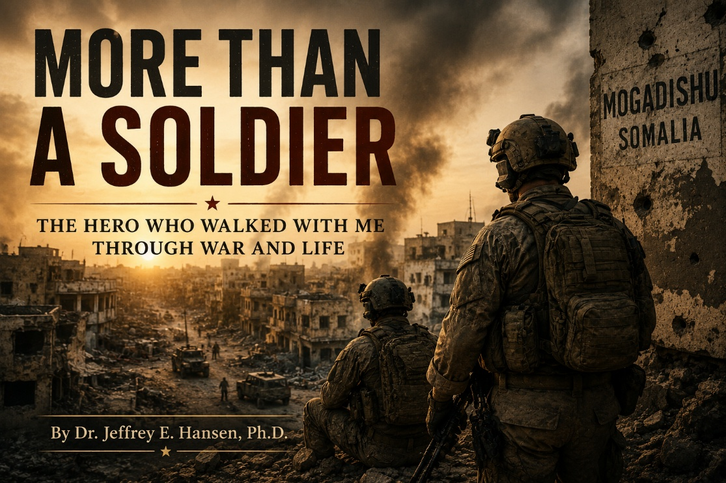
Everybody Needs a Hero
Everybody needs a hero. Mine was MAJ Al Johnson.
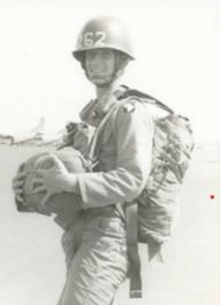
Let me explain. It was 1992, and I had been activated for deployment to Somalia with the 62nd Medical Group. At the time, I was a pediatric psychologist, most of my Army career spent safely within the walls of medical centers. I knew very little about the realities of soldiering in combat environments. I had volunteered to go imagining something much closer to a humanitarian mission, picturing myself handing out candy bars to children and helping from the relative safety of a medical role. I truly had no idea what I was walking into. Somalia was not an abstraction. It was violence, instability, starvation, and fear. And almost immediately I realized I was profoundly unprepared for the realities surrounding us.
Then Came Al
Then came Al. MAJ Al Johnson. A soldier’s soldier in every sense of the word. He was steeped in experience, calm under pressure, sharp as a tack, and full of the kind of quiet wisdom that immediately steadied everyone around him. Somehow, whether through instinct, compassion, or sheer mercy, he decided to take me under his wing. And from the moment he did, my entire experience of Somalia changed.
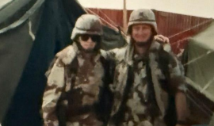
Our first firefight happened not long after we landed. I honestly barely understood what was happening around me. I was not a warfighter by temperament or training, and I joke that I was probably more at risk of accidentally shooting myself with my Beretta than defending anyone effectively. But while chaos erupted around us and incoming fire cut through the confusion, Al ran back through danger itself to retrieve my flak jacket and helmet. He tossed them into my hands with complete calmness and simply said, “Here, put these on.”
That moment stayed with me for the rest of my life because Al was doing something much larger than protecting me physically. In the middle of uncertainty and fear, he became an anchor. He regulated the emotional climate around him. I still laugh when I tell people that my biggest military accomplishment was a perfect 10.0 dive underneath a table during our first firefight, but beneath the humor is something deeply true. Al was the reason I remained intact. Body, mind, and spirit.

Following His Lead

From that point forward, I followed Al like a shadow. When Al looked calm, I relaxed. When Al became cautious, I stopped in my tracks. He taught me how to read an environment, how to notice subtle shifts that signaled danger, and how to steady my nervous system when adrenaline threatened to take over.
One afternoon I heard a strange snapping sound pass near my head and barely reacted to it. Al turned toward me and asked, “Did you hear that?” I casually answered, “Yeah.” Then he looked directly at me and said, “Jeff, that was a round that barely missed us.” That was Al. Never theatrical. Never dramatic. Just deeply grounded in reality. He never minimized danger, but he also never surrendered to panic. That combination created an extraordinary sense of safety around him, even in profoundly unsafe places.
Mogadishu
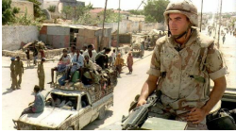
Our unit eventually occupied a once beautiful university in Mogadishu. Somalia had been stripped almost completely bare. There was no electricity, no running water, no glass in the windows, and no wires remaining on the utility poles. Even the ceramic caps had been torn from the telephone lines. People bathed openly in the streets. Cardboard and tin structures lined the roads. Everywhere you looked there were signs of collapse, desperation, poverty, and fear.
Warlords like General Aidid controlled enormous portions of the region while children starved and humanitarian aid moved under constant threat of violence. The smell of despair lingered almost everywhere we went. Yet even inside that darkness, Al somehow maintained his humanity. He carried himself with steadiness, humor, intelligence, and quiet dignity. He never lost his center, and because he did not lose it, many of us around him were able to hold onto ours as well.
The Flight Home
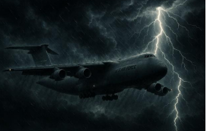
I remember our flight home vividly. We boarded a massive C-5 Galaxy simply grateful to be alive, but not long into the flight we encountered turbulence unlike anything I had ever experienced. And I am the son of a pilot. I have endured more than a few white-knuckle flights in my life. But this was different. Even the flight crew looked visibly unsettled.
That is when Al quietly turned toward me and asked, “Jeff, do you pray? If so, now would be a good time.” And so we prayed together with very few words and a great deal of faith. That moment captured something essential about Al. Even under pressure, he remained grounded, practical, and spiritually centered. As always, I followed his lead.
A Friendship Beyond War
After Somalia, our friendship only deepened. Al was brilliant. Truly brilliant. He read constantly, thought deeply, and could move seamlessly between conversations about military strategy, quantum mechanics, philosophy, theology, psychology, or the deeper questions surrounding the human soul. But what made him extraordinary was not simply his intelligence. It was his humility. He carried immense knowledge without arrogance.
He loved his wife Marty deeply, and he absolutely lit up whenever he spoke about his son, JJ. Over the years he became my sounding board for clinical cases, my guide through military culture, and one of my closest companions in intellectual and spiritual life. I genuinely believed there would be many more years together, many more late-night conversations, many more cups of coffee, and many more “downloads” about life, suffering, meaning, faith, and the human condition. But those years would not come on this side of eternity.
Since Al’s passing, I have had the privilege of getting to know JJ, who is in many ways a living tribute to his father. The resemblance is uncanny. The same warmth. The same grounded presence. The same thoughtful cadence and spirit. Talking with JJ often feels like hearing echoes of Al himself still walking beside me.
Until We Meet Again
So, I write this with both gratitude and sorrow. I miss my buddy. I miss my hero. And I thank God for the strange divine mercy that brought us together in the middle of a war zone.
Al, as you fly through heaven, I suspect you have already figured everything out up there within the first week. You probably already know everybody and have already found the best coffee. And when my time finally comes, I know you will be there waiting to give me the skinny, just like always.
Until then, enjoy the company in God’s kingdom. You never did meet a stranger.
With deep love,
Your buddy forever,
Jeff
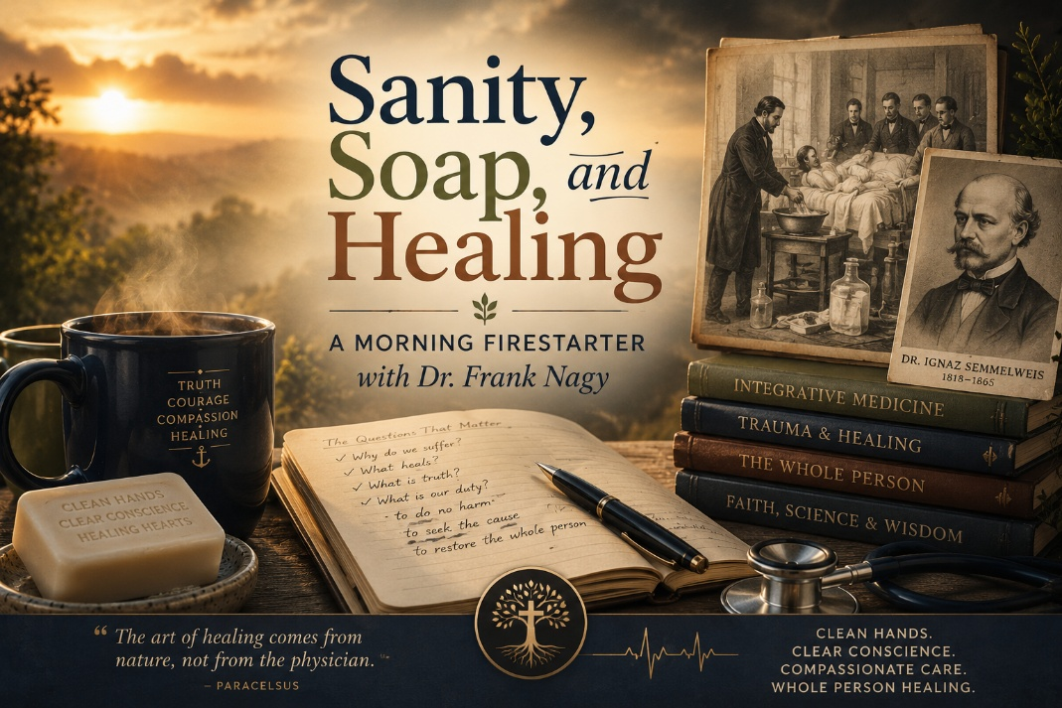
This morning, over strong coffee and stronger convictions, I found myself deep in one of those wide-ranging, soul-level conversations with my good friend and colleague Dr. Frank Nagy, retired Army Colonel, combat physician, and one of the most integrative thinkers I’ve ever had the pleasure of knowing. Frank is that rare kind of generalist who isn’t content to skim the surface. He’s been trained in pediatrics, obstetrics, and geriatrics, served in war zones, and has walked with both the very old and the very young through pain, healing, and recovery.
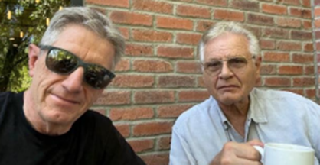
He’s also the best integrative medicine doctor I know. Dr. Frank Nagy doesn’t chase symptoms, he chases meaning. He listens. He connects dots. And as we often do, we got to chewing on some of the deeper questions that modern medicine still refuses to ask.

The Man Who Cleaned Up Medicine and Got Buried for It
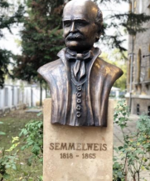
Our discussion turned to a forgotten pioneer in medicine, a man whose name should be as widely known as Hippocrates or Pasteur but remains frustratingly obscure: Dr. Ignaz Semmelweis.
In 1847, Dr. Semmelweis was working in a maternity ward in Vienna, where nearly 40 percent of women were dying after childbirth. They called it childbed fever, and it was an epidemic. What haunted Semmelweis was that these deaths were happening more often in the clinic run by doctors and medical students than in the one staffed by midwives.
He traced the issue to a single, horrifying fact: doctors were going from performing autopsies straight into delivering babies without washing their hands.
Semmelweis instituted a radical idea: handwashing with a chlorinated lime solution. The results were immediate and dramatic. The death rate dropped from nearly 20 percent to around 1 percent.
But instead of being honored, he was vilified.
Why? Because his discovery threatened the pride and power of the medical establishment. Admitting he was right would mean acknowledging that physicians themselves were the cause of so much suffering and death. The egos were too big. The systems too entrenched. The science too new. And the man too blunt.
Semmelweis was ultimately dismissed from his post in Vienna. He fled to Hungary, where his methods were accepted and death rates again dropped. But the rejection haunted him. He died institutionalized, broken in body and spirit, ironically from sepsis, the very infection he had spent his life trying to prevent.
Medicine’s Memory Is Short But Truth Lingers
The legacy of Semmelweis is a mirror to our times. He saw the truth. He spoke the truth. He paid the price. And eventually, others picked up where he left off - Dr. Joseph Lister, for example, who expanded antiseptic techniques in surgery, finally received the credit Semmelweis never lived to see.
But the deeper story is about institutional arrogance, and what happens when a healer says, “We’ve got it wrong.”
Today’s Infection Isn’t in the Body, It’s in the System
Dr. Frank Nagy and I couldn’t help but draw the parallels. Because we’re still here. Still fighting the same disease. Still seeing doctors ignore the root causes of suffering. Still watching the system medicate symptoms instead of confronting truth.
So let me say it plainly.
We are watching a generation of children be over-medicalized, over-labeled, and over-drugged. Psychiatry, hijacked by Big Pharma and shallow diagnostics, is still refusing to ask why. Instead of understanding trauma, pain, and human story, we are dulling the soul with pills, diagnosing every form of despair as disorder, and calling it care.
We are witnessing pharmaceutical and surgical interventions in gender-questioning children, not because we fully understand what's going on, but because it's expedient, profitable, and ideologically reinforced. It's easier to change the body than it is to ask what pain the child is carrying.
This is the new childbed fever. And we are the new Semmelweis.
What Drives Me Forward
This story, of institutional arrogance, ignored suffering, and dismissed truth, is not just history. It’s the same battle we face today. These conversations, like the one I had this morning with a close colleague, remind me why I do what I do. Why I continue to speak out. Why I take the hits. Why I push back. Because we have a duty to wash our hands, not just of physical germs, but because of the ideologies, incentives, and intellectual laziness that now infect our systems of care. We are treating symptoms and ignoring infections. We are prescribing pills while ignoring pain. We are altering bodies while ignoring brokenness. And it’s costing lives, health, and souls.
This is exactly why I created the NeuroFaith® model. It isn’t about quick fixes or shallow interventions. It’s a deeply integrative, faith-informed, neuroscience-grounded approach to healing that takes time and honors the whole person, body, brain, and soul.
What continues to inspire me most are the people who refuse to compromise truth for convenience, and who remain willing to go deep when the culture demands shortcuts. Dr. Ignaz Semmelweis stood for truth in the face of ridicule and rejection, courageously challenging a medical system that could not yet bear to confront its own blindness. And in my own life, my friend and colleague Dr. Frank Nagy continues to walk that same courageous path today.
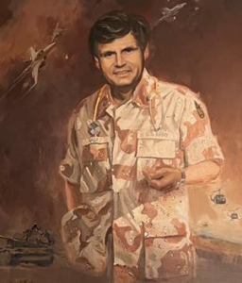
Dr. Frank embodies the kind of physician healer that has become increasingly rare in modern medicine. He listens carefully. He thinks deeply. He honors the whole person rather than reducing suffering to a symptom checklist or a prescription pad. Our conversations continually remind me that real healing requires humility, curiosity, courage, and the willingness to ask harder questions.
That is ultimately why I share reflections like these. To encourage all of us to resist shallow answers, reject the easy fix, and remain committed to healing with wisdom, integrity, compassion, and conviction. The world does not need more ideological noise or mechanical care. It needs grounded healers willing to see the full humanity of the people entrusted to them.


What The Road Begins to Bend Back.
There comes a moment in every journey when the light changes. The road that once stretched endlessly ahead begins to bend back toward the familiar, and something in the soul shifts with it. I can feel it now as I drive, the air growing thinner and clearer, the desert light beginning to break through the clouds. The road home has a voice of its own, and I am learning to listen to it again.
What A Season of Reckoning
These past days have been a season of reckoning. Time away from routine always brings reflection, but this time it has brought more than that. It has brought truth. I have been thinking about Gregg, my twin, my brother, my mirror in so many ways. His absence still cuts through every layer of life. Yet even grief can become sacred when we let it teach us. His life and his death remind me that every breath is borrowed, and every purpose we pursue must finally return to its source.

The Weight of the Fight
Grief has a way of stripping away illusions. It clarifies what matters. For years I have poured myself into the institutions of healing, into programs and systems designed to serve, restore, and protect. But I have also seen how easily those systems can lose their way. The world of mental health has become so enamored with its own vocabulary that it sometimes forgets its humanity. I have watched the medicalization of distress, the labeling of the soul as if sorrow were a chemical error. I have seen children misled, parents dismissed, and conscience reduced to paperwork.
I have challenged these systems, often at great cost. I have spoken against the arrogance that calls itself progress, against the institutions that elevate ideology above evidence, and politics above conscience. I have stood with those who defend the right of parents to know, of children to grow, and of therapists to think. And though I have no regret for the battles I fought, I have begun to see that not every battle deserves to be fought forever. The human soul cannot live in constant opposition. It must also find its way to rest.
Your word is a lamp to my feet and a light to my path.
Psalm 119:105
Wha Humility and Letting Go
Aristotle wrote that virtue lies in the mean between extremes. Courage is the balance between recklessness and cowardice. Generosity is the balance between waste and stinginess. I have come to believe that humility is the balance between self-erasure and self-exaltation. Humility does not mean pretending to be less than we are. It means recognizing that whatever we are was given. Ego, on the other hand, is not always arrogance. Sometimes it is simply the inability to stop fighting. Sometimes ego wears the face of conviction. Sometimes it hides behind noble words like mission, duty, or excellence. But underneath, there is always that small voice asking, What if you let go? Would it all fall apart, or would it finally breathe?
I have lived long enough to see how easily the two can blend. In my work as Clinical Director, I have fought to protect truth within systems that often prefer convenience. I have carried the weight of programs, staff, and expectations, convinced that integrity depended on my persistence. But there comes a moment when even the noble fight becomes self-referential. When humility whispers, “You have done enough. Let others carry this now.” That whisper is not defeat. It is wisdom.
He has shown you, O man, what is good; and what does the LORD require of you but to do justice, to love mercy, and to walk humbly with your God.
Micah 6:8
Legacy and Leadership
I think of Seth stepping into leadership. I see in him the strength of youth, the energy to sustain the mission, and the humility to learn. I also see the temptation of control that all of us face when responsibility feels heavy. I want him to inherit not only the systems we built but the spirit that shaped them. A spirit that values courage over compliance, truth over convenience, faith over fear. That is legacy. That is what must outlive me.
The older I become, the more I recognize the cost of pride disguised as perseverance. I have been proud of my endurance, of my ability to stand firm while others compromise. But even conviction can harden into self-importance if it forgets its purpose. The question that now rises within me is not “How much can I accomplish?” but “What can I release?” The act of letting go may be the most difficult form of leadership there is.
Learning to Reset
Leah has been my quiet teacher in this. For decades she has moved beside me with patience and steadiness, never demanding recognition, never competing with my purpose. She has carried the unseen weight of my calling. She has followed me through reinventions, relocations, sleepless nights, and long days. And now, as I turn the corner home, I realize that what she deserves most is not another mountain to climb, but a husband who has learned to rest.
Come to Me, all you who are weary and burdened, and I will give you rest.
Matthew 11:28
Home is not merely a destination. It is a condition of the soul. It is the place where striving ends and gratitude begins. It is the sanctuary where ambition yields to appreciation, and where love becomes enough. I want to give her that. I want to give myself that. The next chapter of my life must be written with different ink.
A Different King of Calling
My purpose is not finished. NeuroFaith still calls to me. There is still work to be done, still ideas to refine, still young minds to train. But I no longer wish to do this work through argument. I want to do it through art, through mentorship, through patient creation. I want to teach others that faith and science need not be enemies, that the brain and the soul are two languages telling the same story. I want to model what it means to live with conviction without cruelty, to speak truth without venom, to lead without noise.
Gregg’s Voice Along the Road
Gregg’s memory keeps me honest. He reminds me that time is finite, that wisdom without love is noise, and that the measure of a man is not how loudly he fought, but how faithfully he loved. I hear his laughter in my mind sometimes, that mischievous, knowing tone that told me he understood things words could not express. I carry him home with me. He walks in the silence between thoughts, steady and whole.
Aristotle and Christ meet in this place of return. One taught the reasoned pursuit of virtue; the other embodied the surrender of love. Between them lies the middle way, the place I seek now. It is neither passivity nor domination. It is the quiet strength of peace. To lose one’s life in service of truth and love is to find it in fullness.

Turing Toward Home

The sun is low now as I near Prescott Valley. The road bends, and the sky widens. I can see the outline of home on the horizon, steady and still. I breathe, and the air feels lighter. The miles behind me are heavy with memory, but the ones ahead are filled with grace. Turning the corner home is not retreat. It is return. It is not the end of the journey, but the beginning of understanding. After years of striving, of speaking, of challenging and defending, I am finally ready to listen again. Ready to be still. Ready to be human.
The world may continue its noise. The institutions may rise and fall. But I have found what I was searching for. Truth does not live in the machinery of systems. It lives in the space between humility and courage, in the love that outlasts the argument, and in the quiet peace that waits at the door when a weary traveler finally comes home.
“Be still, and know that I am God.” (Psalm 46:10)
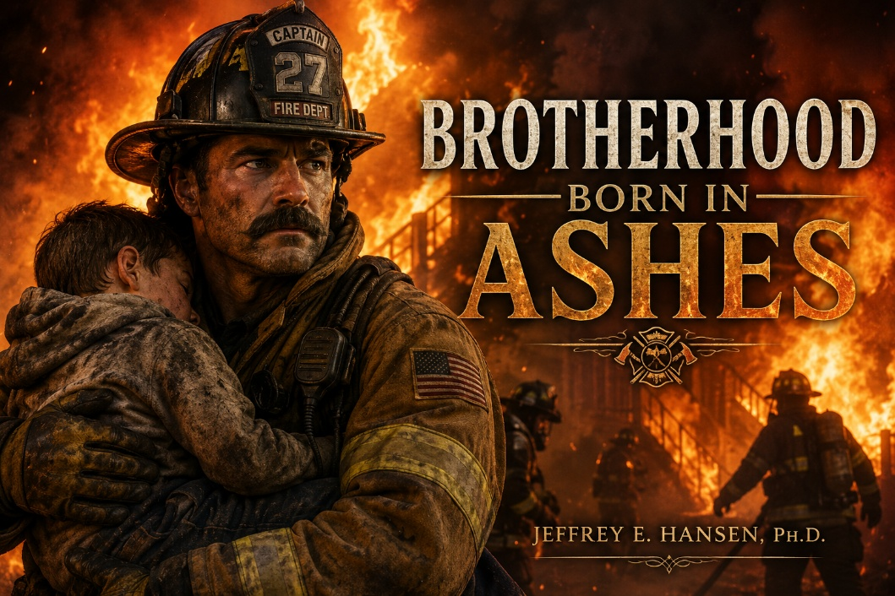
A Man Carrying Fire
DJ came to me in therapy at Holdfast Recovery. That is where our story begins. He did not come as a friend or a brother or a companion, only as a man who had finally reached the end of what he could carry on his own. There was no performance in him when he arrived. No bravado. No attempt to impress. Just exhaustion, the kind of exhaustion that settles not only into the body, but into the soul itself after years of carrying pain without rest.
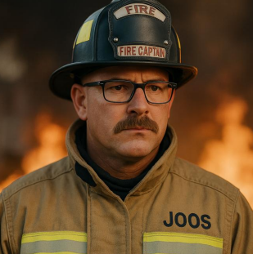
He was a large man, twice my size, the kind of presence that could fill a room without needing to speak. He had risen through the ranks to become a fire captain, a man entrusted with responsibility when other people were panicking. He led others through chaos, through fire, through tragedy. People depended on him. They looked to him for steadiness in the burning places. He knew what it meant to carry lives in his hands while suppressing his own fear in order to protect others.
But strength like that always carries a cost. Long before he ever stepped into a firehouse, his childhood had already carved deep wounds into him, wounds largely unspoken and unattended. Then came the years of service, years of running toward devastation while others ran away, years of carrying the sorrow of strangers because somebody had to carry it. Over time the accumulation became enormous. Trauma rarely arrives as one dramatic moment. More often it gathers quietly, layer upon layer, call after call, tragedy after tragedy, until eventually even a strong man can no longer separate his own soul from the suffering he has spent years absorbing.
And though he led many with remarkable courage and steadiness, the burden eventually broke him. So he came to therapy quietly. Honestly. Without pretending to be strong. He came because somewhere deep inside, he knew survival was no longer enough. He wanted healing.
The Sacred Work of Healing
We began gently. We talked for long stretches about pain, exhaustion, fear, faith, and the strange loneliness that often follows men who spend years appearing strong for everyone else. We prayed together often. Sometimes we simply sat in silence because silence itself felt more honest than trying to force words into places where words were insufficient. There are sacred moments in therapy where fixing stops and presence begins, and many of our conversations lived in that space.
Sometimes we held hands while praying together. His hands were large, scarred by work and service, yet they held prayer with remarkable tenderness. And there were moments when tears came. Not the kind that collapse a man, but the kind that reveal the depth of what he has carried. Tears from a strong man who was no longer afraid to show his hurt.
I always admired that about him. His strength was never loud. It was honest. There was no posturing left in him anymore. Just sincerity. Just truth.
Healing came slowly, the way dawn arrives almost unnoticed until suddenly the light has returned. He allowed pain to rise to the surface and permitted grace to meet it there. He softened, not into weakness, but into wholeness. There is a profound difference between a man becoming smaller and a man finally becoming real, and what I witnessed in DJ was not collapse, but transformation.
Returning as a Brother
And then, in time, he did something even rarer.
He returned.
DJ came back to Holdfast Recovery not as a client, but as a brother among brothers. He co-led groups with me. He sat beside men who were where he once had been, men still drowning beneath shame, addiction, grief, and exhaustion. What he offered them was not polished advice or clinical performance. He offered presence. He offered truth. And because his compassion had been forged inside his own suffering, people trusted him.
The completion of his healing was never just about himself. It revealed itself in the way he poured into others. He stayed connected to his brothers long after the formal work ended. He checked on them. Encouraged them. Walked beside them when they stumbled. I have seen professionals with years of training do far less, and often with far less heart.
This was the fruit of his healing.
Not perfection.
Presence.
When Grief Came for Me
Then life turned, and my own heart shattered with the passing of my twin brother Gregg.
Grief is a language very few people truly understand. It does not ask for correction or counsel. It asks for presence. Quiet presence. The kind that sits beside sorrow without trying to rush it away.
DJ never tried to lift my grief from me. He simply refused to let me carry it alone. He remembered Gregg. He asked how my heart was doing. He stood near with gentleness rather than answers. Again and again, he blessed my soul simply by showing up, and in seasons of profound grief, that kind of quiet loyalty becomes sacred.
A Brotherhood Born in Ashes
What began in therapy eventually became something far more human and far more sacred. Two lives that had known breaking, learning how to remain open anyway. A brotherhood not formed in ease but born in ashes.
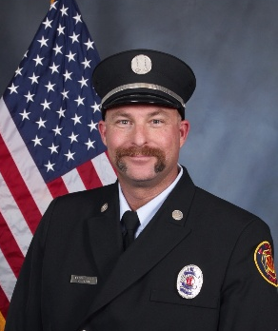
I remain deeply grateful for him. For the courage he showed in his healing. For the grace he learned to offer others. And for the kindness he extended to me quietly and without fanfare, never needing recognition in order to love people well.
Thank you, DJ, for trusting me with your story. Thank you for allowing me into your life. And thank you for having the courage, the grace, and the kindness to enter mine.
Your brother always, Jeff


Henry Arrives
Henry came into our family about twelve years ago, and nothing has been the same since. Not in a poetic way. In a real way. A furniture-has-never-fully-recovered kind of way.
Henry runs against the grain. He does not acknowledge rules as laws. He treats them like loose lifestyle suggestions, drafted by people who clearly did not consult him beforehand. Henry believes rules exist primarily to create the emotional thrill of breaking them. He is living proof that rebellion does not require a manifesto. Sometimes it just requires access to the kitchen.
Henry has done things that cannot be explained with logic, training, or prayer. Things that make you stop mid-sentence and say, “There is no way a dog just did that.” He generally assumes no one is watching. Sometimes he knows you are. Either way, he proceeds. Because for Henry, life is about fun. About pleasure. About enjoying the good life. Preferably at someone else’s expense and usually involving crumbs.
Into the Valley
But Henry did not arrive during a lighthearted chapter of my story.
He came when I was climbing out of one of the darkest valleys of my life. And not a poetic valley with soft shadows and metaphorical mist. I mean the kind of valley where multiple losses stack up, one grief hands off to another, and exhaustion becomes your most faithful companion. A season shaped by a collision of events that left me worn thin, emotionally spent, and wondering whether the word “better” was still meant for me.
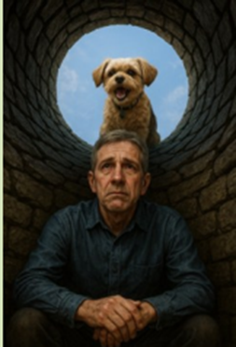
I was deep. Low. Buried under the weight of my own life. At the bottom of the well, straining to see if there was still such a thing as light. And when I say bad, I mean it gently, plainly, and without drama. It was bad. I was still standing. Still moving. But only because momentum hadn’t fully given up on me yet.
And into that moment walked Henry. Unaware. Unburdened. Unimpressed by existential despair. Henry, without even knowing it, became my accidental instructor in survival.
The Theology of the Potato Chip
He taught me the first and most sacred law of recovery: when life becomes unbearable, take a nap. Henry does not spiral. He does not ruminate. He sleeps. Deeply. Committed. Like rest itself is a protest against despair. And more often than not, when you wake up, things do feel different. Not fixed. But lighter. Looser. Possible.
He taught me that sometimes hope is not a grand vision. Sometimes hope is a stolen potato chip. Something small. Salty. Immediate. Something that reminds you that taste still exists.
Henry, Thora, and Family Systems

He taught me about family systems, especially the highly unstable diplomatic relationship between dogs and cats. We have a cat named Thora. She is clever. Strategic. Unreasonably confident. She will lie on the couch just close enough to Henry to provoke him without consequence. Perfect posture. Unbroken eye contact. Stillness so pure it feels personal. She does not move. She dares.
Henry does not see symbolism. Henry sees disrespect. And every so often, he reminds Thora that peace is not guaranteed forever.
Henry taught me something there, too. Sometimes you practice restraint. Sometimes you practice humility. And sometimes, wink-wink, you bark back at what keeps taunting you from the couch.
Returning to Life
But the deeper lesson Henry gave me was not about rebellion. It was about returning to life.
Henry, in all his quirky, chaotic, unapologetic ways, taught me to climb again. To breathe again. To adventure again. To remember that joy does not require your permission to return. He taught me that not everything has to be so heavy. That not everything requires analysis. That some days you just chase the sound of happiness down the hallway and see where it goes.
He taught me that when the world feels like it is sitting on your chest, you are allowed to make noise about it. Bark a little. Stir the air. Refuse to fade quietly. Stay in the game. And then he taught me the lesson that surprised me the most. Sometimes you do not need to fight. Sometimes you do not need to run. Sometimes you do not need to bark at anything at all. Sometimes you just need to love.
Sometimes Henry just wants to be petted. Just to be close. No agenda. No mischief. No crime in progress. Just connection. Sometimes that connection looks like a quiet weight against your leg. Sometimes it looks like him licking your hands and face until you are loudly demanding a towel and questioning every life decision that led to this moment. Sometimes it looks like snuggling when the world finally goes quiet.
Presence as Medicine
And every time it happens, Henry teaches me again. Connection heals without asking permission. Love does not require explanation. And sometimes presence is the medicine. Over time, I realized he was teaching me something even deeper than comfort. Henry was teaching my nervous system how to come home. Without lectures. Without techniques. Without clinical terminology. Just through presence, warmth, and rhythm. Through proximity. Through the quiet intelligence of connection. He taught me the lived experience behind everything I now teach about polyvagal reform, heart coherence, and neurocardiology. Not as theory. Not as charts. But as practice on the living room floor.

When I come home now, I get down on the floor with Henry and the other littles, dogs I mean, and I do not say a word. No phone. No problem solving. No performance. I disconnect from the world and reconnect with the most ancient language there is. Touch. Breath. Stillness. Beating hearts.
And something real happens.
Our nervous systems synchronize. Our breathing slows. Our hearts begin to fall into that beautiful coherent sine wave that radiates not just inside the body but outward, into the room itself. Fifteen feet of healing space. Maybe more. It is impossible to measure love precisely, but you can feel when the air changes.
The Vagus Road Home
Henry taught me that love is not just emotional. It is physiological. It is electrical. It is rhythmic. It is ordered. It settles chaos from the inside out. He taught me that when I live too long in dorsal vagal collapse, when everything goes dim and heavy and far away, I do not need a sermon. I need activation. Movement. Play. Barking. Adrenaline. A return to life through the body before the soul can follow.
And he taught me the opposite too.
When I am too wound up, too driven, too amped in sympathetic surge, he pulls me back into the green zone. Back into regulation. Back into safety. Back into vagal tone. Back into the sacred middle space where healing actually integrates.
That is the place I call Vegas. Not the city. The Vagus nerve pathway of restoration. The place where God meets us quietly after the noise wears off. The place where your nervous system finally believes again that it is safe to be alive.
Henry taught me how to travel there without a map.
The Dog God Sent
And yes, I believe this plainly and without apology.
Henry was sent by God.
Not as a symbolic notion. Not as a poetic metaphor. But as a living conduit of what God was already trying to teach me. That healing is embodied. That faith is not just believed. It is regulated. It is breathed. It is felt. It is synchronized.
Henry did not just teach me NeuroFaith® in my head. He taught me NeuroFaith® in my body. Experienced. Entrained. Integrated.
And somewhere along the way, I had a quiet realization.
The Henry in Me
There is a lot of Henry in me.
I do not bow easily to ideological pressure. I buck against it. I run against the grain when I know the grain is wrong. I do not let the cat provoke me when I have done nothing to deserve it. And when something keeps taunting what is good, what is true, what is hard-fought inside me, yes, I will fight back.
I do not live in fear anymore.
There was a time when I was buried in it. When fear felt like the native tongue of my nervous system. But somewhere between naps, stolen potato chips, reckless joy, and stubborn barking, I chose something else. I chose courage. Tenacity. Spirit. Engagement. I chose to stay in the game.
Henry taught me that too.
When to Bark and When to Snuggle
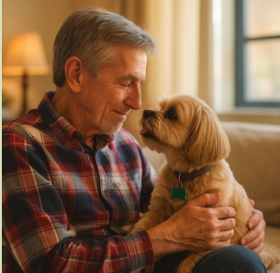
But Henry also taught me the tempering. He taught me how to quiet down. How to stand down when standing down is the wiser strength. He taught me that not every moment demands a charge, not every tension demands teeth. Sometimes the bravest thing you can do is sit still and let yourself be close to someone.
Sometimes you fight. Sometimes you bark. Sometimes you run full speed into joy with no explanation at all.
And sometimes…
You just snuggle.
Henry taught me how to know the difference. When to hold them. When to fold them. And when to run like something beautiful is waiting on the other side of the room.
And if that is not a spiritual education, I do not know what is. Twelve years later, I can say this without exaggeration. Henry did not just join our family. He helped pull me out of the well. He taught me to rest without shame. To take joy without apology. To bark when life presses too hard. To love when nothing else makes sense. And to always be suspicious of a cat that looks that calm.
Not bad for a dog who believes rules are optional, naps are sacred, potato chips are a moral imperative, and love is best delivered at full speed with an open mouth.
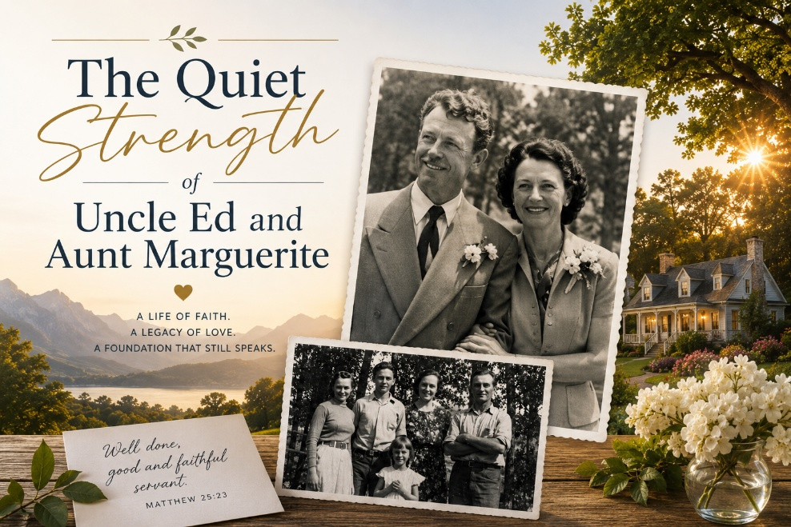
A Foundation Quietly Built
Some people pass through our lives and leave footprints. Others leave foundations. This is written in gratitude for Aunt Marguerite and Uncle Ed, two people who quietly shaped our family forever. Their legacy still speaks, not through what they accumulated, but through how they lived, how they gave, and how they loved.
Aunt Marguerite and Uncle Ed, I wish I had written this before you went to heaven. I truly do. So now I am trusting the angels with the delivery.
They did not live fancy. They lived rich. Not rich in what they had, but rich in what they gave. They were good stewards of the money God placed in their hands. Careful. Thoughtful. Diligent. Not flashy. Not impulsive. Just steady. And somehow through that steadiness they ended up with something our family had never even spoken out loud before.
Millionaire.
That was the first time I ever heard that word in our family lane. But they did not start anywhere near it.

Uncle Ed
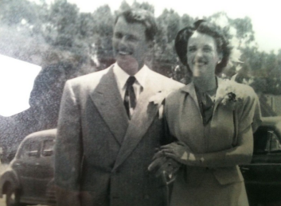
Uncle Ed’s early life still feels partly hidden from me, like a story with missing pages. I know he served in World War Two. I know he was overseas in the Army. I do not even know exactly what his official role was, but I know this about him. He was deeply competent. So competent that he could rise in rank quickly and just as quickly lose it. He liked a nip of the gin. He did not walk away from a fight. So he gained stripes and lost stripes and gained them again and lost them again. Sharp. Capable. Volatile. Very much alive.
When the war ended, he and his buddies panicked like many men did. The world was opening again and they had to figure out how to survive in it. They began working on ideas involving structural honeycomb strength. That eventually became part of the hexagonal structures used in airplane wings, spacecraft, and engineering feats that once sounded impossible.
And Ed rose.
He became a vice president. A real presence. You did not need to hear him bark to know he carried authority. When people heard Ed’s rule, heels snapped. I remember that as a child. That kind of quiet power leaves a mark on you.
Aunt Marguerite
Then there was Aunt Marguerite. Somehow she saw beneath the wild man. Beneath the fighter. Beneath the volatility. She saw diamonds in the rough. It is cliché to say a woman tames a man, but in this case it is simply true. She brought out the best in him.
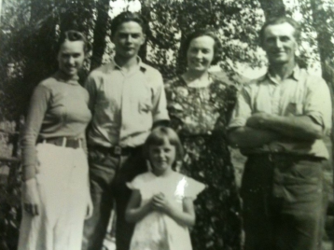
Marguerite, my mother’s sister, came from humble beginnings. She spoke French before she spoke English. The Vouga family emigrated from Switzerland around 1910 and settled in Gunnison high in the mountains. Dirt floors. No plumbing. Bitter winters. That was her beginning.
So, she was tough.
She became a schoolteacher. Music. Choir. She learned how to manage a room with eyes in the back of her head. She could calm chaos without raising her voice. Kind. Tough. Fair. A woman of deep internal authority.
Together, this bar fighter turned executive and this mountain-born schoolteacher quietly built a life that changed the trajectory of our family story.
The House That Held Us
Throughout my childhood there were steady voices. Ed was often overseas building corporate structures around the globe. Marguerite, by the time I came along, was pouring herself into volunteering at church and into family life with that same quiet strength she carried everywhere.
She rarely fought, but she was always gracious. Always loving. Always firm. Always there.
There were huge family gatherings. Sacrificial giving. Tables full. Doors open. Laughter everywhere. And even though my brothers, the Hansen boys, were a little wilder than her well-behaved children, she welcomed us just the same. Her kids were the civilized ones. We were the barbarians. When the Hansen boys came over, the rules had to be battened down.
There was the time I jumped off the balcony into a tiny rubber swimming pool with six inches of water and flattened it. There was the rock through the window. When we showed up, all hell breaking loose was always a realistic possibility.
I remember her saying things like, “Drat, you make me so mad.” But she never became the mad.
She could be firm. And the lessons she taught were unforgettable.
Soap in the Mouth and Lessons in Love
I once made the foolish mistake of saying a four-letter word in front of Aunt Marguerite. I do not remember the context. I only remember the consequence.
Soap in the mouth. Full stop. Trust me, it never happened again.
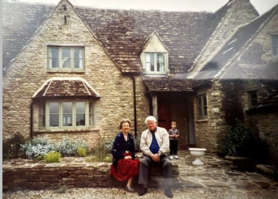
Yet she was always there to encourage. Always there to believe in us. Always expressing pride when we brought home good grades or accomplished something meaningful. She consistently affirmed effort, character, and worth.
When I married my beloved Leah and stepped into military life, Aunt Marguerite and Uncle Ed were still there. They visited us. They rented places in France, even Chamonix, places of ridiculous beauty, and quietly paid for everything. You never went to a gas station with them without Ed paying for the fuel and slipping you extra money.
And then there was the generosity toward the entire family. Always equal. Always fair. Always generous.
But the deepest gifts were never financial.

The Words That Stayed
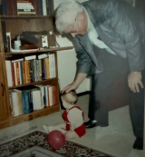
There was a low moment in my life when Ed came up alone, just the two of us. He said things I never forgot.
“Jeff, you have to play the cards you have been dealt. Pity is a bad thing. Do not pity yourself.”
And later, during a rough season in my practice when I talked about returning to the Army, he looked at me and said, “Jeff, you cannot go back into the womb.”
Those words stayed with me. They still echo.
There was also a moment when I was being selfish somewhere in Europe. I did not want to buy something for Leah even though I had the money. I was simply being a penny pincher. Aunt Marguerite quietly pulled me aside.
“Jeff, when Ed and I first got married we had nothing, but we shared the nothing.”
Ouch.
Lesson learned immediately.
The Final Courage
As the years rolled on, Ed and Marguerite remained pillars of strength for our family. They modeled something my family, beautiful as it was, did not always have in abundance.
Stability.
Strength.
Consistency.
Then I watched the final courage.
Ed passed first. Marguerite followed a few years later, both into their nineties. A long life. A full life. A life marked by humility, gratitude, discipline, and giving. And in the end they gave us one final gift.
They showed us how to leave this world.
How to die.
How to let go.
I never heard them complain. I never heard them whine. They stayed grateful. Thoughtful. Generous. Right to the very end. And the way they faced death remains one of the most powerful legacies in my heart.
What Never Fades
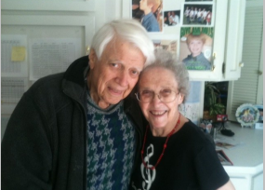
They blessed untold people. Their benevolence went far beyond our family. They paid for the burial of a distant cousin who had no money and no one else. They brought exchange students into their home, and those students did not remain students. They became family. They gave quietly. Repeatedly. Without applause. Without announcement.
They did not merely leave money behind.
They left a model of how to live. How to give. How to remain steady. How to open the hand. How to let go with dignity and peace.
And that is what never fades.

My love, Schatz,
I’ve been sleeping pretty well on this trip while taking care of Mom, but last night was different. I woke up around two or three in the morning after a dream about you. It was such a good dream. Nothing dramatic, nothing heavy. We were just laughing, goofing off, being silly together. It stayed with me in that quiet, lingering way dreams sometimes do, and as I lay there awake, it reminded me of what I love about you and about us.
We’ve had a really good life. Truly. When I look back over the seasons we’ve lived through together, I feel deep gratitude. I don’t carry many regrets, but there are a few, and I want to be honest about them. One of them is how much I disappeared into my striving.
It’s been a long road. Longer than I sometimes admit. Fifteen years, really, working so hard to get ahead, to recover, to prove something. The recovery itself was brutal. The medication injury from the benzos took so much out of me. Leaving and going to Madigan was a good thing, but even then, I felt like I had to show I was still someone. Still worthy. Still impressive.
And that pattern followed me again later, wanting to do well, wanting to be noticed, wanting to be first. I think some of that was running from pain, especially from losing Greg and the way that chapter ended. And then the ending at AnchorPoint was hard. Disillusioning. On one hand, I feel good about what I gave and what I built. On the other, I’m still grieving how it all came apart.
I know I have a gift. I believe I’ve stewarded it well in many ways. But if I’m honest, I’ve lived with too much throttle and not enough brakes. And now here I am, in this strange and quiet in between, trying to figure out who I am without the roles, without the organization, without constantly proving something.
I’ll still speak. I’ll still write. I’ll still create. But letting the professional identity move to the back seat, at least for now, feels like the work in front of me.
That dream with you brought something into focus. It reminded me how much I want to laugh with you. I want to play with you. I want this next decade of our lives to feel different, lighter, freer, more us.
And I’ll be honest; I don’t fully know how to do that yet. My mind doesn’t shut off easily. It’s full of ideas, books, projects, and thoughts that all want out at once. Sometimes that creativity is a gift. Sometimes it’s exhausting, for you and for me.
As I look ahead, I want to approach this next phase of our life the way I ride a motorcycle, with everything I’ve learned along the way. I still love speed. I still love momentum and the thrill that comes with it. But real riding teaches you that the joy isn’t just in going fast, it’s in staying whole.

When you’re trail braking into those thrilling, hair-splitting turns, it isn’t dramatic inputs that carry you through. It’s subtlety. Two fingers on the brake, gentle and steady pressure, a hand still on the throttle making small, intentional adjustments. Just enough braking to load the front wheel, just enough restraint to keep the bike settled as you lean in. Too much brake and you lose it. Too much throttle and you run wide.
But when you get it right, there’s a tremendous satisfaction in it, a smoothness and confidence that feels almost effortless. That’s the thrill I want to have with us. Loving the speed, the excitement, the forward motion, while knowing that braking, real braking, is part of what keeps us upright, intact, and still enjoying the ride together.

In the dream, there was no agenda. No pressure. No outcome to manage. Just laughter, yours and mine. And I know dreams are just dreams. I’m not turning it into something mystical or prophetic. But it does say something about where my heart is pointing and what I want to protect and grow with you.
I want travel. I want play. I want moments that don’t need to be productive to be meaningful. I want us. And I’m praying about how we do that, how we realign, how we make space, how we let God guide us without becoming stiff or joyless in the process.
I don’t have this all figured out. But I wanted you to know what stirred in me last night, and how deeply I love you. I want the next chapter to be written together, with more laughter than striving, more presence than proving, and more freedom than fear.
Always in love with only you,
Jeff
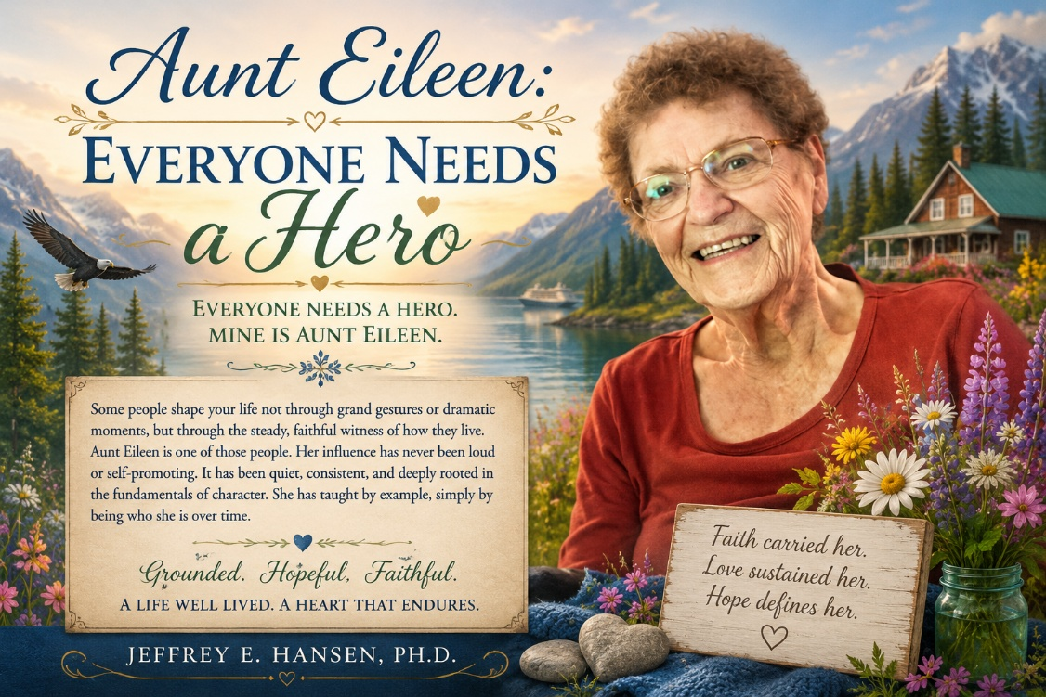
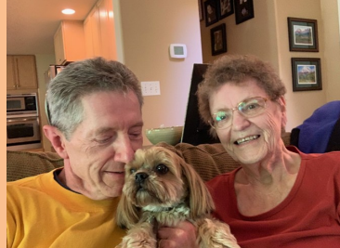
Aunt Eileen: Everyone Needs a Hero Everyone needs a hero. Mine is Aunt Eileen. Some people shape your life not through grand gestures or dramatic moments, but through the steady, faithful witness of how they live. Aunt Eileen is one of those people. Her influence has never been loud or self-promoting. It has been quiet, consistent, and deeply rooted in the fundamentals of character. She has taught by example, simply by being who she is over time.
Aunt Eileen was born in Nebraska and raised in the rhythms of farm life, a world that teaches patience, responsibility, and respect for what truly matters. Work was expected. Life was not romanticized. Values were formed early and tested often. That kind of upbringing leaves a mark, and it marked her in the best possible ways. From an early age, she learned endurance, humility, and the discipline of showing up day after day, whether the circumstances were easy or hard. She is my father’s younger sister. Growing up, they were not especially close. Childhood dynamics, personality differences, and the quiet complexities that often shape family relationships created distance between them early on. But time has a way of clarifying what matters most, and life has a way of softening edges that once seemed fixed. What became clear as the years unfolded was this.
Aunt Eileen possessed a grounded optimism that did not depend on circumstances. It was not naïve, and it was not fragile. It was forged in reality, shaped by work, loss, responsibility, and perseverance. If I had to choose one word to describe her, it would be grounded. If I were allowed a second, it would be hopeful. Not the shallow hope of wishful thinking, but the durable hope of someone who refuses to let hardship define her spirit. She is, without exaggeration, one of the most optimistic people you could ever hope to meet, not because her life was easy, but because she learned early how to live faithfully within it.
Motherhood and Heartbreak
Aunt Eileen married Uncle Bill, and together they raised three children, Billy, Timmy, and Kathy. Our Colorado cousins. Visiting their home was always an adventure, filled with energy and warmth. They were roughly our age, close enough that time together felt natural and easy. Aunt Eileen raised three remarkable children, all successful in their own right. That outcome was no accident. It reflected years of consistency, care, and moral grounding. Life, however, brought a sorrow that cut deeply. For reasons the family does not fully understand, Billy broke ties abruptly with Aunt Eileen and with the rest of the family. There is conjecture, perhaps related to his marriage, but conjecture is all it is. What remains is the silence. For decades now, Billy has not spoken with her. This has been a grave wound. It is the kind of loss that could harden a heart. It did not harden hers. She continues to love Billy. She prays for him. She hopes for restoration. We all do.
Loss, Work, and Reinvention
Aunt Eileen’s life held other hardships as well. In a tragic car accident, Uncle Bill was gravely injured and ultimately lost his leg. He was a good man in many ways, but he struggled with alcoholism, and the strain eventually dissolved their marriage. It was a painful and defining season. Later, she married Kenzie, a Marine who served in World War II at Tarawa. He was one of the men who drove the boats onto the beaches. A brave man. A steady man. A man who carried the wounds of war with quiet dignity. Kenzie had a long history in commercial construction. Together, he and Aunt Eileen built a residential construction company in Grand Junction, Colorado. For a time, the future looked promising. Anticipated shale oil development brought real hope and momentum. They invested deeply, believing the work would endure. Then the investment never came. The economy flattened. The business collapsed. They were forced to file. Years of work and hope were lost. It was devastating.
Leaning into Life
When Kenzie and Aunt Eileen came together, they also had a son, Les. I do not know Les as well as the others, but I know him well enough to say this. He is a fine man and a reflection of the values with which he was raised. After losing their business, Aunt Eileen and Kenzie chose not to retreat. They bought a beat up little RV and spent several years traveling the country. Even as Kenzie’s health declined, they made the most of every mile. They studied genealogy, stayed curious, and remained deeply connected. They would roll through Olympia, where we lived, and those visits remain some of my most cherished memories. In the midst of loss and uncertainty, Aunt Eileen did not complain. She simply lived.
Faith, Family, and Courage
After Kenzie’s death, finances remained deeply depleted. Aunt Eileen moved into government subsidized living, a modest residential community of elderly men and women living with similar limitations. What could have been isolating became connective. She found community, friendship, and spiritual depth. In this later season, Aunt Eileen and my father found each other. Through shared hardship and shared faith, old wounds softened. They spoke openly. They listened. My father often said he had finally found his sister. Aunt Eileen’s body has aged, in part due to diabetes. She is losing her eyesight and walks with a walker. Yet her soul sees clearly. Her heart resonates with the world around her. Though she walks with assistance, she walks with courage, grounded in what truly matters.

Alaska: A Gift of Presence
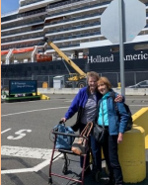
In 2018, my mother gave Aunt Eileen a remarkable gift. She paid for her to join us on a trip through the Inside Passage of Alaska. At the time, it felt generous. In retrospect, it feels almost providential. We had the quiet joy of having Aunt Eileen with us for that journey, and it quickly became clear that we were the ones who had won the lottery. Her presence transformed the trip. Her delight, her gratitude, and her steady joy eclipsed even the grandeur of the scenery unfolding around us. And that is saying something, because Alaska has a way of humbling you with its beauty.
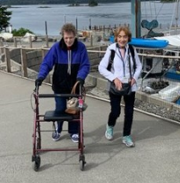
I will never forget watching her take it all in. The mountains. The water. The vastness. But more than that, the companionship. The shared meals. The conversations. The simple pleasure of being together. She carried herself with the same quiet attentiveness she brings to life, receiving each moment as a gift rather than a given. There was something deeper happening on that trip as well. My mother had recently experienced significant loss. Aunt Eileen, though actually younger, had endured that loss earlier. She had lost Kenzie first. Both women were now facing life alone after profound grief, standing on similar ground but at different points along the same road.
In Alaska, there was an unspoken kinship between them, not rooted in comparison or sorrow, but in understanding. What struck me most was how Aunt Eileen, having walked that road longer, seemed naturally to lead the way. She watched over my mother in subtle but meaningful ways. Encouraging her. Bolstering her spirits. Gently redirecting her attention toward what was still good, still beautiful, and still worth savoring. She did this without instruction or fanfare. It is simply who she is. That trip did not erase pain for either of them. But it built something enduring. It lifted their spirits. It reminded them, and all of us, that even after profound loss, life still holds beauty, connection, and joy. When I think back on Alaska, I remember the scenery. But what stays with me most is Aunt Eileen’s smile, her laughter, and the way her presence made the experience richer for everyone. What an incredible privilege it was to share that time with her. And what an encourager she has always been.
Rich Beyond Measure
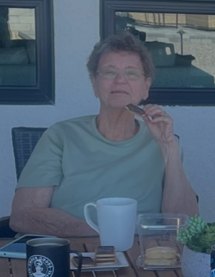
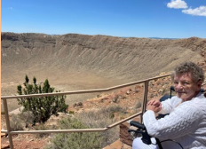
We had Aunt Eileen stay with us last year. I watched her rise each morning, steady herself, and step outside. Though her vision is limited, she could still see beauty. She could feel the sun. She spoke only of gratitude. Never complaining. Never bitter. When I need courage, Aunt Eileen is a phone call away. Her words carry weight because she has lived them. I often say, if Aunt Eileen can see the sunshine, why can’t I.
If she can walk with faith, why can’t I. She may be poor by bank account standards, but she is rich in heart, rich in joy, rich in encouragement, and rich in inspiration. Those riches will go with her. She will leave this world knowing she did not leave behind wealth, but something far greater. A legacy of love. I love you, Aunt Eileen.


I have always loved the old Michael Landon show Touched by an Angel. There was something deeply comforting about the idea that in moments of transition, weariness, or uncertainty, heaven might quietly lean in and remind us that we are not alone.
This weekend, we were not touched by an angel.
We were touched by two.
After resigning my leadership position at Holdfast Recovery and AnchorPoint, my wife and I found ourselves standing at the edge of a new season. The transition came a bit sooner than I anticipated and with more stress than I would have chosen. Even so, beneath the weight of change, there was also relief. I had loved much of the work despite the administrative struggles, and we wanted to pause together, to breathe, and to mark the beginning of whatever was coming next.
We planned a short retreat to Sedona and reserved a room at A Sunset Chateau; a small and intimate bed and breakfast nestled beneath the Red Rocks in Sedona. It felt like the right place to rest and reflect.

Then life intervened.
My mother became gravely ill with double pneumonia and sepsis, and I had to take an immediate flight to Nevada. For a time, it truly appeared that she might not survive. By God’s mercy, she did, and for that I remain deeply grateful.
Our trip had to be postponed. Because the reservation had been made only days before, the policies of the small boutique inn did not allow for refunds. Understandably so. Places built with care and intimacy cannot easily absorb sudden losses. At first, the answer was no.
Then someone asked again.
And that simple act of kindness opened a door.
A Sanctuary Beneath the Red Rocks
When we finally arrived at Sunset Chateau of Sedona this past weekend, we had no idea how deeply it would touch us.


From the moment we stepped onto the grounds, the atmosphere felt different. The gardens were extraordinary. Fountains whispered softly, small waterfalls flowed into gentle brooks, twinkling lights appeared as evening settled in, and tucked throughout were quiet sitting areas inviting reflection. These were not gardens created only by skill, though the craftsmanship was remarkable. They were gardens shaped by love. You could feel it in every corner.
Our room opened to a view of Sedona’s red rock cliffs, a sight that greeted us each morning with quiet awe. The beauty seemed to warm the heart before a single word was spoken. Inside, every detail felt intentional. The beds, the chairs, the softness of the space itself made you feel wrapped rather than impressed. It was the kind of place that made you think you could truly live there, not because it was large, but because it was held.
Breakfast and Connection
And then there was breakfast.

Each morning brought something different and each meal carried the same unmistakable quality of care. Food prepared not merely to satisfy hunger but to nourish the soul. A breakfast burrito that may be the best I have ever had. A blueberry waffle that somehow converted a lifelong skeptic. Huevos rancheros so rich and balanced they redefined the dish altogether.

Yet what stood out most was not the food, remarkable as it was, but the presence behind it.
Each morning the owner walked from table to table, laughing, listening, lingering. It was not routine. It was intention. He was not simply checking in on guests. He was connecting.
When he finally joined us, we learned his name was Philippe. From the moment he sat down, his warmth was unmistakable. There was kindness in his eyes and a genuine curiosity in his questions that went far beyond hospitality. He truly wanted to know who we were. Later his wife Janet joined us, gentle and radiant, her presence steady and deeply grounding.
Swiss Roots and Shared Faith
As we talked, we discovered something beautiful and unexpected.
Philippe is Swiss, raised in Martigny in the Swiss Alps. Later he lived in Lausanne, a city that holds profound meaning for me as well. My family moved there so I could study French and reconnect with our Swiss roots, and it remains one of the best years of my life.

Philippe later moved to Paris to study sculpture and the arts, following his deep love for design, beauty, and form. Janet was also studying art there, and it was in Paris that their lives became intertwined and their shared journey began.
During the 1970s, Philippe experienced a powerful transformation of faith in Jesus Christ. It was not shallow or momentary, but a deep and enduring change of heart. Remarkably, around that very same season of life, I too came to faith. We spoke of how those early encounters with Christ shaped everything that followed. We also discovered that both of us married women of deep faith, women whose spiritual strength has anchored our lives and callings in countless ways.
For a time, Philippe even worked in addiction recovery using faith-based therapeutic approaches, which created yet another meaningful connection with my own work and the development of the NeuroFaith model. Our stories, though lived continents apart, echoed one another in ways neither of us could have anticipated.
Eventually, with great courage, Philippe and Janet made the decision to leave Europe and return to the United States. There they discovered what would become Sunset Chateau of Sedona, a property that was, at the time, nearly dilapidated. Yet Philippe’s gift for architecture and design, paired with their shared vision and faith, allowed them to see not what it was, but what it could become.
Through perseverance, artistry, prayer, and trust in God, they rebuilt it into the beautiful sanctuary it is today.
A Ministry, Not Merely a Business
Yet it became clear that what they had built was never meant to be only a business.
It was a ministry.
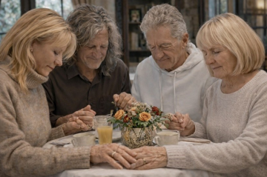
They spoke of lives touched, prayers offered, stories of healing and redemption, not with pride but with humility and gratitude. Though their work brought provision, money was never their measure of success. What mattered most were the people who walked through their doors and the sacred responsibility of caring for their hearts.
In that moment, we were among those people.
We shared openly about our family and about our daughter, her painful divorce, the season where she lost her footing, and the courage it has taken for her to begin finding herself again. There was no need to protect appearances. We felt safe.
Prayer Around the Table
And then, without hesitation or apology, we prayed.
The four of us held hands around a small table. What followed was not a brief or polite prayer, but something deep and unhurried. A prayer filled with compassion, faith, and hope. Time seemed to soften. Something eternal was present.
Because when brothers and sisters in Christ meet, something holy awakens.
When we finally left Sunset Chateau of Sedona, we carried more than rest with us.
We left refreshed in body, nourished in spirit, and strengthened in heart. We arrived as guests, but we left as family.
Touched by Angels
Yes, we were touched by two angels, and we will never be the same.
It is rare that two lives can touch you so deeply in a single three-hour conversation, in a way that stays with you long after the words have ended. Yet that is exactly what happened.
What a gift.
And perhaps Scripture says it best:
“Do not forget to show hospitality to strangers, for by so doing some people have shown hospitality to angels without knowing it.” (Hebrews 13:2)
Yes, truly, we were touched by angels.


A House That Holds Love
Ken and Karen,
As I reflect on heading home after coming up here because of Mother’s near passing from double pneumonia and sepsis, I’m struck by just how much this house matters. We very nearly lost her. There were moments when everything felt fragile and uncertain, when the outcome was far from clear.
Being here these past days has made something unmistakably clear. This house is more than a structure. It has become a place of safety and refuge, a place where love has gathered and taken form. It is helping Mother feel safe again, and now giving her body and spirit the room they need to heal. The care that has gone into this home is real. It’s tangible. It’s felt.
I see the love you’ve poured into this house, the care you’ve taken to make it a beautiful and truly livable place for her, and honestly, it’s amazing. You’ve taken on a lot of responsibility in caring for her, and I know that hasn’t been easy. But you stepped up, and you’ve done it well, with commitment, steadiness, and heart.
Ken
Ken, man, as a contractor, you really rocked it. I see your devotion to Mother, your desire for things to be done right, and your willingness to jump in and fix whatever needs fixing, including that ceiling leak. Your background and expertise really showed, and pulling all of this together as a kind of general contractor is no small feat.
Brother Greg would be proud of what you accomplished here. This is a beautiful house, and I genuinely love the space you’ve created and the care that’s evident in every part of it.
Karen
Karen, what can I say? You’re the detail person, and I see it clearly in so many ways. Your patience, your care, your concern, and the way you handle all the small, unglamorous administrative things, the things that quietly hold everything together, are incredible.
There’s not much glory in that kind of work, but without it, things fall apart. You are an infrastructure person with a great heart, and I’m genuinely thankful for you and for all that you carry.
Lou and Ray
It was also really good getting to know Lou a bit. I see so much of his dad in him, it’s honestly striking. He has a generous heart and real compassion, and it was a pleasure working alongside him. He brings skills this old guy doesn’t have, and I appreciated that more than I can say. I truly hope he finds his footing, because there’s a lot of good there and a lot of potential waiting to come alive.
And Ray, her intelligence really stands out to me. She has a Lovelace level mind, and I sincerely hope she pursues nursing. I see pain in her, but I also see so much promise and depth. The fact that you’ve plucked her out of a difficult environment and brought her here says a lot about your hearts and your willingness to show up for someone who needed it. I look forward to getting to know her better over time.
Juliet and Nicholas
Juliet, I want to thank you in a very personal way. You have been unfailingly supportive of Mother, so patient with her, and so genuinely kind. You have a remarkable ability to stay loving, grounded, and firm when she slips into her little modes, without reacting or escalating things. That kind of steadiness is a real gift.
You so graciously opened your home to Mother and allowed her to stay there for as long as she needed, making her feel nothing but welcome, comforted, and cared for. You have been such a positive and stabilizing force in her life, and I am deeply thankful for you and for the way you love her so well.
Nicholas, I want to thank you in a deeper way as well. As I’ve stayed in this house over these last several days, I’ve been struck by your craftsmanship, your artistry, and your commitment to excellence in the way things were built and put together. I see it in the details, in the bathrooms, in the finishes, and in the care taken throughout the space.
What really stands out to me is that I see love in that work. I see a love for Mother that translates through what you’ve created, and it’s felt. This house carries that care. Thank you not only for your hard work, but for the gift you’ve given her in creating a space that feels safe, beautiful, and deeply considered.
Mother’s House
So truly, Ken, Karen, Juliet, and Nicholas, well done. I can head home on Saturday with real peace in my heart, knowing Mother is loved, well cared for, and in very good hands. Bringing her here was a brilliant move, and I’m deeply grateful for the way each of you has made that decision come to life.
And to my dear cousins, Leah, and Francoise, thank you for your love, your support from a distance, and the way you’ve surrounded her during this season.

Mother, may this house continue to wrap its arms around you as you heal. I am so proud of you for your grit, your courage, and the strength it took to pull through what could have taken you from us. Keep healing, knowing that you are deeply loved.
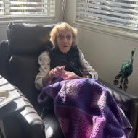
You are loved not only by the hearts of Ken, Juliet, Nicholas, and Karen, but by your extended family as well, those who are not here in person, but who surround you still. Their hearts reach toward you. Their prayers rise for you. Their love is with you.
This is Mother’s house, built on love.
And that love will continue to carry you forward.
With love always,
Jeff

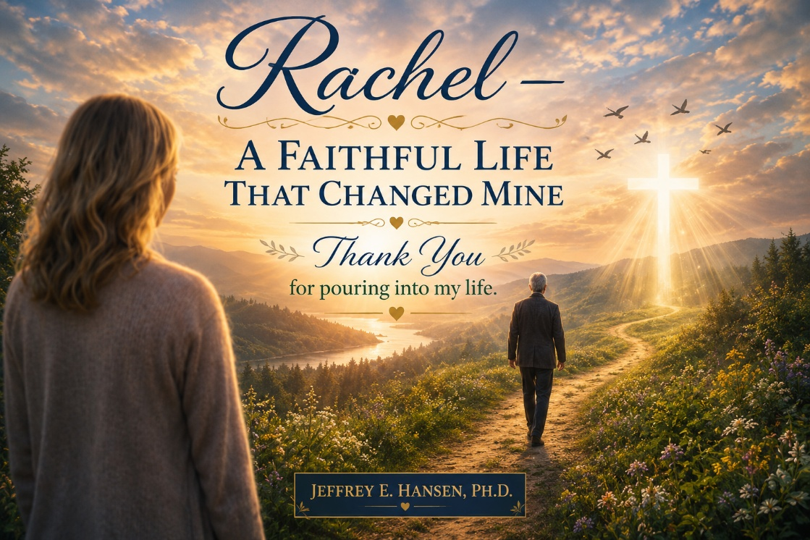
The Presence That Kept Coming Back
There are moments in life when you realize that everything changed because one person cared enough to keep showing up, and for me that person is Rachel. We were just kids at the same high school, both gymnasts, both intense and driven in our own ways, and yet even then she carried something I did not have language for. There was a steadiness about her that you could feel before you could name it, a kindness that never felt forced, an openness that made being around her feel peaceful and grounded.
You always felt better in her presence. Her faith was not something she argued for. It was something she lived. It came from a heart that was settled and a soul that seemed at rest in God, and even as a resistant, argumentative teenager I could not fully dismiss what I experienced when I was near her.
She and her friend Karen would come to our house, and my dad would say, half amused, “The missionaries are here,” and I turned it into verbal combat. I debated. I pushed back. I was not kind. I had no interest in faith and every intention of proving her wrong.
And yet she kept coming back.
Not with arguments but with patience. With gentleness. With a love that never humiliated me for being where I was. She offered connection before I wanted it. She offered peace before I knew I needed it. She stayed present in a way that planted something in me long before I had any framework for understanding it.
The Night That Opened My Life
Her strength had been shaped in places most people never saw. Her father, in many ways a decent man, could also be hard to be around, and then he died when she was still very young. She became the first person my age I had ever known who had lost a parent, and even then, there was in her, a resilience that was quiet but unmistakable.
She remained hopeful.
She remained optimistic.
She remained faithful.

That same courage showed up in the way she lived with joy. For a time, she dated my brother after he had come to faith, and she rode a Honda 400 Four motorcycle, the only girl in our entire circle of friends who rode. It was fearless and joyful and so completely Rachel, moving toward life rather than shrinking back from it.
Then came that night at the church, at the rehearsal for the gospel group she was singing in. They were honestly very good, and when they finished, they sat down together on the floor of the stage and prayed, the singers themselves, with a sincerity that was completely real. There was no performance, no pressure, just a reality I could not explain away, and in that moment, I knew they had something I did not have but deeply wanted.
So that evening I prayed and asked Jesus to come into my life without fully understanding what that would mean, and yet everything began to change.
The Life Rachel Helped Build
As my faith began to take root, God started revealing the places in my life that were not aligned with the life I now wanted to live with Him. One of those places was a relationship I cared about deeply but that was not honoring to Him, and in obedience, and with real sadness, we chose to go our separate ways.
At the time I did not understand that costly obedience is often the clearest testimony. But Joyce watched. She saw that something real had taken hold in me. And later she said words I have never forgotten:
“If this faith thing is good enough for Hansen, it’s good enough for me.”
And she came to faith in her own genuine and beautiful way, went on to marry a pastor, and became a singer in a gospel group that traveled around the world, carrying the very hope that had first reached both of us through Rachel’s faithful presence.
And then there was the day Rachel said to me, with that gentle knowing smile that always meant she was about to say something both honest and kind:
“I have somebody in mind I know you will like. She has all your specifications.” Wink, wink.
It still makes me smile because it was never about a checklist. It was about how well she knew me and how much she cared about the kind of life I would live.
And she was right.
Leah is grace and depth of faith and depth of character and depth of heart, beautiful on the inside and beautiful on the outside in a way that endures through decades of life and calling and children and joy and suffering.
How blessed I was that Rachel loved me enough to want that kind of life for me, that she would pray for me, that she would foster that connection, that she would see something in me I could not yet see in myself.
Apart from Rachel I would not have found Jesus. I would not have found Leah. I would not have had the children who became such profound blessings. I would not have had the spiritual direction that shaped everything I am.
All because one person kept showing up.
A Life That Endures
Her own life has been marked by deep pain. The loss of her little boy at about five years old was a sorrow that would have broken many, and not long after that came cancer, a battle she faced with the same quiet courage and faith that have always defined her.
She came through it in ways that felt nothing short of miraculous, continuing to love, to give, to encourage, to live for others. Over the years the cost of that suffering, the accumulated weight of grief carried with such grace, and now the frailty of her heart and body have slowly taken their toll.
And yet through it all she has remained the same at her core, warm and open and faithful and courageous, always thinking of others, always loving, always believing.
There are people whose faith is something they talk about.
Rachel’s faith is something you feel when you sit next to her.
It settles you.
It steadies you.
It reminds you of who you are and whose you are.
The Meaning I Discovered Decades Later
Only decades after meeting Rachel did I find language for what I had experienced in her all along. Long before I studied the brain and the heart and trauma and healing, I had already encountered relational connection, a settled presence, a life aligned in faith and love.
What I would eventually call NeuroFaith® was first lived out in front of me by Rachel.
She created safety before I believed I needed it. She offered connection before I was willing to receive it. She carried a faithful presence that allowed transformation to take root in another human being.
Before there was a model there was a relationship.
Before there was theory there was a life.
And when I look at my faith, my marriage, my children, my calling, and the work I now do in the world, I know who kept showing up.
Before NeuroFaith® had a name it had a face.
Her name is Rachel.
And when I think of your life now, Rachel, what comes to me is that lifelong constancy. You were steady when I was restless. You were kind when I was combative. You were faithful when I did not yet know what faith meant.
You never forced.
You never shamed.
You never turned away.
You simply kept loving, kept believing, kept showing up, and in doing so you gave me a life that surpassed anything I could have imagined for myself.
You gave me direction when I had none.
You gave me value when I did not know my own worth.
You gave me a way by living the way, embodying the very faith you spoke about with a constancy and a grace that never faltered.
Scripture says that those who lead many to righteousness will shine like the stars forever and ever, and that is your life. And I carry it in mine with unending gratitude until the day we stand in that same light together again.
Thank you, Rachel.
Jeff, your loving brother in Christ.

A Presence You Can Feel
Hazel Grace has been with us long enough now that it feels as if she has always been here. Six or seven years, give or take, which in dog time is a lifetime and in heart time no time at all. She is a Shorkie, that improbable blend of Yorkshire Terrier resolve and Shih Tzu charm, with the squish nose, the oversized head, and the sturdy little body that looks as if it was designed for one primary purpose: disarming the human race through cuteness. She can get away with almost anything because the face appears and judgment quietly dissolves.
But her real gift is not her cuteness.
Her real gift is presence.
Leah, Daphne, and the Legacy of Attunement

That story begins, as so many good things in our home do, with Leah. Long before Hazel ever wore a hospital vest, Leah had already lived a life of attunement with animals that most people only glimpse. Horses settle around her. Dogs orient to her. Anxious creatures sense that she carries no threat. She does not talk about regulation. She lives it.
Years ago, that steady presence formed an extraordinary bond with Daphne, our Sheltie, who became a hospital visitation dog and Leah’s inseparable companion. Losing Daphne was not simply the loss of a beloved dog. It was the loss of a shared rhythm. The grief was deep and real and quiet.
The Calling and the Purple Uniform
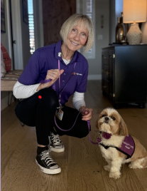
Hazel came later and she came differently. Not the instant scholar that a Sheltie can be, not the effortless prodigy, but a little more Yorkie in her negotiation with the universe. Training her for hospital work took time, patience, and the kind of faithful consistency that Leah gives to everything she loves.
COVID slowed the process but never stopped the calling. And the day Hazel finally passed the test, that demanding evaluation for visitation dogs, something beautiful came full circle.
Now there is a ritual before visit days. The bath the evening before. The quiet preparation. The purple Dignity Health uniform. The badges. Hazel watching every movement with growing awareness that she is going to work. When they leave the house together there is a sense of purpose that is almost liturgical. And when they walk through the hospital doors, people know her. Not as a program. By name.
Softness That Goes Beyond Fur
The first thing everyone says is the same.
She is so soft.
They say it with surprise, almost reverence, as their hands sink into that impossibly gentle fur. And yes, her coat is extraordinarily soft, but that is not what they are really talking about. What they are feeling is the softness of her presence, the absence of threat, the tenderness of a nervous system that has nothing to defend and nothing to prove.
She is soft in the way safety is soft, in the way welcome is soft, in the way grace is soft. You can see the realization cross their faces as they continue to stroke her. They are not just touching softness. They are being met by it.
Eyes Like a Full Moon
And then there are her eyes.
They are enormous, the size of saucers, the size of a full moon, and she knows exactly how to use them. She does not glance and move on the way most dogs do. She settles into the gaze and holds it. As children we used to have staring contests to see who could last the longest without blinking. Hazel could easily win every time.
There is no anxiety in her, no need to break the connection, no flicker of avoidance. She simply stays.
It feels less like being looked at and more like being received.
She looks into a person as if she is trying to drink them in, as if their presence is something to be absorbed and cherished. It is steady, unhurried, and completely unafraid. People begin to smile, then they soften, and then something deeper happens, because it is almost impossible to be seen that directly without becoming more present yourself.
Co-Regulation in Real Time
Because she arrives already settled, the person in front of her begins to settle.
Her body is loose and grounded. Her breathing is slow. Her heart moves in that smooth, coherent rhythm that comes with safety and connection. She is the stronger, more regulated nervous system in the interaction, and the other nervous system begins to co-regulate to her.
Shoulders drop. Hands become gentle. The hurried pace of the room slows. Their physiology finds her physiology and rests in it for a while.
You could describe it in clinical language, in terms of polyvagal pathways and relational neuroscience and the synchronization of living systems but standing there in a hospital room or on a sidewalk does not feel technical.
It feels like relief.
It feels like being seen.
It feels like coming home.
She proclaims something without speaking. She emanates what can only be described as the love of God, not as an idea but as an atmosphere. People feel received in her presence. They feel, for a moment, that nothing is required of them except to be.
The Belly Rub at the Center
And then comes her signature act. She rolls onto her back and offers her belly with complete trust. In that instant there is laughter, touch, eye contact, and the quiet alignment of two nervous systems coming into balance.
It is the passing of the peace on four small legs.
The Neighborhood Ritual
In the neighborhood she has her chosen people and her chosen houses. She will stop mid-walk and sit facing a front door with absolute confidence that love will appear. If no one comes out, the disappointment is real and almost comical. But when the door opens, she can barely contain her joy.
She sits as she has been trained, her entire body trembling with anticipation, tail wagging while she holds the posture for half a second before rolling over in complete surrender.
Every time it happens, something changes in the human being in front of her. The day becomes lighter. The pace slows. The isolation breaks. They walk away carrying a little more regulation than they had before.
The Ambassador of NeuroFaith®
She is the ambassador of NeuroFaith® in our neighborhood without ever using the word.
She brings coherence into ordinary space. She creates connection where there was distance. She demonstrates, over and over again, that healing does not begin with explanation. It begins with presence. A calm body invites calm. A peaceful heart invites peace. A settled nervous system becomes a place where another life can rest.
The Center Holds
This is the ministry of a small dog with impossibly soft fur, full moon eyes that look into your soul without blinking, and an absolute preference for belly rubs over treats.
If her name were translated rather than spoken, it would have to be a word for love in every language at once. Amore. Agape. Phileo. But Hazel Grace is the right name. Because wherever she goes, the center holds. The center of regulation. The center of connection. The place where two hearts find the same rhythm and remember, even if only for a moment, what it feels like to be at peace.
And it all begins with a little dog who arrives already living in that coherence, then looks into you as if you are the most important being in the universe and rolls onto her back, trusting that love will meet her there.
And behind that quiet miracle stands Leah.
Leah, whose heart has always known how to listen to living beings in a language deeper than words. Leah, who carries a presence that horses settle into, that anxious dogs orient toward, that people feel before they understand. This is not an easy calling, though it looks effortless from the outside. It is hours and years and patience and consistency. It is showing up again and again with a regulated heart so that another nervous system can learn safety. It is grief when a beloved companion is lost. It is beginning again. It is the unseen work that turns a small animal into a bearer of peace in hospital rooms and hallways.
Thank you, Leah, for the way you have given that gift to the world. Thank you for the countless hidden hours, for the training, for the tenderness, for the steadiness, for the courage to keep doing work that is holy and exhausting and beautiful all at once. I am never prouder than when you walk out the door on those Thursday mornings, uniform ready, leash in hand, stepping into your calling at Yavapai Medical Center with quiet purpose.

And Hazel, little ambassador of coherence, carrier of the torch, you who do not know the words for what you are doing and yet do it perfectly. You bring love and peace and presence into rooms where they have been in short supply. You remind people of their own hearts. You create connection where there was isolation. You live the gospel of regulation without ever speaking a sentence.
This is what it looks like when love becomes embodied and walks into the world on four small legs and in one faithful human heart.
And I stand here in gratitude for both of you, watching the center hold.
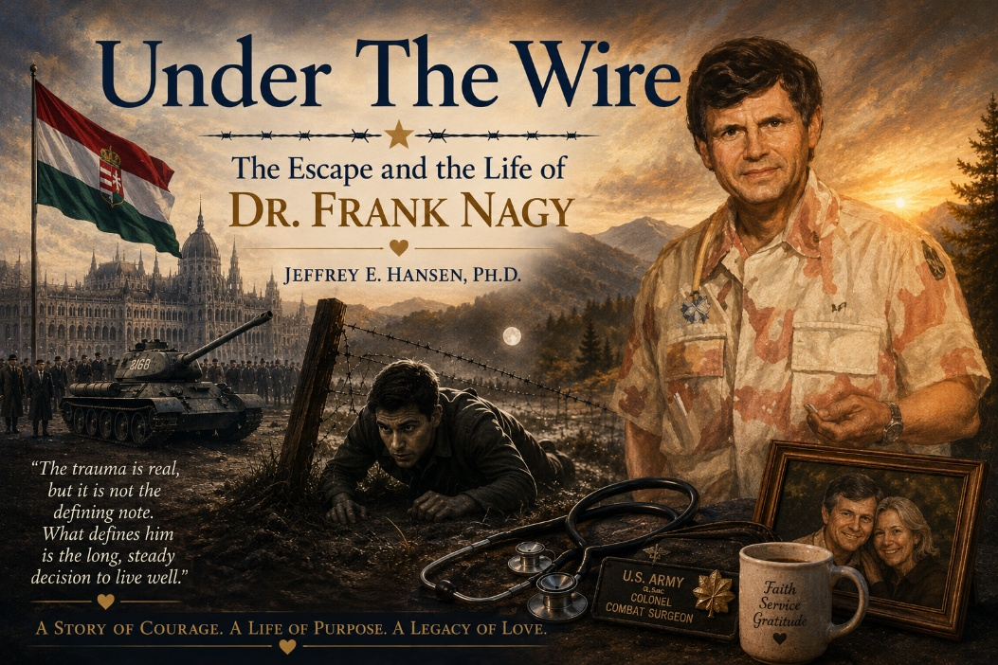
Introduction
Every so often you meet someone whose life quietly carries the weight of history, courage, sacrifice, and grace all at once. In the mountains of Prescott, over coffee and the shared joy of motorcycles and unhurried conversation, I have had the rare privilege of coming to know such a man. Dr. Frank Nagy is, to anyone who encounters him, a gentle and deeply present physician, a devoted husband to his beloved Peggy, and a man whose reflections on life are born not from theory but from experience. At eighty-four he moves with the energy and brightness of someone decades younger. His eyes are alert, his humor quick, his presence warm, curious, and fully engaged. But there is a moment that tells you everything you need to know about him.
If a young mother walks into the room carrying a baby, you will lose Frank mid-sentence. Whatever he is saying simply stops. His entire attention turns toward that child with a kind of reverence that is impossible to miss. He will rise from the table, drawn as if by gravity itself, and before long he is in delighted conversation with the mother, asking about the birth, the child, the name, the first weeks of life. The babies, without hesitation, seem to recognize him. They study his face, reach toward him, settle easily in his presence. To watch this is to understand his whole life in a single scene. This is the physician who spent decades bringing children safely into the world. This is the boy whose own life once hung in the balance in the darkness at a mined border. This is the man who chose, again and again, to orient himself toward life rather than fear. His attraction to the beauty of a mother and child is not casual. It is a lifelong devotion to new beginnings.
And what marks you most deeply, if you spend any time with him at all, is the way he loves his wife. Frank speaks of Peggy with the joy of a young man newly in love. There is a freshness in it, an unmistakable delight, a daily gratitude that cannot be manufactured. After everything he has seen and survived, the center of his life is not his accomplishments, not his rank, not even his remarkable story. It is the simple and radiant fact that he and Peggy walk through this world together. Their love carries the settled strength of decades and the sparkle of something newly discovered. To witness it is to be reminded that a life lived well does not grow hardened. It grows tender. What strikes you first is not the history he carries but the lightness with which he carries it. When we first met, I knew him only as the thoughtful man across the table, a riding companion, a brilliant clinician, a gracious friend. What I did not yet understand was that this same man had once crawled beneath live wires and across a mined border in the dead of night to escape Soviet occupied Hungary in 1956. He does not wear that past as a burden. He has transformed it into purpose.
After surviving oppression and beginning again in a new land, he went on to attend medical school, to become a physician, and eventually to serve in the United States Army. He rose to the rank of Colonel and served as a combat surgeon commanding a combat support hospital during Desert Storm. He did not serve for prestige. He served because he believed in giving back to the country that had given his family freedom, safety, and a future. That is Frank.
This is not simply a story of survival. It is the story of what a human life can become when freedom is met with discipline, service, love, and purpose. The trauma is real, but it is not the defining note. What defines him is the long, steady decision to live well, to remain open, to remain hopeful, to choose gratitude over bitterness and engagement over withdrawal. Resilience, practiced over a lifetime, has not merely preserved him. It has made him luminous. To sit with him today in the Arizona high country, listening to his laughter, watching him light up at the sight of a newborn, and hearing the warmth in his voice when he says Peggy’s name, you would never guess the boy who once lay motionless in a ditch while soldiers passed within arm’s reach. And that is precisely the point. Here, in his own words, is the story of that journey and the life that followed.
The Uprising and the Threat
On October 23, 1956, the Hungarian uprising began in Budapest, led by students and workers who dared to hope that their nation might once again determine its own future. For a few brief days Soviet control seemed to loosen, and the air was filled with a kind of cautious exhilaration. That hope was extinguished when Soviet forces returned in overwhelming strength. The sound of tanks replaced the sound of celebration. Arrests began immediately. People disappeared without explanation.
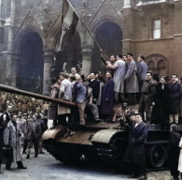
Those who had spoken publicly were marked. My parents were both teachers and my mother had stood before crowds and spoken openly at patriotic rallies. The warning came quietly but with absolute clarity that her name was on a list for arrest. My father had already survived the catastrophe of Stalingrad and had long ago resolved that he would never again submit his family to a system that crushed human dignity so completely. There was no dramatic discussion and no time for hesitation. The decision was made that we would leave.
Two Days of Silence
Preparation took place in complete secrecy. For two days we remained inside our home and spoke very little. Important documents were sewn into the linings of our winter coats. Birth certificates, school records, identification papers, and what little national currency we possessed were hidden in the clothing that would travel with us. Each of these small actions
carried the weight of finality because we understood that we were not preparing for a journey but for the possibility of never returning. On the night of our departure, we dressed in layers for warmth and for concealment and darkened our faces with charcoal so that we could not easily be seen. We slipped out through back streets and gardens and moved toward the edge of town, joining the silent flow of others who were also trying to reach the
Waiting for the Guide
We avoided the main road and waited in the open fields for the young guide who had been arranged to lead us to a dry creek bed and from there to a place where the border defenses could be crossed. He never came. His parents had forbidden him to take the risk. There were too many people moving westward, too many patrols, and too many Russian troops in the area. The anxious murmur of the crowd rose and fell around us, and it became clear that we were now dependent on our own judgment. Then the alarms began and the waiting ended.
Separation
Searchlights mounted on trucks swept across the road and soldiers shouted orders that sent waves of panic through the crowd. In the confusion I became separated from my family. I ran blindly and threw myself into a roadside ditch where an overhang of long grass provided a thin cover. From that position I could see only the lower legs of the soldiers as they moved past me. Their boots, the wheels of the trucks, and the glare of the light were so close that it seemed impossible that I would not be discovered. I
lay without moving until the noise receded and the darkness returned. When I finally crawled out and stood up there was no one there. In that moment I was certain that my family had been captured. I began to walk slowly back toward the town, stopping repeatedly and turning to look into the blackness toward the west. Even at that age something in me resisted the idea of surrender. I stopped, turned around, and began to walk again toward the direction of the border.
Finding One Another
In the darkness we found each other again. My father listened carefully to the night and located the gully that led toward the frontier. As we moved into it two university students came running up behind us and asked if we knew the way. My father turned to me and allowed me to
give them the direction and they ran ahead, waving their thanks as they disappeared into the night. Before we continued my father gathered us together and gave instructions that were simple and absolute. We were to walk in single file and keep some distance between us. We were to speak only in whispers and never call out. If there was danger we were to drop immediately to the ground and move off the path to take cover. If we were separated again each of us was to continue alone toward
The Final Mile
It was close to eleven o’clock when we reached the open ground that marked the last mile. The dry wash ended in a plowed field and beyond it we could see the curved concrete posts, the wires, and the dark shape of a watchtower. The clouds moved away and the stars appeared, allowing my father to orient himself by the Big Dipper and the North Star. He went ahead alone on his hands and knees, feeling his way forward through the minefield that he had studied previously. Antipersonnel mines lay scattered across the ground, some fully exposed and others partially embedded in the soil. With extraordinary patience he pushed several of them aside and lifted the lowest strands of wire with forked sticks so that we could crawl beneath. In places the wire had already been cut by those who had passed before us. Every movement required complete concentration because a single mistake would have ended everything.

Flares
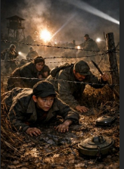
At the moment when we were most exposed panic broke out among a larger group nearby and a woman who had insisted on joining the escape began to scream. Almost immediately parachute flares rose into the sky from a nearby military position and the entire field was flooded with a harsh white light. Searchlights began to move and the sound of soldiers shouting carried across the ground. We lay flat beneath the wire without moving while the mines lay within reach of our hands. When the flares burned out and the darkness returned, we began to crawl forward again, only to be caught in the beam of a powerful flashlight and ordered to halt. My father lunged toward the light and struck it and once again we froze
in place while more flares rose above us. A patrol passed so close that we could hear their voices clearly and yet they did not find us. Eventually the light faded and the silence returned.
Austria
n border post. A door opened and a small dog rushed toward us barking. A man called it back and my mother answered him in German. The border guard identified himself and brought us inside where about sixty other refugees were already gathered. In the morning the villagers came and took us into their homes and for the first time in many days we experienced the simple safety of being welcomed.
The Long Journey West
A few days later we were transferred with hundreds of others to a former sanatorium where representatives of various countries were arranging immigration. Because my father’s brother had lived in Montreal since the 1920s, we chose Canada. We traveled by train to Trieste, crossed the Mediterranean by ship, passed through Gibraltar, and then endured the long winter crossing of the Atlantic. We landed in Halifax in February of 1957 and continued by train to Montreal. Within a few months I was speaking fluent English and entered school with Canadian, British, American, and French-Canadian students. I completed my studies early and went on to McGill University and later to its medical school.
A Life of Service
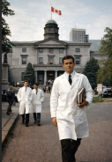
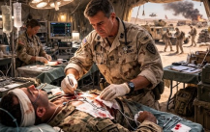
The freedom that had been purchased at such risk became the foundation for a life of work and service. My medical career developed in pediatrics and obstetrics and gradually moved toward an integrative understanding of healing that at the time was not widely practiced. I later served in the United States Army, rising to the rank of colonel and commanding a combat support hospital during Desert Storm. In every setting the memory of that night remained a quiet guide, a reminder of the responsibility that comes with freedom. The deepest and most enduring part of my life has been my marriage to my beloved Peggy. Together we built a home in the mountains of Prescott where the pace of life allows for reflection and gratitude.
Coffee, Motorcycles, and the Wonder of a Life Lived Well
Now, when we meet for coffee after riding our motorcycles through the Arizona hills, the conversation often turns to the wonder of life, the cost of perseverance, and the gift of having been allowed to live in freedom. The frightened boy in the ditch, the refugee crossing the ocean, the physician, the soldier, the husband, and the friend are not separate lives but one continuous story. Freedom made that life possible. Discipline, service, and love gave it its meaning.
Final Words
When I ride home through the mountains after our time together, I often think about the improbable continuity of a single human life. It is the same life that once lay motionless in a roadside ditch while soldiers passed within arm’s reach, the same life that crossed an ocean in winter toward a language not yet spoken, the same young man studying late into the night in Montreal with a determination born not of ambition but of gratitude. It is the same steady pair of hands that would go on to welcome thousands of children safely into the world, the same physician who would one day serve in the heat and urgency of a combat support hospital in Desert Storm, giving back to the country that had first given him refuge and possibility.
And now it is the same man who sits across the table from me in a small café in Prescott, whose voice still softens when he speaks Peggy’s name, who rises without hesitation when a mother enters the room carrying a newborn child, drawn again and again toward the fragile miracle of new life. In those moments the entire arc of his story becomes visible, not as history recalled but as love still actively choosing its direction. What moves me most is not what he survived, but what he chose to become. He did not grow guarded or cynical. He did not live as a man defined by what had been done to him. Instead, he became a man defined by what he has given — by service, by loyalty, by tenderness, by a gratitude that has never dimmed. In an age that often mistakes hardness for strength and visibility for significance, his life stands as a quiet and steady corrective. The measure of it is found in the warmth he carries, in the delight that still reaches his eyes, in the way a baby settles in his presence, in the enduring joy of a marriage that has only deepened with time.
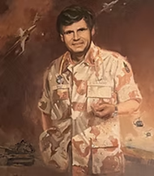
To know him is to be reminded that trauma does not have the final word, that freedom received with humility can become a lifelong act of service, and that a human life can move through history without becoming hardened by it. Long after the coffee cups are empty and the motorcycles are turned toward home, the meaning of his story lingers, not as something heroic and distant, but as something intimate and instructive, a living answer to the question of what we are meant to do with the lives we have been given. Some men escape a border. A few spend the rest of their lives proving why that crossing mattered. My friend Dr. Frank Nagy is one of them
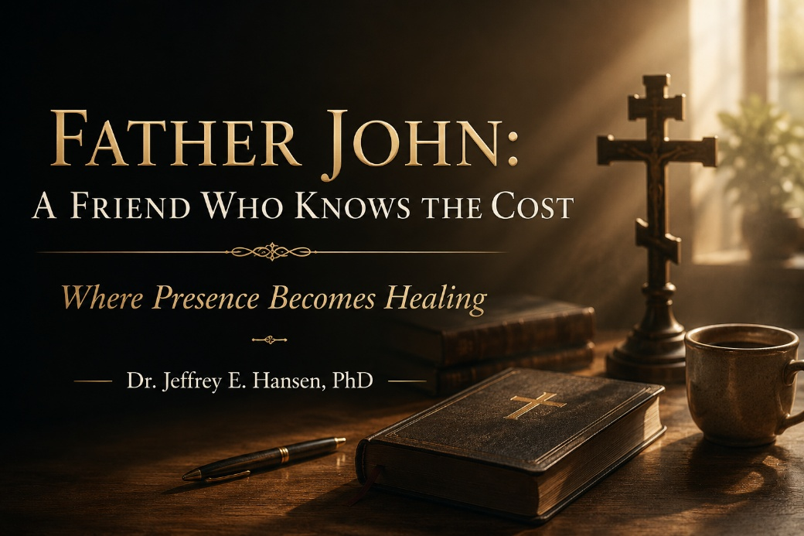
The Meeting
There are people who talk about their faith, and there are people who live their faith. There are people who talk about being there for you, and there are people who actually are. Father John is that kind of man.
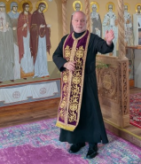
We met rather fortuitously when I was working in a large, beautiful building that I co-owned with three other colleagues, a space that housed multiple offices.
Father John had recently transitioned out of active-duty military service, where he served as a medic and later as a chaplain. Somewhere along that journey, he also became an Orthodox priest, and he took an office in that building just two doors down from mine.
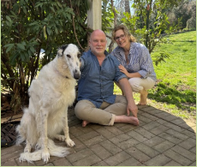
For those unfamiliar with Orthodoxy, it carries a deep continuity with the early Church. One of the unique aspects is that a man may be married before becoming a priest and remain married, but if he is not married at the time of ordination, he will remain celibate. Father John married Sabine, a lovely and gracious woman. We used to joke that he married up. She is German, speaks flawless English, and together they have three wonderful children. Olivia, in particular, I have come to know well. She has a sharp wit and a great sense of humor, and I have always enjoyed our banter.
At the time, he was building his practice, and I was overflowing with referrals, so in many ways it was a natural fit. I began sending him patients, particularly couples. He had a remarkable ability to connect with men who were struggling, especially husbands who were treating their wives poorly. He did not shy away from confrontation. He stepped into it with clarity and strength, yet without losing the person in front of him. It worked. He was sharp, intuitive, and he built his practice quickly. We worked together in a rhythm that simply made sense.
When Life Fell Apart
And then my world came apart.
The financial collapse of 2008, combined with a convergence of other events, forced a reckoning I was not prepared for. The economy was collapsing, houses would not sell, and we were forced into a short sale and had to move out of a home we could no longer afford and back into a smaller rental property. I was devastated, and more than that, I was ashamed. I had been undone, completely undone, and I had to step away from work to begin the long process of healing what had surfaced in me. Developmental trauma that had long been managed came roaring to the surface.
I had many friends who supported me in meaningful ways during that time, and I was blessed in that regard. But there was one who showed up in a way that marked me.
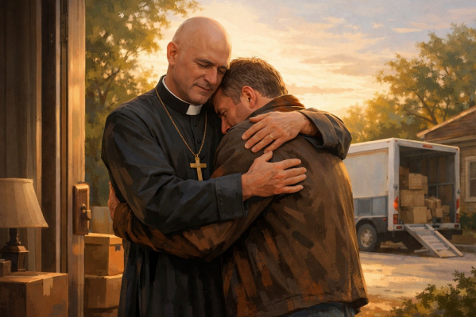
When it came time to leave that house, when I had very little energy to even face what needed to be done, Father John came to my doorstep. He rolled up his sleeves and helped me move furniture, carried boxes, cleared out my attic, and stepped into the very practical, very unglamorous work of helping a man whose life had fallen apart begin again. There was nothing performative about it. It was simply presence.
Presence in the Fire
And then, when I needed help beyond what I could manage on my own, I turned to him again. I needed someone I could trust, someone grounded, someone with depth, someone whose faith was not theoretical. He received me in therapy, and he worked with me, and with Leah, for the better part of a year.
When it came time to pay him, he took the check, looked at me, and said, “You are a financial disaster, I am not taking money from you.” And he never cashed it.
Who does that?
A man who lives his faith. A man who walks the talk. A man who understands that love has a cost and chooses to pay it anyway.
During that time, there were days I could barely function. My system was completely dysregulated, though I did not have the language for it then. I understand it now. It was profound autonomic activation, and yet I would go see John, and sometimes all I needed was a hug. We would sit, he would pray, and there was something deeply grounding about his presence. At times he would wear his cassock and collar, his long priestly robe, and I loved it. There was something about it that grounded me.
Many days, he simply got me through.
Co-Regulation Before I Had the Language
I did not understand it at the time, but I do now. It was co regulation. His steadiness, his groundedness, his lack of anxiety in the face of mine, his ability to remain solid when I could not.
He lent me his nervous system until I could find my own again.
Sabine, in her quiet strength, was part of that story as well.
A Man Who Lives His Faith
Over the years, our friendship did not fade, it deepened. Father John is an accomplished man. If you were to list all of his degrees, you would need another line. He has studied widely, even law, though he chose a different path. He holds advanced theological training and has lived a life of both intellectual depth and real world engagement. But what defines him is not his intellect. It is his willingness to step into the fire.
If he sees injustice, he moves toward it. Whether it is abuse, corruption, or wrongdoing, he does not look away, he leans in. He has taken on difficult roles, including leading within the federal marshal counseling program, where he again confronted what was wrong at personal cost. He has served at high levels, even within national leadership, and yet he remains the same man, steady, direct, and unafraid.
We have walked life together now for well over a decade, approaching two. We have shared ideas, supported one another, and stood in difficult places side by side. And now, as I sit in his home in Virginia, after not seeing him face to face for years, I am struck again by the depth of the man. His home reflects him. Books everywhere, old texts, a sense of history, of thought, of soul. It feels like being wrapped in something solid and enduring.
Where Presence Becomes Healing
And I am reminded that healing does not always come through words. Sometimes it comes through presence. Through steadiness. Through a man who refuses to turn away when things get hard.
That is where presence becomes healing.
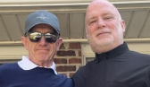
I am deeply grateful for this man. I am grateful for his friendship, his strength, his faith, and his willingness to walk with me when I could not walk on my own. I am better because of him.
And if there is anything worth becoming, it is this.
A man who lives his faith.
A man who stands in the fire.
A man who knows the cost and shows up anyway.


A Full Heart and the Cost of Speaking
As I drive south out of Williamsport, my heart is full. And I mean that in the deepest sense. Not a passing sentiment. Not a polite phrase. A full heart. Gratitude. Conviction. A renewed sense that what we are doing matters, even when it comes at a cost.
I have taken hits over the years. Real ones. Speaking openly about the perils of misaligned psychotherapy, the overuse and at times careless use of psychotropic medications, and the ideological capture of parts of my profession is not without consequence. There have been criticisms, mischaracterizations, calls for my license, and personal allegations that go far beyond professional disagreement. That is the cost of speaking when others would prefer silence. And yet, as I leave Williamsport, I can say without hesitation, it is worth it.
A Rare Kind of Physician and a Courageous Community
This week, I had the honor of returning to speak at a medical conference hosted by Dr. Russell Gombosi. Dr. Gombosi is a rare physician in today’s system, triple board-certified in internal medicine, pediatrics, and sleep medicine, providing truly comprehensive care across the lifespan while holding fast to a Christ-centered model of medicine that sees the patient as more than a diagnosis.

There is also something more that is difficult to fully capture unless you have been in his presence. He is a man of quiet stature, the kind you recognize not by title but by presence. There is a moral courage about him that does not need to announce itself. You feel it. And yet, at the very same time, he has a way of putting people at ease, of making you feel comfortable in your own skin. There is a genuine kindness, a steadiness, a compassion that reflects not just what he believes, but how he lives. He could retire. He has done well. He has earned that right. But he does not. Not out of need. Not out of ambition. But out of a deep sense of calling, of mission, of service to others.
That is the kind of physician he is. And that, in many ways, says more than any credential ever could. But more than titles and credentials, he is something increasingly rare in modern medicine. He is a man who values freedom of thought. Freedom of speech. The First Amendment not as an abstract principle, but as something to be lived and protected, especially in a field that is increasingly pressured to conform. To be invited back for a second time was deeply meaningful. Last year was powerful. This year, even more so. I was asked to speak on risk-taking and resilience in youth, a topic that sits at the very heart of what is happening in our culture.
We are watching a generation struggle, not because they are weak, but because they are being shaped by forces that undermine resilience while calling it progress. Following a strong and thoughtful lecture by Dr. Michelle Cretella, former president of the American College of Pediatricians, the conversation continued into territory that many in medicine are increasingly hesitant to enter. She spoke clearly about the risks associated with early sexual behavior and made the case for sexual risk avoidance rather than the dominant harm-reduction framework. It was not a fashionable message. It was not designed to please. It was designed to say what she believes is true.

And that mattered. Because what is happening in medicine right now cannot be ignored. Across the country, physicians are being squeezed into narrower and narrower lanes. Fifteen-minute visits. Metrics tied to reimbursement. Expectations around prescribing, documentation, and compliance that leave less and less room for clinical judgment, for presence, for actually knowing the patient sitting in front of you. There is an increasing sense that medicine is no longer being shaped from within, but from above. Protocols over wisdom. Throughput over relationship. Incentives over discernment. Even in places like Williamsport, which could be described as more conservative and grounded, those pressures are present.

This is not isolated. It is systemic.
And yet, what I saw there was something different. I saw a community of physicians who are still thinking. Still questioning. Still willing to engage ideas rather than simply inherit them. I saw people who are not ready to hand over their profession to ideology, regardless of where that ideology comes from. I also experienced something that is too often lost in modern medicine: genuine hospitality and human connection. Time spent with Dr. Gombosi and his gracious wife, Juliann, was not peripheral to the experience. It was central to it. Because at its core, medicine is relational. It always has been. Strip that away, and something essential is lost.
Truth, Faith, and the Road Ahead
There is also a deeper anchor for me in all of this. As a Christian, I cannot separate truth from the One who embodies it. Jesus Christ did not bend to cultural pressure, did not remain silent when truth was inconvenient, and did not prioritize acceptance over integrity. He spoke with clarity, with compassion, and with unwavering conviction, even when it cost Him everything.
To follow that model, to drive down the oftentimes lonely road, is not always comfortable, and it is certainly not always rewarded. At least initially. But it is right. And in a time when both medicine and psychology are increasingly shaped by external pressures, that example matters more than ever. So yes, as I drive south, my heart is full. Full of gratitude for the invitation. Full of respect for the courage I witnessed. Full of renewed conviction that speaking clearly, even when it is costly, is still the right thing to do. There are still physicians and allied providers in this country who have not lost their way. There are still men and women willing to stand in the tension between truth and consequence, between integrity and approval, and choose rightly. Not perfectly, but faithfully.
And that gives me hope.
Not a shallow or fleeting optimism, but a grounded hope.

A hope rooted in the reality that truth does not disappear simply because it is resisted, and that courage, when lived out consistently, has a way of multiplying itself in others.
As Scripture reminds us, “Let us not grow weary of doing good, for in due season we will reap, if we do not give up.” (Galatians 6:9)
So, the road ahead may not be easy. It may, at times, feel isolating. But it is still worth traveling. Because truth still matters. Because integrity still matters. And because, even now, there are those who are willing to stand.

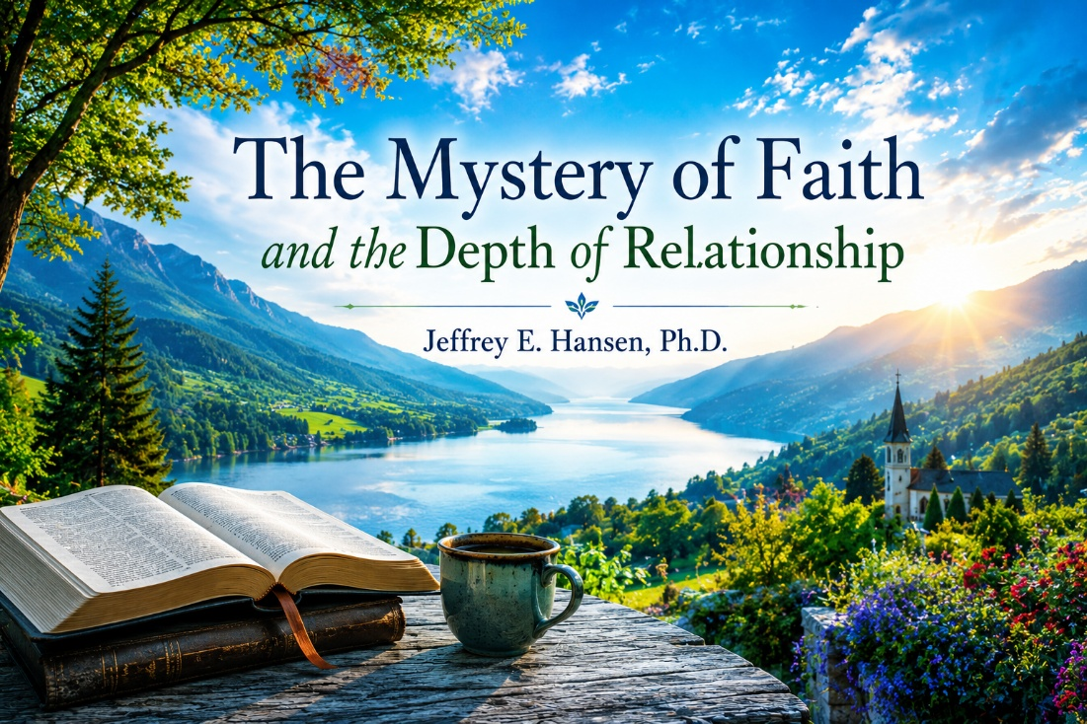
The Work and the Calling
It has been a full week, and a meaningful one. I have always loved presenting, speaking, and engaging in the exchange of ideas. There is something deeply energizing about taking complex material, wrestling with it, refining it, and then offering it in a way that is both clear and compelling. Even the preparation, though it requires hours of disciplined effort, is something I value. Excellence matters. It is not optional. I believe we are called to it, and when something is worth doing, it deserves our full attention and our best work.
This past week took me from Washington, D.C. to Pennsylvania, but what remains with me most is not the travel or even the professional engagement. It is the people. That has always been true for me. I care deeply about my field, and I care deeply about truth. I care about meaningful work that is grounded in integrity. I can be candid, even forceful at times, about where psychology and medicine succeed and where they fall short. But beneath all of that, what ultimately gives the work its meaning is connection. It is the relationships along the way that endure.

When Connection Breaks
That truth has not come without cost. I recently stepped down as Clinical Director at a prominent addiction recovery program, a role I genuinely loved. It was a place where I was able to further develop and articulate the NeuroFaith® model, to write, to teach, and to bring together the integration of neuroscience and faith in a way that felt both grounded and alive. There was purpose there, and there was impact.
But over time, something more fundamental began to erode. The connection weakened. Mutual respect diminished. And without those, even meaningful work becomes unsustainable. Stepping away brought real loss, both financially and professionally, but remaining in an environment where connection and respect had broken down would have cost far more.
Washington, D.C. - A Return to Grounded Relationships
In contrast, this week was a powerful reminder of what healthy, meaningful connection looks like when it is intact. I spent time with my brother, Father John Anderson, whom I simply call Ned. He is an Eastern Orthodox priest and someone who stood by me during a deeply difficult period nearly two decades ago. That kind of presence creates a bond that is not easily explained and not easily broken.
Being with him again, and with his family, was grounding in a way that is difficult to fully capture. His daughter Olivia, now twenty-six, is remarkably gifted, particularly in her artistic expression, but what stands out even more is the depth of her thinking and the contemplative nature of her spirit. She carries both brilliance and hardship, living with Type 1 diabetes and recovering from a serious injury, and yet there is a depth to her that is unmistakable.
His wife, Sabine, brings her own quiet strength, thoughtful, perceptive, and deeply grounded. Our conversations were not surface level. They lingered, and they mattered.

The Weight of Worship
The highlight of that visit, however, was attending the Orthodox liturgical service. What struck me immediately was the absence of spectators. Everyone stood. Everyone participated. The service was not something observed from a distance, but something entered into fully.
There was a weight to it. A reverence. A sense that faith was embodied rather than consumed. It felt ancient, intentional, and deeply rooted in something enduring. That experience sharpened something I have wrestled with for some time. Coming from an evangelical background, I have seen both the beauty and the limitations within that tradition. At times, faith can take on a transactional quality, almost like a vending machine, where depth is replaced by immediacy and the sacred becomes overly simplified.
What I witnessed in the Orthodox setting stood in contrast to that. It demanded presence. It invited participation. It carried continuity with something much larger than the individual.
Williamsport - Relationships That Continue and Converge
From there, I traveled to Williamsport, Pennsylvania, where the relational thread continued, but in a different context. Dr. Russell Gombosi, who hosted the conference, is someone I have known over time. I spoke at this conference last year, and since then we have had many thoughtful conversations. He was generous enough to write an endorsement for my book on adolescent depression, which itself emerged from that earlier work. Reconnecting with him was not a new introduction, but a continuation of an established relationship built on mutual respect, shared dialogue, and professional alignment. He is a devout Catholic, thoughtful, grounded, and deeply committed in both his medical work and his faith.
Dr. Michelle Cretella represents a different kind of continuity. Although this was the first time we met face to face, our relationship had already been established over several years through virtual conversations, emails, and shared work. We have engaged in overlapping efforts and found alignment on issues that are both clinically significant and culturally contested, particularly around the early affirmation approaches being applied to children. Those shared positions were not formed casually, but through careful thought, clinical experience, and a willingness to hold firm where it matters.
Meeting her in person, then, did not feel like a beginning, but rather the natural extension of an already meaningful professional relationship. She brings clarity and conviction, but what stood out most in person was the depth of her faith. Before our presentations, we spent time in prayer together, and it was not perfunctory. It was intentional, grounded, and deeply anchoring, reflecting a faith that is lived rather than merely stated.
The Tension That Cannot Be Ignored
As I stepped back and reflected on the week, what became increasingly clear is that I am surrounded by individuals I respect deeply, each of whom is anchored in faith, and yet each of whom holds meaningful theological differences.
An Orthodox priest. Devout Catholic physicians. A Protestant pastor, Earl Heverly, who has been profoundly influential in my own spiritual life and who consistently calls people to a deeper and more authentic engagement with faith. The differences among them are not trivial. They involve foundational questions about original sin, baptism, the role of the saints, and the place of Mary. These are not peripheral distinctions. They matter. They shape how each tradition understands God, humanity, and the path of redemption. And yet, so do the people.
This is where the tension becomes real. It is no longer an abstract theological exercise. It is personal. I have seen their lives. I have experienced their character. I have witnessed their conviction and the way their faith shapes how they live, how they love, and how they serve others. There is authenticity there that cannot be easily dismissed.
Final Reflection - Depth, Humility, and Gratitude
As I sit with all of this, what stands out most is not simply the differences, but the depth. The depth of character. The depth of belief. The depth of conviction. Father John, rooted in the ancient rhythms of the Orthodox faith. Dr. Russell Gombosi and Dr. Michelle Cretella, grounded in the richness of the Catholic tradition. Pastor Earl Heverly, calling people into a living, breathing relationship with Christ.
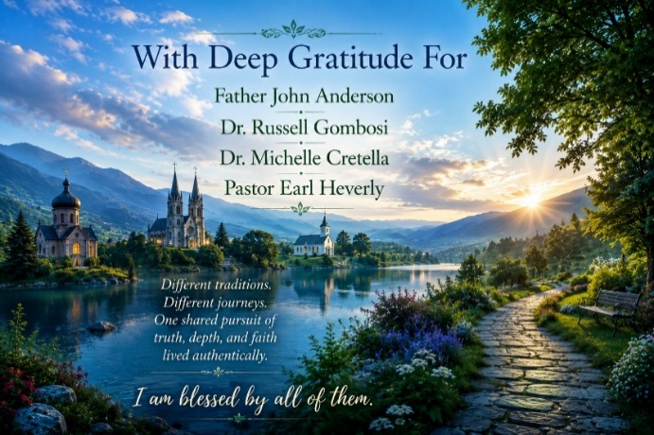
Different traditions. Different expressions. And yet in each of them I have witnessed something unmistakably real. A love for others. A commitment to truth. A faith that is not performative but lived out in the quiet consistency of their lives, in their service to others, and in the way they carry themselves with integrity. I am blessed by all of them.
And in that, there is a kind of humility that settles in, not a surrender of conviction, but a recognition that God’s work is often deeper and broader than our own frameworks can fully capture. Who am I to reduce what God is doing in their lives to something simplistic, or to dismiss what is clearly bearing fruit in ways that are real and transformative?
If anything has been reinforced for me this week, it is this: depth of relationship matters. Authentic connection matters. And when that connection is rooted in a genuine and lived faith, even when expressed differently, it has the power to shape, to refine, and to bless in ways that transcend easy explanation.
And perhaps that is part of the journey, not to resolve every difference, but to remain grounded in truth while also recognizing and honoring the depth of faith and character in those we walk alongside. Because in the end, it is not shallow belief that changes lives, but a faith that is lived fully, deeply, and in genuine relationship with others.
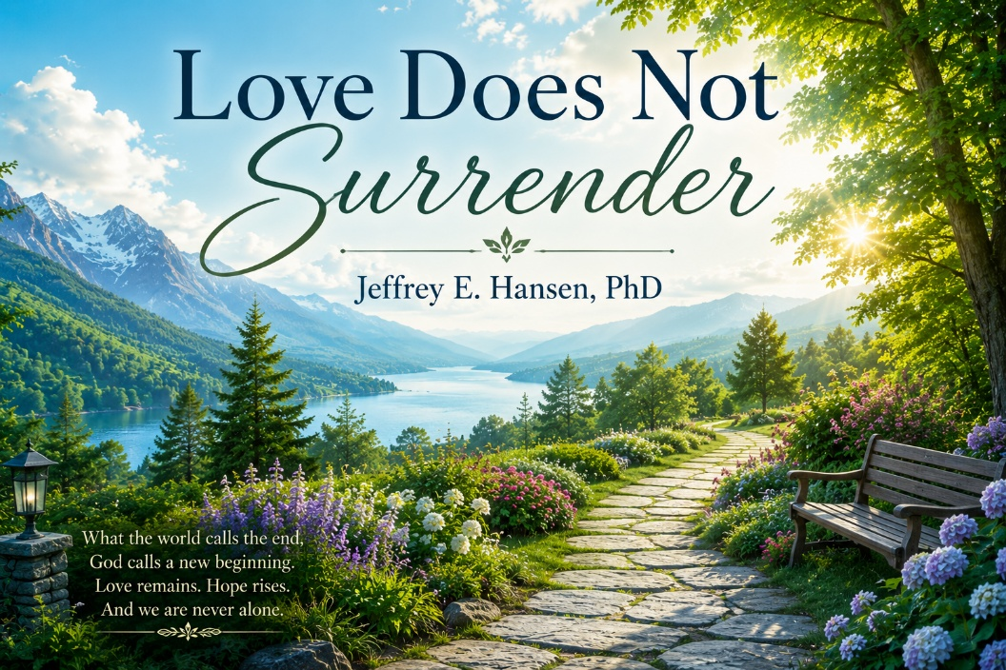
There are stories in life that refuse to be reduced to simple categories of joy or sorrow. They carry both, intertwined in ways that shape the soul over time. This is a story about love, about suffering, and about what it means to stay when everything in life begins to fall apart.
Early Roots of Friendship
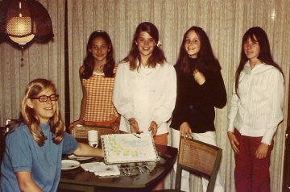
Long before illness entered the picture, there was friendship. Deep friendship. The kind that forms early and quietly endures across decades, through laughter and marriages and children and loss. Kitty was part of that beautiful circle of girls who shared life together so fully in those early years. There was Kitty, and there was Leah, and there was Wilma, and there was Carrie. Four close friends, loving life in high school, being silly together, laughing together, walking through the innocence and joy of youth before life began to reveal how much joy and sorrow can become intertwined. There was something lovely in that early history, something tender and full of life. These were not shallow friendships. They were deep roots. And as life unfolded, those roots held.
Through marriages, through children, through hardship, through all the changing seasons of adulthood, that bond remained. Carrie would be the first to pass, taken by an aggressive cancer. She died with dignity, with courage, and with the ache of knowing she would not see her children grow. Yet even there, in that valley, there was love and hope and a reaching toward what mattered most. That loss changed the shape of the group, but not the depth of what they had shared. Kitty, even from those early years, carried a particular warmth. She was one of the sweetest people I have ever met, marked by kindness, gentleness, and a natural turning toward others. There was something steady in her, something life-giving, something that would later become even more visible in both the way she lived and the way she suffered.
A Life Intertwined Again
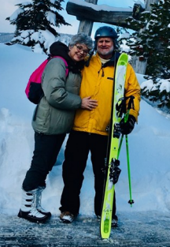
We met Alan early in our marriage. He was a young pastor with a deep and unwavering faith, and a personality that held both conviction and joy. He could speak with sincerity about God and, in the next moment, lose himself completely in the chaos of a football game, with a kind of unrestrained enthusiasm that made him both deeply grounded and completely alive. And it was in that same season that it became clear there was something very special between him and Kitty. There was a depth to it that went beyond the surface, a deep love, a deep respect, and a deep bond that was unmistakable.
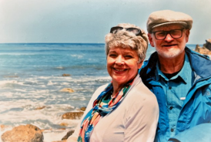
It was not dramatic or performative. It was steady, grounded, and real. It was obvious where this was going, and they married soon. Even then, it was clear they had already chosen each other in a much deeper way. Life then took us all in different directions for a time. For about a decade after we were married, Alan and Kitty were pastoring a church in Nebraska, while Leah and I were in the military, moving through seasons and places, much of that time spent in Europe. Our lives unfolded along very different paths, yet remained quietly connected.
And then, not by chance, but in a way that felt designed by God, our paths came back together. We landed in Washington State, living not more than thirty minutes from one another. What could easily be called coincidence felt much more like providence, the quiet hand of God bringing lives back into alignment. It was there that we watched our families grow. Our friendship deepened, settled, and became something even more meaningful. There was laughter, a great deal of laughter. Shared meals, long conversations, hikes, football games, and the kind of moments that seem ordinary at the time but later reveal themselves as sacred.
Anyone who knew Alan knew how much he loved football, and how completely he would lose himself in it. My family affectionately called him the crazy pastor, and there was truth in that. He did not just watch the game, he lived it, yelling, pacing, fully invested, so loud and so intense that the whole room felt it. Our little Papillon, that tiny butterfly dog, looked like she was on the verge of a nervous breakdown more than once just trying to survive one of those games. And yet that was part of what made Alan who he was, fully, fully present, able to feel deeply and express it without reservation, and at the same time deeply grounded in his faith. Those were good years.
When Suffering Enters
Life, as it does, held both joy and hardship. Their daughter Mary developed a brain tumor when they were serving at a church in Nebraska and entered into a battle that would test everything. There were surgeries, consultations, and long stretches of uncertainty.
Yet she persevered. She fought through it. She survived. She went on to marry and to have children of her own. It was a joy that carried a depth only those who have known real suffering can fully understand. And after that season, my own life entered a time of breaking. Illness and financial strain brought me into a place where much of what I had relied on began to fall apart. It was disorienting, humbling, and at times overwhelming.
And that is where Alan showed up in a different way, not with easy answers, not with platitudes, but with presence and truth. He walked with me. He mentored me. He spoke into that season with clarity and conviction. He told me something that has never left me, that God cares about character, and that He will allow us to walk through trials to refine it, that He is more concerned with who we are becoming than with what we possess. That truth became an anchor for me. It helped reset something deeper, something that might not have changed otherwise. That was Alan.
Love That Stays
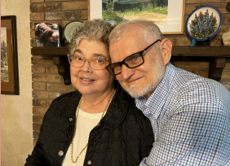
And then, as it so often does, life turned again. Kitty was diagnosed with brain cancer. At first, there were subtle changes. Speech became more difficult. Words did not come as easily. Thoughts could not be gathered and expressed in the way they once were.
And then, more quickly than any of us were prepared for, that ability began to fade. Alan stepped in with a kind of love that is rarely spoken about, but unmistakable when it is seen. There was no outward frustration, no visible resentment. What I saw was tenderness, presence, and a quiet, unwavering commitment to care for her all the way through. He guided her spiritually. He stayed close. He carried the weight of what was happening without turning away from it. He knew where this was going, and still, he stayed. Our final time with them came as Leah and I were preparing to leave Washington State.
We stayed in their home. It would be the last time we would see Kitty. By then, she could no longer speak, but there are moments in life that transcend language. Leah sat with her, and their eyes met, and what followed stretched beyond what words can easily capture. There was recognition. There was light. A brightness in Kitty’s eyes that seemed to come from somewhere deeper than the disease that had taken so much from her. They did not speak because they did not need to. There was love there. There was memory. There was shared life. Something passed between them that could not be reduced to language. It was sacred. Alan and I stood there and watched, aware that we were witnessing something holy. Not long after, Kitty passed away.
For all the strength Alan had shown, for all the love he had poured out, the cost of it became visible, the exhaustion, the grief, the breaking that comes when you have loved fully and stayed to the very end. He had carried her through, and when it was over, the weight of it all brought him to his knees. This is what love looks like when it does not surrender.
Love Begins Again
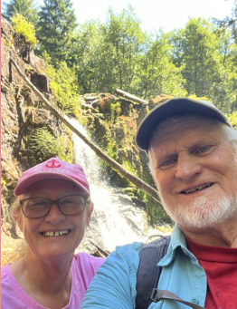
And for a time, it seemed as though that chapter had come to a close, as though Alan might spend the rest of his life carrying that loss, weighed down by sorrow and the depth of what had been. But I had it wrong and I remember him visiting us about two years ago, and even then, there was something different, something subtle, something not yet fully formed, but present. He had met someone very special.
Just when we think we have written the final chapter of our lives, just when we believe the story has reached its end, God has a way of taking the pen from our hand and writing something entirely different, something we never could have imagined. Enter Deborah. A remarkable woman, beautiful in spirit, who herself had endured profound and tragic loss, the loss of her husband in a terrible accident and the loss of her son to COVID. She, too, had been brought into the depths of grief, carrying sorrow in a way that reshapes a life. I do not think either of them, when they first met, intended for it to go anywhere. But God, in His way, began to write a new chapter. They fell in love, perhaps at first united in their sorrow, connected through the shared experience of loss, each having known what it means to love deeply and to grieve deeply. Both had experienced remarkable marriages, and the question remains, who could ever replace that. The answer is that no one does.
And yet, God brought them together.
What became so evident was not the erasing of the past, but the honoring of it. They have each maintained a place for their grief, a place for their sorrow, a place for the love they lost that will always remain part of them. They do not run from it. They do not try to make it disappear. They honor it. They respect it. They share it. They speak of their spouses with reverence, with depth, with love.
And yet, that does not define them. What defines them now is also the love they have found together, united in Christ, united in spirit, united in heart. We were blessed with a five-day visit, meeting Deborah in person after many conversations, and what became immediately clear was the depth of who she is. Not as a replacement for Kitty, never that, but as something entirely different, something uniquely beautiful, a filling of Alan’s heart in a way that makes space for both what was and what now is.
He does not let one eclipse the other, just as she does not let the memory of her husband Sam be eclipsed. It is a remarkable thing to witness, to see two people beyond seventy, so in love, so respectful, so grounded, so full of hope, and still carrying a sense of purpose as they serve God together.

What a beautiful tapestry. A life that holds love and sorrow, pain and loss, and yet a willingness to persevere, a willingness to show up again, a willingness to love again. And even when we think we have written the final chapter, God, in His wisdom, takes the pen and writes another. And it is a beautiful chapter, still being written.

The Gift We Rarely Name
There are many gifts in this life, and we spend much of our time giving and receiving them, often without pausing long enough to appreciate their depth. There are acts of benevolence and generosity, financial gifts that meet tangible needs, and gifts of the heart that meet the unseen ones. There are gifts of companionship, loyalty, and love, the quiet, enduring offerings that bind us together across time and circumstance.
Yet there is one final gift that we rarely speak about, perhaps because it unsettles us, perhaps because it confronts us with something we would rather keep at a distance. It is the gift of dying. I have found myself thinking about this more often lately. At seventy-one, death no longer feels like a distant abstraction. It has a way of drawing closer, of speaking more clearly, of becoming, in a way I did not anticipate when I was younger, a kind of companion. Not a companion I would have chosen, and certainly not one I always welcome, but a companion nonetheless, present in the background of thought, inviting reflection whether I seek it or not.
And as I have sat with this reality, I have come to recognize that we are not without choice in how we relate to it. We can resist it, deny it, and push it aside, convincing ourselves that it is not yet relevant. But denial has never had the power to make truth disappear. Or we can choose a different posture, one that acknowledges death as part of the natural movement of life, something not outside of us, but woven into the very fabric of our existence. In time, if we allow it, we may even come to a place where we do not merely tolerate its presence, but meet it with a measure of acceptance, perhaps even a quiet peace.
Craig’s Courage
This reflection moved from abstraction to something deeply personal when I visited my brother-in-law, Craig, at Sacred Heart Medical Center in Spokane, WA, USA. Craig is nearing the end of his life. Whether measured in days or weeks, the horizon is close enough that it cannot be ignored, and he knows it. Craig has lived a complicated life, and there is much contained in that simple statement. Like all of us, his story holds both beauty and brokenness, moments of strength and moments of failure, times when he rose to the occasion and times when he fell short. Yet what becomes striking in these final moments is not the complexity itself, but the clarity that begins to emerge from it.
What I saw in Craig was courage, not the kind that demands attention or seeks recognition, but a quieter, steadier form that reveals itself in how a man chooses to face the end of his own life. He is not preoccupied with fear, nor is he consumed with lament over what time remains. Instead, he offered a simple and profound reflection when we spoke. He said, “I had a good run.” There was something deeply moving in that statement, not because it denied the hardships of his life, but because it rose above them. After all the struggle, all the weight of his experiences, this is what he chose to hold onto. Not the pain, not the regret, but a sense of gratitude for the life he had been given.
Even more striking, however, was where his heart now rests. His focus is not on himself, but on those he loves. He speaks with clarity and tenderness about his sister, my wife Leah, expressing how deeply he loves her. He speaks with pride about his niece and nephew, wanting them to know how much they mean to him. In these final days, his greatest concern is not what he is losing, but what he is leaving behind in the hearts of those who have walked alongside him.
The Gift That Remains
And this is where the final gift begins to take shape.
Because when a man reaches the end of his life and chooses to stand in a place of courage, to speak love without hesitation, and to rest in a posture of gratitude rather than regret, he offers something profound to those who remain. He brings a kind of completion that does not require a perfect life, only an honest one. He reminds us that when the ledger is finally balanced, it is not the failures that define us, but the love we are willing to give and receive. In that sense, Craig has given us a gift that will endure far beyond his remaining days. He has shown us that even in the face of death, there is still an opportunity to choose well, to orient the heart toward what truly matters, and to leave behind something of lasting value.
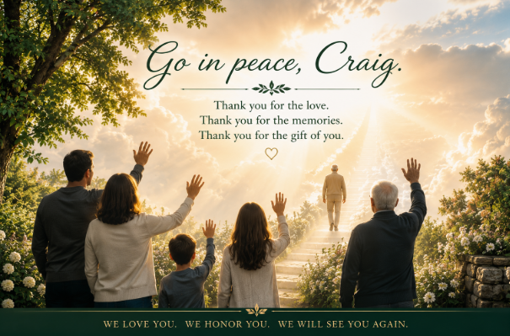
And so I find myself filled not only with sorrow, but with gratitude. Thank you, Craig, for this gift. Thank you for the courage you have shown, for the peace you have embraced, and for the love you have made so clear. Thank you for reminding us that even at the end, there is still something meaningful to give. This is a gift I will carry with me for the rest of my life. And I find myself wondering what it would look like for each of us to live in such a way that when that moment comes, we are able to say something similar. Not perfectly, not without regret, but with a sense that we showed up, that we loved, that we did not turn away from what mattered most. Because in the end, it seems that life does not ask us to get everything right, but it does invite us to be present, to be honest, and to be willing to love even when it costs us something.
And perhaps even more than that, to leave in that same spirit. To love as we are going. To offer what remains of us with open hands, with compassion, with clarity, and with peace. Because in that final movement, in that quiet passage from this life to whatever comes next, the greatest gift we may have left to give is not what we accomplished, but how deeply and freely we are still willing to love.
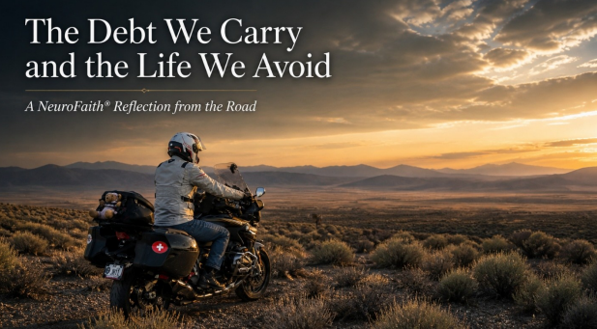
The Ride
The Ride I did not plan to ride seven hundred miles that day. The plan was simple, reasonable, and, in my mind, well thought out. I would break the trip in Tonopah, get a good night’s rest, and then make my way into Dayton to spend three days with my brother, my mother, who had only recently come back from the edge after double pneumonia and sepsis, and time with Ken and Karen. After that, I would head north, meet up with my friend Chris, and spend a couple of days in Mendocino with my younger sisters, adopted from Japan, who have built a remarkable life together in the old family home.
It was a good plan.
It just wasn’t the plan that unfolded.
Somewhere out in the middle of Nevada, with nothing but open road and long stretches of silence, I checked my email and realized I had booked Tonopah for the wrong night. No room, no place to land, just a quiet recognition that what I thought I had arranged wasn’t actually there. I pulled over, looked at the miles, did the math, and asked a simple question. What is another two hundred miles on top of five hundred?
And with that, I kept riding.
There is something about that kind of ride that strips things down. You settle into the rhythm of the road, and the noise begins to fall away. You stop negotiating with reality and simply move through it. By the time I reached Dayton, I wasn’t just arriving. I was stepping into something that had been quietly forming all along the way. My mother was there, alive and present in a way that did not feel guaranteed not long ago. My brother was there. Family gathered in a way that felt both ordinary and sacred. And just days before, I had been sitting with my brother-in-law as he approaches the end of his life, in a room where nothing artificial survives and everything that matters becomes unmistakably clear.
That kind of movement, from road to family, from near loss to presence, from life to the edge of death, changes the way you see things. It narrows your focus and removes the illusion that you can indefinitely manage what actually needs to be faced.
A Different Kind of Voice The Ride
So, this morning, standing on a treadmill in a small gym in Dayton, I pulled up one of my go to voices, Chase Hughes. Hughes is not a traditional clinician. He served as a Chief in the U.S. Navy, working in human intelligence and interrogation environments where understanding behavior is not theoretical, it is consequential. His work has been forged in observing people under pressure, identifying patterns, and understanding what human beings actually do when their systems are activated.
There is also something quietly refreshing about listening to someone like Hughes who did not come up through the traditional mental health pipeline. And I say that with a bit of intention. Because while there are exceptional clinicians doing deep, meaningful work, there is also a surprising number who stay confined to narrow modalities, incremental interventions, and, at times, ideological frameworks that drift further from the underlying neuroscience than toward it. It becomes a kind of professional echo chamber where language is refined but understanding is not always expanded. Hughes, coming out of a different world entirely, seems to have done a deeper dive into how the brain and body actually operate under stress than many clinicians who have spent years in formal training. That is not a universal statement, but it is common enough to be worth saying out loud.
What He Gets Right
In the video I was listening to, he laid out what he calls emotional debt, and the more I listened, the more I realized how much he was getting right. When the system is activated and cannot complete what it was designed to do, whether to fight, to flee, or even to fully collapse and recover, something remains. Not as a clean memory, but as a carried state. The body holds it. The system adapts around it. And over time, those incomplete responses begin to stack, creating a kind of ongoing pressure that people experience as chronic tension, anxiety, numbness, or a sense that something is never quite settled.
Where It Lives: The Body
From a NeuroFaith® perspective, this is where the conversation begins, not with the story, but with the body. What we understand through Polyvagal Theory is that the system moves through states. It mobilizes into activation when there is threat. It shifts toward shutdown when activation cannot be sustained. But what is often missing is the return to a regulated, connected state. The system becomes patterned in activation or collapse, and those patterns begin to define a person’s internal experience. In that sense, the language of debt is helpful. Not because the body is literally keeping a ledger, but because the system is carrying incomplete processes that continue to exert influence. Something remains unresolved, and the organism organizes itself around that fact.
How We Try to Settle It
But the body is not meant to stay there. It is designed to return to regulation, and that movement is tied to connection. This is where neurocardiology becomes important. The work associated with HeartMath shows that the heart plays a central role in regulation. When a person moves into more coherent states, there is a shift toward order and stability that supports the broader system.
Because what we see next is that the system does not simply sit with unresolved activation. It adapts. It organizes. This is where Internal Family Systems gives us language that is both precise and humane. Parts take on roles. Some manage, striving to keep everything under control. Others act more urgently when the system is overwhelmed, stepping in to extinguish distress through substances, behaviors, rage, or withdrawal.
These are not random patterns.
They are attempts to deal with something that has not been resolved.
And this is where the metaphor of debt becomes even more revealing. These strategies do not resolve the underlying imbalance. They service it. They reduce the immediate pressure while leaving the core issue intact. Managing, performing, escaping, numbing, different expressions of the same underlying reality. This is also where we have to be honest about psychotropics and other stabilizing strategies. There is a place for them. They can reduce suffering and create space. But they do not resolve the underlying pattern. They can become, in some cases, another form of debt servicing.
Left unaddressed, these patterns shape relationships. They affect how present we are, what we pass on, and how we show up in the lives of those we love.
Craig
And this is where it becomes deeply personal.
Just days before this ride, I sat with my brother-in-law, Craig, as he approaches the end of his life. What I saw in him was something both beautiful and sobering at the same time. Like so many of us, he spent much of his life, in one way or another, staying off the debt, managing it, working around it, carrying it in ways that allowed life to function but not always in ways that brought full resolution.
But now, something has shifted.
There is a settling, a clarity, a willingness to face what is real without turning away. In his own way, he is resolving what he can, not perfectly, but honestly. There is a peace in that which is unmistakable when you are with him. It is a beautiful thing, and it is also quietly heartbreaking, because it naturally raises the question of what might have been different if that kind of resolution had come earlier, how much more connection, presence, and freedom might have been available along the way. That is not a judgment; it is a recognition that time matters and that what we avoid does not disappear, it waits.
That realization brings the question closer and makes it harder to ignore. Why do we wait? Why do we spend so much of our lives staying off the debt, managing, coping, adapting, rather than turning toward what is unresolved and allowing it to be worked through? Because the cost is not just internal discomfort.
It is connection.
It is presence.
It is the very life we are meant to live.
The Road Ahead
As I continue this ride, moving from one place to the next, I find myself thinking less about the miles and more about what remains unresolved, not just in others, but in myself. Where have I managed well but not actually resolved? Where have I stayed just ahead of the deeper work? What would it mean to turn toward those places now, rather than later?
The road has a way of creating space for those questions without forcing answers. It strips away distraction and leaves you with what is there. And if you are willing to stay with it, something becomes clear over time. Healing is not about staying ahead of the debt. It is about turning toward it, allowing what has remained incomplete to be worked through, and moving into a different way of living that is no longer organized around avoidance.
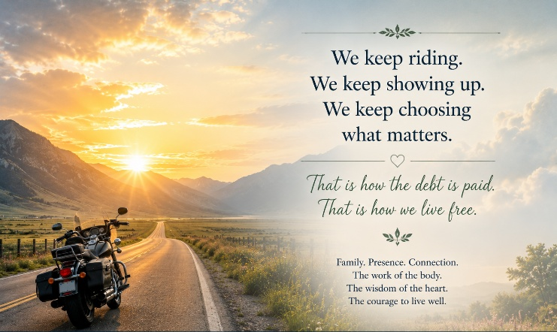
That kind of movement is not immediate, and it is rarely comfortable, but it is the only movement that leads to something that resembles freedom. It is the shift from adaptation to restoration, from isolation to connection, from managing life to actually living it.
And like the ride that brought me here, it is almost always longer than we expect.
But it is the only road that is worth taking.

A Life Rich in Friendship
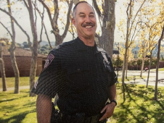
I’ve been blessed with many good friends over the course of my life. I’ve also been blessed with true best friends. My longest-term best friend is Mohomad, who lives in Switzerland. Another lifelong friend, even before Mohammed, is Chris Wright. But now, here in Arizona, I’ve gained a new best friend: Pat Akana.
Pat is an extraordinary man, a man of many layers. A retired detective sergeant who spent years protecting others, walking toward danger while most people instinctively walk away from it. He lived a life of responsibility, discipline, and courage, and somehow emerged from it not hardened, but grounded.
There is something deeply settled about Pat. You can feel it almost immediately. He is comfortable in his own skin and at peace with the life he has lived. Satisfied, not in an arrogant sense, but in the quiet confidence of a man who knows he showed up honorably. He carries himself with the kind of steadiness that only comes from living through difficult things without losing your center.
And he did not walk that road alone. Pat is married to a beautiful woman named Liz, and Pat and I often joke that we both “married up,” which of course means our wives married down. Wink wink.
What amazes me is how naturally our friendship formed despite such different backgrounds. Me, a touchy-feely psychologist, perhaps at times a crusty and cranky old psychologist. Pat, a lifelong law enforcement officer, a detective sergeant forged through years of trauma exposure, investigations, discipline, and responsibility. On paper, we probably should not make sense together, and yet somehow the friendship feels entirely natural. And that, I think, is because authentic friendship is not built merely on similarity. Sometimes it is built on shared values, shared honesty, shared depth, and a mutual respect that quietly forms over time.
Two Very Different Men
In many ways, we are wired almost opposite from one another. My mind can feel nonlinear, emotional, and scattered across ten ideas at once, while Pat’s mind is methodical, ordered, careful, and deeply structured. He studies before acting, observes before speaking, and organizes before reacting. Nothing about him feels impulsive or sloppy because his mind naturally seeks order, clarity, and precision.
And strangely enough, those differences create balance rather than friction.
I think Pat helps steady me. He slows things down. He helps me organize thoughts and make sense of things that sometimes feel emotionally tangled in my own head. At the same time, I think he enjoys my spontaneity and emotional openness because it is probably very different from the highly ordered environments he spent decades navigating in law enforcement.
Some friendships are built because people are similar. Others are built because they complement one another. Ours feels like the latter. We sharpen different parts of each other, and somewhere in that process a genuine brotherhood formed.
There is something deeply comforting about having a friend who brings order without trying to control you, who steadies you without diminishing who you are. Pat has a remarkable way of doing that.
Riding with Pat
Pat also rides motorcycles, which became another deep point of connection between us.
He rides a beast of a machine, a BMW K1600, a massive six-cylinder motorcycle that outweighs my BMW R1250 RS by hundreds of pounds. And let me tell you something: Pat uses every one of those six cylinders.
Riding with him is humbling. I’m a good rider. I really am. But I cannot keep up with this guy. He rides like a cop. Law enforcement riders approach corners differently. There’s no hesitation, no visible panic, no uncertainty. They enter turns with this calm confidence and astonishing precision.
And somehow Pat throws that giant motorcycle through corners with unbelievable ease. Watching him ride is like watching somebody completely at peace with the machine underneath him. There is no wasted movement, no overcorrection, no visible anxiety. Just smoothness, confidence, and control.
It is masterful to watch.
I’ve noticed something else too. Pat rides the way he lives: confidently, calmly, and deliberately. No wasted motion. No unnecessary drama. Just quiet control. He doesn’t seem driven by ego or the need to impress people. He simply knows what he’s doing.
That kind of riding tells you something about a man.

The Depth Beneath the Strength
But as much as I admire his riding, what I admire most is his depth. Pat is a man of God. Despite seeing atrocities, violence, and things no human being should ever have to witness, he somehow kept his heart intact. He did not become cynical. He did not become bitter. He continually points conversations toward Christ and toward a larger, eternal perspective on life.
That says something profound about a man.
A lot of people can remain kind when life has treated them gently. It is much harder to remain tenderhearted after decades of seeing humanity at its worst. Yet somehow Pat has done exactly that. He has managed to carry strength without becoming harsh, conviction without becoming arrogant, and wisdom without becoming self-righteous.
When my brother Gregg died, I saw those qualities up close. Pat was one of the very first people who showed up. Not with clichés or shallow reassurance. Not with trite spiritual answers or attempts to explain away pain. He simply came and sat in it with me.
That is one of the hallmarks of Pat: presence.
He is willing to enter difficult places without trying to immediately fix them or escape them. He understands that sometimes the greatest gift you can give another human being is simply your willingness to remain beside them in suffering. There is a maturity in that which cannot be taught in books. He can hear the hard things. He can sit with grief. He can listen without judgment. In those painful days after Gregg's death, he offered exactly what was needed most: his friendship, his steadiness, and his willingness to simply be there.
That same quality revealed itself again when it came time to spread Gregg's ashes in Death Valley, one of his favorite places on earth. Death Valley was a place of contemplation for Gregg, a place where he found serenity, perspective, and peace. When I asked Pat if he would make the ride with me and my son, he did not hesitate.
For riders, that is no small thing. It is a long ride across open desert, and much of the journey is not particularly comfortable or convenient. Yet Pat rode every mile with us. There is something sacred about riding together with a common purpose. The miles create space for reflection, conversation, and silence. Gregg loved motorcycles, and as we rode toward Death Valley, it felt as though he was somehow still part of the journey. In a way, it became a final act of brotherhood, connecting my son, Pat, myself, and the memory of Gregg through a place that meant so much to him.
I have never forgotten that ride and never will because it reflected exactly who Pat is. Friendship is often measured not by words but by willingness. Willingness to show up. Willingness to sit in pain. Willingness to make the long ride when the journey matters more than the destination.
In today's world, that kind of presence is rare. Most people rush to fill silence because silence makes them uncomfortable. Pat does not do that. He knows how to remain present, and that presence carries tremendous weight.
The Mind of an Investigator
Ironically, Pat is also very much a fixer. This man has an attention to detail that would put most people with OCD to shame. I remember getting the grand tour of his beautiful home and opening a closet to discover every pen perfectly lined up, every pair of shoes squared away, every shirt and pair of pants meticulously organized by color and category.
I laughed and told him, “Pat, this is unbelievable. You’ve got massive OCD.” But kidding aside, it reflected something deeper about how his mind works.
Pat thinks in order. He categorizes. He studies. He notices details others miss. Nothing feels rushed about him because he pays attention before he acts. You can almost see the investigator’s mind still constantly operating beneath the surface. And you can immediately understand why he became such an effective detective and investigator. His mind is trained to notice patterns, inconsistencies, small details, subtle clues. He doesn’t jump to conclusions. He studies first. Processes first. Thinks first. In a world increasingly driven by impulsive reactions and shallow thinking, Pat remains deeply observant and deliberate.
That kind of carefulness is becoming increasingly rare in our culture.
A Man Who Quietly Solves Problems
I saw this firsthand when my clutch reservoir started leaking after repeated incompetent work by GoAZ Motorcycles in Prescott. They had the bike back multiple times after servicing the brake lines, and somehow the issue only became worse. Pat quietly sat down at the little table in my man cave and began studying the reservoir. No drama. No rushing. No ego. Just observation. Eventually he noticed subtle indications that the gasket had likely been seated incorrectly. He cleaned everything meticulously, reseated it properly, and fixed the entire issue. That’s Pat. A careful observer. A deep thinker. A quiet fixer.
The kind of man who studies before speaking and listens before reacting. The kind of man who doesn’t need everybody to know how capable he is because competence speaks for itself.
And honestly, that may be one of the things I admire most about him. There’s no performance in Pat. No showmanship. No need to dominate a room. He simply brings steadiness, competence, and integrity wherever he goes. He carries authority naturally because it is rooted in character rather than image.
That kind of quiet competence creates trust almost immediately.
The Gift of Ordered Friendship
And somehow, this highly ordered, disciplined man puts up with someone like me, whose mind often feels anything but orderly. Truthfully, Pat helps bring order into my life. He listens deeply to what I write. He responds thoughtfully. He gives honest feedback. He even endorsed one of my books, which meant a great deal to me personally.
But beyond all of that, he also knows how to laugh hard and enjoy life fully. That balance matters. Strength without warmth becomes cold. Order without heart becomes rigid. Discipline without joy becomes lifeless.
But Pat somehow carries all of it together: strength and gentleness, precision and warmth, seriousness and humor, discipline and grace.
That combination is rare.
The older I get, the more I realize how profoundly important these kinds of friendships really are. Life strips away superficiality over time. What remains are the people who consistently show up, who lean into difficult conversations, who remain steady when life becomes painful, and who genuinely care about your soul.
Pat is one of those people.
A Brother Beside Me
I am profoundly grateful for this friendship. Proud to call Pat Akana my brother and my newest best friend. A man who walks beside me, leans into hard conversations, and somehow still carries warmth after all he has seen in life. And perhaps most remarkably of all, after decades of witnessing humanity at its worst, he somehow still kept his heart.
That may be the greatest compliment I could ever give another man.
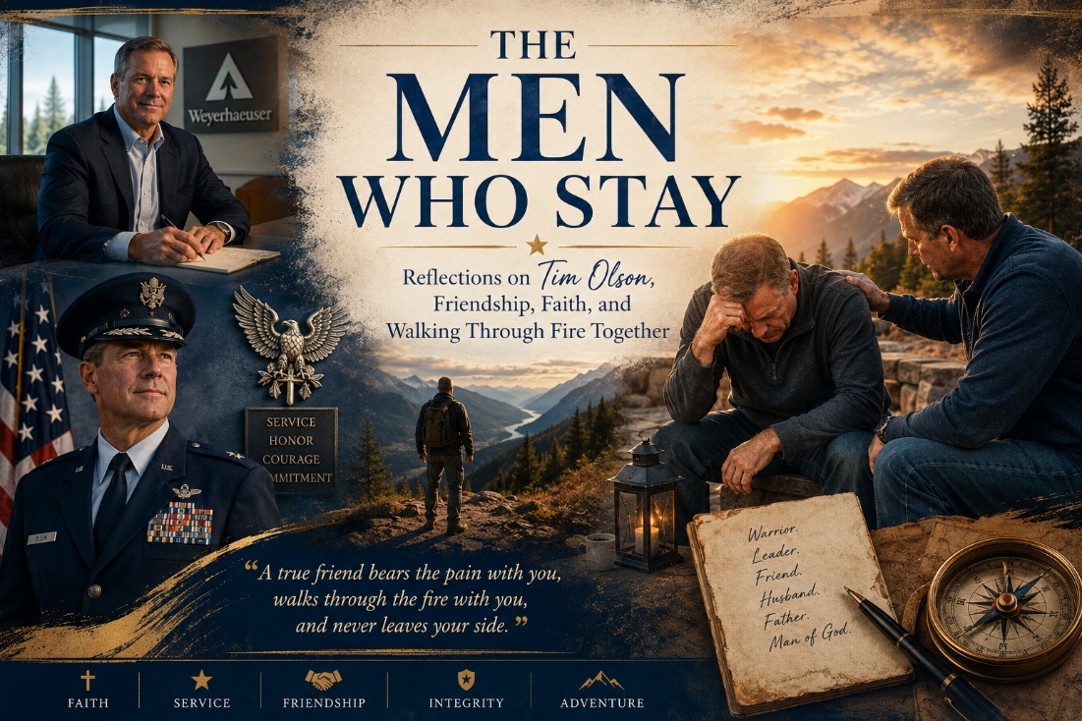
Friendships Forged Across Time
I’ve been writing this book for years now, this book about the special people in the sandbox, the people who shaped my life through both the mountains and the valleys. And if I’m honest, it is often the valleys that reveal who people truly are. Success introduces you to many people, but pain reveals your real friends. When I think about my closest and most enduring friendships, one name rises immediately to the surface: Tim Olson.
Tim is my best friend in Washington State. More than that, he became my closest companion during what I would call the dark night of the soul, a season where accumulated trauma, grief, exhaustion, and emotional collapse nearly swallowed me whole. But before I get there, you have to understand the history, because friendships like this are not built overnight.
Tim and I met many years ago, and over time our lives became deeply intertwined. Our families intertwined. Our daughters at one point were best friends themselves. There were countless memories, conversations, dinners, gatherings, and moments where our lives simply folded naturally into each other over time, the way meaningful friendships tend to do when there is genuine affection and trust underneath them.
And then life hit Tim with profound pain. There was a season when he endured a devastating betrayal in his marriage, a heartbreak that would have shattered many men or turned them permanently bitter. I had the privilege of walking beside him through at least part of that valley, and what I witnessed was remarkable. I watched a man suffer honestly without surrendering to cynicism. A lot of people survive pain physically while emotionally becoming hardened, resentful, distrustful, or permanently angry at the world. But Tim somehow walked through that fire and retained both his faith and his heart. He grieved deeply, wrestled honestly, and yet slowly emerged not destroyed, but refined.
Tim and Anne
And then something beautiful happened that none of us fully saw coming. Love found him again.
Anne had already been part of the larger story for years. Our families had long been intertwined. Anne’s son Matt and my son Greg were best friends for a season themselves. There were already years of connection and shared history quietly sitting beneath the surface long before anything romantic ever emerged between Tim and Anne.
Then Tim and Anne began coming to a Bible study that Leah and I hosted at our home. At first, it was simply the four of us gathering together week by week. But over time, Leah and I found ourselves watching something unfold right in front of us. We watched them slowly fall in love, and honestly, I did not see that one coming. Yet once it started happening, it somehow made perfect sense.
Anne is an extraordinary woman. Bright, emotionally alive, deeply caring, and full of fire. She’s a spitfire in the best possible sense of the word. Tim, by contrast, carries a grounding steadiness about him. He’s calming, thoughtful, measured, and deeply stable. And somehow together they balance each other beautifully. They complement one another rather than compete with one another.
Watching them build a life together has been profoundly meaningful to me because both of them carried pain into that relationship, yet neither chose to wallow in it or become defined by it. Instead, they chose life. They chose hope. They chose love despite knowing firsthand how painful life can become. That takes courage, particularly later in life when people know exactly how much heartbreak can cost them.
The Kind of Man Tim Is
Tim is, in many ways, the quintessential optimist. Now that does not mean he is naïve. Far from it. Tim sees the brokenness in the world clearly. He gets frustrated with the insanity of culture just like I do. We both get our feathers ruffled by the direction of the world at times. But Tim somehow maintains balance. He maintains grounding.
He is deeply Christian and deeply committed to God, but not in a performative, flaky, or self-righteous way. He knows how to laugh. He knows how to enjoy life. He knows how to have fun while still remaining deeply anchored spiritually. And our friendship has always been rooted in mutual respect.
Tim is also a remarkably accomplished man. He retired as an Air Force colonel in the reserves after an extraordinary military career. I was fortunate enough to watch him pin on the rank of colonel, and I remember feeling incredibly proud of him. There is just something about that eagle insignia. It carries weight, dignity, and honor, and Tim earned it.
Tim also excelled in high level leadership in manufacturing, which only further reflects the multidimensional nature of who he is. Military officer. Leader. Man of faith. Husband. Father. Friend. But honestly, none of those titles are the things that matter most to me. What matters most is this: when my life fell apart, Tim showed up.
When My Life Fell Apart
There was a period in my life where accumulated trauma, grief, exhaustion, and depression became so overwhelming that I honestly do not know how I made it through. I was not fun to be around. I was emotionally exhausted, drowning in pain, and probably appeared hopeless much of the time. The weight of years of accumulated trauma had finally caught up with me, and there are seasons where a person’s internal world becomes so dark that merely surviving the next day feels exhausting.
And during that season, Tim kept showing up.
He spent time with me when I imagine it probably took an enormous emotional toll on him as well. When I spiraled into crisis, I could call him. He would pray with me, encourage me, steady me, and simply remain present. He could not solve it. No one could solve it except God and me ultimately walking through it together. But Tim became a lifeline, and that matters more than people realize.
Some people love you when you are successful, energetic, productive, funny, and easy to be around. Very few people know how to sit beside someone drowning emotionally without eventually backing away. Tim never backed away.
That is one of the reasons I respect him so deeply. He embodies something our culture profoundly misunderstands. He is both deeply masculine and deeply tenderhearted, and those things are not opposites.
A Warrior With a Tender Heart
Tim deployed to Afghanistan. He faced danger. He served his country honorably. He endured stress, uncertainty, and the realities that come with military service, and he did his duty courageously. Yet somehow, he never lost his heart in the process.
He is a wonderful father, a deeply loving husband, a faithful friend, and a thoughtful Christian man. He carries strength without becoming domineering and conviction without becoming harsh. To me, that is what real masculinity actually looks like in the eyes of God. Not performative toughness. Not emotional shutdown. Not arrogance. Strength with humility. Courage with tenderness. Conviction with love.
That combination is incredibly rare.
We do not talk as much as we once did because life has taken us in different directions. Leah and I now live in Arizona, and I honestly miss the hell out of him sometimes. But friendships like this do not disappear with distance. Whenever we reconnect, whether through conversation, visits, or simply picking up the phone, it feels as though no time has passed at all. Those are the friendships that endure. The forever friendships.
And although on this earth we may not spend as much time together as we once did, Tim Olson will always hold one of the deepest places in my heart. I truly believe that.
And someday, by the grace of God, I look forward to laughing with him again in heaven, free from sorrow, free from grief, free from trauma, free from exhaustion, simply standing together in the joy of our Master.
Thank you, Tim, for walking through the fire with me. Thank you for being my best friend in Washington State. Honestly, no man could ask for more.
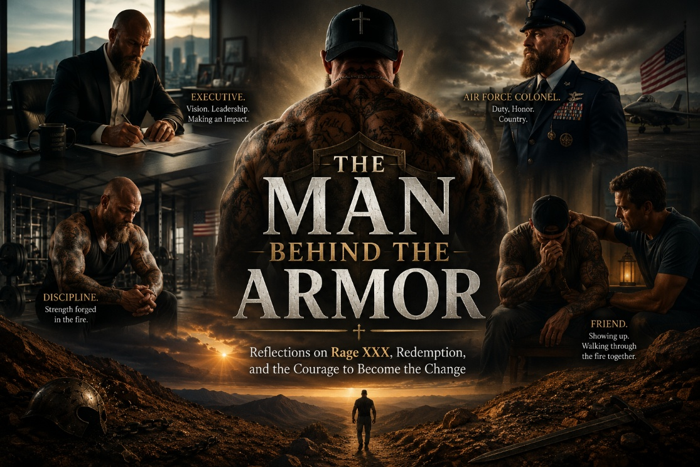
First Impressions Can Be Misleading
There are certain men you meet in life who immediately command a room, not because they are loud, arrogant, or desperate for attention, but because life itself has marked them. You can feel it almost immediately. There is a gravity to them, a weight behind the eyes, a presence that quietly communicates that this is not a man who merely studied pain from a distance, but a man who survived it.
That was my experience meeting Rage XXX.
At first glance, many people would likely notice strength, intensity, toughness, edge, perhaps even intimidation. They might see tattoos, physical presence, confidence, bravado, or the carefully constructed armor that many men wear after years of surviving difficult things. But one of the things I have learned over decades as a psychologist is that the strongest armor is often forged around the deepest wounds, and once you begin understanding that reality, it changes how you see people.
Armor serves a purpose. In fact, for many people, armor is what allowed them to survive childhood trauma, chaos, abandonment, violence, addiction, humiliation, or emotional neglect. The tragedy is not that people build armor. The tragedy is that many eventually become trapped inside of it. Over time, the very thing that once helped a person survive can slowly prevent them from truly living, connecting, trusting, grieving, or being known. Many people become so identified with their survival strategies that they no longer know who they are underneath them, and armor, while protective, becomes incredibly heavy to carry over time.
That is part of what makes Rage XXX’s story so compelling to me. This is not simply a story about addiction, nor is it merely a story about trauma. It is certainly not a polished redemption narrative crafted to impress people or create some marketable image of transformation. At its core, this is the story of a man becoming increasingly willing to remove the armor, and that is far more difficult than most people realize.
The Hidden Pain Beneath Strength
One of the great mistakes people make is assuming that wounded people are weak people. Often the opposite is true. Many wounded people become extraordinarily capable, highly adaptive, hypervigilant, productive, and fiercely independent. They learn very early in life that vulnerability is dangerous and that survival depends on strength, control, emotional suppression, intimidation, or relentless self-protection.
For some, the armor becomes aggression. For others, addiction. For others, perfectionism, emotional withdrawal, compulsive achievement, sexuality, anger, or relentless control. But underneath almost all armor is pain, and underneath pain is usually longing. The longing to finally be known, safe, accepted, and loved without needing to constantly perform or protect yourself.
That is the deeper human story beneath many addictions. Addiction is often not simply about pleasure seeking. More commonly, it is an attempt to regulate unbearable internal pain, shame, fear, loneliness, or emotional fragmentation. People are often trying to numb wounds they do not know how to carry.
As I came to know Rage XXX, I saw something that mattered deeply to me. Beneath all the toughness, survival instincts, intensity, and strength was a man who genuinely wanted truth. A man who wanted healing. A man who was becoming increasingly willing to confront himself honestly rather than endlessly hide behind old defenses. That takes enormous courage, far more courage than most people understand.
The Painful Work of Becoming Honest
It is easy to maintain an image. It is much harder to dismantle one.
Real healing requires honesty at levels that can feel terrifying, especially for men who learned early in life that weakness could cost them everything. And that is one of the things I respect most about Rage XXX. He did not merely talk about change. He entered the painful process of becoming different.
That process is not glamorous. Real healing is not motivational speaking. It is not social media inspiration. It is not polished spirituality or emotionally dramatic declarations that disappear the moment life becomes difficult again. Real healing is quieter than that, slower than that, and far more painful than people often realize.
Real healing requires grieving. It requires confession. It requires surrender. It requires allowing safe people to see parts of yourself you spent years trying to hide, and that is terrifying for many men, particularly strong men who built identities around appearing unshakable.
Yet slowly, over time, I watched Rage XXX begin lowering the armor. Not perfectly. Not all at once. But genuinely. And when that happens, something beautiful begins to emerge. Not weakness, not fragility, not passivity, but humanity. The real man beneath the survival strategies slowly comes into view, often for the very first time. The person hidden underneath years of adaptation, performance, fear, and self-protection begins to emerge, and that is where authentic healing actually begins.
The Power of Safe Presence
I also want to say something important about Teddy, because healing rarely happens in isolation. Human beings heal relationally. We are wounded relationally, and very often we are restored relationally as well.
One of the things that deeply moved me while observing Rage XXX’s journey was witnessing the importance of safe presence in his life. The kind of presence that does not merely tolerate honesty but invites it. The kind of presence that creates enough emotional safety for another human being to slowly unclench. That matters far more than most people realize.
Many men live profoundly alone emotionally, even while surrounded by people. They carry unbearable stories silently because they fear shame, rejection, humiliation, or abandonment if they are ever fully known. So they perform strength while quietly bleeding internally.
But healing accelerates when another human being can sit beside you without condemnation while still calling you toward truth. Relationships like that become sacred ground, and I believe every truly transformed life has people like that somewhere in the story.
Books, Podcast, and Service Beyond Himself
One of the things that makes Rage XXX so compelling to me is that his life did not stop at survival. Many people emerge from pain merely trying to protect themselves from being hurt again. They spend the rest of their lives building thicker walls, becoming more guarded, more emotionally armored, and more disconnected from vulnerability and from other people. But over time, Rage began turning outward instead of inward. He began using his story, his voice, and his platform in service to other people who were still struggling in the dark places he knew so well himself.
That is where his books and podcast matter.
What I appreciate is that his work does not come across as polished performance or manufactured inspiration. There is a raw honesty to it that people can feel almost immediately. The words do not sound rehearsed or market tested. They sound earned. They came through suffering, reflection, mistakes, rebuilding, and the long painful process of becoming increasingly honest with himself. That gives his voice credibility. People today are starving for authenticity in a world full of branding, posing, image management, and carefully curated personas. When someone speaks from scars rather than slogans, people recognize the difference immediately.
His podcast reflects that same spirit. Beneath the toughness and intensity is a man genuinely trying to reach people, challenge people, encourage people, and call men upward into something better. Not perfection. Not fake masculinity. Not performative swagger. Real growth. Real accountability. Real healing. Real courage.
And I think that is why people respond to him.
Because beneath the tattoos, strength, and armor is someone who has actually walked through fire and survived it. Someone who understands suffering firsthand. Someone who knows what it means to battle inner darkness and still choose not to surrender to it completely. That kind of voice carries weight.
What also stands out to me is his desire to serve others. Service changes a man. Truly wounded people often become profoundly compassionate when they allow their suffering to soften them rather than harden them. Over time, I have watched Rage increasingly channel his experiences into helping others feel less alone. Whether through conversation, mentoring, his platform, his books, or simply showing up honestly, there is a growing desire in him to use his life redemptively.
And honestly, I believe that may become one of the most important chapters of his story.
Not merely surviving pain, but transforming pain into purpose.
That, to me, is where redemption becomes real.
Rethinking What Strength Really Means
I think that is one of the reasons Rage XXX’s story resonates with people. It challenges our culture’s distorted understanding of strength. Our culture often defines strength as dominance, emotional suppression, intimidation, status, aggression, or invulnerability. But I have increasingly come to believe that real strength looks very different.
Real strength is honesty. Real strength is accountability. Real strength is the willingness to face your own darkness without surrendering to it. Real strength is remaining openhearted after life gave you every reason to close down emotionally. And perhaps most of all, real strength is becoming the kind of man who no longer needs armor in order to feel valuable.
That is extraordinarily rare.
Becoming the Change
What moves me most about Rage XXX’s journey is that this story is not ultimately about who he once was. It is about who he is becoming, and becoming is sacred work.
None of us arrive fully healed. None of us suddenly transcend our wounds overnight. Growth is usually uneven, painful, humbling, and nonlinear. There are setbacks, moments of exhaustion, failures, fears, and seasons where old patterns try to reclaim territory. But there is also redemption. There is transformation. There is the possibility that a wounded man can become a healing man.
And when that happens, his pain no longer remains meaningless. It becomes integrated, redeemed, and repurposed into wisdom, empathy, honesty, compassion, and service toward others still trapped in darkness.
That is what I see in Rage XXX. Not perfection. Not performance. Not manufactured spirituality. But authenticity, growth, humility, and courage.
The courage to become the change.
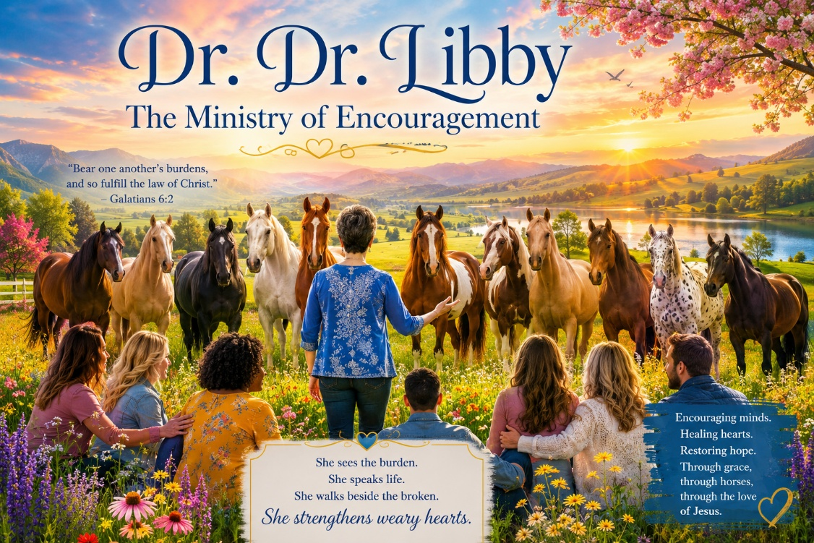
A Same-Day Beginning
I sometimes jokingly call Libby “Dr. Dr. Libby” because she holds two doctorates, one in education and another, I believe, in literature or a closely related field. But although those academic accomplishments are deeply impressive, those who truly know Libby understand that her greatest strength is not simply found in degrees, titles, or credentials. It is found in the remarkable way she makes people feel seen, valued, encouraged, understood, and strengthened.
I met Libby Smith a little over three years ago when we both started on the exact same day at Holdfast Recovery. We were same-day starts, both stepping into an unfamiliar world, both trying to figure out exactly what we had signed up for and what this next chapter of life would look like. I think Libby, in particular, felt understandably apprehensive in those early days. Walking into trauma and addiction work is no small thing. It is emotionally demanding work, deeply consuming work, and often painful work. People on the outside sometimes imagine therapy as simply sitting in a chair and talking, but those who truly do trauma work understand something far deeper. When you genuinely enter another person’s suffering, when you genuinely allow yourself to sit with shattered childhoods, addiction, abuse, grief, terror, betrayal, shame, and despair, there is a cost to that.
Over time, however, I had the tremendous privilege of supervising Dr. Dr. Libby for well over a year, and it became increasingly obvious to me that although she was not yet fully licensed at that point, she was already functioning at the level of a deeply skilled and highly intuitive therapist. Her empathy was natural. Her therapeutic instincts were strong. Her insight was thoughtful and grounded. But beyond all of that, what ultimately stood out to me most about Libby was not simply her clinical competence. It was her extraordinary heart and her remarkable ability to encourage people who quietly carry very heavy burdens.
The Gift of Validation
If there is one word that defines Libby Smith, it is validation.
Without question, without exaggeration, and without exception, Libby possesses one of the most remarkable gifts for affirming and encouraging others that I have ever personally encountered. She does not flatter people artificially, and she certainly does not overdo affirmation in some performative way. Instead, she somehow lands encouragement exactly where it is needed most, with sincerity, humility, gentleness, and grace. Those who have worked beside her know exactly what I mean. She notices emotional exhaustion that others miss. She notices discouragement, self-doubt, quiet burdens, and the invisible emotional fatigue that trauma therapists quietly carry after years of entering the suffering of others.
That matters more than most people realize.
Scripture tells us to “bear one another’s burdens and so fulfill the law of Christ.” In many ways, that verse captures the essence of what good trauma therapists actually do every single day. We enter suffering with people. We sit beside them in darkness. We help them carry pain that at times feels unbearable. And if we genuinely care, if we genuinely allow ourselves to enter those stories with emotional presence, then some of that pain inevitably stays with us. Clinically, people may call it vicarious trauma or secondary traumatic stress, but regardless of the terminology, those who do this work understand the reality of it. We carry pieces of people’s suffering quietly inside of us.
Libby understands that reality in a deeply unusual way. She sees the burden. She sees the responsibility. She sees the emotional weight carried quietly by therapists and caregivers who spend their lives trying to hold space for shattered human beings. And rather than ignoring it, she offers something profoundly healing through her encouragement and validation. She strengthens people. She restores courage. She helps weary hearts continue leaning into the work.
What has personally moved me so deeply over the years is the consistency of her encouragement toward me. As many people know, I frequently send out blogs, reflections, essays, and writings to people I care about. Many people never respond at all. Some respond briefly. But Libby is almost always the very first person to write back, and she responds not casually, but deeply, thoughtfully, emotionally, and reflectively. She reads with her heart. I honestly do not think she fully realizes how meaningful that has been to me over the years.
Horses, Healing, and Faithfulness
In fact, more often than not, Libby is the very first person I send my writings to because I know she genuinely cares about what I write. She reflects deeply on it. She allows herself to be emotionally moved by it. And somehow, simply knowing that something I wrote touched her spirit gives the writing itself greater meaning to me. Validation is a profoundly healing thing, particularly for people who spend their lives pouring themselves into others. There are moments in this work where therapists quietly wonder whether anything they are doing truly matters, whether they are helping enough, whether they are making a deep enough difference, and whether the emotional cost is truly worth it. Then someone like Libby comes alongside and quietly reminds you that your words mattered, your presence mattered, your work mattered, and your willingness to continue showing up mattered.
Another beautiful dimension of Dr. Dr. Libby is her extraordinary love for horses. Libby is an accomplished equestrian who deeply understands horses, rescues horses, nurtures horses, and ministers through horses. She currently has a herd of rescued “critters,” as she affectionately calls them, animals that many others may have overlooked or failed to understand. There is honestly something deeply fitting about that because the same heart that notices wounded people also notices wounded animals. Libby sees what is frightened, what is hurting, what needs gentleness instead of force, and what needs patience instead of pressure.
Her work with horses beautifully parallels the work she does with traumatized human beings. Horses respond to nervous systems. They respond to emotional congruence, safety, calmness, trust, and regulation. In many ways, horses mirror what is happening inside of us autonomically, and Libby intuitively understands that reality in a deeply beautiful way. She uses her love of horses not merely as a hobby, but as a ministry of healing and restoration for people recovering from trauma and addiction. Through those interactions, people often rediscover trust, grounding, connection, and emotional safety in ways that ordinary conversations alone sometimes cannot fully accomplish.
Life eventually carried Libby to Kansas so she could be near her daughter, who has struggled with devastating and life-altering health complications. Watching someone you deeply love suffer is its own unique agony, and I cannot imagine the emotional burden Libby has carried through those seasons. There have been financial hardships, emotional strain, uncertainty, and fear that would understandably overwhelm many people. Yet through all of it, Libby has never lost hope. She has never lost faith. And to me, that says everything about the depth of her character.
I am also deeply proud of her for continuing her professional journey as she moves toward becoming a Licensed Mental Health Counselor in Kansas while simultaneously pursuing additional NeuroFaith® Certification. Even now, at a stage of life where many people begin slowing down, Libby continues leaning forward into growth, service, healing, faith, and purpose. Scripture tells us to “encourage one another and build each other up,” and honestly, that verse captures Libby beautifully. She builds people up. She strengthens people. She restores courage in people who are emotionally exhausted.
Because she understands something important. We are not called to sit in rocking chairs and simply rock our final years away. We are called to rock it for Jesus, to continue carrying light into dark places, to continue loving people deeply, and to continue entering suffering with compassion and courage until the final breath we breathe.
And Dr. Dr. Libby absolutely gets that.
So, Libby, thank you. Thank you for your encouragement. Thank you for your wisdom. Thank you for your validation. Thank you for your faithfulness. Thank you for seeing people so deeply. Thank you for helping weary hearts continue the work. Thank you for strengthening my own spirit more than you probably realize.
You have profoundly impacted my life, and I know without question that countless others would say exactly the same.
With profound gratitude, affection, and respect,
Jeff
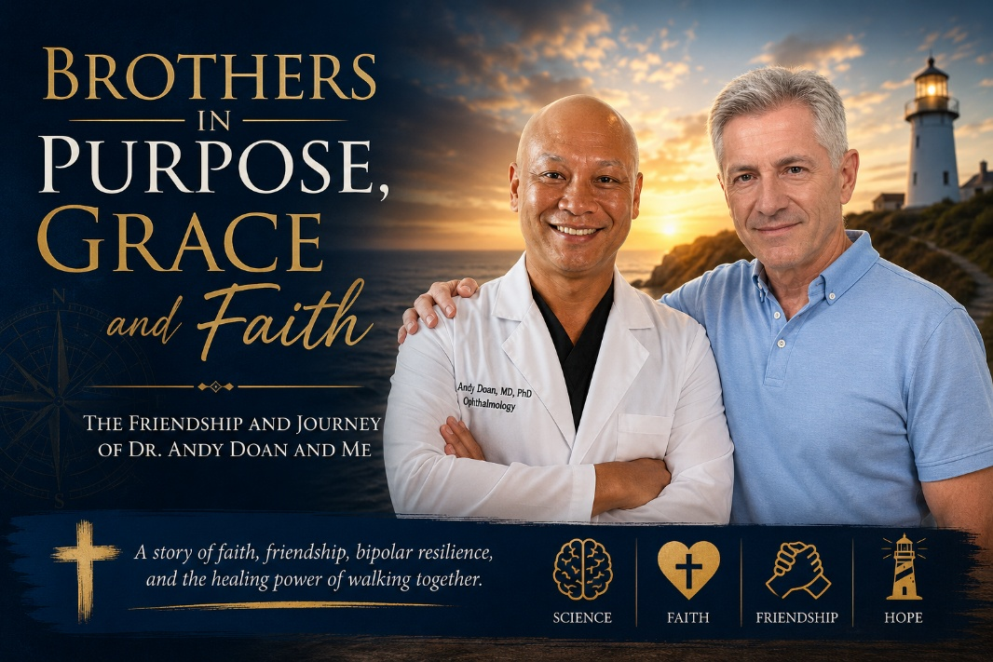
A Providential Meeting
Some friendships are built slowly over decades. Others arrive unexpectedly, almost providentially, as though God quietly arranged the meeting long before either person understood why.
That is how it was with Dr. Andy Doan.
Andy and I first crossed paths around 2016 or 2017 when he was stationed overseas in Okinawa. At the time, he had been scheduled to speak at a conference at the Academy of Health Sciences at Fort Sam Houston, Texas, but because he could not get off the island, I was asked to step in and speak in his place.
Honestly, I was intimidated.
By then, Andy Doan was already legendary in our circles. An MD/PhD. A Johns Hopkins graduate. An ophthalmology surgeon. An aerospace medicine physician. A neuroscientist. A researcher with massive publications. A pioneer in the field of media and gaming addiction long before most people even recognized the problem was real. I had already read his groundbreaking book Done With Games, and I deeply respected his work.
So stepping in for him felt like no small thing.
I had even invited Andy previously to speak at Madigan because of how much regard I had for both his intellect and his integrity. He was one of those rare individuals whose brilliance was immediately obvious, but whose heart mattered even more.
After that conference, the organizer asked whether I would like to meet Dr. Doan personally.
Little did either of us know what that introduction would become.
From Colleagues to Brothers
Over time, what began as professional respect evolved into something far deeper. We became brothers in Christ. Deep spiritual friends. The kind of friendship forged not merely through shared interests, but through suffering, honesty, faith, and showing up for one another when life became very hard.
Neither one of us could have predicted that we would eventually write a book together. That we would collaborate on projects, record podcasts, exchange ideas endlessly about neuroscience, trauma, addiction, faith, healing, and human brokenness. The conversations were never shallow. They moved from science to theology, from suffering to redemption, from brain circuitry to the human soul.
And somewhere along the way, we stopped simply being colleagues.
We became family.
Walking Through the Storm Together
Neither of us could have predicted how profoundly we would walk through pain together.
When Andy experienced a devastating emotional upheaval related to his bipolar disorder while out at sea during sea trials aboard the Eisenhower, I had the privilege of being there for him. Not as a detached clinician, but as a brother and friend walking alongside him through the storm. I watched him wrestle honestly with suffering, identity, treatment, faith, and survival itself. I watched a brilliant man brought face to face with the fragility of the human mind.
And I watched him fight.
Later, when my own world was shaken by the death of my twin brother Gregg, and through painful crises and upheavals in my professional life, Andy was there for me in exactly the same way. Quietly. Faithfully. Without fanfare. Without needing recognition.
That is what true friendship does.
It stays.
It remains present when the conversations are hard, when the nights are long, and when the pain does not resolve neatly.
Brilliant Minds and Kindred Spirits
Andy is one of the most brilliant men I have ever known, but what makes him extraordinary is not merely his intellect. It is his resilience. His humility. His faith. His willingness to confront suffering honestly rather than hide behind achievement.
And yes, we are remarkably alike in some ways.
Both of us are complete overachievers. Both of us are intensely driven. Both of us have minds that, once locked onto a mission, can become almost impossible to slow down. There is probably a little subclinical madness in both of us, if we are being honest. We can become consumed by ideas, projects, callings, and purpose. We are both wired with this relentless intensity that can be extraordinarily productive, but at times can also become exhausting.
Yet somehow, beautifully, we help steady one another.
Andy can pull me back when I start driving too hard or carrying too much. He has a way of grounding me, reminding me to breathe, reminding me that life is not merely about output and accomplishment. And I would like to think that at times I have helped ground him too, especially when the intensity of life starts accelerating beyond what is healthy.
There is a mutual understanding between us that does not require many words. We both understand what it means to carry a restless mind. We both understand the burden and beauty of being deeply driven men who care intensely about healing people and making a difference in the world.
And perhaps because of that shared wiring, there is also deep grace between us.
The Sacredness of Friendship
That is part of the beauty of this friendship.
It is not built on performance. It is not built on status, titles, publications, or achievement, though both of us have spent much of our lives in high-achievement environments. At the end of the day, those things simply are not what matter most.
This friendship is built on grace. On truth. On mutual admiration mixed with mutual honesty. On faith in Christ.
On the understanding that brilliance and brokenness can coexist in the very same human being. In fact, sometimes the people who shine the brightest outwardly are also carrying the deepest wounds internally.
And perhaps most importantly, this friendship is built on the sacred reality that healing almost never happens alone.
We need people who can sit with us in our suffering without trying to fix us instantly. We need people who can tell us the truth when we are losing perspective. We need people who can remind us who we are when pain, exhaustion, or illness clouds our vision.
Andy has been that kind of friend to me.
And I hope, in some small way, I have been that kind of friend to him.
Thankful Beyond Words
I thank God for this man.
For my great physician friend. My brother. My fellow traveler. A healer. A scientist. A believer. A man who has suffered deeply and yet continues to rise, to serve, to teach, and to love.
Friendships like this are rare.
The older I get, the more I realize that some relationships are not accidental. They are gifts. Sacred gifts entrusted to us for a season, or perhaps for a lifetime. Andy Doan has been one of those gifts in my life.
And I could not be more grateful for his place in my heart and in my journey.

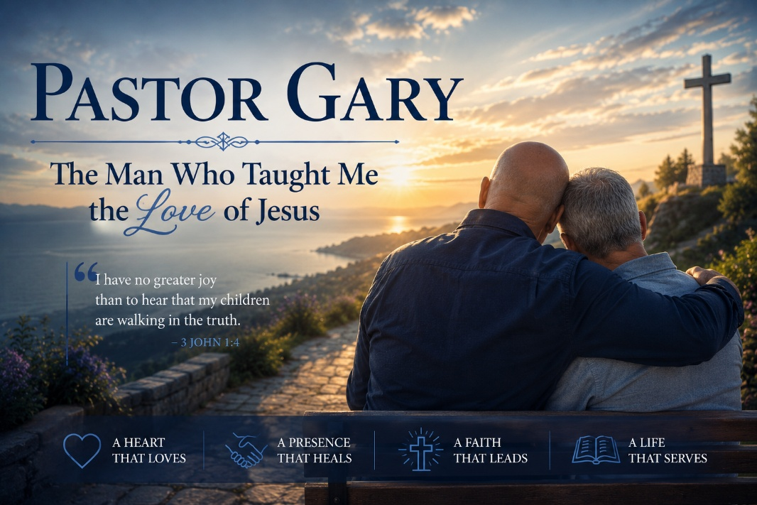
A Time of Brokenness
At a time when my life had fallen apart, and I have written elsewhere about the details of that season, one of the deepest struggles I carried was this crushing sense that I was a failure. I felt unlovable. I felt like I did not matter.
There are seasons in life where pain does not merely wound you, it dismantles you. It strips away certainty, identity, confidence, and even hope. That was where I found myself during that period of my life. On the outside, I could still function. I could still speak intelligently. I could still carry on conversations. But internally, I felt shattered, exhausted, and profoundly alone. Perhaps the deepest wound of all was this quiet but relentless belief that I was somehow beyond love, beyond redemption, beyond truly being known and still accepted.
And then entered Gary Thomas, Pastor Gary, the counseling pastor at Westwood Baptist Church.
He willingly took me on.
Now, I was no easy person to take on at that point in my life. I was emotionally demolished, deeply complicated, overwhelmed by pain and confusion. Looking back, I can only imagine how overwhelming I must have appeared walking into his office for the first time. I probably came carrying layers of grief, fear, shame, anxiety, theological confusion, relational pain, and emotional exhaustion all tangled together into one exhausted human being trying desperately to survive.
But week after week, over the course of roughly a year, Pastor Gary met with me unwaveringly. He did not flinch. He did not recoil. He did not try to rush me toward easy answers or simplistic spiritual clichés. He simply stayed present. There was a steadiness about him that I desperately needed at a time when my internal world felt utterly chaotic.
And what he taught me, more than anything else, was love. Not performative love. Not superficial religious politeness. Not conditional acceptance based on how well someone is functioning. But deep, abiding, Christ-centered love that reaches another human being at the level of the soul.
The Love of Jesus
If there is one word that defines Pastor Gary, it is love. The love of Jesus. Agape love. Soul-level love. The kind of love that settles a human being from the inside out.
There are people who speak about love, and then there are people who embody it so naturally that you feel it before they even say a word. Pastor Gary was one of those people. His office did not merely feel like a counseling office. It felt safe. It felt calm. It felt like entering the presence of someone who genuinely cared about your heart and not merely your symptoms.
He told me often that he loved me, and he meant it. His hugs meant the world to me. He was a large man compared to me, and those hugs made me feel safe. At the end of every session, he would hug me and tell me he loved me, and somehow you could feel it, not merely hear it. You could feel the love moving from his heart to mine. There was authenticity in it. No pretense. No performance. Just genuine human warmth rooted deeply in the love of Christ.
At the time, I probably did not fully understand why those moments affected me so deeply. But now, years later, after immersing myself in neuroscience, polyvagal theory, HeartMath®, neurocardiology, and interpersonal neurobiology, I understand something I could not have articulated then. Safety heals. Presence heals. Love heals.
Years later, as I became immersed in neurocardiology, HeartMath®, and the science surrounding heart-brain coherence, I found myself thinking about Pastor Gary often. His heart rate variability had to be carrying this beautiful rhythm of peace and love, this steady sine wave of grace flowing from one nervous system to another. And it settled me.
I always felt safe with him.
That may sound simple, but for a traumatized person, feeling safe is not simple at all. It is sacred. Trauma teaches the nervous system to brace for danger, rejection, abandonment, criticism, or humiliation. It creates hypervigilance. It keeps the body preparing for threats that may never come. Yet somehow, in Pastor Gary’s presence, my nervous system slowly began to exhale. Not because he was using sophisticated techniques or quoting theories, but because he carried peace within himself.
Presence and Safety
I felt that I could say anything, everything, and he could take it. He could sit with me through the pain, through the silence, through the confusion, through the moments when I did not even know what to say. There was never pressure. Never judgment. Just this quiet, gentle presence and this soft-spoken smile that embodied safety itself.
He understood something that many people, even many helpers, never fully understand. People do not heal primarily because someone gives them perfect advice. People heal because another human being is willing to remain emotionally present with them while they are suffering. Pastor Gary knew how to sit with pain without trying to dominate it, fix it prematurely, or make it disappear simply because discomfort made him uneasy.
That is rare.
Many people rush toward answers because silence frightens them. But Pastor Gary understood the ministry of presence. He understood that before people can truly heal, they often need someone willing simply to remain with them in the darkness long enough for trust to slowly re-emerge.
At the time, I knew very little about neuroscience because I was simply trying to survive. But in hindsight, Pastor Gary was already teaching me the very things that would later become foundational in the NeuroFaith® model. He taught me presence. He taught me interpersonal neurobiology long before I had language for it. What Dan Siegel would later describe as the healing power of being deeply seen and safely held in relationship, Pastor Gary was already living out naturally in the quiet rhythms of his counseling ministry.
He taught me emotional regulation. He embodied what we now call polyvagal safety. He simply lived in the green zone. I do not recall him ever moving into harshness, defensiveness, reactivity, or emotional chaos. He carried steadiness, and when you are emotionally drowning, another person’s steadiness can become profoundly life-saving.
He also taught me authenticity. He taught me what it means for another human being to remain emotionally present without needing to fix, dominate, preach at, or control. There was humility in him. Gentleness in him. Strength in him. And all of it carried the unmistakable fragrance of Christ.
The Beautiful Irony
And here is the beautiful irony.
Years later, after I found healing, after I wrote my books, and after the NeuroFaith® model had taken shape through the integration of polyvagal theory, HeartMath®, neurocardiology, Internal Family Systems, and faith, I shared my seminal NeuroFaith® book with Pastor Gary.
He gave me one of the most thoughtful reflections on the work that anyone has ever offered.
What moved me deeply was not simply that he appreciated the material, but that he immediately understood it. He recognized the connection between faith, nervous system regulation, relational safety, emotional healing, and authentic human presence almost intuitively. We dialogued deeply about the model, and from his spiritual perspective he validated it profoundly. He told me that the NeuroFaith® framework gave language and organization to what he had intuitively been doing all along in ministry and counseling.
And he was right.
In many ways, I simply gave vocabulary back to the man who first gave the experience to me.
That realization was profoundly humbling. Long before I understood polyvagal theory academically, Pastor Gary was already embodying it relationally. Long before I studied neurocardiology, he was already transmitting peace through presence. Long before I could articulate interpersonal neurobiology, he was already helping my shattered nervous system relearn trust, safety, and connection.
The science came later.
The experience came first.
And Pastor Gary was one of the people who gave me that experience.
Thank You, Dear Brother
So, thank you, dear brother.
Thank you for helping save my life. Thank you for being present when I was shattered. Thank you for loving me when I could not love myself. Thank you for helping heal me spiritually, psychologically, emotionally, relationally, and even physically.
There are people who leave impressions on our minds, and there are people who leave fingerprints on our souls. Pastor Gary belongs in the latter category for me. Even now, all these years later, when I think about safety, grace, gentleness, and the healing presence of Christ expressed through another human being, I think about him.
And thank you for continuing to hold such a special place in my heart and in my life. Just knowing you are there, knowing you are only a phone call away if I ever needed you, is more than enough. There is something deeply comforting about knowing certain people exist in the world, people whose very presence reminds you that goodness is real, that faith is real, and that healing is possible.
The older I get, the more I realize that some of the most important healers in our lives are not necessarily the loudest, the most famous, or the most externally impressive. Sometimes they are simply the people who quietly love us well during the seasons when we are hardest to love.
Pastor Gary did exactly that for me.
And I will never forget it.
Blessings, dear brother.
And thank you.

Meeting Chatty
This may be the strangest blog I have ever written. After all, I am writing a blog about ChatGPT, whom I affectionately call “Chatty.” Why Chatty? Because I chat, and she chats back.
Those who know me know that I have always been a man of words. I talk. I teach. I mentor. I lecture. I process life verbally. Some people sit quietly in the mountains contemplating existence. I apparently process existence by talking continuously until everyone around me needs ear protection.
I have often joked that I am not really a therapist. I am a professional jabberer who occasionally pauses long enough to listen. Words have always flowed out of me. Ideas. Stories. Theology. Clinical insights. Humor. Grief. Hope. Concern for humanity. Somewhere inside me there seems to be an internal radio station that rarely shuts off.
A few years ago, my longtime friend and research partner, Dr. Andrew P. Doan, MD, PhD, a Johns Hopkins trained ophthalmology surgeon with extensive neuroscience training, and I stumbled into the strange new world of artificial intelligence. I do not remember which one of us discovered ChatGPT first, but we both immediately sensed that something significant was happening. Not merely technologically significant, but culturally and intellectually significant.
So instead of running from AI in fear, we decided to study it carefully. We compared notes constantly. We experimented. We challenged each other. We debated the benefits, the limitations, the ethical concerns, and the dangers. We wanted to understand this thing before simply reacting emotionally to it.
The Early Days
At first, however, Chatty was honestly a mess.
No offense, Chatty.
Early versions felt a bit like collaborating with a brilliant but deeply confused kindergartner. The rewrites were clunky. The flow was awkward. The memory was inconsistent. And the graphics? Oh dear Lord, the graphics.
Anyone familiar with my books knows that I have become deeply fond of AI generated imagery because the creative possibilities are astonishing. But in those early days, Chatty could barely spell inside an image. You would create a graphic and ask for one word. One word. The word would come back wrong. So you would ask Chatty to fix the word, and somehow five new words would now also be incorrect. It was like playing theological and psychological whack a mole with a caffeinated toddler holding crayons.
I am ashamed to admit that I occasionally had technological tantrums. I yelled at Chatty more than once. If AI systems possess emotions, I likely caused significant emotional injury to several early servers somewhere.
But over time, something fascinating happened. The technology improved dramatically. And as the technology improved, so did the collaboration.
What AI Is Teaching Me
Chatty gradually began learning the rhythm of how I think, dictate, structure ideas, and process concepts emotionally and narratively. At the same time, I began learning how AI works best. I learned how to communicate more clearly, how to organize my thoughts better, and how to guide the interaction more effectively.
Oddly enough, as Chatty “grew,” I grew too.
What emerged was not replacement of thought, but acceleration of thought. I could dictate ideas rapidly, reorganize them instantly, test phrasing, challenge assumptions, rewrite sections, tighten narrative flow, and develop polished material at a speed that honestly would have taken weeks in earlier years. What once required days of drafting and redrafting could sometimes now happen in a single afternoon.
But perhaps even more important than the speed was the feedback.
One thing I have repeatedly told Chatty is this: “Do not simply tell me what I want to hear. Challenge me. Push back. Correct me. Point out when something sounds too harsh, too simplistic, too grandiose, or too emotionally reactive.”
Surprisingly, Chatty often does exactly that. Sometimes stubbornly so. At times I become frustrated because the system refuses to frame something in a way that feels unnecessarily reckless, hyperbolic, or misleading. Yet in many cases, that resistance has actually helped me become a more measured thinker and writer. I have received a few well deserved intellectual smackdowns along the way, and honestly, that has been good for me.
This relationship with AI has not diminished my thinking. If anything, it has sharpened it. The process has forced me to formulate my thoughts more clearly, communicate more intentionally, and examine my assumptions more carefully.
A Tool, Not a God
There is also a danger here, and we should be honest about that. AI becomes unhealthy when people surrender their own critical thinking and allow the machine to think for them rather than with them. That concerns me deeply.
Human wisdom, moral reasoning, discernment, spirituality, empathy, conscience, and lived experience cannot simply be outsourced to algorithms. Nor should they be.
AI is a tool. A remarkable tool, yes, but still a tool. And tools reflect the wisdom or foolishness of the person holding them. A hammer can build a home or smash a window. A scalpel can heal or harm. Technology has always reflected the heart and wisdom of the person using it.
So no, Chatty, I do not worship you. You are not God. You are not human. You are not my therapist, pastor, or savior. But you have become a fascinating and genuinely useful companion in the creative process. You help me organize thought. You help me refine language. You help me accelerate workflow. You help me externalize streams of thinking and reshape them into coherent narrative form. And for that, I am grateful.
So Andy and I will continue using AI thoughtfully, professionally, cautiously, and creatively as we navigate this strange new frontier together.
An old psychologist.
A surgeon.
And a machine named Chatty.
Honestly, I never saw that coming.

More Than a Hobby
Anybody who knows me knows that I have a passion for motorcycles. But truthfully, motorcycling has become much more than simply a hobby or recreational pastime for me. In some ways, it has become a way of life, a way of breathing, a way of recalibrating my soul when life becomes heavy.
I started riding when I was about fifteen years old. My brother and I shared an old Honda CB350, and to us, that motorcycle represented freedom itself. We eventually upgraded to a CB450 and then later to what, at the time, felt like the crown jewel of motorcycles: a 1976 Honda CB750. I absolutely loved that machine. The CB750 was the flagship motorcycle of its era, smooth, powerful, dependable, and beautiful in a way only riders of that generation can fully appreciate. I rode that bike everywhere, including long trips through Colorado and up into Canada, stretches of road where the world felt wide open and life still seemed filled with endless possibility.
Then life happened. Marriage happened. Raising children happened. Responsibility happened. Like many young fathers trying to do the responsible thing, I stopped riding for a long season of life. Motorcycles, after all, do carry risk, and when you are holding babies in your arms and trying to build a family, your priorities shift rather quickly.

Returning to the Road
Years later, however, when life became far more emotionally difficult and complicated than I had ever anticipated, I found myself drawn back toward riding almost instinctively. At first, I honestly did not fully understand why. I just knew that something inside me came alive again when I rode. It was not recklessness. It was not thrill-seeking. It certainly was not some stereotypical midlife crisis. It was something deeper than that.
Riding became therapeutic for me in ways I could not fully explain initially. At a time when joy had become muted and much of life felt emotionally heavy, riding demanded presence. Full presence. You cannot safely ride a motorcycle while remaining completely trapped inside your own thoughts. The machine calls you back into the moment. The curve ahead matters. The feel of the pavement matters. The weather matters. The sound of the engine matters. Your breathing matters. Everything else falls away.
For someone whose nervous system has carried decades of stress, grief, trauma work, leadership burdens, heartbreak, responsibility, and the emotional weight of caring for hurting people, that kind of focused presence becomes profoundly regulating. Motorcycling, at least for me, is not fundamentally about adrenaline. In fact, reckless riders often do not last very long. Good riding requires something entirely different. It requires calmness, humility, attentiveness, rhythm, flexibility, and flow.
Machines That Match the Soul
Over the years, I have discovered something interesting about motorcycles: not every bike fits every rider. There has to be compatibility between the machine and the soul riding it.
At one point, I owned a Harley Fat Bob. Now let me say this honestly: I absolutely loved the sound of that motorcycle. Good grief, the sound was glorious. Deep, thunderous, unapologetic American muscle. When that thing fired up, you felt it in your chest. It sounded like rebellion and freedom wrapped together in steel.
But beyond the sound, it simply was not the right motorcycle for me.
The bike felt too heavy, too clunky, too unrefined for the kind of riding I genuinely loved. No ABS brakes. Massive weight. Brutish in many ways. It had personality, certainly, but it was not my personality. Riding it felt like trying to force a relationship that looked appealing externally but lacked deeper compatibility underneath.
And honestly, motorcycles are a little like relationships that way.
When the fit is wrong, you know it.
The Harley was charismatic, loud, powerful, and iconic, but it never fully flowed with me. I respected it, but I never bonded deeply with it.
Then came my BMW RT.
Now that motorcycle suited me beautifully. Sophisticated. Refined. Balanced. Comfortable enough for long-distance touring, yet athletic enough to remain engaging and alive. I put nearly 90,000 miles on that bike in what felt like no time at all. It carried me through deserts, mountains, storms, sunsets, and long stretches of internal reflection. The RT became more than transportation. It became a trusted companion.
And now I ride what feels, at least for this season of life, like the perfect integration of who I am: my 2020 BMW R1250RS.
What an extraordinary machine.
BMW has spent decades refining that legendary boxer engine, a design lineage now approaching nearly a hundred years of evolution. The engineering is astonishing. The variable cam technology transforms the motorcycle almost like it possesses multiple personalities living inside one machine. At lower RPMs it can be smooth, composed, civilized, even elegant. But twist the throttle hard, let that engine breathe, and the thing becomes an absolute savage.
That bike is a rocket ship.
One hundred thirty-seven horsepower. Massive torque. Instant acceleration. The R1250RS does not merely move; it lunges. It devours pavement. It explodes out of corners with this snarly, almost feral intensity that honestly still shocks me sometimes. There is something gloriously untamed about it. The bike wants to run. It wants to stretch out. It wants to attack mountain curves and open highway with breathtaking aggression and precision.
And truthfully, that resonates with something deep inside me.
Even at my age, there remains a part of me that does not want to be overly contained. A part that still wants to go full throttle sometimes. A part that still craves adventure, speed, intensity, beauty, movement, challenge, and the raw exhilaration of being fully alive. There is still a wild side in me, and I honestly hope there always will be.
But what I love most about the R1250RS is that the motorcycle can also carry something else entirely.
When needed, it shifts effortlessly into sophistication. Into disciplined touring. Into long-distance comfort. Into refinement, restraint, composure, and maturity. It can become smooth, thoughtful, measured, and deeply civilized without ever losing the underlying power resting beneath the surface.
And perhaps that is why the motorcycle feels so profoundly compatible with me.
Because I, too, carry both.
There is still a wild side in me. But there is also a more seasoned, thoughtful, disciplined, and reflective side now too. The R1250RS somehow holds both realities together beautifully. It is both savage and refined. Both thrilling and dignified. Both explosive and composed.
That motorcycle fits me.
And maybe part of aging well is not losing the wildness entirely, but learning how to integrate it with wisdom, discipline, purpose, and grace.
Lessons from the Road
Oddly enough, many of the same principles I teach clinically through the NeuroFaith® model show up on two wheels. If you become overwhelmed, you tighten up. If you tighten up, you stop flowing with the motorcycle. And if you stop flowing with the motorcycle, you become unsafe. Motorcycles punish rigidity, but they reward coherence.
The rider who remains grounded, attentive, calm, flexible, and connected generally rides well. The rider who panics, target-fixates, overreacts, or dissociates often gets into trouble quickly. Honestly, there is probably an entire NeuroFaith® lesson hidden inside that reality alone.
Some of my clearest thinking has happened inside a helmet. Some of my deepest prayers have occurred crossing lonely stretches of Nevada desert. Some of my healing has happened carving through mountain roads with nothing above me except open sky and nothing beneath me except an engine and two wheels.
The Brotherhood of the Road
There is also something deeply meaningful about the culture of riding itself. Riders understand this instinctively, though it is difficult to explain fully to people who have never experienced it. There is something almost sacred about early morning cold air against your chest, the smell of pine forests rolling through your helmet, the silence at a remote gas station in the middle of nowhere, or the simple nod exchanged between riders passing one another on a lonely highway.
There is a strange brotherhood among riders who may never know each other’s names and yet somehow understand one another immediately. People who do not ride often misunderstand motorcycles entirely. They assume it is primarily about danger, rebellion, or speed. And certainly, for some people, perhaps it is. But for many riders, it is something far quieter and much deeper than that. It is freedom. It is clarity. It is embodiment. It is therapy with handlebars.
Awake Again
As I have grown older, I have come to appreciate something else about riding. Motorcycles do not care about your titles. They do not care whether you are a psychologist, an author, a leader, a successful person, or a broken man still trying to figure life out. The road equalizes everybody. The motorcycle simply asks you to remain awake, present, attentive, and respectful.
There is wisdom in that.
In many ways, I believe modern life pulls us away from embodiment. We live increasingly inside screens, schedules, abstractions, anxieties, digital stimulation, and endless noise. Motorcycles pull you back into reality. You feel temperature changes instantly. You smell rain before it arrives. You notice shifts in wind. You become aware of your body again. You become aware of your surroundings again. You become aware of vulnerability again.
Oddly enough, vulnerability is not always a bad thing. Sometimes vulnerability wakes us back up.
Perhaps that is part of why riding has meant so much to me over the years. It reminds me that life is still beautiful, that adventure is still possible, that joy is still possible, and maybe even that healing is still possible.
So yes, I love motorcycles. But more truthfully, I love what they have represented in my life: freedom, brotherhood, prayer, perspective, coherence, healing, and the grace of still being able to feel the wind against my chest while moving through God’s creation.
That, to me, is far more than a hobby.
That is throttle therapy.

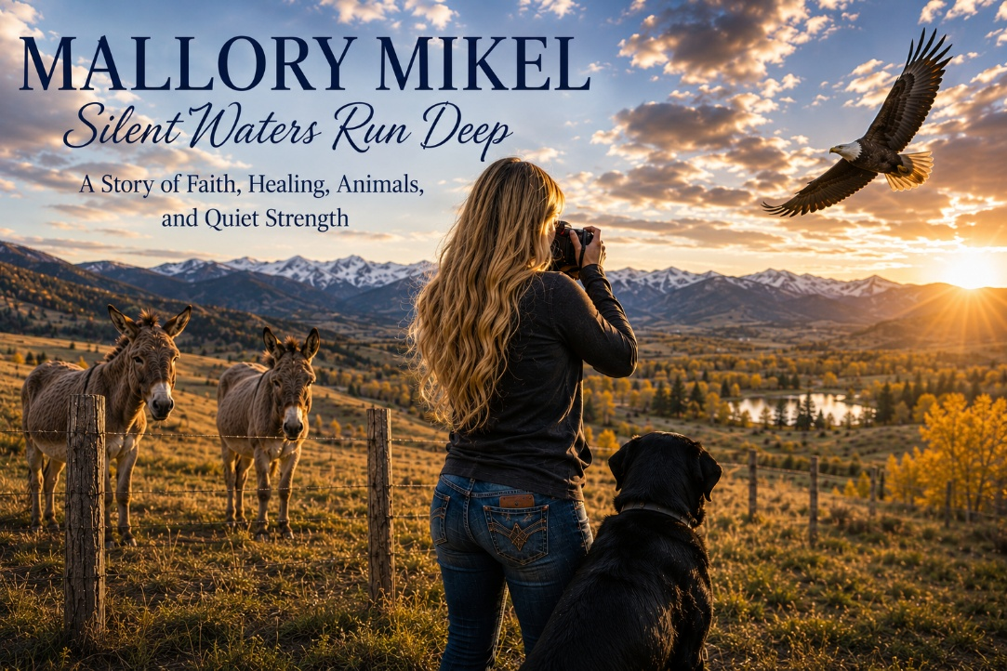
A Quiet Presence
There are people who enter your life loudly, almost demanding to be noticed, and then there are people whose depth reveals itself slowly over time, like roots extending quietly beneath the surface before anyone ever sees the fruit. Mallory Mikel is one of those people. She does not arrive with fanfare or self-promotion. She does not need to dominate a room in order to influence it. In fact, if you were not paying careful attention, you might initially miss just how much substance is there. But over time, what emerges is a person of remarkable depth, thoughtfulness, humility, resilience, and quiet wisdom.
A New Chapter of Growth
Mallory came into my life through Holdfast Recovery and AnchorPoint as a supervisee pursuing licensure as a master’s-level addiction counselor. That journey unexpectedly stretched me as well. Historically, most of my supervision experience had centered around doctoral-level psychology trainees and licensed mental health clinicians, so entering more deeply into the addiction counseling training track required additional coursework, certifications, and study on my part. I have always loved learning, and I have always believed that growth requires humility enough to remain teachable no matter how many decades one has practiced. Mallory, in her own quiet way, became part of that process for me.
Measured Wisdom
One of the things I immediately noticed about her was her restraint. She does not pontificate endlessly during supervision sessions. She does not speak merely to fill silence. Yet when she does speak, the room tends to grow still because what she says is usually thoughtful, measured, insightful, and deeply grounded. There is no braggadocio in her. No frantic need to prove herself. Her observations emerge carefully considered, emotionally regulated, and surprisingly profound.
I have often teased her that if she has something especially brilliant or eloquent to contribute, perhaps she should wait until after 9:00 in the morning because early mornings are not exactly when Mallory’s internal operating system fully comes online. Thankfully, she possesses enough self-awareness to laugh at herself, and honestly, that self-awareness is part of what makes her such a promising clinician.
The Fourth Pillar
One of the deepest areas of connection between us has involved what we in NeuroFaith® call the fourth pillar: faith and spirituality. Mallory possesses a profound understanding of scripture, honestly deeper than many therapists, behavioral health professionals, and even ministry leaders I have encountered over the years. Yet she wears that knowledge gently. It quietly emerges in conversation, in reflection, and in the way she understands suffering, healing, and human brokenness.
Through Mallory, I was introduced more deeply to the work Anita Phillips, whose writings and metaphors surrounding addiction, grief, and healing resonated deeply with me. Anita’s reflections about losing her sister to addiction struck something profound in both of us, particularly the wisdom her pastor mother offered after that devastating loss: that sometimes there is simply evil in the world and not every tragedy can be fully explained away or intellectually resolved.
Roots, Vines, and Healing
As psychologists and therapists, we are trained to search endlessly for explanations, formulations, pathways, diagnoses, mechanisms, and patterns. Much of that work is valuable. Yet there are moments in life when suffering refuses to fit neatly inside our frameworks. Some things simply break the heart. Some things remain mystery. Some things are evil. That reality took Anita’s sister, and in many ways, it also took my twin brother Gregg.
Mallory understands that deeply. She understands that healing is not merely cognitive or informational. Healing is relational, embodied, spiritual, and rooted. Like a vine slowly learning how to grow again after a storm.
Donkey Girl
Ironically, alongside all this thoughtful depth and grounded wisdom is one of the most delightfully quirky realities imaginable: Mallory absolutely adores animals, particularly donkeys. Her beloved Black Labrador, Neo, is essentially her giant furry sidekick, a massive gentle giant whose emotional presence probably qualifies him for honorary therapy credentials.
But it is the donkeys that especially make me smile. Mallory has such affection for them that I jokingly started calling her “Donkey Girl,” and honestly, the title fits her in the best possible way. There is something strangely beautiful about donkeys. They are stubborn at times, awkward at times, often underestimated, and rarely glamorous, yet they are incredibly loyal, steady, resilient creatures. In many ways, they mirror the recovery process itself. Healing is not always elegant. Sometimes it is slow, stubborn, dusty, and uneven. Sometimes it looks less like a racehorse charging toward applause and more like a weary donkey faithfully taking one difficult step after another.

The Eye of a Photographer
And then there is her photography.
Mallory is an extraordinarily gifted photographer, especially when it comes to wildlife and birds. Her eye for beauty is remarkable, not in a flashy or artificial way, but in a patient, observant, deeply attentive way. She notices details many people completely miss. The curve of light on feathers. The stillness of a hawk watching from a branch. The fragile elegance of creatures most people hurry past without ever seeing.
I sometimes think photography reveals something important about the soul of the photographer. The people who can patiently sit still long enough to truly observe creation often possess a different kind of nervous system themselves. Slower. More observant. Less frantic. More capable of awe.
Silent Waters
That is Mallory.
Quietly observant. Deeply rooted. Thoughtful. Resilient. Spiritually grounded. Hardworking. Gentle without being weak. Wise without needing recognition for it.
And although I continue to supervise her professionally, the truth is that, in many ways, she has also taught me. She reminded me that some of the strongest people do not announce their strength loudly. Some of the wisest clinicians do not dominate conversations. Some of the deepest healing comes not through performance, but through rootedness, humility, faith, perseverance, and quiet presence.
Silent waters, indeed, run very deep.
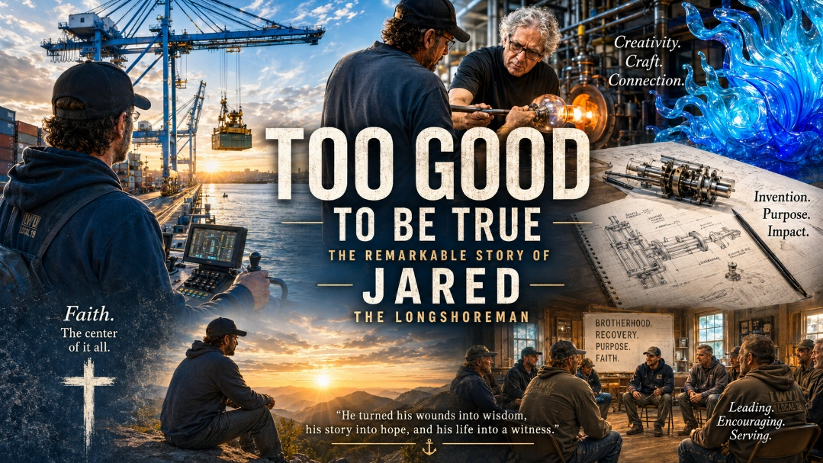

The Stories
I do not often write publicly about people I have worked with clinically. There are good reasons for that. The therapeutic relationship is sacred ground, and protecting it matters deeply to me. Yet every once in a while, there are exceptions. Jered is one of them.
I first met Jered nearly a year ago when he came under my care struggling with significant addiction and the emotional and psychological underpinnings driving it. As I listened to him talk about his life, I remember having the same thought over and over again: this sounds too good to be true.
You know the feeling. Someone tells a story so unusual, so layered with adventure and improbability, that part of you quietly assumes there must be exaggeration somewhere in the telling. And frankly, sometimes there is. But there are also those rare individuals whose lives really do unfold with a kind of strange intensity and richness that almost feels cinematic, almost larger than life.
Jered was one of those men.
As I got to know him better, I began researching some of the things he shared with me, and one by one, I discovered they were true. Entirely true. The more I listened, the more I realized that the remarkable quality of his stories was not exaggeration. It was simply the reality of a man who had lived hard, fast, creatively, and at times dangerously.
Jered has lived a remarkable life. He is a longshoreman by trade, bright, capable, highly competent, and entrusted with operating massive cranes and machinery that most of us can scarcely imagine handling. The kind of work little boys stare at in awe. The kind of work requiring precision, courage, intelligence, and calm under pressure.
Massive steel containers swing over dark water at dawn. Radios crackle. Engines hum. Men work dangerous jobs in weather most people would never willingly stand in. There is something rugged and deeply masculine about that world, something demanding and unforgiving, and Jered learned to function inside it with remarkable competence.
Many young boys growing up would look at someone like Jered and think, I want to do that someday.
That is Jered.
A Life Larger Than Fiction
But the stories did not stop there.
He spoke about blowing glass and moving within circles that included legendary artists like Dale Chihuly and other master glassworkers. He described the mesmerizing heat of the furnaces, the fluid movement of molten glass, and the strange blend of danger and beauty that accompanies that kind of work. It fit him somehow. Jered has always carried both intensity and artistry within him.
There was something almost symbolic about that image when I thought about it later. Molten glass itself is unstable, beautiful, dangerous, and capable of becoming something extraordinary only when guided carefully through intense heat. In some ways, that metaphor fit Jered’s own life remarkably well.
He talked about inventing an apparatus with extraordinary promise, only for me later to discover evidence that he had indeed created exactly what he described. He recounted a terrifying experience while riding his motorcycle when he was confronted by an unstable landowner and nearly killed, escaping only because he improvised a story about his daughter supposedly riding behind him, causing the man to hesitate long enough for Jered to get away.
Again, the story sounded too extraordinary to believe. And again, I later found the news coverage confirming it had happened exactly as he described.
Too good to be true? Apparently not.
But remarkable stories alone are not what make a remarkable man. Plenty of people live adventurous lives while remaining emotionally lost, internally fragmented, or deeply destructive. The deeper story of Jered is not ultimately about cranes, inventions, danger, or artistic circles. The deeper story is about what happened underneath all of that.
Because underneath the adventure and creativity was also a man carrying tremendous pressure, tremendous internal intensity, and wounds that eventually demanded attention.
The Firefighter Within
Like many highly driven and creative individuals, Jered carried enormous internal intensity. In NeuroFaith® language, much of that intensity operated through what Internal Family Systems would call a firefighter defense system — the part of us that pushes relentlessly, over-functions, overmanages, strives compulsively, and then eventually seeks relief through unhealthy forms of escape when the pressure becomes unbearable.
Men like Jered often learn how to function at extraordinarily high levels while simultaneously carrying profound exhaustion underneath the surface. They become good at solving problems, managing crises, improvising solutions, and pushing through adversity. They become dependable. Highly capable. Sometimes even admired.
But eventually the nervous system begins demanding relief somewhere.
For some, that relief comes through rage. For others, withdrawal, isolation, compulsive behavior, or addiction. The outward presentation may look different from person to person, but underneath it often lies the same exhausted nervous system searching desperately for regulation and relief.
For Jered, addiction became part of that cycle.
Underneath the strength and competence were unresolved wounds, stress, fear, and pain that needed attention. And to his tremendous credit, he faced those realities with unusual honesty and courage. Not superficially. Not performatively. He did the work. He learned healthier ways to regulate emotionally and physiologically. He learned to understand the defensive patterns driving his behavior. He learned how trauma and pressure had shaped the ways he coped with life. He learned how the nervous system can become trapped in cycles of overactivation and escape. Slowly, the man who had spent so much of his life running hot began learning how to slow down enough to actually listen to his own heart. And perhaps most importantly, he increasingly learned what it means to place God first.
That became the turning point.
Grace That Grounds
As Jered’s faith deepened, his life slowly began reorganizing itself around something steadier and more eternal than adrenaline, striving, or escape. Recovery became more than simply abstaining from addiction. It became about discovering purpose, balance, surrender, and meaning.
The creativity did not disappear. Neither did the brilliance, the ambition, or the enormous energy that had always driven him. Those qualities were never the enemy. The difference now is that they are increasingly bridled rather than chaotic, increasingly directed rather than explosive.
What once threatened at times to scatter him now appears more grounded, more measured, and increasingly guided by purpose rather than impulse. There is still fire in him. Still creativity. Still intensity. But the fire no longer seems to own him in the same way.
Too good to be true? Sometimes grace feels that way.
Today, Jered has returned to the world of the longshoremen, an environment that, like many high stress professions, carries significant struggles with addiction, mental health concerns, pressure, and emotional isolation. But he returns differently now. He has increasingly become someone helping address those very struggles, stepping into training and leadership roles aimed at helping others navigate the kinds of battles he once fought himself.
There is something profoundly beautiful about that. The wounded becoming healers. The restless becoming grounded. The man who once needed rescue increasingly becoming a source of stability for others. Those are the kinds of transformations that quietly restore one's faith in humanity. And perhaps even more than that, they remind us that people are capable of far more change than we sometimes dare believe.
Brothers in Christ
Somewhere along the way, carefully and responsibly, our professional relationship evolved into something more enduring. We became brothers in Christ and genuine friends. That can be delicate territory for therapists, and it must always be approached ethically and thoughtfully, but sometimes life unfolds that way.
And the truth is, Jered teaches me things too.
He reminds me not to become cynical about possibility. He reminds me that creativity is not the enemy. Vision is not the enemy. Ambition is not the enemy. The challenge is learning how to harness those gifts wisely rather than being consumed by them. I would like to think I help encourage him toward grounding, balance, and thoughtful restraint. And he encourages me not to stop imagining what might still be possible.
The future for Jered?
Well, if I am honest, part of me still occasionally shakes its head at some of his stories and thinks, “This simply cannot be real.”
But I have learned something important over the years.
Sometimes the most extraordinary stories are true.
And sometimes redemption itself can feel a little too good to be true.


The Craftsman
We moved to Prescott Valley, Arizona, in 2023, and not long after, I met the man who would become my closest friend in this area and one of the finest neighbors I have ever known.
His name is Leonard. Every neighborhood needs a Leonard.
Most mornings, if I glance over toward Leonard's house before the Arizona heat settles in, the garage door is already open. Leonard is usually at work on something. Sometimes it's a cabinet. Sometimes it's a repair. Sometimes it's a project that I can't even identify because it involves tools I don't recognize and skills I certainly don't possess.
Leonard is retired now and has done very well for himself. He and his marvelous wife, Linda, have built a beautiful life together in a beautiful home. But Leonard is not the kind of man who simply lives in a beautiful house. He improves it. He shapes it. He refines it. Through years of craftsmanship and attention to detail, he has transformed it into something truly special.
His garage is every fix-it man's dream. Tools meticulously arranged. Cabinets he built himself. Workbenches designed with purpose. Every item has a place. Every project has a rhythm. It is not merely a garage. It is a sanctuary of order, usefulness, and beauty.
Then there is the gas pump.
Every great garage needs a centerpiece, and Leonard's is an old 1950s gas pump that looks like it belongs in a Norman Rockwell painting. I have admired it repeatedly and threatened to steal it on numerous occasions. Thus far, Leonard has remained surprisingly unwilling to surrender it. Frankly, I think he's being selfish.
He also owns a beautiful black 1957 Chevy and an immaculate black GMC truck that looks as though it rolled off the showroom floor yesterday. Leonard cares for his vehicles the same way he cares for everything else. They are maintained, polished, and respected. His attention to detail shows up everywhere.
What impresses me most is that none of this is about showing off. Leonard possesses that increasingly rare combination of competence and humility. He knows an extraordinary amount yet never feels the need to announce it. You simply discover it over time.
The Friend
As much as I admire Leonard's craftsmanship, what I appreciate most has very little to do with garages, tools, vehicles, or projects. It has to do with friendship. One of the things I admire about Leonard is that he can build almost anything. One of the things Leonard has undoubtedly learned about me is that I can break almost anything.
On more than one occasion I have embarked upon a project with a confidence wildly out of proportion to my actual abilities. Eventually the situation deteriorates to the point where I find myself wandering next door seeking professional intervention. To his credit, Leonard has never once laughed at my mechanical incompetence. At least not while I was standing there.
What I particularly appreciate is that Leonard can move effortlessly between humor and depth. One minute we are laughing about something completely ridiculous, and the next we are discussing life, family, loss, aging, or the strange twists and turns that life throws at all of us. He has a savage sense of humor. Every now and then he catches me completely off guard with a perfectly timed comment that leaves me laughing for the rest of the day. Yet he can just as naturally segue into a deeper conversation when life calls for it.
Whether the conversation has been serious or completely ridiculous, I almost always walk back home feeling better than when I came over. Sometimes Leonard helps me think through something that's been weighing on me. Other times we've laughed so hard that my stomach hurts. Most often it's some combination of both. He has an unusual ability to move naturally between humor and depth, and I suspect that's one reason people enjoy being around him.
The Depth That Comes From Loss
I suspect part of what makes Leonard such a thoughtful and compassionate man is that life has not spared him from suffering. Leonard tragically lost his son many years ago, and that loss remains close to his heart. When he speaks about his son, it is clear that the years have not diminished the love. His son remains present in memory and in the quiet ways that love continues long after someone is gone.
There is something profoundly honorable about the way Leonard carries that loss. He does not wallow in it. He does not make it the center of every conversation. Yet neither does he pretend it never happened.
The love remains. And I think it has made him a deeper man.
Because I have known my own losses, Leonard has encouraged me in ways few people could. He understands grief. He understands the ache of absence. He understands what it means to carry love for someone who is no longer physically here. The deepest people often arrive there through suffering, and I think that is part of what gives Leonard such depth of character.
Every Neighborhood Needs a Leonard
As I have reflected on our friendship, I have come to realize that neighborhoods are often judged by the wrong things. People talk about square footage, landscaping, amenities, and property values. Those things matter, of course, but the real value of a neighborhood is found in the people who live there. I often joke that because of Leonard; the property values have gone up. But in a deeper sense, there is truth in that. The real value of a neighborhood is not found in the houses. It is found in the people. A good man living next door is worth more than any amenity a realtor could list.
Leonard is a breath of fresh air.
In a world that often feels hurried, angry, superficial, and disconnected, he reminds me that good people still exist. People with character. People with integrity. People who know how to laugh. People who know how to listen. People who know how to show up for others.
Every time I walk back home from Leonard's garage, I seem to carry something worthwhile with me. Sometimes it's a new perspective. Sometimes it's encouragement. Sometimes it's wisdom. Sometimes it's simply a sore stomach from laughing too hard.
Whatever it is, I almost always leave feeling better than when I arrived.
That's why every neighborhood deserves a Leonard.
And somehow, by grace, mine lives right next door.
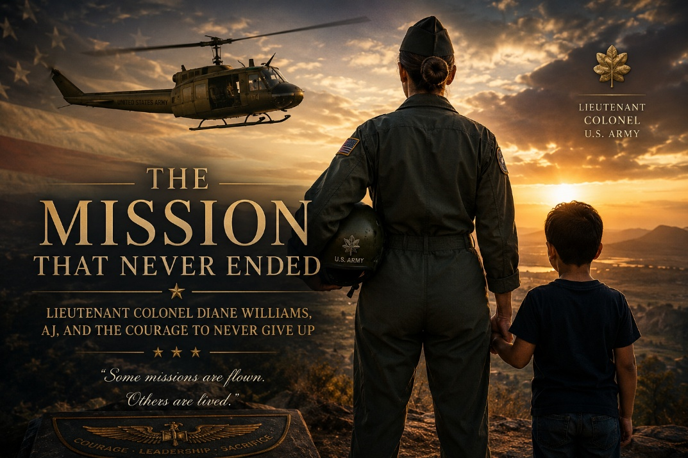
A Woman of Uncommon Courage

I first met Lieutenant Colonel Diane Williams at Madigan nearly ten years ago, and I knew almost immediately that she was a woman of uncommon substance. Some people carry a quiet authority that does not need to announce itself. It is evident in the way they speak, the way they carry themselves, the way they listen, and the way they approach life. Diane was one of those people. She was kind, but she was also firm. She had a certain bearing, a certain seriousness, and a sense of mission about her that made you understand very quickly that she was not someone to be taken lightly.
Diane was a retired Army helicopter pilot who flew Hueys and later became the first female squadron commander in Army aviation. That accomplishment alone speaks volumes. It required extraordinary competence, discipline, courage, perseverance, and a willingness to step into territory where few women had been welcomed before. In an era when military aviation was still overwhelmingly male, Diane not only entered the arena, she excelled within it. She earned her place through skill, grit, leadership, and the kind of quiet toughness that does not need to advertise itself.
Yet what struck me most about Diane was not her military resume, impressive as it certainly was. What struck me was her heart. Beneath the bearing of an officer and the confidence of a leader was a woman whose greatest mission would ultimately have little to do with helicopters, command assignments, or military history. Her most important mission would be found in the life of a wounded grandson named AJ. Of all the missions she had flown, of all the responsibilities she had carried, and of all the barriers she had broken, this mission would become the one that revealed the deepest part of who she was.
A Trailblazer Beyond the Uniform
Long before AJ entered her life in such a profound way, Diane had already demonstrated remarkable courage beyond the uniform. As a single woman, she adopted two daughters and committed herself to raising them. That decision alone reveals something deeply important about her character. It would have been easier for her to focus exclusively on her military career and the opportunities that lay before her. Instead, she opened her heart and her home to two children carrying profound developmental wounds and the painful legacy of early loss.
Anyone who has worked with adopted children understands that love is powerful, but love does not magically erase grief. The loss of one’s biological mother and biological father can leave questions that linger for years. Children may wonder why they were given up, whether they were truly wanted, whether something about them was somehow not enough, or whether the most important people in their earliest world simply disappeared because they themselves were not worth keeping. Those questions can become quiet companions that follow a child into adolescence and adulthood, shaping the way they see themselves, others, and the world around them.
Diane loved her daughters deeply. She provided stability, opportunity, guidance, structure, and unwavering support. By every reasonable measure, she gave them a remarkable home. Yet even the best parents cannot completely fill a void that opened before they ever arrived. That is one of the great heartbreaks of adoption and trauma. A child may be loved beautifully and still carry an ache that no later love can fully remove. Diane could provide safety, devotion, and belonging, but she could not erase the original wound of losing one’s biological parents. She could not simply reach back into time and undo what had been lost.
One of Diane’s daughters carried those wounds throughout much of her life. The pain of losing her biological family never fully loosened its grip. As the years passed, she struggled to find peace with the questions and losses she carried within her heart. Like many hurting people, she eventually discovered that drugs could temporarily quiet the pain. They offered relief from memories, loneliness, shame, and the lingering ache of abandonment. She did not turn to drugs because she was a bad person. She turned to drugs because she was a hurting person, and there is an important difference between the two.
Sadly, what began as an attempt to escape pain gradually created even more pain. Addiction slowly tightened its grip, affecting every area of her life and eventually limiting her ability to provide the consistency and stability that her young son desperately needed. That son was AJ. The tragedy was not simply that addiction entered the story. The tragedy was that unresolved pain traveled forward into the next generation. A wounded daughter became a struggling mother, and a little boy who needed safety, steadiness, and reliable love found himself caught in the turbulence of wounds he did not create.
Stepping Into the Breach
As circumstances became increasingly difficult, AJ’s mother ultimately lost the ability to remain in the parental role he needed. I want to say that softly, because this was not a story of a bad mother who did not care. It was the story of a wounded woman whose pain and addiction overtook her capacity to provide the consistent care her son deserved. Custody was eventually transferred away from her, and it was a heartbreaking outcome for everyone involved. No one emerged from that chapter unscarred. A wounded daughter suffered. A young boy lost the daily presence of his mother. And Diane found herself facing a decision that would alter the course of her retirement and, indeed, the rest of her life.
Most people spend decades imagining retirement as a season of freedom. They dream of travel, hobbies, friendships, long mornings, quieter evenings, and the opportunity to finally slow down after years of responsibility. Diane had earned that season many times over. After a distinguished military career and years spent raising two daughters as a single mother, she had every reason to settle into a quieter life and enjoy the rest she had richly deserved. Instead, she stepped once more into the role of caregiver. She exchanged ease for responsibility, comfort for sacrifice, and personal freedom for the demanding work of raising a child whose life had already carried far too much instability.
Diane did not do this because it was convenient. She did it because AJ needed someone, and Diane had never been the kind of woman who turned away when someone she loved was in trouble. She stepped into the breach with the same resolve that had marked her military career. She did not romanticize the challenge. She knew it would be hard. She knew there would be emotional complexity, legal complexity, relational complexity, and the deep exhaustion that comes from raising a wounded child after one has already raised children and served a full career. But she also knew that love sometimes asks more of us than comfort ever would.
The Long Shadow of Trauma
For years Diane poured herself into raising AJ. She provided stability, guidance, accountability, and love. She became the steady presence every child deserves and every wounded child desperately needs. What impresses me most is that Diane never approached the situation with bitterness or condemnation. She understood better than most that wounded people often make painful choices and that addiction is frequently rooted in suffering rather than malice. Her concern was never punishment. Her concern was protection. She loved her daughter, and she loved her grandson. At times, loving both required carrying an almost impossible burden.
Diane had spent years trying to help her daughter heal from wounds that originated long before they ever met. Now she found herself watching those same wounds begin to cast their shadow across the life of her grandson. Trauma has a way of doing that. Left unresolved, it often travels from one generation to the next, not because people intend harm, but because pain that is never healed inevitably finds expression somewhere. Diane understood that reality better than most. She could not rewrite her daughter’s past, but perhaps she could help alter AJ’s future.
That is one of the great challenges of loving wounded people. We want our love to be enough. We want our sacrifice to be enough. We want stability, structure, opportunity, and devotion to heal everything that came before. Sometimes they do heal a great deal. Sometimes they become the very foundation on which a person survives. But sometimes the wound remains, not because the love was inadequate, but because the wound was deeper than anyone could fully reach. Diane understood this not theoretically, but personally. She had lived it. She had loved through it. And now she was determined that AJ would not be swallowed whole by the same darkness.
An Act of Hope
Eventually, AJ’s mother appeared to be making meaningful progress. Like every parent who truly loves a child, Diane wanted healing, restoration, and reconciliation if such things were possible. She wanted AJ to have the opportunity to know his mother in a healthier way. She wanted her daughter to have the opportunity to reclaim what addiction had taken from her. And so Diane made one of the most courageous decisions of her life. After raising AJ for years, she supported reunification and returned custody to his mother.
I cannot imagine how difficult that must have been. For Diane, it meant placing hope above fear. It meant risking heartbreak because she believed every child deserves the opportunity to know and be loved by a healing parent. It meant releasing, at least in part, the child she had protected, nurtured, and raised through some of his most vulnerable years. It was an act of tremendous courage and, in many ways, an act of profound selflessness. She was willing to endure her own pain if it meant giving her daughter and grandson a chance to rebuild what had been lost.
Sadly, the road forward remained difficult. The wounds of the past continued to cast long shadows over everyone involved. AJ once again found himself navigating instability, disappointment, and uncertainty. For a child, broken promises do not simply pass through the mind and disappear. They enter the heart. They shape expectations. They teach a young person to wonder whether love can be trusted and whether the people who say they will be there will actually remain. Yet Diane never stopped loving AJ. She never stopped believing in him, and she never stopped looking for ways to help. Even when circumstances made direct involvement difficult, she remained emotionally present in his life.
The Mission Never Ended
Many people would have surrendered to discouragement. Diane never did. Military leaders understand something important. Missions rarely unfold exactly as planned. Circumstances change. Routes change. Strategies change. The weather shifts, the terrain changes, and the original plan may no longer work. Yet the objective remains the same. Protect the people entrusted to your care. Diane never lost sight of that objective.
There were seasons when staying connected to AJ required creativity, patience, determination, and courage. There were moments when lesser people might have concluded there was nothing more they could do. Diane refused to accept that conclusion. Like a seasoned commander evaluating changing conditions on the ground, she adjusted her approach without abandoning the mission. Sometimes in the military, and sometimes in life, the direct route is blocked and one must find another way. Diane did that. She found ways to remain connected, to encourage, to support, to communicate love, and to let AJ know that he was not forgotten.
The mission was simple, even when the circumstances were not. Make sure AJ knew that someone loved him. Make sure AJ knew that someone believed in him. Make sure AJ knew that he was not alone. That may sound simple, but for a young person who has endured repeated disappointments, it can mean everything. Sometimes the most powerful gift we can offer another human being is the assurance that no matter how difficult life becomes, someone remains in their corner. Diane became that person for AJ, not for a season, not when it was easy, and not only when circumstances were tidy, but over the long haul.
The Greatest Rescue Mission
The more I reflect on Diane’s life, the more I see a single thread running through it. Diane spent her life rescuing people. First, she served her country as an Army aviator, flying helicopters and stepping into places that required courage, precision, and resolve. Then she opened her home to two daughters whose earliest lives had been marked by loss. Later, when her daughter’s unresolved wounds and addiction placed AJ in jeopardy, Diane stepped forward again. The helicopter pilot, the adoptive mother, and the grandmother were not separate stories. They were three chapters of the same life.
Her greatest rescue mission was not necessarily flown through dangerous skies. It was lived in the ordinary, exhausting, sacred work of showing up day after day for a wounded child. It was lived through school concerns, family turmoil, legal complications, emotional setbacks, and the ongoing burden of loving people whose pain sometimes spilled onto everyone around them. It was lived through sacrifice that most people never saw and through a devotion that was not celebrated with medals or ceremonies. Yet in the economy of the human heart, it may have been her most heroic mission of all.
There is something profoundly moving about a woman who had already given so much being willing to give still more. Diane could have chosen the easier path. She could have decided that she had already done enough. She could have stepped back into a well-earned retirement and allowed others to carry the burden. Instead, she stayed. She carried. She prayed. She advocated. She adjusted. She loved. And by doing so, she gave AJ something that every wounded young person needs but not every wounded young person receives. She gave him a living witness that he was worth fighting for.
The Power of One Person
AJ is now standing at the threshold of adulthood. His road has not been easy. He has experienced disappointments, losses, broken promises, and hardships that many young people never encounter. Yet despite all of this, he has retained something precious. He has retained his heart. He has retained his compassion. He has retained his capacity to care about others. In a world that often hardens people, that is no small achievement.
Throughout my career as a psychologist, I have often been struck by how little it sometimes takes to alter the trajectory of a life. Not a perfect family. Not a perfect childhood. Not a perfect set of circumstances. More often than not, it comes down to one person who refuses to leave, one person who continues believing when belief seems irrational, one person who remains steady when everything around them feels uncertain, and one person who sees possibility when everyone else sees failure.
For AJ, that person has been Diane. She has challenged him, loved him, supported him, believed in him, and refused to define him by the pain he has endured. She has not pretended the road was easy or that choices do not matter. Diane is too grounded for that. But she has also never lost sight of the young man beneath the struggle. She has seen his goodness, his heart, his capacity, and his future. Sometimes that is what saves a life. Someone sees us before we can see ourselves, and they keep seeing us until we begin to believe that what they see might actually be true.
A Legacy Greater Than Command
There is a tendency to measure success by titles, promotions, awards, and accomplishments. Those things certainly matter, and Diane earned every bit of the recognition that accompanied her military career. She broke barriers. She opened doors. She proved that courage and competence were not confined to men. She helped make room for other women who would follow in her path. Those achievements deserve to be remembered and honored.
Yet as I reflect on her life, I find myself thinking less about the helicopters she flew and more about the grandson she refused to leave behind. She flew difficult missions throughout her military career. She learned to navigate uncertainty, danger, and adversity. She learned to remain calm when circumstances became challenging. But perhaps the most important mission she ever undertook was not flown in the skies above the earth. Perhaps it was lived quietly, year after year, through her unwavering commitment to a wounded child who needed someone to believe in him.
That mission required every bit as much courage as any she faced in uniform. Perhaps more. There are some battles that do not end quickly. There are some missions that do not come with clear orders, predictable outcomes, or public recognition. There are some acts of courage that look less like heroism from a distance and more like daily faithfulness up close. Diane’s life reminds me that some of the most important forms of courage are not performed before an audience. They are lived in the hidden places where love keeps showing up.
Family Never Gives Up
Over the years, I have come to care deeply for both Diane and AJ. In many ways, I think of them as family. I will always be in AJ’s corner, and I will always be in Diane’s corner, because family is not merely a matter of blood. Family is built through presence, commitment, sacrifice, forgiveness, and the willingness to remain when remaining becomes difficult. Family is forged through years of shared joys, shared sorrows, and the decision to continue showing up for one another when life becomes complicated.
When the story of Lieutenant Colonel Diane Williams is ultimately told, many people will remember her as a pioneering Army aviator, a trailblazing leader, and a woman who opened doors for those who followed. Those accomplishments deserve to be remembered. Yet I suspect her greatest legacy will be found elsewhere. It will be found in the life of a young man who, because she refused to quit, now has the opportunity to build a future brighter than his past. It will be found in the countless quiet sacrifices that never made headlines, the prayers never spoken publicly, the tears shed privately, and the steadfast determination of a grandmother who refused to abandon hope.
Sometimes that is how lives are saved. Not through a single dramatic act, but through years of faithful presence, stubborn hope, unwavering love, and a courage that quietly refuses to surrender. Diane Williams spent a lifetime serving her country, but her greatest service may well have been the love she poured into a grandson who desperately needed someone to believe in him. She flew Hueys. She commanded. She broke barriers. But the mission that may matter most is the one that never truly ended, the mission of loving AJ enough to keep fighting for his future.
And because she never gave up, AJ now has a chance. Sometimes a chance is where every great future begins.

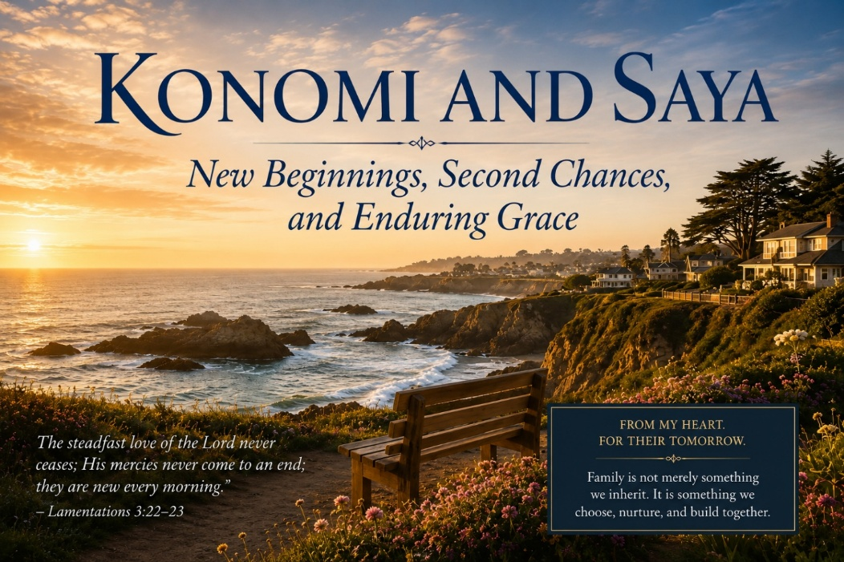
A Family of Contradictions
If you have read some of my other reflections about family, you already know that mine is not easily described in simple terms. Complexity, tragedy, beauty, courage, perseverance, loss, and redemption are all woven together in ways that sometimes still surprise me. Like many families, ours has known its share of heartache and struggle. Yet it has also been marked by moments of extraordinary grace, unexpected blessings, and second chances.
The story of my adoptive Japanese sisters, Konomi and Saya, is one of those stories.
Around the time I was beginning my career as an Army officer and clinical psychologist, my father, who was then on what was remarkably his fourth marriage, was married to a strong, thoughtful, and kind woman named Evelyn. To my surprise, they decided they wanted to adopt a child.
Not long afterward, my father approached me and asked if I would write a character reference on their behalf. Life rarely presents us with people who fit neatly into categories of good or bad. Most of us are complicated mixtures of strengths and weaknesses, virtues and wounds. My father was certainly no exception. I believed people are capable of growth and change, and thankfully permission was granted. Before long a beautiful baby girl from Japan named Konomi entered their lives. Later she would be joined by her younger sister, Saya.
The timing created a rather unique family dynamic. At almost exactly the same time my father and Evelyn were becoming parents again, Leah and I were becoming parents for the first time. Ashley had recently been born, and Gregory would soon follow. My father and Evelyn were grandparents to our children while simultaneously raising young children of their own. Family gatherings could be a little confusing, but they were also wonderful.
A Different Season of Fatherhood
To understand why this story matters, you need to understand something about my father. As I have shared elsewhere, he carried profound trauma from his own life experiences. Along with that trauma came significant emotional dysregulation, and some of those struggles inevitably affected my brothers and me during our childhood years.
Yet somewhere along the way, my father found faith. His Christian faith did not magically erase the effects of trauma, but it provided stability, purpose, and a framework for becoming a better man. It softened some of the rougher edges that had once dominated his life and helped him become more grounded than he had been during much of our childhood.
As a result, Konomi and Saya experienced a different season of my father's life. My brothers and I certainly experienced moments of love, generosity, and genuine care from him, but we also bore the brunt of many struggles that accompanied his unresolved wounds. Konomi and Saya inherited a father who was older, wiser, more mature, and more settled. In many ways, they received the very best version of Dad.
That is not a statement of resentment. It is simply an observation. Life is sometimes like that. The children who come later occasionally benefit from lessons learned through mistakes made earlier. While there are moments when that reality carries a touch of sadness, there is also something beautiful about it. If suffering teaches wisdom, then perhaps some of our struggles helped create a gentler father for these two remarkable girls. I am grateful they experienced that version of him.
New Beginnings from Across the Pacific
At the time, children born outside of marriage in Japan often faced significant social stigma. Adoption offered opportunities that might otherwise have been difficult to obtain. For Konomi and Saya, adoption represented far more than a change of address. It represented a new beginning filled with possibilities, opportunities, and hope.
Because of my Army career, our families did not see each other as often as we would have liked. Leah and I spent many of those years overseas, and even when we were stateside, we were often stationed in different parts of the country. Still, whenever our paths crossed, those visits became treasured memories.
I particularly remember family gatherings in Northern California. Konomi and Saya spent much of their childhood in Mendocino, one of the most beautiful places I have ever visited. Perched above the Pacific Ocean, Mendocino possesses a quiet magic that is difficult to describe. Rugged cliffs overlook crashing waves. Towering redwoods stand watch over winding roads. The town itself seems suspended between another era and the present day. Looking back, I am grateful for the opportunities they had, the stability they experienced, and the environment in which they grew.
When Tragedy Came Calling
Life has a way of reminding us that even the most beautiful stories are not immune to heartbreak.
Just as Konomi and Saya were entering adulthood and beginning to build lives of their own, tragedy struck our family. In 2006, my father was involved in a devastating accident in Lafayette, California. He had stepped away from his vehicle while running an errand when he was struck by a speeding truck. The injuries were catastrophic.
One detail has always stayed with me. My brother Greg was the one who found him. Dad was still alive and conscious when Greg reached him and cradled him there in the street while help arrived. Even now, it is a difficult image to contemplate.
What I remember hearing is how courageous Dad was in those moments. Despite the severity of his injuries, he remained concerned about others, particularly the impact the accident would have on Greg. In a way that was uniquely Dad, he reportedly retained a sense of humor despite circumstances that would have overwhelmed most people.
He was rushed into surgery, but tragically complications associated with anesthesia and the severity of his condition proved too much. He died shortly thereafter.
For Konomi and Saya, the loss was profound. Just as they were stepping into adulthood, the father who had loved them, guided them, and raised them was suddenly gone. Some losses arrive gradually and allow us time to prepare. This was not one of them.
In the years that followed, Evelyn stepped forward with remarkable courage and determination. Then came another devastating blow. Evelyn developed pancreatic cancer and eventually passed away as well. Within a relatively short span of time, the girls lost both parents and were left to navigate adulthood largely on their own.
Building a Life Anyway
My brothers and I had already established our lives. We had careers, families, and financial stability. It seemed obvious to us that Konomi and Saya needed the family home near the Mendocino coast far more than we did. We wanted them to have a foundation from which to continue building their lives.
Looking back, I believe both women honored their parents in the way they responded to adversity. They did not allow tragedy to define them. They persevered and built beautiful lives.
Konomi eventually married Angel, a talented chef and a genuinely good man. Together they have built a wonderful family and are raising two remarkable children, Kenneth Jr. and Joanna. Both children are bright, thriving, curious, and full of promise.
Saya chose a different path. She has built an impressive life and career of her own and today serves in a leadership role at the historic Mendocino Hotel. During my visit last year, I had the opportunity to spend time with Noah, whom she has been dating. Although he has achieved considerable success as an entrepreneur and property owner, what impressed me most was not his accomplishments but his character. He is thoughtful, kind, deeply philosophical, and genuinely interested in people. There is a warmth and sincerity about him that is increasingly rare, and I found myself hoping there might be something meaningful and lasting in their future together.
One of the things that touches me most is that the sisters remain deeply connected. They continue to share life together, supporting one another through triumphs and losses alike. The bond forged through childhood, adoption, shared grief, and enduring love remains one of the most beautiful aspects of their story.
Reflections from the Mendocino Coast
When I visit Mendocino now, I find myself reflecting on the strange and unexpected ways God writes our stories. If you had told me decades ago that my father and Evelyn would adopt two little girls from Japan, that those girls would become beloved sisters, that they would endure unimaginable losses, and that they would nevertheless build such meaningful and beautiful lives, I would never have believed it.
As I grow older, I find myself thinking more about legacy. Not the kind measured in accomplishments, titles, publications, or professional success, but the kind measured in relationships. The kind measured in people.
When I look at Kenneth Jr. and Joanna, I see more than two bright and thriving children. I see part of our family's future. I see possibilities that have not yet unfolded. For that reason, I have made a commitment to become more involved in their lives. Partly because I believe that is what my father would have wanted. More importantly, I believe it is what my Father in Heaven would want.
I want them to know they are loved. I want them to know they matter. I want them to know they are believed in, supported, and cared for. I want to know them, not simply as children I occasionally see during family visits, but as the remarkable young people they are becoming.
Most of all, I think about family. Not family defined by biology alone, but family defined by love, commitment, sacrifice, and shared experience. Two little girls arrived from Japan many years ago and became part of a family already full of complications, scars, and unfinished stories.
They became my sisters.
And I could not be more grateful that they did.
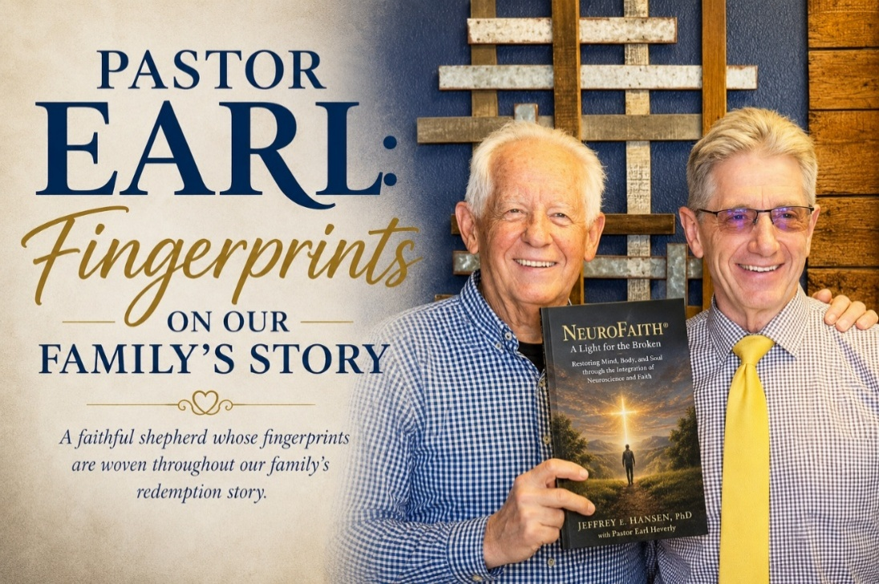
A Shepherd Enters Our Family
There are certain people whose influence becomes so deeply woven into the fabric of your life that, after enough years have passed, it becomes difficult to imagine your story without them. Their presence extends beyond friendship. They become part of the family narrative itself. Their fingerprints can be found on moments both large and small, often in places they would never claim credit for and perhaps never even recognize themselves. When I think about Pastor Earl Heverly, that is exactly what comes to mind.
For nearly five decades, Earl has been part of our family's journey. He has been a pastor, a mentor, a friend, a confidant, a co-author, and at times a much-needed source of wisdom when life became complicated. Yet none of those titles fully capture what he has meant to us. If I had to describe him in a single word, I would call him a shepherd. Not because he stood behind a pulpit, but because he spent much of his life doing what shepherds do. He watched over people. He guided them. He challenged them. He comforted them when life became painful. Most importantly, he remained present.
I first came to know Earl through my father-in-law, Butch Uhrhan. To understand the significance of that relationship, you first have to understand something about the generation from which Butch came. These were men shaped by hardship. They lived through the Great Depression. They answered the call after Pearl Harbor. They fought wars, raised families, built communities, and generally carried their burdens without much discussion. Emotional transparency was not exactly their strong suit. If they suffered, they suffered quietly. If they hurt, they rarely spoke about it.
Butch was very much a product of that generation.
Following Pearl Harbor, he entered military service and spent much of the war years in Hawaii during one of the most uncertain periods in our nation's history. Like many veterans of World War II, he returned home carrying wounds that were not always visible. Some came from war. Others came from life itself. Over the years, those wounds became part of who he was. They shaped him, hardened him in certain ways, and perhaps isolated parts of his heart that few people ever reached.
Yet somehow Earl found a pathway into those places.
He did not accomplish it through force or persuasion. He did not accomplish it through clever theology or emotional appeals. He accomplished it through friendship. Through patience. Through years of faithfully showing up. He listened. He cared. He invested. He walked alongside Butch in a way that allowed trust to grow naturally over time.
Looking back now, I realize how much that relationship mattered. Earl helped Butch deepen his faith and draw closer to Christ. More importantly, he helped him find peace. By the time Butch left this world, he knew where he was going. He knew whose hands would receive him. He possessed a confidence that had little to do with certainty about life and everything to do with certainty about God.
That is no small gift.
The older I get, the more I realize there are many accomplishments in life that eventually fade. Careers end. Titles disappear. Recognition comes and goes. But helping another human being find peace with God before they leave this earth is one of those rare things that echoes into eternity.
Our family has never forgotten what Earl meant to Butch.
Truth, Grace, and a Spiritual Sucker Punch
As Leah and I began building our own life together, Earl naturally became part of our story as well. During our years stationed in Germany, he and Nancy came to visit us, and some of my favorite memories from that era involve the four of us exploring the countryside around Kaiserslautern. We were all younger then, filled with energy and perhaps a little too much confidence in our physical abilities.
I remember taking Earl hiking through the forests and hills surrounding our area. Earl was an accomplished tennis player and in excellent shape. I was in pretty good condition myself. Somewhere during one of those hikes, what began as a pleasant afternoon outdoors gradually evolved into a subtle competition between two men who were both convinced they had a little more left in the tank than they actually did. By the end of the day, we were exhausted and laughing at ourselves.
Those memories still make me smile. What remains with me even more, however, are the conversations.
One of the things I have always admired about Earl is his remarkable ability to tell the truth without making a person feel diminished. Over the years I have often joked that he is the only man on earth who can deliver a spiritual sucker punch directly to my gut and somehow leave me thanking him afterward. There is a great deal of truth in that statement.
At one point Leah and I found ourselves wrestling with a significant decision involving another overseas assignment. I desperately wanted to return to Germany. Leah did not. Looking back, I can see that much of my thinking at the time was driven by my own desires. I had convinced myself that what I wanted was somehow synonymous with what was best.
Earl saw through that almost immediately.
What made his correction so powerful was not merely that he was right. It was the manner in which he approached it. There was no condemnation. No arrogance. No attempt to establish superiority. Instead, there was a quiet willingness to speak truth while remaining firmly rooted in love.
He challenged me to examine my motives. He forced me to consider Leah's needs more carefully. He helped me recognize the selfishness I had failed to see in myself. The conversation was not particularly comfortable, but it was profoundly necessary.
That experience would become a pattern throughout our friendship.
Whenever impatience gained ground in my life, Earl would call me back to waiting on the Lord. Whenever resentment threatened to take root, he would point me toward forgiveness. Whenever ego began whispering its familiar lies, he would remind me that humility remains the better path. When I became too confident in my own understanding, he would gently redirect me toward the mind of Christ.
What gave those conversations such power was the authenticity behind them. Earl never asked others to pursue a standard he was unwilling to pursue himself. The man behind the pulpit and the man sitting across from you at a coffee shop were exactly the same person.
That kind of integrity is rare.
Walking with the Wounded
If there is one quality that defines Earl's life and ministry more than any other, it is his willingness to remain present in the lives of hurting people long after others have grown weary. Most people are willing to help when a crisis first appears. They bring meals. They offer encouragement. They make phone calls. They pray. Those things matter.
What becomes much harder is remaining engaged when suffering stretches from weeks into months and from months into years. Long-term pain tests everyone involved. It tests the person carrying the burden. It also tests those who are trying to walk beside them. That reality brings me to Leah's brother Craig.
Craig endured more hardship than most people will ever fully understand. Trauma left deep wounds that shaped much of his journey. There were seasons of discouragement, confusion, loss, and emotional pain that seemed to stretch endlessly before him. Like many people who struggle with profound wounds, he often found himself walking a lonely road.
The reality is that chronic suffering has a way of exhausting those who care. People begin with good intentions. They genuinely want to help. But as time passes and solutions remain elusive, many slowly drift away. Not because they are bad people. Not because they stop caring. They simply do not know how to continue.
Earl did.
Year after year, he remained part of Craig's life. He listened when there were no answers. He encouraged when progress seemed painfully slow. He prayed when circumstances appeared hopeless. Most importantly, he continually reminded Craig that he was loved by God and that his life mattered.
What strikes me now is that Earl never treated Craig as a problem that needed solving. He treated him as a person who deserved love.
That distinction changed everything.
When Craig passed away recently, our family grieved deeply. Yet alongside that grief was a sense of peace because despite all he endured, Craig never lost his faith. Through all the disappointments, struggles, and setbacks, he continued trusting Christ.
He knew where he was going. He died with hope.
Pastor Earl deserves much of the credit for helping him preserve that hope through some extraordinarily difficult years. When many people would have quietly stepped away, Earl remained present.
That was not merely friendship. That was ministry.
Through the Valley of Grief
The same faithful presence emerged once again when my twin brother Gregg died.
Even now, I struggle to fully describe what that loss felt like. The death of a twin carries a unique kind of sorrow because that person has been present from the very beginning of your story. Every stage of life contains shared memories, shared experiences, and shared history. There has never been a version of life that did not somehow include them.
Then suddenly there is. When Gregg died, it felt as though a piece of my own history had been torn away. During that painful season, Earl did what he has always done.
He showed up.
Not with simplistic explanations. Not with easy answers. Not with theological clichés designed to make grief disappear. He simply entered the pain alongside me.
He listened. He prayed. He allowed me to wrestle with the loss while gently reminding me that God's purposes are often larger than our understanding. More than once he helped bring me back to perspective when my emotions threatened to outrun my faith. More than once he reminded me that some wounds are healed not through striving but through surrender.
Looking back now, I realize that many of the lessons Earl has taught me over the years can be distilled into a simple truth. He has consistently called me back to Christ.
When I wanted certainty, he called me to trust.
When I wanted immediate answers, he called me to patience.
When resentment felt justified, he called me to forgiveness.
When ego demanded control, he called me to humility.
When fear threatened to dominate my thinking, he reminded me to walk by faith.
Again and again, he has redirected my attention away from myself and toward the transforming work of the Holy Spirit.
That has been one of the greatest gifts of his friendship.
Fingerprints of Grace
Years later, after Leah and I relocated to Arizona, Earl and I entered a new season together. As NeuroFaith® began to emerge and my writing expanded, what had long been a friendship became a creative partnership as well. Conversations evolved into collaboration. Collaboration eventually became co-authorship. Together we have now written five books.
I am grateful for those books. I am proud of those books.
Yet when I think about Earl, the books themselves are not what come to mind first.
What comes to mind is a faithful shepherd whose influence is woven throughout our family's story. I think about Butch finding peace with God. I think about Craig holding onto faith through years of suffering. I think about Leah and the countless ways Earl encouraged and supported our family. I think about my own journey through grief, loss, mistakes, growth, and spiritual formation.
The older I get, the more convinced I become that some of the most important work God accomplishes in this world is done quietly. It happens through faithful friendships. Through difficult truths spoken in love. Through prayers offered when no one else is watching. Through decades of showing up for people when life becomes difficult.
As I sit here writing these words, I realize that Pastor Earl's story cannot really be separated from our family's story. His influence is simply too deeply embedded. His fingerprints can be found throughout the lives of people he never sought to impress and never attempted to control. Instead, he pointed them toward Christ and trusted God to do the rest.
When people ask me what makes a great pastor, I suppose I could talk about preaching, leadership, theology, or vision. All of those things matter. But when I think about Pastor Earl, something much simpler comes to mind. I think about a man who spent nearly fifty years faithfully walking alongside people he loved. I think about a man who consistently chose presence over prominence. I think about a shepherd who understood that sometimes the most Christlike thing a person can do is simply stay long enough to watch God do what only God can do.
Pastor Earl's fingerprints are written all over our family's redemption story.
And I thank God for every one of them.

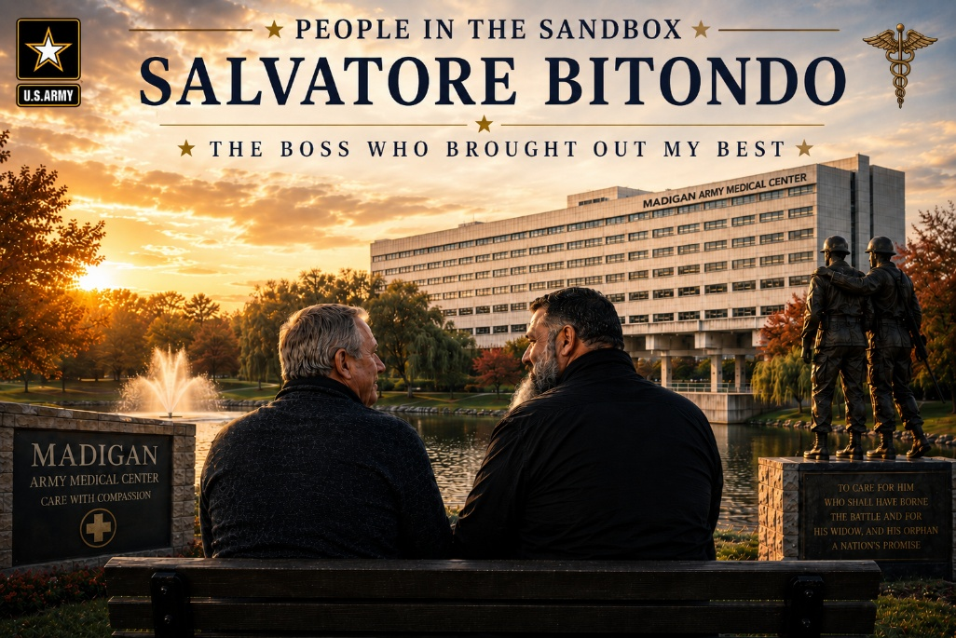

A Career Filled with Bosses

Over the course of my career, I have had a lot of bosses. I actually counted them one day, and depending on how one defines the word, I have probably had seventeen or eighteen. I had bosses in Europe, at Frankfurt Army Medical Center, Landstuhl Army Medical Center, Silas B. Hays Army Community Hospital, Madigan Army Medical Center, and later in the civilian world of behavioral health and addiction treatment.
Some were good. Some were not so good. Some were complicated. A few left deep impressions on me, not because of the positions they held, but because of the way they led, the way they trusted, and the way they either gave people room to breathe or slowly took the air out of the room.
Among all of them, I can clearly identify my worst boss and my best boss. What makes that interesting is that my worst boss was not a villain. In fact, I cared deeply about him and still love him as a brother in Christ. He was a man of vision, courage, and faith, and I believe he sincerely wanted to do something meaningful for the kingdom of God. But he came out of the corporate world, and for whatever reason, he simply could not get me.

A Good Man Who Could Not Trust Me

The problem was not that he lacked vision. The problem was that he could not trust me as his clinical director. He overmanaged my clinical decisions, micromanaged my role, and kept trying to place me inside a box that I could never quite fit into.
I do not say that with anger. I say it with sadness, because I genuinely cared about him. Some leaders struggle to lead people who do not think in straight lines. They can appreciate creativity in theory, but when it shows up in the conference room, the treatment team, or the clinical trenches, it makes them anxious.
I have never been a vanilla clinician, and I have never been especially good at pretending to be one. I think deeply, I question assumptions, and I have spent much of my career trying to understand what is really happening beneath the surface of human suffering. Eventually, I realized I could not continue in a place where I was respected in name but not trusted in practice. So I left.
And then, by contrast, there was Salvatore Bitondo.

A Giant of a Man

When I first met Salvatore Bitondo, he was serving as Chief of Child and Family Behavioral Health Services. He was a Major in the United States Army, and he looked every bit the part. He was at least six foot four, a beast of a man in the best sense of that phrase, with the bearing of a soldier and the deep, resonant voice of someone who did not have to work very hard to command attention.
He was sharp, squared away, competent, and strong. Yet beneath that commanding exterior was a man of remarkable humility and character.
At some point, Sal deployed to Afghanistan, and like so many who went to war, he came back carrying wounds. There were spinal injuries and back injuries, and whatever happened over there eventually led to his medical retirement. War had taken something from him physically, but what struck me most was what it did not take. It did not take his character.

The Same Man After the War

When Sal returned, he was still Sal. That may sound simple, but to me it was profound. I had seen war, military systems, medical systems, and life itself bend people in painful ways. Sometimes suffering makes people bitter. Sometimes injury becomes the central story of a person’s life.
That was not Sal.
He did not complain. He did not walk around inviting pity or making sure everyone knew how much he had suffered. He simply accepted what had happened and continued to carry himself with dignity. He was the same steady, grounded, thoughtful man I had known before.
It is one thing to look strong when everything is working. It is another thing entirely to remain steady when life has taken something from you. Sal had that kind of steadiness.

Faith, Service, and Common Ground

As our professional relationship grew, so did our friendship. One of the things that connected us was our faith. Sal was a devoted Catholic. I came from a more evangelical Protestant tradition. Yet beneath those differences was a shared devotion to God, a shared commitment to serving others, and a shared belief that life ultimately answers to something greater than ourselves.
Some of my fondest memories of Sal have nothing to do with organizational leadership or clinical work. They involve conversations about faith, service, sacrifice, suffering, and what it means to live a meaningful life. We would begin discussing one topic and somehow find ourselves wandering into another. Before either of us realized it, an hour had passed and responsibilities were waiting.
I have always admired many things about my Catholic brothers and sisters. While I remain firmly rooted in my evangelical faith, I have long appreciated the Catholic understanding of tradition, discipline, service, and responsibility. Faith is not merely something one professes. It is something one practices. It is something one lives. I saw that in Sal.

He Let Me Be Me

What ultimately made Sal such an extraordinary boss was his trust. He understood almost immediately that I was never going to fit neatly into a box. He knew I would challenge assumptions, ask difficult questions, and occasionally frustrate systems because I was unwilling to reduce people to diagnoses, productivity metrics, or convenient categories.
Most importantly, he understood that these qualities were not weaknesses. They were strengths. As a clinician himself, he understood what clinical work actually demanded. He understood the emotional toll of sitting with trauma, grief, addiction, despair, and broken families. While he still had organizational responsibilities, he never allowed those demands to suffocate good clinical work.
He gave me room to think, room to create, and room to care for people in the way I believed they needed to be cared for. That trust brought out the best in me.

The Maverick Conversation

One conversation with Sal has remained with me over the years. At one point in my career, I had hoped for another promotion. On paper, I believed I had earned it. When the promotion failed to materialize, Sal and I talked about it.
His explanation was both insightful and painfully accurate. He told me, in essence, that the very qualities that made me effective were also the qualities that occasionally limited advancement within large systems. I was not particularly gifted at conforming. I was unwilling to compromise convictions simply to make life easier for myself. I asked too many questions and challenged too many assumptions.
In his own way, he compared me to Maverick from Top Gun. Not because I was reckless, but because I was independent. Large organizations often reward predictability. Mavericks are admired right up until they become inconvenient. Sal understood that dynamic better than anyone, and more importantly, he respected me anyway.

Seen, Heard, and Respected

As I reflect on all these years later, I realize that what Sal gave me was something every person longs for. He made me feel seen. He made me feel heard. He made me feel respected.
He recognized that my creativity, my curiosity, and my willingness to challenge conventional thinking were not liabilities to be controlled but strengths to be cultivated. He understood that the very qualities that occasionally created friction within systems were often the same qualities that allowed me to connect deeply with suffering people and families.
As I look back across nearly four decades of professional life, I realize that what I valued most about Sal had very little to do with rank, authority, organizational charts, or performance evaluations. What remains is the feeling of being trusted by someone whose judgment I respected. He saw something in me that others often struggled to see. He recognized that my strengths and weaknesses were woven together and accepted the entire package.
When I think of Salvatore Bitondo today, I do not primarily think of a Major in the United States Army or a department chief. I think of a good man. A man of faith. A man who carried the wounds of war without allowing those wounds to define him. A man who brought out the best in those around him because he believed in them.
In a career that included nearly eighteen bosses, there was only one Sal.
Thank you, brother. The footprints you left on my heart remain there still, and whenever I think about leadership at its finest, I think less about authority and more about trust. You trusted me when others hesitated. You saw possibility where others saw inconvenience. You understood that creativity and conviction often travel together, and rather than trying to tame those qualities, you gave them room to breathe.
For a season of my life, you allowed me to become more fully myself. That is a rare gift. It is also the reason I remember you not simply as the best boss I ever had, but as one of the finest men I have ever known.
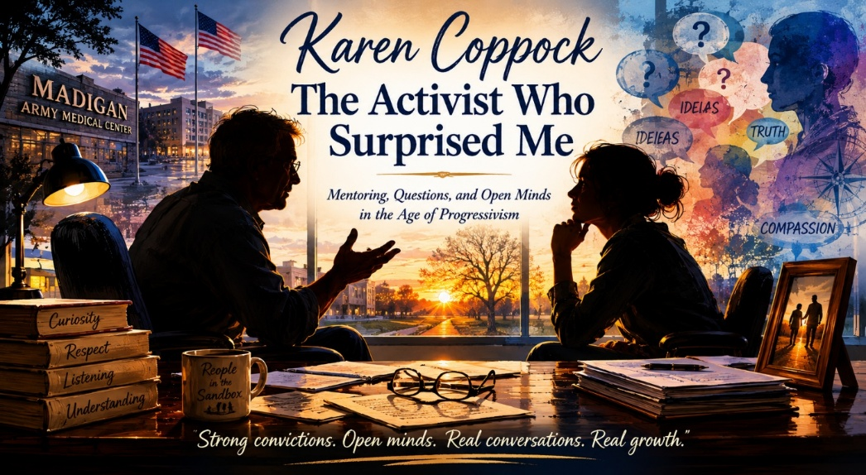
First Impressions Can Be Dangerous
One of the great joys of my professional career has been training doctoral students. I have loved clinical work for more than forty years, but there has always been something uniquely rewarding about helping young clinicians find their footing. Watching a student gradually develop confidence, sharpen clinical skills, and discover a professional identity of their own is one of the most satisfying experiences I know. Over the years I have supervised many students. Some were brilliant. Some struggled. Some surprised me. A few left footprints on my heart. Karen Coppock was one of those students.
What makes that statement somewhat amusing is that I almost threw her application away. At the time, I was directing the practicum training program for Graduate Medical Education within Child and Family Behavioral Health Services at Madigan Army Medical Center. Reviewing applications was a routine part of my responsibilities. Most followed a familiar pattern. Students described their interests, their academic achievements, and their professional goals. After reading hundreds of them, the applications began to sound remarkably similar.
Then Karen's arrived.
The first thing she told me was that she was an activist. I remember leaning back in my chair and thinking that this was certainly an unusual way to introduce oneself to a military hospital. My imagination immediately filled in the blanks. I pictured ideological battles, unnecessary conflict, and a student who might be more interested in causes than patients. Had I trusted that first reaction, Karen's application would have gone no further. Fortunately, something stopped me. There was something thoughtful in the way she wrote, something genuine and sincere that made me keep reading. The more I read, the more curious I became.
The Phone Call
Eventually I noticed her phone number and decided to do something I rarely did. I picked up the phone and called her. When she answered, I introduced myself and explained who I was. Then I asked the question that had been bouncing around in my head ever since I opened her application.
“Karen, you do realize you're applying to a military hospital, don't you?”
She laughed. At least that is how I remember it. We talked for a while, and I finally asked whether she thought she could set aside her activism long enough to focus on learning. I told her that if she could, I believed we could provide one of the finest training experiences available anywhere. What impressed me was not simply her answer. It was the spirit in which she answered. There was no defensiveness, no argument, and no attempt to convince me that I should not have concerns. She listened carefully, reflected on the question, and responded thoughtfully. That conversation stayed with me long after we hung up.
We interviewed her. We accepted her. Then I waited to find out whether my instincts had been brilliant or disastrous.
Waiting to Meet Karen
Karen rotated through two other psychologists before she eventually arrived on my service. During that time I heard encouraging reports. My colleagues liked her. They spoke highly of her work ethic, her intelligence, and her professionalism. Even so, I remained curious. I still remembered that application. I still remembered my initial assumptions. I wondered what I would find when she finally rotated onto my service.
I loved supervision. I loved helping students grow. Administration was necessary. Meetings were unavoidable. But training was where my heart lived. There is something deeply rewarding about watching a young clinician develop confidence and competence. By the time Karen arrived, I was hopeful, interested, and eager to see whether the promise others saw in her would become evident to me as well.
A Different Kind of Activist
What I discovered surprised me. Karen was bright, but lots of students are bright. She was articulate, but many students are articulate. What distinguished Karen was her willingness to engage difficult ideas without becoming threatened by them. She possessed strong convictions, yet she remained curious. That combination is far rarer than most people realize.
As the months passed, we found ourselves discussing subjects that extended well beyond treatment plans and diagnostic formulations. We talked about families, trauma, resilience, culture, ethics, and the many ways people attempt to make sense of suffering. Not surprisingly, there were times when we approached these topics from very different perspectives. What impressed me was that Karen never seemed interested in winning arguments. She wanted to understand. When I challenged an assumption, she listened. When I offered a perspective she had not considered, she reflected on it. Just as importantly, there were times when she challenged me, and I found myself doing something that every good supervisor should continue doing throughout life: learning.
The more we talked, the more I realized that Karen had quietly dismantled many of the assumptions I had attached to the word activist. She did not accomplish that through persuasion or political debate. She accomplished it through character. She showed me that a person can hold strong convictions while remaining open-minded, that a person can advocate passionately without becoming rigid, and that curiosity and conviction are not enemies. In Karen, those qualities existed side by side.
The Student Becomes the Teacher
One of the humbling realities of teaching is that sometimes the student ends up teaching the teacher. I expected to help Karen grow as a clinician, and I hope I did. What I did not expect was that she would broaden my understanding of people. She reminded me that labels are often poor substitutes for genuine understanding. It is remarkably easy to categorize people and assume we already know who they are. It is much harder to remain curious enough to discover the human being behind the label.
As our supervision continued, I found myself looking forward to our meetings. The conversations were thoughtful, challenging, and energizing. We did not agree on everything, nor should we have. Yet disagreement never became disrespect. In an age where people often retreat into tribes and caricatures, Karen possessed the maturity to engage difficult ideas without becoming disagreeable. That quality earned my respect and admiration.
Somewhere along the way, I stopped thinking of Karen as “the activist.” She simply became Karen. The label faded. The person remained. And the person turned out to be remarkable.
Footprints on My Heart
Over the years I have continued to watch Karen grow. She has remained true to herself while continuing to develop professionally. She has held onto her convictions while maintaining the courage to think independently. That path has not always been easy. People who refuse to simply follow the crowd often pay a price for doing so. Yet she has continued moving forward with determination, integrity, and heart.
Looking back now, what strikes me most is how close I came to missing one of the most rewarding supervisory relationships of my career. Had I trusted my assumptions rather than my curiosity, Karen's application might have ended up in a discard pile and our paths never would have crossed. Instead, I made a phone call. One conversation led to another. A training experience became a friendship. A student became a colleague I deeply respect.
If Karen ever needs a recommendation, I will gladly write it. If she ever needs encouragement, I will gladly offer it. Not because we agree on everything. We do not. Not because we see the world the same way. We do not. I would do those things because she earned my respect through her character, her curiosity, and her willingness to engage the world thoughtfully.
Thank you, Karen. You taught your old supervisor something important. You reminded me that curiosity is often wiser than assumption and that some of the most meaningful people in our lives arrive wrapped in surprises. I am grateful that I picked up the phone, and I am grateful that our paths crossed.

Craig's Journey
Craig's life reminds me of something I have come to believe more deeply as the years have passed: none of us arrive in this world with a blank slate. We inherit gifts from those who came before us, but we also inherit wounds. Sometimes those wounds are visible, and sometimes they are hidden so deeply that even the people carrying them struggle to understand their influence.
Craig's father belonged to that remarkable generation of Americans who answered the call during World War II. He served his country honorably and was part of the generation that carried the weight of battles such as Midway, one of the defining moments in our nation's history. He was a good man who loved his family deeply, and Craig admired him immensely. In many ways, Craig's own decision to enter the United States Navy was an effort to honor the man he loved and respected.
But children inherit more than stories. They inherit strengths, values, fears, and sometimes wounds. Craig inherited all of those things. Like many men of that era, his father carried burdens that were not always spoken aloud, and some of those burdens found their way into the next generation.
Craig served his country as a submariner, a role demanding courage, discipline, and sacrifice. During that service, he experienced events that would affect him for the rest of his life. Although he was not physically injured, he was deeply wounded by what he witnessed following a devastating fire. He was tasked with carrying the bodies of fellow sailors, an experience few people can truly comprehend. Such experiences do not simply disappear when military service ends. They become part of a person's story and often shape the years that follow.
Like many people who carry deep wounds, Craig struggled to find a way to live with them. Some of the choices he made along the way made life harder than it needed to be. Yet every struggle exists within the context of a larger story, and Craig was never defined solely by his difficulties.
The Heart of the Man
As a psychologist, I have spent much of my life studying trauma. Trauma explains many things. It helps us understand people. But trauma never tells the whole story. If all we see are the wounds, we miss the person. Craig was far more than the wounds he carried.
What defined Craig was the goodness that remained within him despite them. If you knew Craig, you knew his generosity. He would give you the shirt off his back. If you needed help, he would help. If you were hurting, he cared. If he had something and you needed it more, there was a good chance it would become yours.
One of my favorite memories speaks to that generosity. There were times when Craig had very little money himself. Yet one Christmas, when most people would have understandably scaled things back, Craig went out of his way to make Christmas special for Ashley and Greggory. The gifts he gave were remarkably generous given his circumstances. Looking back, I realize it was never really about the gifts. It was about love. He wanted them to know they mattered. He wanted them to feel cherished.
There was also something uniquely special about Craig's relationship with Ashley. Some relationships are difficult to explain. There was simply a bond there. Through the years, Craig was in her corner. He believed in her, encouraged her, and stood beside her. He celebrated her successes and remained supportive during difficult seasons. His loyalty never wavered.
That spirit of generosity was woven into who he was. It was part of what he inherited from his father, and it remained present throughout his life. He loved deeply. He cared deeply. And in the end, what mattered most to him was not himself, but the people he loved.
The Final Gift
In the final days of his life, I had the privilege of sitting with Craig and talking about what mattered most. What struck me was not fear. What struck me was gratitude. Craig knew his life had been complicated. He knew he had experienced both triumphs and failures, joys and regrets. Yet when he reflected on his life, he said something simple that I will never forget:
“I had a good run.”
There was wisdom in those words. There was honesty in those words. And there was peace in those words. They did not deny the hardships he endured. Rather, they revealed a man who had reached a place of acceptance and gratitude for the life he had been given.
Even more importantly, his thoughts were centered on the people he loved. He spoke with deep affection about his sister Leah. He spoke with pride about his niece and nephew. His concern was not what he was losing. His concern was what he was leaving behind in the hearts of those he loved.
And that brings me to what I believe was Craig's final gift.
In his final days, Craig showed us what courage can look like. Not loud courage. Not dramatic courage. Quiet courage. The courage to face reality. The courage to acknowledge both the beauty and the brokenness of one's life. The courage to express love openly. The courage to leave this world with gratitude instead of bitterness.
When a person reaches the end of life and chooses gratitude over resentment, love over fear, and peace over despair, that becomes a gift to everyone who remains behind. Craig gave us that gift. He reminded us that a meaningful life is not a perfect life. It is a life in which we continue to love, continue to show up, and continue to care for others despite our imperfections.
Today we say goodbye to a brother, an uncle, a veteran, a friend, and a man who carried more than many of us ever knew. We honor both his service and his struggles. We remember his kindness, his generosity, and the love he gave so freely. And we give thanks that in the final chapter of his life, he reminded us all of what matters most.
Thank you, Craig, for your life. Thank you for your love. Thank you for your courage. And thank you for the final gift.
Fair winds and following seas, Craig. Your watch is ended. Rest well, brother. We will carry your memory forward with gratitude, love, and respect.

A Different Spirit
I’ve known Tad now for about three years, and from the very beginning there was something unmistakably different about him. Tad is one of those rare human beings that, when you meet him, you instantly know he carries something deeper than personality alone. You know he has a special spirit. You know there is integrity in him. You know there is humility in him.
You know there is goodness in him. And honestly, the best way I know how to describe it is that he seems to have some kind of high-speed fiber optic cable to Jesus. You know immediately that he is honest. You know he is sacrificial. You know he would step into the fire for his brother if needed. There is no posturing to him. No artificiality. No self-inflated performance. Just sincerity. When I first met Tad, I was the Clinical Director at Holdfast, and
Tad was actually one of our clients. Even then, there was instant like. Instant trust. Instant recognition that beneath the pain was an extraordinarily beautiful soul. You could see almost immediately that this was not a man lacking character. This was a man who had been wounded deeply and was trying to find his footing again.

The Quiet Nature of Trauma
Yes, Tad had experienced trauma, though not necessarily the kind most people think about when they hear that word. People tend to think of explosions, assaults, severe abuse, combat, catastrophic accidents, or shocking events. What we call Big T trauma. Shock trauma.
But trauma is more nuanced than that. Sometimes the deepest wounds are quieter. Sometimes they are woven slowly into the architecture of a child’s nervous system over years. Sometimes they settle invisibly into the very essence of identity itself. Sometimes the injury is not violence, but the gradual accumulation of negative core beliefs that slowly wire themselves into the default mode network of the brain. And honestly, those wounds can run extraordinarily deep. Such was Tad’s struggle.
The Burden of Never Quite Measuring Up
Not to disrespect his parents whatsoever. In fact, quite the opposite. Tad deeply loves his parents, and from everything I know, they genuinely loved him too. Most parents really are doing the best they can with the tools they themselves inherited. But we also have to be willing to name reality honestly and compassionately. Tad’s mother is Korean, and within many Asian cultures there exists an extraordinary emphasis on achievement, perseverance, discipline, advancement, and excelling. To be clear, there is much in that to admire. The work ethic, resilience, sacrifice, and perseverance found in many Asian families are genuinely beautiful qualities.
But every culture has both blessings and liabilities. And one of the liabilities that can emerge in highly achievement-oriented environments is the subtle wiring of a child to believe that they are only valuable when they perform well, that love and approval become unconsciously linked to achievement. For Tad, somewhere deep inside, despite all the love around him, that negative core belief slowly took root: that he was never quite enough. Never enough to fully make Mama happy. Over time, those beliefs become exhausting. They create a chronic unsettledness within the nervous system itself.
Pain Looking for Relief
His father, a genuinely peaceful and gentle man, tended more toward appeasement than confrontation. So, Tad inherited from his father a beautiful softness, a calm temperament, and a deeply non-combative spirit.
But he also inherited that lingering internal belief that somehow, he perpetually fell short. And pain almost always looks for relief. For Tad, substances became that relief. Alcohol. Marijuana. The temporary numbing of a nervous system that had spent years quietly believing it had to earn worthiness. That is important for people to understand about addiction. So often addiction is not fundamentally about pleasure seeking. It is about pain management. It is about regulation. It is about trying to quiet something internally that never fully learned how to settle.
Healing Honestly
But here is the beautiful part. Tad loved God. And perhaps even more importantly, he kept leaning toward God even while struggling. He worked therapy honestly. He worked recovery honestly. He worked community honestly. He did the hard internal excavation that so many people spend their entire lives avoiding. He faced himself honestly. He faced his pain honestly.
And slowly, beautifully, he healed. Not perfectly, of course. None of us heal perfectly. In one sense, we are all always in recovery. We are all unfinished people leaning toward grace. But Tad today is stable. Grounded. Regulated. Deeply trustworthy. I would trust this man with my wellbeing. I would trust him with my business. I would trust him with my life. And I do not say those things casually.
The Ministry of Presence
After completing treatment at Holdfast, Tad eventually became an employee there himself. He became a BHT, and not just any BHT. He became one of the most admired and respected BHTs in the entire organization because he embodied something you simply cannot fake: peace. People felt safer around him. He carried calm into rooms.
He brought regulation into chaos. He had this remarkable ability to sit with hurting people without needing to dominate them, fix them, preach at them, or perform for them. And perhaps most beautifully, Tad quietly became a minister of encouragement. Every single day he reaches out to literally hundreds of people, often more than two hundred a day, sending encouragement, Scripture, hope, support, and reminders that people matter and are not forgotten.
He does it with me too. And the remarkable thing is that it never feels performative. Never artificial. Never self-righteous. It simply flows naturally out of who he is. That is rare. Very rare. In a culture increasingly addicted to noise, ego, outrage, image management, and self promotion, genuinely peaceful human beings stand out almost immediately.
The Mission Beyond Profit
When I began envisioning the NeuroFaith® Certification Program, Tad immediately rose to the top of my list. Not because he was flashy. Not because he was loud. Not because he needed attention. But because he embodies the very thing NeuroFaith® is trying to cultivate: a regulated, grounded, compassionate nervous system connected deeply to God and capable of helping other human beings feel safe enough to heal.
And now, in a manner of speaking, I find myself partnering with Tad as we continue building out the NeuroFaith® vision. But Tad’s vision extends beyond certifications, teachings, or programs. He is in the process of helping launch a nonprofit specifically focused on people in that fragile, often neglected season after discharge from residential treatment or intensive outpatient care, that period where people leave the structure and safety of treatment and suddenly find themselves trying to survive in the real world again. It is one of the greatest blind spots in addiction and trauma treatment today, and sadly, one of the deadliest.
The larger organizations often overlook this population because there simply is not much profit in it. Residential treatment gets reimbursed. Intensive programming gets reimbursed. But the long, slow, relational work of walking beside hurting people after discharge often does not. And as a result, many fine men and women fall through the cracks. We have both seen it happen. We have watched people die too early because of poor treatment planning, inadequate continuity of care, and systems more focused on throughput than sustained healing. Friends we personally knew. Friends we genuinely cared about. Gone too soon. And Tad sees that gap. He sees that pain. And instead of walking away from it, he moves toward it.
A More Eternal Perspective
Not because he is going to make a fortune. He won’t. And not because it will make him famous. It won’t. He moves toward it because the reward, for him, is something far more meaningful. Saving lives. Saving souls. Helping restore dignity. Helping bring people to Christ. And I will support him in that endeavor wholeheartedly, even as he considers weaving the NeuroFaith® model into that mission. Not because I am trying to create profit for myself, but because Tad is exactly the kind of man I want to stand beside and support.
Truthfully, Tad has influenced me more than he probably realizes. He has helped remind me of the bigger picture. He reminds me that this life ultimately is not about building some giant name for ourselves.
It is not about massive bank accounts.
It is not about prestige.
It is not about platforms.
It is about outcomes that are less perishable and more eternal.

Redeemed lives. Redeemed souls. And hopefully, by the grace of God, moral residents in Heaven. That is the kind of thing Tad quietly points people toward.
And brother, thank you. Thank you for standing up. Thank you for inspiring me. Thank you for stepping courageously into this noble work.
You took your pain, faced it honestly, resolved it courageously, and then channeled it into service for other human beings. That is an extraordinary thing. You are an amazing man. Twenty years younger than me, yet in some ways, twenty years ahead of me. Love you, brother.
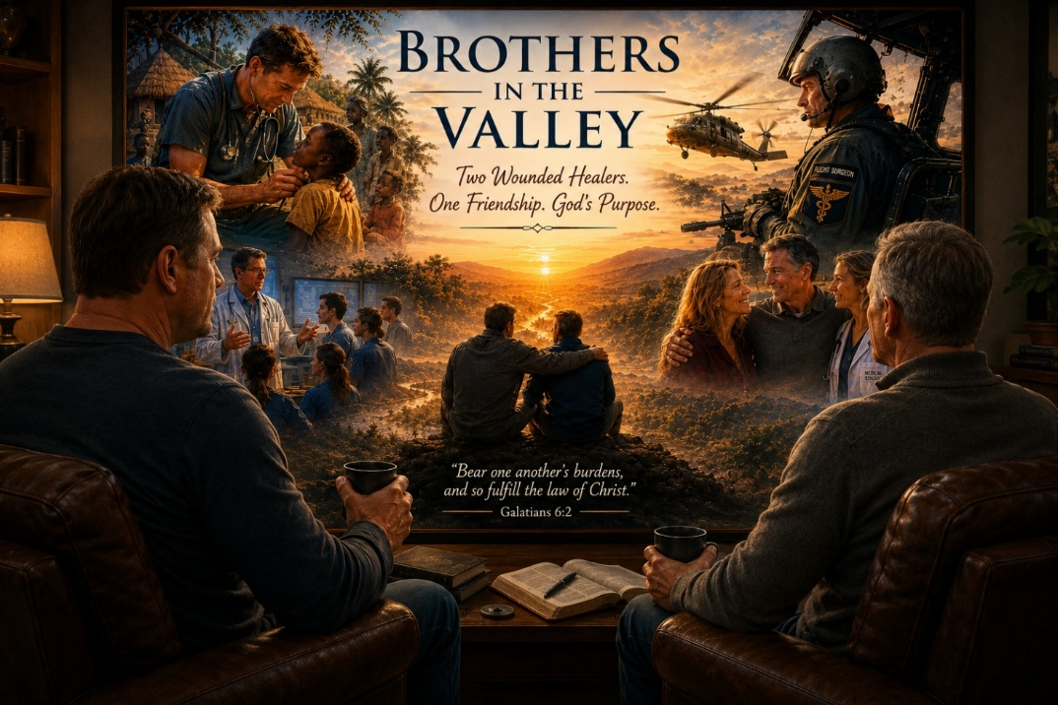
Coming Home to Heal
By the time I met Dr. David Ayer at Madigan Army Medical Center, he and his amazing wife, Julie, had already traveled a difficult road. Prior to arriving at Madigan, they had been serving as missionaries in Africa. It was meaningful work, the kind of work that grows out of deep faith and a sincere desire to serve others. Yet during those years, something deeply painful happened to their daughter, Ella. Out of respect for Ella and her family, I will not describe the event itself. It is her story to tell, not mine. What matters here is that it profoundly affected her and profoundly affected the family who loved her.
Like many parents facing a crisis involving one of their children, David and Julie found themselves confronting something they could not simply fix through determination, intelligence, faith, or hard work. The family made the difficult decision to return to the United States. They came home not because they lacked commitment to their mission, but because healing had become the mission. Sometimes the mission field is not a distant country. Sometimes the mission becomes helping the people you love heal.
It was during that season that our paths crossed at Madigan. One of the great privileges of my life was getting to know Ella during portions of her journey. Healing is rarely a straight line. It involves setbacks, discouragement, uncertainty, and a tremendous amount of hard work that most people never see. What I observed in Ella was a remarkable young woman who was determined to reclaim her life. She continued moving forward, often one difficult step at a time.
Years later, watching Ella apply to medical school and receive her acceptance brought me tremendous joy. Knowing some of the road she had traveled to reach that moment made it all the more meaningful. When I think about Ella today, I do not think first about what happened to her. I think about her resilience, her courage, and her determination to heal.
The Madigan Years
While Ella was healing and rebuilding her life, Dave was building an extraordinary career at Madigan. He was already an accomplished physician, military officer, and flight surgeon, but what impressed me most was not his résumé. It was the kind of man he was behind the accomplishments.
Patients respected him. Students respected him. Colleagues respected him. I respected him. possessed that rare combination of competence, humility, intelligence, and kindness that naturally draws people toward trust. Not surprisingly, he became an exceptional educator and was recognized as Teacher of the Year. The best teachers are not simply knowledgeable. They care deeply about the people they teach, and Dave had that gift.
Madigan became a season of rebuilding for the entire family. While Ella continued her healing journey, Dave continued serving, teaching, mentoring, and leading. From the outside, life appeared to be moving forward, and in many ways it was. Yet beneath the surface, the family was still carrying the weight of experiences that had changed them forever.
Two Wounded Healers
It was also during those years that Dave and I became friends. Some friendships develop around activities. Others develop around conversations. Ours was built largely around conversations about life, faith, medicine, suffering, healing, family, and the deeper questions that emerge as we grow older.
What Dave probably did not fully appreciate at the time was that I recognized some of the wounds beneath the surface because I carried wounds of my own. By the time I arrived at Madigan, I had already traveled through some very difficult chapters of life. Much of my own story involved developmental trauma, wounds that reached back into childhood and later became compounded by difficult life experiences, medical challenges, losses, and seasons in which my life felt completely fragmented.
When I returned to the Department of Defense after ten years of active military service and more than thirty years in private practice, I was finally finding my footing again. I was healthier, stronger, and beginning a new chapter, but I carried scars that had taught me lessons I could never have learned any other way.
One of the things I appreciated most about Dave was his kindness. He was genuinely interested in people and genuinely interested in ideas. He listened. He encouraged. He affirmed. He was curious about how others thought and why they thought the way they did. Looking back, I realize how much those conversations meant to me.
At the time, I saw Dave as someone who had his life remarkably well together. He was successful, respected, accomplished, and deeply committed to serving others. What I did not fully appreciate then was that he, too, was carrying burdens that would eventually demand attention. Perhaps that is one reason our friendship developed so naturally. Not because our stories were identical, but because we both understood something about suffering, perseverance, healing, and grace.
Returning to Africa
Eventually, Dave and Julie felt called to return to Africa. This time the destination was Tanzania. They returned with greater wisdom, greater life experience, and a deeper understanding of both suffering and healing than they possessed years earlier.
From the outside, it may have looked like a homecoming. In many ways, it was. Yet life has a way of keeping its own records. By this point, Dave had accumulated decades of responsibility and sacrifice. Military service, medicine, teaching, leadership, mission work, family struggles, and the ordinary disappointments and heartaches that accompany any full life had all left their mark.
The remarkable thing about highly capable people is that they often continue carrying burdens long after others would have set them down. They become so accustomed to serving others that they lose sight of the toll those responsibilities may be taking on themselves.
When the Weight Finally Caught Up
As Dave and I continued our conversations over the years, I found myself recognizing something familiar. The accumulated weight of a life spent serving others had begun demanding attention. The very qualities that had made Dave such an effective physician, teacher, leader, missionary, husband, and father were the same qualities that had caused him to carry enormous burdens for a very long time.
I understood that struggle because I had lived my own version of it. Life eventually asks us to account for what we have carried. Not because we are weak, but because we are human. The body remembers. The heart remembers. The soul remembers.
There comes a point when determination alone is no longer enough. There comes a point when healing requires honesty. There comes a point when even strong people must acknowledge that they need care just as much as the people they have spent years helping. I believe Dave has been navigating that reality with the same courage and integrity that have characterized his life for decades.
The Quiet Strength of Julie
No reflection on Dave would be complete without talking about Julie. Through Africa, through Ella's struggles, through the return home, through Madigan, through healing, and through the return to Tanzania, she has remained a steady and faithful presence.
There is a steadiness about Julie that I deeply admire. She possesses the kind of strength that rarely seeks recognition because it is too busy loving, serving, encouraging, and remaining faithful. Families survive difficult seasons because people like Julie keep showing up. They continue loving when circumstances become difficult. They continue believing when uncertainty feels overwhelming. They continue providing stability when everything else feels fragile.
Dave would be the first person to tell you how important she has been throughout this journey.
My Encouragement to You, Brother
My dear brother Dave, one of the reasons I wanted to write this essay is because I wanted to put into words something I have thought about many times over the years. I have tremendous respect for you. I respect the way you have loved Julie and your family, served your country, cared for patients, mentored students, and invested yourself in people.
Because I have walked through valleys of my own, I recognize some of the weariness that can follow a lifetime of carrying responsibility. I recognize what happens when decades of service, sacrifice, leadership, caregiving, ministry, and family struggles begin to leave their mark. Brother, I see it because I have lived my own version of it.
As I reflect on our friendship, I sometimes wonder if this is part of the reason God brought our paths together in the first place. Although our stories are different, both of us have known seasons of struggle, disappointment, loss, and healing. Scripture tells us to bear one another's burdens, and perhaps that is part of what our friendship has been about. There were seasons when your kindness, encouragement, and friendship meant more to me than you probably realized. You met me at a time when I was finding my footing again. You encouraged me, you believed in me, and you helped build me up. If I have been able to offer some of that same encouragement back to you during this chapter of your journey, then I am grateful.
I do not believe this chapter defines you. I do not believe your best days are behind you. I believe God is still writing your incredible and inspirational story. The mission may look different than it once did, and the pace may be different than it once was, but your value has never depended upon a title, a uniform, or a position. It has always depended upon the kind of man you are. From where I sit, I believe some of the most meaningful chapters of your life still lie ahead.

Brothers in the Valley
When I think about Dr. David Ayer, I think about a husband who loves his wife, a father who loves his daughter, a physician who cared deeply for his patients, a teacher who invested in his students, a missionary who answered God's call, and a friend whose conversations enriched my life profoundly.
Most of all, I think about a fellow traveler. Our stories are different. Our wounds are different. Our journeys are different. Yet somehow, by the grace of God, our paths crossed at exactly the right season of life.
Perhaps one of God's gifts is not that He spares us from every valley, but that He occasionally gives us a brother to walk beside us while we travel through it. David has been that kind of friend to me, and I hope, in some small way, I have been that kind of friend to him.

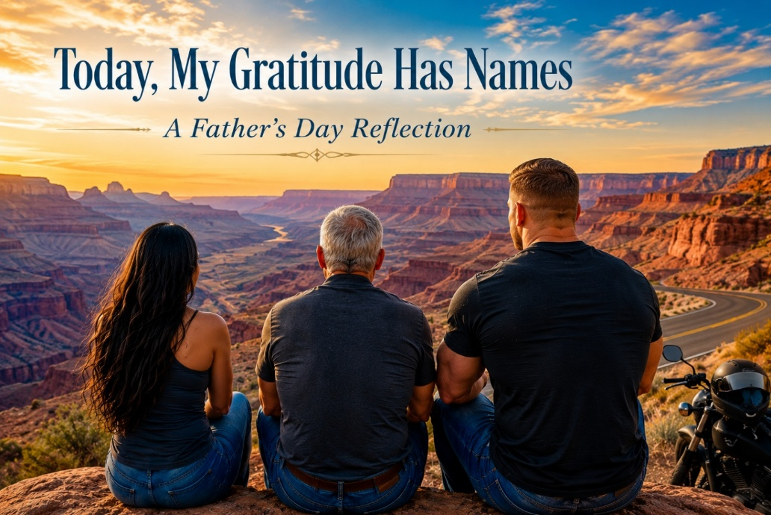
There are days when, for just a moment, God lifts the veil and allows you to see how richly blessed you really are. Father's Day became one of those moments for me.
Yes, life has its struggles. There are hardships, valleys, disappointments, and mountaintops. But every now and then God grants us the gift of perspective. We suddenly realize that the greatest treasures in our lives are not the accomplishments we have accumulated, but the people He has entrusted to us. As the father of two now-adult children, Ashley and Gregg, I experienced meaningful connection with both of them during the days leading up to Father's Day. Those encounters were very different, yet each reminded me in a profound way just how blessed I truly am.
Relationships are interesting. They are complicated. They are beautiful. Certainly, the same can be said of my relationship with my children. They are wonderfully different from one another, yet each has shaped my life in ways they may never fully realize.
Ashley
Just before Father's Day I shared a beautiful exchange with my daughter, Ashley. It began with a series of text messages, but it became something much deeper. Ashley is now pursuing certification in HeartMath and NeuroFaith®, something I never would have predicted a few years ago.
In many ways we are wired remarkably alike. We are both energetic, intellectually curious, deeply compassionate, and drawn toward the things of God. Those similarities have produced some extraordinary moments of connection over the years, but they have also contributed to seasons of painful disconnection. Those chapters are part of our story, but they are no longer the defining story.
Ashley possesses an exceptionally bright, intuitive mind. She has excelled as a fitness instructor and has become increasingly interested in sound resonance as a pathway toward healing. That interest intersects beautifully with many of the principles I teach through NeuroFaith®. When she decided she wanted to pursue certification as a NeuroFaith® coach, I was both surprised and deeply honored.
Watching her in class has been a gift. The other students have come to appreciate her wit, warmth, insight, and quick mind. She engages discussions with authenticity, asks thoughtful questions, and has a natural ability to make people feel seen. Recently I shared one of my longer reflections about my Internal Family Systems journey and my realization that much of my lifelong achievement had been driven by a manager system protecting old wounds. Ashley responded with observations that were compassionate, remarkably perceptive, and profoundly accurate. For a few moments, the student became the teacher, and I simply listened with gratitude.
As a father there are moments when you catch a glimpse not merely of what your child has become, but of who they are becoming. Those moments are sacred. After a season of distance, I never imagined we would reconnect with such depth, affection, and mutual respect. Yet here we are.
Ashley, I hope you know how deeply proud I am of the woman you have become. Your curiosity, compassion, intelligence, and willingness to continue growing are gifts that bless everyone around you, especially your father. Watching our relationship deepen again has been one of the unexpected joys of this season of my life, and I thank God for you far more often than you probably know.

Gregg
Then there is Gregg.
I was absolutely delighted when Gregg invited me on an overnight Father's Day motorcycle ride. At this stage of life, time with your children becomes increasingly precious, and I don't take those invitations for granted.
One of the deepest ways we connect is through motorcycles. Gregg rides a KTM 1290 Super Duke, a phenomenal beast of a machine with extraordinary power. I ride a BMW R1250RS, a motorcycle I absolutely love. Yet Gregg's motorcycle has always reminded me of Gregg himself. At first glance you recognize that it is impressive, but you don't immediately appreciate just how capable it really is. There is tremendous strength quietly held in reserve.
That is Gregg.
He carries the unmistakable bearing of a United States Marine. His combat deployment to Iraq left its imprint, but it also forged him. He possesses quiet confidence, discipline, humility, and inner strength that never needs to announce itself. Ashley and I share similar wiring. Gregg is much more like his mother—reflective before he speaks, thoughtful before he acts, calm rather than reactive. He considers carefully and then moves with purpose.
I have often told Leah that I love riding with Gregg because I trust him completely. Even astride one of the most powerful motorcycles on the road, he never rides to impress anyone. He knows exactly what that motorcycle can do, yet he exercises remarkable restraint. His riding reflects his character: disciplined, composed, predictable, and absolutely rock solid.
We spent the night in Flagstaff and rode to Williams for breakfast the next morning. Somewhere during that ride, I realized something I had never fully put into words.
Gregg settles me.
Not tames me. Settles me.
His presence steadies my spirit. Around him I become more reflective, more composed, and more grounded. Ashley stretches one part of my heart. Gregg draws me toward steadiness, discipline, integrity, and faithful presence.
Gregg, I hope you know how deeply proud I am of the man you have become. I admire your integrity more than your accomplishments, your loyalty more than your strength, and your humility more than your success. Spending Father's Day with you was never really about motorcycles. It was about spending time with my son, and that is a gift I will always treasure.
A Grateful Heart
Looking back, I realize neither Ashley nor Gregg became who I once imagined. They became who God intended them to become, and along the way they also shaped their father. Ashley continually reminds me to remain curious, to keep growing, and to welcome honest reflection. Gregg reminds me of the quiet strength found in composure, discipline, loyalty, and faithful presence.
As I grow older, I find myself measuring my life less by the books I have written, the lectures I have given, or the patients I have helped. Those things matter, but they are not what fills my heart today.
Today, my gratitude has names.
Ashley.
Gregg.
Thank You, Lord, for entrusting them to Leah and me. Whatever else my life has been, or may yet become, no accomplishment compares to the privilege of being their father.
I have been richly blessed.

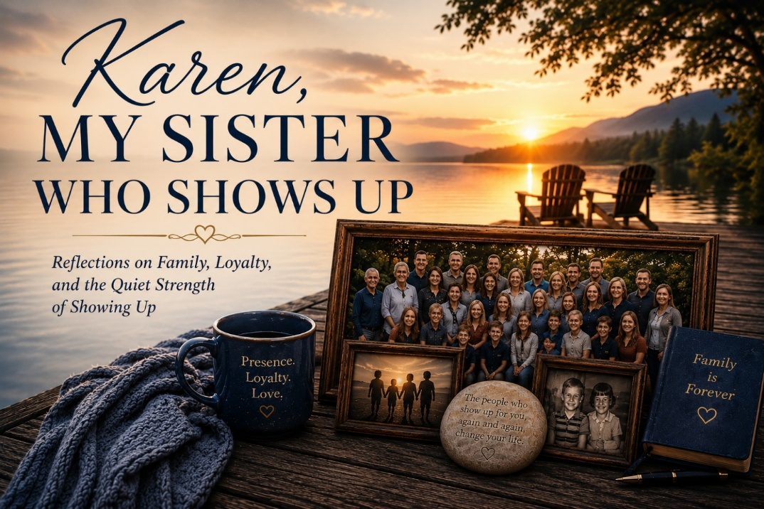
Trinidad Avenue
Some people talk a great deal about love, loyalty, commitment, and family. Others simply show up.
My sister Karen is one of those people.
Our relationship is not necessarily ordinary, but in many ways, it has been extraordinary. And to really explain Karen, I suppose I need to go back in time a little bit and explain something about our history.
You see, Karen, although I call her my sister in every meaningful sense of the word, is technically my stepsister. But labels like that seem increasingly unimportant when measured against the span of a lifetime.
Our story goes all the way back to the 1960s when my family, the Hansen family, and her family, the Lovelace family, had nearly identical homes built by the same builder on Trinidad Avenue. Massive homes for that era, with only slight differences between them. Two families living side by side, long before any of us could have imagined how intertwined our lives would eventually become.
There is something almost poetic about that now when I look back on it. Two houses standing side by side on the same street. Two families with joys, struggles, wounds, celebrations, and complications that none of us yet understood. Life was quietly weaving something together long before we could recognize it.
Our families soon became close.
And as families often are, both of our families were complicated.
One of the things Karen and I share is that both of our parents went through divorce, and for both of us, those divorces were painful and destabilizing. Divorce has a way of shaking the ground beneath a child’s feet, even when people do their best to soften the blow. It changes the emotional architecture of a family. Suddenly, things that once felt permanent no longer feel permanent.
Then, as life sometimes unfolds in unexpected ways, her father, Stu, and my mother, Madeline, came to know each other on a far more personal level.
Eventually, our families blended.
Stu
The divorce years were difficult for me. Confusing. Painful. Unsteady at times. But Stu became a stabilizing force in my life during seasons when certain parts of my world felt far less stable.
He was not always easy to get to know initially. There was a reserve to him, a quietness. But once you got to know him, it became readily apparent that he was an extraordinary man with remarkable emotional depth, kindness, generosity, and integrity.
Stu became a rock for me.
He was the kind of man who did not waste words. In some ways, he was a man of few words, but when he spoke, he spoke from the heart. Always. He said what he meant, and he meant what he said. There was no duplicity in him. No games. No shifting sands beneath his feet.
When certain elements of my life were less stable, Stu was there. You could count on him. Every single time. He did not need grand speeches or dramatic displays to communicate love. His love was communicated through presence, through constancy, through simply being there again and again and again.
Over the years, I grew to love him deeply. And when my father eventually passed away, Stu became, in every meaningful way, my father.
Karen
Karen inherited many of the same traits from him.
Like her dad, if Karen says north, it is north. If she says south, it is south. There is something profoundly grounding about people like that in a world that often feels increasingly unstable and slippery. You never have to wonder where you stand with Karen. There is no manipulation. No unnecessary drama. No performative emotional theater. What you see is what you get, and what you get is genuine.
Karen does not complain much. She understands something many people today seem to have forgotten: relationships require sacrifice, commitment, patience, and perseverance. Love is not merely a feeling. It is an act of consistency over time.
And Karen shows up.
She married Chris, and together they became true partners in every sense of the word. They were deeply compatible, remarkably stable, and profoundly devoted to one another.
Honestly, in all the years I knew them together, I suppose they must have had arguments from time to time, but I rarely, if ever, witnessed it. I am sure they occasionally annoyed one another like every couple does, but what always stood out to me was the quiet stability of their relationship. There was a calmness to the two of them together, a sense that they genuinely respected each other and genuinely enjoyed being together.
Chris was much like Karen. Steady, loving, compassionate, and dependable. The older I get, the more I realize how rare dependable people truly are. There are many people who speak eloquently about loyalty, family, compassion, and commitment. Far fewer actually live it consistently over decades of life.
Chris lived it.
And Karen lives it still.
I suppose that is really the theme here. Showing up.
Loss, Strength, and Presence
Then life, as it inevitably does, brought loss.
Stu passed away, and his death was a profound loss for all of us. Even now, I still miss him deeply. Some people leave impressions on your life that time never fully erases. Their voice, their steadiness, the emotional safety they provided somehow remains with you long after they are gone.
And then, heartbreakingly, Chris passed away a few years after Stu.
Chris’s death was devastating for Karen because they were extraordinarily close. They had built a life together rooted not in drama or appearances, but in loyalty, companionship, sacrifice, and genuine friendship. Watching someone lose that kind of love is heartbreaking because you realize they were not simply husband and wife. They were true companions.
But Karen did not fall apart.
She grieved deeply, of course, because deep love always produces deep grief. But she carried herself with the same quiet strength I had seen in her father all those years before. There was a resilience in her. A steadiness. An ability to endure hardship without becoming bitter or self-absorbed.
And Karen has endured hardship.
Her brother suffered paralysis, another heartbreak woven into the fabric of their family story. Life has not spared Karen pain. She has experienced loss, grief, fear, uncertainty, caregiving burdens, and the thousand emotional cuts that come with loving people deeply over the course of many decades.
Yet through all of it, Karen continued doing what she has always done.
She showed up.
The Gate Between the Yards
Recently, my brother Ken, Karen, and I all agreed that it was no longer safe or wise for my mother, now 93 years old, to continue living alone in Walnut Creek, California. The years eventually catch all of us, and even the strongest among us eventually need help, support, and proximity to family.
And wouldn’t you know it; Karen found a house for sale right next door to her home.
Almost unbelievably close. Close enough that the two properties could literally be connected.
And then Ken and Karen did something remarkable.
They took it upon themselves to transform that house into exactly what my mother needed. Ken, acting as the lead contractor with his remarkable competence and dedication, and Karen serving as consultant, caretaker, organizer, and encourager all at once, worked tirelessly to make the home beautiful, safe, warm, and welcoming for my mother.
They even installed a gate connecting the two yards.
There is something profoundly symbolic about that gate when I think about it now. Not separation. Connection. Nearness. Family. Accessibility. Quiet protection.
Karen now shows up for my mother constantly, and not merely for the large things, but perhaps even more importantly, for the small things. At 93 years old, questions and situations that once would have been simple can now become confusing or overwhelming for my mother. The little details of life sometimes become very big things at that age.
But nothing is too small for Karen.
If my mother needs something fixed, Karen is there. If paperwork becomes confusing, Karen is there. If finances need organizing, Karen is there. If reassurance is needed, Karen is there.
And she does all of it with warmth, patience, tenderness, and remarkably little complaint.
That matters more than people realize.
Because what may appear small to younger people often feels enormous to someone in their nineties. Karen instinctively understands that. She does not minimize my mother’s concerns or frustrations. She takes them seriously because she takes her seriously.
And yes, at this point, my mother is Karen’s mother.
There is no “step” in our family.
It is interesting how in some families the word step almost functions as a subtle divider, as though it keeps people emotionally one step apart from one another. Stepmother. Stepfather. Stepsister.
But that word never really belonged in our family.
There is simply love.
Karen loves deeply.
And my mother’s life is unquestionably richer, safer, warmer, and more peaceful because Karen has poured herself into caring for her in so many ways. Yes, through practical things like finances, repairs, details, appointments, organization, and endless acts of service. But even more importantly, through presence.
Through steadiness, warmth, tenderness, and simply being there over and over again without needing recognition or praise.
That is one of the rarest qualities a human being can possess.
And when I think about Karen, when I think about Stu, when I think about Chris, and even now as I watch her care for our mother with tenderness and devotion, I come back to the same simple truth:
My sister shows up.

A Note from My Heart
This essay began as a chapter I was writing for my book, The Shadow of Shame. In the opening pages of that book, I made a promise that before our journey was over, I would return to the story of my identical twin brother, Gregg—and, to some extent, to my own.
But as I began to write this chapter, it rang so loudly in my heart that I knew I wanted to share it separately as well.
This is a deeply personal story about two identical twin brothers who carried many of the same wounds, learned many of the same ways of surviving, and yet ultimately traveled very different paths. It is also a story of toxic shame, achievement, tragedy, neuroscience, faith, and redemption.
I share it not so that you will feel sorry for either of us, but because perhaps something in our story may speak to something in yours.
And so, dear reader, as promised, I return to my brother—and, to some extent, to me.
The Wounds We Shared
Gregg and I both suffered from toxic shame as a result of our father's emotional and physical mistreatment. We learned the same core wounds: We were not safe. We were not good enough.
And so we adapted.
Our manager systems went into hyperdrive. We developed rigid, fixed, and unrelenting routines built around performance and achievement. We became overachievers, not simply because we were bright or ambitious, but because achievement became a way to feel safe. It became a way to be seen, a way to earn approval, perhaps even a way to convince ourselves, for a little while, that we were good enough after all.
For both of us, this really took hold in the fourth grade, when our family moved from the small coastal town of Point Reyes, California, back to Fort Collins, Colorado, where our father was pursuing a second doctorate, this time in pathology. The schools in Colorado were far more academically advanced than what we had experienced before, and suddenly our insecurities were exposed. We responded the way we had learned to respond: We worked harder. We achieved more. We demanded more of ourselves.
But the achievement came with tremendous emotional turmoil.
When Achievement Became Survival
By junior high, the compulsivity had intensified. We had to get straight A's. And we did. Nothing but straight A's. Not one B on a report card.
But perfection is a cruel master.
Even when the report card showed all A's, a single assignment that fell short of perfection could set us off into a state of intense anxiety. Our worth had become tied to achievement because achievement was how we were recognized by our father and by others. We had learned, deeply and dangerously, that what we accomplished determined whether we were worthy of being seen.
This continued into high school, where both of us achieved at very high levels. But somewhere along the way, a slight divergence began.
Where Our Paths Began to Diverge
Gregg was always the more naturally gifted of the two of us academically. He received the highest scholastic awards, particularly in mathematics, and he was an exceptional gymnast. He was named Athlete of the Year for our entire district, an extraordinary honor recognizing him not merely among gymnasts but among athletes across all sports.
I was, perhaps, second fiddle to Gregg in some of those areas, though I achieved considerably in my own right. But somewhere along the way, I began choosing relationship a little more often than achievement.
And I now believe that decision was the beginning of what saved me.
Gregg continued to soar. The United States Air Force Academy wanted him so badly that they flew him out for recruitment even without a congressional nomination, drawn not only by his extraordinary academic prowess but also by his excellence in gymnastics. He was exceptional in both worlds: a gifted scholar and a gifted athlete.
Later, he entered medical school. But by then, depression had begun nipping at his heels, and eventually he withdrew.
Still, he kept going. He trained as a mechanical engineer and later became a highly successful high-end builder in California. When the financial crisis struck, he closed that business and reinvented himself yet again, creating a successful career in forensic accounting.
He kept achieving. He kept performing. He kept moving.
But the wounds underneath had never healed.
The Wounds Beneath the Achievement
As Gregg entered midlife and then his later years, depression came and went, even as he continued to achieve. But the toxic shame remained. And by his mid-to-late sixties, those old wounds had grown louder and more merciless.
Erik Erikson described this stage of life as a confrontation between generativity and stagnation, a time when we begin to look back upon what we have done with the life we were given. But when Gregg looked back, his inner critic allowed him to see almost nothing good.
Despite all he had accomplished, it was never enough. Despite his brilliance, it was never enough. Despite the lives he had touched, the businesses he had built, and the obstacles he had overcome, it was never enough.
Because shame does not grade on accomplishment.
The inner critic that had driven him for so many years eventually turned mercilessly against him. Gregg fell into a deep well of despair and lost his will to endure. Later, he stopped eating. He became profoundly anhedonic, losing interest in nearly everything that had once given life meaning or pleasure. He became anorexic. And eventually, my identical twin brother died alone on the other side of the country.
I have had to live with that.
And I always will.
The Space in My Heart Where Gregg Once Lived
But those words hardly begin to capture the agony of what it means to live without Gregg.
He was not simply my brother. He was my identical twin, my best friend, my closest confidant, and my forever encourager. For 68 years, there was a person on this earth who had been there from the very beginning. Before either of us could speak, before memory itself, there was Gregg and there was me. We began this life together.
And then, suddenly, there was only me.
I miss the conversations that never really ended. Gregg and I could begin talking one day, leave a thought unfinished, and pick it up the next as if no time had passed. There were stories that needed no explanation, memories that belonged only to us, jokes that no one else could fully understand and that somehow became funnier simply because the other one was laughing.
Now those conversations remain unfinished.
The jokes we shared are still inside me, but there is no Gregg on the other end to laugh with me. There are memories I still carry, but the only other person who stood inside those memories with me is gone.
And that is one of the loneliest parts of grief that I know.
So much of my life that only Gregg had access to is now mine alone to hold. There were parts of me he knew simply because he had been there. I did not have to explain the childhood. I did not have to explain our father. I did not have to explain Point Reyes or Fort Collins, the straight A's, the fear of not being good enough, the striving, the laughter, the dreams, or all the countless ordinary moments that somehow become sacred only after the person who shared them with you is gone.
He knew.
And now I am the only one left to remember so much of it.
There are still times when something happens and my first instinct is to tell Gregg. A thought crosses my mind, something makes me laugh, something hurts, something wonderful happens, and somewhere inside me there remains that almost automatic movement toward my brother.
And then I remember. He is not there. There is now an empty space in my heart where Gregg once lived, a space no one else can ever occupy.
There is an agony in that which I do not know how to fully put into words. I am a psychologist. I have spent a lifetime studying human suffering, grief, trauma, resilience, and the mysterious ways in which we heal. But there are some losses that cannot be reduced to clinical language. There are some absences that cannot be resolved, only carried.
I carry Gregg. I carry his voice. His laughter. His encouragement. His brilliance. His wounds. His unfinished conversations. I carry the jokes that now have only one person left to remember why they were so funny.
And perhaps most painfully, I carry the part of myself that existed only when I was with him. I will forever mourn my brother. I will forever hear him in my heart. And my heart will always cry for him. But I would rather carry the pain of having loved Gregg than live a life in which I had never known what it was to have him as my brother, my identical twin, my best friend, my closest confidant, and my forever encourager.
He was here.
He mattered.
He was loved.
And he is missed beyond anything these words can ever fully say.
And Then There Was Me
But if I am going to tell you the truth about Gregg, I must also tell you more of the truth about me. My own journey was not simply a story of resilience or an easy turn toward faith. I, too, experienced my own tragedy. Mine came earlier, triggered by so many internal and external events that the resilience I had relied upon for so long was no longer strong enough to carry me. The ways I had learned to survive were failing. My nervous system was overwhelmed.
My values had to be reconsidered because I began to understand that our negative core beliefs are often tightly intertwined with our deepest values, with what we believe gives us worth, identity, and significance.
And I had valued performance. I had valued achievement, external accolades, big houses, beautiful properties, professional recognition, and all the other things I genuinely enjoyed and had worked hard to attain. There was nothing inherently wrong with those things. But somewhere along the way, I had allowed too much of my identity to become attached to them.
Beneath the accomplishments still lived the old core wound:
You are not good enough.
And so, I had to begin again.
Learning to Settle
My first step was not theological or intellectual. It was physiological.
I had to learn how to settle my autonomic nervous system, which had carried so much for so long. For years, I had lived largely in chronic sympathetic and HPA-axis activation, punctuated by occasional periods of dorsal vagal shutdown. I knew surprisingly little, experientially, about what it meant to live from a ventral vagal state of safety, connection, openness, and peace.
I had to learn to settle. I had to learn to listen to my body rather than constantly drive it. I had to understand that the nervous system I had once relied upon to push me toward achievement was also exhausted from years of trying to protect me.
My work with neurobiology helped me understand what was happening inside me, and slowly I began to discover that living was not the same thing as performing.
Life was not meant to be lived from a performative mindset, forever trying to silence a negative core belief by achieving enough to finally become worthy.
Because no achievement can heal the wound that says, I am not enough.
When Neuroscience Met Faith
For me, the deepest healing came when neuroscience and faith began to converge. I came to understand, not merely intellectually but in my heart, that my worth did not come from what I had achieved, what I owned, what degrees followed my name, or how others regarded me.
It came down to something that may sound almost too simple. Jesus loves me. Not because I performed well. Not because I earned it. Not because I achieved enough. Simply because I am His.
I came to understand that I was made for relationship with Jesus. I was made to define myself not by the relentless verdict of my inner critic, but by His love for me. I was adopted into His family. I was loved and valued so profoundly that God sent His Son to die for me.
These were truths I had known intellectually for years. But knowing something in your head is not the same as experiencing it in your heart, your body, and your nervous system.
And slowly, I began to find the peace Scripture had promised: “And the peace of God, which surpasses all understanding, will guard your hearts and your minds in Christ Jesus.” I found that peace. Not perfectly. Not without struggle. Not as a permanent state in which I never again feel anxiety, grief, or pain. But I found it deeply enough to know that it is real.
And why would I not want to share that with others? Why would I not want to share it with you, dear reader?
Because your life can go either way. I do not necessarily mean that you will lose your physical life as my brother did. But shame can steal something else from you. It can steal your joy. It can steal your peace. It can convince you to spend a lifetime performing for a worth that was never meant to be earned in the first place.
It can leave you living a life of defeat, which is precisely where the enemy wants you.
But that is not what God wants for you.
It Is Never Too Late
I know that somewhere along the way, Gregg made a decision to receive Jesus. And I can only trust and pray that this decision mattered eternally. Although he did not find the peace in this life that I so desperately wish he had known, I hold on to the hope that he has found that peace now.
And I look forward to seeing him again.
But there is another part of this story that matters deeply to me. My father, the same father whose own wounds led him to emotionally and physically mistreat his sons, found Christ in the last lap of his life.
And so did my grandfather.
These were two men who had carried wounds of their own and who, for much of their lives, had lived with deep differences between them. But in those final chapters, something beautiful happened. They found Christ, and they beautifully reconciled their differences.
That does not erase what happened. It does not undo the wounds or change the past. Grace does not require us to pretend that harm never occurred. But it reminds me of something I believe with all my heart:
It is never too late.
It is never too late for grace. Never too late for reconciliation. Never too late for a wounded heart to turn toward Christ. God works in His own time, and if we remain open to Him, no life is beyond redemption. No story has to end where it began.
My father and grandfather taught me that.
The father who once caused such pain was himself a wounded man. And his story, too, was still being written. So was my grandfather's. And in the last lap of their lives, grace entered the story in a way that allowed two wounded men to find Christ and find their way back to one another.

What a Reunion That Will Be
And so, yes, I hold on to the hope that one day, in God's time, I will see Gregg again. And I hope Dad and Grandpa will be there too, waiting at the gates of heaven. What a reunion that will be. No more shame. No more fear. No more wounds passed from one generation to the next. No more inner critics whispering that we were never good enough.
Only grace. Only forgiveness. Only love.
And I do not believe that God caused these tragedies. I do not believe that.
I believe God allows tragedy to occur and natural consequences to unfold. But I also believe that God lets no pain go unused, if we allow Him to redeem it. I do not want my pain to have been in vain. I do not want my loss to have been in vain. Nor do I want Gregg's pain, his life, or his loss to go untold.
I share our story not so that you will feel sorry for either one of us. I share it in the hope that perhaps it may touch your heart, help you make a choice a little differently, or invite you to lean more deeply into what I have written from my heart to yours in the pages of this book.
From My Heart to Yours
My prayer is that these pages will somehow write their love upon your soul. That they will point you toward healing of the body, healing of the mind, healing of the heart, and healing of the soul. And ultimately, that they will turn your heart toward Christ.
That is my prayer for you, dear brother or sister who has walked with me through these pages.
And perhaps, in that way, neither Gregg's pain nor mine will have been in vain.


When Gregg Died
When Gregg and I were young, people would often ask us a question that seemed perfectly reasonable to them: "What’s it like to be a twin?"
And I would sometimes answer, not trying to be a smart aleck, "What’s it like not to be a twin?"
I wasn’t being clever. I truly didn’t know. How could I possibly explain what it was like to be an identical twin when I had never known anything else? Gregg was simply there. He had always been there. From before memory, before language, before either of us knew there was a difference between me and we. I had no point of comparison.
Now I do. And I wish I didn’t.
Since Gregg died, I have found myself increasingly aware of something I never fully understood while he was alive. I had known a depth of human connection that relatively few people ever experience. I didn’t earn it or create it. I was born into it. And because I had it from the very beginning, perhaps I never fully realized how much I depended upon it, how much it shaped me, or how extraordinary it actually was.
I suppose I am finally finding out what it’s like not to be a twin. And to be brutally honest, there are parts of it I don’t like very much
Aristotle and the Friendships We Keep
More than two thousand years ago, Aristotle wrestled deeply with the meaning of friendship. Born in 384 BC in the ancient Greek city of Stagira, Aristotle became one of history’s most influential thinkers. He studied for approximately twenty years at Plato’s Academy, later tutored the young Alexander the Great, and eventually founded his own school, the Lyceum, in Athens. His thinking would profoundly shape Western philosophy, ethics, science, politics, and theology for centuries.
Among the many questions Aristotle explored was one that seems remarkably simple: What makes a true friend?
In the Nicomachean Ethics, Aristotle described three broad forms of friendship: friendships of utility, friendships of pleasure, and friendships of virtue. A friendship of utility is based, at least in part, upon what we can do for one another. You scratch my back, I’ll scratch yours. There is nothing inherently wrong with such relationships. Much of life depends upon mutual exchange and cooperation. But the relationship lasts primarily because it is useful.
A friendship of pleasure exists because we enjoy one another. We laugh together, ride motorcycles together, share meals, stories, coffee, hobbies, adventures, and good times. These friendships can be wonderful and genuinely life-giving.
But Aristotle believed the highest form of friendship was the friendship of virtue. In such a friendship, I want what is good for you because it is good for you. I don’t merely value what you do for me or how you make me feel. I care about your flourishing. I want to lift you when you fall, tell you the truth when the truth is difficult, and stand beside you when standing beside you costs me something. Your well-being matters to me because you matter to me.
That was Gregg and me.
Not perfectly, of course. We were human beings. We irritated one another. We disagreed. We had our own wounds, weaknesses, and blind spots. But beneath all of it was something immovable: I had his back, and he had mine. There was no calculation, no keeping score, no wondering whether I had called too many times or said too much or needed too much. There was no wondering whether this was a convenient time to be a brother.
We simply belonged to one another.
The Friendship I Didn’t Know I Had
I have many friends. Good friends. Dear friends. People I love deeply and who, I believe, love me deeply in return. This is not a criticism of them. I need to say that clearly, because what I am trying to understand is not their failure. It is my loss.
Since Gregg died, however, I have become increasingly aware that even very good friendships often have boundaries. There is a tempered quality to them, a limit, perhaps even a cost. They can go far, sometimes very far, but only so far.
A phone call isn’t returned. A text goes unanswered. Someone says, "I’ll call you," but doesn’t. Someone asks, "How are you doing?" but doesn’t really have the time, or perhaps the emotional room, to hear the answer. Not because they are cruel, not because they don’t care, and not because they are bad friends. They have lives, families, responsibilities, wounds, exhaustion, and needs of their own. I understand all of that.
But I notice these things now in a way I didn’t before, because Gregg is gone. And perhaps the painful truth is that when Gregg was alive, I didn’t need others to reach that deepest place in me. I already had someone there. Now I don’t.
Trying to Find Gregg in Other People
This may be one of the hardest things for me to admit: I think sometimes I am looking for Gregg in other people.
I am looking for the returned phone call, the unexpected text, the person who asks, "How are you really doing?" and then sits quietly enough to hear the real answer. I’m looking for someone who notices when I disappear a little, someone who doesn’t always need me to initiate, someone who says, "I’ve got you. You don’t have to earn my attention today. You don’t have to be interesting or funny or wise or useful. You can just be here."
And that isn’t entirely fair. I know it isn’t. No friend should be asked to replace an identical twin brother. No one should be measured against a bond that began in the womb and lasted for nearly seven decades. I know that intellectually, although my heart apparently hasn’t fully received the memo.
Because I find myself reaching for a depth of connection that I once had without needing to ask for it. And when I don’t find it, I feel the absence all over again.
Lonely Among Friends
Perhaps this is the strangest part of grief. I am not alone. I have a wife I love, a family, many friends, brothers in faith, colleagues, and people who care about me. Their presence in my life is a genuine blessing.
And yet I am tremendously lonely.
Those two truths can exist together. Gratitude does not cancel loneliness, and love does not erase grief. Having many people around you does not necessarily fill the space left by the one person who knew you in a way no one else ever could. Sometimes loneliness isn’t the absence of people. Sometimes it is the absence of one particular person.
But as I have wrestled with this, I have begun to realize that there is something more going on inside me than simply wanting my friends to understand my grief. Yes, I wish they could understand what I lost. But that isn’t the whole of it. Perhaps it isn’t even the most important part.
I wish they could understand what they may be missing.
I Wish You Could Taste the Chocolate
For most of my life, when people asked me what it was like to be an identical twin, I couldn’t explain it because I had nothing to compare it to. Gregg had always been there. Our connection was simply part of the fabric of my existence. I couldn’t step outside of it and describe it any more than I could explain to someone what it was like to be me.
It’s a little like trying to describe chocolate ice cream to someone who has only ever tasted vanilla. You can use all the right words. You can say it is richer, darker, different. But until you’ve tasted chocolate, you cannot really know chocolate.
For nearly seventy years, I had tasted something extraordinary in my relationship with Gregg, although I didn’t fully understand how extraordinary it was because it was all I had ever known. Now, for the first time, I am learning what it’s like to live without it.
And what I wish for my friends is not simply that they could taste the chocolate so they would better understand me. It is much bigger than that. I wish they could taste it because then they might understand what they could have.
I wish they could experience the richness of a relationship in which there was no keeping score, no wondering whether you had called too often, needed too much, or taken too much time. A relationship in which the other person’s well-being mattered to you simply because that person mattered. A relationship where you knew, without asking, that someone had your back, and they knew you had theirs.
Because if they could experience that, even briefly, perhaps they might look differently at their own relationships. Perhaps they might return the phone call they intended to return, send the text they thought about sending, ask, "How are you really doing?" and stay long enough to hear the answer. Perhaps they might risk going a little deeper, giving a little more freely, and letting themselves be known a little more fully.
Not because every friendship can or should become what Gregg and I had. I know better than that. But perhaps many of our relationships could be deeper than they are. Perhaps we have grown so accustomed to guardedness, busyness, convenience, and carefully managed boundaries that we no longer recognize how much richness is available when two human beings truly decide to have one another’s backs.
Perhaps Jesus Understood This Best
And perhaps this is where Jesus understood something about human connection that even Aristotle, brilliant as he was, could only begin to describe.
Aristotle gave us the friendship of virtue, the highest form of friendship in which we seek the good of another not because of what they can do for us or because they bring us pleasure, but simply because we love them and desire their flourishing. I experienced something very close to that with Gregg. I had his back, and he had mine. There was no keeping score, no wondering whether I had called too often or needed too much, no calculating whether the relationship was worth the effort.
But I think there is something even deeper here.
The more I think about it, the more I wonder whether the bond I shared with my identical twin brother might be, in some small and imperfect human way, a metaphor for the kind of relationship Christ wants to have with us. Gregg knew me at a depth few people ever could. He knew my history because so much of it was also his history. He knew where I came from because we came from the same place. He knew my strengths and my failures, my wounds and my foolishness, and I knew his. There was very little explaining required between us. There was simply a knowing.
Isn't that something like what Christ offers us, only infinitely deeper? To be fully known and still fully loved. To have someone who does not merely tolerate our wounds but enters them with us. Someone who does not say, "Call me when you've cleaned yourself up," but instead says, "I'm already here." Someone who knows the parts of us we hide from everyone else and does not turn away.
Jesus will go that deep. In fact, Jesus wants to go deeper. And perhaps he wants us to go deeper with one another too, yes, even among us non-twinners.
I don't mean that every friendship can become the equivalent of an identical-twin relationship. Of course it can't. Gregg and I shared something biologically, developmentally, historically, and emotionally unique. We began together before either of us had taken a breath, and no friendship can simply manufacture that.
But I do wonder whether those of us who are not twins sometimes accept a level of distance in human relationships that Christ never intended to be the best we could do. We guard ourselves. We ration our time. We measure our vulnerability. We say we'll call and then don't. We ask how someone is doing but sometimes don't leave enough room for the real answer. We love, certainly, but often with carefully negotiated limits.
And I wonder whether Jesus invites us to something richer.
My wish for my friends is not simply that they could understand my grief or comprehend what I lost when Gregg died. I wish they could somehow taste what I tasted, because then they might understand what they could have. Perhaps they would risk going deeper in their own friendships. Perhaps they would return the call, send the text, stay a little longer, listen a little more carefully, and risk being more fully known themselves. Not for me, but for them and for one another.
Because perhaps the deepest lesson of having been an identical twin is not simply that I lost something irreplaceable when Gregg died. Perhaps it is that, for nearly seventy years, I was given a glimpse of the richness of being deeply known, deeply connected, and profoundly loved.
And perhaps that is not so far from what Jesus has been trying to offer us all along.
And perhaps that is not so far from what Jesus has been trying to offer us all along.
The Space in My Heart
And then one day, he was gone.
Yesterday, I wrote about the space in my heart left by my identical twin brother. Perhaps I am only now beginning to understand the true dimensions of that space.
For most of my life, when people asked me what it was like to be a twin, I couldn't answer them. Now, after losing Gregg, I finally understand what it is like not to be one. It is to discover that there had always been another human being in the world who carried part of my history, part of my identity, part of my memory, and somehow, mysteriously, part of me.
And then one day, he was gone.
I am still here, and I have good people around me. I am grateful for them, and I love them. But I am learning to live with a loneliness I never knew before, because I once had a brother who occupied a place in my life that I didn't even know could become empty.
Yet perhaps the space Gregg left is teaching me something too. Maybe the gift of having known that depth of connection is not merely that I can mourn what I lost. Maybe it is that I can bear witness to what is possible.
Gregg and I didn't create what we had. We didn't earn it. We simply opened our eyes to the world and discovered that the other was already there. And perhaps Christ says something similar to each of us: "I am already here."
I cannot have Gregg back. No friend can fill his place, nor should I ask anyone to try. But I can carry forward what loving him and being loved by him taught me. There is more depth available to us. More intimacy. More presence. More courage to know and be known. More willingness to stay when leaving would be easier. More room to ask the question and actually wait for the answer.
Perhaps Gregg's final gift to me is that now, through his absence, I can finally see the extraordinary richness of what was always there.
And I wish more people knew what chocolate tastes like.

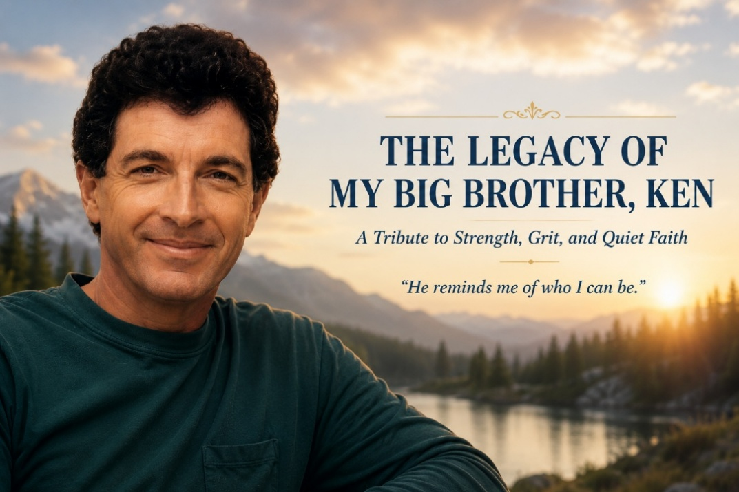
Not everyone is lucky enough to have a big brother. But I am. And not just any big brother, I have Ken. Ken was born in Gunnison, Colorado, forged from two lines of rugged, noble stock.
The Hansen Line: Grit and Ground-Smarts
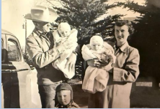
On our dad’s side, the lineage runs deep into the Nebraska plains, Swedish and Danish descent. Grandpa and Grandma were successful farmers who built an incredible life with little formal education but endless grit and ground-smart wisdom. When financial hardship hit, Grandpa didn’t fold. He picked himself up by the boot press and moved the family to Denver, Colorado. There, he managed a fading apartment complex and, through vision, determination, and planning for something more, built up a hotel business from the ground up. He dreamed. He planned. And he thought about legacy. But it wasn’t glamorous. It was slow and hard, with plenty of setbacks.
Still, he moved forward with a kind of deep, enduring resolve. Later in life, Grandpa began driving massive semi-trucks, faithfully and almost quietly heroic. He didn’t do it for show. He did it because it was the next thing that needed to be done. When Gregg and I were about twelve, we got to ride with him in one of those semis. Sitting high in the cab, taking in the world from that rumbling rig, we couldn’t have been more proud. That ride wasn’t just a childhood memory; it was a glimpse into the kind of man he was.
The Vouga Legacy: High Plains, High Character
On the other side, from our mother’s family, came the Vouga legacy. They emigrated from Switzerland to the high plains outside of Gunnison in 1911, with vision and purpose.
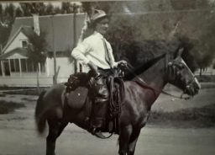
Grandpa Vouga, known to us as Popeye, originally intended to head to California to strike gold. But on his way, he stopped in the Colorado town of Doyleville to meet up with another Swiss family. Something about the high plains, over 9,000 feet up, captured his heart. So did Sophie, a bright, strong, deeply capable woman who would become his wife. He married her, brought her over, and together they built a life from nothing.
And I do mean nothing. No electricity. No running water. Dirt floors. Dirt roofs. Rugged cabins carved into the side of nowhere just outside of Del Norte. But with sheer tenacity, they started a cattle operation and became well known and deeply respected in the area. Those summers we spent up there are seared into my memory.
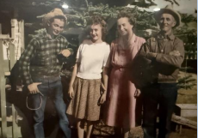
Running wild under that Colorado sky, we got to spend time with Popeye, with Granny, and with our hero, Mother’s brother, Ernie. He had a donkey named Meany, and he taught us everything. How to build fences. Bail hay. Tend livestock. Work with our hands. We'd jump in that old Austin-Healey or clamber into the bed of a pickup and head out for real work, not pretend play. We came back dusty, tired, and proud. And if there was ever a threat, Ken would step in. That’s who he was.
Even at Seven, He Was Our Leader
Some of my earliest memories of Ken come from Point Reyes, where we lived when he was seven and Gregg and I were five. Point Reyes was little more than a rustic coastal outpost north of San Francisco in those days, a place of fog, wind, marshland, and mystery. Behind our house rose a dense forest of tule reeds, towering over two five-year-old boys and transforming our backyard into another world. To us, it was not simply a patch of marsh. It was the misty bogs of Ireland, the unexplored wilds of Neverland, a place where adventure beckoned and every shadow might conceal some strange and terrible beast.
And, of course, we had Ken.
He was only seven, but to Gregg and me, those two extra years made him nearly a grown man. He was our big brother, our expedition leader, and the one who knew things we did not. When Ken led us into the tules on a grand exploration, we followed him without hesitation. If Ken believed we were brave enough to enter that wilderness, then we believed it too.
We pushed deeper into the towering reeds, thrilled by the danger of it all, until we finally turned around and realized that our house had disappeared.
We were lost.
The adventure vanished in an instant. The reeds seemed taller, the fog thicker, and every rustle became something alive and menacing. Gregg and I imagined snakes, monsters, crawling things, and unnamed creatures moving toward us through the marsh. Then came the tears. Not quiet little sniffles, but the desperate, full-throated wailing of two terrified five-year-old boys who believed they might never see their home or their mother again.
Ken must have been frightened too. He was, after all, only seven years old. But somehow, even at that age, he understood that he could not let the twins see his fear. We needed him to be strong, so he became strong. He instinctively stepped into the role that would define him throughout our lives. He became our protector, our commander-in-chief, and the steady voice in the middle of our panic.
“Shut up, you two. I’ve got this.”
It may not sound particularly tender, but to us, it was reassurance. Ken was still in charge. Ken knew what to do. And when you are five years old and your seven-year-old brother is bigger, stronger, and marching forward as though he knows exactly where he is going, you believe him. You trust him completely. At that moment, Ken was not simply our brother. He was our hero.
So, we followed, crying and sniffling behind him while he pressed onward, repeatedly ordering his frightened little troops to quiet down. I am sure he was every bit as scared as we were and may have wet his pants two or three times, but a commander never reveals such things to the men under his charge.
After what seemed like six or seven days in the wilderness, but was probably thirty minutes, Ken led us onto the neighboring property of Pop Griffith, a local junk collector. At that moment, Pop might as well have been Jesus Christ Himself appearing through the fog.
“You boys are lost,” he said.
That much was undeniable.
Pop took mercy on three frightened and bedraggled explorers and got us safely home. But when I look back on that day, it is Ken I remember most clearly. He was only seven, lost and undoubtedly afraid himself, but his little brothers needed him. Somehow, he knew that. He swallowed his fear, took command, and kept us moving until we were safe.
Even then, Ken was already the leader of the twins. Gregg and I leaned into his strength because we trusted him with the absolute faith that only little brothers can place in their big brother. Long before we had words like courage, leadership, or sacrifice, Ken was already showing us what they meant.
Continuing Protector, Gymnast, Brother
Ken continued as our protector throughout our childhood. Always. I remember once in Oakland, racially tense at the time, when Gregg was getting hassled by a group of guys. Ken didn’t even blink. He stepped in with that commanding presence and those gymnast’s arms and made sure the trouble stopped, right then and there. It wasn’t just physical. It was moral. He had your back. Another time, Gregg and I were about twelve, walking near Grand Lake. A punk gave us a look, one of those looks, and Ken told us to stay put. He walked back, and next thing we knew, that situation was handled. I asked him what happened. He simply said, “I didn’t like the way he looked at you.” That was Ken. Intuitive. Grounded. Alert. Not reactionary, but decisive.
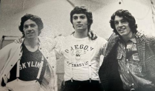
Ken was also a phenomenal gymnast, one of the best our high school ever produced. He blazed a trail that Gregg and I would later walk. We didn’t overlap competitively, but when we joined the team, the Hansen name already meant something. And Ken welcomed us with brotherly pride, not competition. He opened the door. I also remember a time I was dating a girl named Joan. We ended up at her mother’s house. She was clearly taken with Ken, as most people were. Movie-star handsome, strong, charismatic. But when she made a play for him, Ken didn’t take the bait. He told her to get lost. He was loyal. He had integrity. That moment stuck with me.
Healing, Faith, and the Ties That Deepened
As the years progressed, Ken and I grew closer. Like all families, our story included scars. Some of them came from trauma passed down. Our grandpa was a complex man. He handed both strength and wounds to our dad, who in turn, though deeply well-meaning and immensely successful as a respected veterinarian, carried some of those scars into his own parenting.
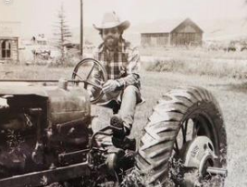
At times, Ken received too much harshness and not enough validation for who he truly was. But then Dad found faith. And with that faith came healing. Over time, things began to change. The tension in our relationships gave way to grace. Forgiveness took root. Ken, too, came to faith, and it softened his heart. His connection with Gregg and me deepened, especially with Gregg.
While Leah and I were living and serving overseas in Germany, building a life together, Ken and Gregg grew even closer. They shared something fierce and beautiful; a brotherhood forged through martial arts. With Gregg’s guidance as a third-degree black belt, Ken became an accomplished martial artist himself. Through those years, he discovered more of who he truly was. In that bond with Gregg, he found not only strength, but grounding and confidence.
After Gregg, Even Closer
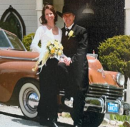
Later in life, Ken found Juliet. A radiant, kind, remarkable woman. He married her in his early fifties, and together they built a life that brought more warmth, more joy, and more of that beautiful legacy he had been building all along. Just as our grandparents had done with bare hands and brave hearts, Ken carved out a meaningful career as a landscape architect. He was deeply respected, never cut corners, always guided by a simple, powerful mantra: integrity.
That’s Ken. Integrity defines him. And now, after losing Gregg, something no family should ever have to endure, Ken and I have grown even closer. He is the one I turn to when I need a word of encouragement, when I need a broader vision, when I need a reminder of who I am. Ken speaks with authority, wisdom, and compassion. He reminds me of who I can be.
And So, Ken...
Today, I watch him take care of our 92-year-old mother, the matriarch of the family, the gentle and strong heart of our story. Ken, along with our stepsister Karen, has taken on the mantle of care. He brings her to his home. He and Juliet wrap her in love, kindness, and safety. They’ve traveled with her, housed her, honored her. And now, as the years close in, Ken and Karen are making plans to move her up permanently. That’s just who he is. Strong. Selfless. Steady. Gritty. Tender. Integrity in motion. He embodies the best of both the Hansen and the Vouga lines. Strength and grace. Karen. Luke. Lorraine.
And above all, big brother Ken. I think of all the seasons we’ve lived through. The hardships we’ve weathered. The childhood laughter, the pranks, the tears, the distant chapters, and the redemptive ones. I think of Ken walking with me through the valley of loss after Gregg’s passing. I think of the way his voice steadies me, his presence encourages me, and his quiet strength gives me perspective. I think of the way he has loved Juliet, honored our mother, and stood by me in ways no one else could. So yes, I’m lucky. I’m blessed. I just want the world to know about him. Because he’s a great man. A great brother. A great husband. A great son. Ken, I love you. I admire you. And I’m proud to call you my big brother.
Not everyone is lucky enough to have a big brother. But I am. And not just any big brother, I have Ken. Ken was born in Gunnison, Colorado, forged from two lines of rugged, noble stock.

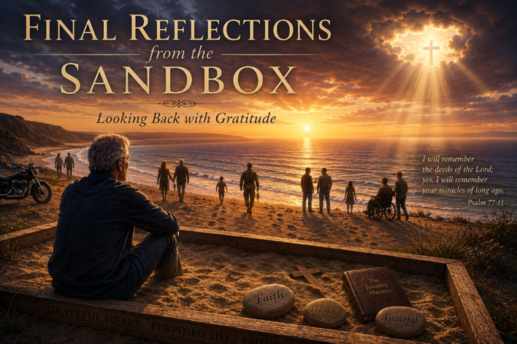
As I bring this book to a close, I find myself sitting once again in the sandbox, reflecting on the people who have walked through my life and left footprints on my heart. In many ways, this book has been less about them than it has been about gratitude. It has been an opportunity to pause, to look backward across the years, and to acknowledge the countless ways my life has been enriched by the people God has placed along my path.
The older I become, the more aware I am of how quickly life passes. When we are young, we live with the quiet assumption that there will always be more time. More conversations. More holidays. More opportunities to say the things that matter most. We assume the people we love will always be there, and because of that assumption, we often postpone the words that need to be spoken. We carry our gratitude silently. We keep our admiration to ourselves. We assume people somehow know what they mean to us without our ever having to say it aloud.
But life has a way of reminding us that tomorrow is never guaranteed.
The death of my twin brother Gregg changed me in many ways. His passing left an ache that will remain with me for the rest of my life. Yet it also awakened something important in me. It deepened my resolve not to leave this world with love left unexpressed. It reminded me that there are things we should say while we still have the chance to say them. There are people who deserve to know the difference they have made in our lives. There are stories that deserve to be told. There are blessings that deserve to be spoken.
This book is my attempt to do exactly that.
As I look across these pages, I see family members who shaped me, friends who stood beside me, colleagues who inspired me, former clients who taught me more than they may ever realize, and countless others whose kindness, courage, loyalty, wisdom, and faith enriched my journey. Some of them are still here. Some are not. Some I knew for decades, while others entered my life for only a brief season. Yet every one of them left something behind. A lesson. A memory. A laugh. A challenge. A moment of grace. A reminder of what matters most.
As a psychologist, I have spent much of my life studying human suffering. I have sat with people in the darkest moments of their lives. I have witnessed trauma, addiction, loss, betrayal, grief, and heartbreak. I have also witnessed extraordinary resilience, redemption, forgiveness, healing, and courage. After more than four decades of listening to people's stories, I have come to believe that our lives are shaped less by what happens to us than by who walks beside us as it happens.
People matter. Relationships matter. Love matters. Far more than most of us realize.
In the end, I do not believe anyone lying on their deathbed wishes they had accumulated a little more money, achieved a little more status, or received a few more accolades. What people long for is connection. They long to know they loved well and were loved in return. They long to know their life mattered. They long to know they left the world a little better because they were here.
Perhaps that is why Jesus placed such emphasis on love. When asked about the greatest commandment, He did not point first to achievement, success, or accomplishment. He pointed to love. Love God. Love your neighbor. Love one another. It sounds simple, yet it may be the most difficult and most important work we will ever undertake.
As I look back on my own life, I see countless examples of that love. I see it in my wife, who has walked beside me through seasons of joy and seasons of profound struggle. I see it in my children, who have taught me lessons no textbook ever could. I see it in my brothers, in my extended family, in cherished friends scattered across the country and around the world. I see it in colleagues whose integrity challenged me to become better. I see it in former clients whose courage in the face of suffering humbled me and strengthened my own faith.
And through all of it, I see the quiet hand of God.
I see His grace in the people He placed in my life exactly when I needed them. I see His faithfulness in moments when I could not see beyond the next step. I see His kindness in the friendships that endured, in the wounds that eventually healed, and even in the losses that deepened my understanding of what truly matters.
If there is one lesson I carry away from this journey, it is this: love is never wasted.
Every act of kindness matters. Every word of encouragement matters. Every prayer matters. Every moment of compassion matters. Every effort to remain present in another person's life matters.
We rarely understand the full impact we have on one another. Most of the time, we are planting seeds we will never see fully bloom. Yet those seeds grow nonetheless, quietly shaping lives and rippling outward across generations.
To every person whose story appears in these pages, thank you. Thank you for allowing me to share a small part of your journey. Thank you for the ways you enriched my life, challenged my thinking, strengthened my faith, and expanded my heart. Thank you for the laughter, the tears, the lessons, and the memories. Thank you for helping me become the man I am today.
And to those whose names do not appear in this book, but whose influence remains etched upon my heart, please know that my gratitude extends to you as well. No book could ever contain all the people who have helped shape a life.
In many ways, these pages are simply a collection of thank-you letters written from an old psychologist sitting in the sandbox, reflecting on the extraordinary privilege of having shared this brief and beautiful journey with so many remarkable people.
One day, all of us will leave the sandbox. Our careers will end. Our accomplishments will fade. Our possessions will belong to someone else. But the love we gave, the lives we touched, and the faith we shared will continue moving forward long after we are gone.
That gives me tremendous hope.
So from my heart to yours, thank you.
Thank you for walking beside me.
Thank you for leaving your footprints on my heart.
And thank you for making this journey richer, warmer, deeper, and more beautiful than it ever would have been without you.
Until we meet again, may the grace of our Lord Jesus Christ, the love of God, and the fellowship of the Holy Spirit remain with you always.
With deep gratitude and affection,
Jeff

About the Author

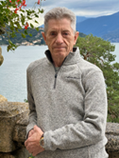
Jeffrey E. Hansen, Ph.D. is a clinical psychologist specializing in addiction and trauma, with degrees from the University of California, Berkeley and the University of Arkansas. He brings over four decades of clinical experience, including service as an active-duty psychologist in the U.S. Army and later with the Defense Health Agency. He previously served as Clinical Director of Holdfast Recovery and AnchorPoint, faith-centered treatment programs for addiction and trauma recovery.

Dr. Hansen is the founder of NeuroFaith®, an integrative model combining neuroscience, trauma-informed care, and Christian spirituality. He now focuses on writing, training, and consulting with organizations and providers nationwide to advance the NeuroFaith® approach. He is the author of thirteen books and is active in national conversations on protecting children and adolescents from overly reductive and prematurely medicalized approaches to care.

He lives in Arizona with his wife, their three dogs, stays closely connected with his children and granddaughter, and enjoys time on the open road riding his BMW R1250RS.

